­­­­

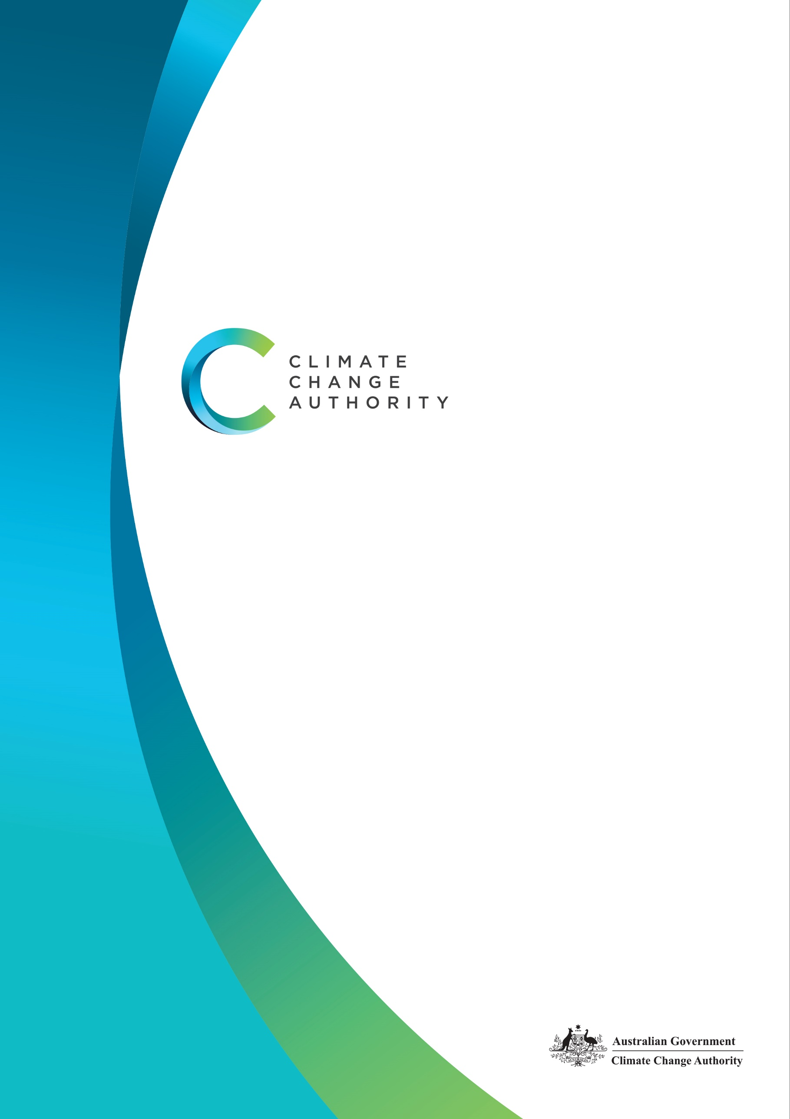

CLIMATE CHANGE AUTHORITY

CORPORATE PLAN 2023-24

AUGUST 2023

**The Climate Change Authority recognises the First Nations people of this land and their ongoing connection to culture and country. We acknowledge First Nations people as the Traditional Owners, Custodians and Lore Keepers of the world's oldest living cultures, and pay our respects to their Elders.**

**Statement of Preparation**

I, Brad Archer, as the accountable authority of the Climate Change Authority, present the authority’s Corporate Plan 2023-24, which covers reporting periods 2023-24 to 2026-27 as required under s.35(1)(b) of the *Public Governance, Performance and Accountability Act 2013*. The plan is prepared in accordance with the *Public Governance, Performance and Accountability Rule 2014* and s.55 of the *Climate Change Authority Act 2011*.

**Brad Archer**   
Chief Executive Officer

**Copyright**

Published by the Climate Change Authority [www.climatechangeauthority.gov.au](http://www.climatechangeauthority.gov.au)

Copyright © Commonwealth of Australia 2023

Unless otherwise stated and except for the Commonwealth Coat of Arms, the authority’s logo, all photographs, graphics and trademarks, this publication is licensed under a Creative Commons 4.0 International licence.

More information on this CC BY license is set out at the [Creative Commons Website](http://www.creativecommons.org/licenses/by/4.0).

The Climate Change Authority asserts the right to be recognised as author of the original material in the following manner:

 or 

©Commonwealth of Australia (Climate Change Authority) 2023.

**Accessibility**

The authority makes its documents and information available in accessible formats. If you have problems accessing the document, please contact us: [Contact us | Climate Change Authority](https://www.climatechangeauthority.gov.au/contact-us) or phone 1800 475 869.

**IMPORTANT NOTICE – PLEASE READ**

This document is produced for general information only and does not represent a statement of the policy of the Commonwealth of Australia. The Commonwealth of Australia and all persons acting for the Commonwealth preparing this report accept no liability for the accuracy of or inferences from the material contained in this publication, or for any action as a result of any person’s or group’s interpretations, deductions, conclusions or actions in relying on this material.

Contents

Chair’s opening statement 4

Chief Executive’s foreword 5

Purpose and strategy 6

Our purpose 6

Our functions 6

Our guiding principles 7

Our strategy 8

Who we are 10

Our operating context 11

Operating environment 11

Resources and Capability 13

Workforce 13

Cooperation – partnerships 14

Corporate governance 16

Corporate governance framework 16

Our activities and performance 19

Performance framework 19

Activities 2023-24 20

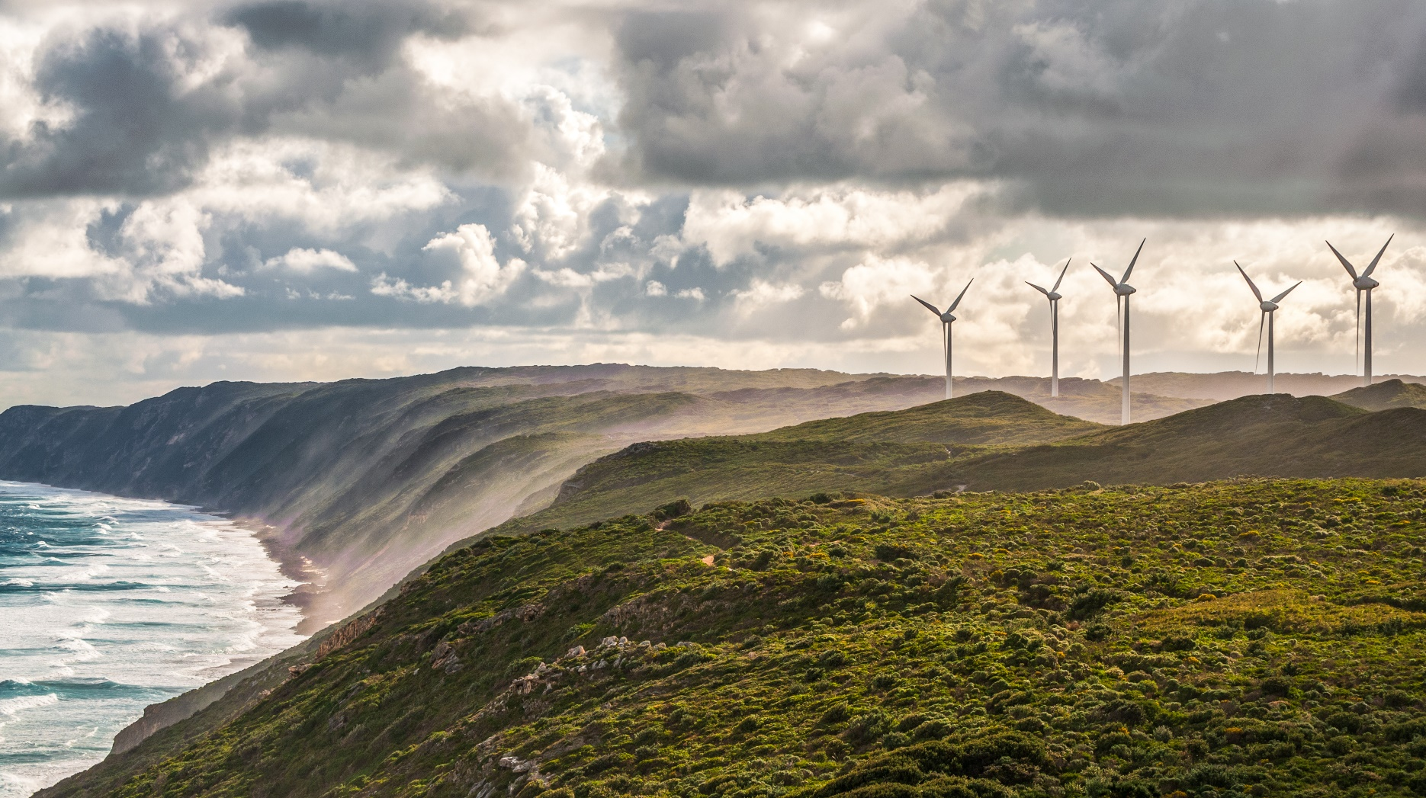

### Chair’s opening statement

It is with great pleasure that I introduce the Climate Change Authority’s 2023-24 Corporate Plan. This plan reflects a substantially expanded role and work program for the authority, spanning existing and new statutory responsibilities, and backed by a restored capacity to deliver.

International reports consistently show us that the need for accelerated action to reduce emissions and address climate change impacts is more pressing than ever. Each day we witness increasing extreme weather events and other damaging environmental impacts. The choices that are made now will have long-term consequences, and it is therefore essential that nations assume their fair share of the task ahead and assist each other to deliver.

Domestically, climate concern and ambition need to translate into real traction and momentum by governments, business and communities working together. While responding to these challenges is a collective priority, the burden of change needs to fall fairly. We need to be mindful of vulnerable groups and critically exposed sectors, and be at our creative best in finding solutions and seizing opportunities. We should focus on transformative strategies that both effectively mitigate climate change and position the Australian economy to prosper, rather than falter, as the world decarbonises. The benefits of this transformation should be shared equitably. We should also do more to identify and address impediments to the necessary changes.

The authority has been tasked with playing a central advisory role in this process. In 2023-24 the authority will undertake four interrelated projects—two broad-reaching advisory projects (advice on Australia’s next Nationally Determined Contribution under the Paris Agreement and the 2023-24 Annual Progress Report on Climate Change) and two targeted reviews of legislated schemes. We also expect to progress advice on sectoral pathways to net zero and will prepare for an expansion of our Annual Progress Report, which from 2024-25 will include detailed advice on the effectiveness of the key emissions reduction scheme, the reformed safeguard mechanism.

The authority will continue to provide advice and analysis that is evidence-based, rigorous and thoughtful. In our work we are guided by principles enshrined in our governing legislation, which aim to ensure that climate change measures deliver on their goals in a way that is economically efficient, environmentally effective and equitable. We take account of impact on households, business, workers and communities, and have regard to boosting economic, employment and social benefits, including for rural and regional Australia.

In keeping with this we will continue to consult as widely as possible, with integrity and with a view to identifying opportunities for the nation to undertake a just transition and to prosper out of the necessary transformative process ahead.

I thank authority members and staff for their ongoing efforts and look forward to continuing to work together, and with our Minister and stakeholders, as we deliver on this important agenda in the year ahead.

**Grant King**  
Chair



### Chief Executive’s foreword

I am pleased to present the Climate Change Authority’s 2023-24 Corporate Plan, which will guide our activities over the next four years. This Corporate Plan outlines who we are, what we will do, and how we will measure our performance over the life of the plan.

This Corporate Plan reflects a step-change in the authority’s role. We have been asked to deliver on a substantially expanded work program, in keeping with markedly increased government, business and community ambition to tackle climate change and its impacts. There is more demand than ever for rigorous and robust evidence-based advice to government on climate change issues, and for information and analysis to inform and support our communities. The authority is well-placed to contribute, with restored capacity that will allow us to build on our established track record as a trusted expert source in our field.

Over the past year, the authority has:

* provided and published its [*First Annual Progress Report 2022: The baseline, global context and methodology*](https://www.climatechangeauthority.gov.au/news/authority-releases-advice-annual-climate-change-statement) which underpinned the Minister’s first climate change statement to Parliament.
* released its self-initiated insights paper: [*Reduce, remove and store: The role of carbon sequestration in accelerating Australia’s decarbonisation*](https://www.climatechangeauthority.gov.au/news/reduce-remove-and-store-role-carbon-sequestration-accelerating-australias-decarbonisation).
* contributed submissions and other input to a broad range of climate-related initiatives, undertaken consultation in a variety of forms, and responded to invitations to present at numerous forums.

In all our work, the authority seeks to embody its values of independence; broad and meaningful outreach and engagement; excellence in research and analysis; transparency; and good governance and accountability.

Our reports are attracting increasing attention and coverage, and sparking the kind of discussion and debate that they aim to. Our work continues to be informed by wide public consultation. We view inclusiveness as essential to ensuring the quality of our work, as well as its public acceptance and influence. We are always looking to enhance our outreach and engagement with communities, institutions, business and other stakeholders. Our broad consultation on our issues paper [*Setting, Tracking and Achieving Australia’s Emission Reduction Targets*, released in May this year, underscores these aims and will provide us with essential insights for our 2023-24 work program.](https://www.climatechangeauthority.gov.au/news/setting-tracking-and-achieving-australias-climate-targets-consultation-launch)

In 2022-23 we successfully increased our workforce to position us to deliver upon our expanded role. In addition to enhancing our technical capacity, we have targeted building essential internal capability across our key functional and corporate areas, so that we can operate more independently and sustainably. We have also moved to new premises in Canberra to accommodate our growth.

In the next twelve months, the authority will:

* provide its second Annual Progress Report on climate change, which will support the Minister’s 2023 annual climate statement to Parliament. We will also prepare to deliver our third Annual Progress Report, which will expand as a result of the Government’s reforms to the safeguard mechanism.
* complete and report on statutory reviews of the legislation which creates the Australian Carbon Credit Unit (ACCU) Scheme and the National Greenhouse and Energy Reporting Scheme.
* progress advice to Government on Australia’s 2035 emissions reduction targets for its next Nationally Determined Contribution under the Paris Agreement.
* progress advice on sectoral emissions reduction pathways to net zero, expected to be commissioned in late 2023 by a Parliamentary referral.

I’d like to thank the authority’s Chair Grant King, and members Cathy Foley, Lesley Hughes, Mark Lewis, Virginia Marshall, John McGee, Sam Mostyn, Russell Reichelt and Susie Smith who lead and guide the work of the authority. Thanks also to our excellent staff, who are absolutely essential in allowing the authority to continue to deliver and to grow.

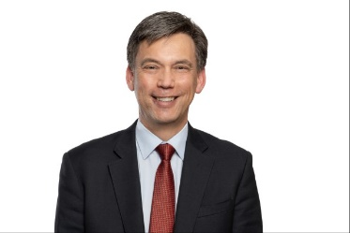**Brad Archer**

Chief Executive Officer

# Purpose and strategy

### Our purpose

The Climate Change Authority’s purpose is to provide evidence-based advice on the response to climate change, to:

* accelerate emissions reductions and position Australia as a leader in the global effort to limit temperature increases.
* guide Australia to new opportunities and new ways of doing things, to sustain Australia’s prosperity as the world transitions to net zero emissions.
* help Australia prepare for and adapt to the impacts of climate change, which have already begun and will continue to increase.

### Our functions

The authority’s functions are set out in its enabling legislation, the *Climate Change Authority Act 2011*, and can be summarised as follows:

* providing advice on achieving Australia’s emissions reduction targets and the effectiveness of climate change policies for the Minister for Climate Change and Energy’s annual statement to the Parliament under the *Climate Change Act 2022*
* providing advice to the Minister, as required by the *Climate Change Act 2022*, on Australia’s Nationally Determined Contributions under the Paris Agreement
* conducting reviews of the *Carbon Credits (Carbon Farming Initiative) Act 2011* (which creates the Australian Carbon Credit Unit (ACCU) Scheme) and the *National Greenhouse and Energy Reporting Act 2007* (which creates the Safeguard Mechanism)
* conducting special reviews of matters relating to climate change as requested by the Minister or the Parliament
* undertaking research into matters relating to climate change and other matters relating to the performance of our functions.

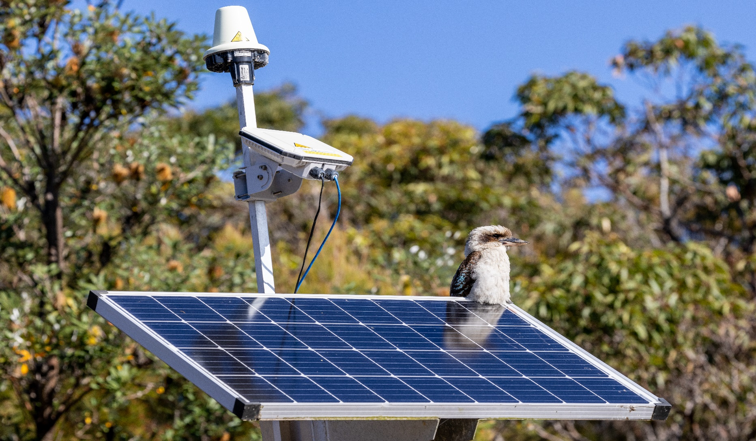

### Our guiding principleS

In performing our functions, our legislation requires us to have regard to the principle that any measures to respond to climate change should:

* be economically efficient
* be environmentally effective
* be equitable
* be in the public interest
* take account of the impact on households, business, workers and communities
* support the development of an effective global response to climate change
* be consistent with Australia’s foreign policy and trade objectives
* take account of the matters set out in Article 2 of the Paris Agreement
* boost economic, employment and social benefits, including for rural and regional Australia.

OUR VALUES

**Independence**

The authority operates independently under its own legislation, budget allocation and staff, as a non-corporate statutory body located in the Climate Change, Energy, the Environment and Water portfolio. We are committed to independence and impartiality when undertaking research and reviews and providing advice based on our own research and judgements.

**Transparency**

The authority operates in an open and transparent manner. We have a statutory obligation to publish our research, advice and review reports. Where possible we also publish public submissions to our review reports. Our advice and reports are the result of reviewing and synthesising existing materials, engaging with stakeholders and undertaking independent research to generate original reporting, analysis and advice.

**Excellence in research and analysis**

The credibility of the authority relies on the quality of its research, analysis and reporting. We undertake detailed planning and thorough research and analysis, drawing on the best available knowledge, and seek input from expert advisers. We also have a skilled workforce with a broad range of experience, and established links to relevant national and international expert organisations.

**Valuing our most valuable asset**

The authority's professional, capable and committed workforce is its most valuable resource. Continued investment in our staff, in an inclusive way that respects and reflects the diversity of our skills, knowledge and backgrounds, is vital for maintaining and enhancing the authority's performance. We provide all staff with the opportunity to develop skills and knowledge through formal training and other development opportunities.

**Broad and positive stakeholder engagement**

The authority takes account of available inputs and perspectives by engaging with a wide range of stakeholders and other contributors with an interest in climate change policy and related matters. We consult the public on every review, and in preparing our advice, consistent with the requirements set out in our legislation.

**Good governance and accountability**

The authority maintains high standards of accountability and governance. As a government agency, the authority is subject to the *Public Governance, Performance and Accountability Act 2013* and *Public Service Act 1999*, and has specific additional governance requirements under the *Climate Change Authority Act 2011*.

### Our strategy

We will deliver influential, independent and expert advice by:

* undertaking rigorous research, analysis and policy development
* conducting in-depth analysis of relevant sectors and contemporary research
* commissioning other analytical work (for example, economic modelling) where required
* conducting meaningful and transparent consultation with experts and stakeholders, including business, industry, First Nations, environment and other community groups to gather information and debate policy options
* monitoring developments in climate change policy by reviewing publicly available resources and building networks with expert, local and international organisations
* presenting insightful and practical reports
* operating within a strong governance and accountability framework.

Strategic framework

We have identified six actions that can drive the bulk of abatement and adaption changes needed for a prosperous and resilient net zero Australia. These actions are supported by six enablers that the Government has a critical role in facilitating.

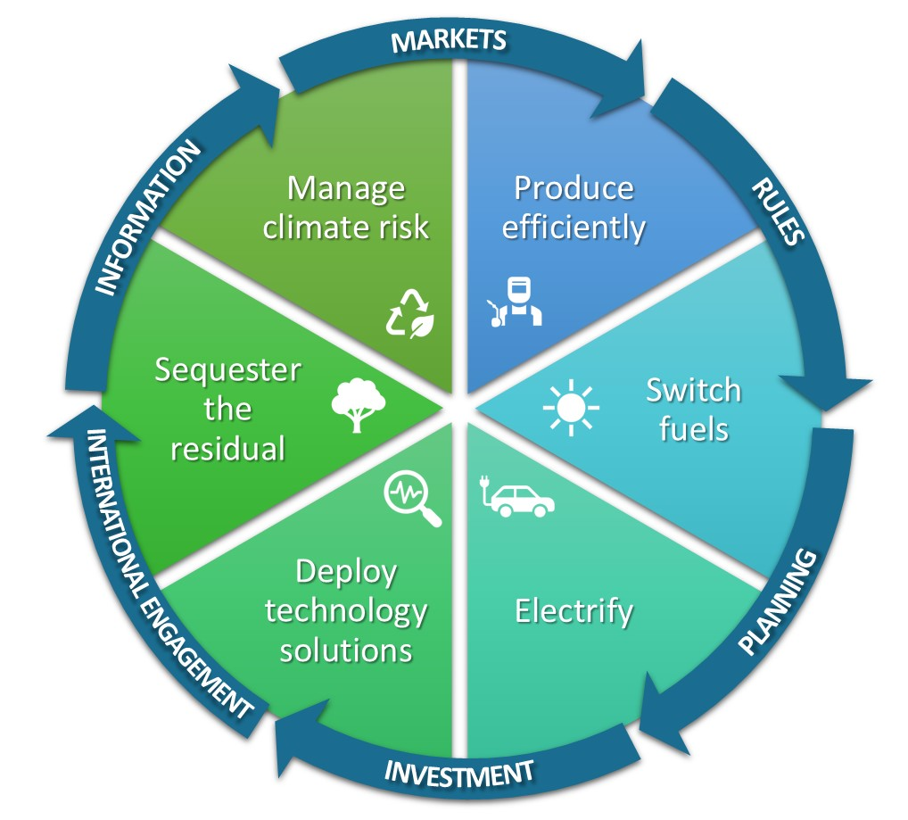

**Wedges = Actions**

**Arrows = Enablers**

**THE ACTIONS**

**Produce efficiently**

Reduce the emissions intensity of production and reduce inefficient use of resources such as energy and land.

**Switch fuels**

Shift from high emitting fuels to lower-emissions, and ultimately zero-emissions, alternatives.

**Electrify**

Generate enough affordable and clean energy to meet growing demand, and electrify as much as possible.

**Deploy technology solutions**

Do as much as we can with the mitigation and sequestration technologies we already have, and accelerate the development and deployment of new technologies.

**Sequester the residual**

Mitigate as much as possible and sequester the rest.

**Manage risks**

Build resilience and plan for and manage the risks that climate change presents to Australian industries, businesses, communities, the environment and our region.

**THE ENABLERS OF ACTIONS**

**Information**

Efficient collection of accurate, consistent and comprehensive information on emissions and decarbonisation will minimise costs on business, while supporting optimal decision-making and Australia’s competitive position in the global economy.

**Markets**

Open, competitive and transparent markets.

**Rules**

Governments can use rules to solve market failures. Governments are responsible for compliance with rules through appropriate combinations of formal and informal mechanisms and dealing with conflicts that arise among stakeholders with different perspectives, interests and priorities.

**Planning**

Governments can enable industries, workers, and communities to make decisions about the future by planning and communicating their intent in advance. Urban planning, infrastructure and land use planning can enable timely and efficient mitigation, sequestration, and adaptation. Governments can enable a smooth transition by planning for institutional adaptation and change.

**Investment**

Invest in science such as the research, development and deployment of abatement technologies. Public investment can stimulate innovation and provide high-risk capital for new technologies, shift activities down the cost curve to price parity and catalyse new markets.

**International engagement**

Actively partnering with countries to support the development of carbon markets, transparent reporting of emissions and deployment of clean technologies and fuels will create new trade opportunities, and help less developed countries lift their disadvantaged communities out of poverty while bypassing the emissions intensive development of industrialised nations. Internationally consistent, transparent ways of sharing information will enable sustainable finance, trade and carbon markets to play their part.

### Who we are

Authority members

The current membership comprises:

*Chair*: Mr Grant King

*Member*: Professor Lesley Hughes

*Member*: Mr Mark Lewis

*Member*: Dr Virginia Marshall

*Member*: Mr John McGee

*Member*: Ms Sam Mostyn AO

*Member*: Dr Russell Reichelt AO

*Member*: Ms Susie Smith

*Member*: Dr Cathy Foley AO PSM (Chief Scientist of Australia) (ex officio)

Our members bring substantial experience, knowledge and standing in the fields that underpin our work and are identified in our Act, including economics, industry, technology development and adoption, energy production and supply, greenhouse gas emissions measurement and reporting, greenhouse gas abatement measures, financial markets and investment, trading of environmental instruments, land resource management, environmental management and public administration. Details of members’ qualifications and expertise can be found on our website at [www.climatechangeauthority.gov.au](http://www.climatechangeauthority.gov.au/).

Authority staff

The authority’s analysis and strategy branches discharge our core advisory, analysis, modelling, policy, communications, outreach and engagement roles. The corporate and executive teams manage the authority’s financial, human resources, procurement, accommodation, security, risk, governance and information technology functions. Our staff have expertise and qualifications in a wide range of fields, including climate science, economics, law, international relations, public affairs, human relations, accounting and communications.

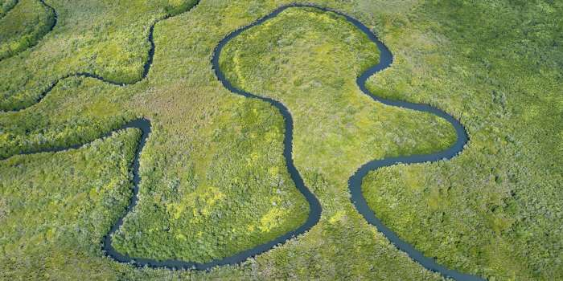

# Our operating context

### Operating environment

Our operating environment has important implications for how we can deliver on our vision and purpose. Although many factors are out of our direct control, we proactively consider how they impact our delivery and how we can respond.

Our work in providing evidence-based advice relevant to Australia’s response to climate change is shaped by scientific knowledge, the international and domestic economic and climate policy environment, as well as the experiences of Australian communities.

The sense of urgency is increasing in the light of more scientific evidence and the lived experience of climate impacts.

Our work is underpinned by science, particularly the work of the Intergovernmental Panel on Climate Change (IPCC), the United Nations body established to assess and advise on the science related to climate change. In its March 2023 Synthesis Report[1], the IPCC found that:

* Rapid and far-reaching transitions are necessary to achieve a liveable and sustainable future for all.
* Choices and actions this decade will have impacts now and for thousands of years.
* Rapid, deep and, in most cases, immediate greenhouse gas emissions reductions in all sectors feature in all global modelled pathways that limit warming to 1.5°C (>50%) with no or limited overshoot, and those that limit warming to 2°C (>67%).
* Accelerating mitigation and adaptation actions this decade would reduce losses and damages and deliver benefits for humans and ecosystems. Delaying mitigation and adaptation action would lock-in high-emissions infrastructure, raise risks of stranded assets and cost-escalation, reduce feasibility, and increase losses and damages.
* The impacts of a changing climate are increasingly felt in Australia, accompanied by growing need for climate adaptation.
* Australian land areas have warmed by around 1.4°C between about 1910 and 2020, and annual temperature changes have emerged above natural variability in all land regions. Heat extremes have increased, cold extremes have decreased, and these trends are projected to continue.[2]

In response to this growing urgency, we are increasing our outreach to affected communities and providing more advice to the Government on the policy response to the impacts of climate change. The growing need for effective, efficient and equitable policies to foster climate adaptation and resilience will be a significant focus for us in the period ahead.

International momentum presents risks and opportunities for Australia.

Globally, many countries have in recent years enhanced emissions reduction commitments. Current global ambition, including net zero targets, would put the world on track to warming of less than 2°C. The Glasgow Climate Pact, agreed by Parties to the Paris Agreement, strengthened the commitment to pursue efforts to limit temperature increase to 1.5°C above pre-industrial levels by the end of the century. However, recent UN Environment Programme analysis finds that global ambition is still not matched by current policies and emissions levels, which instead point to an outcome of more than 2°C warming this century.[3]

Factors including global economic conditions, the state of critical supply chains and conflicts such as the Ukraine crisis will continue to impact accelerating momentum towards achieving decarbonisation goals.

The Australian economy relies significantly on exports. As the global economy moves towards net zero, a large portion of the Australian economy risks being a less-preferred trading partner unless it can compete on the emissions intensity of its exports. At the same time, the global transition presents opportunities for exports that contribute to decarbonisation, such as critical minerals, green steel and green hydrogen.

We are tracking the ambition and actions of other countries and the implications for Australia’s transition. We also track global emissions trends and, by extension, the likely level of warming for which Australia must prepare.

An orderly transition will require wide-ranging social licence and a shared understanding of the plan.

Achieving Australia’s 2030 and 2050 targets means stepping up and sustaining a much higher average rate of emissions reduction. It requires coordinated action across all sectors and jurisdictions, and success hinges on the decisions made by individuals. It requires change in the context of concerns about the cost of living and an increasing focus on wellbeing. Further major policy responses are to be expected, and communities are expected to react, with implications for the authority’s work in the term of this Plan.

Achieving Australia’s 2030 target requires rapid deployment of the emissions reduction technologies available today. To achieve this, the practical, real world barriers to deployment must be overcome. Shocks and shortages in global supply chains put at risk the delivery of the projects essential for achieving net zero which need to be rolled out at unprecedented levels. Up-skilling the workforce, along with the planning, permitting and approvals of major renewables and other infrastructure projects must happen even faster, and must be supported by resilient supply chains and private finance.

The policy environment for enabling an orderly transition to net zero is less clear, with the Government yet to set out a detailed long-term strategy. While the appetite for change is growing in some areas, social licence is faltering in others. In the context of the rising cost of living, uncertainty about the future has an understandable impact on wellbeing. We stand ready to work alongside the new national Net Zero Authority to ensure workers, industries and communities are set up for a prosperous, resilient future.

These considerations will be central to our consultation, analysis and outputs during the term of this Plan.

### Resources and Capability

The Government’s commitment to restore the authority has resulted in a substantial uplift in its capability during 2022-23. The authority’s total operating budget for 2023-24 is $13.46 million (up from $2.6 million in 2021-22). As at 30 June 2023, our staffing levels have increased to a headcount of 62 employees (up from 13 employees as at 30 June 2022).

This additional resourcing will assist the authority to deliver on the significant expansion of its responsibilities arising from additional functions in the *Climate Change Act 2022* and the *Safeguard Mechanism (Crediting) Act 2023*,requests for it to conduct additional review and advice work, and additional outreach and engagement activities.

We will apply this enhanced capability to deliver:

* advice that supports an equitable, efficient and effective transition and complementary and appropriately sequenced approaches that are in the national interest.
* advice on progress with climate adaptation and resilience measures.
* broader and deeper engagement with stakeholders to ensure advice reflects the latest developments in theory, practice, technology and policy thinking.
* enhanced capacity to engage with the community to explain the reasons for recommended policy actions – helping to build the social licence for climate action.
* international engagement.

We have expanded our in-house expertise to maintain a greater breadth of sectoral and technical knowledge including in relation to:

* carbon and energy markets, and systems innovation to support development of transition pathways to net zero emissions for hard to abate sectors
* international climate change developments
* the power, transport, industry, land and agriculture sectors
* climate science, adaptation, resilience and carbon removal
* data analysis and presentation and climate change modelling.

Our corporate function has also grown to support the efficient and effective operation of the restored agency.

We will continue to use our partnerships within government to deliver some core functions that we will ultimately look to conduct in-house. For example, we intend to work closely with the Treasury as we rebuild our climate change modelling capability during the period of this Plan.

### Workforce

The authority relies on its staff to undertake the research and analysis that supports its advice, reviews and reports, and to manage the corporate functions of the agency. Staff expertise and professionalism are critical to the production of high-quality advice and reports, building and maintaining good stakeholder relationships, and ensuring the smooth operation of the agency.

Staff are encouraged to undertake learning and development to build up competencies relevant to their roles. We have a study policy that sets out the assistance provided to staff for external learning and development. The policy provides financial and leave assistance to staff enrolled in study or training that is relevant to the operational needs of the agency.

We provide extensive on-the-job training and support, and staff have access to undertake courses through the online learning and development platform Each staff member has the opportunity to identify and access appropriate training through their Performance and Development Plan.

In 2023-24, the authority will negotiate a new Enterprise Agreement. This will provide an opportunity to update employment terms and conditions for staff, who currently operate under the *Department of Climate Change and Energy Efficiency Enterprise Agreement 2011-2014*.

### Cooperation – partnerships

#### Shared services arrangements

As a small agency, the authority maintains agreements with other agencies for some corporate services. These arrangements are performed on a fee-for-service basis. They are appropriate for the size of the authority and are in line with the Government’s shared services agenda.

The Department of Industry, Science and Resources (DISR) has been the authority’s shared services provider since early 2020, covering finance, payroll, human resources and legal services, and information technology systems and support. There have been substantial changes to these arrangements resulting from the July 2022 Machinery of Government changes, which saw the Department of Climate Change, Energy, the Environment and Water (DCCEEW) succeed DISR as the authority’s portfolio department.

* ICT, protective security, learning & development system, and several other employee-related services are now being provided by DCCEEW.
* DISR is continuing to supply financial and payroll system management and support services.
* All other corporate services have been, or are being, transitioned back to the authority to be performed in-house.

We also work closely with other Government agencies, including the Clean Energy Regulator with which we have a shared graduate program.

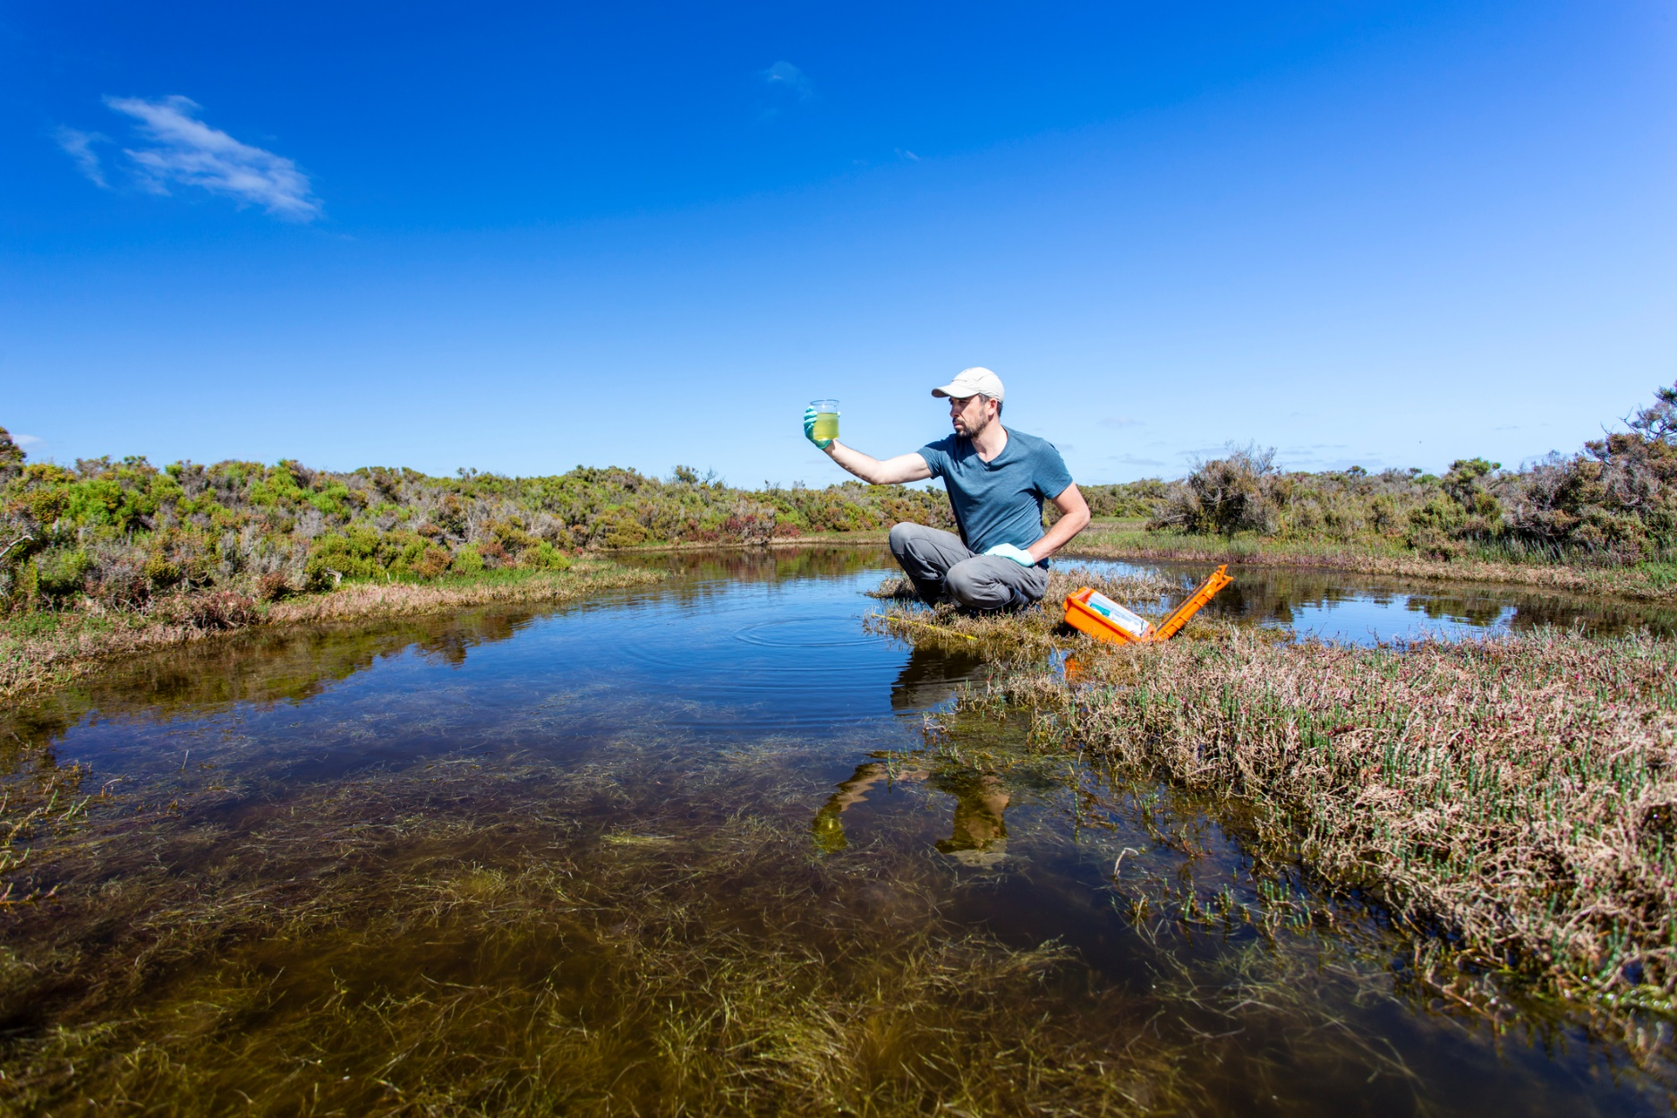

#### Strategic Relationship Agreement – Climate Science Advice

In 2021, the authority and the Bureau of Meteorology entered a Strategic Relationship Agreement to strengthen engagement and enhance coordination between the two agencies. The Bureau of Meteorology partners with Geoscience Australia, CSIRO and Australian Bureau of Statistics to bring together world-leading science, information and expertise on climate and climate-related natural hazards. The agreement facilitates regular knowledge exchanges between the two agencies and helps strengthen the authority’s advice to Government on climate change and its impacts.

#### Indigenous partners

In 2021-22, the authority developed our first Reconciliation Action Plan (RAP). The plan includes actions to build mutually beneficial relationships and partnerships with First Nations peoples. We will develop and finalise our second RAP in 2023-24, which will build on the first plan with a range of new actions to strengthen our contribution towards reconciliation in Australia.

#### International partners

In 2022-23, we met with other independent climate change agencies from around the world, coming together as an International Climate Councils Network, to share experiences, discuss common challenges and explore how to support one another in our work. We will continue to participate in the network as part of our international engagement.



# Corporate governance

The Climate Change Authority is an independent advisory body created under Commonwealth legislation and reporting to the Minister for Climate Change and Energy.Its members are appointed by the Minister, and comprise the Chair, the Commonwealth Chief Scientist and up to seven other members.

The members are supported by a Chief Executive Officer (CEO), who is also a statutory appointee. As the accountable authority of the agency under finance law, the CEO is responsible for the day-to-day running of the authority. The members and CEO are supported by the staff of the authority, who are engaged under the *Public Service Act 1999*.

As a government agency, the authority’s officials are subject to the *Public Governance, Performance and Accountability Act 2013* and *Public Service Act 1999*. The authority is also subject to specific additional governance requirements under the *Climate Change Authority Act 2011*.

### Corporate governance framework

The authority undertakes its work within a strong governance framework, including meeting relevant requirements under the *Public Governance, Performance and Accountability Act 2013*. To ensure we comply with governance requirements, we will continue to:

* maintain sound systems for control and oversight of projects, procurements, finances and human resources.
* apply a comprehensive risk management framework to our activities, conduct internal assurance and maintain an Audit Committee.
* maintain strong probity and integrity procedures, including stringent conflicts of interest frameworks.
* carry out awareness-raising activities for officials (including new authority members and staff).
* maintain governance as a standing agenda item at regular senior management meetings.
* ensure that governance mechanisms are subject to regular review and continuous improvement.

*Risk management*

The authority has a Risk Management Framework and policy to drive a positive risk management culture. We are accountable for our actions and decisions while adopting a ‘no-blame’ approach, where we all work together to manage risks and continuously improve in pursuit of the authority’s objectives.

The framework complies with the requirements of the *Commonwealth Risk Management Policy 2023* and the *Public Governance, Performance and Accountability Act 2013*. The Framework and Risk Management Policy are updated regularly and reviewed by the authority’s Audit Committee. All staff are required to complete annual integrity and risk training.

Table 1 sets out the authority’s high-level strategic risks for the reporting period, along with risk ratings and mitigation strategies. Risk treatments and treatment owners are outlined in the authority’s Strategic Risk Register and Plan, which is reviewed at least quarterly, by the Executive Team. Our strategic objectives are the starting point of the strategic risk identification process and risks and opportunities are balanced in accordance with the authority’s Risk Management Framework.

Our strategic risks are those that, if realised, would materially affect our ability to achieve the authority’s purposes.

*Climate risk management and Net Zero Government Initiative*

In all facets of our own operations we consider climate risks. Our staff are all responsible for identifying, assessing and managing climate risks in the context of their work. We also actively contribute to the Net Zero Government Initiative through our own agency planning as well as advocacy within government.

TABLE 1: CLIMATE CHANGE AUTHORITY STRATEGIC RISKS

|  |  |  |  |  |  |
| --- | --- | --- | --- | --- | --- |
| RISK DESCRIPTION | LIKELIHOOD, CONSEQUENCE AND RATING | | | MITIGATION STRATEGIES | |
| **Maintain confidence and trust** |  | | |  | |
| The authority is unable to maintain the confidence and trust of the government, industry and the public. | **Possible; moderate; medium** | | | * The authority operates in a transparent and accountable way and stakeholder opinions are valued and considered * Outputs are reviewed for quality assurance and accuracy and conclusions are supported by evidence based advice * Maintain a constructive working relationship with the Minister, Minister’s Office and the Department * Maintain good lines of communication with relevant government policy and regulatory agencies, including during design and implementation of work plans * Conflict of interest are declared by employees and authority members and are managed in keeping with legislative requirements, relevant guidance and expectations of the APS * Stakeholder networks are reviewed and maintained and their operating environments are well understood. | |
| **Advice** |  | | |  | |
| The authority fails to deliver high quality, evidenced based advice. | **Possible; moderate; medium** | | | * Adequate scoping of tasks, problem definition, and review methodologies is undertaken * Outputs are reviewed for quality assurance and accuracy * Knowledge resources are available to staff (eg, policies, standard operating procedures, factsheets and guidance) * Learning and development for staff to build and develop knowledge * External expertise accessed/procured as required and as resourcing allows * Scheduling tools and progress reporting are implemented * Open and ongoing communication and collaboration with staff and the authority members * Ongoing workload planning and resource allocation reviews. * Ideas and recommendations are tested both internally and, where appropriate, externally. | |
| **People capability** | | |  | |  |
| The authority is unable to attract, develop and retain the people capability it needs. | | **Almost certain; moderate; high** | | * Staff retention practices are reviewed and refined where retention issues become apparent * Implement activity and project scheduling and planning to optimise the use of resources * Professional career development and training opportunities are available to all staff * Recruitment material and engagement strategies attract appropriately skilled people * Inclusive approach to working and decision-making * Substantive response to APS Census results and planning day outcomes * Staff have access to and can take appropriate leave to promote wellbeing * The authority has implemented initiatives and training to contribute to the health, safety and wellbeing of the authority’s workforce (including having a WHS representative, first aid officer and fire warden). | |
|  | |  | |  | |
| **Information** | |  | |  | |
| The authority fails to protect its information and information systems. | | **Possible; moderate; medium** | | * System controls and monitoring is in place to identify breaches and misuse of data and information * Business continuity plans and compliance checks are in place * Restricted access to applications and files for officials * Formal process for release of information and data * Police checks and security clearances are required for all employees and contractors working for the authority * Education for staff on appropriate electronic security classification markings and practices. | |
| **Legal obligations** | |  | |  | |
| The authority fails to adhere to its legal obligations. | | **Unlikely; substantial; medium** | | * Appropriately experienced staff are engaged to perform roles across the authority * Appropriate guidance, documentation and training is available * Systems to capture instances of non-compliance with legislation are in place * Instances of non-compliance are reviewed with appropriate remediation and mitigation strategies implemented. | |
| **Financial sustainability** | |  | |  | |
| The authority is unable to maintain financial sustainability. | | **Unlikely; substantial; medium** | | * Key priorities are planned and align to funding allocation * Budget expenditure is monitored closely and any under/over spends are communicated and addressed * Actions to increase the authority’s funding are pursued when necessary with the portfolio department * The Chief Executive Officer and the Chief Finance Officer monitor budget expenditure closely. | |
| **Organisational change** | |  | |  | |
| The authority fails to manage organisational change successfully | | **Possible; moderate; medium** | | * Key priorities are planned and align to funding allocation * The Senior Executive team reviews the organisational, meeting and committee structures to ensure they are appropriate, engaging and achieve their purposes to support an agile workplace and organisation. * Engagement of external consultants to assist with determining roles and responsibilities and change management activities. * Engagement and communication with staff across all branch and teams is ongoing * Appropriate use of change management tools and staff change champions. | |

# Our activities and Performance

This plan covers the four financial years from July 2023 to June 2027. Our performance framework is set out below, followed by detail on our 2023-24 activities. Our activities over the life of this plan, and our key performance indicators for those activities, are listed in Table 2.

As set out in the Government’s Portfolio Budget Statements, the authority is responsible for the following outcome:

“Provide expert advice to the Australian Government on climate change initiatives, including through conducting regular and specifically commissioned reviews and through undertaking climate change research.”

Accordingly, our objective is to provide rigorous, independent and expert advice to the Minister for Climate Change and Energy and to assist the Department and the Australian Parliament on climate change policy, in order to improve the quality of life for all Australians.

### PERFORMANCE FRAMEWORK

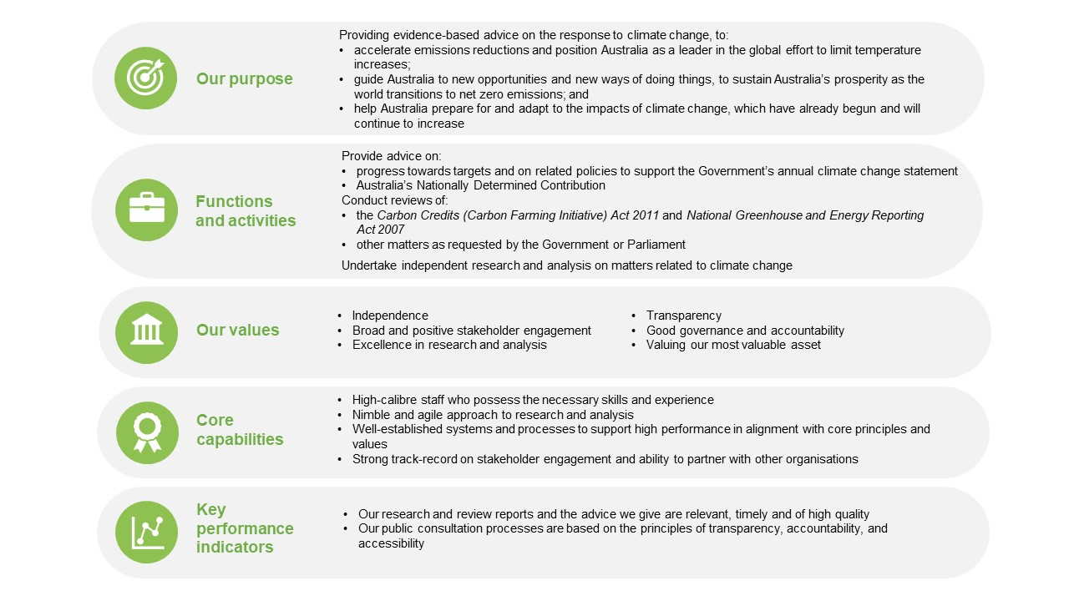

### Activities 2023-24

Our activities over the 2023-24 reporting period will focus on advice on progress towards targets and related policies to support the Government’s annual statement to the Parliament on climate change, statutory reviews, and self-initiated research on climate change matters. The authority will also undertake any special reviews requested by the Minister or the Parliament.



**Activity 1: Annual statement advice: progress towards targets and on related policies**

In 2023, the authority will deliver its advice to inform the Government’s second annual climate change statement.

We will also commence work on advice in 2024 to inform the Government’s third annual climate change statement, which will include the effectiveness of the safeguard mechanism.

**Activity 2: Nationally Determined Contribution advice**

In 2023 the authority will carry out research and analysis on Australia’s national greenhouse gas emissions reduction targets for 2035. This will inform advice to the Minister, due in late 2024, that will support the Government in determining Australia’s next updates to its NDC under the Paris Agreement, due in 2025.

**Activity 3: Complete statutory reviews**

In 2023, the authority will review the legislation underpinning the Emissions Reduction Fund and the national emissions reporting framework concurrently for the first time.

The authority is legally required to review, by 31 December 2023:

* the *Carbon Credits (Carbon Farming Initiative) Act 2011,* whichunderpins the Emissions Reduction Fund
* the *National Greenhouse and Energy Reporting Act 2007*, which establishes a national reporting framework for greenhouse gas emissions and energy consumption and production. The legislation also creates the safeguard mechanism, which sets limits on the emissions of large businesses. This review will include advice requested by the Minister on measurement, verification and reporting of methane emissions.

**Activity 4: Complete special reviews**

The government has indicated that in late 2023, the authority can expect to receive a Parliamentary referral to conduct a special review into sectoral pathways to assist the government develop a national net zero by 2050 plan.

**Activity 5: Self-initiated research and analysis**

The authority’s self-initiated research often supports its other mandated functions.

During the period covered by this corporate plan, the authority will identify and undertake further research on climate change matters if opportunities arise.

TABLE 2: ACTIVITIES AND KEY PERFORMANCE INDICATORS

**2023-24 – 2026-27**

|  |  |  |  |  |
| --- | --- | --- | --- | --- |
| YEAR | ACTIVITY | KEY PERFORMANCE INDICATORS | TARGET | ASSESSMENT |
| 2023-24  -  2026-27 | Provide advice on:   * progress towards targets and on related policies to support the Government’s annual climate change statement to the Parliament. * Australia’s Nationally Determined Contribution.   Conduct reviews of:   * the *Carbon Credits (Carbon* *Farming Initiative) Act 2011* * the *National Greenhouse and Energy Reporting Act 2007* * other matters as requested by the Government or the Parliament (Special Reviews).   Undertake other self-initiated research on climate change matters. | * Our research and review reports, and the advice we give, are relevant, timely, and of high quality. * Our public consultation processes are based on the principles of transparency, accountability and accessibility. | * Reviews and research reports and advice draw on the best available knowledge and are informed by a broad range of perspectives. * Public consultation is comprehensive, representative and transparent. * The authority’s analysis, findings and advice are communicated clearly and effectively. * Reviews and research reports and advice are provided by the due date. * Research and review reports and advice are relevant to the government and stakeholders of the day, and influence the public debate on climate change policy. * Government considers the authority’s findings and recommendations in developing and implementing policy. | * Relevant and up-to-date academic, scientific, scholarly and other external sources are referenced in the research and analysis that informs the authority’s advice and reports. * Levels of stakeholder participation in consultation processes and references to representative stakeholder views in the authority’s reports and advice. * Date of delivery to the Minister responsible for climate change or the Parliament and date of publication on the authority’s website. * Analysis of feedback by the Government and other stakeholders on the authority’s research and analysis. * Analysis of the use and discussion of the authority’s reports and advice in public policy forums and discussions. |

1. Intergovernmental Panel on Climate Change (2023), *Climate Change 2023 — Synthesis Report: Summary for Policymakers*, [IPCC_AR6_SYR_SPM.pdf](https://www.ipcc.ch/report/ar6/syr/downloads/report/IPCC_AR6_SYR_SPM.pdf)
2. Intergovernmental Panel on Climate Change (2023), *Sixth Assessment Report: Working Group I – The Physical Science Basis: Regional Fact Sheet – Australia*, [Regional_Fact_Sheet_Australasia (ipcc.ch)](https://www.ipcc.ch/report/ar6/wg1/downloads/factsheets/IPCC_AR6_WGI_Regional_Fact_Sheet_Australasia.pdf)
3. United Nations Environment Program (2022), *Emissions Gap Report 2022: The Closing Window — Climate crisis calls for rapid transformation of societies* [Emissions Gap Report 2022 (unep.org)](https://www.unep.org/resources/emissions-gap-report-2022)