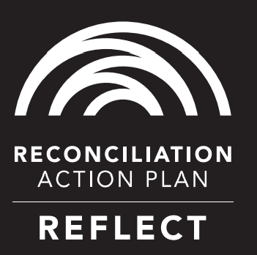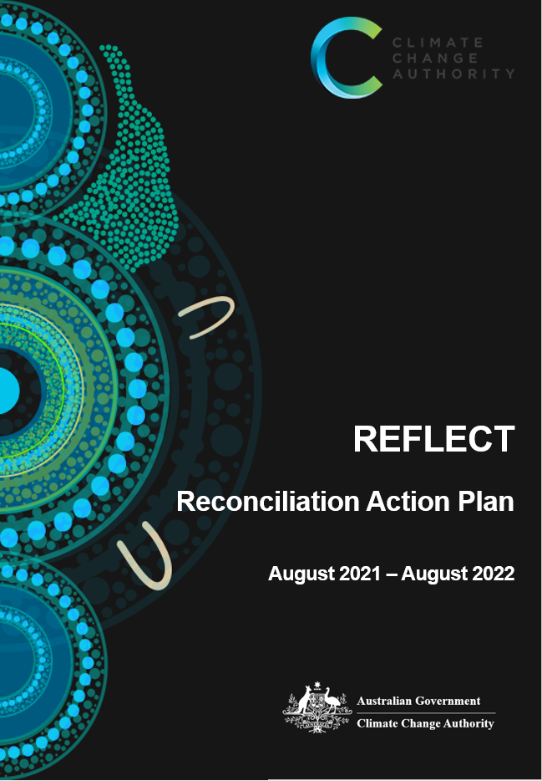



# Artists’ Statement

***Lynnice Letty Church and Leilani Keen-Church***

Mother and daughter, Lynnice and Leilani, have developed this artwork for the Climate Change Authority’s ‘Reflect’ Reconciliation Action Plan. Lynnice is Ngunnawal, Wiradjuri, and Kamilaroi. Leilani is Ngunnawal, Wiradjuri, Kamilaroi and Barkindji.

Both have lived and grown up on the lands of their people and developed artworks that incorporate the uniqueness of their country’s landscapes, culture, knowledge, and experiences, as Aboriginal women taught them throughout their life, from their maternal and paternal family and Elders. Leilani and Lynnice see opportunities to share their culture through artwork as a responsibility and privilege and also as a means to educate and bring people together.

***About the artwork***

The artwork is titled “Dhawura” (*Ngunnawal* word meaning “earth”). Its design represents our mother earth and the connection between land, waterways, sea and air as a delicate balance. Our people have always understood the importance of taking care of country and our role as custodians to ensure the ongoing preservation of plants, animals and waterways that are essential to our existence and connection.

Climate change is already happening. Our efforts today rely on the importance of coming together, listening and learning and taking action. One part of this journey is recognising and valuing the knowledge of Aboriginal and Torres Strait Islander people and their strong connection with country, so we can bring our shared knowledge together to address climate change and help ensure environmental protection and conservation.

The Authority acknowledges the Traditional Owners of Country throughout Australia and pays its respects to them, their cultures and the Elders – past, present and future. The Authority recognises the Traditional Owners’ profound connection to and custodianship over countryꟷwhich has endured for more than 65,000 yearsꟷhelping the land, air, waterways and sea prosper for future generations.

# Contents

[Artists’ Statement 3](#_Toc78882467)

[Contents 5](#_Toc78882468)

[CEO Foreword 6](#_Toc78882469)

[Our Business 7](#_Toc78882470)

[Our Reconciliation Action Plan 8](#_Toc78882471)

[Relationships 9](#_Toc78882472)

[Respect 10](#_Toc78882473)

[Opportunities 11](#_Toc78882474)

[Governance 12](#_Toc78882475)

# CEO Foreword

I am pleased to present the Climate Change Authority’s “Reflect” Reconciliation Action Plan (RAP). The Authority recognises that reconciliation is a crucial step towards creating a more sustainable and prosperous Australia. We regard the actions set out in this RAP as important opportunities to deepen, diversify and enrich the Authority’s work in an inclusive manner that upholds and protects the rights of Australia’s First Nations people.

In 2009, the Australian Government announced its support for the United Nations Declaration on the Rights of Indigenous Peoples. The Declaration formally recognises that respect for traditional knowledge, cultures and practices leads to stronger environmental management. This is especially the case in Australia, where Traditional Owners draw upon a rich and intricate history of shared connection to Country, both as its custodians and as unique agents of change.

The Declaration on the Rights of Indigenous Peoples also reinforces the importance of consulting with Traditional Owners on decisions directly affecting them. Vast areas of land already impacted by Australia’s changing climate are under Aboriginal and Torres Strait Islander control, and First Nations people in Australia are disproportionately affected by the impacts of climate change, especially those living in rural and remote areas.

In spite of this, Aboriginal and Torres Strait Islander voices remain under-represented in Australia’s climate change policy dialogue. The actions outlined in the Authority’s Reflect RAP are designed to lay the foundations for addressing this critical gap. By valuing and promoting diverse ways of *being, knowing and doing* with respect to the land and waters, we hope to help forge a more unified national identity: one that recognises the need to respect each other and the natural world.



Brad Archer

CEO, Climate Change Authority

# Our Business

The Climate Change Authority is an independent statutory agency established to provide expert advice to the Australian Government on climate change policy. The Authority currently undertakes statutory reviews of the Emissions Reduction Fund and National Greenhouse and Energy Reporting scheme, advises the Australian Government and Parliament on climate change matters as requested, and carries out other relevant independent research.

The Authority’s overarching mandate is to provide rigorous and balanced advice on climate change policy to contribute to an improved quality of life for all Australians, including First Nations people.

Meaningful engagement with Aboriginal and Torres Strait Islander Australians, and the incorporation of traditional knowledge into the development of policy approaches to climate change, will help ensure the Authority’s contributions remain holistic and relevant. Capacity-building for emissions abatement, climate change adaptation and community resilience is often necessarily rooted in local traditional knowledge and practices that derive from a deep understanding of Australia’s natural landscapes and weather patterns. For example, Aboriginal fire management strategies―including savanna burning―rely on a sound understanding of local conditions to safely and effectively contribute to the prevention of more extreme bushfires while also promoting regeneration and biodiversity.

The Authority is a small agency based in Canberra, ACT. It has a Board comprising a Chair, Australia’s Chief Scientist as an ex officio member, and up to seven other members. The Board is currently supported by a secretariat with an average staffing level of nine employees, including a Chief Executive Officer. No staff presently employed by the Authority identify as Aboriginal and/or Torres Strait Islander people.

# Our Reconciliation Action Plan

The Authority has developed a Reflect RAP because we recognise that Australia serves to benefit from becoming a more inclusive society, one in which institutions, communities and individuals are encouraged to celebrate the unique and important contributions that have been and continue to be made by Aboriginal and Torres Strait Islander Australians. We are especially focused on the role that reconciliation efforts can play in developing meaningful mitigation and adaptation policies in response to a changing climate.

In February 2020, the Authority signed a joint Statement of Reconciliation with the Department of Industry, Science, Energy and Resources and all agencies within the Industry, Science, Energy and Resources portfolio. In doing so, we committed to a series of guiding principles for collaborative progress towards reconciliation. Our Reflect RAP aims to adapt these guiding principles to the Authority’s circumstances and translate them into measurable, achievable actions, highlighting the observation of cultural protocols; the implementation of recruitment and leadership opportunities; improved mobility and skills development; and consultation with Aboriginal and Torres Strait Islander stakeholders in the delivery of policies and programs.

Within our workplace, we are seeking to better understand, value and engage Aboriginal and Torres Strait Islander perspectives, knowledge and cultures. Through this, we aim to foster a highly inclusive workplace that recognises the importance of reconciliation, while also strengthening cultural capabilities across the agency.

With respect to our work program, we are seeking to ensure that the research and reviews we undertake and policy advice we provide align with reconciliation efforts, and incorporate Aboriginal and Torres Strait Islander priorities, knowledge and cultural considerations through meaningful consultation with First Nations stakeholders. This includes taking into account local context considerations, and ensuring that a diversity of First Nations Australian perspectives are captured respectfully and communicated appropriately.

The Authority’s Reflect RAP provides a framework through which we will engage in the reconciliation process. To ensure we are embarking on our reconciliation journey in a meaningful way, we have formed a RAP Working Group and consulted with Reconciliation Australia and the Department of Industry, Science, Energy and Resources. The Authority’s Chief Executive Officer, Brad Archer, is our inaugural RAP Champion.

# C:\Users\lg7647\AppData\Local\Microsoft\Windows\INetCache\Content.Word\RAP_Icon_Relationships.jpgRelationships

|  |  |  |  |
| --- | --- | --- | --- |
| Action | Deliverable | Timeline | Responsibility |
| Build mutually beneficial relationships and, where appropriate, partnerships with Aboriginal and Torres Strait Islander organisations and stakeholders. | Identify Aboriginal and Torres Strait Islander organisations and stakeholders, both internal and external to government, within our sphere of influence.  Research best practice and principles that support partnerships with Aboriginal and Torres Strait Islander stakeholder and organisations. | Nov 2021  Dec 2021 | RAP Chair  RAP Officer |
| Build relationships through celebrating National Reconciliation Week (NRW). | Encourage and support staff and senior leaders to participate in at least one external event to recognise and celebrate NRW.  Circulate Reconciliation Australia’s NRW resources and reconciliation materials to Authority staff, and share NRW event material with Authority staff and staff in other agencies across the Industry, Science, Energy and Resources portfolio as appropriate.  RAP Working Group members to participate in an external NRW event. | May 2022  May 2022  May 2022 | RAP Chair  RAP Champion  RAP Chair |
| Promote reconciliation throughout the Authority and within our portfolio, and raise external awareness of our RAP. | Communicate our commitment to reconciliation to all staff as well as key external stakeholders.  Collaborate with the Department of Industry, Science, Energy and Resources and agencies within the portfolio on our reconciliation journey.  Identify external stakeholders that our organisation can engage with through our reconciliation journey. | Aug 2021  Mar 2022  Nov 2021 | RAP Champion  RAP Chair  RAP Chair |
| Promote positive race relations through anti-discrimination strategies. | Research best practice and policies in areas of race relations and anti-discrimination.  Conduct a review of HR policies and procedures to identify existing anti-discrimination provisions and future needs. | Sep 2021  Sep 2021 | Chief Financial Officer  Chief Financial Officer |
| Build capacity to better establish formal partnering arrangements that are appropriate for the Authority and reflect Aboriginal and Torres Strait Islander interests and priorities. | Establish a partnership plan that sets out principles for partnering with Aboriginal and Torres Strait Islander organisations and other stakeholders, based on the best practice and principles research undertaken in 2021. | Feb 2022 | RAP Chair |

# C:\Users\lg7647\AppData\Local\Microsoft\Windows\INetCache\Content.Word\RAP_Icon_Respect.jpgRespect

|  |  |  |  |
| --- | --- | --- | --- |
| Action | Deliverable | Timeline | Responsibility |
| Increase understanding, value and recognition of Aboriginal and Torres Strait Islander cultures, histories, knowledge and rights through cultural learning. | Conduct a review of cultural learning needs within our organisation.  Implement cultural awareness training to ensure all staff meet a minimum level of understanding and cultural literacy.  Develop a learning framework for cultural competency training to increase staff’s understanding, value and recognition of Aboriginal and Torres Strait Islander cultures, histories, knowledge and rights. This framework should be contextually relevant to the Authority’s work. | Aug 2021  Aug 2021  Feb 2022 | RAP Officer  RAP Chair  RAP Chair |
| Demonstrate respect to Aboriginal and Torres Strait Islander peoples by observing cultural protocols. | Research and develop an internal policy for the ethical use of traditional knowledge in research and review projects.    Develop an understanding of the local Traditional Owners or Custodians of the lands and waters within our organisation’s operational area.  Through a series of information sessions, increase staff understanding of the purpose and significance of Aboriginal and Torres Strait Islander peoples’ cultural protocols and connection to Country. | Dec 2021  Dec 2021  May 2022 | RAP Officer  RAP Officer  RAP Chair |
| Build respect for Aboriginal and Torres Strait Islander cultures by celebrating NAIDOC Week. | Raise awareness and share information amongst staff about the meaning of NAIDOC Week.  Introduce staff to NAIDOC Week by promoting external events in our local area.  RAP Working Group to participate in an external NAIDOC Week event. | Jul 2022  Jul 2022  Jul 2022 | RAP Chair  RAP Officer  RAP Chair |

# C:\Users\lg7647\AppData\Local\Microsoft\Windows\INetCache\Content.Word\RAP_Icon_Opportunities.jpgOpportunities

|  |  |  |  |
| --- | --- | --- | --- |
| Action | Deliverable | Timeline | Responsibility |
| Improve employment outcomes by increasing Aboriginal and Torres Strait Islander recruitment, retention and professional development. | Develop a business case for Aboriginal and Torres Strait Islander employment within the Authority.  Build our understanding of current Aboriginal and Torres Strait Islander staffing to inform future employment and professional development opportunities. | Jun 2022  Jun 2022 | Chief Financial Officer  Chief Financial Officer |
| Increase Aboriginal and Torres Strait Islander supplier diversity to support improved economic and social outcomes. | Develop a business case for procurement from Aboriginal and Torres Strait Islander owned businesses.  Investigate becoming a Supply Nation member. | Aug 2021  Dec 2021 | RAP Officer  Chief Financial Officer |

# C:\Users\lg7647\AppData\Local\Microsoft\Windows\INetCache\Content.Word\RAP_Icon_Report.jpgGovernance

|  |  |  |  |
| --- | --- | --- | --- |
| Action | Deliverable | Timeline | Responsibility |
| Maintain a RAP Working Group. | Maintain a RAP Working Group made up of executive level and other relevant staff across the agency to deliver and implement the RAP actions.  Review the RAP Working Group’s Terms of Reference.  Establish Aboriginal and Torres Strait Islander representation on the RAP Working Group to guide future RAP work. | Jul 2022    Jul 2022  Jul 2022 | RAP Champion  RAP Chair  RAP Champion |
| Provide appropriate support for the effective implementation of RAP commitments. | Define resources needed for RAP implementation.  Engage senior leaders in the delivery of RAP commitments.  Define appropriate systems and capability to track, measure and report on RAP commitments. | Aug 2021  Aug 2021  Sep 2021 | RAP Chair  RAP Champion  RAP Chair |
| Build accountability and transparency by reporting RAP achievements, challenges and learnings, both internally and externally. | Complete and submit an annual RAP Impact Measurement Questionnaire to Reconciliation Australia. | Aug 2022 | Chief Financial Officer |

*For further information about the Authority’s Reconciliation Action Plan, please contact* [*enquiries@climatechangeauthority.gov.au*](mailto:enquiries@climatechangeauthority.gov.au)*, or phone (02) 6243 7684.*