|  |  |
| --- | --- |
|  |  |
|  | Consultation Paper: Modelling illustrative electricity sector emissions reduction policies  Climate change Authority  29 May 2015 |
|  |  |
|  |  |



|  |  |
| --- | --- |
| Modelling illustrative electricity sector emissions reduction policies | |
| Project no: | RO016500 |
| Document title: | Modelling illustrative electricity sector emissions reduction policies |
| Document no: | Final |
| Revision: | 1.1 |
| Date: | 29 May 2015 |
| Client name: | Climate Change Authority |
| Project manager: | Paul Nidras |
| Author: | Walter Gerardi, Paul Nidras |
|  |  |
|  | |
| Jacobs Group (Australia) Pty Limited ABN 37 001 024 095 Floor 11, 452 Flinders Street Melbourne VIC 3000 PO Box 312, Flinders Lane  T +61 3 8668 3000 F +61 3 8668 3001 www.jacobs.com | |
| COPYRIGHT: The concepts and information contained in this document are the property of Jacobs Group (Australia) Pty Limited. Use or copying of this document in whole or in part without the written permission of Jacobs constitutes an infringement of copyright. | |

Contents

Abbreviations 1

1. Introduction 4

1.1 Climate Change Authority’s Special Review and the electricity sector 4

1.2 Context for this modelling 4

2. Scenarios to be modelled 6

2.1 Overview and common features 6

2.2 Detailed descriptions 7

Reference case 7

Policy scenario 1: RET only 7

Policy scenario 2: Low emissions target (LET) 8

Policy scenario 3A: Cap and trade 8

Policy scenario 3B: Carbon tax 8

Policy scenario 4: Absolute baselines 9

Policy scenario 5: Intensity target 9

Policy scenario 6: Regulatory approach 9

Policy scenario 7: Feed-in tariffs (FiT) with contracts for differences (CfD) 10

3. Modelling Approach 12

3.1 Models used 12

3.2 Emissions constraint 13

3.3 Electricity demand 14

3.4 Other assumptions 15

3.4.1 General assumptions 15

3.4.2 Market structure 17

3.4.3 Existing generators 17

3.4.4 New entrant technology costs 18

3.4.4.1 Method 18

3.4.4.2 Trends and comparisons 19

3.4.4.3 Learning rates 20

3.4.5 Gas prices 21

3.4.6 Coal prices 22

Appendix A. Modelling Suite

A.1 Strategist

A.2 DOGMMA

A.3 REMMA

Appendix B. Illustrative policy scenarios—comparison table

Appendix C. Further detail on assumptions

C.1 Demand

C.2 Retail prices

C.3 Interconnectors and losses

Appendix D. Technology cost assumptions

Appendix E. Costs and performance of existing and prospective thermal plants

Abbreviations

|  |  |
| --- | --- |
| AEMO | Australian Energy Market Operator |
| AETA | Australian Energy Technology Assessment |
| CCGT | Combined Cycle Gas Turbine |
| CCS | Combined Capture and Storage |
| CfD | Contract for Differences |
| CPI | Consumer Price Index |
| DOGMMA | Distributed On-site Generation Market Model Australia |
| EITEI | Emission-intensive, Trade-exposed industry |
| EPC | Engineer-Procure-Construct |
| ERF | Emissions Reduction Fund |
| ESOO | Electricity Statement of Opportunities |
| FiT | Feed-in Tariff |
| GFC | Global Financial Crisis |
| IDC | Interest During Construction |
| IEA | International Energy Agency |
| IGCC | Integrated Gasification Combined Cycle |
| IMO | Independent Market Operator (WA) |
| LET | Low Emission Target |
| LGC | Large-scale Generation Certificate |
| LNG | Liquefied Natural Gas |
| LRET | Large-scale Renewable Energy Target |
| MMAGas | Market Model Australia – Gas |
| NEFR | National Electricity Forecasting Report |
| NEM | National Electricity Market |
| NTNDP | National Transmission Network Development Plan |
| PED | Price Elasticity of Demand |
| PPA | Power Purchase Agreement |
| PV | Photovoltaic |
| REMMA | Renewable Energy Market Model Australia |
| RET | Renewable Energy Target |
| SRES | Small-scale Renewable Energy Scheme |
| SWIS | South-West Interconnected System |
| WEM | Wholesale Electricity Market (WA) |

Important note about this report

The sole purpose of this report and the associated services performed by Jacobs is to assess the electricity sector impacts of a range of policy scenarios to reduce emissions of greenhouse gases in accordance with the scope of services set out in the contract between Jacobs and the Client. That scope of services, as described in this report, was developed with the Client.

In preparing this report, Jacobs has relied upon, and presumed accurate, any information (or confirmation of the absence thereof) provided by the Client and/or from other sources. Except as otherwise stated in the report, Jacobs has not attempted to verify the accuracy or completeness of any such information. If the information is subsequently determined to be false, inaccurate or incomplete then it is possible that our observations and conclusions as expressed in this report may change.

Jacobs derived the data in this report from information sourced from the Client (if any) and/or available in the public domain at the time or times outlined in this report. The passage of time, manifestation of latent conditions or impacts of future events may require further examination of the project and subsequent data analysis, and re‑evaluation of the data, findings, observations and conclusions expressed in this report. Jacobs has prepared this report in accordance with the usual care and thoroughness of the consulting profession, for the sole purpose described above and by reference to applicable standards, guidelines, procedures and practices at the date of issue of this report. For the reasons outlined above, however, no other warranty or guarantee, whether expressed or implied, is made as to the data, observations and findings expressed in this report, to the extent permitted by law.

This report should be read in full and no excerpts are to be taken as representative of the findings. No responsibility is accepted by Jacobs for use of any part of this report in any other context. The scenario results should not be treated as a forecast for commercial purposes.

This report has been prepared on behalf of, and for the exclusive use of, Jacobs’s Client, and is subject to, and issued in accordance with, the provisions of the contract between Jacobs and the Client. Jacobs accepts no liability or responsibility whatsoever for, or in respect of, any use of, or reliance upon, this report by any third party.

# Introduction

## Climate Change Authority’s Special Review and the electricity sector

This document outlines the proposed approach to modelling for the Climate Change Authority’s electricity sector analysis, for public feedback.

The Climate Change Authority is undertaking a Special Review of Australia’s climate action, at the request of the Minister for the Environment. As part of this Special Review the Authority will analyse options for Australia’s emissions reduction policies, and consider whether Australia should have an emissions trading scheme. The Authority will publish a draft report on emissions trading schemes for public consultation by 30 November 2015, and a final report on Australia’s emissions reduction action by 30 June 2016.

The electricity sector accounts for the largest share—around one-third—of Australia’s total greenhouse gas emissions. The Authority’s previous analysis has highlighted the important role that the electricity sector is projected to play in achieving deep emissions reductions in Australia and globally.[1] As the sector is characterised by long-lived capital investments, credible and consistent policy is important to providing the signals required for reducing the emissions intensity of electricity supply over time. These factors mean the sector provides a valuable case study for comparing policy options to reduce emissions, including their relative costs and benefits, effectiveness in reducing emissions and impacts on different groups.

The Authority’s Special Review will therefore, as part of its broader assessment of Australia’s policy options, pay particular attention to options for reducing Australia’s electricity sector emissions. The Authority has commissioned Jacobs to undertake modelling to support this work. The modelling will inform the Authority’s draft report, and the final modelling report and results will be published on the Authority’s website. The Authority welcomes feedback on this material, which should be emailed to [submissions@climatechangeauthority.gov.au](mailto:submissions@climatechangeauthority.gov.au) by 12 June 2015. Further details about the Special Review are available on the Authority’s website, <http://www.climatechangeauthority.gov.au>.

The rest of this document covers the proposed policy scenarios for analysis, and proposed approach to the modelling.

## Context for this modelling

The purpose of the modelling is to help compare a range of illustrative policy scenarios using common sets of input assumptions, including a common emissions constraint (see section 3.2). The work will have two broad phases.

Phase one will compare seven policies, broadly representative of those proposed and discussed in recent years. The Authority will evaluate the policies by comparing their performance across a range of quantitative and qualitative indicators of effectiveness, efficiency and equity. Examples include:

* the cost effectiveness for society as a whole and the distribution of those costs
* the main policy risks and who bears them
* whether the policy can easily be scaled up or down to achieve a different emissions reduction target.

In phase two, the Authority will select a sub-set of better-performing policy scenarios for further investigation and refinement, including sensitivity analysis and robustness tests.

Over the coming decades, the electricity sector may change a great deal. As part of phase two the Authority therefore intends to consider the performance of policy scenarios against a range of possible futures for the electricity sector, including one with a substantial, rapid increase in distributed generation and electricity storage technologies.

In interpreting this consultation document and the Authority’s modelling:

* Readers should not interpret any of the scenarios in this exercise as the Authority’s proposals or preferred policy positions or designs. The scenario results should not be treated as a forecast for commercial purposes. Modelling is a helpful input to policy analysis, but necessarily requires many assumptions and simplifications.
* Readers should not interpret the sectoral (rather than economy‑wide) focus of this modelling as a preference for sector-specific emissions reduction policies in the electricity or any other sector. The Authority will consider questions of policy scope and coverage as part of its broader Review, and the analysis and recommendations in its November draft report will consider policies for Australia as a whole.

# Scenarios to be modelled

## Overview and common features

This part of the document describes eight scenarios (one reference case and seven policy scenarios) that will be modelled in phase one of the electricity sector analysis.

The modelling horizon of interest is the period to 2050. The geographical scope of the modelling will be the National Electricity Market (NEM) and the Wholesale Electricity Market of Western Australia (WEM) which together make up about 95 per cent of Australia’s electricity demand[2].

In phase one of the work, both the common emissions constraint and modelling inputs determined by global rather than domestic factors (for example technology costs and the prices for internationally traded coal and LNG) will be consistent with strong global action to limit global average warming to no more than 2 degrees. Alternative consistent sets of emissions constraints and global inputs will be examined in phase two of the work.

The illustrative policy scenarios will be compared to a reference case incorporating the Renewable Energy Target. We will model a Large-scale 2020 target of 33,000 GWh (as agreed by the Government and the Australian Labor Party). Each policy scenario will:

* match the reference case to 2020
* (like the reference case) include the LRET and Small‑scale Renewable Energy Scheme (SRES) trajectories from 2020 to 2030
* assume all prospective zero- and low‑emissions technologies—including nuclear—are available to achieve the emissions constraint
* exclude the sector from the Emissions Reduction Fund’s (ERF’s) safeguard mechanism, noting that option 4 examines a scenario with some features in common with the electricity sector safeguard mechanism
* model the impacts of the policy on electricity users prior to any assistance being provided (for example, for the impacts of increased electricity prices on households or large electricity users). This will highlight groups affected by each policy and how these differ across the scenarios examined. The design of potential assistance measures will be considered in phase two of the analysis.
* apply the same design for policy features such coverage thresholds, limits on banking and borrowing of permits, and so on. This helps ensure that differences in the policy scenarios are driven by material differences between the policies.
* (where it could otherwise apply) exclude the use of ‘offsets’ from other sectors or overseas to acquit liabilities under the policy. While the ability to surrender such units is an important potential design feature of some policies, its inclusion can mean that modelling results will be dominated by expected future offset prices, which are particularly uncertain. Instead, the ability to use offsets to lower compliance costs will be assessed as part of the Authority’s qualitative comparison between policy scenarios, and possibly in phase two of the modelling work.

The seven illustrative policy scenarios are:

1. ‘RET only’: RET expanded to achieve the emissions constraint.
2. ‘Low emissions target’: operates in a similar manner to the ‘RET only’ policy scenario but with an expanded set of eligible technologies including more efficient gas generation and carbon capture and storage (CCS).
3. Explicit carbon price via a ‘cap and trade emissions trading scheme’ (version A) or a ‘carbon tax’ (version B).
4. ‘Absolute baselines’: a scenario with some features in common with the safeguard mechanism for the electricity sector under the ERF.
5. ‘Intensity target’: sector is subject to a declining sector-wide emission intensity baseline. All generators receive an allocation of permits at the baseline level of intensity; at the end of the compliance period all generators surrender permits for each tonne of carbon dioxide equivalent emitted (tCO2-e).
6. ‘Regulatory approach’ of standards for existing and new generators. Maximum allowable emissions intensity standards for new generators introduced. Existing generators are closed in order of age (version A) or emissions intensity (version B).
7. ‘Feed-in tariffs with contracts for difference’: incentives are provided for specific forms of low emissions generation through feed-in tariffs with contracts for difference (broadly based on policy design in the United Kingdom).

All modelling requires a series of assumptions and simplifications, including assumptions about what market participants know about the future and their expectations about the longevity of policy settings. In particular this modelling assumes that:

* each illustrative policy remains in place over the whole study period with no expectation of regulatory change by market participants
* all market participants have perfect foresight about future costs and electricity demand
* regulatory settings are designed to achieve efficient outcomes over the study period with perfect foresight about future costs.

The Authority will conduct qualitative analysis to explore the impacts of substantial and unexpected changes in important variables on the performance of the policy scenarios.

The next section provides a more detailed description of each scenario to be modelled. A list of specific assumptions required to model each policy is at Appendix B.

## Detailed descriptions

### Reference case

The reference case provides a projection of the future and the starting point to compare the performance of the illustrative policy scenarios. Emissions will not be constrained.

Climate change policies in the reference case are:

* The Renewable Energy Target (both Large-scale and Small-scale) as agreed by the Government and the Australian Labor Party, with a 2020 LRET target of 33,000 GWh and emissions‑intensive, trade‑exposed industries (EITEIs) fully exempt from RET costs.
* State-based policies affecting the sector such as feed-in-tariffs for solar photovoltaic (PV) systems.

The reference case will also incorporate assumptions about the speed and nature of changes in network pricing resulting from recent Australian Energy Market Commission rule changes encouraging cost-reflective network pricing (see section 3.4.1). These are relevant for the level of retail prices and the level of peak demand, which in turn affects the generation mix. As discussed in section 1.2, phase two will consider the performance of the illustrative policies against a different possible future for the electricity sector involving a more substantial, rapid increase in distributed generation and storage.

### Policy scenario 1: RET only

With ‘RET only’, a new large-scale Renewable Energy Target (LRET) operates from 2020 through to 2050 such that renewable energy generation takes sufficient market share to achieve the emissions constraint.

The bulk of the scheme would operate in the same way as the current LRET (see Box 1). To avoid creating windfall gains for pre-existing renewables, generators constructed prior to 2020 and eligible for the current LRET would be excluded from the new policy. A new RET trajectory over and above the existing one would start in 2020, and would follow the same rough shape as the current LRET (that is, rise linearly until 2040 and then stay flat for 10 years to stabilise investments prior to end of the policy horizon). This shape is intended to accelerate investments ahead of 2040 as later investments would have limited effect on cumulative emissions to 2050. The current SRES would phase out as currently legislated, ending in 2030.

|  |
| --- |
| **Box 1: How the existing LRET works**  The LRET works by creating a market for additional renewable electricity that supports investment in new renewable generation capacity. It places a legal obligation on entities that purchase wholesale electricity (mainly electricity retailers) to surrender a certain number of certificates to the regulator each year. These certificates are generated by accredited renewable generators. Each certificate represents one megawatt hour (MWh) of additional renewable energy for compliance purposes; the certificates are tradeable and can be 'banked' in unlimited quantities for use in later compliance years. Liable entities can also effectively ‘borrow’ from future surrenders (this is limited to 10 per cent of an entity’s annual liability). If a liable entity does not surrender the number of certificates required, a 'shortfall charge' applies to the outstanding amount. Costs incurred by purchasing certificates are tax‑deductible, while payment of the shortfall charge is not. |

### Policy scenario 2: Low emissions target (LET)

The LET would operate in the same way as the ‘RET only’ policy but with wider eligibility. The target has the same shape as in the ‘RET only’ scenario (linear increase from 2020 to 2040 then flat to 2050); eligibility is extended to all new zero- and low-emissions generation below a threshold level of emissions intensity. CCS retrofits to existing plant would also be eligible. Eligible generators receive certificates adjusted by how much the generation outperforms the threshold intensity, such that a zero emissions generator would receive one certificate for every MWh of output, while a generator with half the threshold intensity would receive half a certificate.

To avoid windfall gains for pre-existing generation, zero- and low‑emissions generators existing at 2020 would be eligible to produce LET certificates only for any generation above pre-specified historic baselines (similar to pre-existing renewable generation under the current LRET).

### Policy scenario 3A: Cap and trade

In cap and trade, an absolute emissions constraint is set for the electricity supply sector as a whole. All generators whose emissions exceed a given absolute emissions threshold are liable for surrendering permits to cover all of their emissions each compliance period (for example, each year). Emissions permits are purchased through government auction or a secondary market and can be traded, banked indefinitely for future use or borrowed in limited quantities. Demand for the fixed amount of permits available in each year creates an explicit carbon price, and the relative price of electricity made from more emissions-intensive sources increases.

### Policy scenario 3B: Carbon tax

A carbon tax sets a price per unit of carbon dioxide equivalent emitted. Generators whose emissions exceed a given absolute emissions threshold are liable for paying tax to cover all of their emissions each compliance period (for example, each year). The tax is an explicit carbon price and the relative price of electricity made from more emissions-intensive sources increases.

A carbon tax and a cap and trade scheme operate in essentially the same way (in terms of economic incentives), so they have essentially identical impacts in deterministic electricity sector models. Nevertheless, these policies give rise to different risks. While both set explicit prices for carbon, a cap and trade scheme fixes the quantity of emissions and lets the price vary; a tax fixes the price of emissions and lets the quantity vary. A cap and trade scheme therefore brings more financial risks for liable entities; a carbon tax brings more risks for the environment.

These different risks will not be reflected in the modelling, however, the Authority will make qualitative comparisons of the policy scenarios as part of its analysis.

### Policy scenario 4: Absolute baselines

This scenario has some features in common with the baseline being considered for the electricity sector under the ERF safeguard mechanism, noting that the Government is still consulting on its design.

Under this policy scenario an emissions baseline would be set for facilities that report their emissions under the National Greenhouse and Energy Reporting Scheme in the form of a sector-wide baseline for grid-connected generators based on average emissions over specified historical period. If the sectoral baseline is exceeded, individual baselines set with reference to the same historical period would apply from the year after the sectoral baseline was exceeded. Baselines for new facilities and significant expansions will be set at a level to encourage facilities to achieve and maintain ‘best practice’.

The modelling assumes that baselines would decline at the rate necessary to achieve the emissions constraint. This is not a design feature of the safeguard mechanism under Government policy. The sector‑wide baseline in the scenario is set using average annual sectoral emissions between 2009–10 and 2013–14. Based on the projected demand path, sectoral emissions will breach the baseline during the modelling horizon, triggering the application of individual baselines. These baselines will initially be set using average annual generator-specific emissions from the same period as the sectoral baseline and will then decline to achieve the emissions constraint. Baselines would only apply to generators above the industry average emissions intensity; this intensity threshold would decline over time. Given the strong emissions constraint, the scenario assumes that the ‘best practice’ requirement for new entrants would prohibit fossil fuel generators from being built without CCS.

The scenario does not currently incorporate any ERF type crediting for electricity generators however this may be incorporated. The crediting mechanism may encourage additional energy efficiency improvements in the broader economy; the different paths for electricity demand explored in phase two of the work will incorporate different rates of efficiency improvement.

### Policy scenario **5: Intensity target**

An emissions intensity baseline is set for the electricity supply sector as a whole (based on tonnes of carbon dioxide equivalent per megawatt hour sent out (tCO2-e/MWh)). All generators are allocated permits (representing one tonne of carbon dioxide equivalent) equal to their own output multiplied by the baseline. At the end of the compliance period all generators surrender permits for each tonne of carbon dioxide equivalent emitted. This effectively means that generators with intensity below the baseline have surplus permits to sell (so receive a subsidy) and generators with intensity above the baseline need to buy additional permits (so incur an extra cost). Emissions permits can also be banked indefinitely for future use or borrowed in limited quantities.

As with a conventional cap and trade scheme, demand for permits available in each year creates an explicit carbon price, and the relative price of electricity made from more emissions-intensive sources increases. In contrast to a conventional cap and trade scheme, there is no absolute emissions cap, so in practice overall sectoral emissions will vary depending on electricity demand. In this exercise, the model will solve for the declining trajectory for emissions intensity baselines to meet the emissions constraint.

### Policy scenario 6: Regulatory approach

Regulations force the closure or CCS retrofit of existing high-emitting generators. There are two variants: ‘age‑based’ closures (option A) or ‘intensity-based’ ones (option B). New coal without CCS is prohibited in either case.

Each scheme would close existing coal capacity in roughly linear fashion starting with the oldest or most emissions intensive, with the order of plant closure publicly announced at the time the policy is introduced. Each plant identified for closure would be legally required to either close or CCS retrofit by its closure date.

Prior to investigation through modelling, it is not obvious whether the targeted emissions constraint can be met by only closing coal capacity, or whether gas capacity may also need to be withdrawn. If gas closures are required to meet the constraint, simply closing (say) the most emissions intensive may be an unnecessarily costly approach, as it may prohibit less efficient but more flexible open-cycle gas turbines to continue to provide a peaking role. This suggests that the regulation on existing gas plants takes the form of a declining maximum level of emissions per MW capacity per year constraint, starting in 2020 at the level of a best-practice base‑loading combined cycle plant, (i.e. 2,200 tonnes per MW installed per year). The gas constraint would be imposed if coal-only regulation would not be sufficient to meet the emissions constraint.

For the purposes of simplicity, the modelling will assume closure requires complete withdrawal of the whole generator at a specific date (or complete conversion to CCS). In practice, if a regulatory approach were adopted it might incorporate more efficient approaches where plants are retired more gradually (for example, unit by unit).

### Policy scenario 7: Feed-in tariffs (FiT) with contracts for differences (CfD)

Feed-in tariff (FiT) schemes set prices rather than quantities for eligible technologies. The FiT–CfD scenario is broadly based on the scheme recently introduced into the United Kingdom.[3] In this approach, the government holds periodic reverse auctions to encourage new low emissions capacity at the lowest acceptable tariff. The tariff for the successful bidders is realised through a CfD, a long-term contract between the government and the generator under which the generator receives the difference between a premium (‘strike’ price) and reference wholesale electricity price for each unit of electricity generated. If the reference wholesale price exceeds the strike price, generators pay back the difference (Figure 1).

Under CfDs, payments made by the government are unpredictable and potentially large. The payments are recovered from electricity consumers via a customer levy.

Figure 1 Operation of contracts for difference

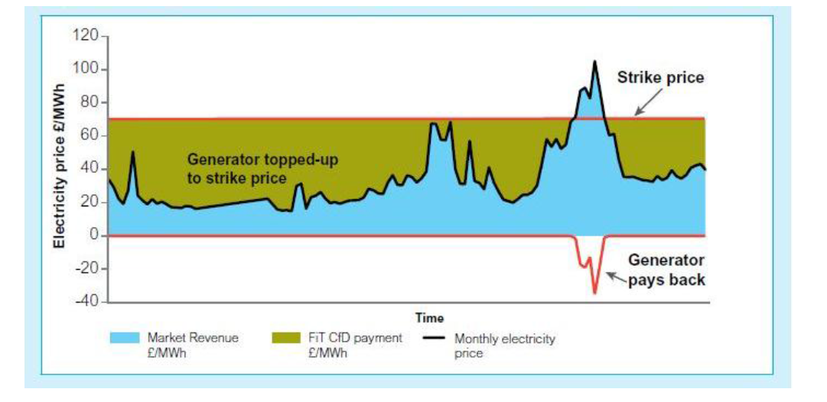

Source: United Kingdom Department of Energy and Climate Change 2011, *Planning our electric future: a White Paper for secure, affordable and low‑carbon electricity*, July 2011, London.

The CfD removes most electricity market risk for eligible generators. It is similar to the Power Purchase Agreements (PPAs) that emerge under Australia’s LRET, but with the following differences:

* CfD contracts are contracts between an eligible generator and the government rather than with liable parties under the LRET
* PPAs generally provide a fixed unit price for both electricity and the renewable energy certificates, so generators will not necessarily respond to wholesale market signals. Under a CfD, eligible generators receive the difference between the strike price and a reference wholesale price (for example a monthly average), but their revenue from the wholesale market depends on the actual wholesale price received. This means that CfDs maintain the incentive for eligible generators to respond to wholesale market price signals and therefore to supply electricity efficiently.

# Modelling Approach

The modelling task is to model the impact of the seven policy scenarios for greenhouse gas mitigation. The cumulative emissions constraint is the same for all scenarios, but each scenario will differ in their effects on existing generation, as well as the adjustments and timing for new investment. Scenarios may also have different impacts on wholesale and retail prices, and hence may have different impacts on electricity demand.

In this section, we provide a broad outline of the approach taken to model electricity market impacts of each policy. The impacts are determined by comparing outcomes in each of the policy scenarios with those for the reference scenario.

The estimated impacts include those on:

* Wholesale and retail prices
* Generation mix in each region by technology
* Investment mix in new generation by technology
* Resource cost of electricity supply
* Emissions pathway
* Cost of abatement
* Generator profitability
* Supply reliability (through such measures as energy not served and loss of load hours)

The modelling will also provide insights into how the illustrative policy may affect the electricity sector and what the issues and uncertainties may be with each policy scenario.

## Models used

Jacobs uses a suite of three models to determine the least cost generation mix in the electricity sector - that is, the electricity sector investments required to satisfy demand at least resource cost for society as a whole given input prices, policies and the emissions constraint. This requires iteration between three models to determine both the direct impacts and interactions between the electricity market and the various ancillary markets used as instruments to meet the emissions constraint. The three models are: Strategist, the electricity sector dispatch and investment model; REMMA, the renewable energy market model; and DOGMMA, a model that projects the uptake of small-scale embedded generation and storage technologies. Figure 2 shows the interactions between the models.

The approach to modelling the electricity market impacts, associated fuel combustion and emissions is to utilise externally derived electricity demand forecasts (adjusted for the embedded generation component) in our Strategist model of the major electricity systems in Australia. Strategist accounts for the economic relationships between generating plants in the system. In particular, Strategist calculates production of each power station given the availability of the station, the availability of other power stations and the relative costs of each generating plant in the system to match the demand profile, assuming a sufficient level of competition to drive efficient dispatch.

The iterative approach is as follows. An initial estimate of total electricity demand and retail price projections are used to work out the level of embedded generation each year and the level and timing of new large-scale renewable generation. The level of embedded generation determines the net demand for electricity faced by the electricity grid, which is input into the electricity market models. The level and location of new renewable generation (from REMMA) is also input into Strategist. Strategist then simulates the response of the thermal generation sector to produce a new set of wholesale and ultimately retail price projections. The whole process is repeated until a stable set of wholesale prices and renewable energy mix by region is achieved.

Figure 2: Modelling approach

Prices affect demand response

Prices earnt by renewables

Source: Jacobs

Further detail about the modelling approach and each of the models used is at Appendix A.

## Emissions constraint

In order to facilitate a like-for-like comparison of policies, the modelling will constrain each policy scenario to achieve the same cumulative emissions. The Authority has specified that the emissions constraint be set at a level consistent with Australia’s contribution to a likely chance (two-thirds) of limiting global average warming to no more than 2 degrees—this implies very deep cuts in electricity sector emissions by 2050. Weaker emissions constraints will be examined as part of the sensitivity analysis in phase two of the work.

There is no single ‘correct’ level of emissions within Australia’s electricity sector consistent with limiting warming to 2 degrees—it will depend on future economic conditions, technology costs and policies across the economy.

For the purposes of this modelling exercise, the constraint will be determined by using the explicit carbon price scenario (scenario 3). This involves:

* Using a carbon price projection consistent with a likely chance of achieving the 2 degree goal as an input into the carbon price scenario in the modelling
* Using the resulting emissions to 2050 as the cumulative sectoral emissions constraint for all other policy scenarios.

The Authority has specified the carbon price projection should be the relevant median estimates from the Intergovernmental Panel on Climate Change’s Fifth Assessment Report[4].

The paths for modelling inputs determined by global rather than domestic factors (for example the prices for internationally traded coal and LNG) are likely to be influenced by the strength and pace of global action to reduce emissions. In phase one, their values are chosen to be consistent with strong global action to limit global average warming to no more than 2 degrees (see sections 3.4.4 to 3.4.6). Alternative consistent sets of emissions constraints and global inputs will be examined in phase two of the work.

## Electricity demand

As described in section 3.1, Jacobs’ models take total projected electricity demand as an input and forecasts grid-based and embedded generation.

The core electricity demand projection for the modelling is based on the series from the Department of the Environment’s 2014-15 emission projections. These official projections use a total electricity demand series developed by Pitt&Sherry and ACIL Allen. For the purpose of this exercise, the original series will be extended to 2050 by applying the average growth rate from the final five years of the original projection and restricted to areas covered by the NEM and WEM[5]. In these projections:

* Residential demand increases slightly from 2017 onwards as retail prices are projected to level off. Per capita consumption continues to decline slightly as energy efficiency standards for buildings and appliance drive increases in end use efficiency.
* General business demand is projected to grow in line with, but less quickly than, economic activity.
* Large industrial demand is projected to decrease slowly over the projection period after an initial increase driven by gas developments in Queensland.

Relative to the latest demand forecasts from the NEM and WEM market operators (the Australian Energy Market Operator and Independent Market Operator, respectively), the projections are broadly similar at an aggregate level, with the Department of the Environment series slightly higher than both the AEMO and IMO projections across the forecast horizon. Figure 3 shows the grid-based generation components of each series. The main driver of the differences is the projected faster growth of general business demand in the Department of the Environment series.

Figure 3 Electricity demand in the NEM and WEM: comparison

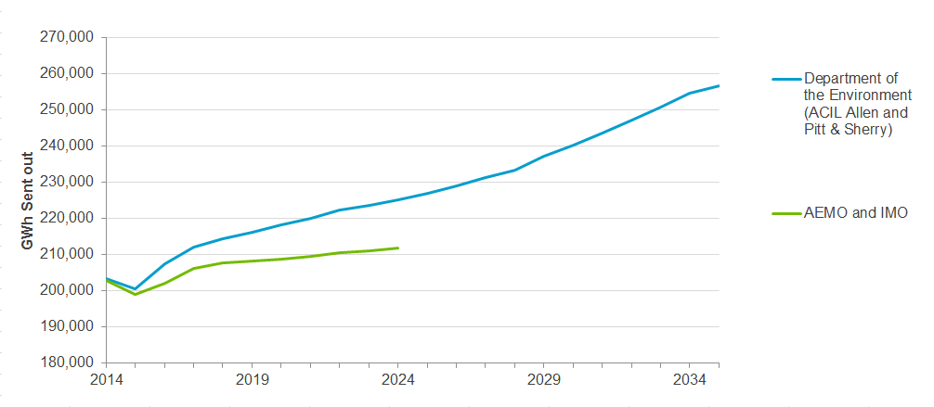

Notes: AEMO and IMO series are the latest medium demand projections from the National Electricity Forecasting Report Update December 2014 and SWIS Electricity Demand Outlook June 2014, respectively. Both are ‘sent out’, that is, they include transmission and distribution losses but exclude auxiliary generation. Neither series in this figure includes ‘grid exempt’ demand (for example, embedded generation such as methane generation at coal mines). Two adjustments have been made to the Department of Environment series for the purposes of this comparison of grid-based demand, but not to the series used in the modelling. First, projected generation from rooftop PV has been removed; as per section 3.1 it is included in the estimate of total demand used as an initial input into Jacobs’ suite of models. Second, the Department of Environment series constructed for this comparison figure includes both on- and off-grid large-scale solar so will slightly overestimate total projected generation from large-scale solar in the NEM and WEM.

Further information on the series will be available in the forthcoming technical sectoral emissions projections papers which will be available on the Department of the Environment’s website.

Electricity demand over the period to 2050 is very uncertain. In addition to exploring the performance of policy scenarios against a substantial, rapid increase in distributed generation and electricity storage technologies, phase two of the modelling will conduct sensitivities with higher and lower projected levels of total (grid-based and embedded) demand.

In phase one, for each of the policy scenarios, the core demand path will be adjusted to reflect the impact of each policy on demand through its impact on electricity prices. The size of the expected change in electricity demand depends on:

* How much and in what direction each policy affects the overall prices faced by consumers, and
* How responsive demand is projected to be to a price change (the estimated elasticity of demand).

The demand impacts are estimated by adjusting the core demand path with long-run own price elasticities of demand (PED). Elasticities used are based on those from AEMO 2014 (Table 1). These elasticities apply to all loads (residential, commercial, industrial and large loads) in each state because the underlying price used to derive the elasticities, referred to as the Total Price of Elasticity, is essentially the average customer electricity price weighted across all classes. These PEDs represent the percentage change in demand expected for a 1% increase in electricity price.

Table 1: Assumed regional price elasticity of demand

|  |  |
| --- | --- |
| State | Price elasticity (%) |
| New South Wales | -0.313 |
| Victoria | -0.208 |
| Queensland | -0.284 |
| South Australia | -0.141 |
| Tasmania | -0.407 |
| Western Australia | -0.23 |

Source: AEMO NEFR 2014 Forecast Methodology Information Paper for the NEM states[6]. The Western Australian elasticity is based on information from Synergy.

These elasticities are defined on an ‘energy over time’ basis. Peak demand is less elastic. We assume the peak demand elasticity will be reduced by the proportion of air conditioning demand in the peak demand. This is because air conditioning demand is observed to be relatively inelastic.

Further material on demand is at Appendix C.

## Other assumptions

### General assumptions

Structural assumptions used in the modelling include:

* Capacity is installed to meet the reserve requirements[7] for the NEM in each region. Unless induced by policy (for example the RET), additional capacity on top of what is required to meet reliability criteria is unlikely as this would tend to depress prices below levels to recover costs of new plant[8].
* Annual demand shapes consistent with the relative growth in summer and winter peak demand. The native load shape is based on 2010/11 load profile for the NEM and WEM regions, with this being representative of a normal year in terms of weather patterns. The load profile presented to the thermal generation plant is modified by two factors: the small scale solar and wind resources added to the market since 2010/11 and forecast by the modelling to be added; and the changing trend in growth of peak demand relative to average demand implicit in the forecasts.
* Wind generation varies by location:
* Wind generation profiles in South Australia, Victoria and New South Wales are based on the observed aggregate wind power patterns for each region from the 2013/14 financial year. Where historical data is limited (for example in New South Wales), we will use AEMO’s projected wind traces, developed for the 2014 NTNDP study[9].
* Wind power in Tasmania is treated as if it were a contributor to hydro energy. This reflects the expectation that hydro generation will be dispatched around the wind generation with regard to regional load and trading opportunities on Basslink.
* Wind power in Queensland is less significant than in other states over the modelling horizon and is modelled as an unreliable thermal generator. A partial outage and full outage model is used to approximate the availability of wind power[10].
* Wind generation profiles in the WEM are treated the same as those of the major wind regions in the NEM.
* Generators behave rationally:
* Uneconomic capacity is withdrawn from the market. Generators are typically retired under three conditions. First, if a generating unit is making losses on its annual avoidable operating costs for periods greater than two years, then the unit is decommissioned for a period[11]. Second, if some steam units that traditionally operate in base load are found to have annual capacity factors consistently less than 15%, then they are shut down. Third, (for mine-mouth operations) if the operating mine supplying the power station runs out. Shut down decisions incorporate retirement and/or rehabilitation costs as estimated for AEMO by ACIL Allen[12].
* Bidding strategies are limited by the cost of new entry. This is a conservative assumption (that is, it may underestimate wholesale prices) as there have been periods when prices have exceeded new entry costs when averaged over 12 months, typically when there are prolonged periods of high temperatures and/or when there has been major supply constraints such as major outages or water shortages. In the WEM, generators are assumed to bid into the wholesale market at short run marginal cost in accordance with the market rules.
* Infrequently used peaking resources are bid near market price cap or removed from the simulation to represent strategic bidding of these resources when demand is moderate or low.
* Retail electricity prices are composed of wholesale, network and retail prices. Retail prices by customer class (residential, commercial, large business, energy intensive industrial) and state are built up by adding the various components as described in Appendix C.
* For network components, future prices are projected on regulatory determinations where available. The share of networks costs recovered from fixed, demand and capacity charges for residential and commercial customers is assumed to be 50% by 2020 in Victoria, where interval meter installations are already mandatory, and 50% by 2030 for all other regions in the NEM and for the WEM. This does not affect overall retail prices but does affect the costs avoided through consuming the output of embedded generation such as rooftop PV.
* The Consumer Price Index (CPI) is assumed to be 2.5% per annum in line with the mid-point of target rates by the Reserve Bank. The CPI is used to calculate real fuel prices and network tariff escalations. The wholesale market models are created in real dollar costs to show trends in real price terms.
* Below-baseline generation from renewable generators that existed prior to the Mandatory Renewable Energy Target is projected at 14,300 GWh[13] per year over the modelling horizon.
* The Australian dollar exchange rate in 2014/15 is assumed to be US77c and to decline over 5 years to US76c and hold that value. This is based on Department of Industry and Science’s projected exchange rate in its latest quarterly outlook[14].

### Market structure

We assume that the market is structured to remain largely competitive and continues the following arrangements:

* Victorian generators are not further aggregated
* The generators’ ownership structure in Queensland remains as public ownership
* The South Australia, Tasmanian and New South Wales assets continue under the current portfolio groupings
* Synergy generation assets (Western Australia) remain publically owned.

### Existing generators

The marginal costs of thermal generators consist of the variable costs of fuel supply including fuel transport plus the variable component of operations and maintenance costs. The indicative variable costs for various types of existing thermal plants are shown in Table 2. For brown coal in Victoria and for Leigh Creek coal in South Australia, where the open-cut mine is owned by the generator, the variable costs also include the net present value of changes in future capital expenditure.

Table 2: Indicative average variable costs for existing thermal plant ($June 2014)[15]

|  |  |  |  |
| --- | --- | --- | --- |
| Technology | Variable Cost $/MWh | Technology | Variable Cost $/MWh |
| Brown Coal – Vic | $3 - $10 | Brown Coal – SA | $24 - $31 |
| Gas – Vic | $46 - $64 | Black Coal – NSW | $20 - $23 |
| Gas – SA | $37 - $111 | Black Coal - Qld | $9 - $31 |
| Oil – SA | $250 - $324 | Gas - Qld | $25 - $56 |
| Gas Peak – SA | $100 - $164 | Oil – Qld | $241 - $295 |
| Black coal – WA | $25 - $31 | Gas - WA | $52 - $59 |

Source: Jacobs data base of generation costs, which in turn is based on market data published by AEMO and IMO, annual reports of generators and fuel suppliers, ASX announcements and other media releases.

Fixed operating cost data are based on available data on operating cost for like plant and data published by the market operators for their planning processes. Fixed operating cost data change over time in accordance with assumptions on projections of growth in wage rates, which are sourced from Treasury projections[16]. Details of fixed operating cost by plant are provided in Appendix E.

Thermal power plants are modelled with planned and forced outages with overall availability consistent with current performance. Coal plants have available capacity factors between 86% and 95% and gas fired plants have available capacity factors between 87% and 95%. Capacity, fuel cost and heat rate data by generator type are shown in Appendix E.

### New entrant technology costs

#### Method

Jacobs’ modelling selects new capacity from a range of currently available fossil fuel and renewable technologies that could be considered in the Australian market. Parameters for technologies that are not presently commercially available are included where an estimate can be made of their performance and costs for use in the modelling. In each scenario the least cost mix of plant is dispatched to meet demand, conditional on the emissions constraint, fuel and capital costs, and any policy constraints (for example prohibitions on new coal without CCS).

New entrant technology costs are derived at a-point-in-time (generally an estimate of current costs) and future costs are handled within the modelling using learning curves and adjustments for changes in exchange rates.

For gas turbine based plants (including open cycle, combined cycle, cogeneration and Integrated Gasification Combined Cycle (IGCC) plants) and conventional Rankine Cycle (or “thermal”) plants (including sub-critical, supercritical and ultra-supercritical, and biomass), and for variations of these with carbon-capture, Jacobs’ method is generally to use the capital cost estimating tool within the Thermoflow Inc suite of software (including GTPro, SteamPro and PEACE) for the Engineer-Procure-Construct (EPC)[17] base power-island cost. This model estimates capital costs based on technical configurations of each plant design selected by Jacobs that is considered to be appropriate for Australian conditions and fuels. Jacobs applies local factors (such as the unit sizing, suitability for Australia’s climate and fuel alternatives) for the configuration of the plants and for regional factors (such as plant costs for Australian construction versus cost in, for example, South East Asia). These factors are based on Jacobs’ experience and judgement.

Jacobs refines the cost estimates using adjustment factors where considered appropriate based on market soundings and information from other projects (such as overseas).

The latest Thermoflow database is dated May 2014. Adjusted for changes in exchange rates, the resulting EPC costs per kW of power plant capacity appear reasonable against current prices being seen in Asia (adjusting as necessary for local Australian cost factors).

In addition to the EPC costs, allowances have been made for coal drying plant costs (where relevant for brown coal), connection costs (for electricity and gas where applicable) and owner’s costs. Interest during Construction (IDC) costs are handled separately in the modelling.

Wind and PV costs have been updated using observed recent costs.

Solar thermal, geothermal, hydro and nuclear costs are subject to limited new data in the Australian context and remain as assumed in previous Jacobs’ studies. Additional information on nuclear technology assumptions is in Appendix C.

Current estimates for capital costs of new technologies are shown in Appendix D. These are based on 0.77 USD/AUD.

Small-scale storage costs are based on Tesla’s recently released Powerwall product, which is based on Lithium Ion battery technology. The current literature shows that large-scale battery costs are significantly higher than the cost of the Powerwall product. Our understanding is that the technology underpinning the Powerwall product is scalable, and therefore for the large-scale costs we propose to apply a further 10% discount relative to the small-scale cost, to represent economies of scale that should be achievable for a larger system size.

#### Trends and comparisons

Technology costs proposed for this review are compared against costs shown in the AETA 2012[18]. The AETA was based on the exchange rate trending to 1.13 USD/AUD in 2016/17 and then declining to 0.86 USD/AUD by 2031-32. The AETA assessments used Thermoflow Version 21; for this review Jacobs is using the current version (i.e. Version 24). A comparison is shown in Table 3.

Considering the changes in the market between 2012 and the present, the differences in assumptions such as exchange rate, and likely differences in configurations selected, the AETA data does not suggest that the proposed parameters are inappropriate. Technologies with larger differences have a larger share of imported components.

Table 3: Selected new technology cost comparisons, including connection and owner’s costs

|  |  |  |
| --- | --- | --- |
| Technology | AETA $/kWnet[19] | Proposed $/kWnet |
| Black coal, supercritical | 3,357 | 2,966 |
| Brown coal, supercritical | 4,071 | 4,860 |
| Large CCGT | 1,141 | 1,341 |
| Black coal with carbon capture | 7,877 | 6,665 |
| Wind | 2,719 | 2,400 |
| Large-scale PV (net AC basis)* | 3,632 | 2,987 |
| Concentrated solar thermal with storage | 8,928 | 9,500 |
| Geothermal (hydrothermal) | 7,522 | 6,500 |
| Nuclear | 3,729[20] | 5,140 |

* Note: $/kW costs for PV are usually quoted on a DC basis. We have applied a DC to AC conversion factor which makes the PV costs comparable to other large-scale technologies.

Source: Jacobs analysis, AETA 2012

Table 4: Technology cost assumptions for storage by scale

|  |  |
| --- | --- |
| Technology | Proposed $/MWh net |
| Small-scale storage | 325 |
| Large-scale storage | 293 |

Source: Jacobs analysis

Trends observed by Jacobs over time in the estimated costs of the main fossil fuel plant types considered in the Australian market are shown in Figure 4. It is notable that whereas prior to 2005 the estimated capital costs were stable over a long period of time, subsequently the costs have been volatile and influenced by significant shifts in the global market consequent on the minerals and petroleum boom period leading up to the GFC and the period subsequent to the GFC with a depressed global market for new power plant sales and volatile exchange rates.

Figure 4 Trends in power plant EPC costs in Australia[21]

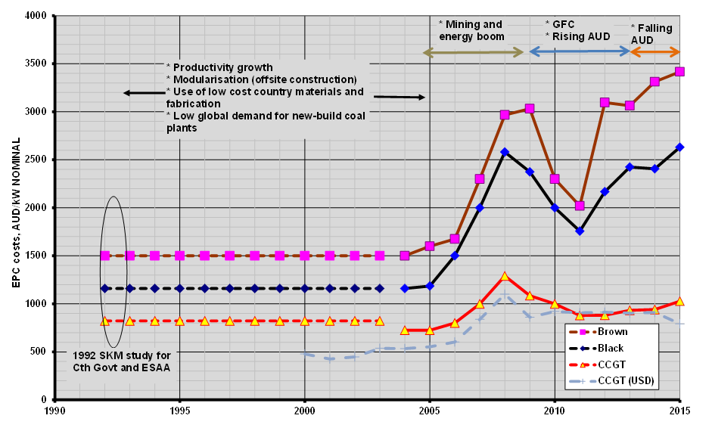

Source: Jacobs’ database

#### Learning rates

Learning rates represent the impact that rapid adoption of new technologies has in lowering future installation costs. Typically, the first plant of any new technology may be over engineered to ensure successful operation – as installation and operating time increases, people learn how to reengineer the technology and reduce costs of installation (or of operation).

Rates are considered in two parts. First learning rates are applied as a result of uptake of generation technologies due to global action. This means that, other things equal:

* Faster rates of global deployment reduce the per-unit costs of a technology more rapidly, and
* The per-unit technology costs at a given time will depend on the learning rate for the technology and the cumulative amount of globally deployed capacity.

For this exercise, learning rates are sourced from the international literature[22], adjusted for projected global deployment rates consistent with strong global action to reduce emissions as sourced from the IEA[23]. These values are applied to the equivalent of the equipment costs, which typically comprises 50% to 70% of total capital costs. The learning rates are shown in Appendix D (as capital cost de-escalators), which are based on strong global action to curb emissions - that is, a reasonably rapid rate of deployment globally.

Second, learning rates are applied to the domestic component of these investments reflecting learnings from domestic deployment of these technologies. These rates only apply to novel technologies in Australia – typically geothermal, solar thermal, wave, CCS and some biomass technologies. The rates apply to the domestically sourced components of capital costs which vary from 30% to 50% of total costs. The learning rates for this component are assumed to be around 20% for each doubling of capacity[24]. An iterative approach is adopted to translate this learning rate to final capital costs.

### Gas prices

Jacobs prepares gas price forecasts based on projected demand-supply balance in Eastern Australia using Jacobs’ proprietary model, MMAGas (Market Model Australia – Gas), which intends to replicate the essential features of Australian wholesale gas markets:

* A limited number of gas producers, meaning that prices can rise above export parity levels when producers can exercise market power.
* Dominance of long term contracting and limited short term trading.
* A developing network of regulated and competitive transmission pipelines[25].
* Domestic market growth driven by gas-fired generation and large industrial projects.

The model is structured around some fundamental principles:

* With the export market being the predominant market from 2016/17, gas prices converge to between the export parity and import parity levels. The degree to which prices are above export parity levels depends on the degree of competition in the domestic gas market.
* Export parity levels are set at the LNG net back prices (that is, world prices for LNG - assumed to be set at export prices for natural gas in major markets - after shipping, processing and handling costs are deducted). Prices can go below export prices for short periods due to the fact that coal shale gas wells cannot be plugged or turned down easily so there may be short periods with a glut of gas. Price projections are based on US Energy Information Agency or the International Energy Agency on world gas prices in these markets. Shipping and other costs are based on the historical differential between cost insurance and freight (c.i.f) prices in Japan and free on board (f.o.b) export prices.
* Import prices are set at the energy equivalent of oil or liquid fuels, being the main substitute for gas in most end-uses.

For the period to 2020 we have used our medium gas price projections, which assume gas prices rise above world parity levels over the period to 2018/19 due to a shortage of gas to meet contracted commitments for LNG. Thereafter prices fall to world parity level. Figure 5 shows the gas price assumptions used.

Prices are affected by the following factors:

* Over the next few years, supply of gas will remain tight as LNG trains come on line and gas is required to meet export commitments.
* The tightness of supply is not likely to dissipate until 2019 at the earliest due to time required to attain approval and develop additional coal seam gas wells.
* Thereafter, gas prices follow world price growth rate trends. From 2020, world prices follow the trajectory predicted by the IEA for a scenario involving concerted global action to curb emissions so that atmospheric concentration of greenhouse gas do not exceed 450 ppm CO2-e[26]. This sees prices for natural gas on world markets decreasing by around 0.5% per annum in real terms.

Figure 5: Gas price assumptions, city gate prices

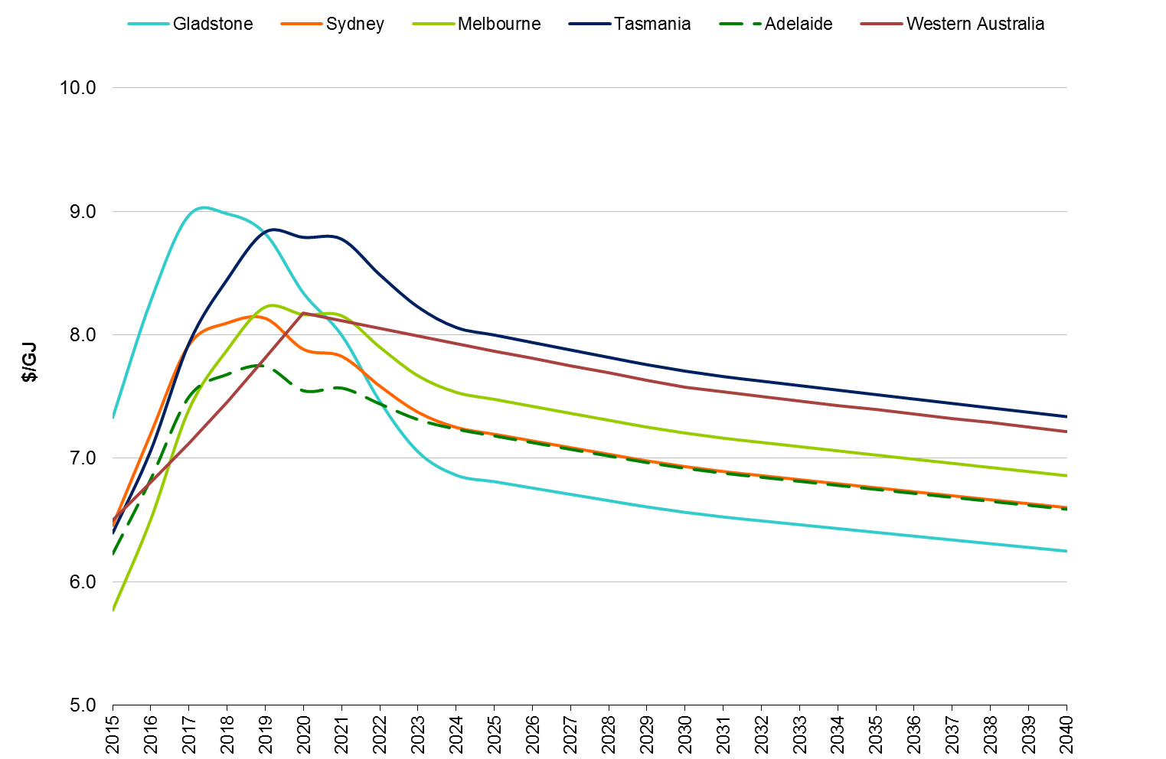

Source: Jacobs’ MMAGas model, IEA 450ppm scenario

### Coal prices

Coal prices are treated in three ways depending on the plant characteristics:

* For those mines containing coal that is unlikely to be exported (typically brown coal plant in Victoria and South Australia), prices are equal to the long run average cost of production including expected continuing mine development
* For plant with long term coal contracts, prices remain at contract price terms (as we understand them) until the contracts expire. Once they expire the prices increase to concurrent market levels
* All other coal prices are linked to trends in world market prices which are assumed to grow slowly to 2020 due to stable world demand for coal[27]. Thereafter, world coal prices are assumed to move in line with projections by the IEA for a scenario involving concerted global action to curb emissions so that atmospheric concentration of greenhouse gas do not exceed 450 ppm CO2-e[28].

The coal prices assumed for key NEM power stations are shown in Figure 6. Coal prices are expected to be depressed over the long term and are forecast to continue decreasing if there is concerted action to curb greenhouse emissions.

Figure 6: Projected variable coal price for NEM black coal power stations ($June 2014)

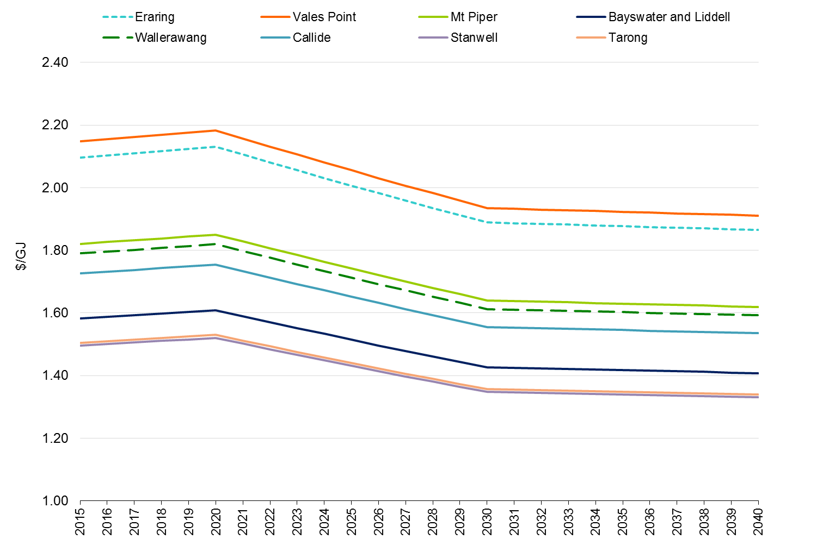

Source: Jacobs analysis, IEA 450ppm scenario

1. Modelling Suite
   1. Strategist

Jacobs will use its market simulation model of the energy markets (NEM and WEM) to estimate the impacts on the electricity markets. Electricity market modelling will be conducted using Jacobs’ energy market database and modelling tools in conjunction with use of probabilistic market modelling software called Strategist. Strategist represents the major thermal, renewable, hydro and pumped storage resources as well as the interconnections between different regions. Average hourly pool prices are determined within Strategist based on plant bids derived from marginal costs or entered directly.

In terms of selection of new generators and dispatch of generating plant, both the NEM and WEM are modelled in the same way using Strategist.

Market impacts are essentially driven by the behavioural responses of the generators to the incentives and/or regulatory requirements of the policy options being examined and the change in the mix of investment due to the incentives provided by the policy options. Wholesale prices are affected by the supply and demand balance and long-term prices being effectively capped near the long run marginal cost of new entry on the premise that prices above this level provide economic signals for new generation to enter the market. Generation mix and other impacts are also influenced by the incentives or regulations provided by the policy option being examined. Other factors affecting the timing and magnitude of the impacts include projected fuel costs, unit efficiencies and capital costs of new plant.

The market impacts take into account regional and temporal demand forecasts, generating plant performance, timing of new generation including renewable projects, existing interconnection limits and potential for interconnection development.

Jacobs’s market models are designed to create predictions of wholesale electricity price and generation driven by the supply and demand balance, with long-term prices capped near the cost of the cheapest new market entrant (based on the premise that prices above this level provide economic signals for new generation to enter the market). Price drivers include carbon prices, fuel costs, unit efficiencies and capital costs of new plant.

The primary tool used for modelling the wholesale electricity market is Strategist, proprietary software licensed from Ventyx that is used extensively internationally for electricity supply planning and analysis of market dynamics. Strategist simulates the most economically efficient unit dispatch in each market while accounting for physical constraints that apply to the running of each generating unit, the interconnection system and fuel sources. Strategist incorporates chronological hourly loads (including demand side programs such as interruptible loads and energy efficiency programs) and market reflective dispatch of electricity from thermal, renewable, hydro and pumped storage resources.

The Strategist model is a multi-area probabilistic dispatch algorithm that determines dispatch of plant within each year and the optimal choice of new plant over the period to 2050. The model accounts for the economic relationships between generating plant in the system. In particular, the model calculates production of each power station given the availability of the station, the availability of other power stations and the relative costs of each generating plant in the system. The timing of new thermal generation plant and interconnection upgrades is determined by a dynamic programming algorithm that seeks to minimise total system production and new capital costs.

The model incorporates:

* Chronological hourly loads representing a typical week in each month of the year. The hourly load for the typical week is consistent with the hourly pattern of demand and the load duration curve over the corresponding month.
* Chronological dispatches of hydro and pumped storage resources either within regions or across selected regions (hydro plant is assumed to shadow bid to maximise revenue at times of peak demand).
* Where an auction market exists, a range of bidding options for thermal plant (fixed prices, shadow bidding, average price bidding).
* Chronological dispatch of demand side programs, including interruptible loads and energy efficiency programs.
* Estimated inter-regional trading based on average hourly market prices derived from bids and the merit order and performance of thermal plant, and quadratic inter-regional loss functions.
* Scheduled and forced outage characteristics of thermal plant.
* Energy efficiency and interruptible loads as a dispatchable resource.

The model projects electricity market impacts for expected levels of generation for each generating unit in the system. The level of utilisation depends on plant availability, their cost structure relative to other plant in the system and bidding strategies of the generators. Bids are typically formulated as multiples of marginal cost and are varied above unity to represent the impact of contract positions and price support provided by dominant market participants.

New plant or energy efficiency programs, whether to meet load growth or to replace uneconomic plant, are chosen on two criteria:

* To ensure electricity supply requirements are met under most contingencies. The parameters for quality of supply are determined in the model through the loss of load, energy not served and reserve margin. We have used a maximum energy not served of 0.002% on a regional basis, which is in line with planning criteria used by system operators.
* Revenues earned by the new plant/energy efficiency program equal or exceed the long run average cost of the new generator.

Each power plant is considered separately in the model. The plants are divided into generating units, with each unit defined by minimum and maximum operating capacity, heat rates, planned and unplanned outages, fuel costs and operating and maintenance costs.

Strategist also accounts for inter-regional trading, scheduled and forced outage characteristics of thermal plant (using a probabilistic mechanism), and the implementation of government policies such as the expanded Renewable Energy Target (RET) schemes.

Timing of new generation is determined by a generation expansion plan that defines the additional generation capacity that is needed to meet future load or cover plant retirements by maintaining minimum reserve and reliability standards. As such by comparing a reference scenario to a policy scenario, we can quantify any deferred generation benefits. The expansion plan has a sustainable wholesale market price path, applying market power where it is evident, a consistent set of renewable and thermal new entry plant and must meet reserve constraints in each region. Every expansion plan for the reference and policy scenarios in this study is checked and reviewed to ensure that these criteria are met.

Strategist represents the major thermal, hydro and pumped storage resources as well as the interconnections between the NEM regions. In addition, Jacobs partitions Queensland into three zones to better model the impact of transmission constraints and the trends in marginal losses and generation patterns change in Queensland. These constraints and marginal losses are projected into the future based on past trends.

Average hourly pool prices are determined within Strategist based on thermal plant bids derived from marginal costs or entered directly. The internal Strategist methodology is represented in Figure 7 and the Jacobs modelling procedures for determining the timing of new generation and transmission resources, and bid gaming factors are presented in.

The PROVIEW module of Strategist is used to develop the expansion plan with a view to minimising the total costs of the generation system plus interconnection augmentation. This is similar to the outcome afforded by a competitive market. However due to computational burden and structural limitations of the Strategist package, it is not feasible to complete in one analysis:

* The establishment of an optimal expansion plan (multiplicity of options and development sequences means that run time is the main limitation)
* A review of the contract positions and the opportunity for gaming the spot market prices.

We therefore, conduct a number of iterations of PROVIEW to develop a workable expansion plan and then refine the expansion plan to achieve a sustainable price path applying market power where it is apparent and to obtain a consistent set of emissions reduction prices and new entry plant mix.

Strategist generates average hourly marginal prices for each hour of a typical week for each month of the year at each of the regional reference nodes, having regard to thermal plant failure states and their probabilities. The prices are solved across the regions of the NEM having regard to inter-regional loss functions and capacity constraints. Interregional capacity is increased in line with capacity needed to avoid prolonged substantial price separation between interconnected regions, with price separation not being greater than typical line losses. It will be assumed that these expansions do not change existing interregional marginal losses.

Bids are generally formulated as multiples of marginal cost and are varied by ratios above unity to represent the impact of contract positions and the price support for plant with limited dispatch time to recover fixed costs. Some capacity of cogeneration plants is bid below short run marginal cost to represent the value of the steam supply which is not included in the power plant model. .

Each power plant is considered separately in the model. The plants are divided into generating units, with each unit defined by minimum and maximum operating capacity, heat rates, planned and unplanned outages, fuel costs and operating and maintenance costs.

Figure 7: Strategist Analysis Flowchart



Source: Jacobs

Figure 8: Jacobs Strategist Modelling Procedures



Source: Jacobs

* 1. DOGMMA

Uptake of small-scale renewable technologies is be affected by a number of factors. *DOGMMA* (Distributed On-site Generation Market Model Australia) determines the uptake of renewable technologies with and without storage based on net cost of generation (after FiT revenue and other subsidies are deducted from costs) versus net cost of grid delivered power. Because the cost of small-scale generation will vary by location and load factors, the model estimates uptake based on renewable and fuel resources and load levels within distribution regions. Other factors that may impact on the decision are modelled such as a premium prepared to be paid for small scale renewable generation. We calculate the premium based on market survey data and other published market data. The premium will be assumed to decrease as the rate of uptake increases (reflecting the fact that the willingness to pay will vary among customers).

The cost of small scale renewable energy technologies is treated as an annualised cost where the capital and installation cost of each component of a small scale generation system is annualised over the assumed lifespan of each component, discounted using an appropriate weighted average cost of capital. Revenues include sales of electricity to the grid using time weighted electricity prices on the wholesale and retail market (as affected by the emissions reduction policy), avoidance of network costs under any type of tariff structure, including upgrade costs if these can be captured, and the cost of avoided purchases from the grid.

The model is characterised by:

* A regional breakdown, where each region is defined by transmission or distribution connection point zones. The number of regions in each State depends on the availability of data on availability or customer numbers.
* The handling of different technologies of differing standard sizes including PV systems, solar and heat pump water heaters, small-scale wind and mini-hydro systems with and without battery storage systems.
* Differentiation into the commercial and residential sectors where each sector is characterised by standard system sizes, levels of net exports to the grid, tariffs avoided, funding approaches and payback periods.
* The ability to test implications of changing network tariff structures and changes to Government support programs.

The DOGMMA model determines uptake of small-scale renewable technologies and these will then be fed into the Strategist model, where the level of small-scale technology uptake, especially that of rooftop PV, will effectively distort the load shape seen by the grid. Current modelling already shows that the large rate of rooftop PV uptake which is expected to continue, albeit at a slower pace than previously, distorts the transmission level load shape, which is the shape seen by large-scale generators, in the coming years.

* 1. REMMA

The renewable energy market under any renewable energy target scheme will be modelled in REMMA, Jacobs’ renewable energy model. REMMA is a tool that estimates a least cost renewable energy expansion plan, and solves the supply and demand for LGCs having regard to the underlying energy value of the production for each type of resource (base load, wind, solar, biomass with seasonality).

Strategist will be run in conjunction with the renewable energy market model to determine the wholesale market solution that is also compatible and most efficient with regard to renewable energy markets. Additional renewable generation has the effect of reducing wholesale prices while reduced wholesale prices typically have the effect of reducing investment in renewable generation. Iteration of these models typically allows the overall solution to converge to a stable model of consistent wholesale and renewable energy markets.

The REMMA model allows Jacobs to model the impact of policies affecting an expanded target or through external price incentives. Uptake of renewable generation, both its timing and location, is affected both by mandated targets and the impacts of other policies designed to reduce emissions of greenhouse gases.

Projecting certificate prices with the REMMA model is based on the assumption that the price of the certificate will be the difference between the cost of the marginal renewable generator and the price of electricity achieved for that generation. The basic premise behind the method is that the certificate provides the subsidy, in addition to the electricity price, that is required to make the last installed (marginal) renewable energy generator to meet the mandatory target economic without further subsidisation. The REMMA uses a linear programming algorithm to determine least cost uptake of renewable technologies to meet the target, subject to constraints in resource availability and regulatory limits on uptake. The optimisation requires that the interim targets are met in each year (by current generation and banked certificates) and generation covers the total number of certificates required over the period to 2030 when the program is scheduled to terminate. The certificate price path is set by the net cost of the marginal generators, which enable the above conditions to be met and result in positive returns to the investments in each of the projects. Jacobs has a detailed database of renewable energy projects (existing, committed and proposed) that supports our modelling of the renewable uptake. The database includes estimation of capital costs, likely reductions in capital costs over time, operating and fuel costs, connection costs, and other variable costs for over 900 individual projects. Two snapshots of the supply curve used in the REMMA model (which represents all available new renewable energy projects in Australia) are shown in Figure 9.

The model can be readily extended to include other forms of low emission generation. The model already includes waste coal mine gas as an option to meet a separate target.

1. Illustrative policy scenarios—comparison table

| Policy scenario | Coverage, liability and eligibility | Parameters to meet emissions constraint | Banking and borrowing | New entrants standards | Other** |
| --- | --- | --- | --- | --- | --- |
| *1 – RET only* | **Eligibility:**   * new (from 2020) large-scale renewable generators (generators registered for existing scheme and all coal-mine methane generators ineligible) * new commercial-scale PV (systems larger than 10kW)* * brownfield projects on existing sites.   **Liability**: same liabilities as existing scheme. | **LRET trajectory:** a ‘new LRET’ trajectory additional to the existing LRET trajectory grows from zero in 2020 to the required level in 2040 then flat to 2050.  Existing small‑scale scheme phases out as planned. | Unlimited banking; borrowing limited to 10 per cent of the following year’s permits. | No explicit standards. | **Existing LRET:** investments unchanged from reference case. Assume investors in existing scheme invest on existing economics (that is, they do not delay to take advantage of new scheme). |
| *2 – Low emissions target* | **Eligibility and liability:** same as the ‘RET only’ scenario, with the following additions to eligibility:   * all new fossil and nuclear generation with an emissions intensity below the threshold * existing fossil generation that has had a CCS retrofit resulting in an emissions intensity below the threshold * coal-mine methane capture eligible according to emissions intensity of generation only * existing low emissions fossil plant and renewable generators eligible for generation that exceeds historic baseline levels. | **LET trajectory:** a LET trajectory additional to the existing LRET trajectory grows from zero in 2020 to the required level in 2040 then flat to 2050. | Unlimited banking; borrowing limited to 10 per cent of the following year’s permits. | No explicit standards. | **Threshold intensity:** Linearly declining threshold beginning at 0.6 tCO2‑e/MWh (sent-out) in 2020 to provide a moderate incentive for low emissions generation; for example a combined‑cycle gas turbine (the least polluting existing fossil plant has an intensity of 0.4 tCO2‑e/MWh).  **Existing LRET:** investments unchanged from reference case. Assume investors in existing scheme invest on existing economics (that is, they do not delay to take advantage of new scheme). |
| *3 – Cap and trade* | **Coverage/liability:** all generators in NEM and WEM with emissions above 25,000 tCO2‑e/year. | **Emissions cap**: solve for the sectoral caps to meet the emissions constraint. | Unlimited banking; borrowing limited to 10 per cent of the following year’s permits. | No explicit standards. | **Permit allocation:** full auctioning  **Use of offsets:** model without offsets. The ability to use offsets to lower compliance costs will be assessed when policies are compared off‑model. |
| *4 – Absolute baselines* | **Coverage/liability:** all generators in NEM and WEM with emissions above 25,000 tCO2‑e/year (for the sectoral baseline); above average intensity generators (for the individual baselines). The coverage intensity threshold for individual baselines to decline at a fixed rate from commencement of the scheme. | **Baselines**: individual absolute baselines to meet the emissions constraint. | Not applicable. | Required to be at ‘best practice’ (that is, no new coal or gas plant without CCS). | **Use of offsets**: model without offsets. The ability to use offsets to lower compliance costs will be assessed when policies are compared off‑model. |
| *5 – Intensity target* | **Coverage/liability**: all registered generators in NEM and WEM. This would essentially cover all generators expected to be either buyers or sellers of permits. Generators built after 2020 will create only permits under this scheme (that is, none would be eligible to create certificates under the RET). | **Baseline trajectory**: declining linear emissions intensity baseline starting at grid average intensity in 2020 with level in 2050 chosen to meet the emissions constraint. | Unlimited banking; borrowing limited to 10 per cent of the following year’s permits. | No explicit standards. | **Permit allocation:** free allocation of permits to each generator determined by own output multiplied by the baseline. |
| *6 – Regulatory approach* | **Coverage:** limited to coal-fired generators (and gas if required to meet emissions constraint).For simplicity, complete withdrawal of whole of a generator at a specific date or complete conversion to CCS. | **Closure sequence:** Generator closure dates set in 2020. Closure dates chosen to remove capacity starting with oldest/most emissions intensive to achieve a roughly linear MW per year total closure to meet the emissions constraint. | Not applicable. | Standards prohibit new coal without CCS. | **Closure ranking:**  Age-based: by date of first unit’s commissioning. Plant life extensions ignored. Once determined, the ranking is publicly announced and fixed.  Intensity-based: by emissions intensity (tCO2‑e/MWh sent out) as measured in a suitable period of recent history, with state‑based adjustment due to extreme geographical concentration of closure. Once determined, the ranking is publicly announced and fixed. |
| *7 – Feed-in tariffs with contracts for differences (CfDs)* | **Eligibility**: new renewables and new fossil with CCS; CCS retrofits; nuclear. Eligible renewables as per LRET with 10kW PV threshold (renewables receiving certificates under the existing RET ineligible).  **Liability**: funds for payments to successful generators raised via energy‑based customer levy shared across NEM and WEM. | **Allocation trajectory**: allocate the same volume of 15 or 20 year contracts each year from 2020 to 2035 to obtain a progressively increasing volume of low emissions energy. This volume will be chosen to achieve the emission constraint. | Not applicable. | No explicit standards. | **Reference price for CfDs:**  NEM: monthly national average wholesale electricity spot price.  SWIS: average monthly wholesale electricity spot price. |

Notes: * While providing support under the LRET may have practical disadvantages, for the purposes of simplicity this uniform level of support is modelled by including commercial-scale PV in the expanded LRET. **In practice policies would have penalties for non-compliance. These are not be incorporated into the modelling because the aim is to find the policy parameters under which businesses comply with the policy through mitigation action rather than paying the financial penalty.

1. Further detail on assumptions
   1. Demand

The 2010/11 load shape is used to shape hourly demand profiles as it reflects demand response to normal weather conditions and captures the observed demand coincidence between the States. The energy forecasts were originally developed by Pitt&Sherry and ACIL Allen for the Department of the Environment’s 2014/15 emissions projections. Jacobs derived the peak demand forecast from these energy projections by applying the load factors from AEMO’s 2014 NEFR forecast, and the IMO’s 2014 SWIS Electricity Demand Outlook forecast.

Jacobs adjusts the forecasts to account for small scale embedded generation uptake as projected by the DOGMMA model. Jacobs’ Strategist model is then used in conjunction with REMMA to explicitly project the uptake of renewable energy generation.

The use of the 50% probability of exceedance (POE) peak demand is intended to represent typical peak demand conditions and thereby provide an approximate basis for median price levels, generation dispatch and assessing long-term system costs. Reserve margins allow for coverage of 1 in 10 year peak demands (10% POE).

The load is modelled hourly and therefore the peak is applied as an hourly load in Strategist rather than half-hourly as it occurs in the market. Because the Strategist model applies this load for one hour in a modelled typical week it is effectively applied for 4.3 hours per year and therefore it represents a slightly higher peak demand exposure than the pure half-hour 50% POE. This compensates to some degree for not explicitly representing the variation up to 10% POE.

* 1. Retail prices

Retail prices by customer class (residential, commercial, large business, energy intensive industrial) and state are built up by adding the various components as follows:

* Wholesale prices at the regional reference node weighted by the average hourly demand profile for the customer class.
* Multiplying regional reference node prices by marginal network loss factors to arrive at customer busbar wholesale prices
* Adding market fees
* Adding costs of meeting policy targets, as relevant. These will vary by scenario, examples include the costs of the RET or LET certificates, the costs of energy efficiency schemes operating in the reference case, and so on.
* Adding typical network fees using published data for typical voltage levels for each customer class in each State
* Adding a gross margin for retailing, which typically is expressed as a percentage mark-up on the other costs.
  1. Interconnectors and losses

The model begins with a representation of the existing network capacity. As discussed in section A.1, interregional capacity is increased in line with capacity needed to avoid prolonged substantial price separation between interconnected regions, with price separation not being greater than typical line losses.

Assumptions on initial interconnect limits are shown in Table 5. We have retained a Snowy zone in our Strategist model to better represent the impact of intra‑regional constraints on each side of the Victoria/NSW border.

Table 5: Interconnection limits – based on maximum recorded flows in 2011/12

|  |  |  |  |
| --- | --- | --- | --- |
| From | To | Capacity | Summer |
| Victoria | Tasmania | 480 MW |  |
| Tasmania | Victoria | 600 MW |  |
| Victoria | South Australia | 630 MW |  |
| South Australia | Victoria | 630 MW |  |
| South Australia | Redcliffs | 135 MW |  |
| Redcliffs | South Australia | 220 MW |  |
| Victoria | Snowy | 1,300 MW |  |
| Snowy | Victoria | 1,900 MW |  |
| Snowy | NSW | 3, 559 MW | 3,117 MW |
| NSW | Snowy | 1,150 MW |  |
| NSW | South Queensland | 120 MW |  |
| South Queensland | NSW | 180 MW | 120 MW |
| NSW | Tarong | 589 MW |  |
| Tarong | NSW | 1,078 MW |  |

Source: Combination of ESOO and historical market data

Inter-regional loss equations are modelled in Strategist by directly entering the Loss Factor equations published by AEMO except that Strategist does not allow for loss factors to vary with loads. Therefore we allow a typical area load level to set an appropriate average value for the adjusted constant term in the loss equation. The losses currently applied are those published in the AEMO report entitled “List of Regional Boundaries and Marginal Loss Factors for the 2014-15 Financial Year”.

Negative losses are avoided by shifting the quadratic loss equation so that the minimum passes through zero loss.

Benefits due to lower losses across the inter-regional interconnects are modelled directly in the Strategist model using equations that mimic the transfer equations used in AEMO/IMO dispatch algorithms.

Intra-regional losses are applied as detailed in the AEMO report entitled “List of Regional Boundaries and Marginal Loss Factors for the 2014-15 Financial Year”.

The long-term trend of marginal loss factors is extrapolated for two more years and then held at that extrapolated value thereafter.

* 1. Further details on nuclear energy

Nuclear energy, like other plant types, will be constructed and dispatched if it is part of the least cost generation mix to meet total electricity demand given technology costs, fuel prices and the emissions constraint.   This assumes that the regulatory and support frameworks are in-place at the necessary time to allow the consideration of this technology.  These frameworks are not in-place at the present time in Australia and there are no current proposals to put these in-place. The necessary requirements would include:

* The political and legislative framework at the Commonwealth and (where relevant) the State level.  The larger States each have legislation prohibiting the construction of a nuclear power station (the Lucas Heights facility operates under a Commonwealth framework).  Bi-partisan support and broad social acceptance is likely to be a pre-requisite to nuclear development.  This would take some time to establish.  The most commercially developed and cost effective technologies presently available are large unit sizes that could only practically be installed in NSW, Victoria or Queensland.
* An institutional framework would be required to supervise the industry in its construction and operational phases
* A siting study would be required necessitating significant political and consultative processes
* An environmental assessment framework specific to nuclear power in Australia would need to be established and undertaken
* An insurance framework would need to be established to address the insurer-of-last-resort issues of a nuclear power plant.

The costs of these processes have not been incorporated into the analysis.

Should an Australian nuclear plant be considered, it would be envisaged that a proven design would be selected from an international vendor. Accordingly, although some of the specialised construction techniques would be first-of-a-kind in Australia they would not be first-of-a-kind for the vendor nor for the global industry. It is assumed that the Australian regulatory regime would not require different or additional design or construction requirements than would apply in other jurisdictions where the vendor(s) have previously applied the design.

In this analysis it is assumed that the design and construction arrangement would be able to apply the benefits of prior learning on other plants overseas.

Costs allowed are based on the “N”-of-a-kind cost for a large scale Generation III reactor (1000MW) in the US of AUD3750/kW ($2013), which is the average cost reported by the World Nuclear Association. These do not include decommissioning costs and an allowance has been included of $20/kW (based on $1000/kW discounted for 60 years at 7% real). An assumed cost of AUD5140/kW is allowed ($2015, and reflecting exchange rate differences).

It should be noted that nuclear costs will always be a highly debatable point in the Australian context until proposals are developed and the framework that they would be built under is established.

Overseas, the experience has been varied.

Indicative contemporary costs as reported by the World Nuclear Association for Generation III plants are approximately USD3500-4000/kW in USA, USD2300-3000/kW in China and for Hinkley C in UK USD7750/kW.  The UK industry has always had costs significantly higher than elsewhere for nuclear plants.

These are typically $2013 to present and all are overnight basis (that is as if construction costs were paid in full at once, so excluding interest during construction). If we are to compare these to capital costs quoted in Table 3, then they should be escalated by 36% to be converted from USD to AUD and inflated to $2015. Thus, typical capital costs for nuclear energy in the USA are AUD4780-5460/kW, AUD3140-4090/kW in China and AUD10,570/kW for the Hinkley C plant in the UK.

The Climate Change Authority requested Jacobs to model an earliest date of entry for nuclear energy of 2035. This is based on the significant time for the processes described above to be implemented and accepted.

Other nuclear technologies may become available in the future however their technical and cost parameters are not presently known.

1. Technology cost assumptions



* Costs for storage technologies are presented as $/MWh.

** Construction periods are build times only and exclude time required for regulatory approvals.

*** Small-scale PV costs exclude the SRES subsidy, and also include a factor to convert from DC power to AC power

Figure 9 Assumed renewable supply curve for Australia in 2020 and 2030 for new projects only

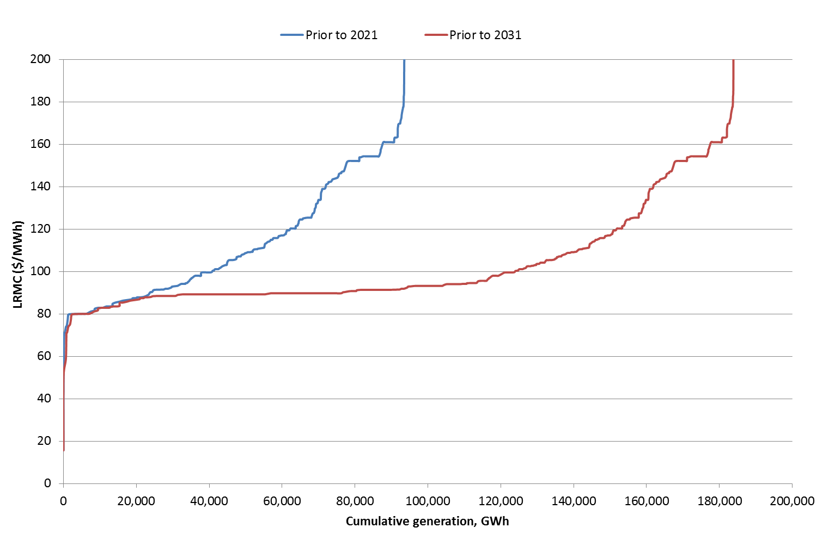

Source: Jacobs’ data base of renewable energy projects, which in turn is based on annual reports of generators, ASX announcements and other media releases.

1. Costs and performance of existing and prospective thermal plants

The following tables show the parameters for power plants used in the Strategist model. Costs are reported in March 2014 dollars for 2014/15.

**NEM**

| Plant | No Units | Capital Cost $/kW | Total Sent Out Capacity | Scheduled Maintenance (Weeks pa) | Effective Forced Outage Rate | Available Capacity factor | Full Load Heat Rate GJ/MWh so | Fixed O&M $/kW/yr | Variable O&M $/MWh | Variable Fuel Cost $/GJ | Total Variable Cost $/MWh |
| --- | --- | --- | --- | --- | --- | --- | --- | --- | --- | --- | --- |
| **Tasmania** | | | | | | | | | | | |
| Tamar Valley CCGT | 1 |  | 201.8 | 1.9 | 3% | 93.6% | 7.54 | 38 | $2.87 | $7.16 | $56.86 |
| Bell Bay GT | 3 |  | 119.4 | 3.0 | 1% | 93.3% | 11.50 | 14 | $4.30 | $4.72 | $58.53 |
| Tamar Valley OCGT | 1 |  | 57.7 | 3.0 | 1% | 93.3% | 11.50 | 14 | $4.30 | $15.11 | $178.06 |
| New Tas CCGT | *prospective* | 1150.0 | 195.5 | 2.5 | 3% | 92.3% | 6.93 | 38 | $3.60 | $7.16 | $53.20 |
| New Tas GT | *prospective* | 902.9 | 319.2 | 2.8 | 2% | 93.3% | 11.43 | 13 | $5.80 | $15.11 | $178.50 |
| Tas CCGT CCS | *prospective* | 2533.9 | 482.5 | 2.5 | 3% | 92.3% | 7.87 | 62 | $4.51 | $7.16 | $60.84 |
| **Victoria** | | | | | | | | | | | |
| AGL Somerton | 4 |  | 161.7 | 4.0 | 9% | 83.9% | 13.50 | 14 | $2.87 | $4.38 | $61.98 |
| Anglesea | 1 |  | 145.4 | 1.0 | 2% | 96.6% | 13.00 | 54 | $1.43 | $0.15 | $3.37 |
| Bairnsdale | 2 |  | 83.6 | 3.0 | 1% | 93.3% | 11.50 | 14 | $4.30 | $4.52 | $56.33 |
| Hazelwood | 8 |  | 1472.0 | 4.0 | 9% | 84.0% | 13.30 | 40 | $0.66 | $0.67 | $9.56 |
| Jeeralang A | 4 |  | 230.8 | 2.1 | 1% | 95.0% | 13.75 | 14 | $8.61 | $4.28 | $67.44 |
| Jeeralang B | 3 |  | 253.7 | 2.1 | 1% | 95.0% | 12.85 | 14 | $8.61 | $4.28 | $63.59 |
| Laverton North | 2 |  | 338.3 | 2.0 | 2% | 93.9% | 11.55 | 14 | $4.30 | $4.38 | $54.87 |
| Loy Yang A | 4 |  | 2043.0 | 2.5 | 4% | 91.9% | 11.58 | 54 | $1.15 | $0.51 | $7.03 |
| Loy Yang B | 2 |  | 966.0 | 2.5 | 3% | 92.3% | 11.70 | 54 | $1.15 | $0.51 | $7.09 |
| Valley Power | 6 |  | 334.3 | 2.1 | 1% | 95.0% | 13.75 | 14 | $8.61 | $4.28 | $67.44 |
| Yallourn W | 4 |  | 1361.6 | 3.0 | 6% | 88.6% | 12.91 | 28 | $3.43 | $0.52 | $10.15 |
| Newport | 1 |  | 484.5 | 2.2 | 3% | 93.0% | 10.33 | 25 | $2.87 | $4.38 | $48.10 |
| Mortlake OCGT | 2 |  | 550.2 | 2.5 | 2% | 93.0% | 10.78 | 14 | $3.65 | $6.44 | $73.06 |
| Qenos Cogen | 1 |  | 21.0 | 2.0 | 3% | 93.3% | 11.00 | 28 | $2.07 | $7.94 | $89.40 |
| Generic VIC CCGT | *prospective* | 1150.0 | 546.1 | 2.5 | 3% | 92.3% | 6.93 | 35 | $3.51 | $7.94 | $58.53 |
| Generic VIC GT | *prospective* | 753.3 | 281.3 | 1.5 | 2% | 95.2% | 10.38 | 13 | $7.30 | $16.76 | $181.27 |
| **South Australia** | | | | | | | | | | | |
| Angaston | 1 |  | 49.8 | 0.0 | 1% | 99.4% | 9.00 | 14 | $12.31 | $20.41 | $196.05 |
| Dry Creek | 3 |  | 147.3 | 5.6 | 3% | 86.1% | 17.00 | 14 | $8.61 | $11.07 | $196.77 |
| Hallett | 5 |  | 220.0 | 4.0 | 4% | 88.3% | 9.60 | 14 | $9.83 | $11.07 | $116.08 |
| Ladbroke Grove | 2 |  | 83.6 | 3.0 | 2% | 92.1% | 10.00 | 14 | $7.17 | $5.24 | $59.60 |
| Mintaro 1 | 1 |  | 89.6 | 4.0 | 5% | 88.1% | 16.00 | 14 | $8.61 | $11.07 | $185.70 |
| Northern | 2 |  | 505.1 | 0.0 | 2% | 97.9% | 11.50 | 49 | $2.79 | $2.41 | $30.53 |
| Osborne | 1 |  | 185.4 | 2.0 | 2% | 93.9% | 10.40 | 28 | $2.79 | $5.24 | $57.32 |
| Pelican Point | 1 |  | 462.6 | 3.0 | 3% | 91.4% | 7.71 | 35 | $2.87 | $4.99 | $41.36 |
| Port Lincoln | 3 |  | 72.6 | 3.0 | 3% | 91.4% | 11.67 | 14 | $8.61 | $20.41 | $246.78 |
| Quarantine | 5 |  | 217.9 | 4.0 | 3% | 89.1% | 10.35 | 14 | $9.15 | $11.07 | $123.71 |
| Snuggery | 3 |  | 65.7 | 4.0 | 5% | 88.1% | 15.00 | 14 | $8.61 | $20.41 | $314.83 |
| Torrens Island A | 4 |  | 456.0 | 4.0 | 5% | 87.7% | 10.80 | 39 | $8.61 | $9.22 | $108.17 |
| Torrens Island B | 4 |  | 760.0 | 4.0 | 5% | 87.7% | 10.50 | 58 | $2.15 | $8.02 | $86.34 |
| Pelican Point GT | *prospective* | 902.9 | 164.7 | 1.5 | 2% | 95.2% | 11.36 | 13 | $7.22 | $8.02 | $98.30 |
| SA OCGT | *prospective* | 902.9 | 164.7 | 1.5 | 2% | 95.2% | 11.36 | 13 | $7.22 | $16.93 | $199.50 |
| Hallett | *prospective* | 902.9 | 220.0 | 4.0 | 4% | 88.3% | 9.60 | 13 | $9.83 | $11.07 | $116.08 |
| **New South Wales** | | | | | | | | | | | |
| Bayswater | 4 |  | 2592.7 | 2.5 | 2% | 93.3% | 10.00 | 43 | $2.87 | $1.74 | $20.22 |
| Colongra OCGT | 4 |  | 720.4 | 2.5 | 3% | 91.9% | 11.84 | 14 | $9.90 | $17.45 | $216.49 |
| Eraring | 4 |  | 2707.2 | 2.5 | 4% | 91.8% | 10.08 | 43 | $2.87 | $2.03 | $23.36 |
| Eraring GT | 1 |  | 41.8 | 2.5 | 3% | 91.9% | 11.84 | 14 | $9.90 | $20.41 | $251.57 |
| Hunter Valley GT | 2 |  | 49.8 | 4.0 | 3% | 89.1% | 23.38 | 14 | $9.90 | $20.41 | $487.20 |
| Liddell | 4 |  | 1936.4 | 2.5 | 3% | 92.3% | 10.38 | 43 | $2.59 | $1.74 | $20.60 |
| Mt Piper | 2 |  | 1259.6 | 1.0 | 1% | 97.1% | 9.93 | 43 | $2.73 | $1.76 | $20.26 |
| Smithfield | 1 |  | 151.2 | 3.0 | 3% | 91.4% | 10.00 | 28 | $5.45 | $5.97 | $65.11 |
| Tallawarra | 1 |  | 422.0 | 2.5 | 3% | 92.3% | 7.17 | 35 | $3.64 | $8.27 | $62.90 |
| Uranquinty | 4 |  | 660.7 | 2.5 | 2% | 93.3% | 10.98 | 14 | $3.47 | $17.45 | $195.08 |
| Vales Point | 2 |  | 1240.8 | 3.8 | 4% | 89.0% | 9.87 | 43 | $3.59 | $2.08 | $24.14 |
| Wallerawang | 2 |  | 940.0 | 4.8 | 8% | 83.9% | 11.13 | 43 | $4.30 | $1.74 | $23.62 |
| Generic NSW CCGT | *prospective* | 1150.0 | 546.1 | 2.5 | 3% | 92.3% | 6.93 | 35 | $3.56 | $8.27 | $60.85 |
| Generic NSW OCGT | *prospective* | 753.3 | 281.3 | 1.5 | 2% | 95.2% | 10.38 | 13 | $7.15 | $17.45 | $188.30 |
| NSW CCGT CCS | *prospective* | 2533.9 | 482.5 | 2.5 | 3% | 92.3% | 7.87 | 62 | $4.38 | $8.27 | $69.44 |
| NSW coal CCS | *prospective* | 5568.5 | 396.0 | 3.0 | 7% | 87.6% | 9.87 | 157 | $4.72 | $2.33 | $27.74 |
| **Queensland** | | | | | | | | | | | |
| Barcaldine CC | 1 |  | 36.8 | 3.0 | 3% | 91.4% | 8.02 | 28 | $4.30 | $5.21 | $46.09 |
| Braemar | 6 |  | 1017.9 | 2.0 | 2% | 94.2% | 11.00 | 14 | $3.61 | $1.96 | $25.19 |
| Callide B | 2 |  | 658.0 | 2.0 | 3% | 93.3% | 9.88 | 43 | $2.07 | $1.69 | $18.72 |
| Callide C | 2 |  | 846.0 | 1.2 | 6% | 91.9% | 9.00 | 43 | $1.43 | $1.69 | $16.61 |
| Darling Downs | 2 |  | 898.7 | 2.3 | 2% | 94.2% | 8.54 | 28 | $5.45 | $11.61 | $104.62 |
| Gladstone | 6 |  | 1579.2 | 2.4 | 5% | 91.1% | 10.22 | 43 | $1.26 | $1.96 | $21.27 |
| Kogan Creek | 1 |  | 699.4 | 3.0 | 3% | 91.4% | 9.50 | 43 | $1.29 | $0.79 | $8.83 |
| Mackay GT | 1 |  | 33.8 | 2.0 | 2% | 94.2% | 13.50 | 14 | $11.48 | $20.41 | $287.08 |
| Millmerran | 2 |  | 787.5 | 3.0 | 8% | 86.5% | 9.88 | 43 | $1.29 | $0.79 | $9.13 |
| Moranbah | 1 |  | 45.6 | 3.0 | 3% | 91.4% | 8.02 | 14 | $4.30 | $- | $4.30 |
| Mt Stuart GT | 3 |  | 416.9 | 2.0 | 2% | 94.2% | 11.50 | 14 | $5.74 | $20.41 | $240.51 |
| Oakey GT | 2 |  | 338.3 | 2.0 | 2% | 94.2% | 11.50 | 14 | $5.74 | $11.00 | $132.25 |
| Roma | 2 |  | 67.7 | 4.0 | 9% | 84.0% | 13.50 | 14 | $5.74 | $5.21 | $76.08 |
| Stanwell | 4 |  | 1372.4 | 1.8 | 1% | 95.6% | 9.99 | 43 | $1.15 | $1.75 | $18.61 |
| Swanbank E | 1 |  | 358.9 | 2.0 | 2% | 94.2% | 8.10 | 35 | $2.87 | $5.21 | $45.08 |
| Tarong | 4 |  | 1316.0 | 1.0 | 2% | 96.0% | 10.50 | 43 | $1.19 | $1.50 | $16.94 |
| Tarong North | 1 |  | 416.4 | 1.0 | 0% | 98.0% | 9.50 | 43 | $1.19 | $1.50 | $15.44 |
| Yabulu | 1 |  | 235.7 | 3.0 | 2% | 92.4% | 7.44 | 38 | $2.87 | $3.16 | $26.39 |
| Qld North CCGT CCS | *prospective* | 2533.9 | 482.5 | 2.5 | 3% | 92.3% | 7.87 | 62 | $4.52 | $9.20 | $76.90 |
| Qld North GT | *prospective* | 902.9 | 164.7 | 1.5 | 2% | 95.2% | 11.36 | 13 | $7.22 | $19.42 | $227.80 |
| Qld North CCGT | *prospective* | 1268.1 | 239.4 | 2.5 | 3% | 92.3% | 7.83 | 38 | $3.61 | $9.20 | $75.63 |
| Qld South CCGT | *prospective* | 1150.0 | 385.0 | 2.5 | 3% | 92.3% | 6.93 | 35 | $3.67 | $9.67 | $70.65 |
| Qld South OCGT | *prospective* | 902.9 | 164.7 | 2.5 | 2% | 93.3% | 11.36 | 13 | $7.33 | $20.40 | $239.13 |
| Qld South CCGT CCS | *prospective* | 2533.9 | 482.5 | 2.5 | 3% | 92.3% | 7.87 | 62 | $4.59 | $9.67 | $80.66 |
| Qld West CCGT CCS | *prospective* | 2533.9 | 482.5 | 2.5 | 3% | 92.3% | 7.87 | 62 | $4.40 | $9.23 | $77.02 |
| Qld West coal CCS | *prospective* | 5568.5 | 396.0 | 3.0 | 7% | 87.6% | 9.87 | 157 | $4.67 | $1.42 | $18.66 |
| Qld Central IGCC | *prospective* | 4717.4 | 457.2 | 3.0 | 7% | 87.6% | 8.08 | 134 | $4.41 | $1.69 | $18.03 |
| Qld Central CCGT | *Prospective* | 1150.0 | 380.0 | 2.5 | 3% | 92.3% | 6.93 | 35 | $3.56 | $9.68 | $70.65 |
| Qld Central coal CCS | *Prospective* | 5568.5 | 396.0 | 3.0 | 7% | 87.6% | 9.87 | 157 | $4.78 | $1.69 | $21.42 |

Source: Jacobs data base of generation costs, which in turn is based on market data published by AEMO, annual reports of generators and fuel suppliers, ASX announcements and other media releases.

**SWIS**

| Station | Type | Capacity in summer peak, MW sent out | Maintenance (%) | Forced outage (%) | Available capacity factor | Heat rate GJ/MWh | Fixed costs ($000s/yr) | Variable costs ($/MWh) | Variable Fuel cost $/GJ | Total variable costs $/MWh |
| --- | --- | --- | --- | --- | --- | --- | --- | --- | --- | --- |
| Albany | Wind turbine | 12 x 1.8 | 3 | 3 | 94.1% | - | 0 | 4 | 0 | 4 |
| Mumbida | Wind turbine | 55 | 3 | 3 | 94.1% | - | 0 | 4 | 0 | 4 |
| Greenough | Solar PV | 10 | 3 | - | 97.0% | - | 0 | 5 | 0 | 5 |
| Collie A | Steam | 304 | 6 | 2 | 92.1% | 10.0 | 12,000 | 5 | 3.14 | 36.40 |
| Muja A/B | Steam | 4 x 60 | 6 | 6 | 88.4% | 13.0 | 16,000 | 9 | 3.41 | 53.33 |
| Muja C | Steam | 2 x 185.5 | 4 | 4 | 92.2% | 11.0 | 12,500 | 6.5 | 3.41 | 44.01 |
| Muja D | Steam | 2 x 200 | 4 | 3 | 93.1% | 10.5 | 12,000 | 6 | 3.41 | 41.81 |
| Kwinana C | Steam | 2 x 180.5 | 4 | 6 | 90.2% | 10.8 | 17,000 | 8 | 6.5 | 78.2 |
| Kwinana GT | Gas turbine | 16 | 2 | 3 | 95.1% | 15.5 | 1,000 | 9 | 6.5 | 109.75 |
| Pinjar A,B | Gas turbine | 6 x 29 | 6 | 3 | 91.2% | 13.5 | 2,000 | 5 | 6.5 | 92.75 |
| Pinjar C | Gas turbine | 2 x 91.5 | 6 | 3 | 91.2% | 12.5 | 4,000 | 5.5 | 6.5 | 86.75 |
| Pinjar D | Gas turbine | 123 | 6 | 3 | 91.2% | 12.5 | 4,000 | 5.5 | 6.5 | 86.75 |
| Mungarra | Gas turbine | 3 x 29 | 6 | 3 | 91.2% | 13.5 | 2,000 | 5 | 6.5 | 92.75 |
| Geraldton | Gas turbine | 16 | 2 | 3 | 95.1% | 15.5 | 500 | 5 | 20 | 315 |
| Kalgoorlie | Gas turbine | 48 | 2 | 3 | 95.1% | 14.5 | 500 | 5 | 20 | 295 |
| Cockburn | CCGT | 2*120 | 4 | 2 | 94.1% | 7.5 | 11,000 | 3 | 6.5 | 51.75 |
| LMS100 | OCGT | 2*100 | 3 | 3 | 94.1% | 10.8 | 2,800 | 5 | 6.5 | 75.2 |
| Worsley1 | Cogeneration | 70 | 4 | 2 | 94.1% | 8.0 | 4,000 | 5 | 6.5 | 57 |
| Tiwest | Cogeneration | 29 | 6 | 3 | 91.2% | 9.0 | 4,000 | 5 | 6.5 | 63.5 |
| Alcoa | Cogeneration | 212 | 3.8 | 2 | 94.3% | 12.0 | 6,000 | 5 | 6.5 | 83 |
| BP/Mission | Cogeneration | 100 | 3.8 | 2 | 94.3% | 8.0 | 2,800 | 5 | 6.5 | 57 |
| Southern Cross | Gas turbine | 120 | 3.8 | 4 | 92.4% | 11.7, 12.7 | 1,680 | 4 | 6.5 | 80.05 |
| Goldfields Power | Gas turbine | 90 | 3.8 | 1 | 95.2% | 9.5 | 1,260 | 4 | 6.5 | 65.75 |
| Worsley | Cogeneration | 27 | 3.8 | 2 | 94.3% | 8.0 | 756 | 4 | 6.5 | 56 |
| NewGen | CCGT | 350 | 3.0 | 2.0 | 95.1% | 7.4 | 11,900 | 2 | 6.5 | 50.1 |
| Kemerton | Gas turbine | 308 | 1.0 | 1.5 | 97.5% | 12.2 | 4,312 | 5 | 6.5 | 84.3 |
| Alinta Wagerup | Cogeneration | 351 | 3.0 | 2.0 | 95.1% | 11.2 | 9,828 | 2 | 6.5 | 74.8 |
| Alinta Pinjarra | Cogeneration | 266 | 2.0 | 2.0 | 96.0% | 6.5 | 7,448 | 2 | 6.5 | 44.25 |
| Bluewaters | Steam | 400 | 3.0 | 3.0 | 94.1% | 9.7 | 17,200 | 2 | 3.14 | 32.46 |

Source: Jacobs data base of generation costs, which in turn is based on market data published by IMO, annual reports of generators and fuel suppliers, ASX announcements and other media releases.

1. See for example Climate Change Authority 2014 *Renewable Energy Target Review report;* Climate Change Authority 2014 *Reducing Australia’s Greenhouse Gas Emissions—Targets and Progress Review Final Report.*
2. The WEM operates dispatch and delivery in South West Interconnected System (SWIS), which is a grid system with major load centres at Perth/Kwinana and that extends north to Geraldton on the mid-west coast to Kalgoorlie in the east and past Albany in the south-east coast.
3. The UK policy incorporates some technology-specific assistance or ‘banding’. For the purposes of comparability, this exercise models an unbanded scheme.
4. IPCC, 2014. *Working Group III Contribution to the Fifth Assessment Report, Climate Change 2014—Mitigation,*

   Cambridge University Press, Cambridge.
5. ‘Grid exempt’ demand (for example, methane generation at coal mines) is also removed as this component of demand is not projected in Jacobs’ modelling.
6. There are many sources of estimates of the own price elasticity of electricity demand in the NEM, but all estimates are characterised by relatively low price elasticities (see M. O’Gorman and F. Jotzo (2014), “Impact of the carbon price on Australia’s electricity demand, supply and emissions”, *Centre for Climate Economics and Policy Working Paper 1411*, Canberra). A review study has found these elasticities reducing over time (A. Rai, L. Reedman and P. Graham (2014), *Price and income elasticities of residential electricity demand: the Australian evidence)*. Given the broad similarities across estimates, the likely changes in demand response from using alternative estimates are likely to be minimal.
7. In the modelling we adopt an unserved energy and loss of load probability criteria as energy reliability requirements that are required to be met.
8. In some of the scenarios, there may be high levels of intermittent renewable generation which may increase the requirement for reserve plant for when these generation sources are unavailable. This should be captured in the modelling through the use of loss of load probability logic, which if breached would require more backup plant to preserve reliability of the grids.
9. These are available at http://www.aemo.com.au/Electricity/Planning/Related-Information/Planning-Assumptions.
10. This conservative approach may underestimate diversity but based on prospective projects there is not a large wind resource in this State.
11. This decommissioning is made permanent if the period of decommissioning is greater than 10 years.
12. ACIL Allen 2014, *Fuel and technology cost review*, report to the Australian Energy Market Operator.
13. Based on Jacobs data base of renewable energy projects. Renewable generators that existed before the Mandatory Renewable Energy Target (the precursor to the current RET) are allocated baselines based on their average historical output and are eligible to receive certificates for output above those baselines. The actual amount of generation below their baselines needs to be added to generation from the RET to calculate the total amount of renewable generation in a given year.
14. Department of Industry and Science, “Resources and Energy Quarterly”, March 2015.
15. The variable cost of gas based peaking plant assumes that the fixed cost of pipelines and processing assets are converted into a variable cost to reflect opportunity cost of using assets at low levels of utilisation and to enable bids for these plants to be set at a rate that will recover their fixed costs for the limited time they are typically dispatched.
16. Federal Treasury, “Treasury’s medium-term economic projection methodology”, May 2014.
17. Engineer-Procure-Construct turnkey project delivery.
18. Bureau of Resources and Energy Economics, “Australian Energy Technology Assessment”, 2012.
19. AETA costs are original quoted in $2012. In this table we have escalated these AETA costs to $2015 for comparison purposes.
20. “N of a Kind”, that is the cost of the technology after the first few plants have been deployed in a particular country. The costs of the first plants built in a new country would typically be higher due to an initial lack of knowledge in the local context.
21. EPC basis costs do not include connection costs and owner’s costs, not interest-during-construction costs.
22. SETIS (2012), *Technology learning curves for energy support policies*, Joint Research Centre Scientific and Policy Reports; EPRI (2013), Modelling Technology Learning Rates for the Electricity Supply Sector: Phase 1 report, Palo Alto, California
23. IEA (2014), *World Energy Outlook: 2014*, Paris
24. ATA, CSIRO
25. The modelling does not consider the possibility of building a pipeline to link Queensland with the Northern Territory. The impact of this assumption on gas prices in the NEM is considered to be immaterial.
26. International Energy Agency, *World Energy* Outlook, 2014, p.48.
27. Source: Bureau of Resources and Energy Economics, *Resource and Energy Quarterly*, March 2015
28. International Energy Agency, *World Energy* Outlook, 2014, p.48.