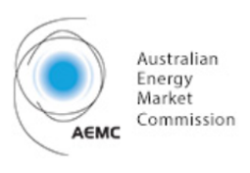

TOWARDS THE NEXT GENERATION: DELIVERING AFFORDABLE, SECURE AND LOWER EMISSIONS POWER

JunE 2017

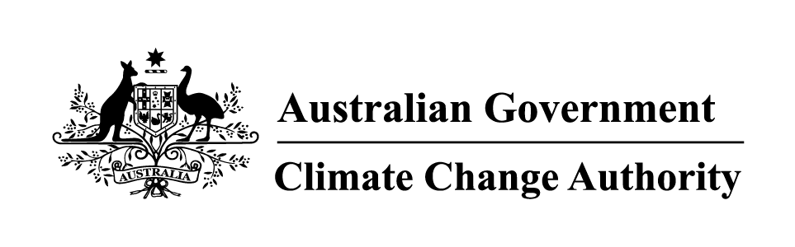

# CONTENTS

Chairs’ Foreword 4

Executive Summary 6

List of recommendations 11

chapter 1: Introduction 13

1.1. About the report 13

1.2. About the Climate Change Authority and the Australian Energy Market Commission 13

1.3. Relationship to current reviews 13

1.4. Public consultation and drawing on previous review processes 13

1.5. Independent economic modelling 14

Chapter 2: The electricity sector and Australia’s emissions reduction goals 15

2.1. 2030 emissions reduction target 15

2.2. Australia’s electricity generation 15

2.3. Australia’s electricity emissions 17

2.4. Current climate policies in the electricity sector 18

2.5. Supply side policies 18

2.6. Demand side policies 19

2.7. Electricity markets 20

2.8. Retail electricity prices and consumer spending on electricity 23

Chapter 3: Electricity reliability and security 26

3.1. Defining reliability and security 26

3.2. The AEMC’s System Security work program 28

3.3. AEMO – Future Power System Security program 29

3.4. Work to be undertaken by the Reliability Panel 29

Chapter 4: Possible policies and key evaluation considerations 31

4.1. Analytical framework 31

4.2. Policy evaluation criteria for this review 31

4.3. Policy options to improve power system security and affordability of electricity prices while meeting Australia’s Paris Agreement emissions reduction goals 33

Chapter 5: Recommendations 38

5.1. Assessing policies against the evaluation criteria 38

5.2. Policy recommendations to address security and affordability while meeting emissions targets 42

5.3. Consideration of an alternative emissions policy mechanism 43

5.4. Requirements for an integrated reform approach 44

5.5 Demand management reforms…………………………………………………………………46

5.6 Additional and specific measures to address power system security……………………..49

Appendix A: Terms of reference 55

Appendix B: public consultation 57

Appendix C: An overview of policy evaluation criteria used in previous reviews 58

Appendix D: stakeholder support for an eis 59

References 60

**Figures**

Figure 1: Electricity generation in Australia by fuel source, 2000-2030 16

Figure 2: Australia’s electricity emissions, 1990-2030 18

Figure 3: Entry and exit of generation capacity in the NEM since 2007 22

Figure 4: Annual electricity bill trend for a representative consumer across jurisdictions 24

Figure 5: ASX NSW baseload quarterly futures prices 24

Figure 6: Average annual increase in residential electricity bills, relative to the reference case, 2020-2050 40

Figure 7: National weighted average wholesale prices ($/MWh) 40

**Tables**

Table 1: State and territory renewable energy targets 19

Table 2: Evaluating the possible policy options 38

Table 3: Average cost of abatement, $/tonne CO2-e. 41

**Boxes**

|  |  |
| --- | --- |
| Box 1: Integrating renewables into the National Electricity Market – some important terminology | 16 |
| Box 2: Governance arrangements to support reliability and security | 26 |
| Box 3: Opportunities for reducing emissions: the five levers | 33 |
| Box 4: System security market frameworks review | 51 |
| Box 5: Five minute settlement | 53 |

# Chairs’ Foreword

The Australian Energy Market Commission (AEMC) and the Climate Change Authority have prepared this joint report to provide advice on policies to enhance power system security and to reduce electricity prices, consistent with achieving Australia’s emissions reduction targets in the Paris Agreement.

A joint report of this kind is a little unusual. Our two organisations have very different roles. The AEMC is an inter-jurisdictional body with many functions and responsibilities in the Australian electricity and gas markets. The Authority is a small Commonwealth agency established solely to provide advice on emissions reduction policy.

In approaching this task, as one would expect, the two agencies drew on their respective knowledge, skills and experience. Our advice has been informed by these different perspectives and ways of looking at policy challenges. We believe this diversity of outlook has added considerable scope and depth to our work on this report.

In some cases, our two agencies have placed different degrees of emphasis on some of the report’s findings. That said, both agencies unequivocally support the broad thrust of the report as a whole.

The AEMC and the Authority firmly agree on the pressing need for greater coherence in the design and implementation of energy and emissions reduction policy.

Energy and emissions reduction policies have been largely pursued as separate agendas. In the AEMC and the Authority’s view, this fragmentation between energy and emissions policy has placed considerable pressure on the National Electricity Market’s ability to supply secure and low cost electricity for Australian businesses and consumers.

Emissions reduction policy in Australia has been marked by frequent changes of direction and uncertainty in recent years. This has led to a high degree of policy uncertainty in the energy sector resulting in delays in investment, consequent increases in electricity prices and increasing risks to the reliability of the power system.

It has also hampered Australia’s ability to achieve the cost effective and durable emissions reductions needed to meet the Paris targets.

We note that the future of energy technologies, demand and input costs is inherently uncertain. Hence the policy mechanisms used to integrate energy and emissions policy objectives should not depend on forecasts of a particular, possible future but have the ability to adapt to changing circumstances in a predictable way over time. Without this key attribute, policy mechanisms will not be sustainable and the certainty necessary to support efficient investment and the lowest cost transformation of the sector will not emerge.

The policy advice provided in this report is intended to provide a platform to underpin the better integration of energy and emissions reduction policies in the future, to provide greater investment certainty and in doing so, help keep electricity prices as low as possible while enhancing power system security.

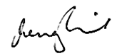 

John Pierce Wendy Craik AM

Chairman, AEMC Chair, Climate Change Authority

1 June 2017

# Executive Summary

The Minister for the Environment and Energy, the Hon Josh Frydenberg MP, asked the Australian Energy Market Commission (AEMC) and the Climate Change Authority to jointly provide advice on policies to enhance power system security and to reduce electricity prices consistent with achieving Australia’s emissions reduction targets in the Paris Agreement (Appendix A). In developing its advice, the Authority and the AEMC were asked to draw on existing analysis and review processes and be informed by independent modelling.

This report *Towards the next generation: delivering affordable, secure and lower emissions power* outlines the AEMC and the Authority’s findings on these important matters.

Australia’s energy sector is undergoing a significant transformation. This change is being driven by new technologies, business models and consumer preferences. It also reflects the intent of governments (particularly the Commonwealth Government as well as the state and territories) to reduce emissions from energy generation to meet emissions reduction targets or, in some cases, to support renewable technology industries.

As many commentators have observed, energy and emissions reduction policies have been largely pursued as separate agendas. In the AEMC and the Authority’s view, this lack of cohesion between energy and emissions policy has placed considerable pressure on the National Electricity Market’s (NEM’s) ability to supply secure and low cost electricity for Australian businesses and consumers. The policy advice provided in this report is intended to provide a platform to underpin the better integration of energy and emissions reduction policies in the future and in doing so, help keep electricity prices as low as possible while enhancing power system security.

The NEM was established to introduce competition in the wholesale electricity sector with the objective of decentralising operational and investment decisions to commercial parties who are best placed to bear the costs and manage the risks of those decisions. The overall aim of the NEM is to provide reliable, secure energy at the best possible price for consumers. To continue to do so, the NEM will need to continue to transform and significant commercially driven capital investment will be needed.

Investment decisions taken today affect reliability, security, prices and emission levels for many years to come. A policy or policies to reduce emissions and help meet Australia’s Paris targets would need to attract widespread support, if they are to be durable and provide investment certainty.

Uncertainty and electricity prices

Emissions reduction policy in Australia has been marked by frequent changes of direction and uncertainty in recent years. This has led to a high degree of policy uncertainty in the energy sector resulting in delays in investment, consequent increases in electricity prices and increasing risks to the reliability of the power system. Analysis undertaken for this report by the Centre for International Economics (2017) indicates that current wholesale electricity prices are above long-run costs by around $27 per megawatt hour (MWh) to $40/MWh. The AEMC and the Authority are of the view that policy uncertainty is a significant driver of this cost impost, which is having a direct impact on electricity prices. It follows that electricity prices could be lower than they would otherwise be if durable policy is put in place to reduce emissions in the electricity sector.

Supply side measures

The AEMC and the Authority remain of the view that an Emissions Intensity Scheme (EIS) is the preferred policy mechanism for the electricity generation sector consistent with the options they analysed in previous reports.

In its *Special Review on Australia’s Climate Goals and Policies*, the Authority recommended Australia adopt an EIS in the electricity sector (CCA 2016b). The Authority found that an EIS performs nearly as well on cost of abatement and resource cost metrics as the other market mechanism modelled and would increase electricity prices by less.

Similarly, the AEMC (2016c) also found, in its advice to the COAG Energy Council, that an EIS was the best alternative of the three emissions reduction mechanisms it evaluated and also produced better outcomes than doing nothing. An EIS met the emissions reduction target at lowest cost, integrated well with the means of exchange in the NEM, was most resilient to changes in market dynamics and was the most effective at supporting a secure power system.

Given the ability of an EIS to accommodate changes in the NEM when today’s expectations of technology costs, gas prices and other input costs turn out to be different in reality, this conclusion holds irrespective of what the future may bring. An EIS is much less dependent on forecasting ability than other measures to reduce emissions.

Designing an emissions reduction mechanism in a manner that is both consistent with the government’s energy policy objectives and the operation of a competitive energy market will contribute to the resilience and longevity of both the emissions reduction policy and its associated mechanism. A more sustainable policy is likely to provide the certainty that investors in the sector need and in turn allow for a more reliable and secure power system.

Many different policies or policy sets can help to reduce emissions although their impacts on electricity prices and power security will vary depending on their nature and design features. The Authority considers that good design and implementation are as important as policy choice if measures are to meet the three objectives of affordability, security and emissions reductions.

With this in mind, and in recognition of the Commonwealth Government’s decision to rule out consideration of an EIS, the Authority recommends that the Commonwealth Government consider implementing an alternative policy in the form of a Low Emissions Target (LET). Depending on its design, a LET could also assist with enhancing power security and reducing electricity bills as well as reducing emissions.

While commitment to a sustainable, credible emissions reduction policy mechanism is a prerequisite, the AEMC and the Authority are of the view that in addition to the above, other reforms are key to assisting with affordability and power system security.

Further, the AEMC considers that for these reforms to be effective they must be implemented at a national level and will require the Commonwealth and State governments to work together with stakeholders. Renewed commitment to the COAG Energy Council, and continued focus on improving the timeliness of decision making, will be necessary. Refreshing the Australian Energy Market Agreement would reaffirm the commitment and focus on unified policy making processes of all jurisdictions.

Demand side measures

The public debate about emissions reduction policy is often dominated by the supply side and the technologies needed to generate energy. The Authority is of the view that demand management measures can potentially contribute to resolving the energy trilemma more quickly than measures that aim to incentivise investment in large scale generation.

In this regard, the AEMC and the Authority support the development of the competitive energy services market and its associated demand management opportunities. The development of the competitive energy services market will allow opportunities for consumers to make informed choices about the way they use energy based on the benefits that end-use services provide to them. This is enabled by the competitive provision of metering services and cost reflective network tariff structures, following recent AEMC rule changes.

The Australian Energy Regulator (AER) is developing a new demand management incentive scheme and innovation allowance mechanism. The scheme’s objective is to provide electricity distribution businesses with an incentive to undertake efficient expenditure on demand management with programs that provide customers, through the contracts offered by their retailers, with incentives for direct load control for major appliances like air conditioners and pool pumps. The Authority encourages the AER to accelerate this work with the aim of putting these arrangements in place as quickly as possible.

The Authority also encourages COAG Energy Ministers to maintain their commitment to cost reflective network pricing and to pursue tariff arrangements that allow NEM consumers to readily exercise the ‘power of choice’.

Further, the Authority supports the AEMC work on the five minute rule change, which would reduce the time interval for settlement in the wholesale electricity market from 30 minutes to five minutes. The Authority notes that this rule could create new incentives for storage technologies.

The Authority recommends that a National Energy Savings Scheme (NESS) be implemented. A NESS would provide additional incentives for the uptake of low cost emissions reduction opportunities by electricity users and consumers. This would reduce electricity bills and enhance energy affordability. A NESS could also reduce demand in peak times which could assist if the grid is experiencing security issues. The Commonwealth Government should also consider allowing retailers or generators with obligations under an EIS or LET to meet their obligations with NESS certificates to further lower compliance costs and reduce electricity prices.

Access to consumer electricity data will be important for the development of demand management services. Stakeholder feedback suggests that while arrangements are in place for data portability, the process is cumbersome and time consuming for consumers. The Authority therefore recommends that the AER work with key stakeholder groups like Energy Consumers Australia to improve the process for energy consumers to access their energy data and share it with other service providers.

The Authority recommends that the Productivity Commission review the demand management incentive scheme for distribution businesses, the new requirements on distribution networks for cost reflective pricing structures, data portability and new competition arrangements for smart meters once they have been in operation for a period of time to test if they are working effectively.

Sub-regional power sharing arrangements for groups of households or businesses could further assist with demand management and grid congestion in peak periods by drawing PVs and batteries together in virtual networks. If uptake of efficient power sharing arrangements became widespread, they could lead to lower electricity prices for consumers, less pressure on the network and avoid or postpone investment in new infrastructure and generation plant.

The Authority recommends that the Commonwealth Government and Australian Renewable Energy Agency (ARENA) consider new trials in other states (beyond the one in South Australia) with a broader set of participants including households, local governments, businesses and large energy users.

Some industries and consumers are more vulnerable to electricity disruptions and cost increases than others. As such, it would be valuable if the needs of Australian electricity consumers are better represented in the governance arrangements of electricity rule makers and market operators. The Authority recommends that individuals with commercial, retail expertise (beyond the electricity sector) are appointed to the AEMC and Australian Energy Market Operator (AEMO) boards through a merit based process.

The AEMC agrees that it is critical for the Commission to be engaged with consumers and their representatives on the issues affecting Australia’s energy markets. Commissioners and staff regularly interact with different consumer groups to discuss their experience of the markets, areas of concern and potential regulatory and policy options. AEMC Commissioners are appointed on merit rather than to represent a particular constituency or sectoral interests and this preserves the independence of decision making which is so crucial for the integrity and effective development of the energy market. These and other issues related to energy market governance were addressed during the Review of Governance Arrangements for Australian Energy Markets in 2015.

There are opportunities and challenges for the NEM arising from the increased uptake of distributed energy resources (DER) such as solar PV and battery systems. In order to better support power system security, the AEMC and the Authority support calls for better access to DER related data. This data would provide information to support both planning and operational management of distribution networks and the power system. In order to facilitate this, the Authority recommends that changes be made to information disclosure provisions in the National Electricity Rules (NER).

Gas reforms

Increasing gas market efficiency is important for maintaining power system security. Reforming the gas markets to remove existing barriers to the use of gas including in the electricity sector is important if the transition to a lower emissions electricity sector is to be done in a cost effective way while maintaining system security.

The Authority recommends that the Commonwealth Government continues efforts to work with states to remove state restrictions on gas exploration and development with a view to increasing supply. Further, the Authority and AEMC support the ongoing work of the Gas Market Reform Group (GMRG). A key element of the success of these reforms will be establishing a consistent national framework for the gas market.

The Authority also recommends that COAG Energy Ministers consider an obligation on large vertically integrated companies to publish gas prices and offer contracts at the published prices on a market-based trading platform.

System security measures

Significant work is being done to integrate increasing amounts of renewable generation into the NEM while managing the exit of high emission generators. The AEMC is currently working with AEMO on developing a range of future system security services such as inertia, fast frequency response emergency control schemes and services to increase system strength. The Authority supports the timely implementation of reforms arising from this work.

With respect to system security, the Authority recommends that licence conditions be changed on a national basis to require new wind farms to adopt technology to supply inertia, and where technology is low cost and available, it be considered for other new and incumbent non-synchronous generators.

Rule change process

Some of these reforms will need to be given effect with changes to the NER. In some cases, there appears to be a significant lag between issues being raised in relation to the operation of the NEM and (if agreed), changes being made to the rules. The Authority recommends that COAG Energy Ministers revisit the Vertigan Review on Governance Arrangements for Australian Energy Markets as well as other relevant proposals submitted to the Independent Review into the Future Security of the National Electricity Market (the Finkel Review) on the NER processes.

# List of recommendations

#### Joint Climate Change Authority and AEMC recommendations

|  |
| --- |
| The AEMC and the Authority recommend an Emissions Intensity Scheme for the electricity generation sector consistent with the options they analysed in previous reports. |
| The AEMC and the Authority support the ongoing work of the COAG Gas Market Reform Group, and believe that a key element of the success of the reforms will be establishing a national framework for the gas market. |
| The AEMC and the Authority support the development of the competitive energy services market and its associated demand management opportunities. |

#### AEMC recommendation

|  |
| --- |
| The AEMC is of the view that refreshing the Australian Energy Market Agreement would reaffirm commitment and focus on unified policy making processes of all jurisdictions. |

#### Authority recommendations

|  |
| --- |
| As the Commonwealth Government has ruled out an Emissions Intensity Scheme, the Authority recommends a Low Emissions Target be considered as an alternative policy for the electricity generation sector. |
| The Authority is of the view that a National Energy Savings Scheme should be implemented as a Commonwealth measure to build on, and eventually replace, existing state ‘white certificate’ schemes. |
| The Authority is of the view that the Commonwealth Government should also consider allowing retailers or generators with obligations under an Emissions Intensity Scheme or Low Emissions Target to meet their obligations with National Energy Savings Scheme certificates to further lower compliance costs and reduce electricity prices. |
| The Authority supports the timely implementation of reforms arising from AEMC and the Australian Energy Market Operator work on developing a range of future system security services to increase system strength including inertia and fast frequency response emergency control schemes. |
| The Authority encourages COAG Energy Ministers to maintain their commitment to cost reflective network pricing and to pursue tariff arrangements that allow national electricity market consumers to readily exercise the ‘power of choice’. |
| The Authority recommends that the Australian Energy Regulator work with key stakeholder groups like Energy Consumers Australia to improve the process for energy consumers to access their energy data and share it with service providers. |
| The Authority considers that the needs of Australian electricity consumers would be better represented in the governance arrangements of electricity rule makers and market operators if individuals with commercial, retail expertise (beyond the electricity sector) are appointed to AEMC and Australian Energy Market Operator boards through a merit based process. |
| The Authority encourages the Australian Energy Regulator to accelerate work to develop a new demand management incentive scheme and innovation allowance mechanism with the aim of putting these arrangements in place as quickly as possible. |
| The Authority supports calls for better access to data related to distributed energy resources for planning and operational purposes. |
| The Authority supports the AEMC work on a rule change request to reduce the time interval for settlement in the wholesale electricity market from 30 minutes to five minutes. |
| The Authority recommends that the Productivity Commission review the Australian Energy Regulator demand management incentive scheme for distribution businesses, the new requirements on distribution networks for cost reflective pricing, data portability and new competition arrangements for smart meters once they have been in operation for a period of time to test if they are working effectively. |
| The Authority recommends that the Commonwealth Government and the Australian Renewable Energy Agency consider extending the South Australian based trial of sub-regional power sharing arrangements to new trials in other states with a broader set of participants including households, local governments, businesses and large energy users. |
| The Authority recommends that the Commonwealth Government continues efforts to work with states and territories to remove restrictions on gas exploration and development with a view to increasing supply. |
| The Authority recommends that COAG Energy Ministers consider an obligation on large vertically integrated companies to publish gas prices and offer contracts at the published prices on a market-based trading platform. |
| The Authority recommends that licence conditions be changed on a national basis to require new wind farms to adopt technology to supply inertia, and where technology is low cost and available, it be considered for other new and incumbent non-synchronous generators. |
| The Authority recommends that COAG Energy Ministers revisit the Vertigan Review on Governance Arrangements for Australian Energy Markets as well as other proposals made to the Finkel Review on the National Electricity Rules processes. |

# Chapter 1: Introduction

## About the report

The Minister for the Environment and Energy, the Hon Josh Frydenberg MP, asked the Climate Change Authority and the Australian Energy Market Commission (AEMC) to jointly provide advice on policies to enhance power system security and to reduce electricity prices consistent with achieving Australia’s emissions reduction targets in the Paris Agreement (Appendix A). In developing its advice, the Authority and the AEMC were asked to draw on existing analysis and review processes and be informed by independent modelling (Chapter 5).

## About the Climate Change Authority and the Australian Energy Market Commission (AEMC)

The Authority provides independent, expert advice to the Commonwealth Government and Parliament on policies and measures to reduce the risks of climate change. The Authority is a Commonwealth agency established under the *Climate Change Authority Act 2011 (*Cth).

The AEMC is responsible for rule making and providing advice to the COAG Energy Council, including in respect of the National Electricity Rules, the National Gas Rules and the National Energy Retail Rules which govern the National Electricity Market (NEM), elements of natural gas markets and energy retail markets. The AEMC is established under South Australian law and its key functions and powers in relation to the making of national energy rules and market reviews are set out in the national energy laws[1] and the *Australian Energy Market Commission Establishment Act 2004* (SA). The AEMC’s funding is provided by the jurisdictions’ contributions.

## Relationship to current reviews

The Authority and the AEMC have prepared this review report with the aim of informing, in particular, two key review processes that are currently underway. The first is the blueprint for energy security that is being developed through the Independent Review into the Future Security of the National Electricity Market (the Finkel Review). The blueprint will cover national policy and legislative and rule changes needed to maintain the reliability, security and affordability of the NEM as well as considering policies to reduce emissions.[2] The Commonwealth Government has said that it intends for this joint review to inform the Finkel Review (Cth 2017). The second process is the Commonwealth Government’s 2017 review of climate change policies including the energy sector that is being led by the Department of Environment and Energy (DoEE 2017). The Finkel Review blueprint will be a key input into the 2017 review.

## Public consultation and drawing on previous review processes

There has been significant work and consultation on matters covered by this special review, most recently through the Authority’s *Special Review on Australia’s Climate Goals and Policies* (which covered policies for electricity generation and concluded in 2016), the AEMC’s report to the COAG Energy Council, *Integration of Energy and Emissions Reduction Policy* (Dec 2016) and for the Finkel Review. In the interests of efficiency, the Authority and the AEMC have drawn on submissions made to the Finkel Review and the Authority’s 2014–16 special review.

Interested organisations and individuals were invited to provide new or revised submissions for this special review, and nine submissions were received (Appendix B). These can be found on the Authority’s website at <http://www.climatechangeauthority.gov.au/submissions>.

The AEMC and the Authority thank organisations and individuals that provided submissions, noting the short timeframes involved.

## Independent economic modelling

The Authority and AEMC have separately undertaken modelling and qualitative analysis of the impact of alternative emissions reduction mechanisms on the electricity sector.

The Authority examined alternative mechanisms or policies to reduce emissions in the electricity generation sector consistent with limiting warming to 2 or 3 degrees as part of its special review into Australia’s climate goals and policies (CCA 2016a). This work drew on independent modelling prepared by Jacobs (2016).

In December 2016, the AEMC produced a report to COAG Energy Ministers providing advice on the integration of energy and emissions reduction policy (AEMC 2016c). This work drew on empirical analysis prepared by Frontier Economics (2016) of the characteristics of three emissions reduction mechanisms designed to achieve an emissions reduction target of 28 per cent on 2005 levels by 2030. This report also included analysis by the Australian Energy Market Operator (AEMO) on the system security impacts of three emissions reduction policy mechanisms.

The Authority and the AEMC commissioned the Centre for International Economics (CIE) to review this work by the Authority and AEMC with a view to highlighting the reasons they differ in their findings and what particular insights they offer in consideration of emissions reduction mechanisms that could be applied in the electricity generation sector. The CIE (2017) was also asked to provide advice on the costs associated with ongoing policy uncertainty for investment in energy.

# The electricity sector and Australia’s emissions reduction goals

## 2030 emissions reduction target

In 2015, the Commonwealth Government committed to reducing Australia’s carbon dioxide equivalent (CO2-e) emissions by 26 to 28 per cent below 2005 levels by 2030. This target forms Australia’s Nationally Determined Contribution (NDC or emissions reduction target) for the Paris climate change agreement.

The Paris Agreement establishes a cycle of reviews that will require all countries, including Australia, to review and progressively increase their emissions reduction commitments every five years, with reference to the global emissions goal that there be zero net global emissions before the end of the century (UNFCCC 2015).

As well as policies to meet its 2030 obligation, Australia will need policies that are capable of being scaled up to meet more ambitious goals in the decades ahead.

As the electricity sector accounts for around one-third of Australia’s emissions (DoEE 2016), efforts to reduce economy wide emissions efficiently will require reducing emissions in the electricity sector. Previous studies and analysis have found that there are low cost emissions reductions available in the energy sector (CCA 2016a). Over time, if sectors such as manufacturing and transport are electrified as some predict, a lower emissions electricity sector could assist with further emissions reductions across the broader economy (ClimateWorks Australia et al. 2014, CSIRO & ENA 2016).[3]

A policy or set of policies implemented to reduce emissions in the energy sector must also deliver on the other horns of the electricity trilemma – namely energy affordability and security (Finkel et al. 2016). These issues are explored in Section 5.1.

## Australia’s electricity generation

Electricity is a fundamental part of Australia’s society and economy, used by households to power and heat homes and by businesses to produce goods and services. About half of all Australia’s electricity is consumed by large industrial users, and roughly one quarter each from households and other businesses (DIIS 2015).

In 2014–15, black coal was the largest single source of generation, contributing 43 per cent of total generation (Figure 1), followed by natural gas (21 per cent), brown coal (20 per cent) and renewables (14 per cent) (DIIS 2016). Between 2009–10 and 2014–15, the amount of electricity generated from wind more than doubled and solar photovoltaics (PV) generation increased by a factor of 14 (DIIS 2016).

Future demand for grid supplied electricity is driven by a range of factors in Australia including growth in electricity intensive sectors, uptake of small-scale rooftop PV and batteries, the rate of technological change including energy efficiency improvements and emissions reduction policy. Figure 1 shows projected growth in Australia’s electricity generation to 2030 under a business-as-usual scenario. It also shows that electricity generation in Australia is continuing to transition from predominantly large-scale synchronous generation to greater amounts of smaller, distributed and intermittent non-synchronous generation. The increased reliance on renewable, non-synchronous generation affects the technical characteristics of the system and the ability to supply reliable, secure energy (Box 1).

Figure 1: Electricity generation in Australia by fuel source, 2000-2030

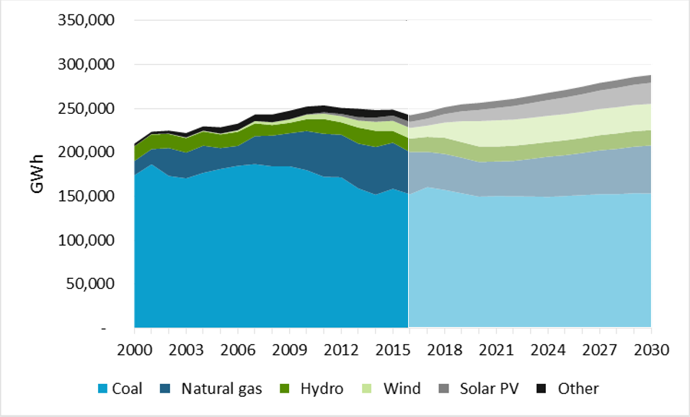

**Source:** Climate Change Authority based on DIIS 2016, DoEE 2016.

|  |
| --- |
| 1. Integrating renewables into the National Electricity Market – some important terminology   Two important aspects of the NEM are its security (the ability of the power system to continue operating within defined technical limits even if a major piece of power system infrastructure fails) and its reliability (whether there is sufficient generation and network capacity to meet demand).  The NEM operates within a narrow frequency range below or above 50 Hertz. Frequency within this narrow band means that power supply and demand are balanced. This underpins the safe, secure and reliable transmission of electricity. If the rate of change of frequency (RoCoF) is too great, generation (supply) and load (demand) can be disconnected.  Historically, RoCoF has been maintained within manageable limits through the presence of synchronous generators that have inherent inertia provided by the large rotating masses of the generator and turbines. These rotate with the system frequency (in a synchronous way), and their mass resists changes to frequency. Although some non-synchronous generators, like wind, also have rotating parts, these technologies are usually connected to the power system via power electronic converters, so the mechanical movement is decoupled from the power system (AEMO 2015).  The increasing penetration of non-synchronous generation means there is less physical inertia in the system making it more difficult to maintain frequency at the required level. Supply from intermittent generators such as solar PV and wind can also fluctuate rapidly in response to changes in sunlight and wind speed. This may pose a challenge to grid reliability as there may be periods of the day where supply is unavailable or uncertain. In addition, these technologies cannot provide a system restart capability (Finkel et al. 2016).  The Australian Energy Market Operator (AEMO) is responsible for maintaining the frequency of the NEM. It does this by carefully forecasting and matching demand and supply (through controlling dispatch) and procuring frequency control ancillary services (FCAS) when needed. The market for FCAS in the NEM was worth about $30 million in 2014 (or less than one per cent of the value of the wholesale market).[4] This is expected to rise in the future given the increased penetration of non-synchronous generators in the grid and the exit of existing coal plants. |

## Australia’s electricity emissions

Australia’s electricity sector emissions are determined by a range of factors including electricity demand, the emissions intensity of electricity generation, technological advancements and emissions reduction policies. In 2015, emissions from electricity generation made up the largest share of Australia’s emissions, contributing more than a third of Australia’s total emissions (DoEE 2016). In Australia, electricity generated from brown coal has the highest emissions intensity with an average NEM emissions intensity of 1.15 tonnes of greenhouse gas emissions per megawatt hour (t/MWh), followed by black coal at 0.89 t/MWh and gas at 0.74 t/MWh (CER 2016a). Closed cycle gas turbines and open cycle gas turbines have average emissions intensities of 0.36 t/MWh and 0.56 t/MWh respectively. Renewable energy, such as wind and solar, has zero emissions associated with its generation.

Between 2009 and 2015, emissions from electricity declined by 12 per cent (Figure 2). Emissions from electricity generation are projected to remain fairly constant between 2015 and 2017, before decreasing by seven per cent to 2020 as a result of continued improvements in energy efficiency, the closure of the Hazelwood brown coal power station and increases in renewable energy to meet the Renewable Energy Target (RET). However, beyond 2020 emissions from electricity are projected to return to roughly 2015 levels by 2030 as a result of increased demand for electricity (DoEE 2016).

The average emissions intensity of Australia’s electricity sector is high by international standards at 0.81 t/MWh (CER 2016a). In 2014, the emissions intensity of Australia’s electricity sector was 66 per cent above the global average, 52 per cent greater than that of Japan and 91 per cent greater than that of the United States of America (DoE 2014, IEA 2016) due to the mix of generation technologies and the efficiency of generation plant.

Figure 2: Australia’s Electricity emissions, 1990 to 2030

Figure 2 shows electricity emissions from the period of 1990 to 2030 in terms of million tonnes of carbon dioxide emissions. Emissions between 1990 and 2015 are based on the National Greenhouse Gas Inventory. Emissions between 2016 and 2030 are based on the 2016 Department of Environment and Energy projections. It shows that between 2009 and 2015, emissions from electricity declined. Emissions from electricity generation are projected to remain fairly constant between 2015 and 2017, before decreasing to 2020. However, beyond 2020 emissions from electricity are projected to return to roughly 2015 levels by 2030.

**Source:** DoEE 2016

## Current climate policies in the electricity sector

There is a range of policies at the Commonwealth, state and territory levels designed to reduce emissions in the electricity sector. Some jurisdictions support particular technologies with low or zero emissions with the aim of creating employment in their states. Policies are often conceptualised as affecting either the supply side, meaning they target generally the large scale energy supply sector, or the demand side meaning they target consumers of energy through energy efficiency or productivity. These policies are described in Sections 2.5 and 2.6.

There is also a range of policies at the Commonwealth level that support innovation in the energy sector. The Authority considered low-emissions innovation in its *Special Review on Australia’s Climate Goals and Policies* and found that technologies with broad application and commercial potential are likely to be developed outside Australia so it will often be preferable for Australia to be a technology taker rather than duplicating research efforts in other countries (CCA 2016b). Further consideration of policies to support innovation in the energy sector is beyond the scope of this review.

## Supply side policies

On the supply side, the main Commonwealth policy is the RET which is designed to drive investment in renewable electricity generation capacity and reduce emissions from the electricity sector. The RET places an obligation on electricity retailers to surrender a certain number of renewable energy certificates each year, with the target based on electricity demand. These certificates are generated by accredited renewable power stations (such as large scale wind, solar and hydro) and eligible small-scale technologies, such as solar panels and solar hot water systems. The RET has been in operation since 2001 but has undergone a number of legislative changes since then. The RET’s Large-scale Renewable Energy Target aims to achieve 33,000 GWh of additional renewable electricity generation by 2020 and is set to end in 2030.

There are also five renewable energy targets operating or in prospect at a state or territory level (Table 1).

Table 1: State and territory renewable energy targets

|  |  |  |
| --- | --- | --- |
| **State/Territory** | **Renewable energy target** | **Mechanisms to deliver state targets** |
| Australian Capital Territory | 100% by 2020 | Contracts for difference awarded through reverse auctions to fund renewable energy generation projects anywhere in the NEM. Successful bidders enter into contracts of up to 20 years to supply electricity. The scheme is funded through a retail tariff added to electricity bills. |
| South Australia | 33% by 2020  50% by 2025 | Mechanisms include streamlining of development approval processes and opening up of pastoral land for co-location of solar and wind development, mandated payments to pastoralists and native title owners that host wind turbines and a proposed $150 million battery storage and renewable technology fund. |
| Victoria | 25% by 2020  40% by 2025 | Proposed contracts for difference awarded through reverse auctions to fund renewable energy generation with part of the decision making criteria being whether projects create jobs in Victoria. Successful bidders enter into 10-20 year contracts to supply electricity. The scheme costs will be passed through to customers’ bills. |
| Northern Territory | 50% by 2030 | Not yet known. |
| Queensland | 50% by 2030 | Not yet known. |

**Source:** *Climate Change and Greenhouse Gas Reduction (Renewable Energy Targets) Determination 2016* (ACT), DELWP 2016, *Electricity Feed-in (Large-scale Renewable Energy Generation) Act 2011* (ACT), Government of the ACT 2016, RenewablesSA 2015, n.d., Government of SA n.d., NT Government 2016, QLD Government 2017, *Pastoral Land Management and Conservation (Renewable Energy) Amendment Bill 2014* (SA). For details of contracts for difference see Section 4.3.

The Emissions Reduction Fund (ERF) safeguard mechanism is a regulatory measure aimed at ensuring emissions reductions purchased through the ERF are not offset by emissions growth beyond business-as-usual elsewhere in the economy. The policy requires large emitters, including grid connected electricity generators, to keep their net emissions below a set limit (known as a baseline). The electricity sectoral baseline is set at 198 Mt CO2-e which was the highest level of reported emissions in the five years to 2013–14 (DoE 2016). Emissions projections (DoEE 2016) indicate this baseline is unlikely to be breached between now and 2030 so the safeguard is unlikely to impact on emissions from electricity generation unless policy settings change.

## Demand side policies

There is a range of policies at the Commonwealth and state levels that support energy efficiency or energy productivity outcomes, reducing demand for electricity, usually by substituting capital expenditure for energy consumption. Processes that produce more value from a given energy input improve energy productivity.

The ERF crediting and purchasing mechanism is a voluntary scheme aimed at encouraging emissions reduction activities throughout the economy. The crediting component provides Australian carbon credit units (ACCUs) for projects that reduce emissions or enhance carbon storage. There are currently six methods which allow proponents to earn ACCUs by enhancing energy efficiency, including in electricity use. There is also the facilities method, which enables facilities that report under the National Greenhouse and Energy Reporting Scheme to undertake a broad range of activities to reduce the emissions intensity of their facility including by installing low emissions-intensity electricity generation equipment. The purchasing element of the ERF involves the acquisition of ACCUs by the Clean Energy Regulator on behalf of the Commonwealth Government. Currently 4.6 Mt CO2-e have been contracted for reducing emissions through energy efficiency methods (CER 2017a).

The COAG Energy Council released the National Energy Productivity Plan (NEPP) in December 2015. The NEPP provides a framework for improving energy productivity by 40 per cent by 2030 and encompasses a range of measures including standards for commercial and residential buildings and appliances (COAG Energy Council 2015).

There is also a range of other energy efficiency policies (at the Commonwealth, state and territory levels) designed to decrease the amount of energy used to produce the same level of economic output. Energy efficiency schemes operate in the Australian Capital Territory, South Australia, Victoria and New South Wales. These schemes establish energy efficiency targets to be met by electricity and gas retailers and impose penalties on retailers for non-compliance. In the Australian Capital Territory, Victoria and New South Wales, energy retailers can trade the credits they generate from undertaking energy efficiency activities (Environment, Planning and Sustainable Development Directorate – Environment 2016).

## Electricity markets

### Market structure

The NEM is the wholesale electricity market for the electrically connected states and territories of eastern and southern Australia – Queensland, New South Wales, the Australian Capital Territory, Victoria, South Australia and Tasmania. The NEM supplies around 80 per cent of Australia’s electricity consumption (AEMC 2017c). The NEM is an interconnected system and electricity is sold across regions through interconnectors which connect adjacent regions. They deliver energy from lower price regions to higher price regions and so aim to equalise prices between regions, to the extent that it is efficient to do so given the cost of transmission infrastructure.

The spot market is essentially a mechanism for co-ordinating the physical production and consumption of electricity, while the economic and financial outcomes, including investment and dis-investment decisions, are primarily driven by contracts.

### Investment in the National Electricity Market

Appropriate investment signals, risk allocation and risk management tools are critical in achieving sufficient and timely investment in the technologies necessary to maintain reliability, security of supply and competition in the retail market, as the sector transforms. The efficacy of the pricing signal is critical to market participants making efficient decisions. This is because short term dispatch and long term investment decisions are underpinned by current and future expectations of prices and volumes in the wholesale contract market.

If this market is diluted by external factors, for example, subsidies designed in a way that allows particular technologies to be financed by mechanisms that operate outside the NEM, the ability of price signals and risk management tools to coordinate investment and divestment decisions, and hence achieve a system that is reliable and secure for consumers is undermined. The effective functioning of the wholesale and contract markets is therefore critical to maintaining reliable and secure supply to consumers.

The NEM operates as a market where generators are paid for the electricity they produce and retailers pay for the electricity their customers consume. All energy traded through the NEM must be settled, in the first instance, through the spot market, an arrangement referred to as the “gross pool”. Both generators and retailers face risk from being exposed to spot market prices which can, and do, fluctuate significantly on a 30 minute basis. This volatility reflects the complex and dynamic nature of the power system.[5]

To manage their exposure to the spot market, participants typically seek to enter into contracts settled by reference to the spot market price for the region in which their production or consumption occurs. Contracts allow generators and retailers to effectively convert uncertain future spot market prices into more certain wholesale prices to better match upstream or downstream obligations that are also relatively stable across time.[6]

A liquid contract market also facilitates efficient generation investment and retirement decisions in two ways: by providing information on expected future market prices; and by providing a mechanism through which new generation can be financed.

Contract prices provide information about expected future spot prices, which in turn reflect participants’ views of future wholesale market demand and supply conditions. Because expected future spot prices are not directly observable, new and existing investors, be they generators, traditional retailers or new energy service providers, tend to look to the prices of contracts to help inform them about what are likely to be profitable and unprofitable decisions.[7] As long as the wholesale market is ‘workably competitive’,[8] decisions that are profitable will promote economic efficiency and the long term interest of consumers.

An emissions reduction mechanism that, through its effect on the way new investment and businesses are financed, preserves or enhances contract market liquidity will assist participants on both sides of the market to manage risks and invest efficiently for the long term benefit of consumers.

### Current trends in wholesale markets

The electricity generation sector is currently undergoing significant changes in the type of generation capacity entering and exiting the market. The transition within the NEM is evident in a number of recent and planned retirements of large-scale synchronous generators (coal and gas). Figure 3 shows the entry and exit of generation capacity in the NEM over the period from 2007 to 2017. This shows that the primary types of generation entering the NEM have been closed cycle gas turbines (CCGT), open-cycle gas turbines (OCGT), wind and small-scale PV, while the primary types of generation exiting the NEM are black coal and brown coal. The large capacity exiting in 2017 relates to the retirement of the Hazelwood power station.

Increases in gas prices also have an impact on wholesale prices. In the last 12 months, gas prices have increased rapidly which has fed through into wholesale electricity prices. Retirement of major coal-fired stations has increased reliance on gas-fired power (AEMO 2017).

Figure 3: Entry and exit of generation capacity in the NEM since 2007

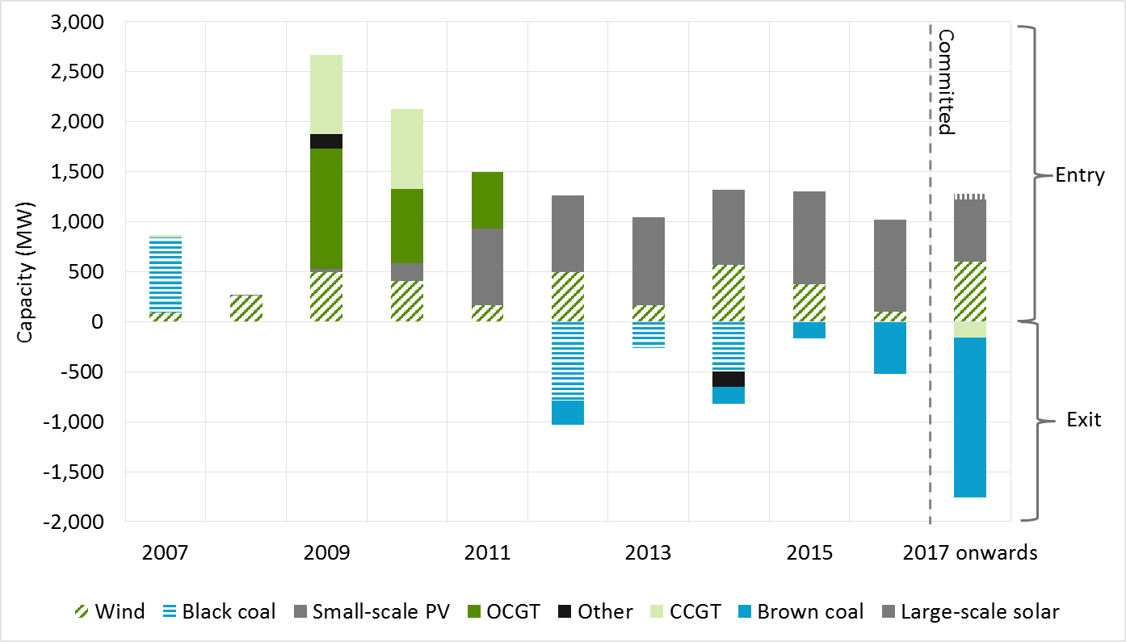

**Source**: Endgame Economics, as referenced in AEMC 2016a, p20.

**Note:** The final bar in the chart indicates generating capacity that has been committed to enter or exit the market in 2017 or in the near future.

### Generator retirements

There are a number of potential drivers for retirement of a generator, including:

* the plant is at or near the end of its life
* fuel supply reasons, such as the extinction of a local fuel source, or step-change in the cost of that fuel source
* the expectation that the generator's revenue from the wholesale market will no longer cover its operating costs and
* changes in policy or expectation of policy changes.

Plant can also retire due to other site-specific costs, policy interventions and broader company strategies. The RET can also influence retirement decisions by placing downward pressure on wholesale prices. For example, Alinta Energy cited oversupply in the South Australia electricity market in announcing the closure of coal fired Northern power station, due to a decline in household and industrial demand and policies designed to grow renewable energy generation (Alinta Energy 2015).The closure of the Hazelwood power station was in line with the owner’s (ENGIE) global strategy to gradually end its coal activities (ENGIE 2016). ENGIE (2016) also noted that hundreds of millions of dollars would be required to ensure the continued safe operation of the Hazelwood power plant.

### Effect of generator retirements on the wholesale market

Retirements reduce the amount of generating capacity available to meet demand, and so generally increase the wholesale cost of electricity. In turn, increasing wholesale costs usually place upwards pressure on retail prices because retailers pass through cost increases to consumers. Retirements can also place upward pressure on wholesale prices by:

* reducing competition in the wholesale electricity spot and contract markets and
* increasing electricity spot price volatility where the proportion of intermittent generation increases.

AEMO noted that the announcement of the closure of Hazelwood power station, “will remove 1,600 megawatts (MW) – or 13.8% of scheduled and semi-scheduled generation capacity – from Victoria, and will reduce the surplus generation Victoria has traditionally exported” (AEMO 2016b). In the absence of any market response, AEMO found that the closure of Hazelwood may lead to reliability standard breaches in Victoria and South Australia by the summer of 2017-18.

AEMO has noted some possible market responses to the closure of Hazelwood (AEMO 2016b). These include:

* conserving water this year, to allow more generation from Murray Hydroelectric Power Station in summer 2017–18 and
* withdrawn plants returning to service, including Pelican Point Power Station in South Australia, Tamar Valley Power Station in Tasmania and Swanbank E Power Station in Queensland.

It is expected that the closure of Hazelwood will result in a higher wholesale price that should send a signal for more generation capacity to enter the market to replace some of the generation that was previously provided by Hazelwood, although this may take some time to occur, possibly beyond 2017–18.

## Retail electricity prices and consumer spending on electricity

The above trends in wholesale prices impact on retail electricity prices. In the decade preceding 2013, average retail electricity prices increased by around 70 per cent in real terms (ABS 2016). This has been largely due to increased investment in transmission and distribution networks to add to or replace ageing network infrastructure (DIIS 2015) to meet demand at peak times and increase reliability standards. Since 2013, retail electricity prices have fluctuated up and down but remained largely constant overall (ABS 2016). Between 2016–17 and 2018–19, the AEMC projects residential electricity prices to increase by between two and nine per cent in all jurisdictions except Queensland and Tasmania (AEMC 2016a) (Figure 4).

Figure 4: Annual electricity bill trend for a representative consumer across jurisdictions

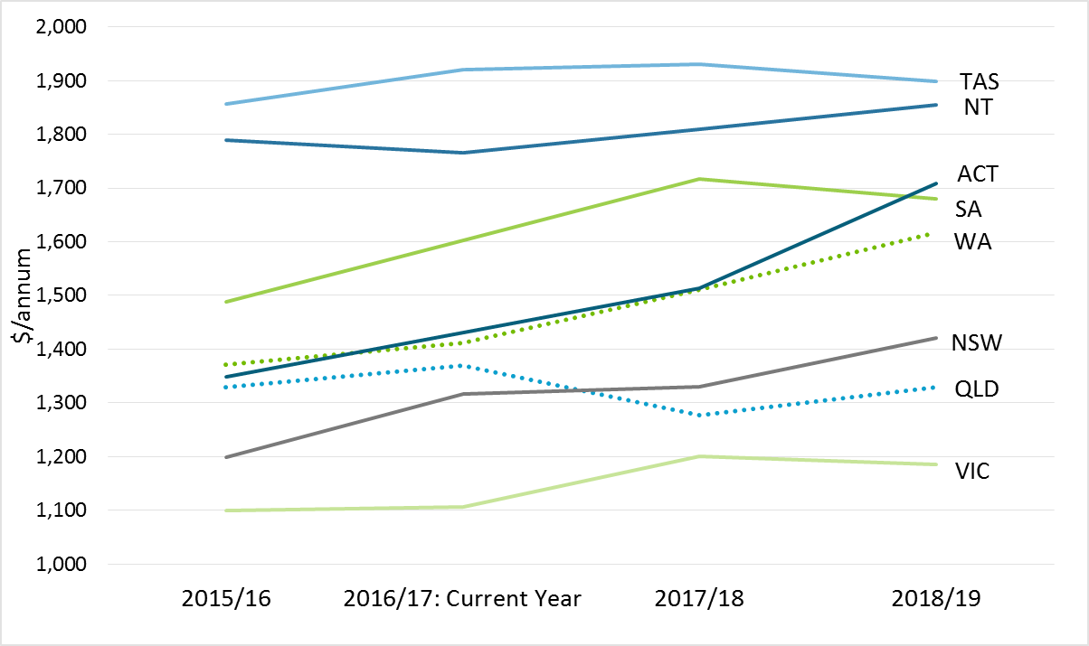

**Source**: AEMC 2016a.

**Note:** 2015/16 figures are observed rather than projected.

Since the closure of Hazelwood expectations of future prices have changed. Figure 5 shows quarterly futures prices for energy in New South Wales and shows that the price of forward wholesale swaps has increased significantly. This implies that retail prices may rise further in the future.

Figure 5: ASX NSW Baseload Quarterly Futures Prices

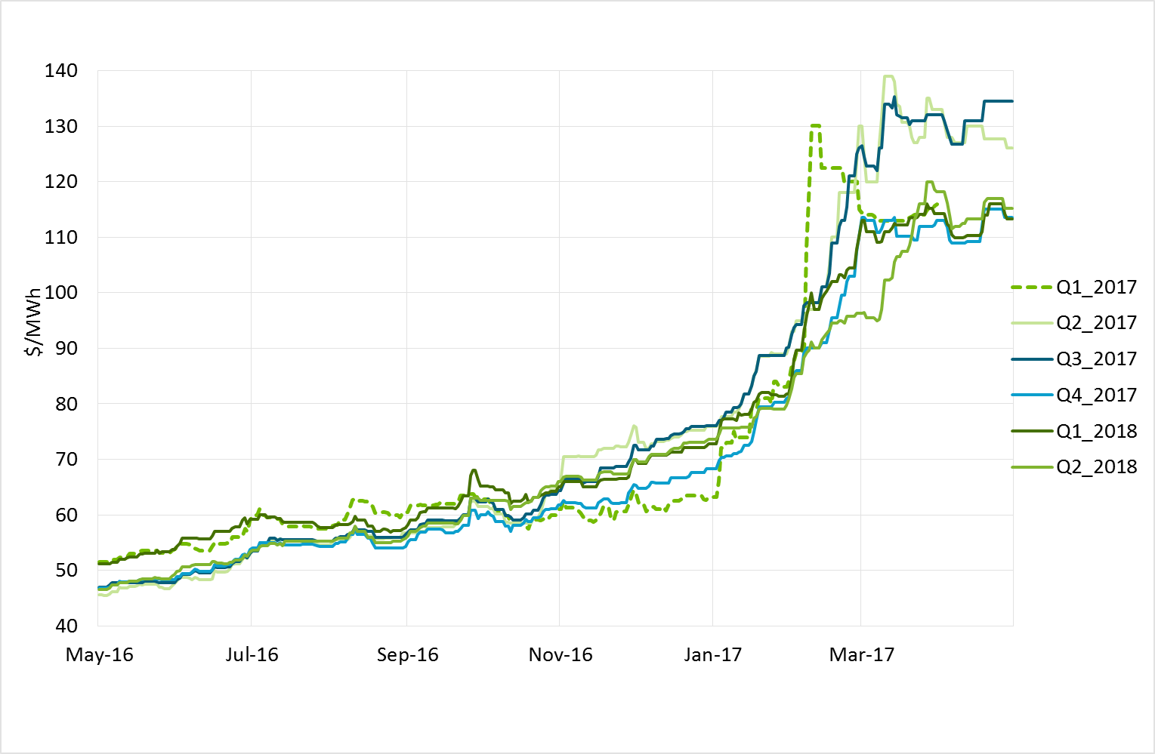

**Source**: AEMC analysis based on ASX data.

In recent years, network costs (transmission and distribution) made up, on average, around 40 to 55 per cent of an average residential electricity bill, while market costs (wholesale and retail business) made up around 40 to 50 per cent (AEMC 2016a). The costs of complying with Commonwealth, state and territory environmental policies, such as the RET, and state- and territory-based renewable and energy efficiency schemes, contribute the remaining five to fifteen per cent (AEMC 2016a).

There is also a slight upward trend observed in network costs across a number of jurisdictions. The current legal challenges of distribution network revenues in New South Wales, Australian Capital Territory, South Australia and Victoria, means there is some uncertainty associated with these estimates (AEMC 2016a).[9] The decision of the Federal Court with respect to the revenue determinations of networks in New South Wales and Australian Capital Territory is likely to result in an increase in distribution charges.[10]

Business and industry have raised concerns about the impact of higher electricity prices on their profitability and international competitiveness.

Household spending on energy (electricity and gas) represents a small proportion of household income. An ABS survey on household energy consumption, completed in 2012, found that Australian households’ average expenditure on dwelling energy (electricity and gas for use at home) represented two per cent of total gross weekly household income (ABS 2013). However, on average low income households spend three times more on dwelling energy as a proportion of their gross household weekly income than high income households (ABS 2013), so any change in electricity prices has a higher proportional impact on lower income households.

# Electricity reliability and security

## Defining reliability and security

The terms reliability and security have specific meanings in the context of the NEM. ‘Reliability’ of the power system is about having sufficient physical capacity in the system to generate and transport electricity to meet consumer demand (AEMC 2017b). ‘Security’, on the other hand, relates to operating the system within defined technical limits even if there’s an incident (such as the loss of a major transmission line or large generator) (AEMC 2016b). Reliability and security are distinct concepts. However, in order to ‘keep the lights on’ the power system overall needs to be both reliable and secure.

A reliable supply of electricity requires generators to produce electricity, and the transmission and distribution networks to transport the electricity to customers. As a result, a reliable supply of electricity to customers requires effective market processes that encourage investment in adequate capacity, as well as maintenance across all parts of the electricity supply chain so that electricity can be delivered to customers when and where it is required. For example, it is generators’ response to the price signals in the NEM that leads them to maintain and operate their generating plant and, over time, invest in new plant. It is the response to price signals, and the incentives that these create, that deliver a reliable supply of electricity both in the short and long term.

AEMO is responsible for maintaining and improving power system security, and has a role in reliability.[11] Power system security means that the power system meets certain physical operating parameters and returns to such a state following supply disruptions. System security deals with the technical parameters of the power system such as voltage, frequency, the rate at which these might change and the ability of the system to withstand faults.

Box 2 outlines the existing governance arrangements to support reliability and security.

|  |
| --- |
| 1. Governance arrangements to support reliability and security   A number of parties, including market bodies, jurisdictions and industry participants, which have a role to play in achieving the safe secure and reliable supply of electricity are set out below.  **AEMC**  The AEMC assesses rule change requests, and also undertakes reviews to provide advice on the energy market to the COAG Energy Council. The AEMC also annually indexes the Market Price Cap and Cumulative Price Threshold following the formula set out in the National Electricity Rules (NER).[12] The AEMC is currently undertaking a review, and a number of related rule change processes, related to system security. This work is discussed in more detail below.  **Reliability Panel**  The Reliability Panel’s key responsibilities set out under the National Electricity Law (NEL) include monitoring, reviewing and reporting on the safety, security and reliability of the national electricity system and providing advice, when requested, to the AEMC in relation to the safety, security and reliability of the national electricity system. The main outputs of the Panel are guidelines, standards and market reviews and advice.  Standards are developed by the Panel and specify information to market participants, such as generators and large customers. For example, they specify important requirements for connecting to, and operating under, the national electricity system, such as performance standards and operating frequencies. The Panel also develops guidelines to assist AEMO when it performs its power system security and reliability functions.  The Panel is currently undertaking a review of the reliability standard and settings (which include the Market Price Cap and Market Price Floor), and will make a recommendation to the AEMC about whether these should change. The reliability settings create a price envelope intended to allow for the market to send the necessary price signals to deliver generation and transmission capacity in the electricity system needed to meet consumer demand for energy at least to the level of the reliability standard. Market participants enter into contracts to hedge their risks against price volatility in the spot market.  **AEMO**  As the system operator, AEMO is responsible for the day to day operation of the power system and maintaining the system in a reliable and secure operating state. It also operates the systems that settle the spot market. This involves managing the dispatch of electricity on a five minute basis to make sure that supply meets demand and, where necessary, constraining parts of the generation fleet and the network so that assets are operating within their technical limits in order to maintain a safe, reliable and secure system. It also includes preparing and following guidelines on the operation of the system, often in accordance with the standards and guidelines set by the Panel, as well as monitoring demand and generation capacity in accordance with the reliability standard implementation guidelines. AEMO is also responsible for transmission network planning in Victoria.  **AER**  The Australian Energy Regulator (AER) is the body that monitors compliance with, and enforces breaches of, the NER, and associated procedures, guidelines and standards. The AER is also responsible for setting network businesses’ revenue allowances.  **Jurisdictions**  Each state and territory government retains control over how transmission and distribution network reliability is regulated and the level of reliability that must be provided. Reliability standards relate to how the transmission and distribution networks can withstand risks without consequences for consumers and guide the level of investment that networks undertake.  **Networks**  Network businesses (distribution and transmission) are responsible for maintaining the individual networks in a safe and secure operating state. Networks plan, invest and operate to achieve set reliability standards for networks (which are set by the jurisdictions as discussed above), along with additional default planning, design and operating criteria specified in the NER. The regulatory framework also provides incentives on networks to maintain and improve on the level of reliability.  **Generators**  Generators are responsible for maintaining and operating their generation assets in accordance with their performance standards, as set out in their connection agreement. |

## The AEMC’s System Security work program

The AEMC is currently conducting a system security work program, comprising the current system security markets frameworks review and associated rule change request, as well as two recently concluded emergency frequency control scheme rule change requests (AEMC n.d.).

#### System Security Market Frameworks Review

New generation technologies have technical characteristics that differ from the plant they are replacing. The impact of non-synchronous generation, such as wind power and solar PV, on how the system is maintained in a secure state is an important focus and likely to remain so in the coming years.

The AEMC is undertaking the system security market frameworks review to consider, develop and implement changes to the market rules to allow the continued uptake of these new forms of generation, while maintaining the security of the system. The review is drawing upon work being undertaken by AEMO, as part of its Future Power System Security Program, to identify and prioritise current and future challenges to maintaining system security and is focusing on:

* management of frequency and
* system strength in a power system with reduced levels of synchronous generation.

The review is also being conducted in parallel with the assessment of a number of rule change requests submitted by AGL and the South Australian Government relating to frequency control and system strength. The AGL and South Australian Government rule change requests on frequency control aim to establish a means for additional services to be brought into the NEM to help manage the rate of frequency change to be provided. The South Australian Government rule change request related to system strength seeks to clarify the framework for maintaining system strength so that generation and load are better able to withstand faults.

The AEMC has published a directions paper that outlines its proposed approach to resolving these issues (AEMC 2017g). It builds on the interim report, published in December 2016, which explored the challenges associated with frequency control and set out potential mechanisms for procuring new frequency management services (AEMC 2016d). See Box 4 for more details on this work.

## AEMO – Future Power System Security program

AEMO, as the power system operator, is also undertaking work on power system security. It has established the Future Power System Security (FPSS)program to formalise and accelerate the work it has undertaken in the last few years to address operational challenges arising from the changing generation mix. The FPSS program focuses entirely on power system security. It aims to adapt current processes to address immediate risks, while promoting solutions to maintain power system security over the next 10 years (AEMO 2016a).

As part of the current work undertaken by AEMO on system security-related issues, a new working group, the Ancillary Services Technical Advisory Group has been established. This advisory group is made up of industry, market bodies, and AEMO experts that will provide contributions to AEMO on matters relating to ancillary services, both those currently remunerated and those potentially needed in the future e.g. the content of the market ancillary services specification document (AEMO 2017a).

Any reforms in the provision of ancillary services arising from the AEMC’s work will also be considered by this working group. This group demonstrates one way in which current and future challenges related to the provision of ancillary services in the NEM are being considered and dealt with by AEMO, with input from stakeholders.

## Work to be undertaken by the Reliability Panel

As per its responsibilities under the NEL, the Panel regularly determines standards and guidelines, which are part of the framework for maintaining a secure and reliable power system. Two current reviews of standards that are underway by the Panel are noteworthy: the Reliability Standard and Settings Review (AEMC 2017d); and the Review of the Frequency Operating Standard (AEMC 2017d).

The Reliability Panel reviews the reliability standard and settings once every four years. The reliability standard is the maximum amount of electricity expected to be at risk of not being supplied to consumers in a financial year. The standard is expressed as a percentage of the annual energy consumption for the associated regions.[13] The reliability settings encompass the Market Price Cap, Cumulative Price Threshold and Market Floor Price.

This periodic review of the reliability standard and settings enables the Panel to consider whether the standards and settings remain suitable for current market arrangements and whether they continue to meet the requirements of the market, market participants and consumers. At the end of the review the Panel makes recommendations to the AEMC as to whether the standard or any of the market settings need to change. The next reliability standard and reliability setting review is to be published by April 2018. An issues paper for public consultation will be published in mid-2017.

The Panel will also be undertaking a Review of the Frequency Operating Standard (FOS). This review will investigate the appropriateness of the settings in the FOS as the market transforms from conventional synchronous generators towards non-synchronous generation such as wind and solar panels.

This review of the FOS follows the [Emergency Frequency Control Schemes rule change](http://www.aemc.gov.au/Rule-Changes/Emergency-frequency-control-schemes-for-excess-gen)s.[14] The following issues were raised in these rule changes and will be considered with respect to their impact on the FOS in this review:

* the appropriateness of the requirements in the FOS relating to multiple contingency events[15] and
* the incorporation of the new contingency event classification for “protected events”[16] into the FOS.

The Panel will publish an issues paper in mid-2017 followed by a draft report later in the year for consultation. This review must be completed by 22 December 2017.

# Possible policies and key evaluation considerations

## Analytical framework

Policies that affect the electricity generation sector have differing impacts on economic costs and electricity prices, security, reliability and emissions. Well-designed policies also provide clear, predictable and sustainable signals to generators and investors to ensure efficient production, operation and investment in the sector. Ideally, policy options will also be adaptable and scalable in order to respond to potential changes in technology costs, economic and market conditions, demand, and domestic and international progress on reducing emissions.

In assessing policy mechanisms to enhance power system security, reduce electricity prices and meet the Paris emissions reduction targets, the AEMC and the Authority have used the evaluation criteria set out below. In developing these criteria the Authority and AEMC have been guided by their legislated mandates. Specifically, the AEMC has been guided by the National Electricity Objective (Appendix C), whereas the Authority has been guided by principles under the *Climate Change Authority Act 2011* (Cth) section 12.

## Policy evaluation criteria for this review

#### Cost effectiveness

Cost effectiveness refers to minimising the expected cost of achieving a policy objective. Cost effectiveness relates to short and long term impacts on customers and the economy and encompasses:

a. *Resource costs:* the direct net costs of the policy mechanism to the economy (such as the capital and operating costs of new generation plant). This can also be presented as a cost per tonne of emissions reduced relative to the reference case.

b. *Indirect or flow-on costs:* such as changes in the cost of electricity to customers, or indirect economic effects such as the interaction of policies with existing taxes or charges.

c. *Administration and compliance costs:* including the costs to government of setting up and administering policies and to individuals and firms from complying with them.

Costs of a policy can be reduced if the greatest variety of technologies and locations can be accessed to meet the policy obligation. Costs can also be reduced if risks are allocated to parties that are best placed to identify and effectively manage them (AEMC 2016c).

Some policies may have relatively higher resource costs but still deliver lower wholesale electricity prices than other policies. For example, some policies may lead to higher resource costs as new investment in generation capacity occurs but also lead to lower wholesale prices if the supply of generation is increased and subsidies are provided so that generators bid into the wholesale market at a lower price. The degree to which consumers bear costs depends on a range of factors including how the mechanisms operate, the degree of cost pass through, whether generators retire assets in response to policies and the marginal emissions intensity of the generation sector (AEMC 2016c).

#### Environmental effectiveness

Environmental effectiveness refers to the ability of a policy to achieve a government-set emissions reduction target at the nationalor international level. This means that emissions reductions need to be additional to emissions reductions that would have occurred in the absence of the policy. Carbon leakage can also undermine the environmental integrity of emissions reduction policies in Australia if emissions reductions here are eroded by increases in other countries. Box 3 outlines the five broad avenues through which policy mechanisms can reduce emissions. A broader view of environmental effectiveness would also account for emissions that cause air pollution and associated health and amenity impacts, but is beyond the scope of this review.

#### Equity and distributional impacts on electricity customers

The Authority is of the view that policy design should take account of and support an equitable distribution of impacts and risks across households, businesses and communities. For the Authority, an equitable policy means that costs do not fall disproportionately on groups that are less able to bear them (e.g. low-income households) and treats individuals or firms in similar situations the same. In the context of this review, the Authority is particularly interested in the affordability of electricity for Australian households and businesses. Increases in electricity prices will tend to fall disproportionately on lower income households, unless they are assisted, as lower income households spend a relatively higher portion of their income on electricity than higher income households (ABS 2013). Changes in electricity prices will also affect industries differently, depending on how much electricity they use and their ability to pass on costs. Impacts on regions will also differ depending on the type of electricity generation assets they have and their reliance on electricity intensive businesses.

#### Investment certainty and sustainability

Ongoing uncertainty around energy and emissions reduction policies or mechanisms in Australia has affected the ability of companies to invest in the electricity sector, which has been one factor posing challenges for system security and reliability (Finkel et al. 2016). In order to invest effectively, investors generally need a level of confidence that the mechanism for achieving policy objectives will remain in place rather than changing frequently as a result of changes in government policy. Policies that are sufficiently robust and adaptable to deal with different futures, including changes in energy market conditions, demand, technology or fuel costs, or emissions reductions targets are generally considered to be more sustainable.

The investment environment will also be enhanced if the policy mechanism does not negatively affect the ability of investors to respond to prices in the NEM, as well as expected future prices provided by contract market liquidity. Allocating risks to those best equipped and commercially motivated to manage them and decentralising decision making on emissions reductions occurs to those with greater expertise can also assist efficient decision making and investment (AEMC 2016c).

#### System security implications

System security is necessary for the efficient functioning of the NEM. Australia’s electricity industry is undergoing a fundamental transformation with a rapid rise in the penetration of new generation technologies, such as wind and solar, over the past decade. These are now a critical part of Australia’s power system, and their significance is continuing to grow, with this growth having implications for maintaining power system security (AEMC 2016d). Different policies will have different impacts on power system security. For example, policies may have differing impacts on the level of inertia in the power system and flow on effects to power system frequency (Box 1).

#### Public interest

The Authority is of the view that it is in the public interest to establish a set of durable and scalable policies to reduce emissions in a way that is technologically and geographically neutral, and least cost. Similarly, for the AEMC, the consistency of emissions policies with the long-term interests of consumers is a key consideration in comparing the ability of alternative emissions reductions mechanisms to be integrated with energy policy (AEMC 2016c). In order for emissions reduction policies to achieve the energy market objectives, the effects of the policy on system security and energy prices should also be considered.

|  |
| --- |
| 1. Opportunities for reducing emissions: the five levers   Policies can reduce emissions in the electricity sector by pulling five broad levers:   * Retiring higher emissions intensive plant such as brown and black coal-fired generators * Building lower emissions plant such as renewable energy or highly efficient gas * Fuel switching across existing plant, for example generating more electricity from existing lower emissions gas-fired plants and less from coal * Improving the efficiency of existing plant such as through equipment refurbishment or plant upgrade * Reducing electricity demand through measures that improve energy efficiency.   As outlined in CCA (2016a) amongst the most important options for reducing emissions from the electricity sector on the supply side are retiring higher emission plants and building new or lower emissions plants. This means that investors’ beliefs about the longevity and stability of policy in the electricity generation sector are very important for achieving cost-effective emissions reductions. |

## Policy options to improve power system security and affordability of electricity prices while meeting Australia’s Paris Agreement emissions reduction goals

A variety of policy mechanisms or combinations of policies could be used in the electricity sector to meet the Paris targets. These policies have different implications for affordability and power system security and will lead to different outcomes for these objectives, depending on their design (Section 5.1). This chapter outlines these different policy choices and presents a framework for how these policies can be assessed.

This section focuses on four broad categories of policy options that are most likely to drive the large-scale emissions reductions required in the electricity sector. Other policy options such as innovation support, voluntary pricing and information programs are not considered here.

Separate analysis is being undertaken by the AEMC, in co-operation with AEMO, on how best to address the system security and reliability issues that have arisen as a result of the high penetration of intermittent generation and the retirement of traditional thermal generation to date (Chapter 3). The results of this analysis will be provided to Ministers in coming months (AEMC 2017g).

None of the emissions reduction mechanisms considered in this report are designed specifically to address concerns around system security and reliability. Instead different mechanisms, and their ability to integrate with the wholesale electricity market, will have differing impacts on security and reliability.

An assessment of how different emissions reduction mechanisms perform against the evaluation criteria and which policies should be applied in Australia is outlined in Chapter 5.

The four broad categories of emissions reduction policies are outlined below:

* *Market mechanisms* such as an emissions intensity scheme (EIS) provide incentives for emissions reductions by making low emissions intensive activities relatively cheaper and high emissions intensive ones relatively more expensive. They provide incentives for both entry of lower emissions plant and exit of higher emissions plant.
* *Technology pull policies* such as renewable or low emissions targets or contracts for difference encourage the deployment of additional low emissions electricity generation, but do not directly encourage exit of existing high emissions plant.
* *Regulatory approaches* require certain technological standards or practices to be met such as requiring exit of high emissions plant or setting certain standards for new plant.
* *Demand side* policies lead to reductions in demand for electricity by incentivising uptake of more energy efficient technologies.

### Emissions intensity scheme

An EIS is a market mechanism where government sets an emissions intensity baseline in emissions per unit of electricity generated. Electricity generators below the baseline receive permits that they can sell and generators above the baseline must buy permits for excess emissions. This changes relative generation prices based on emissions intensity and ensures that emissions are reduced utilising the lowest cost technology mix to do so. The baseline could be set to achieve the desired level of emissions, based on projected output, and could decline over time.

A well-designed EIS is a cost-effective and flexible way to reduce emissions. It can provide incentives for both entry of lower emissions plant and exit of higher emissions plant in a technologically and geographically neutral manner. It can also allocate risk effectively by using the market to determine where emissions should be reduced (CCA 2016a, AEMC 2016c).

Importantly, the design of the emissions intensity target under the EIS is adaptable to changes in electricity consumption and emissions reduction targets, without modifying the underlying architecture of the scheme. Flexibility under the scheme can be achieved by implementing a transparent and mechanistic gateway process to set the emissions intensity target in the face of inherent uncertainty regarding future electricity demand or emissions reduction targets. This flexibility means that, whatever outcomes eventuate in the future, the scheme can adapt and investors can be more confident that the mechanism will remain in place to meet emissions reduction goals.

### Extended Renewable Energy Target

The RET is a technology pull policy where the government sets a target for new renewable generation. Eligible electricity generators can create certificates, based on their output, to sell, which subsidises the cost of new renewables and electricity retailers buy these to meet their target obligations. In 2015, around 15,200 GWh of electricity was generated in Australia from large scale renewables (CER 2016b). Australia’s large-scale RET is currently set at 33,000 GWh by 2020 (CER 2017b). This existing target could be increased and extended beyond 2020. Based on AEMO’s forecasts for future electricity consumption, [17] the RET would need to increase to 86,000 GWh to achieve the 28 per cent emissions reduction target in 2030 (AEMC 2016c). By way of comparison, Hazelwood typically generated around 12,000 GWh per year.

### Low EmissionS Target

A LET can provide assistance to low emissions technologies by placing an obligation on liable entities to supply electricity from low emissions generation sources. The Authority included a LET policy in its previous modelling (CCA 2016a). There are a number of possible design options for a LET. It can incentivise a wide range of generation technologies (including, for example and depending on the design, renewables, carbon capture and storage (CCS), and highly efficient gas) provided they can help reduce emissions from the sector and assist in meeting Australia’s Paris targets.

The target could be expressed in terms of low emissions generation or it could be set in line with a desired level of emissions intensity per unit of electricity generated. The target or obligation could be changed over time without changing the measure’s architecture if emission reduction goals are not being met or to meet new emissions reduction goals.

### Contracts for Difference

Contracts for difference (CfD) is a technology pull policy that encourages new zero or low emissions electricity generation. Under this policy, government contracts to purchase a required quantity of new low or zero emissions electricity generation. Low emissions electricity generators bid through a reverse auction for long-term CfD with the government agreeing a price per megawatt hour received by generators (CCA 2016a). Funding for these contracts could come from government revenue, or be recovered through levies placed on retailers or network businesses and hence ultimately on consumers. Further contracts could be issued over time using the same scheme design if emission reduction goals are not being met or if needed to meet new emissions reduction goals.

### Safeguard mechanism – declining baselines

A safeguard mechanism with declining baselines is a regulatory policy. The Commonwealth Government would set individual baselines for each electricity generator. Generators would be required to reduce their emissions to their baseline. In Report 3, the Authority found that such an approach had amongst the highest impacts on wholesale and retail electricity prices and it is not considered further in this report (CCA 2016a).

### Regulatory closure

Under a regulatory closure policy approach, the Commonwealth Government imposes regulation, such as specifying closure dates or retrofitting with CCS for high emissions generators (typically coal) after they reach a specified age or if they emit above a mandated emissions standard. Such a policy could be implemented with or without payment for closure. Generators could be required to give notice of their intention to close within a given period (but before they are due to close) with the aim of facilitating an orderly exit based for example on expectations of future electricity demand. The Commonwealth Government could also require a plant to continue to operate for grid security or reliability reasons. This policy could be complemented by mandated emissions standards for new generators.

### Demand side measures

Demand side measures are designed to change the amount or timing of electricity used. Demand side measures include cost reflective pricing for energy (i.e. electricity or gas tariffs would be cheaper when demand is lower), energy efficiency (white certificate) schemes, standards for energy performance and energy rating labels.

Measures that reduce demand for electricity could be complementary to policies which are designed to reduce emissions from the supply of electricity. They can help to offset increases in retail electricity prices by reducing electricity use or providing lower cost compliance options for electricity generators or retailers to meet other policy obligations.

#### Energy efficiency schemes

Energy efficiency schemes are also known as white certificate schemes or energy savings schemes and generally operate by obliging electricity retailers to achieve a target for energy savings. The retailers invest in energy efficiency activities in order to meet the target (CCA 2016b). Although a number of energy efficiency schemes are already in operation in the market (Section 2.6), a national energy efficiency scheme could be created with broader coverage to capture additional opportunities.

For the schemes to create additional energy savings, the credited energy efficiency activities need to go beyond existing legislative requirements and not already be occurring as common practice in a given sector or industry (CCA 2016b).

#### Cost reflective and time of use pricing, and smart meters

Consumers are a key factor in driving the transformation of the energy sector through the decisions they make about their household and business energy needs. Reforms flowing from the AEMC’s Power of Choice review (2017f) have laid foundations for an energy system where more engaged and better informed energy shoppers have greater access to new products and services like solar, storage, electric vehicles and smarter consumption management. Key reforms include new rules to support cost-reflective network prices and competition in metering (AEMC 2017f). In 2014, the AEMC changed the NER to require distribution networks to reflect the efficient costs of providing network services to individual consumers. New cost reflective tariffs are required to be implemented by networks by the end of 2017. When prices reflect how much it costs to use different appliances at different times, consumers will be able to make more informed decisions in the face of changing energy products and services and increasingly competitive energy deals (AEMC 2014a).

Retailers have an important role in this process, and the distribution pricing rule change provides retailers with additional tools to manage the risks associated with the costs of various electricity supply inputs, including network charges, and to package these inputs into a range of retail offers for consumers. Once these services and products are offered on a wide scale, consumers will be able to select the retail product that best aligns with their preferences (AEMC 2014b).

Advanced metering infrastructure can help consumers monitor, manage and adjust their electricity consumption, giving retailers incentives to develop contract structures and services that provide consumers more opportunities to manage their energy use. The AEMC’s competition in metering rule change, which takes effect on 1 December 2017, removed the networks’ effective metering monopoly, instead introducing a competitive framework. This is expected to result in more competition between retailers and others to deliver new services via smart meters; giving consumers the choice of keeping existing working meters or to take up new services enabled by advanced meters (AEMC 2015).

# Recommendations

This chapter presents the AEMC and the Authority’s views on preferred policy in light of the terms of reference and the evaluation criteria in Chapter 4.

## Assessing policies against the evaluation criteria

In Chapter 4 the AEMC and the Authority set out the criteria against which policies should be evaluated. Table 2 provides a high level assessment of the performance of possible policy options including supply side policies that affect generation supply, demand side policies that affect consumer demand as well as policies designed specifically to enhance power system security.

The AEMC and the Authority both undertook quantitative assessments of the performance of different emissions reduction mechanisms. However different emissions targets were used in their analyses. The choice of emissions constraint can impact on the costs of emissions reduction and the relative performance of policy mechanisms. This is because the scale of the emissions reduction targeted in the modelling determines how quickly the electricity generation sector must transition to a lower–emissions future.

While the AEMC modelling considered a range of scenarios, they were all built around a common emissions reduction target of 28 per cent emissions reduction on 2005 levels by 2030. The Authority modelled a 2 and 3 degree reduction goal. The 3 degree scenarios compare more closely to the AEMC’s empirical analysis than the 2 degree scenarios.

Further information about previous economic modelling undertaken by the AEMC and the Authority is provided in CIE (2017). The CIE (2017) conclude that the recent studies draw similar conclusions when ranking policies. Policies that offer generators the greatest degree of flexibility as to how they adjust their emissions are likely to perform best under uncertainty, while policies that are less flexible such as regulatory measures will not perform as well.

Table 2: Evaluating the possible policy options

|  | ENVIRONMENTAL EFFECTIVENESS | COST EFFECTIVENESS | EQUITY/ DISTRIBUTIONAL IMPACTS | INVESTMENT CERTAINTY | SYSTEM SECURITY |
| --- | --- | --- | --- | --- | --- |
| EMISSIONS INTENSITY SCHEME (EIS) | Intensity benchmark set to reach target. Can be reduced over time to further reduce intensity and achieve given emissions targets. | Technology neutral and can realise least-cost emissions reductions.  Lowest resource costs under all scenarios. | Lowest price impacts compared to reference case under AEMC scenarios. | Flexible to changing market conditions.  Sends direct price signal to all investors and integrates well in the NEM. | AEMO analysis for AEMC indicated security related concerns are the lowest under the EIS. |
| EXTENDED RENEWABLE ENERGY TARGET (RET) | Can meet emissions targets if target is adjusted.  Does not directly incentivise the exit of high-emissions generation. Uneconomic plant closes due to short term impact on wholesale spot prices. | Highest resource costs under the Authority’s 3ºC and AEMC scenarios. | Lowers wholesale costs in the short term by subsidising renewable generation but certificate cost passed on to consumers.  In the AEMC modelling, wholesale prices rise as total system costs increase following plant retirement. | Does not allow NEM wholesale price alone to drive investment.  May lead to overinvestment in new low emissions generation as investors respond to subsidy. | Highest share of renewables under the Authority’s 2ºC scenario so could have security concerns.  AEMO analysis for AEMC indicates this had greatest adverse impact on power system security of mechanisms considered. |
| LOW EMISSIONS TARGET (LET) | Can meet emissions targets if measure can be increased over time.  Does not directly incentivise the exit of high-emissions generation. | More technologies are eligible than under a RET and is therefore lower cost.  Somewhat higher resource costs than EIS in the Authority’s 3ºC scenario. Lowest resource costs after market based mechanisms under the Authority’s 2ºC scenario. | The Authority’s modelling indicates relatively low impacts on retail electricity prices. | May lead to overinvestment in new low emissions generation as investors respond to subsidy. | Could encourage new lower emissions synchronous generation such as gas and carbon capture and storage. |
| CONTRACTS FOR DIFFERENCE (CFD) | Can meet emissions targets if measure adjusted over time.  Does not directly incentivise the exit of high-emissions generation. | Performs similarly to a LET but could lock in higher cost technologies if prices fall quickly. | The Authority’s modelling indicates relatively low impacts on retail electricity prices. | Transfers risk of investment to government and ultimately taxpayers. | Second highest share of renewables under the Authority’s 3ºC scenarios so could have security concerns. |
| REGULATORY CLOSURE | Unable to meet the required emissions reductions under the Authority’s 2ºC scenario, but can meet less stringent emissions targets. | Lower resource costs than technology-pull options under the Authority’s 3ºC and AEMC scenarios.  Highest resource costs under the Authority’s 2ºC scenario. | Highest retail costs under the Authority’s scenarios.  Highest price impacts under AEMC scenario. | Provides some certainty around date of closure for plant which could assist with investment. | Depending on design it could allow government to intervene to help with security. May be difficult to compel plant to stay open e.g. due to health and safety concerns. |
| NATIONAL ENERGY SAVINGS SCHEME AND DEMAND MANAGEMENT MEASURES | Will only reduce emissions if energy savings are additional. | Can realise least-cost emissions reductions across eligible activities.  Can reduce cost of compliance for supply side sector. | Can improve access to efficient technologies and reduce energy bills. | May reduce demand and wholesale prices, and lower requirement for new generation and transmission. | Decreased demand, especially in peak times, could reduce pressure on networks and reduce costs. |
| GAS REFORM | Could reduce emissions if results in greater uptake and displaces more emissions intensive generation. | Could place downward pressure on gas and electricity prices. | Could reduce impact of energy prices on low income households. | Transparent gas market could assist with investment certainty. | Downward pressure on gas prices could assist with system security by incentivising gas uptake. |

**Source**: Climate Change Authority based on AEMC 2016c, CCA 2016a.

**Note***:* The performance of policies against the evaluation criteria depends on a range of factors including policy design, ambition and interaction with existing policies. In the Jacob’s modelling undertaken for the Authority, it was assumed that the cost of CfD was passed onto electricity consumers, but other designs are possible so that taxpayers fund the contracts.

Figure 6 shows how different policy options explored by the Authority are projected to affect residential electricity bills to 2050 under either a 2 or 3 degree scenario.[18]

Figure 6: Average annual increase in residential electricity bills, relative to the reference case, 2020-2050

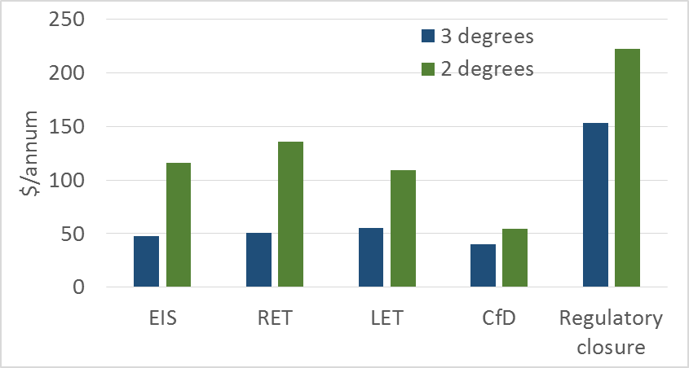

**Source**: Climate Change Authority based on Jacobs 2016.

**Note**: Residential bills calculated for an average Australian household taking the net present value of annual bills from 2020-2050, discounted at 7 per cent, and then dividing by the number of years. Household consumption based on ABS (2013) data and long-term trends.

Figure 7 from the AEMC analysis shows national weighted-average wholesale prices for business-as-usual (BAU) and the emissions reduction mechanisms. In order to compare the mechanisms on a like-for-like basis, wholesale prices include the large-scale generation certificates (LGC) levy.

Figure 7: National weighted average wholesale prices ($/MWh)

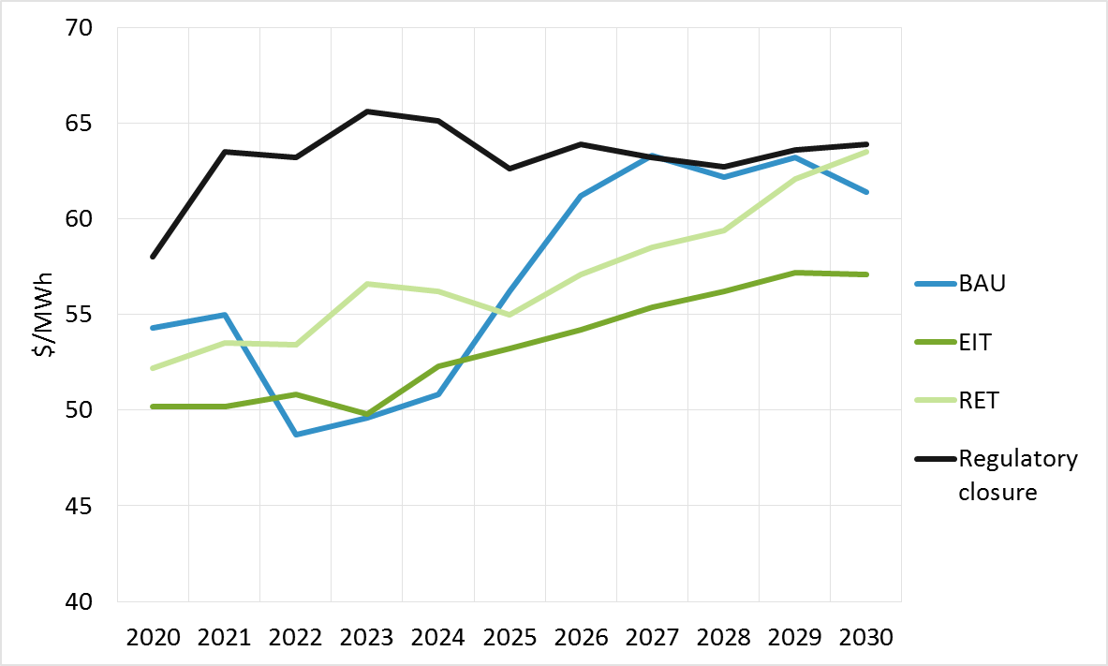

**Source**: Frontier Economics 2016.

**Note**: Wholesale prices include LGC levy and, in the case of the EIS, the costs of certificates under this scheme.

The BAU in the AEMC’s work was developed as the counterfactual against which to compare the effect of the three emissions reduction mechanisms. BAU includes the existing LRET, which is a target of 33,000 GWh by 2020, with this target amount remaining the same through to 2030. AEMC considers this is effectively the ‘do nothing’ option.

The AEMC’s analysis shows that, under a number of different scenarios, the EIS still performs better relative to the other policy mechanisms analysed. This shows that even as input assumptions change, the EIS provides stable and predictable outcomes.

Some recent commentary on the effectiveness of an EIS in the context of currently high domestic gas prices misunderstood the purpose of the analytic work undertaken as part of the AEMC’s report to the COAG Energy Council.[19] Modelling is a useful tool in understanding the characteristics of policy mechanisms and to demonstrate how a given mechanism responds to changes in a number of variables. In order to conduct modelling, a number of assumptions must be made about what the future will look like, for example technology costs and input costs such as gas. Table 3 demonstrates that regardless of the future outcomes the EIS would allow the most efficient investments to be deployed and is therefore not dependent on any of the assumptions used in the modelling eventuating.

Table 3: Average cost of abatement, $/tonne CO2-e.

| MECHANISM | BASE CASE | HIGH GAS PRICES | HIGH DEMAND | 50% EMISSION REDUCTION TARGET |
| --- | --- | --- | --- | --- |
| EIS | $30.4/t | $51.5/t | $29.8/t | $34.7/t |
| Regulatory Closure | $34.2/t | $73.9/t | $35.5/t | $37.9/t |
| Extended LRET | $75.7/t | $72/t | $93.6/t | $85.3/t |

**Source**: Frontier Economics.

**Note**: Figures show average cost of abatement per tonne of CO2-e, net present value Real 2016$, 2020-2030.

As noted by the CIE (2017), policies that offer the greatest degree of flexibility as to how generators adjust their emissions are likely to perform best under uncertainty, while less flexible policies will not perform as well. Under a flexible policy, such as the EIS, even if assumptions turn out to be wrong, the mechanism is still likely to result in desired emissions reductions for the lowest cost because generators can adjust their behaviour accordingly. It is also noted that mechanisms that are not technologically-neutral, such as the RET, are highly dependent on the actual costs of inputs, such as renewable costs.

Another important consideration in comparing the different policies is their impact on the contract market. As noted earlier, the contract market is vital for underpinning investment in generation. The current RET, for example, has led to an increase in the penetration of intermittent generation. These generators cannot easily offer traditional hedge contracts that retailers and customers need to manage their exposure to the spot price. The AEMC is of the view that in some regions in the NEM this has led to a lack of liquidity in the forward contract market, which has exacerbated the rise in forward prices. Retailers and generators are typically incentivised to enter into long-term contracts to minimise price risk.

However, generators that also receive LGC revenue have less incentive than other generators to enter into contracts, as the LGC revenue mitigate these generators’ exposure to wholesale energy prices. Furthermore, as traditional generators retire, and more capacity comes from renewables, fewer generators are available to offer contracts, further raising the cost of forward contracts.

The EIS does not negatively impact the liquidity or availability of hedging contracts for market participants, as this emissions reduction mechanism does not directly subsidise investment in new renewables.

## Policy recommendations to address security and affordability while meeting emissions targets

Emissions reduction policy in Australia has been marked by frequent changes of direction and uncertainty in recent years. Furthermore, energy and emissions reduction policies have been largely pursued as separate agendas. In the AEMC and the Authority’s view, this lack of cohesion between energy and emissions policy has placed considerable pressure on the NEM’s ability to supply secure and low cost electricity for Australian businesses and consumers. Better integration of energy and emissions reduction policies in the future is needed to help keep electricity prices as low as possible while enhancing power system security.

The AEMC and the Authority remain of the view that an EIS is the preferred policy for the electricity generation sector consistent with the options they analysed in previous reports.

In its special review on Australia’s climate goals and policies, the Authority (2016b) recommended Australia adopt an EIS in the electricity sector. The Authority found that an EIS performs nearly as well on cost of abatement and resource cost metrics as the other market mechanism modelled and would increase electricity prices by less.

The AEMC (2016c) also found in its advice to the COAG Energy Council, that an EIS was the best alternative of three emissions reduction mechanisms included in the analysis and also produced better outcomes than maintaining BAU. An EIS met the emissions reduction target at lowest cost, integrated well with the means of exchange in the NEM, was most resilient to changes in market dynamics and was the most effective at supporting a secure power system. A policy mechanism that can simultaneously achieve a chosen emissions reduction target while minimising abatement costs and price impacts under a wide range of conditions is likely to be sustainable over the long term.

The analysis showed that an EIS can accommodate changes in market dynamics to a greater extent than the other mechanisms analysed, which enables it to better accommodate changes to conditions in the energy market. The EIS is therefore expected to be the most sustainable, meaning that once it is in place there will be greater confidence that the mechanism will remain and still be effective in achieving the emissions reduction target, no matter what the future may bring. Confidence in the stability of a policy mechanism is an important foundation for future investment in the sector that underpins reliability and efficient prices.

Both the Authority and the AEMC also highlighted that an EIS could be scaled up if required in a way that is robust across a range of alternative futures (AEMC 2016c, CCA 2016a). See CIE (2017) for a review on these modelling exercises by the CIE.

The system security analysis, conducted by AEMO as part of the AEMC report, showed that of the three emissions reduction mechanisms, the NEM-wide system-security related issues are smallest under the EIS and greatest under the Extended RET. This is because the Extended RET is likely to result in the highest share of non-synchronous generators in the generation mix (AEMC 2016c).

A wide range of business, industry and some environment organisations support an EIS to reduce emissions and provide certainty for investment in energy generation. These include the Grattan Institute, the Australian Energy Association, the Business Council of Australia, the National Farmers Federation, and The Australia Institute (see Appendix D for more detail).

Some commentators have likened an EIS to a carbon tax. The AEMC and the Authority consider this comparison to be erroneous and note that the Authority’s modelling shows that an EIS has less impact on electricity prices than a carbon tax. It also raises no revenue for governments.

## Consideration of an alternative emissions policy mechanism

In December 2016, the Commonwealth Government ruled out the implementation of an EIS (Prime Minister of Australia 2016). Climate policy in Australia has been marked by frequent changes of direction and uncertainty in recent years (CCA 2016b). This has led to a high degree of uncertainty in the energy sector resulting in delays in investment and consequent increases in electricity prices and increasing risks to reliability of the power system (Finkel et al. 2016).

Analysis undertaken for this report by the CIE (2017) indicates that current wholesale electricity prices are above long-run costs by around $27/MWh to $40/MWh. The AEMC and the Authority are of the view that policy uncertainty is a significant driver of this cost impost, which is having a direct effect on electricity prices. It stands to reason that electricity prices could be lower than they would otherwise be if durable policy is put in place to reduce emissions in the electricity sector.

The Authority considers that the public interest, and the AEMC considers that the long-term interests of consumers, would be served by the implementation of a pragmatic and effective policy to reduce emissions soon. Given the capital intensive nature of the sector, decisions taken today affect reliability, security, prices and emissions levels for many years to come. Such a policy to reduce emissions would need to attract widespread support, if it is to be durable and provide investment certainty. Increased certainty around Australia’s energy and emissions reductions policies could assist investment decisions.

Many different policies or policy sets can help to reduce emissions although their impacts on electricity prices and power security will vary depending on their nature and design features. The Authority considers that good design and implementation are as important as policy choice if measures are to meet the three objectives of affordability, security and emissions reductions.

This being the case the Authority recommends that the Commonwealth Government considers implementing an alternative policy in the form of a LET for the electricity generation sector.

The AEMC has not conducted any quantitative analysis of a LET-type emissions reduction policy mechanism. Without such analysis it is not possible for the Commission to assess the impact of such a policy mechanism on the electricity market, and specifically its impact on prices and system security.

As discussed in Chapter 4, the AEMC believes that the specific design features of a LET must also be defined before any assessment of this mechanism’s impact on the energy market can be made. As the AEMC has not analysed a LET it is not able to comment on its potential impacts or to make a meaningful comparison of the performance of a LET mechanism relative to an EIS or other alternative emissions reduction policy mechanisms.

Any alternative policies such as a LET would also need to be considered against the same criteria as utilised in this report. Key issues to be addressed are:

* How does the mechanism impact the liquidity of the contract market in electricity? Does the resulting generation mix support risk management tools such as hedge contracts that are required by large consumers and retailers to manage exposure to wholesale market spot prices?
* How does the mechanism impact the financing decision of new generation? Does it provide an incentive to participate in the contract market as a way of underwriting investment?
* Does the mechanism’s design allow it to adapt to changing market conditions, such as demand levels and new technologies, to deliver the sustainable policy required to support investor confidence?

Unless the alternative mechanism can answer ‘yes’ to all these questions, the AEMC would suggest it is unlikely to be as effective as an EIS at meeting emissions reduction targets, at least cost.

The AEMC considers that in designing and comparing the impacts of alternative emissions reduction mechanisms a key step is to confirm the primary objective that governments are seeking to achieve through the policy in question – whether it is a reliable, secure power system that delivers lowest possible prices to consumers while meeting an emissions reduction target for the system, or their primary focus is an industry policy that promotes specific technologies that have particular characteristics. It is important to be clear and consistent on the policy objective that is being pursued, since the objective itself will lead to different choices about policy mechanisms and so outcomes.

## Requirements for integrated reform approach

The AEMC and the Authority are of the view that concerns about energy security and electricity prices need to be addressed as quickly as possible through policy decisions. While an EIS (or LET) will go a long way toward assisting with the trilemma, other reforms must also continue for the three objectives - to reduce electricity prices, enhance power system security and meet the Paris emissions reduction targets - to be met. More information on these additional reforms is provided in the following section.

The AEMC considers that for these reforms to be effective, they must be implemented at a national level and will require the Commonwealth and State governments to work together with stakeholders. Renewed commitment to the COAG Energy Council, and continued focus on improving the timeliness of decision making, will be necessary. Refreshing the Australian Energy Market Agreement would reaffirm the commitment and focus on unified policy making processes of all jurisdictions.

### An Emissions Intensity Scheme (EIS) compared to alternative options

The AEMC and the Authority recommend an EIS for the electricity generation sector consistent with the options they analysed in previous reports.

As the Commonwealth Government has ruled out an EIS (Prime Minister of Australia 2016), the Authority recommends a LET be considered as an alternative policy for the electricity generation sector.

The Authority’s modelling indicates that a LETcan achieve deep emissions reductions and if designed well, may have lower impacts on retail electricity prices than an EIS (CCA 2016a). It can also be designed to enhance power system security by encouraging investment in low emissions gas, and CCS (assuming CCS becomes cost-effective).

In the Authority’s view, the LET can be designed to have similar cost effectiveness to an EIS and is preferred over the other main policy options that are currently attracting attention in the public discussion.

One of these is a variation on regulatory closure of existing coal generation plant, based on a 50 year rule that also involves mandatory disclosure of an intention to retire plant three years before the plant owners intend to shut.[20] The Authority recognises the great value that orderly exit of plant would have for system security, and as a spur to investment in new generation assets. From a political economy perspective, the degree of support the measure has among some environmental NGOs, businesses and industry may also count in its favour. The AEMC is of the view that regulatory closure would also be easier to transition to an EIS at some future point in time given there are no contractual arrangements to unwind.

The Authority is concerned that the operation of the three year notice rule may be impeded by other regulatory requirements, such as the need to maintain work place health and safety (which could be a factor in plant nearing the end of their capital life), or the requirement that businesses do not trade if they are insolvent. It may also not be feasible for generation plant to keep operating if major and costly upgrades are needed. This means that while the three year notice rule is intended to add certainty, it may not do so if in fact individual plant needs to close sooner. If the plant stays open because of power system security reasons (as the three year notice rule seems to envisage), governments may be required to offer contractual payments and assume the associated risk.

Both the Authority and the AEMC’s modelling suggest that regulatory closure is likely to be among the more expensive emissions reduction policies, even if governments manage to avoid paying compensation to generation owners if plant close, or to keep plant operating for security reasons when they would otherwise close (AEMC 2016c. CCA 2016a).

The other policy option attracting attention is contracts for difference (CfD). The Authority’s modelling suggests that CfD performs very well on household electricity prices compared with other policies. It is somewhat more costly than a LET on resource and abatement cost metrics (CCA 2016a).

The problem with CfD is that they do not align well with the operation of the NEM. With CfD, governments (and ultimately either taxpayers or electricity consumers depending on how the contracts are funded) take a direct role in investing in new generation assets. This means governments assume much of the risk of these investments rather than allowing private sector players (who are likely to be better informed as to the nature of risk) to do so. This in turn could reverse some of the privatisation gains from the Hilmer energy market reforms of the 1990s (Australian Government 1993) and return governments to a central control and planning role.

CfD tend to be long term (the ACT government contracts are for up to 20 years see CCA 2016a) so CfD can risk locking in technologies that could be over-taken by new, lower emissions and lower priced alternatives.

For these reasons the Authority believes the public interest would be better served by a LET in preference to CfD or regulatory closure if an EIS cannot be implemented.

The specifics of the design of a LET are beyond the scope of this review. However, if the Commonwealth Government decided to implement a LET, the Authority believes it should be designed with the following principles in mind:

* Be cost effective and provide affordable power to consumers by being geographically neutral and allowing the broadest possible range of technologies to participate while still meeting emissions reduction goals
* Incentivise investment in technologies that could be used to help stabilise the grid such as low emissions gas generation and CCS
* Be designed to progressively lower the emissions intensity of the NEM over time in line with Australia’s Paris obligations rather than create a strong, short term incentive for new generation that may be surplus to demand
* Provide a clear signal for investment by providing a transparent pathway for lowering the emissions intensity of electricity generation with clear review points at intervals no less than five years to reduce uncertainty and
* Carefully consider its likely interaction with the wholesale electricity market and design operational rules with the aim of integrating the LET as seamlessly as possible with the NEM

## Demand management reforms

The Authority is of the view that demand management measures can potentially contribute to achieving the energy trilemma more quickly than measures that aim to incentivise new energy supply.

The Authority notes that demand management approaches would be expected to provide incentives for the uptake of small scale storage. It would be useful for further work to be done to better understand the emissions reduction implications of using batteries to store electricity.

### A National Energy Savings Scheme

A National Energy Savings Scheme (NESS) would create an obligation, possibly on energy retailers, to implement energy efficiency activities. In the special review, the Authority (2016b) recommended that the Commonwealth and states pursue harmonisation of white certificate schemes through the COAG Energy Council.

The Authority is now of the view that the NESS should be implemented as a Commonwealth measure to build on and eventually replace existing state ‘white certificate’ schemes (see CCA 2016b) as the COAG process may cause considerable delays.

A NESS can contribute to all three horns of the electricity trilemma. In its 2013 modelling of a National Energy Savings Initiative, the Commonwealth Government estimated that a policy designed to meet an energy savings target of five percent could result in a net benefit of $1.5 to $5.3 billion over the period 2015 to 2050 (Australian Government 2013). [21]

A NESS provides more direct and immediate reductions in energy bills, through increasing uptake and access to efficient technologies. By putting downwards pressure on overall demand and assisting with lowering of peaking demand, it could reduce costs in generation and networks and so reduce electricity prices. A NESS could also reduce demand in peak times, for example by targeting particular activities like air-conditioning upgrades, which could assist if the grid is experiencing security issues.

The Commonwealth Government should also consider allowing retailers or generators with obligations under an EIS or LET to meet their obligations with NESS certificates to further lower compliance costs and reduce electricity prices.

### Demand side management and an increased role for consumers

#### Time of use and reduced network charges

When energy prices reflect how much it costs to use energy at different times, and information is readily available so that these cost differences are apparent, consumers (or energy service providers working on their behalf) are able to make more informed decisions. Consumers’ choices can drive more efficient outcomes when the prices they pay for energy reflect the cost of supplying them, and the supply chain is flexible enough to respond to their choices (AEMC 2014b).

Time of use pricing can help reduce overall energy costs to consumers, and also help to enhance power system security by smoothing peak demand if consumers respond to higher prices by reducing demand at those times. It can also reduce the need for network investment, with recent studies estimating that the implementation of cost reflective network tariffs could by 2034 deliver up to $17.7 billion of savings to Australian customers from more efficient investment in network and distributed energy resources capacity (ENERGEIA 2014).

There is a range of reforms already underway, including changes made by the AEMC to the NER in 2014 that require distribution networks to develop pricing that better reflect the efficient costs of providing network services to individual consumers and have those in place in 2017 (AEMC 2014b).

Distributors have an incentive to pass on cost reflective tariffs to retailers because it better reflects the costs the distributors themselves incur. The distribution pricing rule change that comes into effect later this year will provide retailers with additional tools to manage the risks associated with the costs of various electricity supply inputs, including network charges, and to package these inputs into a range of retail offers for consumers. When these new products join those already on offer from retailers, consumers will be able to select the retail tariff that best aligns with their preferences (AEMC 2014b).

The Authority notes however that one NEM jurisdiction has ruled out consumers being placed on new tariffs as a default by requiring them to actively opt in to the new tariff arrangements, and other jurisdictions are considering their approach. The Authority encourages COAG Energy Ministers to maintain their commitment to cost reflective network pricing and to pursue tariff arrangements that allow NEM consumers to readily exercise the ‘power of choice’.

#### Smart meters, data collection, information provision and demand management for households and businesses

Advanced smart meters can help consumers monitor, manage and adjust their electricity consumption based on changes in prices giving consumers more opportunities to manage their energy use in ways that suit them. Industrial and medium sized businesses have access to interval and smart metering technology but most households and small businesses in the NEM, outside Victoria, still have meters that record consumption on an accumulation basis and are only read every three months (AEMC 2012).

The AEMC’s Power of Choice review (2012) found that the limited availability of real-time metering data was one of the reasons why most consumers were not paying prices that reflected the underlying costs of their electricity supply.

The AEMC’s competition in metering rule change, which takes effect on 1 December 2017, will remove the networks’ effective metering monopoly by introducing a competitive framework where retailers, networks and others will compete to deliver new services via smart meters. This will give consumers the choice of keeping existing working meters or to take up new services enabled by advanced smart meters (AEMC 2015).

As smart meters become more widely available as a result of these changes, aggregators may be more able to “bundle-up” energy savings from multiple consumers. Such services could reduce consumer bills by providing options for more efficient energy use, for example by altering appliance settings in response to high prices (AEMC 2015).

In its recent report on data availability and use, the Productivity Commission (2017) found that improved data access and use can enable new products and services that transform everyday life, drive efficiency and safety, create productivity gains and allow better decision making including in the provision of energy services.

Stakeholder feedback on the Finkel Review suggests that while arrangements are in place for data portability, at the moment, the process is cumbersome and time consuming for consumers. The Authority therefore recommends that the Australian Energy Regulator (AER) work with key stakeholder groups like Energy Consumers Australia to improve the process for energy consumers to access their energy data and share it with other service providers.

#### Consumer representatives in governance frameworks

Australian businesses and households rely on secure and affordable electricity to produce their goods and services and heat and light their homes. Some industries and consumers are more vulnerable to electricity disruptions and cost increases than others. As such, it would be valuable if the needs of Australian electricity consumers are better represented in the governance arrangements of electricity rule makers and market operators. This could be done by having individuals with commercial, retail expertise (beyond the electricity sector) appointed to the AEMC and AEMO boards through a merit based process.

The AEMC agrees that it is critical for the Commission to be engaged with consumers and their representatives on the issues affecting Australia’s energy markets. Commissioners and staff regularly interact with different consumer groups to discuss their experience of the markets, areas of concern and potential regulatory and policy options. AEMC Commissioners are however appointed on merit, rather than to represent a particular constituency or sectoral interests and this preserves the independence of decision making which is so crucial for the effective development of the energy market. These and other issues related to energy market governance were addressed during the Review of Governance Arrangements for Australian Energy Markets in 2015 (Vertigan, Yarrow & Morton 2015).

#### Demand management services by distributors

The AER is developing a new demand management incentive scheme and innovation allowance mechanism. The scheme’s objective is to provide electricity distribution businesses with an incentive to undertake efficient expenditure on demand management with programs that provide customers with incentives for direct load control for major appliances like air conditioners and pool pumps. The separate innovation allowance mechanism will provide distribution businesses with funding for research and development in demand management projects that have the potential to reduce long term network costs (AER n.d.).

Once in place, distribution businesses would be expected to lower the costs they pass on to retailers and for these lower costs to flow through so that, all things being equal, electricity bills are lower than they would be otherwise.

For example, retailers could offer services similar to those currently being provided by Energex whereby the amount of electricity used by air conditioners is limited in exchange for payments to energy consumers, reducing stress on the network.

The Authority encourages the AER to accelerate this work with the aim of putting these arrangements in place as quickly as possible.

The Authority recommends that the Productivity Commission review the demand management incentive scheme for distribution businesses, the new requirements on distribution networks for cost reflective pricing, data portability and new competition arrangements for smart meters once they have been in operation for a period of time to test if they are working effectively.

#### Sharing the power – virtual power grids

Sub-regional electricity sharing arrangements for groups of households or business could further assist with demand management and grid congestion in peak periods by drawing PVs and batteries together in virtual networks. The localised power sharing arrangements could be run by third party operators using information and communication technologies in the cloud. These cloud connected intelligent control systems allow a number of batteries to be directed to operate at the same time so that electricity consumers can use their stored power during peak electricity demand periods (AGL 2017). Using battery stored electricity at scale can provide grid stability services by ensuring that the batteries are discharged when prices are high and the grid is under pressure. If uptake became widespread, it could lead to lower electricity prices for consumers, less pressure on the network and interconnectors and avoid or postpone investment in new distribution or transmission infrastructure and generation plant.

One such initiative is already being funded and trialled in a partnership arrangement between AGL, the Australian Renewable Energy Agency (ARENA) and the South Australian Government. One thousand households and businesses are participating in the trial (ARENA n.d.). Once operating, other similar networks could offer FCAS to AEMO or bid into the wholesale market like a generator. The Authority recommends that the Commonwealth Government and ARENA consider new sub-regional power sharing trials in other states with a broader set of participants including households, local governments, businesses and large energy users.

## Additional and specific measures to address power system security

The Authority is of the view that in addition to the recommended EIS or LET and demand side policies, specific measures are required to address power system security and reliability to take effect in the shorter term. Gas has an important role to play here.

### Reforms to the gas market

Increasing gas market efficiency is important for maintaining power system security. As renewable generation makes up a larger part of the energy mix, gas fired generation is expected to play a more prominent role in supporting the intermittent nature of wind and solar power. This is because:

* The emissions intensity of gas (average of around 0.74 t CO2/MWh) is lower than black and brown coal (CER 2016a)
* Gas is flexible and can be more readily ramped up or down in response to inherent variability in output of renewables compared to coal and
* Gas generation is synchronous, unlike wind and solar PV. Consequently the use of gas powered generators helps maintain the security of the system through the provision of inertia.

Reforming the gas markets to remove existing barriers to the use of gas in the electricity sector is therefore important for transitioning to a lower emissions electricity sector in a cost effective way while maintaining system security.

The gas market on the east coast of Australia is undergoing a structural change. This has been accelerated by the Queensland LNG export industry driving a threefold increase in demand, with consequential impacts on the level and variability of gas flows and wholesale prices (AEMC 2016e). At around the same time a number of gas supply agreements have come up for renewal with domestic users re-negotiating their agreements in a very different market. Gas customers are being offered shorter, less flexible agreements (with respect to gas volumes) at significantly higher prices (AEMC 2016e).

Against this background, a number of submissions on the Finkel Review highlight the role that gas could play in providing solutions to all three elements of the energy trilemma. If it is to do so, emissions reduction policy needs to be stable and as technologically neutral as possible while still allowing emissions reduction goals to be met.

The AEMC and the Authority are cognisant of the impacts that continued high gas prices have on the profitability of Australian businesses. Commentators have made the point that while gas prices are unlikely to fall to levels seen earlier in the decade, increasing supply would place downward pressure on prices.

The Authority recommends that the Commonwealth Government continues efforts to work with states to remove state restrictions on gas exploration and development with a view to increasing supply.

The Commonwealth Government recently announced the Australian Domestic Gas Security Mechanism, which gives it the power to impose export controls on companies when there is a shortfall of gas supply in the domestic market. Details of how this mechanism will work are being developed (Prime Minister of Australia 2017).

Concerns over the operation of Australia’s gas markets have existed for a number of years and there have been significant efforts through COAG to reform and improve the gas market. The COAG Energy Council agreed, in August 2016, to implement a comprehensive Gas Market Reform Package based largely on recommendations from the AEMC’s East Coast Gas Review. The reforms aim to establish a liquid wholesale gas market by improving the wholesale gas trading arrangements, introducing markets for pipeline capacity trading and improving the transparency of the market through a substantial increase in the type and granularity of data presented on AEMO’s Gas Bulletin Board (COAG Energy Council 2016a).

The Gas Market Reform Group (GMRG) was established to help lead the implementation of the reforms in conjunction with the COAG Energy Council and energy market institutions (COAG Energy Council 2016a). The Commonwealth Government is providing $19.6 million over four years to the GMRG to implement the gas market reforms (The Australian Government Department of the Environment and Energy 2017).

The Authority and AEMC support the ongoing work of the GMRG, and believe that a key element of the success of the reforms will be establishing a national framework for the gas market.

Additionally, in April 2017 the Commonwealth Government directed the Australian Competition and Consumer Commission (ACCC) to conduct a wide-ranging inquiry into the supply of and demand for wholesale gas in Australia, as well as to publish regular information on the supply and pricing of gas for the next three years (ACCC n.d.). The Authority supports the ACCC Review and through COAG Energy Ministers, to reform Australia’s gas markets to enhance price transparency and improve competition.

The Authority also recommends that COAG Energy Ministers consider an obligation on large vertically integrated companies to publish gas prices and offer contracts at the published prices on a market-based trading platform.

### New mechanisms to incentivise power system security services

As outlined in Section 3.2, the penetration of large amounts of non-synchronous generation in the grid can affect grid security if system security services are not supplied. The AEMC is currently working with AEMO on developing a range of future system security services such as inertia, fast frequency response emergency control schemes and services to increase system strength (Box 4). The Authority supports the timely implementation of reforms arising from this work.

|  |
| --- |
| 1. SYSTEM SECURITY MARKET FRAMEWORKS REVIEW   The AEMC is undertaking the system security market frameworks review (2017e) to consider, develop and implement changes to the market rules to allow the continued uptake of new forms of non-synchronous generation, while maintaining the security of the system.  The Commission's preliminary view is that frequency control in the NEM would be enhanced by the introduction of both:   * a mechanism to obtain inertia, which would reduce the rate of change of frequency (RoCoF) following a contingency event, such as the loss of a large generator, load or transmission line, and extend the time available to restore the frequency; and * a fast frequency response service, which would act to arrest the frequency change more quickly than the current fastest acting contingency frequency control ancillary services, which have a response time of up to six seconds.   To implement these services, the Commission proposed two packages of complementary measures relating to inertia and fast frequency response. A staged approach to implementation of these changes seeks to strike a balance between addressing immediate issues related to the management of power system security and developing an efficient and effective framework to address such issues in the medium to longer term.  The immediate package contains a number of complementary measures to maintain control of power system frequency following a contingency event, including:   * a requirement on transmission businesses to provide and maintain a defined operating level of inertia at all times * the ability for transmission businesses, as an interim measure, to contract with third party providers of fast frequency response services where the transmission business considers, and AEMO agrees, that a fast frequency response service can be used to meet the required operating inertia level and * an obligation on new non-synchronous generators to have the capability to provide fast frequency response services.   The Commission is also proposing that two additional mechanisms should be subsequently implemented to enhance this immediate package: a transmission business incentive framework to guide investments in inertia; and a market sourcing approach for fast frequency response. Under the incentive framework, transmission businesses would be rewarded for the delivery of market benefits from a project to provide additional inertia that allowed for greater power transfer capability in the network (AEMC 2017h). These mechanisms would aim to improve the overall effectiveness and efficiency with which inertia and fast frequency response services are procured in the long term.  The directions paper also sets out the Commission's proposed approach to system strength, which is to amend the rules to clarify that network businesses should be responsible for maintaining an agreed minimum short circuit ratio to connected generators. These changes are designed to address the key risk the Commission has identified in relation to system strength, which is that declining levels of system strength can affect the ability of generators to operate correctly such that they can meet their technical performance standards. This can increase the risk of cascading outages leading to major supply disruptions (AEMC 2017h).  **Emergency frequency control schemes rule change request**  Emergency frequency control schemes protect the power system following a major disturbance, such as the simultaneous loss of multiple generators. These schemes shed load or generation in a controlled and coordinated manner in order to prevent major blackouts. They are essential to maintaining a secure and reliable supply of electricity for consumers.  The AEMC recently considered two rule changes that were designed to enhance the frameworks for emergency frequency control schemes in the NEM. The final determination for these consolidated rule change requests was made on 30 March 2017 (AEMC 2017h). The final rule includes:   * a framework to regularly review current and emerging power system frequency risks, and then identify and implement the most efficient means of managing emergency frequency events * an enhanced emergency frequency control scheme framework to allow for the efficient use of all available technological solutions to limit the consequences of emergency frequency events, including a formalised arrangement for the management of over-frequency events and * a new classification of contingency event, the protected event, that will allow AEMO to manage the system at all times by using some ex-ante solutions, as well as load shedding, to limit the consequences of the protected event.   This integrated and enhanced framework for emergency frequency control schemes and protected events will support security of supply for consumers as the generation mix changes and technology evolves. However, it is important these measures are delivered efficiently, so that costs for consumers are as low as possible. The final rule therefore sets out clear governance arrangements, including the requirement for robust cost benefit processes (AEMC 2017f). |

With respect to improvements to system security, the Authority notes that a low cost and effective ICT technology could be deployed on new wind farms to provide inertia. Licence conditions in South Australia are being changed to require that wind farms adopt this technology (ESCOSA 2017). The Authority recommends that this requirement be adopted on a national basis for new windfarms and where technology is low cost and available, it be considered for other new and incumbent non-synchronous generators.

As outlined in the AEMO submission on the Finkel Review, there are opportunities and challenges arising from the increased uptake of distributed energy resources (DER) such as solar PV and battery systems. In order to better support power system security, the Authority and AEMC supports better access to DER-related data. This data would provide information to support both planning and operational management. In order to facilitate this, the Authority recommends that changes be made to information disclosure provisions in the National Electricity Rules.

### Changes to the National Electricity Rules: the Five Minute Rule

The Authority supports the AEMC work on a rule change request to reduce the time interval for settlement in the wholesale electricity market from 30 minutes to five minutes (Box 5). This could enhance power system security by encouraging more flexible technologies such as batteries which can ramp up and down quickly in response to price signals.

|  |
| --- |
| 1. FIVE MINUTE SETTLEMENT   The AEMC is currently considering a rule change request to reduce the time interval for settlement in the wholesale electricity market from 30 minutes to five minutes. The physical electricity system matches demand for electricity from consumers with the supply of electricity by generators in five minute intervals. However, the price signal received by generators is currently the average of the six prices that generators bid to supply electricity in those five minute intervals. Changing the time interval for settlement from 30 minutes to five minutes would align the physical electricity system with the price signal provided by the market.  The five minute settlement period would apply to all market participants including generators and consumers and there would be a transition period of three years to implement the rule change. The AEMC will publish its final determination in September 2017.  Benefits of a five minute settlement period include:   * the settlement price would provide a signal for electricity supply to respond to demand over a shorter time frame, putting downward pressure on average wholesale electricity prices through a more efficiently functioning market * the price signal would be more granular, leading to more efficient investment in generation assets and demand response capabilities * generators are encouraged to introduce or withdraw electricity supply over a shorter time frame, enhancing system security and reliability.   Costs of a five minute settlement period include:   * IT systems and metering infrastructure would need to be reconfigured to operate under a five minute settlement price * could reduce the ability for generators and consumers to enter into contracts (given increased price variability) to reduce their price uncertainty leading to increased forward wholesale and retail electricity prices.   The five minute settlement rule may advantage certain technologies over others. Flexible technologies such as battery storage can be used to support increasing renewable generation and enhance the reliability and security of the electricity system. Currently, gas peaking generators play this role by providing energy during periods of peak demand. As batteries can ramp up and down much faster than gas generators, the five minute rule could favour their discharge and result in greater investment in flexible technologies and less in gas generation as they can respond more quickly to changing price signals.  **Source:** AEMC 2017a. |

### Rule change process

In some cases, there appears to be a significant lag (sometimes up to multiple years) between issues being raised in relation to the operation of the NEM and (if agreed), changes being made to the National Electricity Rules. Rule changes can have significant impacts on incumbent asset holders or existing contracts. It is important that stakeholders are consulted and the implications of NEM rule changes are considered carefully. The Authority recommends that COAG Energy Ministers revisit the Vertigan review on Governance Arrangements for Australian Energy Markets (Vertigan, Yarrow & Morton 2015) as well as other proposals made to the Finkel Review on the rule change processes.

# Appendix A: Terms of reference

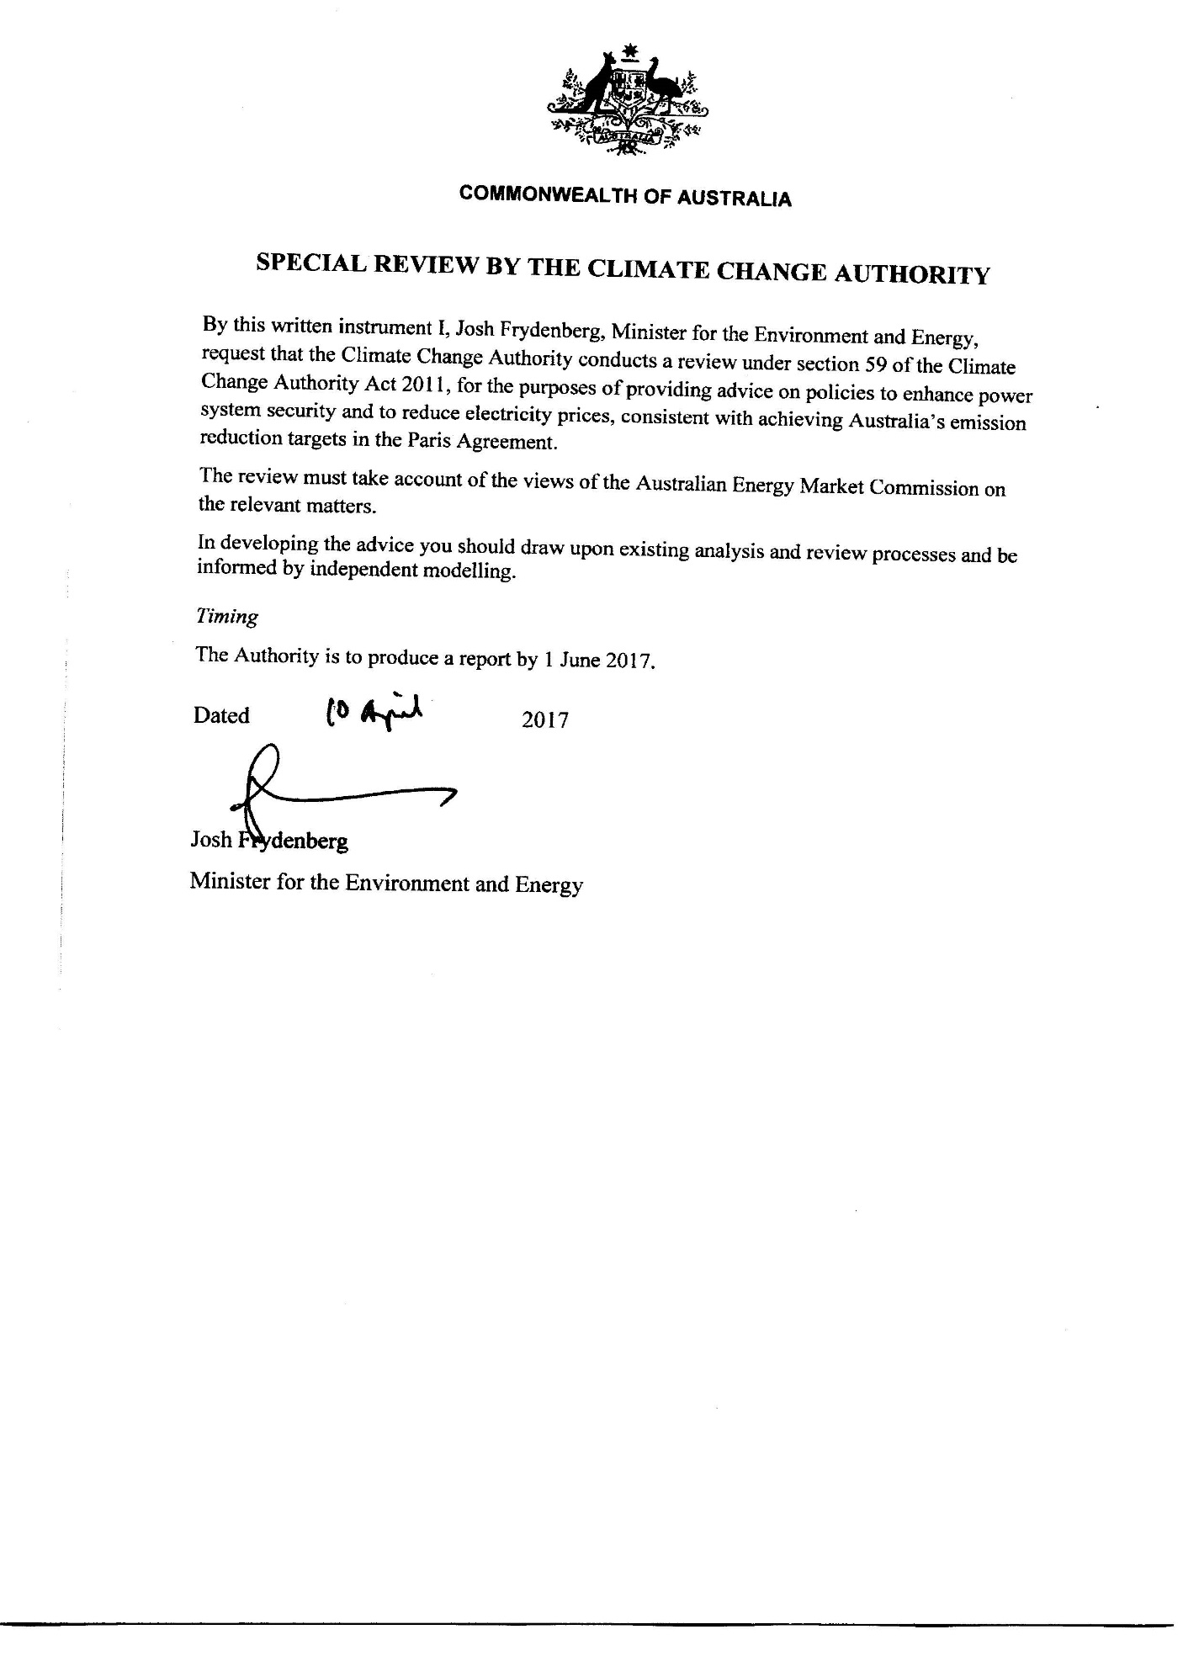

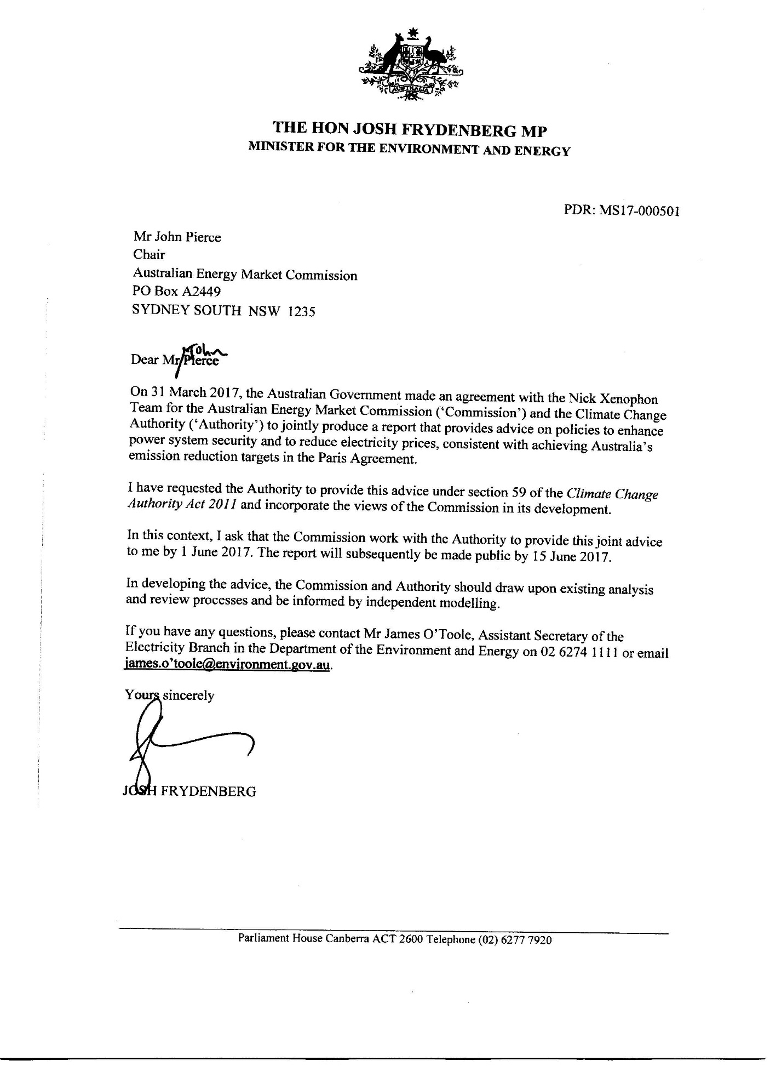

# Appendix B: public consultation

The Authority conducts public consultations for all of its reviews.

Given the short time period in which to complete this review, the Authority and the AEMC called for formal submissions from 13 April to 5 May 2017. Nine submissions were received, none of which were confidential. The submissions are on the Authority’s website www.climatechangeauthority.gov.au.

In the interests of efficiency, the Authority and the AEMC also drew on submissions made to the Finkel Review and the relevant previous submissions to the Authority.

The AEMC and the Authority thank organisations and individuals that provided submissions, noting the short timeframes involved.

Organisations that made submissions to this review were:

* Australian Sustainable Built Environment Council
* Jemena Limited
* St Vincent de Paul and South Australian Council of Social Service
* The Australia Institute
* Lock the Gate Alliance
* CSR Limited
* Australian Gas Networks
* Hydro Tasmania
* Doctors for the Environment Australia.

Appendix C: An overview of policy evaluation criteria used in previous reviews

The work of the Climate Change Authority is guided by a set of principles under the *Climate Change Authority Act 2011* (Cth). The Act states that, in conducting a review and in making recommendations, the Authority must have regard to the following matters:

* economic efficiency
* environmental effectiveness
* equity
* the public interest
* the impact on households, business, workers and communities
* the development of an effective global response to climate change
* Australia’s foreign policy and trade objectives
* any additional principles the Authority considers relevant.

In undertaking its functions the AEMC is required to have regard to the National Electricity Objective (NEO). The NEO is to promote efficient investment in, and efficient operation and use of, electricity services for the long term interest of consumers of electricity with respect to: price, quality, safety, reliability, and security of supply of electricity; and the reliability, safety and security of the national electricity system.

The AEMC (2016c and submission on the Finkel Review) have also outlined a set of factors or evaluation criteria against which mechanisms designed to effectively integrate energy and environmental policy should be assessed. These include:

* cost estimates and impacts on consumers
* certainty of achieving the emissions reduction objective
* adaptable and sustainable design
* flexibility to adapt
* technology neutral
* geographically neutral
* contract market liquidity
* appropriateness of risk allocation.

# Appendix D: stakeholder support for an eis

| CATEGORY | COMPANY | INDICATIVE SUPPORT |
| --- | --- | --- |
| Industry bodies | Australian Energy Council | Directly recommends an EIS |
| Energy Networks Australia | Directly recommends an EIS |
| Market Participants | AGL | Directly recommends an EIS |
| Origin Energy | Directly recommends an EIS |
| EnergyAustralia | Directly recommends an EIS |
| Snowy Hydro | Directly recommends an EIS |
| Hydro Tas | Directly recommends consideration of an EIS |
| Delta Electricity | Directly recommends an EIS |
| Networks | Ausgrid | Favourably discusses an EIS |
| Ausnet Services | Favourably discusses an EIS |
| Spark Infrastructure (co-owner of SAPN, Citipower Powercor, Transgrid) | Directly recommends an EIS |
| Energy Consumers | National Farmers Federation | Directly recommends an EIS |
| Business Council of Australia | Directly recommends an EIS |
| The Australian Industry Group | Directly recommends an EIS |
| Future Business Council | Directly recommends an EIS |
| Major Energy Users | Favourably discusses an EIS |
| Gas businesses | Australian Gas Networks | Directly recommends an EIS |
| Australian Pipelines and Gas Association | Directly recommends an EIS |
| Suppliers to generators, networks and retailers | General Electric Australia, New Zealand & Papua New Guinea | Directly recommends consideration of an EIS |
| S&C Electric Company | Directly recommends an EIS |
| Tilt Renewables | Directly recommends an EIS |
| RepuTex Carbon | Directly recommends an EIS |
| Government | SA Government | Directly recommends an EIS |
| Other | NSW Young Nationals | Directly recommends an EIS |
| Grattan Institute | Directly recommends an EIS |
| The Climate Institute | Directly recommends an EIS |
| Australian Academy of Technology and Engineering | Directly recommends an EIS |
| Gilbert + Tobin | Directly recommends an EIS |
| Professor Frank Jotzo, Director of the Centre for Climate Economics and Policy | Directly recommends an EIS |

**Source:** AEMC analysis of public statements and documents.

# References

**Alinta Energy 2015,** *Flinders operations announcement,* 11 June viewed 25 May 2017, <https://alintaenergy.com.au/about-us/news/flinders-operations-announcement>.

**Australian Bureau of Statistics (ABS) 2016,** *Consumer Price Index, Australia, Dec 2016,* cat.no. 6401.0, ABS, Canberra.

**ABS 2013,** *Household Energy Consumption Survey, Australia: Summary of Results, 2012,* cat.no.4670.0, ABS, Canberra.

**Australian Competition and Consumer Commission (ACCC) 2017**, *Electricity supply & prices inquiry,* ACCC, Canberra.

**ACCC n.d.,** *Gas market transparency measures* viewed 26 May 2017, <https://www.accc.gov.au/regulated-infrastructure/energy/gas-market-transparency-measures>.

**Australian Energy Market Commission (AEMC) 2017a,** *Directions Paper – Five Minute Settlement,* AEMC, Sydney*.*

**AEMC 2017b,** *Fact sheet: What is reliability?,* viewed 18 May 2017, <http://www.aemc.gov.au/Major-Pages/AEMC-work-overview/System-security-review/What-is-reliability.aspx>.

**AEMC 2017c,** National Electricity market viewed 26 May 2017, <http://www.aemc.gov.au/Australias-Energy-Market/Markets-Overview/National-electricity-market>.

**AEMC 2017d,** *Review of the Frequency Operating Standard* viewed 22 May 2017, <http://www.aemc.gov.au/Markets-Reviews-Advice/Review-of-the-Frequency-Operating-Standard>.

**AEMC 2017e,** *Review of the reliability standard and settings -* *Terms of Reference*, AEMC, Sydney.

**AEMC 2017f,** *Rule Changes* viewed 26 May 2017, <http://www.aemc.gov.au/Rule-Changes?topicId=1&status=2>.

**AEMC 2017g,** *Rule Determination – National Electricity Amendment (Emergency frequency control schemes) Rule 2017,* AEMC, Sydney.

**AEMC 2017h,** *System Security Market Frameworks Review: Directions Paper, March 2017,* AEMC, Sydney*.*

**AEMC 2016a,** *2016 Residential Electricity Price Trends*, AEMC, Sydney.

**AEMC 2016b,** *Fact sheet: Power system security* viewed 18 May 2017, <http://www.aemc.gov.au/getattachment/8647c57c-8ef7-422c-8a65-0674651e47e0/Fact-sheet-on-energy-security.aspx>.

**AEMC** **2016c**, *Integration of energy and emissions reduction policy,* AEMC, Sydney.

**AEMC 2016d,** *Interim Report – System Security Market Frameworks Review,* AEMC, Sydney.

**AEMC 2016e,** *Stage 2 Final Report – East Coast Wholesale Gas Markets and Pipeline Frameworks Review,* AEMC, Sydney.

**AEMC 2015,** *Final advice – Implementation advice on the shared market protocol,* AEMC, Sydney.

**AEMC 2014a,** *New rules for cost-reflective network prices,* 27 November viewed 19 April 2017, <http://www.aemc.gov.au/News-Center/What-s-New/Announcements/New-rules-for-cost-reflective-network-prices>.

**AEMC 2014b,** *Rule Determination – National Electricity Amendment (Distribution Network Pricing Arrangements) Rule 2014,* AEMC, Sydney.

**AEMC 2012,** *Final Report – Power of choice review – giving consumers options in the way they use electricity,* AEMC, Sydney.

**AEMC n.d.,** *System Security work program* viewed 22 May 2017, <http://www.aemc.gov.au/Major-Pages/System-Security-Review>.

**Australian Energy Market Operator** (**AEMO) 2017a,** *Ancillary Services Technical Advisory Group Terms of Reference as of 28 February 2017,* AEMO*.*

**AEMO 2016a,** *Future Power System Security Program: Progress Report*, AEMO.

**AEMO 2016b,** *Update: Electricity Statement of Opportunities for the National Electricity Market,* AEMO.

**AEMO n.d.**, National Electricity Market, viewed 31 May 2017, <https://www.aemo.com.au/Electricity/National-Electricity-Market-NEM>

**Australian Energy Regulator (AER) n.d.,** *Demand management incentive scheme and innovation allowance mechanism* viewed 26 May 2017, <https://www.aer.gov.au/networks-pipelines/guidelines-schemes-models-reviews/demand-management-incentive-scheme-and-innovation-allowance-mechanism>.

**AGL 2017,** *AGL’s Virtual Power Plant Goes Live,* 16 March viewed 26 May 2017 <https://www.agl.com.au/about-agl/media-centre/article-list/2017/march/agl-virtual-power-plant-goes-live>.

**Australian Government 2013,** *Information Paper – Investigation of a National Energy Savings Initiative: economic modelling and potential regulatory impacts,* Department of Resources, Energy and Tourism and Department of Industry, Innovation, Climate Change, Science, Research & Tertiary Education, Canberra.

**Australian Government 1993,** *National Competition Policy*, Commonwealth of Australia, Canberra.

**The Australian Government Department of Environment and Energy 2017,** *Portfolio Budget Statements 2017-18,* DoEE, Canberra.

**Australian Renewable Energy Agency (ARENA) n.d.,** *Virtual Power Plant* viewed 26 May 2017 <https://arena.gov.au/projects/virtual-power-plant/>.

**The Centre for International Economics (CIE 2017),** *Review of economic modelling exercises & assessment of the impact of uncertainty,* CIE.

**Clean Energy Regulator (CER) 2017a,** *Combined results for all auctions - Emissions Reduction Fund* viewed 25 May 2017, <http://www.cleanenergyregulator.gov.au/ERF/Auctions-results/april-2017>.

**CER 2017b**, *How the scheme works* viewed 18 April 2017, <http://www.cleanenergyregulator.gov.au/RET/About-the-Renewable-Energy-Target/How-the-scheme-works>.

**CER 2016a,** *Designated generation facility data 2015-16* viewed 25 May 2017, <http://www.cleanenergyregulator.gov.au/NGER/National%20greenhouse%20and%20energy%20reporting%20data/electricity-sector-emissions-and-generation-data/electricity-sector-emissions-and-generation-data-2015-16>*.*

**CER 2016b,** *RET Administrative report 2015 achievements snapshot* viewed 25 May 2017,<http://www.cleanenergyregulator.gov.au/DocumentAssets/Documents/RET_Admin-Highlights-2015.pdf>.

**Climate Change Authority (CCA) 2016a,** *Policy options for Australia’s electricity supply sector,* CCA, Melbourne.

**CCA 2016b**, *Towards a Climate Policy Toolkit: Special Review on Australia’s Climate Goals and Policies,* CCA, Melbourne.

***Climate Change Authority Act 2011***(Cth).

***Climate Change and Greenhouse Gas Reduction (Renewable Energy Targets) Determination 2016***(ACT).

**ClimateWorks Australia, ANU, CSIRO and CoPS 2014,** *Pathways to Deep Decarbonisation in 2050: How Australia can prosper in a low carbon world: Technical report,* ClimateWorks, Melbourne.

**Council of Australian Governments (COAG) Energy Council 2016a,** *Gas Market Reform Package* – Bulletin Two viewed 25 May 2017, <http://www.coagenergycouncil.gov.au/sites/prod.energycouncil/files/publications/documents/Gas%20Market%20Reform%20Package%20Bulletin%20-%20August%202016.pdf>.

**COAG Energy Council 2016b,** *National Energy Productivity Plan 2015 – 2030: Annual Report 2016,* Commonwealth of Australia, Canberra.

**COAG Energy Council 2015,** *National Energy Productivity Plan 2015-2030,*Commonwealth of Australia, Canberra.

**Commonwealth of Australia (Cth) 2017***, Parliamentary Debates*, Senate, 30 March 2016, <http://parlinfo.aph.gov.au/parlInfo/download/chamber/hansards/644a98a8-8eaf-4347-a5ff-4d72ba01c276/toc_pdf/Senate_2017_03_30_4900_Official.pdf;fileType=application%2Fpdf#search=%22chamber/hansards/644a98a8-8eaf-4347-a5ff-4d72ba01c276/0000%22>.

**CSIRO & Energy Networks Australia (ENA) 2016,** *Electricity Network Transformation Roadmap: Key Concepts Report*, CSIRO and ENA, Australia*.*

**Department of the Environment and Energy (DoEE) 2017**, *Review of Australia’s climate change policies* viewed 18 May 2017, <http://www.environment.gov.au/climate-change/review-climate-change-policies>.

**DoEE 2016,** *Australia’s emissions projections 2016*, Australian Government, Canberra*.*

**Department of the Environment (DoE) 2016,** *The safeguard mechanism - Electricity sector* viewed 26 May 2017, [http://www.environment.gov.au/system/files/resources/2afcab8c-545b-4059-abfd-d7f9a35312e7/files/factsheet-safeguard-mechanism-electricity-sector.pdfDoE.](http://www.environment.gov.au/system/files/resources/2afcab8c-545b-4059-abfd-d7f9a35312e7/files/factsheet-safeguard-mechanism-electricity-sector.pdfDoE.%20)

**DoE 2014,** *National Greenhouse Accounts Factors,* Department of the Environment, Canberra.

**Department of Environment, Land, Water and Planning (DELWP) 2016,** *Victorian Renewable Energy Auction Scheme – Consultation Paper,* The State of Victoria DELWP.

**Department of Industry, Innovation and Science (DIIS)** **2016,** *Australian Energy Statistics,* Office of the Chief Economist, Canberra.

**DIIS 2015,** *Energy in Australia: 2015,* Office of the Chief Economist, Canberra.

***Electricity Feed-in (Large-scale Renewable Energy Generation) Act******2011***(ACT).

**ENERGEIA 2014,** *Network Pricing and Enabling Metering Analysis,* prepared by ENERGEIA for the Energy Networks Association.

**ENGIE 2016,** *Hazelwood power station in Australia to close at the end of March 2017*, 3 November viewed 25 May 2017, <https://www.engie.com/wp-content/uploads/2016/11/pr-engieaustralie-031116_v2.pdf>.

**Environment, Planning and Sustainable Development Directorate – Environment 2016,** *How the scheme works* viewed 18 April 2017, <http://www.environment.act.gov.au/energy/smarter-use-of-energy/energy_efficiency_improvement_scheme_eeis/how-the-scheme-works>.

**Essential Services Commission of South Australia (ESCOSA) 2017,** *Inquiry into the licensing arrangements for generators in South Australia DRAFT REPORT,* ESCOSA, Adelaide.

**Finkel, A, Moses, K, Munro, C, Effeney, T, O’Kane, M 2016,** *Independent Review into the Future Security of the National Electricity Market – Preliminary Report,* Commonwealth of Australia, 2016*.*

**Frontier Economics 2016,** *Emissions reduction policy options, A report prepared for the*

*Australian Energy Market Commission,* Frontier Economics.

**Government of the Australian Capital Territory (Government of the ACT) 2016,** *How do the ACT’s renewable energy reverse auctions work?* viewed 25 May 2017, <http://www.environment.act.gov.au/energy/cleaner-energy/how-do-the-acts-renewable-energy-reverse-auctions-work>.

**Government of South Australia (Government of SA) n.d.,** *Our Plan* viewed 25 May 2017, <http://ourenergyplan.sa.gov.au/our-plan.html>.

**International Energy Agency (IEA) 2016,** *World Energy Outlook,* IEA, Paris.

**Jacobs 2016**, *Modelling illustrative electricity sector emissions reduction policies,* Jacobs, Melbourne.

**Northern Territory Government (NT Government) 2016,** *Roadmap to Renewables* viewed 13 April 2017, <https://roadmaptorenewables.nt.gov.au/>.

***Pastoral Land Management and Conservation (Renewable Energy) Amendment Bill 2014*** (SA).

**Prime Minister of Australia (2017),** *Delivering affordable gas for all Australians,* 27 April viewed 26 May 2017, <https://www.pm.gov.au/media/2017-04-27/delivering-affordable-gas-all-australians>.

**Prime Minister of Australia (2016),** *Doorstop,*07 December viewed 26 May 2017, <https://www.pm.gov.au/media/2016-12-07/doorstop>.

**Productivity Commission (PC) 2017,** *Data Availability and Use Privacy Report*, May 2017.

**Queensland Government (Qld Government) 2017,** *A solar future: powering Queensland’s renewable energy industries* viewed 13 April 2017, <https://www.dews.qld.gov.au/electricity/solar/solar-future>.

**RenewablesSA 2015,** *A Low Carbon Investment Plan for South Australia,* RenewablesSA, Adelaide.

**RenewablesSA n.d.,** *About Us,* RenewablesSA, Adelaide.

**United Nations Framework Convention on Climate Change (UNFCCC) 2015**, Adoption of the Paris Agreement, Draft decision -/CP.21, United Nations.

**Vertigan, M, Yarrow, G & Morton, E 2015,** *Review of Governance Arrangements for Australian Energy Markets – Final report,* Commonwealth of Australia, Canberra.

1. Part 4, National Electricity Law, Part 2, National Gas Law, and Part 9, National Energy Retail Law.
2. See terms of reference for the Independent Review, available at <http://coagenergycouncil.gov.au/publications/independent-review-terms-reference>.
3. This report makes no judgement about the contribution the electricity sector could make to the Paris Agreement’s economy wide target.
4. $7.7 billion of electricity was traded in the NEM in 2014–15 (AEMO n.d.)
5. Currently, prices in the spot market range from the floor price of -$1,000 to the market price cap of $14,000 (AEMC 2017e).
6. Further information on risk management structures can be found in the AEMC's submission to the Independent review into the future security of the NEM. See: http://www.aemc.gov.au/getattachment/6ecd9317-10f8-40b6-b053-bfad507099b6/AEMC-submission-to-the-independent-review-on-the-f.aspx.
7. Specifically, investors will look at forward-dated swap contracts to provide an indication of market expectations of future average spot prices, and forward-dated cap contract premiums to provide an indication of the future level and duration of spot prices in excess of the cap strike price (typically, $300/MWh).
8. In a workably competitive market it is expected that firms display profit maximising behaviour, seeking the widest possible margin between prices and their underlying costs. Pricing behaviour is disciplined by the threat of new suppliers entering the market in response to price signals and consumers exercising choice.
9. There are currently legal challenges of distribution network revenues underway in New South Wales, Australian Capital Territory, South Australia and Victoria.
10. The original AER determinations of the revenue that Ausgrid, Endeavour Energy, Essential Energy, ActewAGL and Jemena Gas Networks (NSW) could collect from customers to operate their networks were made in 2015 and have been the subject of appeal to the Australian Competition Tribunal and the Full Federal Court. On 24 May 2017, the Federal Court upheld the AER’s appeal in relation to the Tribunal’s decision on the cost of corporate income tax but upheld the Australian Competition Tribunal’s findings in relation to the networks’ operating expenses and the cost of debt. The maximum revenue that these networks can collect from customers will increase as a result of this decision.
11. In its management of power system reliability, AEMO can use any one of three reliability intervention mechanisms. The first is the Reliability and Emergency Reserve Trader (RERT), which allows AEMO to contract for reserves ahead of a period where reserves are projected to be insufficient to meet the reliability standard, and then for AEMO to dispatch these reserves to manage power system reliability. The second is reliability directions, where under NER clause 4.8.9(a), AEMO may direct a registered participant to do any act or thing if AEMO is satisfied that it is necessary to do so to maintain or re-establish the power system to a reliable operating state. Finally, under NER clause 4.8.9 AEMO can instruct registered participants with non-market, non-scheduled generating units or loads to maintain or re-establish the power system to a reliable operating state.
12. The market price cap is the maximum price that can be reached in any dispatch interval and in any trading interval. The market price cap is currently set at $14,000/MWh. The cumulative price threshold limits participants’ financial exposure to the wholesale spot market during prolonged periods of high prices. It limits the total market price that can occur over a period of one week, before an administered pricing period is declared. Once an administered price period is triggered, the administered price cap applies, currently $300/MWh.
13. The reliability standard is referred to as the maximum expected unserved energy (USE), and is 0.002 per cent of annual energy consumption, that is, out of 100,000MWh of demand no more than 2MWh of outage should be expected.
14. For more information on the Emergency Frequency Control Schemes rule changes see <http://www.aemc.gov.au/Rule-Changes/Emergency-frequency-control-schemes-for-excess-gen>.
15. Contingency events are those events that AEMO considers are reasonably possible, such as the loss of a generator.
16. A protected event is a non-credible contingency event where it may be economically efficient to manage using ex-ante operational measures in addition to some limited load or generation shedding.
17. This estimate is based on AEMO’s 2015 National Electricity Forecasting Report forecasts for electricity demand.
18. These scenarios modelled emissions constraint consistent with global action to limit global average warming to no more than 2 degrees and 3 degrees, respectively.
19. Australian Financial Review, 5 May 2017.
20. See Business Council of Australia submission on the Finkel Review.
21. This study assumed that a carbon trading scheme was in operation from 2012 to 2050.