

Reduce, remove and store

The role of carbon sequestration in accelerating Australia’s decarbonisation

April 2023

November 2022



**The Authority recognises the First Nations people of this land and their ongoing connection to culture and country. We acknowledge First Nations people as the Traditional Owners, Custodians and Lore Keepers of the world's oldest living cultures, and pay our respects to their Elders—past and present.**

**The Authority recognises the First Nations people of this land and their ongoing connection to culture and country. We acknowledge First Nations people as the Traditional Owners, Custodians and Lore Keepers of the world's oldest living cultures, and pay our respects to their Elders - past, present and emerging.**

This report was published on Ngunnawal and Ngambri country.

*In designing and carrying out this project, the Authority has had regard to the principle set out in the Climate Change Authority Act 2011: that any measures to respond to climate change should be economically efficient, environmentally effective, equitable, and in the public interest. Measures should also take account of impacts on households, business, workers, and communities, support the development of an effective global response to climate change, be consistent with Australia’s foreign policy and trade objectives, take account of the matters set out in Article 2 of the Paris Agreement, and boost economic, employment and social benefits, including for rural and regional Australia.*

**Copyright**

Published by the Climate Change Authority [www.climatechangeauthority.gov.au](http://www.climatechangeauthority.gov.au)

This work is licensed under the Creative Commons Attribution 3.0 Australia Licence. To view a copy of this licence, visit <http://creativecommons.org/licenses/by/3.0/au>

The Climate Change Authority asserts the right to be recognised as author of the original material in the following manner:

 or 

©Commonwealth of Australia (Climate Change Authority) 2023.

ISBN: 978-0-6481620-8-7

**IMPORTANT NOTICE – PLEASE READ**

This document is produced for general information only and does not represent a statement of the policy of the Commonwealth of Australia. The Commonwealth of Australia and all persons acting for the Commonwealth preparing this report accept no liability for the accuracy of or inferences from the material contained in this publication, or for any action as a result of any person’s or group’s interpretations, deductions, conclusions or actions in relying on this material.

# Acknowledgements

The Authority would like to thanka number of Government agencies and organisations for their assistance, including: the Commonwealth Scientific and Industrial Research Organisation, the Department of Climate Change, Energy, the Environment and Water; the Clean Energy Regulator; the Department of Industry, Science and Resources; the Department of Agriculture, Fisheries and Forestry; Geoscience Australia; and the Australian Academy of Science.

The Authorityis grateful to the individuals and organisations who have contributed time and expertise to this report through participation in workshops, webinars, roundtables, and other forms of engagement through the course of the Carbon Sequestration Potential project.

The Authorityis also grateful to the individuals and organisations who have contributed time and expertise to the Authority’s broader work, including those who provide submissions and participate in consultation. These contributions help inform the Authority’s analysis and advice and will continue to shape our advice to Government.

The views expressed in this Insights Paper are the Authority’s own and should not be taken as the views or positions of the entities listed above.



# Executive Summary

Time has run out to avoid dangerous climate change by reducing emissions alone. In scenarios analysed by the Intergovernmental Panel on Climate Change (IPCC), limiting warming to 1.5°C is only possible with both rapid reductions in global greenhouse gas (GHG) emissions and the removal of emissions from the atmosphere ([IPCC, 2021](https://www.ipcc.ch/report/ar6/wg1/); [IPCC, 2022](https://www.ipcc.ch/report/ar6/wg3/)). Storing carbon away from the atmosphere is essential, both to prevent greenhouse gases from entering the atmosphere and to remove them from it.

Strong and urgent emissions reductions, together with sequestration, are critical not only to achieve global net zero emissions by mid-century, but also to go beyond and reach net negative emissions to avoid the worst impacts of climate change.

Australia is endowed with carbon sequestration potential. The purpose of this paper is to help policymakers, emitters, and markets to better understand how it can be scaled, accelerated, and used responsibly.

Scaling sequestration in Australia requires developing a carefully designed portfolio of approaches, as no single technology can achieve the levels likely to be needed. (Policy Insight PI.1)

## Define It

A lack of consistency and agreement on key terms in relation to sequestration stymies technical discussions and policy development.

Australia should play a leading role in the development of a science-based sequestration taxonomy and terminology, through the development of national standards and international guidelines. (PI.2)

## Understand It

The potential supply and demand for sequestration in Australia and how it will be delivered is not well understood. Policymakers and markets need this type of information about sequestration, and government agencies have an important role in providing that information.

Development of a sophisticated modelling capability on sequestration – for example, through a partnership between the Government, industry and academia – would enhance future policy advice and decisions. (PI.3)

Sectoral pathways and targets for decarbonisation would help build a more rigorous framework for anticipating future sequestration demand, by clarifying the extent to which mitigation is likely to be possible in the future, particularly from production processes in the agriculture and industrial sectors. (PI.4)

Governments should pursue policies that help ensure there is adequate supply of sequestration to meet demand, including policies that: 1) prioritise direct emissions reductions where economically feasible; 2) protect, increase, and

renew biological sequestration; and 3) scale-up engineered and geological sequestration, both onshore and offshore. (PI.5)

## Improve It

While conventional carbon accounting is simple and economically flexible, it does not consider crucial differences between different sources and sinks of GHG emissions. Different types of sequestration have attributes that determine their relative quality.

Australia should play a leading role in developing a sequestration standards framework to enable different forms of sequestration to be classified against an agreed set of attributes and inform how they may best be used, particularly for counterbalancing emissions. (PI.6)

For emissions to be counterbalanced via sequestration, carbon should be stored in a quantity and for an amount of time appropriate for the nature of the emissions. Further work is needed to explore alternative approaches to global warming potential for determining equivalence of different types of emissions and removals in policy instruments. (PI.7)

The Government should prioritise the development of long-lived geological and mineral storage technologies. (PI.8)

Measures to restore carbon dioxide (CO2) released from carbon sinks should be reviewed and enhanced as appropriate. (PI.9)

Policies to incentivise sequestration should take account of trade-offs and unintended consequences for food and water security, the environment, and communities. (PI.10)

Australia should prioritise sequestration approaches that make optimum use of resources (land, energy, and water) for the mass of carbon stored. Addressing market imperfections would enable markets to better resolve trade-offs in an economically efficient way. (PI.11)

Public investment in sequestration should leverage co-funding opportunities by aligning with areas of non-carbon benefits and product use. (PI.12)

## Scale It

The amount of carbon dioxide removal (CDR) deployment required globally in the second half of the century will only be feasible with substantial new deployment in the next ten years as a result of driving down costs, building knowledge, and addressing policy uncertainty.

Australia should invest in scalable and durable sequestration technologies that leverage Australia’s non-arable-land, geological storage capacity and renewable energy resources. (PI.13)

Carbon dioxide removal should be included as a distinct category in national decarbonisation plans, emissions reporting, projections, and the Authority’s annual progress reports. (PI.14)

The development of carbon dioxide removal technologies should be accelerated with support from existing agencies such as the Australian Renewable Energy Agency and the Clean Energy Finance Corporation, or new institutions. (PI.15)

Australian governments should work together to develop a mature, streamlined and coordinated legislative and regulatory framework for onshore and offshore geological storage. (PI.16)

Governments should explore risk-sharing approaches for investments in sequestration technologies with high up-front costs, including co-investing in subsurface basin analyses for geological sequestration and keystone storage and transport infrastructure. (PI.17)

Strategies for collaborative information sharing should be developed to encourage broader industry progress, for example, Government partnering with industry to develop high quality data on geological injection and storage potential at sub-basin scale. (PI.18)

## Use It

To make the most of its sequestration potential, Australia will need to use it wisely. Separate targets for emissions reduction and removal can establish a pathway for reducing emissions and scaling sequestration. Smart policy design can minimise the unintended consequence of sequestration delaying emissions reduction and uptake of low-quality sequestration.

Australia needs a plan for effective and efficient deployment of sequestration and a climate policy suite that mitigates moral hazards. To be effective, sequestered carbon used to counterbalance emissions from activities elsewhere should remain stored for time periods appropriate for the nature of the associated emissions activity. To be efficient, access to sequestration for counterbalancing emissions should be prioritised for emissions with no near-term decarbonisation options (hard-to-abate emissions). (PI.19)

The Government’s net zero plan, and the Authority’s Annual Progress Reports, should include sequestration and identify how it will be delivered and used over time. (PI.20)

Separate targets for emissions reduction and removal should be set to help incentivise future demand and help guard against sequestration being used to delay emissions reductions. (PI.21)

Compliance markets and Commonwealth procurement policies could incentivise development of quality sequestration by favouring engineered forms of sequestration and net-zero and carbon capture-derived products, and drawing on market mechanisms including advance market commitments, contracts for difference and concessional loans. (PI.22)

## Share It

Global demand for sequestration and low emissions energy is expected to grow rapidly over the coming decades, presenting economic opportunities for Australia to drive global ambition, establish new industries, and reinvent existing ones.

Consistency across international, national, and subnational regulatory approaches will be needed to enable cooperation, trade, and cross-border movement of CO2. (PI.23)

Sequestration is a necessary part of any rapid, urgent decarbonisation and represents a huge opportunity for Australia, if we get it right.

**Introduction**

Time has run out to meet the Paris goals through emissions reductions alone. In scenarios analysed by the Intergovernmental Panel on Climate Change (IPCC), limiting warming to 1.5°C is only possible with both rapid reductions in global greenhouse gas (GHG) emissions and the removal of emissions from the atmosphere ([IPCC, 2021](https://www.ipcc.ch/report/ar6/wg1/); [IPCC, 2022](https://www.ipcc.ch/report/ar6/wg3/)).

Similarly, the pathway to net zero by 2050 identified by the International Energy Agency (IEA) as the most technically feasible, cost effective and socially acceptable, includes a major decline in the share of fossil fuels in the global energy mix, from 80 per cent in 2020 to 20 per cent in 2050. What remains of fossil fuel use in 2050 would be paired with carbon capture, use and storage (CCUS) or have emissions counterbalanced with carbon dioxide removal (CDR) technologies that sequester carbon away from the atmosphere ([IEA, 2021](https://www.iea.org/reports/net-zero-by-2050), p 57).

***Strong and urgent emissions reduction, together with sequestration, are critical not only to achieve global net zero emissions by mid-century, but also to go beyond and reach net negative emissions to avoid the worst impacts of climate change.***

Sequestration – the focus of this Insights Paper – is the cornerstone of CCUS and CDR technologies.

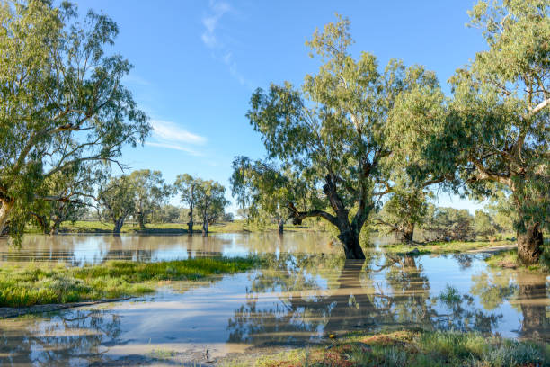This paper summarises the Authority’s policy insights that follow from the Commonwealth Scientific and Industrial Research Organisation’s (CSIRO) technical report entitled ‘Australia’s Carbon Sequestration Potential,’ ([CSIRO, 2022](https://www.csiro.au/en/research/environmental-impacts/emissions/carbon-sequestration-potential)), commissioned by the Authority and the Clean Energy Regulator, and other related reports on carbon sequestration.

**Box 1: Carbon sequestration** is the capture and storage of carbon* (see Figure 1).

Carbon is captured through:

* **carbon dioxide removal (CDR)**, whereby CO2 is removed from the atmosphere (sometimes referred to as negative emissions), or
* **point source carbon capture**, whereby CO2 is separated from other gases at the point of origin (emissions reduction).

Once captured, carbon is stored in **carbon sinks** such as geological formations (via **carbon capture and storage, CCS**), biological material (via photosynthesis), minerals (via mineral carbonation), long-lived products (via **carbon capture and use, CCU**) or the ocean (via fertilisation or alkalinisation).

The steps of capture and storage can be performed by different enabling technologies.

* Use of carbon in short-lived products (e.g., synthetic fuels) is not classified as carbon sequestration because that carbon is re-released when the product is used.Although beyond the scope of this report, the Authority recognises utilisation of carbon in short-lived products and biomass cycling will play an important role in the response to climate change.

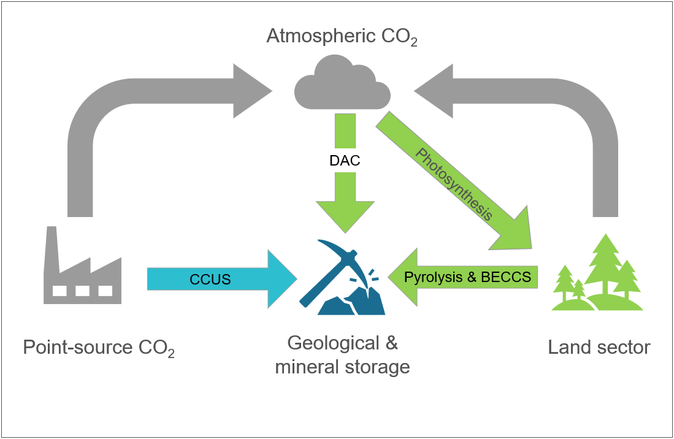

Figure 1: Avenues of carbon sequestration. Emissions (sources, flows and stocks) are represented in grey. The grey cloud represents emissions from all sources and sectors. Arrows indicate how carbon is captured. Icons indicate where carbon is stored. CCUS is represented in blue and CDR in green.

Scenarios for achieving net zero emissions by mid-century, like those from the IPCC and IEA outlined above, show just how challenging it will be to limit global warming to 1.5°C above preindustrial levels. There is broad understanding of the scale of the challenge to reduce emissions, but there is far less awareness of the critical and urgent need to scale up sequestration and how to do so.

Recent assessments have found nationally determined contributions (NDCs) to the Paris Agreement would reduce emissions to 0.3 per cent below 2019 levels by 2030 and result in around 2.5°C of warming by 2100 ([UNFCCC, 2022](https://unfccc.int/ndc-synthesis-report-2022); [IPCC, 2022](https://www.ipcc.ch/report/sixth-assessment-report-working-group-3/), p. 14). The IPCC reported that even if all NDCs in place as at late 2021 were met, it would make it likely that warming will exceed 1.5°C during the 21st century ([IPCC 2023](https://www.ipcc.ch/report/ar6/syr/), p. 10). For NDCs to align with mitigation pathways that limit warming to 1.5°C, global emissions need to reduce by 43 per cent below 2019 levels by 2030, 60 per cent by 2035, 69 per cent by 2040, and 84 per cent by 2050 ([IPCC, 2023](https://www.ipcc.ch/report/ar6/syr/), p. 22). These analyses highlight the urgent need for greater near-term ambition and action.

Additionally, in IPCC pathways consistent with the Paris goals, around 6 billion tonnes of carbon dioxide (Gt of CO2) would have to be removed from the atmosphere per year by 2050 globally, and about 14 Gt per year by 2100 ([IPCC, 2022](https://www.ipcc.ch/report/ar6/wg3/): Ch 12, p.1265). This compares with current global annual rates of CCUS of 43 million tonnes (Mt) ([GCCSI, 2022](https://status22.globalccsinstitute.com/), p. 7) and CDR of around 2 Gt CO2, of which 99.9 per cent is via biological sequestration ([Smith et al., 2023](https://www.stateofcdr.org/)).

Achieving the rates of carbon sequestration required by the IPCC and IEA 1.5°C scenarios relies on rapid and significant scaling-up of CDR and CCUS, and no single technology can currently deliver the level of sequestration needed. Most current sequestration comes from familiar biological forms, such as reforestation and afforestation. However, these technologies have significant limitations. For example, sequestration in living systems such as forests has limited durability[1] of storage, particularly in a changing climate. These solutions can also place demands on arable land and on water, creating competition between sequestration and food production. Sequestration in geological and mineral carbon sinks (including long-lived products), on the other hand, can have greater durability but is generally more costly and not as commercially ready. Despite these challenges, both CDR and CCUS technologies, if deployed using the best available science, could offer environmental and economic benefits, particularly for Australia’s regions and First Nations peoples.

##### Policy Insight 1

Scaling sequestration in Australia requires developing a carefully designed portfolio of approaches, as no single technology can achieve the levels likely to be needed.

Sequestration is not a panacea for climate change nor a substitute for reducing emissions. Nonetheless, it plays an important role in all feasible decarbonisation scenarios.

Australia’s carbon sequestration potential is a finite national resource, and like other resources, it is important to consider the most efficient and socially equitable way to use it. As the Authority has previously stated, the task is to “lower emissions in all sectors of the economy as quickly as we can” and “mitigate [reduce] as much as possible and sequester the rest” ([CCA, 2022](https://www.climatechangeauthority.gov.au/about-authority/corporate-documents)). Every tonne of GHGs emitted now adds to pressure on CDR in the future. In other words, the more Australia emits now, the greater the nation’s carbon debt down the track and the risk of significant climate change and impacts. And CDR is the only – and for a number of approaches a very expensive – way to make good.

In the near term (Figure 2), carbon sequestration, when additional to emissions reduction, can help drive steeper net emissions cuts. It is also true that sequestration has an important role to play in abating unavoidable emissions from essential processes and products with no near-term decarbonisation options, by preventing carbon dioxide from entering the atmosphere (via CCUS) or counter balancing GHG emissions with removals (via CDR). The reality is that there are not yet tools to mitigate some emissions.

**Sequestration is a necessary part of any rapid, urgent decarbonisation**

The role of sequestration will change as technologies, policies, products, and markets evolve to make emissions more and more avoidable, but as the IEA and IPCC scenarios have shown, some residual emissions will remain in the longer term. The importance of that role (see Figure 2) will be most evident by the middle of the century, when global net zero emissions are necessary (when the solid line crosses the x-axis).

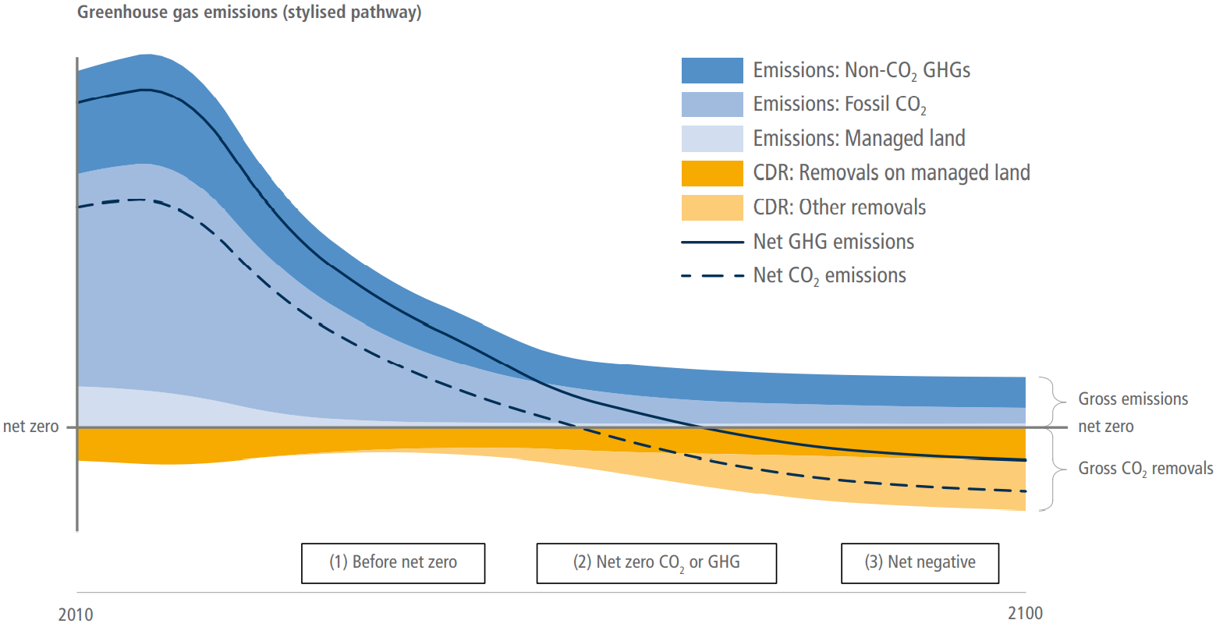

Figure : Emissions reductions and removals required for the Paris goals over time (IPCC, 2022, Ch. 12).

Sequestration also has an important role to play in climate restoration (see Figure 2). The effects of climate change are already being felt and there is a real and growing risk that warming will overshoot the goals of the Paris Agreement ([Climate Analytics, 2021](https://climateanalytics.org/publications/2021/the-science-of-temperature-overshoots-impacts-uncertainties-and-implications-for-near-term-emissions-reductions/#:~:text=2021-,The%20science%20of%20temperature%20overshoots%3A%20impacts%2C%20uncertainties%20and%20implications,for%20near%2Dterm%20emissions%20reductions&text=Climate%20science%20uses%20emission%20pathways,C%20or%202%C2%B0C.); [IPCC, 2022](https://www.ipcc.ch/report/ar6/wg3/)). To restore atmospheric GHGs to levels consistent with the Paris goals, more must be removed from the atmosphere than are emitted (net negative emissions). At the same time, it is important to note that continued warming could push the climate system towards transitions that may be irreversible over many, many generations. The earlier net zero is reached, the sooner CDR can help avoid or correct any overshoot.

***Box 2:*** [***The Carbon Sequestration Potential Project***](https://www.climatechangeauthority.gov.au/publications/australias-carbon-sequestration-potential)

The Authority’s self-initiated Carbon Sequestration Potential project aims to:

* Build understanding of Australia’s realisable carbon sequestration potential.
* Inform the Authority’s advice on climate policies and the role of sequestration in Australia’s next emissions reduction target.
* Raise awareness of the importance of carbon sequestration in the net zero transformation and of the longer-term need for net negative emissions.

The project follows on from earlier work by the Authority, including the 2021 Insights Paper, *Paris Plus: From cost to competitive advantage* ([CCA, 2021](https://www.climatechangeauthority.gov.au/publications/paris-plus-cost-competitive-advantage)), which found an improved understanding of Australia’s carbon sequestration potential is needed to underpin advice on Australia’s future targets and policies.

Carbon sequestration is distinct from carbon credits. While the generation and trade of credits in carbon markets are mechanisms to support realisation of carbon sequestration potential, there are many other enablers. This paper considers carbon sequestration that could be visible to the Australian National Greenhouse Accounts, of which a subset may be recognised with carbon credits issued under the Emissions Reduction Fund (ERF - also known as the Australian Carbon Credit Unit or ACCU scheme). Not all approaches considered in this paper are currently included in the National Greenhouse Accounts or currently eligible under the ERF.

The Authority partnered with the Clean Energy Regulator (CER) to commission CSIRO to produce two supporting technical reports: the first report is a stocktake of Australia’s sequestration potential ([CSIRO, 2022](https://www.csiro.au/en/research/environmental-impacts/emissions/carbon-sequestration-potential)); and the second identifies priority technological advances for reducing the cost and scaling up the deployment of sequestration options ([CSIRO, 2023](https://www.climatechangeauthority.gov.au/publications/australias-carbon-sequestration-potential)).

For the purposes of this assessment, carbon capture and use (CCU) including use in short-lived products such as synthetic fuels, and ocean sequestration technologies were considered out of scope. This includes algae farming and the emerging technologies of ocean fertilisation and alkalinisation. Further research and development are needed on emerging sequestration technologies not considered in the CSIRO technical report and this Insights paper. The Australian Academy of Science released a report in March 2023 on these and other novel CDR approaches – titled, ‘Greenhouse Gas Removal in Australia’ ([AAoS, 2023](https://www.science.org.au/supporting-science/science-policy-and-analysis/reports-and-publications/greenhouse-gas-removal-in-australia-a-report-on-the-novel-negative-emissions-approaches-for-australia-roundtable)).

***Box 3: International support for sequestration***

International recognition that sequestration is critical for meeting the Paris goals has led to growth in policy and financial support for the development and deployment of sequestration technologies.

Figure 3 illustrates sequestration initiatives from Australia and other countries. These initiatives can be classified as specifically targeting sequestration technologies, such as the European Union’s Carbon Removal Certification Framework, or generally supporting low- and negative-emissions pathways that include sequestration, such as the United Kingdom’s Net Zero Strategy ([European Commission, n.d.](https://climate.ec.europa.eu/eu-action/sustainable-carbon-cycles/carbon-removal-certification_en); [HM Government, 2021](https://www.gov.uk/government/publications/net-zero-strategy)). Some nations directly invest in sequestration projects through grants, such as the United States’ US$2.54bn Carbon Capture Demonstration Projects Program, while others use tax credits such as Canada’s C$2.6bn CCUS Tax Credit program ([Department of Energy, n.d.](https://www.energy.gov/oced/carbon-capture-demonstration-projects-program); [Department of Finance Canada, 2022](https://www.canada.ca/en/department-finance/news/2022/08/additional-design-features-of-the-investment-tax-credit-for-carbon-capture-utilization-and-storage-recovery-mechanism-climate-risk-disclosure-and-k.htm)). A significant development in 2022 was the implementation of the United States’ Inflation Reduction Act (IRA). The IRA raised the ‘45Q’ tax credit to US$85 per tonne sequestered and to US$180 per tonne for Direct Air Capture ([The White House, 2023](https://www.whitehouse.gov/wp-content/uploads/2022/12/Inflation-Reduction-Act-Guidebook.pdf)).

Many of Australia’s trading partners are likely to drive market demand for the development and deployment of sequestration technologies. This may present opportunities for Australia to export sequestration technologies and import carbon dioxide for storage. For example, Japan’s Roadmap to ‘Beyond-Zero’ Carbon recognises the critical role of sequestration in the nation’s approach. Singapore’s Carbon Tax is also expected to drive demand for sequestration ([National Climate Change Secretariat, 2022](https://www.nccs.gov.sg/singapores-climate-action/mitigation-efforts/carbontax/)). With limited availability of geological and biological storage of their own, both countries are expected to seek to export CO2 for storage in other countries.

The private sector is becoming more active in sequestration. Initiatives such as Microsoft’s US$1bn Climate Innovation Fund and the Xprize Foundation’s US$100m Prize for Carbon Removal aim to drive commercialisation and scale ([Microsoft, n.d.](https://www.microsoft.com/en-us/corporate-responsibility/sustainability/climate-innovation-fund?activetab=pivot1%3aprimaryr6); [Xprize, n.d.](https://www.xprize.org/prizes/carbonremoval)). These initiatives highlight the need for governance mechanisms to support investments in verifiable and durable sequestration.

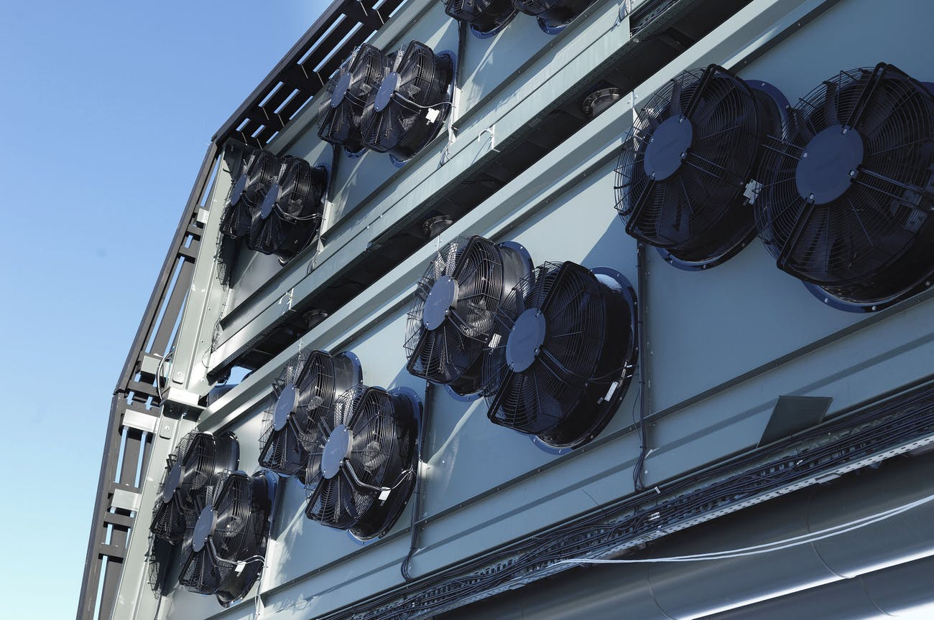

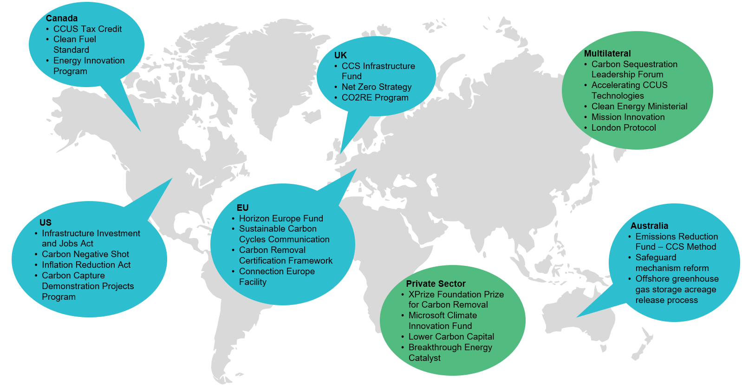Figure 3: Key pieces of international support for engineered sequestration technology and projects from governments, multilateral initiatives, and the private sector.

## Steps to maximise Australia’s carbon sequestration

## Define it

A lack of consistency and agreement on key terms in relation to sequestration, such as ‘carbon sequestration,’ ‘carbon dioxide removal,’ ‘greenhouse gas removal,' ‘negative emissions technologies,’ and ‘carbon capture, use and storage’ stymies technical discussions and policy development.

Australia is a nation endowed with sequestration potential and knowledge, and its governments, technical experts, and industry representatives could take a leading role in the development of a science-based taxonomy and terminology. Clear definitions can streamline technical and policy progress and increase Australia’s influence in negotiations on internationally agreed reporting guidelines. Developing and disseminating taxonomies through global and national standard-setting agencies such as the IPCC under the Paris Agreement framework, the International Organization for Standardization (ISO), and Standards Australia could support adoption. This could be accomplished through expanding existing standards (e.g., ISO 265) or developing new ones.

##### Policy Insight 2

Australia should play a leading role in the development of a science-based sequestration taxonomy and terminology, through the development of national standards and international guidelines.

## Understand it

Sequestration will play an important role in meeting Australia’s targets. It is the only way to compensate for unavoidable emissions to reach net zero and go beyond to achieve net negative emissions, and it may present economic opportunities for Australia. Yet the potential supply and demand for sequestration and how it will be delivered is not well understood.

Policymakers and markets need information about sequestration as a resource, as they do for other resources. Australian Government agencies such as Geoscience Australia and the Australian Bureau of Agricultural Research and Economics play an important role as trusted sources of information on geological and agriculture, fisheries and forestry resources. However, information about sequestration resources is currently diffuse and hard to find.

The CSIRO technical report, ‘Australia’s Carbon Sequestration Potential,’ commissioned for the purpose of this paper, finds that “Australia has good opportunities to sequester carbon.” However, no single technology would be sufficient to deliver the necessary scale. Figure 4 (below) shows the broad range of sequestration technologies considered by CSIRO and their key attributes.

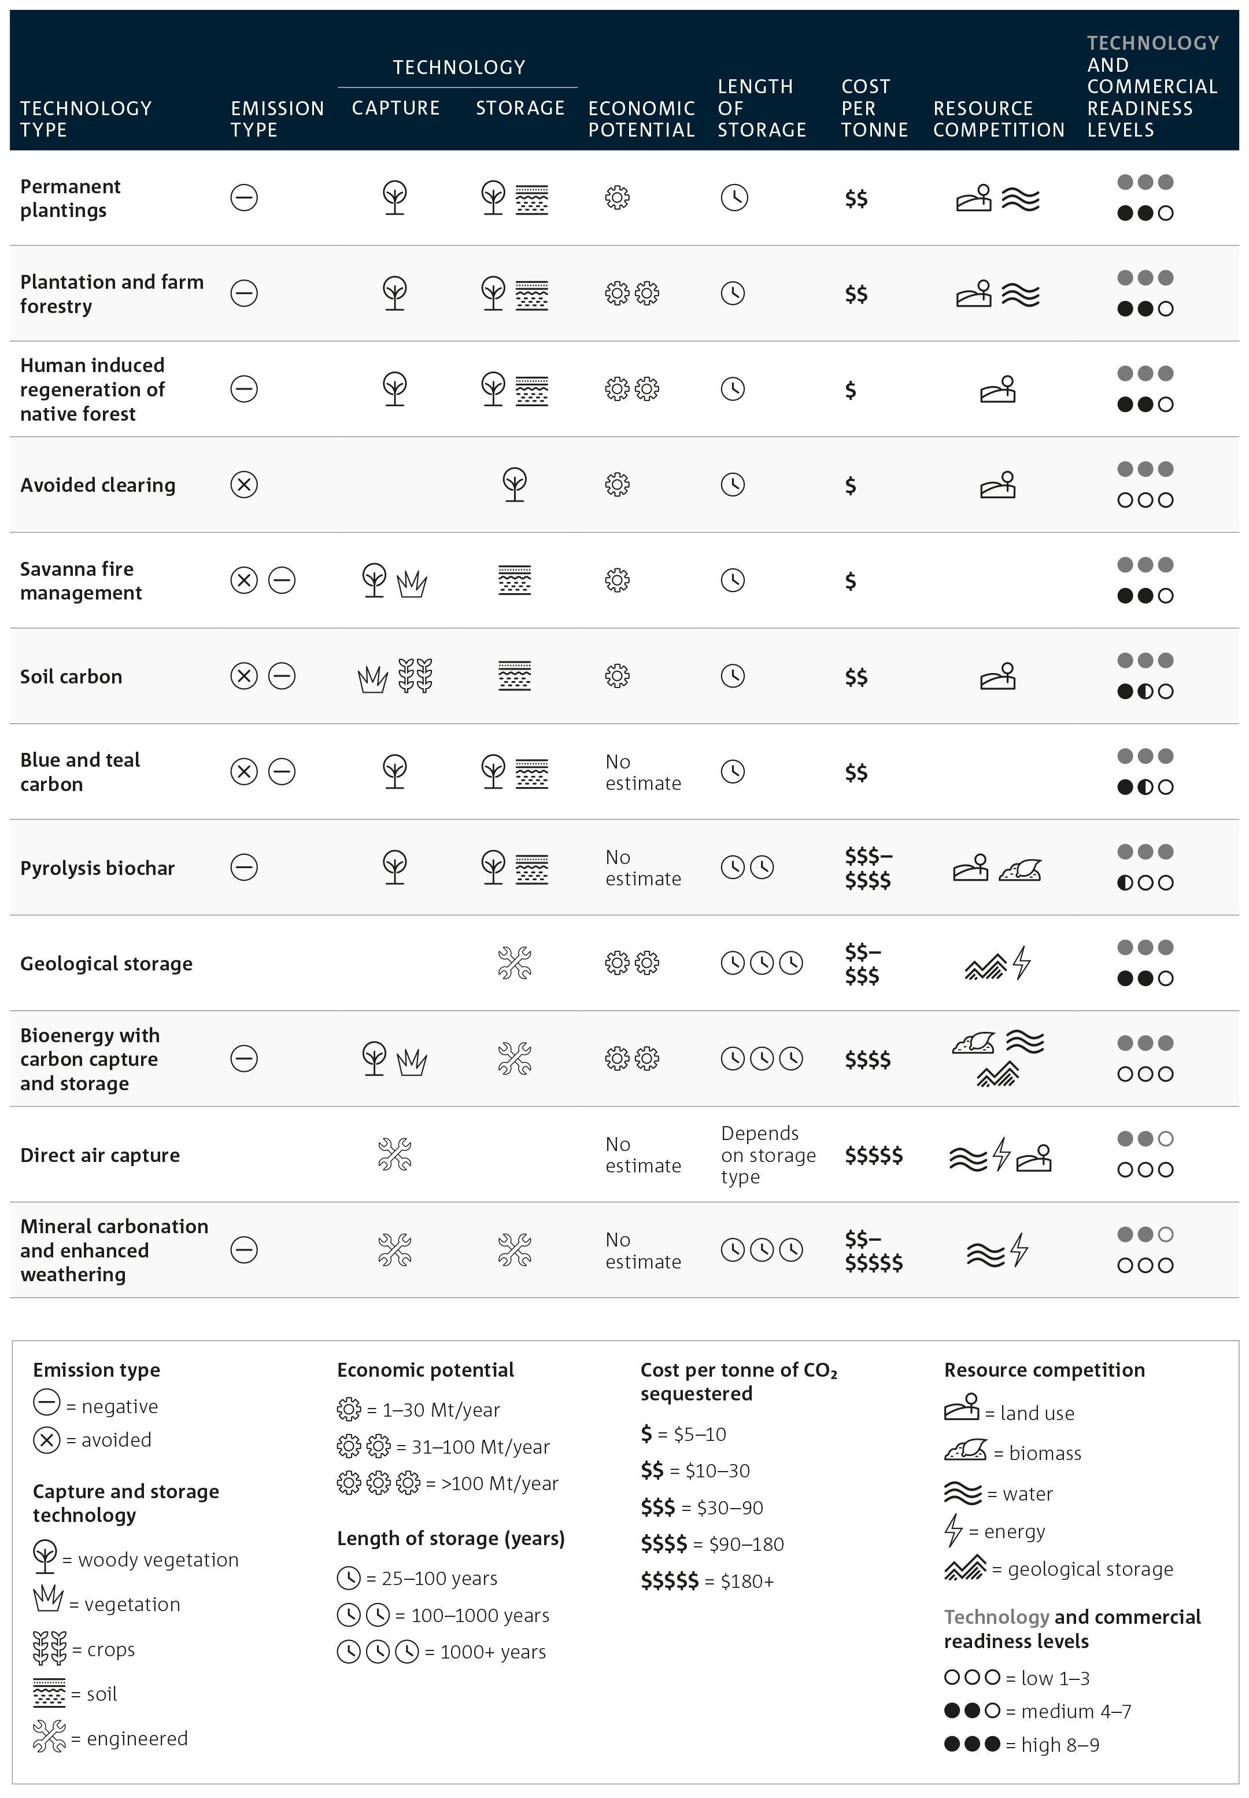

Figure 4: Sequestration technology options and their attributes (CSIRO, 2022). Note these activities do not align with the land use categories reported on in Australia’s National Greenhouse Accounts.

The CSIRO report provides a framework for understanding three categories of carbon sequestration estimates (Figure 5).

The report provides “speculative yet defensible estimates for technical and economic potential sequestration,” uncertain in part because many technologies remain at small scale (particularly engineered technologies).

Further work is needed to understand *realisable* potential to guide investment and policy decisions. For example, sequestration technologies with a large gap between current sequestration rates and realisable potential would be areas for further investigation of the causes of the gap and options to unlock this potential.

It is important to note that the CSIRO technical report investigated *technical* potential and estimates of *economic* potential. The economic potential of each technology cannot be summed to provide an indication of Australia’s total achievable sequestration – this requires enhanced integrated modelling capabilities to better estimate realisable potential. The economic potential is a useful indicator but likely overestimates the scale of opportunity because it does not take account of resource competition and other economic and social limitations.

CSIRO’s assessment of biological sequestration approaches was based on modelling conducted in 2019 which estimated technical and economic potential under ERF methods – one of which was a focus of the recent *2022 Independent Review of Australian Carbon Credit Units* (Human-Induced Regeneration) ([Chubb et al., 2022](https://www.dcceew.gov.au/climate-change/emissions-reduction/independent-review-accus)). The economic potential will be influenced by price incentives and the 2019 modelling assumed a price of $20 per tonne of CO2-e. The use of this modelling does not imply biological sequestration is reliant on the ERF. It could occur via other incentives or policy settings.

Technical sequestration
The maximum sequestration that is biophysically, or technically, possible. It does not consider economic feasibility, nor competition for resources (e.g. land).
Economic sequestration
The sequestration that is possible when economic feasibility is considered. Technical and management challenges are addressed at this level, however competition for resources remains unresolved.
Realisable sequestration
The sequestration that is possible when competition for resources is considered and resolved in addition to economic feasibility. Here, incentive structures are in place and barriers are removed.
Sequestration, like any other resource, is finite. Fully understanding the realisable potential requires taking into account competition for land, water, energy, feedstocks, infrastructure, price, capital, and other underpinning enablers. This in turn requires the analytical capability to optimise sequestration and its interactions with activities sharing the resource, including other sequestration approaches. The demand for resources will only increase as the need to electrify and produce alternative fuels grows and the pressure to counterbalance hard-to-abate emissions grows.

Figure 5: Sequestration pyramid (adapted from CSIRO, 2022) defining the three tiers of carbon sequestration potential.

Modelling and analysis would build understanding of Australia's sequestration potential and the influence and impact on a region-by-region basis, of factors such as economic trade-offs and feedbacks (on land-use, energy, and water availability), as well as social considerations, non-carbon benefits, barriers, and risks for different sequestration options. Simulations that include representation of the Earth system (covering land, ocean, weather, and climate) would also throw light on the impact of a changing climate on different sequestration options.

A collaboration among industry, government, university, and research agencies could chart the course to a sophisticated modelling capability on sequestration. Such a collaboration would inform the Authority’s annual progress reports and advice on future emissions reduction targets. It could include recurrent assessment, for example linked to the submission of National Determined Contributions to the United Nations Framework Convention on Climate Change (UNFCCC) and have a role in communication and education around issues related to sequestration.

##### Policy Insight 3

Development of a sophisticated modelling capability on sequestration – for example, through a partnership between the Government, industry, and academia – would enhance future policy advice and decisions.

****Australia will require sequestration to achieve its current emissions reduction targets, including net zero emissions. The contribution sequestration can make to meeting targets depends on both supply of sequestration and the demand for it. Although Australia’s current supply of sequestration is better understood than potential future demand, both are uncertain.

##### Demand

One way to estimate Australia’s long-term demand for sequestration is through understanding ‘hard-to-abate’ emissions: sequestration will be in demand to counterbalance these emissions. Recent analysis from several sources indicates that significant volumes of residual emissions are likely to persist in 2050 despite concerted mitigation efforts (including via CCUS). For example:

* Analysis by McKinsey in 2021 projected Australia would produce about 87 Mt CO2-e per year in 2050 of “non-technologically abatable” emissions (excluding the land sector), primarily from agriculture and industrial processes ([Australian Government, 2021](https://www.dcceew.gov.au/climate-change/publications/australias-long-term-emissions-reduction-plan), Modelling and Analysis, p. 38).
* Interim modelling for the Net Zero Australia project estimated the land, forestry, agriculture, waste and cement industries will have around 26 Mt CO2-e of residual emissions in 2050 ([Batterham et al., 2022](https://www.netzeroaustralia.net.au/mass-document-aug-2022/)).
* Under the most ambitious scenario presented by the Australian Energy Transitions Initiative ([ETI, 2023](https://energytransitionsinitiative.org/): Phase 3 Report), the industrial sector alone will emit about 17 Mt CO2-eper year in 2050.

While helpful, these estimates are very uncertain.

##### Policy Insight 4

Sectoral pathways and targets for decarbonisation would help build a more rigorous framework for anticipating future sequestration demand, by clarifying the extent to which mitigation is likely to be possible in the future, particularly from processes in the agriculture and industrial sectors.

##### Supply

In 2020, Australia sequestered around 43 Mt CO2-e , primarily via the land and forestry sector, with around 3 Mt CO2 emissions reduced by the Gorgon Liquified Natural Gas CCS project ([DCCEEW, 2022a](https://www.dcceew.gov.au/climate-change/publications/national-inventory-report-2020): Vol 1, p. 165).

Sequestration rates will change over time. The Government’s 2030 emissions projections indicate a decline to 38 Mt CO2-e of sequestration: 33 Mt CO2-e via the land and forestry sector, and 5 Mt CO2 of emissions reduction via the Gorgon and Moomba CCS projects. The reduced sequestration in the land sector is projected to be driven by plantation harvesting and reduced regrowth of native forest accompanying the recovery of livestock numbers ([DCCEEW, 2022b](https://www.dcceew.gov.au/climate-change/publications/australias-emissions-projections-2022), pp. 45, 47, 63).

Biological sequestration rates may also decline over time or require renewal as they are exposed to the impacts of climate change, and engineered sequestration may not grow fast enough to meet demand. The risks that these possibilities present to Australia’s ability to achieve net zero and eventually net negative emissions can be addressed by policies that 1) have the effect of reducing emissions directly and hence reduce demand for sequestration; 2) protect, increase, and renew biological sequestration; and 3) scale-up engineered and geological sequestration, both onshore and offshore beneath Australia’s marine estate.

##### Policy Insight 5

Governments should pursue policies that help ensure there is adequate supply of sequestration to meet demand including policies that: 1) reduce emissions directly; 2) protect, increase, and renew biological sequestration; and 3) scale-up engineered and geological sequestration, both onshore, and offshore.

## Improve it

There is growing evidence to challenge the maxim that “a tonne is a tonne”, often taken to mean all types of abatement are equivalent and able to counterbalance any GHG once global warming potential is considered. There are important differences between types of emissions sources and sinks, and between types of greenhouse gases.

Some greenhouse gases, such as methane and nitrous oxide, are more potent than carbon dioxide but also have a shorter lifespan in the atmosphere. Global warming potentials[2] are used to convert non-CO2 gases to the common metric of CO2 equivalent (CO2-e), commonly over a 100-year time horizon which can have the effect of underestimating the near-term warming effect of shorter-lived greenhouse gases.

While conventional carbon accounting is simple and economically flexible, it does not consider crucial differences between different sources and sinks of GHG emissions ([Carton et al., 2021](https://www.frontiersin.org/articles/10.3389/fclim.2021.664130/full)). Different types of sequestration have attributes that determine their relative quality:

* Durability: How long carbon sequestered into a sink can remain intact – the anticipated duration of a carbon stock.
* Storage medium: some storage media have longer or shorter expected lengths of storage and different levels of vulnerability to disturbances.
* Emissions source: capture at an emissions point source represents a reduction of emissions, at the point of origin. Removal from the atmosphere can reduce emissions and also contribute to net negative emissions.
* Non-carbon benefits: environmental, social, and other benefits beyond abatement.
* Pace and scalability: different sequestration approaches capture and store carbon at different rates and vary in their potential to be scaled in terms of size and pace.
* Quantifiability: ability to trace, measure and verify the life cycle of sequestered carbon and the emissions involved in the process.
* Alignment with National Greenhouse Accounts: measurement, reporting and verification aligns with international reporting frameworks, as specified by the latest IPCC guidelines.
* Resource efficiency (in relation to resources used for carbon storage): ability to deliver sequestration at scale with low resource demand.
* Risk of adverse impacts: for example, relating to the environment, local communities, and First Nations peoples.

An evidence-based standards framework would enable policy makers, investors and offsetting entities to assess and identify the quality of sequestration, taking account of related international developments including the Integrity Council for the Voluntary Carbon Market’s Core Carbon Principles ([ICVCM, 2023](https://icvcm.org/the-core-carbon-principles/)), the Oxford Offsetting Principles ([Oxford University, 2020](https://www.smithschool.ox.ac.uk/research/oxford-offsetting-principles)) and the Carbon Removal Certification Framework being developed by the European Union ([European Commission, n.d.](https://ec.europa.eu/info/law/better-regulation/have-your-say/initiatives/13172-Certification-of-carbon-removals-EU-rules_en)).

Australia is well positioned to play a leading role in the development of an internationally accepted, evidence-based sequestration standards framework. It has developed a depth of knowledge and expertise in relation to carbon markets, land and water management, and climate change science.

##### Policy Insight 6

Australia should play a leading role in developing a sequestration standards framework to enable different forms of sequestration to be classified against an agreed set of attributes and inform how they may best be used, particularly for counterbalancing emissions.

Currently biological and geological sequestration are treated as equivalent in carbon markets, where no distinction is made between the carbon credits issued for the sequestration. Although geological sequestration can last many thousands of years, the vulnerability of biological sequestration means it may only last decades to centuries unless continually renewed ([CSIRO, 2022](https://www.csiro.au/en/research/environmental-impacts/emissions/carbon-sequestration-potential)). Once sequestered carbon is released to the atmosphere, it can no longer counterbalance emissions (Figure 6). The International Organisation for Standardisation’s Net Zero Guidelines specify GHG emissions should be counterbalanced with storage duration comparable to the lifespan of the emissions ([ISO, 2022](https://www.iso.org/obp/ui/en/#iso:std:iso:iwa:42:ed-1:v1:en): S.9.1.1). Unless sequestration losses are continually replaced, CDR via biological sinks only postpones GHGs driving further anthropogenic climate change.

Estimating the average lifetime of anthropogenic CO2 in the atmosphere is complicated by its wide range of interactions with many carbon sinks over different timescales. CO2 interacts with the land biosphere and the ocean over 200 to 2000 years. Around 20 to 35 per cent is likely to remain in the atmosphere after 10,000 years. Reaction with calcium carbonate minerals and igneous rock would remove the remainder over timescales of hundreds of thousands of years ([Archer et al., 2009](http://climatemodels.uchicago.edu/geocarb/archer.2009.ann_rev_tail.pdf)).



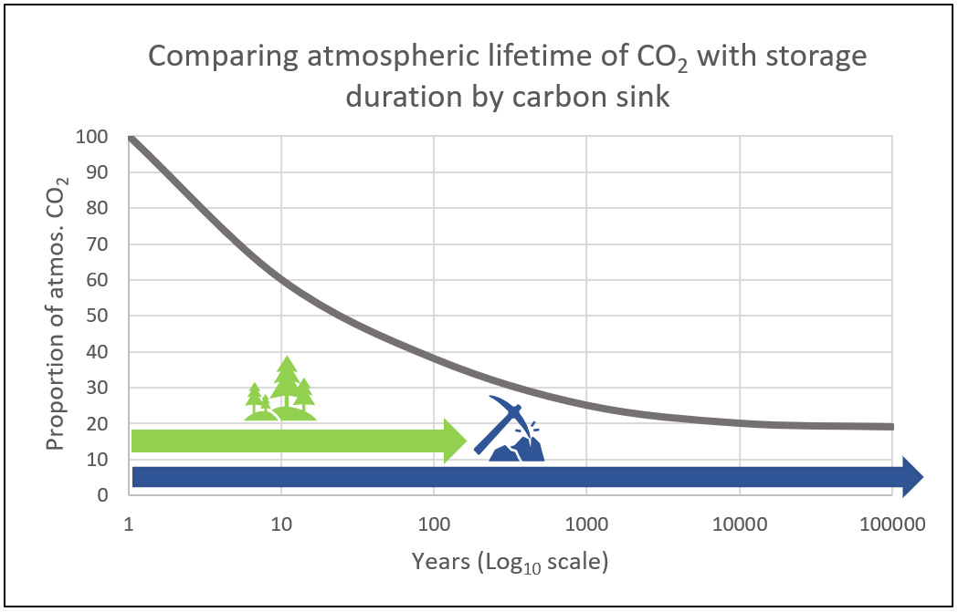

Figure 6: Comparing biological (green arrow) and geological (blue arrow) storage duration with the atmospheric lifetime of CO2.

##### Policy Insight 9

Measures to restore CO2 released from carbon sinks should be reviewed and enhanced as appropriate.

##### Policy Insight 8

The Government should prioritise the development of long-lived geological and mineral storage technologies.

##### Policy Insight 7

For emissions to be counterbalanced via sequestration, carbon should be stored in a quantity and for an amount of time appropriate for the nature of the emissions. Further work is needed to explore alternative approaches to global warming potential for determining equivalence of different types of emissions and removals in policy instruments.

Scaling-up of carbon sequestration will require building up social licence to do so. Acceptance of approaches to carbon sequestration can be strengthened through early and ongoing engagement to ensure benefits are equitably shared and risks appropriately managed. Rural and regional communities, including First Nations peoples, have extensive experience in managing Australia’s lands. By ensuring their participation, the deployment of sequestration activities can support building their capability and capacity, while benefiting from the positive enduring environmental outcomes their expertise can enable.

Biological sequestration (Figure 7) can improve soil health, increase biodiversity, and provide other ecosystem services as well as economic benefits and employment opportunities. For example, regenerative agriculture can improve water quality, reduce soil erosion, provide habitat for wildlife, bring jobs to remote areas, and increase agricultural productivity ([Buss et al., 2021](https://doi.org/10.1093/oxfclm/kgab006); [CSIRO, 2022](https://www.csiro.au/en/research/environmental-impacts/emissions/carbon-sequestration-potential)).

However, there is a risk that carbon plantings can displace food production and impact local communities and wildlife. The Land Gap Report found current global climate pledges rely on unrealistic amounts of land-based CDR ([Dooley et al., 2022](https://www.landgap.org/)), requiring an area equivalent to the entire global cropland or one and a half times the size of Australia: around 1.2 billion hectares. If implemented, this would place further pressure on food security, ecosystems, and livelihoods.

Biological sequestration:
Enablers, barriers, co-benefits and risks 
Enablers
Improved quantification of co-benefits
Improved modelling & analysis to consider resource competition and trade-offs
Expanded supply chains
Expanded skilled workforce
Innovative methods for cost reduction, particularly MRV
Increased carbon price
Activity and benefit stacking
Potential non-carbon benefits
Improved soil health
Increased biodiversity
Increased landscape connectivity
Regional employment opportunities
Increased agricultural productivity and resilience
Engagement with Indigenous Australians
Barriers and risks to storage
Vulnerable to climate change
Perception of displacing conventional land-use
Supply constraints
Skills constraints
Not all carbon benefits credited
High cost of MRV
Ongoing management of the land required
Potential adverse impacts
Displace production of food & fiber
Increased fire risk from increased fuel loads
Reduced landscape water availability
Disruption of conventional land-use practices
Spread of invasive weeds


Figure 7: Enablers, barriers and potential non-carbon benefits and adverse impacts of biological sequestration (adapted from [CSIRO, 2022](https://www.csiro.au/en/research/environmental-impacts/emissions/carbon-sequestration-potential)). Note this is not an exhaustive list.

Engineered sequestration approaches (Figure 8) including bioenergy with CCS (BECCS), Biochar and direct air capture with CCS (DAC + CCS or DACCS) also offer non-carbon benefits and entail trade-offs. BECCS offers a zero-emission energy source but the potential need for large areas to grow biomass could compete for land needed for food production and biodiversity habitat. DACCS processes can be flexibly located but may place demand on electricity networks unless combined with renewables for independent power (see Box 4: Case study).

When added to soil biochar can increase yields by 10 to 42 per cent; reduce non-CO2 emissions by 12 to 50 per cent; and enhance retention of organic carbon, according to a recent meta-analysis of 20 years of global research ([Joseph et al., 2021](https://doi.org/10.1111/gcbb.12885)). Biochar production can also generate energy as a by-product of the pyrolysis process but requires a sustainable feedstock that does not displace biomass grown or retained for other purposes.

##### Policy Insight 12

Public investment in sequestration should leverage co-funding opportunities by aligning with areas of non-carbon benefits and product use.

##### Policy Insight 11

Australia should prioritise sequestration approaches that make optimum use of resources (land, energy, and water) for the mass of carbon stored. Addressing market imperfections would enable markets to better resolve trade-offs in an economically efficient way.

##### Policy Insight 10

Policies to incentivise sequestration should take account of trade-offs and unintended consequences for food and water security, the environment, and communities.

Engineered/hybrid sequestration
Enablers, barriers, co-benefits and risks 
Enablers
Innovative methods for cost reduction – particularly energy and MRV
Policy incentives to drive industry investment
Innovative risk sharing business models
Demonstration sites
Quantification of socio-environmental risks and impacts
Potential non-carbon benefits
Regional employment opportunities
Makes use of waste streams
Multiple commercial products
Barriers
Social license
High upfront costs
Supply constraints
Distance from emissions source to storage site
Potential adverse impacts
Environmental contamination
High energy demand


Figure 8: Enablers, barriers and potential non-carbon benefits and adverse impacts of engineered sequestration (adapted from [CSIRO 2022](https://www.csiro.au/en/research/environmental-impacts/emissions/carbon-sequestration-potential)). Note this is not an exhaustive list.

**Box 4: Case study**

**Solar Powered Direct Air Capture by Southern Green Gas and AspiraDAC**

An Australian partnership is developing a first-of-its-kind Direct Air Capture (DAC) project using modular and scalable solar-powered units (shown in Figure 9). The captured CO2 can be permanently stored in geological formations or utilised. Because each unit includes its own solar energy source, and is therefore not reliant on traditional electricity grids, the project can be located in remote regions where land is plentiful and cheap, where conditions for solar power generation are ideal, and where geological storage sites are located.

The project is being jointly developed by AspiraDAC (the project developer) and Southern Green Gas (SGG – the technology developer and supplier of DAC modules) using SGG’s innovative CO2 capture technology invented in partnership with the University of Sydney. AspiraDAC’s parent company received Commonwealth funding support for the project, and the project has also been supported by pre-sales of carbon removal certificates under an advance market commitment arrangement by the Unites States based Frontier group.

The technology could be an efficient method of durable CDR, by harnessing Australia’s abundant solar energy and vast geological storage resources. To meet their energy needs, current DAC technologies consume a significant amount of energy, which can place additional strain on electricity networks and limit their scalability. Because all the required energy is generated by the SSG modules themselves, energy demand does not compete with other users.

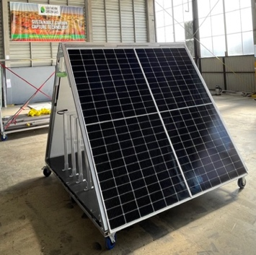The initial project aims to sequester one tonne of carbon dioxide a day (around 310 tonnes per year), and the partnership aims to scale up rapidly and reduce costs to below US$100 per tonne of CO2 by 2030. Current costs for DAC of over $1,000 per tonne of CO2 are prohibitive to its adoption. Significant cost reductions are expected by utilising equipment modularity, high-volume manufacturing, and innovations in energy supply and materials - including capture technology.

Figure 9: An example of the Southern Green Gas AspiraDAC solar-powered DAC module. Photo courtesy of Southern Green Gas.

The partnership estimates around 500-800 tonnes of CO2 per hectare per year can be sequestered with their technology. This means that to sequester 1 million tonnes of CO2 per year, a land area of between 1,250 – 2,000 hectares (or 12.5 to 20 square kilometres) would be needed.

## Scale it

To limit warming to 2°C, *The State of CDR* report estimates a global need for 1,300 times more engineered CDR on average (from 2 Mt to 2,600 Mt (2.6 Gt) CO2 per year) and twice as much from trees and soils (from 2 Gt to 4 Gt CO2 per year) than is currently taking place ([Smith et al., 2023](https://www.stateofcdr.org/)). The amount of CDR deployment required globally in the second half of the century will only be feasible with substantial new deployment in the next ten years as a result of driving down costs, building knowledge, and addressing policy uncertainty.

Within this context, the sequestration technologies Australia invests in should be scalable, durable and leverage Australia’s comparative advantages. Australia has vast areas of non-arable land, significant geological storage capacity on- and offshore, and low-cost renewable energy potential.

As well as the different qualities, trade-offs and non-carbon benefits outlined above, some technologies are more scalable than others. Scalability is an important consideration in decisions about public investment in technologies likely to have the most significant impact on atmospheric GHGs.

Starting from a low base, engineered technologies have significantly more potential growth to 2050 than biological solutions ([CSIRO, 2022](https://www.csiro.au/en/research/environmental-impacts/emissions/carbon-sequestration-potential): S. 2.1, and illustrated in Figure 10). Biological carbon sinks, such as forests, tend to ‘saturate’ and become less able to take up additional carbon over time. In other words, CO2 drawdown eventually slows and stops, for example when land available for reforestation is scarce, forests mature, and soils reach new equilibria. Engineered technologies are less susceptible to saturation over policy-relevant time-frames, and are in most cases faster to remove and sequester carbon. Therefore, engineered sequestration is expected to comprise an increasingly larger share of Australia’s sequestration.

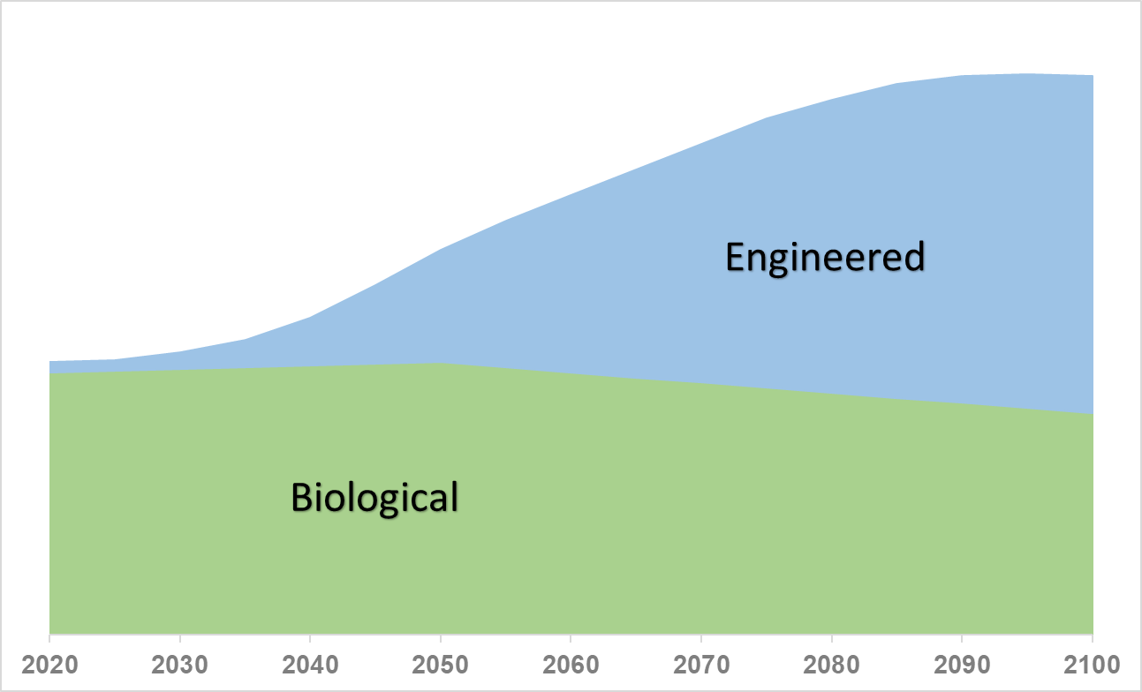

Figure 10: Illustrative comparison of projected growth in engineered and biological sequestration.

Effective public-private collaborations can support the cost-effective and safe deployment of sequestration at scale. Governments can support private-sector technological developments with effective and simple regulations that protect the environment, maximise benefits to communities and ensure secure markets for existing and emerging solutions. Identifying what form this support may take requires careful policy design and considerations of non-carbon benefits and trade-offs.

Government action can provide security and improve certainty for long-term strategic investments, creating effective regulation for emerging technologies and ensuring robust measurement, reporting and verification (MRV) systems. To help scale-up sequestration at the rate required, carbon dioxide removal should be treated as a distinct category – for example alongside traditional sectoral categories found within greenhouse gas inventories – in national decarbonisation plans, emissions reporting, projections, and the Authority’s annual progress reports. Reporting should include the volumes of public and private investment committed to different forms of sequestration.

Australia has existing policies and institutions to incentivise sequestration, including land clearing laws and a mature carbon crediting scheme with rigorous underpinning infrastructure, including modelling frameworks such as the Full Carbon Accounting Model – FullCAM ([DCCEEW, 2020](https://www.dcceew.gov.au/climate-change/publications/full-carbon-accounting-model-fullcam)).

However, more could be done. A decade ago, Australia established the institutions needed to accelerate the development and deployment of renewables – particularly the Australian Renewable Energy Agency (ARENA) and the Clean Energy Finance Corporation (CEFC). These institutions could be given expanded roles, or separate specialist institutions established to accelerate the development of CDR technologies.

##### Policy Insight 15

The development of carbon dioxide removal technologies should be accelerated with support from existing agencies such as the Australian Renewable Energy Agency and the Clean Energy Finance Corporation, or new institutions.

##### Policy Insight 14

Carbon dioxide removal should be included as a distinct category in national decarbonisation plans, emissions reporting, projections, and the Authority’s annual progress reports.

##### Policy Insight 13

Australia should invest in scalable and durable sequestration technologies that leverage Australia’s non-arable-land, geological storage capacity and renewable energy resources.

At present, engineered CDR is ineligible for the ERF because of a gap in the definition of ‘sequestration offsets projects’ under the *Carbon Credits (Carbon Farming Initiative) Act 2011* (CFI Act), which only includes sequestration via living biomass, soil, or dead organic matter ([*CFI Act 2011*](https://www.legislation.gov.au/Series/C2011A00101) (Cth): s. 54).

Some sequestration activities, such as DAC, are currently ineligible because legislative amendments would be required to include these activities under the CFI Act, and international guidance has not yet been developed for their estimation and inclusion in national GHG inventories.

Some forms of engineered sequestration are technologically mature. A notable example is CCS (see Figure 4), which has been operating internationally for years. However, how it is deployed needs to change in line with decarbonising hard-to-abate emissions and as an enabling CDR technology with DAC and bioenergy.

Legislative and regulatory environments for onshore and offshore geological storage can be complex, including duplications, uncertainties, and inconsistencies in application of state and territory and Commonwealth legislation and regulations. Maturing, coordinating, and providing greater guidance for navigating this legislative and regulatory landscape would facilitate the development, testing, and implementation of CCS.

Investments in approaches like CCUS with high up-front costs need to be de-risked. Governments should explore risk-sharing approaches (e.g., CCS hubs) including opportunities to co-invest in subsurface basin analyses for geological sequestration both on- and offshore, and keystone infrastructure for storage and transport.

Strategies for collaborative information sharing should be developed to encourage broader industry progress. For example, there is limited understanding of well-defined geological storage sites on- and offshore. Government could partner with industry for data sharing – including privately held data – to undertake analyses of geological injection and storage potential at sub-basin scale.

##### Policy Insight 18

Strategies for collaborative information sharing should be developed to encourage broader industry progress, for example, Government partnering with industry to develop high quality data on geological injection and storage potential at sub-basin scale.

##### Policy Insight 17

Governments should explore risk-sharing approaches for investments in sequestration technologies with high up-front costs, including co-investing in subsurface basin analyses for geological sequestration and keystone storage and transport infrastructure.

##### Policy Insight 16

Australian governments should work together to develop a mature, streamlined and coordinated legislative and regulatory framework for onshore and offshore geological storage.

## Use it

To make the most of its sequestration potential, Australia will need to use it wisely. Moral hazard is a real risk to the effective and efficient deployment of Australia’s sequestration potential. This hazard may play out in two ways: the first is that perceived sequestration potential may lessen the sense of urgency to reduce direct emissions as early and as quickly as possible. The other is that concerns about the moral hazard become a barrier to deployment and stymie policies to advance and scale the very technologies the science indicates are needed.

##### Policy Insight 19

Australia needs a plan for effective and efficient deployment of sequestration and a climate policy suite that mitigates moral hazards. To be effective, sequestered carbon used to counterbalance emissions from activities elsewhere should remain stored for time periods appropriate for the nature of associated emissions activity. To be efficient, access to sequestration to counterbalance emissions should be prioritised for emissions with no near-term decarbonisation options (hard-to-abate emissions).

Separate targets for emissions reduction and removal can establish a pathway for reducing emissions and scaling sequestration. Divergence from the pathway might indicate a need for policies (such as qualitative and quantitative limits) to address problematic reliance on sequestration. The Government has agreed with the Authority’s advice to develop a plan showing Australia’s pathway to net zero emissions by 2050 ([DCCEEW, 2022c](https://www.dcceew.gov.au/climate-change/strategies/annual-climate-change-statement), p. 71).

Smart policy design can minimise the unintended consequence of sequestration delaying emissions reduction and uptake of low-quality sequestration. For example:

* carbon markets could move away from emissions reduction to increase focus on emissions removals.
* emissions reduction targets and projections could separately identify the contribution of emissions reductions and removals.
* policies that institutionalise robust, clear, and readily-available information about the quality – including durability – of carbon storage could enable investment and innovation.
* the Safeguard Mechanism could be further shaped to prioritise onsite emissions reductions and prioritise use of carbon credits achieved through engineered forms of sequestration and utilisation of carbon in products (such as building material and cement).

Extended Producer Responsibility-based (EPR) policies, such as a Carbon Takeback Obligation (CBTO) ([Jenkins et al., 2021](https://doi.org/10.1016/j.joule.2021.10.012); [Oxford University, 2023](https://www.ox.ac.uk/news/2023-01-12-climate-goals-can-be-achieved-affordable-cost-if-fossil-fuel-producers-pay-carbon)), could ensure that GHG emissions are counterbalanced with sequestration. This could be phased in and scaled up over time. EPR policies target the producers of GHG emissions and could ensure the cost of emitting is considered in production.

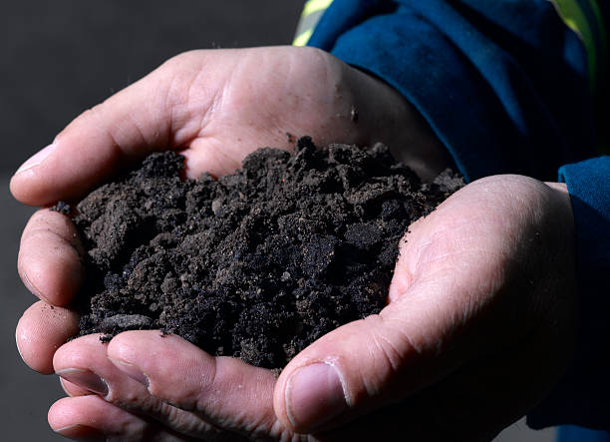

##### Policy Insight 22

Compliance markets and Commonwealth procurement policies could incentivise development of quality sequestration by favouring engineered forms of sequestration and net-zero and carbon capture-derived products, and drawing on market mechanisms including advance market commitments, contracts for difference and concessional loans.

##### Policy Insight 21

Separate targets for emissions reduction and removal should be set to help incentivise future demand and help guard against sequestration being used to delay emissions reductions.

##### Policy Insight 20

The government’s net zero plan, and the Authority’s Annual Progress Reports, should include sequestration and identify how it will be delivered and used over time.

## Share it

Global demand for sequestration and low emissions energy is expected to grow rapidly over the coming decades, presenting economic opportunities for Australia to drive global ambition, establish new industries and reinvent existing ones.

Australia will need to determine what contribution it makes to the global effort. As a wealthy and emissions-intensive nation, endowed with sequestration potential, there may be an expectation that Australia removes carbon dioxide from the atmosphere beyond our own unavoidable emissions.

To rapidly develop and deploy sequestration technologies at scale, Australia will need to partner with other countries. By exporting our expertise and technologies, Australia can contribute to the global effort to scale sequestration. Many countries, such as Singapore and Korea, that have limited geological and biological sequestration capacities, will look to countries like Australia to meet their carbon storage needs ([Chevron, 2022](https://www.chevron.com/newsroom/2022/q4/chevron-and-mol-to-study-co2-shipping-from-singapore-to-australia); [Ha-yeon, 2022](https://pulsenews.co.kr/view.php?sc=30800028&year=2022&no=790803)).

To enable trading of sequestration, countries will need to decide how they would use sequestration domestically, how such abatement would be recognised internationally, how it might be traded and how it would contribute to global emissions reductions. At present, abatement from some CDR technologies is not recognised in IPCC’s GHG inventory reporting guidelines. Continued participation in international negotiations on these guidelines will enable Australia to influence which technologies are included to allow for the resulting abatement to be traded, and contribute to international decarbonisation efforts.

Transboundary transport of CO2 is governed by several international treaties, such as the London Protocol that oversees disposal of waste in the sea. Australia may need to support partner countries to develop carbon capture technologies and establish regulatory frameworks to enable this trade. Australia would also need to ratify the 2009 amendment to the London Protocol to allow transport of CO2 for storage.

##### Policy Insight 23

Consistency across international, national, and subnational regulatory approaches will be needed to enable cooperation, trade, and cross-border movement of CO2.

For Australia, achieving higher levels of sequestration is critical for meeting targets and maintaining trade competitiveness. Global discussions have already begun to shift focus from net zero to net negative targets to correct or avoid overshooting warming limits. As a nation endowed with land, sun, wind and a geologically stable land mass, sequestration presents economic opportunities for Australia in a low-emissions world through the creation of new industries and reshaping existing industries.

Sequestration is a necessary part of any rapid, urgent decarbonisation and represents a huge opportunity for Australia, if we get it right.

# Glossary of terms

|  |  |
| --- | --- |
| Biological sequestration approaches | Human-induced activities that take advantage of natural biological systems to capture and store atmospheric carbon dioxide (CO2) in living biomass, dead organic matter, soil and in aquatic environments. |
| Carbon capture and storage (CCS) | A process in which a relatively pure stream of CO2 from industrial and energy related sources is separated (captured), conditioned, compressed and transported to a storage location for long-term isolation from the atmosphere. |
| Carbon capture and use (CCU) | A process in which CO2 is captured and the carbon then used in a product. The climate effect of CCU depends on the product lifetime, the product it displaces, and the CO2 source (fossil, biomass or atmosphere). |
| Carbon capture, use and storage (CCUS) | Processes in which CO2 is captured and then either: the CO2 is transported to a storage location for long-term isolation from the atmosphere (see *CCS*); or the carbon is used in a product (see *CCU*). |
| Carbon dioxide equivalent (CO2-e) | The amount of CO2 emission that would have an equivalent effect on a specified key measure of climate change, over a specified time horizon, as an emitted amount of another greenhouse gas (GHG) or a mixture of other GHGs. |
| Carbon dioxide removal (CDR) | Anthropogenic activities removing CO2 from the atmosphere and durably storing it in geological (see *geological sequestration* and *CCS*), terrestrial or oceanic reservoirs (see *biological sequestration*), or in products (see *CCU*). It includes existing and potential anthropogenic enhancement of biological or geochemical CO2 sinks and direct air carbon dioxide capture and storage (DACCS), but excludes natural CO2 uptake not directly caused by human activities. |
| Carbon sequestration | The process of storing carbon in a carbon pool. |
| Counterbalance (of emissions) | The act of balancing out GHG emissions from one activity with the removal of emissions from the atmosphere via CDR. This can occur at the national, sub-national, corporate and facility scale. |
| Durability | The capacity of a carbon stock to resist degradation or loss of carbon due to factors including environmental changes, human activities, and other natural disturbances. |
| Emissions reduction | Reducing the emissions from an activity, such as through energy efficiency improvements. |
| Emissions removal | The withdrawal of GHGs from the atmosphere as a result of deliberate human activities. These include enhancing biological sinks of CO2 and using chemical engineering to achieve long-term removal storage. Also called ‘anthropogenic removals’ and ‘greenhouse gas removal’. |
| Engineered sequestration | Approaches that rely on chemistry to: capture and store atmospheric GHGs (see *CDR* and *emissions removal*); or those that capture carbon from the point of origin and durably store them (see *CCUS*). |
| Geological sequestration | The process of storing CO2 (generally as a supercritical fluid) in suitable geological formations, typically around 2000 metres below the surface. Formations can be onshore and offshore and include depleted oil and gas fields and saline aquifers. |
| Hard-to-abate emissions | Emissions from essential processes and products with no near-term decarbonisation options. |
| Net negative emissions | When metric-weighted anthropogenic GHG removals exceed metric-weighted anthropogenic GHG emissions. |
| Net zero emissions | Condition in which metric-weighted anthropogenic GHG emissions are balanced by metric-weighted GHG removals over a specified period. |
| Nature based solutions | Actions to protect, conserve, restore, sustainably use and manage natural or modified terrestrial, freshwater, coastal and marine ecosystems which address social, economic and environmental challenges effectively and adaptively, while simultaneously providing human well-being, ecosystem services, resilience and biodiversity benefits. |
| Offset | The reduction, avoidance or removal of a unit of greenhouse gas (GHG) emissions by one entity, purchased by another entity to counterbalance a unit of GHG emissions by that other entity. |

# References

AAoS, 2023. Australian Academy of Science. *Greenhouse gas removal in Australia: A report on the novel negative emissions approaches for Australia roundtable*. <https://www.science.org.au/supporting-science/science-policy-and-analysis/reports-and-publications/greenhouse-gas-removal-in-australia-a-report-on-the-novel-negative-emissions-approaches-for-australia-roundtable>

Archer et al., 2009. Atmospheric Lifetime of Fossil Fuel Carbon Dioxide, *Annual Review of Earth and Planetary Sciences.* vol. 37, pp. 117–34. <http://climatemodels.uchicago.edu/geocarb/archer.2009.ann_rev_tail.pdf>

Australian Government, 2021. *Australia’s Long-term Emissions Reduction Plan: Modelling and Analysis*. <https://www.dcceew.gov.au/climate-change/publications/australias-long-term-emissions-reduction-plan>

Batterham et al., 2022. Net Zero Australia: *Methods, Assumptions, Scenarios & Sensitivities*. University of Melbourne, Princeton University, The University of Queensland, and Nous Group. <https://www.netzeroaustralia.net.au/mass-document-aug-2022/>

Buss et al., 2021. Enhancing natural cycles in agro-ecosystems to boost plant carbon capture and soil storage**,** Oxford Open Climate Change, vol. 1, Issue 1. <https://doi.org/10.1093/oxfclm/kgab006>

Carton et al., 2021. Carton W., Lund J. F. and Dooley K., Undoing equivalence: rethinking carbon accounting for just carbon removal, *Frontiers in Climate,* vol. 3, issue 30. <https://www.frontiersin.org/articles/10.3389/fclim.2021.664130/full>

CCA, 2021 Climate Change Authority, *Paris Plus: From cost to competitive advantage*. <https://www.climatechangeauthority.gov.au/publications/paris-plus-cost-competitive-advantage>

CCA, 2022 Climate Change Authority, *Actions and enablers of a prosperous, resilient net zero Australia*. *A strategic framework to guide Australia’s response to climate change.* <https://www.climatechangeauthority.gov.au/sites/default/files/2022-04/CCA%20Strategic%20Framework%202022.pdf>

CFI Act 2011. Commonwealth Government*, Carbon Credits (Carbon Farming Initiative) Act 2011.* <https://www.legislation.gov.au/Series/C2011A00101>.

Chevron, 2022. Chevron and MOL to study CO2 shipping from Singapore to Australia. Singapore/San Ramon. Retrieved from <https://www.chevron.com/newsroom/2022/q4/chevron-and-mol-to-study-co2-shipping-from-singapore-to-australia>

Chubb et al., 2022. Chubb I., Bennett A., Gorring A. and Hatfield-Dodds S., *Independent Review of Australian Carbon Credit Units. Final Report*, Department of Climate Change, Energy, the Environment and Water, Canberra. <https://www.dcceew.gov.au/climate-change/emissions-reduction/independent-review-accus>

Climate Analytics, 2021. *The science of temperature overshoots. Impacts, uncertainties and implications for near-term emissions reductions.* <https://climateanalytics.org/publications/2021/the-science-of-temperature-overshoots-impacts-uncertainties-and-implications-for-near-term-emissions-reductions/>

CSIRO, 2022 Fitch P., Battaglia M., Lenton A., Feron P., Gao L., Mei Y., Hortle A., Macdonald L., Pearce M., Occhipinti S., Roxburgh S. and Steven A., *Australia’s carbon sequestration potential. A stocktake and analysis of sequestration technologies*. <https://www.csiro.au/en/research/environmental-impacts/emissions/carbon-sequestration-potential>.

CSIRO, 2023 Publication is envisaged in coming months, and will be notified via the CCA’s carbon sequestration web page: <https://www.climatechangeauthority.gov.au/publications/australias-carbon-sequestration-potential>

# DCCEEW, 2020. Australian Government Department of Climate Change, Energy, the Environment and Water, Full Carbon Accounting Model (FullCAM). <https://www.dcceew.gov.au/climate-change/publications/full-carbon-accounting-model-fullcam>.

DCCEEW, 2022a. Australian Government Department of Climate Change, Energy, the Environment and Water, *National Inventory Report 2020.* <https://www.dcceew.gov.au/climate-change/publications/national-inventory-report-2020>.

DCCEEW, 2022b. Australian Government Department of Climate Change, Energy, the Environment and Water, *Australia’s emissions projections* 2022. <https://www.dcceew.gov.au/climate-change/publications/australias-emissions-projections-2022>

DCCEEW, 2022c. Australian Government Department of Climate Change, Energy, the Environment and Water, *Annual Climate Change Statement 2022*. <https://www.dcceew.gov.au/climate-change/strategies/annual-climate-change-statement>

Department of Energy. (n.d.). United States Government, *Carbon Capture Demonstration Projects Program*. Retrieved from energy.gov: <https://www.energy.gov/oced/carbon-capture-demonstration-projects-program>

Department of Finance Canada, 2022. *Additional Design Features of the Investment Tax Credit for Carbon Capture, Utilization and Storage: Recovery Mechanism, Climate Risk Disclosure, and Knowledge Sharing*. Retrieved from Department of Finance: <https://www.canada.ca/en/department-finance/news/2022/08/additional-design-features-of-the-investment-tax-credit-for-carbon-capture-utilization-and-storage-recovery-mechanism-climate-risk-disclosure-and-k.htm>

Dooley et al., 2022. Dooley K., Keith H., Larson A., Catacora-Vargas G., Carton W., Christiansen K.L., Enokenwa Baa O., Frechette A., Hugh S., Ivetic N., Lim L.C., Lund J.F., Luqman M., Mackey B., Monterroso I., Ojha H., Perfecto I., Riamit K., Robiou du Pont Y., Young V., 2022. *The Land Gap Report 2022*. Available at: <https://www.landgap.org/>

ETI, 2023 Australian Industry Energy Transitions Initiative, *Pathways to industrial decarbonisation. Positioning Australian industry to prosper in a net zero global economy. Phase 3 report – February 2023.* <https://energytransitionsinitiative.org/>

European Commission. (n.d.). *Carbon Removal Certification*. Retrieved from: <https://climate.ec.europa.eu/eu-action/sustainable-carbon-cycles/carbon-removal-certification_en>

GCCSI, 2022 Global CCS Institute, *Global Status of CCS 2022*. <https://status22.globalccsinstitute.com/>

Ha-yeon, 2022. SK E&S to explore offshore CO2 storage site in Australia, with Santos and Chevron. Retrieved from <https://pulsenews.co.kr/view.php?sc=30800028&year=2022&no=790803>

HM Government, 2021. *Net Zero Strategy: Build Back Greener.* London. doi:978-1-5286-2938-6

ICVCM, 2023 The Integrity Council for the Voluntary Carbon Market, *Core Carbon Principles, Assessment Framework and Assessment Procedure*. <https://icvcm.org/the-core-carbon-principles/>

IEA, 2021 International Energy Agency, *Net Zero by 2050. A Roadmap for the Global Energy Sector.* Section 2.4.1, p. 57. <https://www.iea.org/reports/net-zero-by-2050>

IPCC, 2021 *Climate Change 2021: The Physical Science Basis. Contribution of Working Group I to the Sixth Assessment Report of the Intergovernmental Panel on Climate Change.* Masson-Delmotte, V., P. Zhai, A. Pirani, S.L. Connors, C. Péan, S. Berger, N. Caud, Y. Chen, L. Goldfarb, M.I. Gomis, M. Huang, K. Leitzell, E. Lonnoy, J.B.R. Matthews, T.K. Maycock, T. Waterfield, O. Yelekçi, R. Yu, and B. Zhou (eds.). Cambridge University Press, Cambridge, United Kingdom and New York, NY, USA. <https://www.ipcc.ch/report/ar6/wg1/> doi:10.1017/9781009157896.

IPCC, 2022 *Climate Change 2022: Mitigation of Climate Change. Contribution of Working Group III to the Sixth Assessment Report of the Intergovernmental Panel on Climate Change*, P.R. Shukla, J. Skea, R. Slade, A. Al Khourdajie, R. van Diemen, D. McCollum, M. Pathak, S. Some, P. Vyas, R. Fradera, M. Belkacemi, A. Hasija, G. Lisboa, S. Luz, J. Malley, (eds.). Cambridge University Press, Cambridge, UK and New York, NY, USA. <https://www.ipcc.ch/report/ar6/wg3/> doi: 10.1017/9781009157926.001.

IPCC, 2023 *Climate Change 2023: Synthesis Report to the Sixth Assessment Report of the Intergovernmental Panel on Climate Change*, Arias P., Bustamante M., Elgizouli I., Flato G., Howden M., Mendez C., Pereira J., Pichs-Madruga R., Rose S.K., Saheb Y., Sanchez R., Urge-Vorsatz D., Xiao C. and Yassaa N. (eds.). <https://www.ipcc.ch/report/ar6/syr/>

ISO, 2022 International Organization for Standardization, *IWA 42:2022(en) Net zero guidelines.* [*https://www.iso.org/obp/ui/en/#iso:std:iso:iwa:42:ed-1:v1:en*](https://www.iso.org/obp/ui/en/#iso:std:iso:iwa:42:ed-1:v1:en)

ISO 265 International Organization for Standardization. ISO/TC 265. *Carbon dioxide capture, transportation, and geological storage*. (Creation date 2011). <https://www.iso.org/committee/648607.html>.

Jenkins et al., 2021. Upstream decarbonization through a carbon takeback obligation: An affordable backstop climate policy**.** *Joule*, [Volume 5, Issue 11](https://www.sciencedirect.com/journal/joule/vol/5/issue/11), 17 November 2021, Pages 2777-2796. <https://doi.org/10.1016/j.joule.2021.10.012>

Joseph et al., 2021. Joseph, S., Cowie, A. L., Van Zwieten, L., Bolan, N., Budai, A., Buss, W., Cayuela, M. L., Graber, E. R., Ippolito, J. A., Kuzyakov, Y., Luo, Y., Ok, Y. S., Palansooriya, K. N., Shepherd, J., Stephens, S., Weng, Z., & Lehmann, J. (2021). How biochar works, and when it doesn’t: A review of mechanisms controlling soil and plant responses to biochar. *GCB Bioenergy*, 13, 1731– 1764. <https://doi.org/10.1111/gcbb.12885>

Microsoft. (n.d.). *Climate Innovation Fund*. Retrieved from Microsoft: <https://www.microsoft.com/en-us/corporate-responsibility/sustainability/climate-innovation-fund?activetab=pivot1%3aprimaryr6>

National Climate Change Secretariat, 2022. Carbon tax. <https://www.nccs.gov.sg/singapores-climate-action/mitigation-efforts/carbontax/>

# Oxford University, 2020. The Oxford Offsetting Principles. <https://www.smithschool.ox.ac.uk/research/oxford-offsetting-principles>

# Oxford University, 2023. University of Oxford, Climate goals can be achieved at affordable cost, if fossil fuel producers pay for carbon clear up – Oxford-led study. <https://www.ox.ac.uk/news/2023-01-12-climate-goals-can-be-achieved-affordable-cost-if-fossil-fuel-producers-pay-carbon>

Smith et al., 2023. Smith, S. M., Geden, O., Nemet, G., Gidden, M., Lamb, W. F., Powis, C., Bellamy, R., Callaghan, M., Cowie, A., Cox, E., Fuss, S., Gasser, T., Grassi, G., Greene, J., Lück, S., Mohan, A., Müller-Hansen, F., Peters, G., Pratama, Y., Repke, T., Riahi, K., Schenuit, F., Steinhauser, J., Strefler, J., Valenzuela, J. M., and Minx, J. C.. *The State of Carbon Dioxide Removal - 1st Edition. The State of Carbon Dioxide Removal*. <https://www.stateofcdr.org/> doi:10.17605/OSF.IO/W3B4Z.

The White House, 2023. *Building a clean energy economy: A guidebook to the Inflation Reduction Act's investments in clean energy and climate action*. <https://www.whitehouse.gov/wp-content/uploads/2022/12/Inflation-Reduction-Act-Guidebook.pdf>

UNFCCC, 2022. United Nations Framework Convention on Climate Change, ‘Nationally determined contributions under the Paris Agreement: Synthesis report by the secretariat’. <https://unfccc.int/ndc-synthesis-report-2022>.

XPrize. (n.d.). *$100M Prize For Carbon Removal*. Retrieved from XPrize: <https://www.xprize.org/prizes/carbonremoval>



ENQUIRIES@CLIMATECHANGEAUTHORITY.GOV.AU



1. ‘Durability’ refers to the capacity of a carbon stock to resist degradation or loss of carbon due to factors including environmental changes, human activities, and other natural disturbances. In other words, how long carbon sequestered into a sink can remain intact.
2. “Global warming potential” is the amount of carbon dioxide (CO2) emission that would cause the same integrated radiative forcing or temperature change, over a given time horizon, as an emitted amount of a non-CO2 greenhouse gas or a mixture of greenhouse gases.