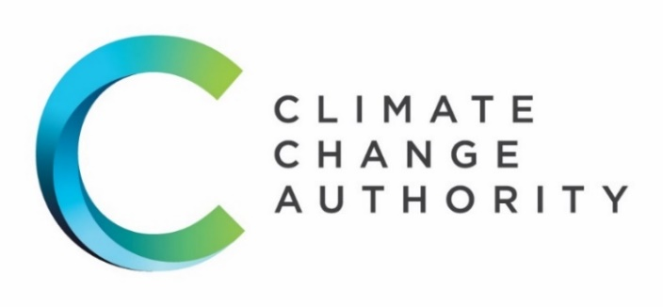



**Review of International Offsets**

**August 2022**

This page is intentionally blank



**The Authority recognises the First Peoples of this nation and their ongoing connection to culture and country. We acknowledge First Nations peoples as the Traditional Owners, Custodians and Lore Keepers of the world’s oldest living cultures, and pay our respects to their elders – past, present and future.**

**Copyright**

Published by the Climate Change Authority [www.climatechangeauthority.gov.au](http://www.climatechangeauthority.gov.au)

This work is licensed under the Creative Commons Attribution 3.0 Australia Licence. To view a copy of this license, visit <http://creativecommons.org/licenses/by/3.0/au>

The Climate Change Authority asserts the right to be recognised as author of the original material in the following manner:

 or 

©Commonwealth of Australia (Climate Change Authority) 2022.

ISBN: 978-0-6481620-6-3

**IMPORTANT NOTICE – PLEASE READ**

This document is produced for general information only and does not represent a statement of the policy of the Commonwealth of Australia. The Commonwealth of Australia and all persons acting for the Commonwealth preparing this report accept no liability for the accuracy of or inferences from the material contained in this publication, or for any action as a result of any person’s or group’s interpretations, deductions, conclusions or actions in relying on this material.

**Acknowledgements**

The Climate Change Authority would like to thank the many governments, individuals and organisations who contributed time and expertise to this review, including those who provided formal submissions and participated in consultation. These contributions have improved the quality of the review and helped inform the Authority’s recommendations.

The Authority would like to thank the Department of Climate Change, Energy, the Environment and Water, the Clean Energy Regulator, the Department of Foreign Affairs and Trade, Bureau of Meteorology, EY and Gilbert + Tobin which provided expertise to the Authority in the preparation of this review.

The views expressed in the review are the Authority’s own and should not be taken as the views or positions of any of the entities listed above.

Contents

Glossary of terms vii

Table of acronyms ix

Executive Summary 1

Part 1 Introduction 8

Part 2 "…in the context of the Paris Agreement” 17

Part 3 The “plus” part of the Paris context 29

Part 4 The most important criteria 43

Part 5 Climate Active - eligible offsets 65

Appendix A Stakeholder engagement 79

Appendix B Costs and benefits of recommendations 81

References 86

## Boxes

BOX 1.1: Requesting Instrument 9

BOX 1.2: Paris Plus 12

BOX 2.1: What is double counting? 19

BOX 2.2: Article 6.2 example 20

BOX 2.3: Article 6.2 extract from Gilbert + Tobin 22

BOX 2.4: Article 6.4 extract from Gilbert + Tobin 23

BOX 2.5: Case Study – Joint Crediting Mechanism in Indonesia 28

BOX 3.1: What is Climate Active? 32

BOX 3.2: Targets and accounting frameworks 37

BOX 4.1: REDD+: Managing adverse impacts 49

BOX 4.2: Climate Active offsets integrity principles 62

## Figures

Figure 1.1: Offset lifecycle 11

Figure 2.1: Units available in the Paris Plus context 25

Figure 2.2: Examples of approaches to Article 6 27

Figure 3.1: The use of Australian Carbon Credit Units 33

Figure 3.2: Climate Active Units 34

Figure 4.1: Leading practice approaches for avoiding adverse impacts 50

Figure 4.2: Offsets in best practice approaches to decarbonising 58

Figure 4.3: ACCU project types purchased by Climate Active participants 63

Figure 4.4: Offset type and location used under Climate Active. 64

Figure 5.1: assessing carbon offset schemes 67

Figure 5.2: Various levels of the generation of carbon offsets 70

## Tables

Table 3.1: How offsets relate to Australia’s targets 38

Table 4.1: Criteria for offset schemes 59

Table 4.2: Indo-Pacific Carbon Offsets Scheme Principles 61

Table 5.1: Overall Quantitative Integrity Scores 71

Table 5.2: Principles Assessment 71

Table 5.3: Governance Assessment 72

# Glossary of terms

|  |  |
| --- | --- |
| Abatement | Reduction of an amount of carbon dioxide or equivalent. |
| Additionality | Abatement is additional if it would not have occurred in the absence of a government program or a market for offset units. |
| American Carbon Registry | American Carbon Registry produces Emission Reduction Tonne (ERT). |
| Article 6 Rules | Article 6 of the Paris Agreement establishes a framework for international cooperation of countries to reduce emissions and meet their nationally determined contributions. |
| Australian National Registry of Emissions Units | National registry to track the location and ownership of carbon units issued under the Emissions Reduction Fund and Kyoto Protocol. |
| Carbon credit | A tradable unit that represents one tonne of greenhouse gas equivalent abatement. |
| Carbon offset | A type of carbon credit that represents a reduction in emissions – whether prevented from entering the atmosphere or removed from the atmosphere – that is used to compensate for emissions that occur elsewhere. |
| Carbon neutrality | Having a balance between emissions and absorption of greenhouse gases from the atmosphere. | |
| Certified Emission Reduction | Tradable unit representing one tonne of carbon dioxide-equivalent abatement generated under the Clean Development Mechanism. | |
| Clean Development Mechanism | A market mechanism under the Kyoto Protocol associated with emissions reduction projects in developing countries. | |
| Compliance market | A carbon market created and regulated by international, national or regional emissions reduction regimes. | |
| Corresponding adjustments | Actions taken by a host party and buying party to adjust their accounts for reporting under the Paris Agreement in order to avoid double counting of abatement under Article 6. | |
| Double counting | One tonne of abatement is used to compensate for more than one tonne of emissions. Double counting can occur through double crediting (also known as double issuance), double use, and/or double claiming. | |
| Double crediting or issuance | Two offset units are issued for the same tonne of abatement. This can occur, for instance, when the same project is registered under two different carbon programs or twice under the same carbon program. | |
|  |  | |
|  |  | |
| Double use | One offset unit claimed to compensate for two tonnes emitted by the same entity. For example, an airline uses the same unit to compensate for on-land emissions and in-flight emissions. | |
| Double claiming | One offset unit is claimed to compensate for two tonnes emitted by different entities. For example, an offset generator and buyer both claim the abatement. | |
| Emissions avoidance | Activities that avoid emissions of greenhouse gases, such as avoided deforestation or avoided fossil fuel extraction. | |
| Emissions reduction | Reducing the emissions from an activity, such as through efficiency improvements. | |
| Emissions removal | Activities that involve capturing and durably storing emissions from the atmosphere. | |
| Entity | A corporation, government, non-government sector actor or individual. | |
| Gold Standard | An offset scheme that produces Verified Emissions Reductions (VERs). | |
| Guardrails | Mechanisms, policies or rules to avoid adverse impacts. Also known as safeguards. | |
| Host Country | Country hosting a carbon offset project. | |
| Nationally Determined Contribution | A submission by a Party to the Paris Agreement that articulates the Party’s efforts to contribute to the global task of decarbonisation and adapt to the impacts of climate change. | |
| Net zero emissions | An overall balance of greenhouse gas emissions and removals. | |
| Plan Vivo | Plan Vivo is an offset scheme that produces Plan Vivo Certificates. | |
| Scheme | The overarching design, governance and management of carbon offset standards and the units they produce. | |
| Scope 1 Emissions | The release of greenhouse gases into the atmosphere as a direct result of activities occurring within a responsible entity’s control (or geographic boundary). | |
| Scope 2 Emissions | The release of greenhouse gases into the atmosphere from the consumption of electricity, heating, cooling or steam that is generated outside of a responsible entity’s control (or geographic boundary). | |
| Scope 3 Emissions | Greenhouse gases emitted as a consequence of a responsible entity’s activities (other than Scope 2 emissions) but beyond the responsible entity’s control or geographic boundary. | |
| Verified Carbon Standard | An offset scheme operated by Verra that produces Verified Carbon Units (VCUs). | |
| Verra | The organisation that runs the Verified Carbon Standard, which administers Verified Carbon Units (VCU), CCBs and SD VISta. | |
| Voluntary carbon market | Market for voluntary carbon offset units outside of the compliance market. | |

# Table of acronyms

|  |  |  |
| --- | --- | --- |
| **Acronym** | **Term** | |
| A6.4ER | Article 6.4 Emission Reduction unit | |
| ABU | Australian Biodiversity Units | |
| ACCU | Australian Carbon Credit Unit | |
| BTR | Biennial Transparency Report | |
| CCB | Climate, Community & Biodiversity Program | |
| CDM | Clean Development Mechanism | |
| CER | Certified Emission Reduction | |
| CERT | Corporate Emissions Reduction Transparency | |
| CFI Act | Carbon Credits (Carbon Farming Initiative) Act 2011 | |
| CORSIA | Carbon Offsetting and Reduction Scheme for International Aviation | |
| ERF | Emissions Reduction Fund | |
| EU ETS | European Union Emissions Trading Scheme | |
| GHG | Greenhouse Gas | |
| IPCC | Intergovernmental Panel on Climate Change | |
| IPCOS | Indo-Pacific Carbon Offsets Scheme | |
| ISO | International Organisation of Standardization | |
| ITMOs | Internationally Transferred Mitigation Outcomes | |
| JCM | Joint Crediting Mechanism | |
| lCER | Long-term Certified Emission Reduction | |
| LGC | Large-scale generation certificate | |
| MRV | Measurement, Reporting, Verification | |
| OMGE | Overall Mitigation in Global Emissions | |
| NDC | Nationally Determined Contribution | |
| NGER | National Greenhouse and Energy Reporting | |
| REDD+ | Reducing Emissions from Deforestation and forest Degradation, plus the sustainable management of forests, and the conservation and enhancement of forest carbon stocks | |
| RMU | Removal Unit | |
| SBTi | Science Based Targets initiative | |
| SDGs | Sustainable Development Goals | |
| SD VISta | Sustainable Development Verified Impact Standard | |
| TCFD | Task Force on Climate-related Financial Disclosure | |
| UN | | United Nations | |
| UNDP | United Nations Development Programme | |
| UNFCCC | United Nations Framework Convention on Climate Change | |
| VCMI | Voluntary Carbon Markets Integrity initiative | |
| VCS | Verified Carbon Standard | |
| VCU | Verified Carbon Units | |
| VER | Verified Emissions Reduction unit | |
| VVB | Validation and Verification Body | |

# Executive Summary

The Climate Change Authority’s *Review* of *International Offsets* comes at a pivotal time for global action on climate change, with the Paris Agreement rules for carbon markets – the Article 6 Rules – agreed in Glasgow last year.

Limiting global temperature rise this century to 1.5oC above pre-industrial levels requires moving rapidly to global net zero carbon dioxide emissions by 2050, and to net negative emissions in the second half of the century.

Environmental effectiveness, economic efficiency, equity and rapid decarbonisation are among the key principles guiding the Authority’s approach to this review (Part 1.2).

**While offsetting is not the plan to decarbonise, it can be part of a plan for faster, deeper transition to net zero and beyond.**

In the near term, while businesses reduce emissions and develop low or no emissions commercial substitutes, offsets can help address very difficult to abate emissions. By facilitating trade in offsets, markets can smooth the transition for businesses while they make the necessary changes.

In the longer term, markets can play an important role in getting to net negative emissions. The Authority is currently investigating Australia’s carbon sequestration potential, including how markets offer pathways to commercialisation of the negative emissions technologies the world needs to achieve the Paris Agreement goals.

**The Paris Agreement is changing the way countries think about carbon markets.**

Almost all countries now have targets in their Nationally Determined Contributions (NDCs), but only one country can claim each tonne of abatement towards its target. There can be no ‘double counting’.

Governments are deciding whether – and if so, how – to use Article 6 and compliance carbon markets to meet their NDCs.

In parallel, companies are voluntarily setting their own decarbonisation targets and many plan to use offsets to help meet them. With demand for offsets rising rapidly, offset schemes are proliferating to meet it.

These developments throw a spotlight on the current disconnect between compliance and voluntary carbon markets, with different accounting frameworks, standards and rules applying to them.

The Article 6 Rules could provide the framework for a unified international carbon market, bringing compliance and voluntary markets together, but this will require collaboration between government and private sector leaders.

**Integrity and transparency are crucial.**

Robust integrity criteria are the way to ensure carbon units represent genuine abatement. Measurement, reporting and verification (MRV) must underpin every part of the carbon offset value chain, from generation of abatement to issuance of units, to trade, and use towards targets.

Transparency allows market participants and observers to track what is happening, to have confidence in what units represent, to hold one another to account, and to drive continuous improvement.

Transparency is important in national greenhouse gas accounts and in corporate reporting. A shared understanding of the relationship between them is just as important.

**‘Double counting’ is a contested concept when it comes to voluntary markets.**

The Article 6 Rules avoid double counting of abatement by the nations hosting and buying abatement. However, the term ‘double counting’ is not defined in the Paris Agreement, leaving the door open to different and contradictory understandings.

Double counting – whereby one tonne of abatement is counted against two tonnes of emissions – must be avoided. The Authority holds the view that subnational and corporate greenhouse gas accounts are nested within national accounts, and that nested accounting is not a form of double counting. Just as the same emissions can be included in greenhouse gas accounts at different levels, so too can the same offsets.

Most countries routinely count voluntary direct emissions reductions and carbon units used in compliance mechanisms towards their national targets. However, it is unclear whether countries will include voluntary offsetting towards their Paris Agreement targets.

Governments that do not include voluntary offsetting will face difficult decisions about whether to:

* mandate emissions reductions that can occur voluntarily,
* limit ambition in their NDC, and/or
* identify other sources of abatement to redress the emissions that are voluntarily offset.

**The role of voluntary markets in meeting Australia’s target is not yet clear.**

The emissions of Climate Active participants are counted in Australia’s national greenhouse gas inventory. However, international offsets used under Climate Active do not contribute to Australia’s target.

Australia’s voluntary carbon market has grown rapidly in recent years and is dominated by international offsets. Ninety-five per cent of offsets ever used under Australia’s voluntary Climate Active program are international units.

In developing Australia’s next Paris Agreement target, the Government will need to consider whether all action will count towards Australia’s national target, including voluntary use of offsets to meet corporate targets.

If voluntary offsetting is to contribute to Australia’s target, the Authority recommends there be some exceptions and suggests that the Government increase ambition in Australia’s NDC as voluntary action increases.

**Right now, carbon is priced in Australia, though the market is fragmented, inefficient and complicated.**

The Authority recommends the Government publish a National Carbon Market Strategy, setting out how Australia will use carbon markets in its transition to net zero emissions by 2050. A strategy that:

* makes Australia’s carbon price more visible and understandable, to embed decarbonisation in everyday decision-making;
* upholds the integrity of offsets – in both the ways they are generated and the ways they are used – to build confidence and trust in Australia’s approach;
* clarifies the role of domestic and international units in the mix of voluntary action and compliance mechanisms to help smooth and accelerate Australia’s decarbonisation;
* ensures Australia’s institutional and regulatory infrastructure is fit for participation in Article 6;
* builds understanding of the approach domestically and with other nations; and
* enhances links between carbon markets and international trade and measurement standards, to underpin Australia’s engagement in the development of a robust, liquid, high integrity, trusted and effective global carbon market.

**Article 6 is about much more than facilitating least-cost abatement.**

As well as achieving overall mitigation in global emissions, countries are now looking to market-based approaches to drive sustainable development and relationships between trading partners.

Article 6 presents new ways for Australia to cooperate with its Indo-Pacific neighbours and build relationships founded on mutual interest in accelerating the region’s transition to net zero.

In domestic and international markets, Australia should hold itself to the highest environmental and social standards by mitigating the risk of adverse impacts and maximising the opportunities for environmental, health and social benefits in carbon projects.

**The Government’s response to this review can set the standard for Australia’s voluntary and compliance markets beyond Climate Active.**

State governments and companies already use Climate Active as a benchmark in their decisions about which carbon offsets they will purchase or accept in their own jurisdictions.

The Authority adopted a robust methodology to analyse the features and integrity of international offsets:

* First, decide the most effective level of analysis: individual projects, project types, classes of units, or offset schemes. The offset schemes that generate offset units are the appropriate level of analysis for this review (Part 4).
* Second, determine the criteria that matter most for integrity (such as additionality and permanence) and assessing other features of a carbon offset (such as biodiversity benefits) as appropriate (Part 4).
* Third, analyse the performance of schemes against the criteria. The Authority focused on four schemes that generate the units currently or potentially eligible in Australia: Gold Standard, Verra, Plan Vivo and the Clean Development Mechanism (Part 5).
* Fourth, determine which schemes perform best against the criteria that matter most in the specific context of the assessment (Part 5).

For Climate Active, the Authority considers that units from the Clean Development Mechanism should be phased out by 2025. Other types of units should remain eligible for now, but should be reviewed regularly alongside other schemes entering the market.

The new Paris Agreement rules prevent carry-over of old units from the Kyoto Protocol era to meet Paris era targets, with few exceptions. It’s time to phase out older units.

The Authority recommends a rolling five-year vintage rule be applied to all units under Climate Active to keep up with evolving practices and encourage continuous improvement.

**The rules, norms and practices of carbon markets are still evolving, and may for some time**.

Markets will be increasingly important as countries and companies progress towards net zero emissions and beyond. It makes sense to adopt a continuous improvement approach to carbon markets for the long term.

The Paris Agreement could help bring voluntary and compliance markets together or drive them apart. Now is the time to bring them together to:

* realise their potential to unlock capital to finance the net zero transition;
* increase liquidity, efficiency and effectiveness, thereby enhancing the carbon pricing signal throughout the economy for better decision-making by business and consumers;
* ensure social, environmental and governance risks are mitigated; and
* embed the levels of integrity and transparency needed for continuous improvement and confidence.

Australia’s strengths include transparency, emissions measurement, reporting and verification, and markets. The Authority recommends that the Australian Government engage internationally to harmonise rules and support well-functioning international markets.

**It makes sense – and it is in Australia’s national interest – to play a leading role in the development of a robust, liquid, high integrity, trusted and effective global carbon market.**

.

## Recommendations

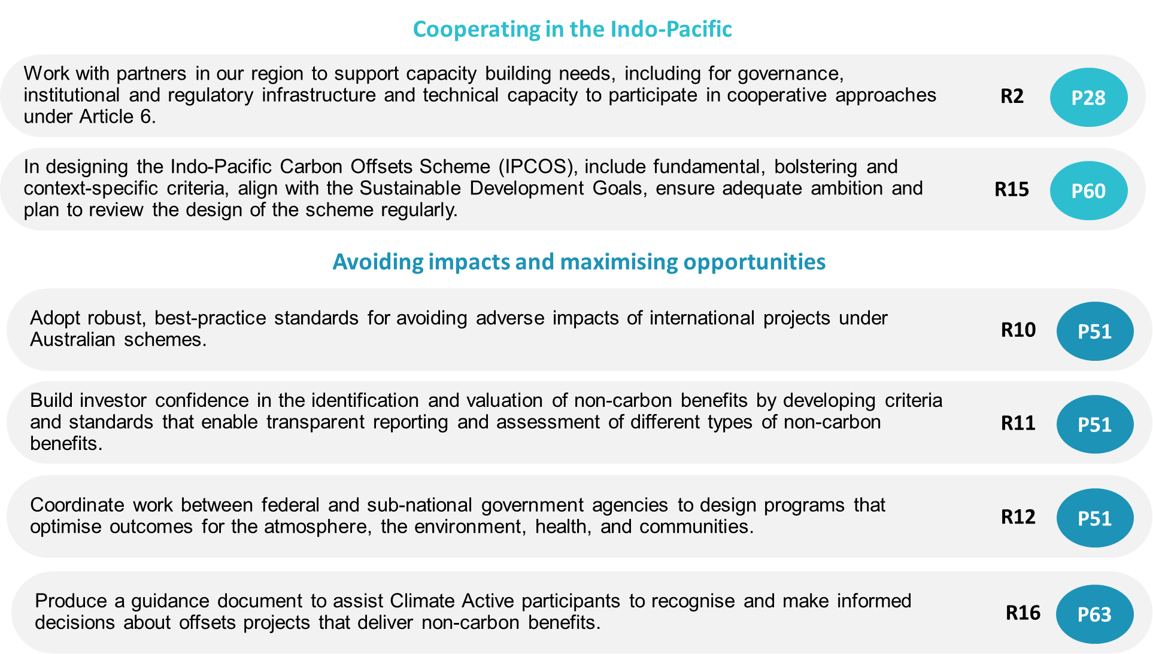

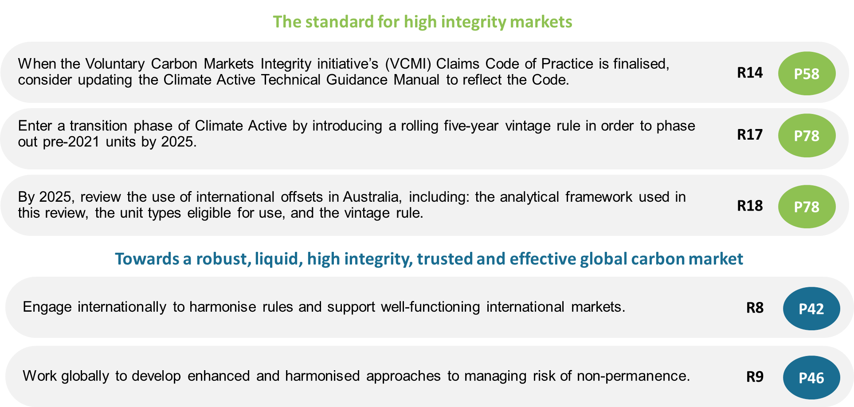

# Myall Beach at Cape Tribulation**Part 1 Introduction**

## 1.1 About this review

##### BOX 1.1: Requesting Instrument

I, Angus Taylor, Minister for Industry, Energy and Emissions Reduction, acting under subsection 59(1) of the *Climate Change Authority Act 2011*, request the Authority to conduct a review of the following matters to the extent to which they relate to the use of offsets related to carbon abatement outside Australia under the Climate Active program and/or the creation or use of offsets as part of the Indo-Pacific Carbon Offsets Scheme (IPCOS) in the context of the Paris Agreement (including recent outcomes from Glasgow and the finalised Article 6 Rulebook):

1. the most important criteria for accepting emissions offsets for use in Climate Active and as part of IPCOS, including considering emissions offset claims from within and across different carbon accounting frameworks; and
2. what are leading practice approaches for taking into account non-carbon benefits and avoiding adverse impacts; and
3. potential differences in criteria relating to the use of those offsets under Climate Active, as part of IPCOS or for other purposes; and
4. whether the criteria can or should be applied at a scheme level, by classes of units or project types or individual projects; and
5. to what extent the vintage of units (such as relating to abatement, project registration or issuance) should be relevant to the use of those offsets; and
6. which offsets could be eligible for use under Climate Active at the present time.

Receipt of the report under paragraph 60(1)(b) of the Act by 30 June 2022 would assist in the review of Climate Active and the development of IPCOS.

The Climate Change Authority is an independent statutory agency, established to provide expert, evidence-based advice to the Government on Australia’s climate change targets, policies and progress.

In February 2022, the then Minister for Industry, Energy and Emissions Reduction requested the Authority conduct a review of the use of international carbon offsets in Australia in the context of the Paris Agreement, as set out in the terms of reference (Box 1.1).

In June 2022, the newly elected Australian Government submitted an updated Nationally Determined Contribution (NDC) under the Paris Agreement with a target to reduce emissions by 43 per cent below 2005 levels by 2030 and a long-term target to reach net zero emissions by 2050 (Australian Government, 2022). The NDC does not indicate whether international offsets will contribute to meeting the targets.

The Government recognises the importance of integrity in offsets markets and in July 2022 announced an independent review into the integrity of Australian Carbon Credit Units (ACCUs), to be led by former Chief Scientist, Professor Ian Chubb AC. Professor Chubb’s review will focus on Australia’s Emissions Reduction Fund, a domestic scheme beyond the scope of this Climate Change Authority Review of International Offsets.

The terms of reference set out in the requesting instrument focus on two schemes:

1. Climate Active - a voluntary Australian Government program that provides a carbon neutral certification standard for use by entities to demonstrate that they have credibly reached carbon neutrality, supporting them to measure, reduce, and offset their carbon emissions.
2. The Indo-Pacific Carbon Offsets Scheme (IPCOS) - an Australian-led initiative under development to support climate action in the Indo-Pacific region through enhancing the capacity of partner countries to participate under Article 6 of the Paris Agreement and boosting public and private investment in mitigation projects. The Australian Government intends to work with partner countries in the generation and trade of carbon offsets, ensuring high standards of environmental integrity and delivering social and economic benefits for local communities.

A **carbon offset** represents a one tonne reduction in emissions—whether prevented from entering the atmosphere or removed from the atmosphere—that is used to compensate for emissions that occur elsewhere.

Emissions can be prevented from entering the atmosphere in several ways, though there is disagreement about the definition and attributes of them. For the purposes of this report, the Authority adopts the following definitions.

* **Emissions avoidance[1]** – activities that avoid emissions of greenhouse gases, such as avoided deforestation or avoided fossil fuel extraction.
* **Emissions reduction** – reducing the emissions from an activity, such as through efficiency improvements.

The term **carbon removal** refers to the process of removing carbon dioxide from the atmosphere and storing it long term. Trees, plants and soils are prominent examples of natural carbon removal, and new carbon removal technologies are emerging.

The term **abatement** includes emissions avoidance, emissions reduction and removal of greenhouse gas emissions.

Carbon markets are where offsets and other types of carbon units (such as **allowances**or **permits** in cap-and-trade schemes) are transacted.

In this report, the Authority uses **national carbon markets** to mean the generation, trade and use of carbon units within Australia**. International carbon markets** refers to the generation of units in one jurisdiction made available for trade internationally.

**Compliance action** refers to abatement activity that occurs to meet a mandatory obligation, such as an emissions cap in an Emissions Trading Scheme or baseline under the Safeguard Mechanism. **Voluntary action** refers to the autonomous decisions of entities to reduce their net greenhouse gas emissions.

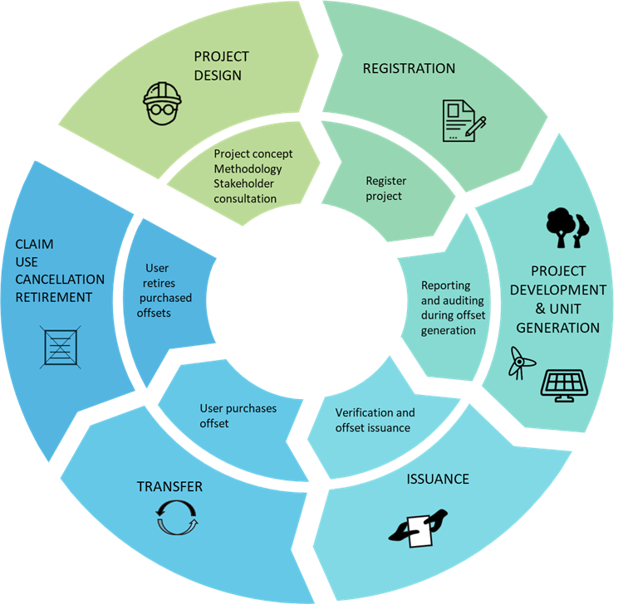Offsets play a central role in voluntary carbon markets and in some compliance mechanisms, such as Australia’s Safeguard Mechanism. Some Australian states and territories are also integrating offsets in their planning and development approval processes and state emissions reduction schemes.

*.*

|  |
| --- |
| Figure 1.1: Offset lifecycle  **Source**: Climate Change Authority. |

This review of international offsets comes at an opportune time. Nations met in Glasgow in November 2021 and agreed the rules for carbon markets under the Paris Agreement (Article 6 Rules). In parallel, financial institutions and companies around the world are committing to decarbonisation and putting carbon markets to increasing use.

##### BOX 1.2: Paris Plus

‘Paris Plus’ includes the various agreements, targets, cross-border instruments and other initiatives that implement or contribute to the goals of the Paris Agreement, such as:

* the Paris Agreement Rulebook;
* carbon trading mechanisms;
* carbon border tariffs and clubs;
* subnational and corporate targets;
* climate-related financial disclosure;
* taxonomies and certification schemes; and
* international agreements to reduce aviation and maritime emissions.

**Source**: Paris Plus: From cost to competitive advantage. (Climate Change Authority, 2021).

A new global climate architecture for climate action is emerging, reflecting actions that implement and complement the 2015 Paris Agreement. Actions are not just taken by governments, but by buyers, sellers and investors in markets as well. The Authority calls this architecture ‘Paris Plus’ (Box 1.2).

This review is undertaken in the context of the Paris Agreement and the Paris Plus architecture. The Authority has considered both the generation and use of offsets, in voluntary and compliance markets, and both domestic and international rules and standards.

## 1.2 Principles

The *Climate Change Authority Act 2011* (Cth) (section 12) requires the Authority to have regard to the following principle when undertaking its functions:

*Any measures to respond to climate change should:*

* *be economically efficient; and*
* *be environmentally effective; and*
* *be equitable; and*
* *be in the public interest; and*
* *take account of the impact on households, business, workers and communities; and*
* *support for the development of an effective global response to climate change; and*
* *be consistent with Australia’s foreign policy and trade objectives.*

The Act also provides for the Authority to have regard to other principles it considers relevant.

In completing this review, the Authority was guided by the additional principles that measures to respond to climate change should:

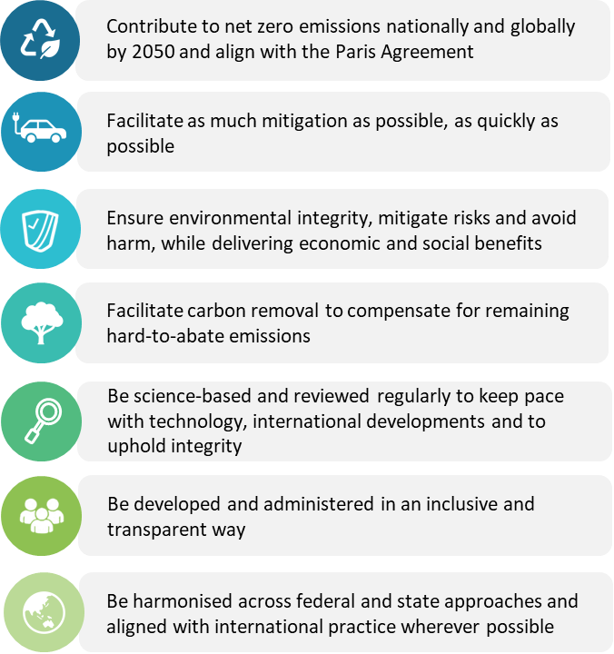

## 1.3 Public consultation

The Authority consulted widely as part of this review and is grateful to everyone who contributed their time and expertise to enhance the quality of the report and inform its findings.

The Authority received 38 written submissions in response to the consultation paper released in April 2022 (list provided in Appendix B). Non-confidential submissions are available on the Authority’s website.

The Authority met with 30 entities and hosted two webinars, attended by 50 representatives, to seek further input from a cross section of organisations and government agencies.

## 1.4 Technical reports

### Stocktake and analysis of international carbon offset programs, EY

For this review, the Authority commissioned EY to undertake a stocktake of international carbon offset schemes, prepare an analytical framework for comparing the quality of schemes, and assess several shortlisted international offset schemes:

* Gold Standard, Verra[2] and the Clean Development Mechanism, which generate units currently eligible under Climate Active;
* Plan Vivo, which is an example of a scheme that prioritises non-carbon benefits; and
* Japan’s Joint Crediting Mechanism (JCM), which is an example of a scheme based on bilateral agreements, like those expected under Article 6.2 of the Paris Agreement.

The Authority worked with EY to select schemes for assessment based on their current eligibility and their representativeness of different types of schemes. It is not intended to be exhaustive or representative of any recommendation by the Authority for inclusion. The number of schemes was limited by the time available to complete this review.

### Briefing report on the Article 6 Rules agreed at COP 26: Implications for Australia, Gilbert + Tobin

The Authority also commissioned Gilbert + Tobin to prepare a technical report on the rules for implementing Article 6 of the Paris Agreement and how it avoids double counting and upholds integrity. The report explains cooperative approaches under Article 6.2 and the centralised mechanism under Article 6.4, and considers their implications for Australia.

Both technical reports are available on the Authority’s website <www.climatechangeauthority.gov.au>.

This review also draws on the Authority’s earlier research reports, including the following.

#### [Paris Plus: From cost to competitive advantage](https://www.climatechangeauthority.gov.au/publications/paris-plus-cost-competitive-advantage) (Climate Change Authority, 2021)

As detailed in Box 1.2, Paris Plus describes the emerging global climate architecture that builds on the Paris Agreement.

The report describes six key enablers governments could pursue in support of the drive to net zero emissions, including:

* *Markets* – encouraging the development of open, competitive and transparent markets, to drive lowest cost decarbonisation outcomes; and
* *Rules* – implementing rules and regulations to create trust in markets and guard against market failures, ensuring that they are up-to-date and not impeding new ways of reducing emissions.

The Authority recommended that Australia be deeply embedded in the development of international climate change rules. Australia has valuable knowledge and expertise in transparent emissions reporting and high-integrity carbon markets. This is due to Australia’s established institutions and world-leading policy architecture, including the National Greenhouse Gas Inventory, the National Greenhouse and Energy Reporting (NGER) scheme, the Emissions Reduction Fund (ERF) and Clean Energy Regulator.

#### [Prospering in a low-emissions world: An updated climate policy toolkit for Australia](https://www.climatechangeauthority.gov.au/publications/prospering-low-emissions-world-updated-climate-policy-toolkit-australia) (Climate Change Authority, 2020b)

This research report outlines how Australia can reduce greenhouse gas emissions to meet its 2030 Paris Agreement target and subsequent, more ambitious targets while prospering in a world transitioning to net zero emissions.

In the report, the Authority recommended the Government develop an international climate strategy to, among other things:

* support a strong global response to climate change that minimises physical impacts on Australia and increases international demand for Australia’s emerging low-emissions export industries; and
* maximise the opportunities for Australia from international trade in emissions reductions, including by:
  + identifying potential carbon trade partners and prioritising developing countries in the region;
  + supporting potential trade partners to build their capacity to deliver lower-cost, high-integrity international units; and
  + defining the criteria for and identifying the international units considered to be ‘high-integrity’ and acceptable to Australia.

## Eucalyptus tree bark1.5 Structure of this report

This Review of International Offsets presents the Authority’s responses to the terms of reference (Box 1.1) in five parts.

Part 1 introduces this Review, its guiding principles, terminology, consultation process and technical inputs.

Part 2 explains how carbon markets function in the context of the Paris Agreement.

Part 3 explains greenhouse gas accounting frameworks at the national, subnational and corporate level, how voluntary use of international offsets are accounted for in them, and the implications for national targets.

Part 4 presents findings on the most important criteria that can be used to identify the voluntary schemes that generate high integrity offsets for use in Climate Active and the IPCOS, the appropriate level of analysis, and the leading practice approaches to generating non-carbon benefits and avoiding adverse impacts.

Part 5 present the analytical framework for and results of an assessment of four offsets schemes against the criteria described in Part 4, and presents recommendations on scheme, unit and vintage eligibility under Climate Active.

# Part 2 “…in the context of the Paris Agreement”

“… the Authority to conduct a review of the following matters … in the context of the Paris Agreement (including recent outcomes from Glasgow and the finalised Article 6 Rulebook)”

**Key insights**

The Article 6 Rules provide the framework for an international carbon market.

International carbon markets can help unlock ambition to meet the Paris goals. As well as cost minimisation for importing countries, exporting countries see the potential for advancing economic transformation and geopolitical considerations.

The Paris Agreement has changed the way countries think about carbon markets. All countries now have NDCs and a country that exports offsets cannot count that abatement towards its own NDC. For some host countries, Paris carbon markets are less about trading carbon units and more about longer term investment in sustainable development outcomes.

The costs and benefits of exporting abatement are not easy for host countries to assess. In Article 6 negotiations countries are emphasising the need for comprehensive capacity building support so that they can make informed decisions about Article 6 participation.

## From Kyoto to Paris

##### BOX 2.1: What is double counting?

Double counting is not defined in the Paris Agreement, leaving the door open to different and contradictory understandings.

**The Authority has adopted the following definitions in this report.**

**Double counting** occurs when one tonne of abatement is used to compensate for more than one tonne of emissions. It occurs in three ways.

* **Double crediting or issuance:** Two offset units are issued for the same tonne of abatement. This can occur, for instance, when the same project is registered under two different carbon programs or twice under the same carbon program.
* **Double use:** One offset unit is claimed to compensate for two tonnes emitted by the same entity. For example, this would occur if an airline used the same unit to compensate for on-land emissions and in-flight emissions.
* **Double claiming:** One offset unit is claimed to compensate for two tonnes emitted by different entities. This would occur if an offset generator and buyer both claimed the abatement.

**Nested accounting** is not a form of double counting (see Part 3.2). It provides for two entities (e.g. a company and a nation) to report the same emissions, but for different purposes. Nested accounting of offsetting is not problematic because the same offset unit is used to compensate for the same emissions.

The Authority was asked to review international offsets “in the context of the Paris Agreement, including recent outcomes from Glasgow and the finalised Article 6 Rulebook”.

As international carbon markets transition from the Kyoto Protocol context to the Paris Plus world, their core purpose remains: to help unlock ambition. The Article 6 Rules prevent double counting (Box 2.1) between countries and are designed to uphold the integrity of carbon markets.

However, the Paris Agreement has changed the way countries think about carbon markets. All countries now have NDCs, and the requirement for corresponding adjustments means selling mitigation affects a country’s progress towards its own NDC. Countries have different understandings of what ‘double counting’ and ‘integrity’ mean, and different views on the appropriateness of using markets. Part 2.3 summarises some of the approaches adopted by countries.

Under the Kyoto Protocol, developed countries had emissions reduction targets and reported on their emissions. Developing countries were not required to set targets or report on their emissions. (United Nations Framework Convention on Climate Change, 1997).

##### BOX 2.2: Article 6.2 example

Country A, a developed nation, could provide technology and finance for projects in Country B, a developing nation.

* Country A finances clean energy projects in Country B.
* Country B builds clean energy infrastructure instead of fossil fuel energy infrastructure. The project supports Country B’s sustainable development, energy security, and health by reducing air pollution and enabling building temperature control.
* Country B authorises some of the abatement generated by the clean energy project as Internationally Transferred Mitigation Outcomes (ITMOs) for use towards country A’s NDC.

Country B is able to skip the large scale adoption of fossil fuels by leaping straight to clean energy.

Developed countries could trade certain types of units among themselves and purchase offsets from projects in other countries without targets of their own.

Countries are now focussing more on geopolitical considerations and the potential for economic transformation and sustainable development. Cooperative approaches under Article 6 could support developing countries avoid the development pathways of industrialised countries, skipping the use of older, emissions intensive technologies to instead use newer, cleaner infrastructure and systems – with longer-term benefits (Box 2.2).

## 2.2 Article 6 Rules under the Paris Agreement

The Article 6 rules underpin voluntary cooperation by countries in achieving their NDCs through markets in two ways:

* Article 6.2: guidance on the use of international carbon markets; and
* Article 6.4: a United Nations (UN) backed carbon market mechanism.

For abatement in one country to be counted towards another country’s NDC, an authorised transfer must take place under Article 6.

* The host country (where the mitigation occurs) must authorise the transfer of a mitigation outcome for the purpose of counting it towards another country’s NDC.
* Both the host country and the purchasing country must make corresponding adjustments to their NDC accounts so that the host country does not count the emissions reductions towards achievement of its NDC, and the purchasing country can count the abatement towards achievement of its NDC without resulting in double counting.

To be eligible for use towards a purchasing country’s NDC, international units must be ITMOs. At present, most international units sit in the voluntary carbon market outside the Article 6 Framework and are not ITMOs (Figure 2.1). Governments that host voluntary carbon market projects could choose to authorise the international transfer of units as ITMOs, which would make those units eligible for use towards other countries’ NDCs.

Corresponding adjustments bring the carbon market, enhanced transparency framework and ambition elements of the Paris Agreement together. The Article 6 Rules require a host country to effectively underwrite the integrity of the abatement it agrees to transfer. The host country needs to deduct the ITMO amount from its target account, even if the exported ITMO does not represent genuine abatement. To meet its NDC target, the host country may need to find genuine abatement elsewhere to make up the difference (Part 4.4).

Voluntary and compliance carbon markets could converge as more units are authorised for transfer as ITMOs within the Article 6 Rules. In the voluntary carbon market, buyers are increasingly aware of the importance of using high-integrity units and might be attracted to ITMOs because they offer an additional level of integrity through their link with the host country’s target. Figure 2.1 illustrates the types of units available in the Paris Plus context.

The technical report by Gilbert + Tobin commissioned for this review is summarised below (Gilbert + Tobin, 2022). The report, *Article 6 Rules agreed at COP 26: Implications for Australia*, is available on the Authority’s website.

### Article 6.2

Article 6.2 provides guidance on using market-based bilateral or multilateral cooperative approaches to meeting NDCs, including accounting for ITMOs.

Participating countries must:

##### BOX 2.3: Article 6.2 extract from Gilbert + Tobin

Article 6.2 at its core operates as an accounting framework that applies to country-to-country transfers of Internationally Transferred Mitigation Outcomes (ITMOs). It enables ITMOs generated in a host Party to be transferred to a using Party, and ensures that such ITMOs are only counted towards the using Party’s NDC (unless authorised for another use).

Article 6.2 transfers are not governed by a centralised UN body, and key details of the transactions (e.g. the methodology for quantifying mitigation outcomes achieved) are decided bilaterally between the countries. However, participating Parties are required to put in place recording systems for ITMO creation, transfer and cancellation; apply corresponding adjustments for each ITMO transfer; and provide a series of reports to enable ITMO transfers to be transparently recorded and reviewed.

Whilst public and private entities (non-State actors) may participate in the cooperative approaches (for example, undertaking activities that generate ITMOs or acting as intermediaries in the transfer of ITMOs), the Article 6.2 Rules require the making of corresponding adjustments through international GHG inventories and accounting frameworks, which only apply to Parties. As such, participating Parties may authorise non-State actors to perform certain functions, and ITMOs could technically be held and used by those actors. However, if the mitigation outcome is to be used for one of the purposes authorised by Article 6.2, national level accounting and reporting will need to be undertaken by the participating Parties.

**Source***:* (Gilbert + Tobin, 2022)*.*

1. be a Party to the Paris Agreement;
2. have prepared, communicated and be maintaining an NDC;
3. have arrangements in place for authorising the use of ITMOs towards the achievement of NDCs (e.g. via a letter of authorisation);
4. have arrangements in place for tracking ITMOs (e.g. via a national registry or the international registry to be established by the United Nations Framework Convention on Climate Change (UNFCCC) Secretariat);
5. have provided their most recent national inventory report; and
6. ensure that their participation contributes to the implementation of their NDC and long-term low-emissions development strategy (if applicable), and the long-term goals of the Paris Agreement.

Participating Parties must avoid double counting by making corresponding adjustments to the progress towards their NDCs to account for the total amount of authorised ITMOs first transferred and used each year.

ITMOs must be authorised by a Party, generated from abatement since 2020, be real, verified and additional, and can include emissions reduction and removals. The eligibility of emissions avoidance activities is still under debate and will continue to be discussed at COP27 (United Nations Framework Convention on Climate Change, 2021a).

Under Article 6.2, countries are encouraged to make contributions to adaptation funding and to Overall Mitigation in Global Emissions (OMGE).

### Article 6.4

##### BOX 2.4: Article 6.4 extract from Gilbert + Tobin

Article 6.4 sets out principles for the establishment of a centralised UN mechanism which is to be governed by a Supervisory Body. The aims of the Article 6.4 mechanism include:

* contributing to the mitigation of GHG emissions and supporting sustainable development;
* incentivising and facilitating public and private sector participation;
* contributing to emissions reductions in host Parties that can also be used by a using Party to fulfil its NDC (in which case the prohibition against double counting applies and the host Party must correspondingly adjust its emissions upwards as the using Party adjusts its emissions downwards); and
* delivering an overall mitigation in global emissions (OMGE).

The Article 6.4 mechanism will enable mitigation outcomes to be generated (in a unitised form known as A6.4ERs) pursuant to methodologies approved by the Supervisory Body, and such mitigation outcomes are to be recorded and tracked by a centralised UN registry.

The Article 6.4 mechanism aims to deliver an overall mitigation in global emissions (OMGE). The concept of OMGE was introduced to ensure that the new mechanism under Article 6.4 will move beyond offsetting. That is, it ensures a net reduction in emissions, rather than being limited to net offsetting of emissions (CO2 released in one country with savings elsewhere). The Article 6.4 Rules require a levy of 2% of A6.4ERs at issuance be cancelled to ensure OMGE.

**Source***:* (Gilbert + Tobin, 2022)*.*

The Article 6.4 mechanism is similar in many respects to the CDM but is designed to be consistent with the Paris Agreement, where all Parties have NDCs.

Members of the Supervisory Body were nominated in June 2022 to commence the operationalisation of Article 6.4 in the second half of 2022 (United Nations Framework Convention on Climate Change, 2022c).

To participate as a host of Article 6.4 activities, a Party must:

1. be a Party to the Paris Agreement;
2. have prepared, communicated and be maintaining an NDC;
3. have communicated its designated national authority for the Article 6.4 mechanism to the Secretariat;
4. have publicly indicated how its participation in the Article 6.4 mechanism contributes to sustainable development (acknowledging that sustainable development is a national prerogative); and
5. have publicly indicated the types of Article 6.4 activities that it would consider approving and how such types of activity and any associated emissions reductions would contribute to the achievement of its NDC and long-term low greenhouse gas emissions development strategy (if applicable).

For registration of a project to proceed, host Parties must provide their approval to the Article 6.4 Supervisory Body, which may contain conditions or limitations on the activity, and authorise the participation of private sector entities.

Units from an Article 6.4 project may only be used towards an NDC or for other international mitigation purposes if the host Party has authorised this to the Supervisory Body. In this case the Article 6.2 rules, including on corresponding adjustment, apply.

The Article 6.4 Rules include some mandatory fees and contributions, including:

* contributions to OMGE by a levy of two per cent of A6.4ERs at issuance being cancelled;
* a levy of five per cent of A6.4ERs at issuance be contributed to the Adaptation Fund; and
* a share of proceeds to cover administrative expenses included in the transaction cost.

As noted above, contributions of resources for adaptation and of ITMOs for overall mitigation are strongly encouraged but not mandatory under Article 6.2.

The Article 6.4 Rules provide for the limited transition of CDM projects and units. CDM units (CERs) will not be issued for post-2020 emissions reductions, but pre-2021 CERs may be used towards a country’s first NDC provided several requirements are met. The CDM will no longer register activity, renew crediting periods or issue CERs in relation to emissions reductions since 2020. However, the Article 6 rules provide for the transition of CDM activities to the 6.4 mechanism upon request to the UNFCCC secretariat and the host Party, provided it is approved by the host Party. With the exception of a time-limited waiving of the requirement to apply Article 6.4 methodologies, Article 6.4 rules apply to transitioning activities, including on corresponding adjustments.

|  |  |  |  |  |
| --- | --- | --- | --- | --- |
| **Units available in the Paris Plus context** | | | | |
|  | **ITMOs** | | **Not ITMOs** | |
| **Units** | **ITMOs under Article 6.2**  Units authorised by host country for use towards another country’s NDC or other international mitigation purposes. These units could include units from schemes currently operating in the voluntary market (e.g. VERs and VCUs), provided those units are first authorised for transfer by the host country. | **ITMOs: authorised A6.4ERs**  Units issued under Article 6.4 and authorised by host country for use towards another country’s NDC or other international mitigation purposes. | **Not ITMOs: non-authorised A6.4ERs**  Units issued under Article 6.4 but not authorised by host country for use towards another country’s NDC or other international mitigation purposes. | **Not ITMOs**  Units that sit outside the Article 6 Rules are not authorised by host country in accordance with Article 6.2. This currently includes ACCUs, VERs and VCUs. |
| **Contributions** | Contributions strongly encouraged:   * resources for adaptation * resources for delivering overall mitigation in global emissions (OMGE). | Contributions mandatory:   * 5% to the Adaptation Fund; and * ≥ 2% to OMGE. | Contributions mandatory:   * 5% to the Adaptation Fund; and * ≥ 2% to OMGE. | Sits outside the Paris Agreement framework. No mandatory contributions. |
| **Targets** | The host country must make a corresponding adjustment so that it does not count a transferred mitigation outcome towards its NDC.  Subject to the host country authorisation, ITMOs can be used for either:   * counting towards the NDC of a purchasing country, and/or * other international mitigation purposes (e.g. Carbon Offsetting and Reduction Scheme for International Aviation, voluntary carbon markets). | | Mitigation outcome may count towards host country NDC. No corresponding adjustment required.  Not permitted to count towards any other country’s NDC. | No corresponding adjustment required. Not permitted to count towards any other country’s NDC. |

Figure 2.1: Units available in the Paris Plus context

## 2.3 Operationalising Article 6

The Article 6 Rules provide the framework for international carbon markets, and now organisations and countries still have many decisions to make to operationalise it.

To participate in Article 6 countries must:

1. create the infrastructure to track ITMOs and A6.4ERs, which is likely to interact with existing registry systems and the new system to be established by the UNFCCC;
2. develop rigorous accounting practices consistent with Article 6.2 guidance to ensure best practice target accounting and record and track ITMOs and corresponding adjustments;
3. have arrangements in place for the oversight and coordination of Article 6 participation, in particular the tracking and authorising of ITMOs; and
4. nominate a designated national authority and determining participation under that mechanism.

**RECOMMENDATION 1**

**Update Australia’s institutional and regulatory infrastructure for participation in Article 6.**

As hosts or buyers, countries will also face a number of other decisions, such as: when mitigation outcomes will be counted towards or as additional to their NDC; whether mitigation from certain types of projects should be eligible for import/export; and whether new or amended domestic policies are needed to enable generation and use of international units. These matters are discussed further in Part 3 below.

### Approaches to Article 6

Nations around the world are working to operationalise Article 6 Rules in different ways (Figure 2.2).

Given the requirement for increasing ambition under the Paris Agreement, countries supplying offsets are more cautious about engaging in early international trade of offsets. Indonesia has recently introduced a moratorium on validating offsets within the Riau Ecosystem Restoration carbon project, finding these did not comply with the applicable laws and regulations (Tilly, 2022). A similar moratorium on voluntary carbon standards has also been introduced in Papua New Guinea, banning all new proposals while appropriate regulations are being established (Donald, 2022).

Some countries are deciding not to incorporate the use of international units in the operation of key policy initiatives. For example, the European Union has excluded use of international credits for compliance with the European Union Emissions Trading Scheme (EU ETS) since 30 April 2021 (Directorate-General for Climate Action, 2021; Directorate-General for Climate Action, n.d.).

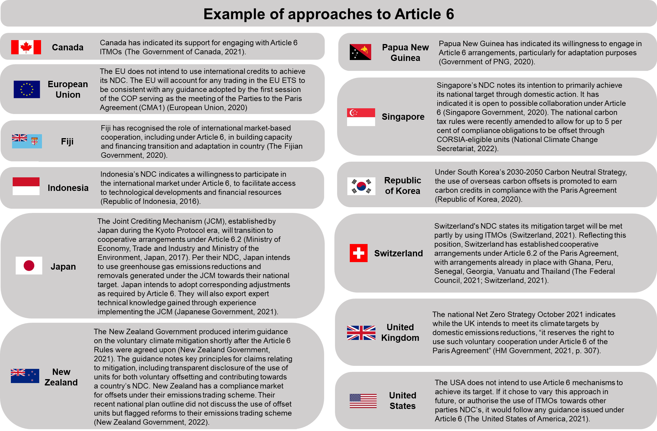

Figure 2.2: Examples of approaches to Article 6

Developing countries are identifying the need for support across a wide range of capacity building needs, including for governance, infrastructure, and technical capacity to assess merits of participation.

BOX 2.5: Case Study – Joint Crediting Mechanism in Indonesia

The JCM generates units through the operation of bilateral agreements. It is a Japanese scheme that provides emissions reductions technologies to host countries. Japan and 16 host countries can use the offset units generated through these projects to achieve NDC targets. The JCM requires local stakeholder consultation and identification of potential negative impacts according to national or local regulations.

In a study by Amellina (2017), projects in Indonesia were required to allocate a minimum of 10 per cent of credits to the Indonesian government. Projects were typically proposed by Japan, however Indonesia created a procedure for Indonesian companies to propose technology needs. In the project proposed by PT Semen Indonesia, the JCM subsidy equated to around 18 per cent of the project cost. After the project, PT Semen Indonesia suggested improving the MRV system and optimising capacity building to enhance the implementation of the scheme. This includes improving leadership of project hosts through to engaging host involvement in designing equipment and selecting equipment and suppliers.

For some time now, the Government has collaborated with countries to help them build technical capacity to track greenhouse gas emissions. For example, Australia is working directly with Indonesia, Thailand, Papua New Guinea and Fiji through the Global Forest Observations Initiative and International Partnership for Blue Carbon, to build systems to measure and report on emissions and carbon sequestration. This capacity-building work lays the foundations for effective mitigation.

Australia has particular strengths in carbon markets with expertise and an industry experienced in their operation, including measuring, reporting and verifying abatement. Australia already supports other countries in our region through capacity-building programs.

As well as supporting partner countries to meet their targets, these programs build the foundations of carbon markets and, together with other fora, provide an avenue for influencing the development of standards for offsets schemes in our region.

Through schemes like the IPCOS, Australia works with partners in the region to develop and implement the institutional and regulatory infrastructure needed to facilitate engagement with Article 6.

**RECOMMENDATION 2**

**Work with partners in our region to support capacity building needs, including for governance, institutional and regulatory infrastructure and technical capacity to participate in cooperative approaches under Article 6.**

# Turtle leaving an Australian reef for the deep bluePart 3 The “plus” part of the Paris context

|  |
| --- |
| **Key Insights**  The voluntary carbon market has grown considerably in recent years, largely driven by corporate use of offsets in their decarbonisation plans.  In the transition to the Paris Plus world, the Article 6 Rules may have the effect of converging voluntary and compliance markets or driving them apart.  International offsets appear to dominate the voluntary market in Australia. There are data gaps that new Government programs could help to address.  Most countries routinely count voluntary direct emissions reductions and carbon units used in compliance mechanisms towards their national targets. However, it is unclear whether countries – including Australia – will include voluntary offsetting towards their Paris Agreement targets.  Governments that do not include voluntary offsetting towards their targets will face difficult decisions about whether to mandate emissions reductions that can occur voluntarily, to limit ambition in their NDC, and/or to identify other sources of abatement to redress the emissions that are voluntarily offset.  Unlike compliance markets, the voluntary carbon market is largely self-regulated and is not subject to a single standard or centralised register for the tracking or trading of units.  Greenhouse gas accounting could be better aligned and linked to trade and measurement standards.  It makes sense – and it is in Australia’s national interest – to play a leading role orchestrating the development of a robust, liquid, high integrity, trusted and effective global carbon market. |

## 3.1 Voluntary carbon markets under Paris

To meet the goals of the Paris Agreement, countries, sub-national governments, non-government organisations and communities will all need to play their part. Companies and other organisations are increasingly setting emissions reduction targets and developing plans to meet them. Many plan to use carbon offsets to meet their voluntary targets.

The voluntary carbon market is largely self-regulated and not subject to a single standard or centralised register for the tracking or trading of units. Generators and users of offsets choose the standards applicable to their activities, often with a view to seeking eligibility (for generators) or accreditation (for users) under programs such as Climate Active.



|  |  |  |
| --- | --- | --- |
| BOX 3.1: What is Climate Active? | | |
| The Government launched the National Carbon Offset Standard and Carbon Neutral Program in 2010 to provide a framework for Australian entities to manage emissions and achieve carbon neutrality. The National Carbon Offset Standard was later renamed Climate Active. Under Climate Active, organisations, buildings, events, precincts, and products and services are certified as carbon neutral through a verified reduction in emissions and purchasing offsets for the remaining emissions.  Certification under Climate Active requires organisations to account for all emissions under their direct control or ownership and emissions they can strongly influence, including scope 1, 2 and 3 emissions.[3] [4] Climate Active has Offset Integrity Principles (called ‘offset criteria’ in this report) to guide decisions about the eligibility of units, modelled on the Offsets Integrity Standards set out in section 133 of the *Carbon Credits (Carbon Farming Initiative) Act 2011* (Cth) (CFI Act).  The Climate Active Technical Guidance notes the list of eligible offsets can be updated at any time on the basis of “a decision framework based on the offset integrity principles”. |  | The units eligible under Climate Active are:   * Australian Carbon Credit Units (ACCUs) issued by the Clean Energy Regulator in accordance with the framework established by the CFI Act. * Certified Emissions Reductions (CERs) issued as per the rules of the Kyoto Protocol from CDM projects, with the exception of:   + long-term (lCERs) and temporary (tCERs); and   + CERs from nuclear projects, the destruction of trifluoromethane, the destruction of nitrous oxide from adipic acid plants or from largescale hydro-electric projects not consistent with criteria adopted by the European Union (based on the World Commission on Dams guidelines). * Removal Units (RMUs) issued by a Kyoto Protocol country on the basis of land use, land-use change and forestry activities under Article 3.3 or Article 3.4 of the Kyoto Protocol. * Verified Emissions Reductions (VER) issued by the Gold Standard.[5] * Verified Carbon Units (VCU) issued by the Verified Carbon Standard (VCS) by Verra.   **Source**: Department of Industry, Science, Energy and Resources, 2020 and 2021a. |

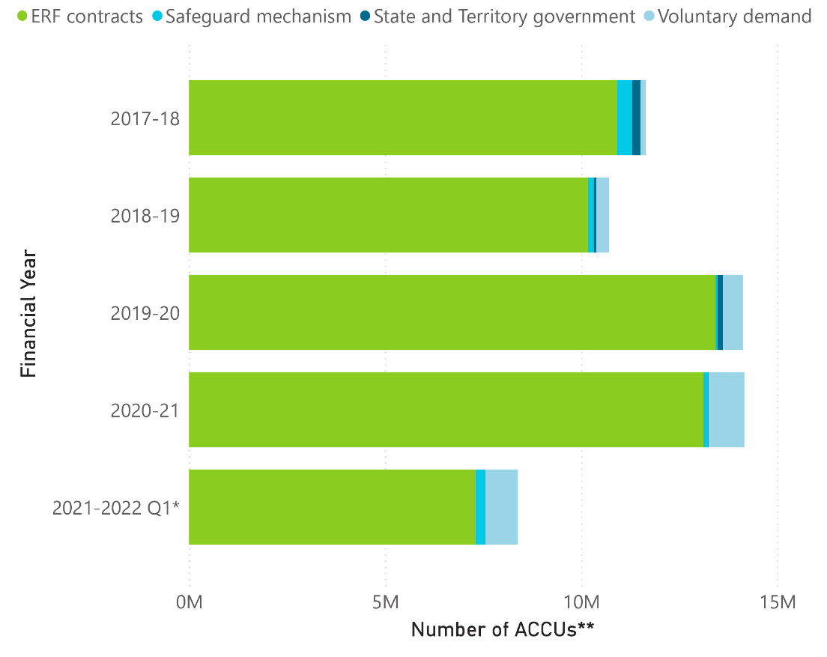Voluntary action has grown rapidly in recent years, but currently accounts for a very small percentage of total demand for ACCUs, as shown in Figure 3.1. The vast majority of ACCUs have been purchased by the Commonwealth, although this may change with:

* declining baselines under the Safeguard Mechanism;
* increasing private sector demand and reforms to reporting requirements such as the Corporate Emissions Reduction Transparency report (CERT);
* the introduction of optional delivery contracts;
* the new fixed delivery contract exit arrangements; and
* the former Government’s announcement that all Climate Active certifications will be required to use at least 20 per cent ACCUs (Taylor, 2021), noting that this requirement is now under review (Bowen, 2022).

Figure 3.1: The use of Australian Carbon Credit Units

**Source**: Climate Change Authority based on (Clean Energy Regulator, 2022c; Clean Energy Regulator, 2022d).\***Note** - Data for 2022 quarter two ACCU usage is not yet available.   
\*\***Note** - ERF contracts refer to the Emissions Reduction Fund auction. All other credits are number of ACCUs cancelled.

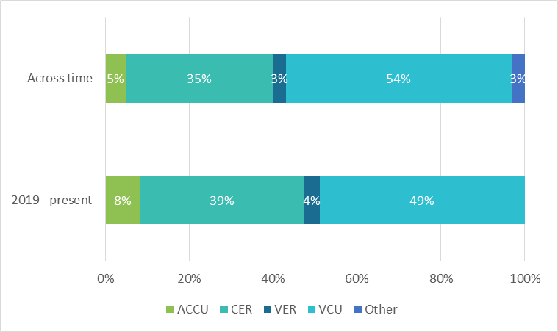Ninety-five per cent of offsets ever used under Climate Active are international units. From 2019, ACCUs represented eight per cent of the 12.8 million offsets contributing to Climate Active certifications (Figure 3.2).

Figure 3.2: Climate Active Units

**Source**: based on Climate Active data.

### Corporate Emissions Reduction Transparency reports

CERT reports are voluntary disclosures of emissions reductions and renewable energy commitments and progress by Australian companies that report more than 50,000 tonnes of scope 1 and 2 CO2-e emissions annually under the NGER scheme (Clean Energy Regulator, 2022a).

Under the program, participants report on their commitments and progress to voluntarily reducing their scope 1 and scope 2 emissions, including through the use of offsets. Scope 3 and international commitments are optional and can be reported under “Other commitments (company assured)” (Clean Energy Regulator, 2022b, p. 7).

As discussed in Part 3 to this review, the carbon market is now operating in a Paris “Plus” context. In time, the Government will need to decide whether voluntary use of offsets contributes to meeting Australia’s NDC.

The Authority considers the CERT reporting scheme, currently in its pilot phase, offers a model for reporting voluntary offsetting.

The following are accepted under CERT for scope 1 and 2 emissions:

* ACCUs (voluntary or compliance uses but units relinquished under the CFI Act are excluded);
* CERs, with some exclusions;
* VERs;
* VCUs; and
* Large-scale generation certificates (noting these are not offsets) may be included in market-based scope 2 emissions accounting.

Eligible units must reflect the vintage requirements set out under Climate Active (Clean Energy Regulator, 2022b).

### Self-governance of the voluntary carbon market

In recent years, the number of voluntary offset generation schemes around the world has increased, with new schemes adopting varying rules and standards of integrity. Furthermore, different approaches are emerging on how the schemes will interact with the Article 6 framework (World Bank, 2022).

For example, within the voluntary carbon market industry there are different views on the need for corresponding adjustments to countries’ NDCs:

* Verra has announced that it will not require corresponding adjustments, arguing that such a requirement could curtail climate finance flows to developing countries and impose onerous accounting systems (Verra, 2021), however has recently proposed labelling to distinguish credits authorised for use in alignment with the Article 6 Rules including to require corresponding adjustments for labelled units (Verra, 2022c); and
* Gold Standard’s Claim Guidelines encourage users to consider NDC targets and corresponding adjustments, but allows all carbon credits to be used for a climate change mitigation impact claim (Gold Standard, 2022a).

The voluntary carbon market is largely self-regulated, meaning the industry sets its own standard (or standards) and there is no centralised register for the tracking or trading of units. Generators and users of offsets determine the standards applicable to their activities, and influence one another by establishing practices and norms about what is acceptable. Divergence from those practices can bring a reputational risk.

Networks such as the Integrity Council for the Voluntary Carbon Market (ICVCM) and the Voluntary Carbon Markets Integrity initiative (VCMI) are seeking to harmonise offset generation and use standards across the voluntary carbon market. Although these are yet to be finalised and will not be binding (Integrity Council for the Voluntary Carbon Market, 2022; Voluntary Carbon Markets Integrity Initiative, 2022), they are anticipated to have a strong influence on the voluntary carbon market given the extensive stakeholder involvement to date.

In the transition to the newly-agreed Article 6 Rules, the lines between voluntary and compliance markets are blurring. Voluntary schemes that have traditionally operated outside the Kyoto Protocol could play an important role in cooperative approaches under the Paris Agreement. Some voluntary users may seek units that have been authorised for international transfer under Article 6 and hence which could count towards the achievement of NDCs. Others may obtain offsets outside the Article 6 Rules, which are likely to trade at a lower price.

## 3.2 What counts towards Australia’s target?

The Article 6 Rules, and in particular the application of corresponding adjustments, seek to ensure that the trading of mitigation outcomes does not lead to the double counting (Box 2.1) of those outcomes and hence undermine the achievement of emissions reduction goals. However, there remains disagreement about whether nested accounting leads to a type of double counting. Box 3.2 explains the national, subnational and corporate emissions reduction targets and accounts.

Under the Paris Agreement, countries are required (or encouraged, if they don’t already) to include in their national greenhouse gas inventories emissions from every sector across the economy.

National greenhouse gas inventories track increases or decreases in emissions over time. For example, if a company reduces its domestic emissions, the change will be reflected in the inventory of the nation where it operates. It makes no difference whether the company’s actions are voluntary or compliance-related.

The Article 6 Rules do not require corresponding adjustments for the transfer of units within a nation (e.g. a transfer from a company to government to meet a compliance obligation). In effect, it provides for a nested accounting approach.

‘Nested accounting’ refers to the different greenhouse gas accounts maintained by national governments, subnational governments and corporations or other entities.

Some have argued that counting voluntary offsetting towards a national target would be a type of ‘double counting’ because the same offsets are claimed by a company and by a nation. The Authority does not consider nested accounting of offsetting to be problematic because the same abatement is used to offset the same emissions. The company and government are not using the same unit to offset different emissions.



|  |  |
| --- | --- |
| BOX 3.2: Targets and accounting frameworks | |
| **National greenhouse gas accounting and targets**  Under the Paris Agreement, Parties will estimate and report their national greenhouse gas emissions in accordance with the rules and guidance adopted under that Agreement, including Intergovernmental Panel on Climate Change (IPCC) Guidelines for emission estimation. These “National Inventory Reports” do not reflect the use of carbon units or offsets.  Parties will report progress towards their Paris Agreement NDCs in Biennial Transparency Reports (BTR). BTRs will reflect the target accounting approaches underpinning a Party’s NDC, including any use of Internationally Transferred Mitigation Outcomes under Article 6.  National greenhouse gas inventories can also support the design, implementation and evaluation of domestic emissions reduction policies as well as inform future emissions reduction commitments.  Under the Paris Agreement, Australia will continue to submit its National Inventory Report annually, in addition to the BTR which is submitted every two years, and National Communication which is submitted every four years (Department of Industry, Science, Energy and Resources, 2022b; United Nations Framework Convention on Climate Change, 2022d).  **Sub-national greenhouse gas accounting**  The National Greenhouse Accounts prepared by the federal Department of Climate Change, Energy, the Environment and Water include annual State and Territory Greenhouse Gas Inventories. These Accounts do not reflect carbon units or offsets.  Australia’s state and territory governments have determined their own emissions reduction targets | (Government of WA, 2020; Tasmanian Government, 2022; ACT Government, 2019; Department of Environment and Natural Resources, 2020; Department of Planning, Industry and Environment, 2020; Department of Environment and Heritage Protection, 2017; Department for Environment and Water, 2022). Many local governments have climate change strategies or action plans for reducing emissions in areas under their control, including waste, street lighting and trees (Beyond Zero Emissions, 2018).  **Corporate greenhouse gas accounting**  Companies are increasingly setting their own emissions reduction targets and reporting on their progress towards meeting them. The Investor Group on Climate Change’s June 2021 survey of Australian and New Zealand institutional investors, which represent over AUD$3.1 trillion in collective assets under management globally, found that over 40 per cent of respondents have made a portfolio wide commitment to net-zero emissions by 2050. This is a 27 per cent increase from 2020 (Investor Group on Climate Change, 2021).  In Australia, entities with emissions, energy consumption or energy production exceeding specified thresholds are required to report emissions and energy information under the NGER Scheme, which forms a key data source for Australia’s National Inventory. As a consequence, NGER facility level emission reporting requirements are designed to be consistent with the rules and guidance adopted under the UNFCCC and the Paris Agreement. This approach enables changes in facility level emissions to be reflected in Australia’s National Greenhouse Accounts, and counted towards Australia’s targets.  Climate Active certification requires the generation, assessment and reporting of a carbon inventory. A carbon inventory is a measure of the carbon dioxide equivalent emissions that are attributable to an activity, and under Climate Active, can relate to the emissions of an organisation, product, service, event, building or precinct. This can also be known as a carbon footprint. |
|  |  |

### Voluntary offsetting and Australia’s national targets

The Government has yet to announce whether voluntary offsetting will count towards Australia’s Paris Agreement targets. Table 3.1 explains how domestic and international units relate to Australia’s targets.

Emissions from every sector are counted in Australia’s greenhouse gas inventory and impede meeting Australia’s target. Abatement in every sector – including planting trees or cycling instead of driving – contributes to meeting the target, regardless of whether the activity is compliance-related or voluntary.

However, voluntary offsetting under the Kyoto Protocol was treated as additional to Australia’s target, rather than contributing to meeting it (Climate Change Authority, 2014).

In submissions to this review, stakeholders expressed different views as to whether voluntary offsetting should contribute to Australia’s NDC. Some stakeholders told the Authority that best practice voluntary offsetting should contribute beyond NDC targets (Minerals Council of Australia, Iberdrola, EnergyAustralia, and Carbon Market Institute). WeAct argued that entities may leave the Climate Active program and continue their voluntary activities outside of the scheme or seek carbon neutral accreditation elsewhere if their participation is not additional to the NDC.

|  |  |  |
| --- | --- | --- |
| Table 3.1: How offsets relate to Australia’s targets | | |
|  | **Domestic** | **International** |
| **Voluntary** | ACCUs surrendered voluntarily did not contribute to Australia’s Kyoto Protocol targets. The Government has yet to announce whether voluntary surrenders will count towards Australia’s NDC. | The voluntary use of international offsets did not contribute to Australia’s Kyoto Protocol targets. The Government has yet to announce whether Australia will use any international units in meeting its NDC. |
| **Compliance** | Abatement achieved and credited with ACCUs contributes towards Australia’s targets. | International units are not currently eligible to meet compliance obligations in Australia. |

Offsetting is often thought of as a zero-sum game, with no net benefit to the atmosphere. However, the counterfactual is important. If emissions would otherwise have occurred and the abatement would not have occurred, then the offset has delivered a benefit by maintaining the status quo rather allowing emissions to increase. This idea is ‘additionality’, discussed further in Part 4.

With the Article 6 Rules only agreed in November 2021, international units that could contribute to Australia’s Paris Agreement targets are not yet available.

Most countries routinely count voluntary direct emissions reductions towards their targets. International offsets used in compliance schemes also routinely contribute to national targets. However, it is currently unclear whether other countries will count voluntary offsetting towards their national targets.

In approaching net zero goals, governments that do not count voluntary offsetting towards their target face difficult decisions about whether to mandate emissions reductions that can occur voluntarily, to limit ambition in their NDC, and/or to identify other sources of abatement to redress the emissions that are voluntarily offset.

The Authority recommends that the Government determine an approach to voluntary offsetting that works in Australia’s national interest, and build understanding of that approach with other nations.

The data gap around voluntary use of international units outside Climate Active should be addressed to inform the Government’s decision. Currently, data are available for the use of international offsets under Climate Active and by companies choosing to report under the pilot phase CERT scheme. Australia’s annual Emissions Projections do not include the use of international units.

**RECOMMENDATION 3**

**Enhance collection of data on voluntary use of international offsets and report estimated future use in Australia’s emissions projections to inform policy decisions.**

**RECOMMENDATION 4**

**Determine an approach to voluntary offsetting that works in Australia’s national interest, and build understanding of that approach with other nations.**

In determining the appropriate approach for Australia, it is important to note that Australia’s new NDC is ambitious, which may increase the willingness of third parties to voluntarily contribute to meeting that target. However, there is a risk that mandating contributions in voluntary schemes (such as Climate Active) could dampen the desire to participate. The Authority proposes measures to mitigate this risk.

* As recognised in the Garnaut Review, voluntary activity should lead “to a commensurate increase in the ambition of the emissions reduction target” (Garnaut, 2011, p. 76). If voluntary offsetting contributes to Australia’s NDC, the Authority recommends subsequent NDCs should be adjusted to be more ambitious if voluntary offsetting surpasses levels projected when the last NDC was submitted. This provides a pathway for voluntary offsetting to contribute to ratcheting up Australia’s ambition over time. Consideration should also be given to the ability to maintain this level of voluntary action.

**RECOMMENDATION 5**

**If voluntary offsetting contributes to meeting Australia’s Nationally Determined Contribution (NDC), make commensurate increases in the ambition of future NDCs.**

* International scope 3 emissions are not counted in Australia’s emissions inventory, so there is no need for offsets used against them to contribute to Australia’s target.
* Article 6 Rules strongly encourage contributions to mitigation beyond all countries’ targets. The units that can be counted towards an OMGE are ITMOs. At present, people can only access ITMOs for that purpose with the support of a government.

**RECOMMENDATION 6**

**Facilitate voluntary contributions to Overall Mitigation in Global Emissions (OMGE) by supporting access to international Article 6 units for that purpose.**

## 3.3 Fit for Paris Plus

To achieve Australia’s net zero goal, every effort needs to be made to reduce emissions as much as possible as soon as possible. But some emissions are harder to abate than others.

Markets can smooth Australia’s net zero transition by offering businesses a way to reduce their net emissions while they develop low or no emissions business models and commercial substitutes. Where there are no substitutes for essential products, such as the critical minerals needed for batteries, businesses have no option but to offset their unavoidable emissions if they are to decarbonise.

The Authority noted in 2016 that using credible international units could lower the cost of meeting Australia’s emissions reduction goals and may also reduce international competitiveness concerns for Australian businesses by providing access to a wider range of low-cost emissions reductions opportunities (Climate Change Authority, 2016). In 2020, the Authority discussed the potential role for international units under the Safeguard Mechanism, noting strong support from business stakeholders keen to ensure that abatement is sourced at lower cost from around the world (Climate Change Authority, 2020a). In the same report, the Authority recommended a scheme with a similar design to the IPCOS. The Article 6 Rules and discussions since then have highlighted the need for capacity building and a bigger focus on non-carbon benefits, rather than a transactional focus on lowest cost abatement (Part 2).

The principles for the use of international units that the Authority outlined in 2016 remain relevant in context of the Paris Agreement:

* the transition to a lower emissions economy must not be delayed by the use of international units. This risk can be managed through limiting the volume of international units that can be used to meet emissions reduction obligations in Australia; and
* there are many different types of international units, and their environmental integrity varies, which means the confidence that they genuinely represent abatement and avoid adverse impacts (for example, on biodiversity or communities) varies. To preserve the environmental integrity of Australia’s climate policies, Australia should only link with robust sources of international permits and credits and set strict eligibility criteria based on their environmental integrity.

The Authority recommends the Government develop a National Carbon Market Strategy to establish how Australia will use carbon markets to achieve net zero emissions by 2050.

A strategy that:

* makes Australia’s carbon price more visible and understandable will help embed decarbonisation in everyday decision-making;
* clarifies the role of high integrity domestic and international units in the mix of voluntary and compliance related mitigation action will provide certainty and help smooth and accelerate Australia’s decarbonisation;
* upholds the integrity of offsets markets – in both the ways they are generated and the ways they are used –will help build confidence and trust in Australia’s approach; and
* enhances links between carbon markets and international trade and measurement standards, could underpin Australia’s engagement in the development of a robust, liquid, high integrity, trusted and effective global carbon market.

**RECOMMENDATION 7**

**Publish a National Carbon Market Strategy.**

The Strategy should:

* be developed to inform Australia’s next NDC;
* be developed with reference to updated modelling from the Treasury Department;
* be guided by the principles set out in section 12 of the *Climate Change Authority Act 2011;*
* map out Australia’s use of offsets to 2050; and
* identify the circumstance in which ACCUs may be authorised for export (e.g. for use by Australian airlines under CORSIA, for contributions to OMGE).

The National Carbon Market Strategy could also:

* improve alignment between international, national and state and territory carbon market rules;
* support the development of negative emissions technologies; and
* inform reporting obligations for entities under corporate and consumer laws, including whether the CERT program should be changed to ensure offsetting reported contributes towards Australia’s emissions reduction targets.

Guided by the National Carbon Market Strategy and the role for international offsets, Australia should engage internationally in rules and standards setting.

Harmonising international and domestic rules, including standards, criteria and classification, will improve fungibility, liquidity and integrity in international markets.

The Clean Energy Regulator is currently establishing an Australian Carbon Exchange to facilitate the trading of ACCUs and potentially other offset units. Complementary work through bilateral exchanges and long-term policy positions on the role of international units should accompany the design of this exchange.

Improved transparency, connection and interoperability of registries would enhance fungibility within the voluntary carbon market and with the compliance market by enabling trade across schemes.

Greater transparency and interoperability would also enable voluntary scheme administrators (such as Gold Standard) to ensure their issuance of offsets would not credit abatement that has already been credited elsewhere. This would also enable certification scheme administrators (like Climate Active) and offset users to confirm that a unit has not been ‘double issued’.

**RECOMMENDATION 8**

**Engage internationally to harmonise rules and support well-functioning international markets.**

# Part 4 The most important criteria

“… the Authority to conduct a review of … the most important criteria for accepting emissions offsets for use in Climate Active and as part of IPCOS…”

**Key insights**

Offsets criteria provide the means by which offset schemes demonstrate - and investors, buyers, and governments are assured - that offsets represent genuine abatement. They can also help promote non-carbon benefits and guard against adverse impacts that could otherwise result from the undertaking of carbon offset projects.

Most criteria are concerned with ensuring the integrity of offsets. Other criteria, such as transparency, bolster confidence in the integrity of offsets. Some criteria, such as those related to non-carbon benefits, are more or less important depending on the objectives of an offsets scheme.

The Authority considers it is appropriate for the context-specific criteria adopted under the IPCOS to diverge from Climate Active, in order to place much stronger emphasis on the promotion of non-carbon benefits. This should not be at the expense of the fundamental criteria necessary to ensure the integrity of offsets generated.

Transparency and integrity are ultimately required to underpin a robust, liquid and trusted carbon market both here and internationally, and can potentially unlock capital to support the transition of developing countries in the region.

High integrity measurement, reporting and verification (MRV) must underpin every part of the carbon offset value chain, from generation of abatement to issuance of units, to trade, and use towards targets.

## 4.1 Why criteria matter

The criteria used to ensure offsets are fit for the purpose of offsetting emissions – such as additionality and permanence – are central to the design of offset schemes. The extent to which those criteria are met determine the quality of the units schemes generate.

The terms ‘criteria’, ‘standards’ and ‘principles’ are often used interchangeably in relation to carbon offsets. The Authority adopted the following definitions for the purposes of this review:

* + **Criteria** – quality-related attributes of an offset scheme, project and/or unit.
  + **Standards** – ways and extent to which criteria can be met.
  + **Principles** – the combination of criteria and the standards to which they should be met.

Criteria can be quantifiable, process-based and/or rules-based. The permanence criterion, for example, often includes a ‘100 year’ standard and ‘risk of reversal’ management standards.

The criteria that underpin scheme design and governance provide a framework for ensuring and assessing the quality of offsets. Assessments against criteria and standards can give confidence to the market, and the broader community, that an offset genuinely represents emissions reduction or removal (Spalding-Fecher & Broekhoff, 2021).

The Authority has been asked to advise on the most important criteria for accepting offsets and how criteria should vary for different uses. The terms of reference for this review also seek the Authority’s advice specifically on taking into account non-carbon benefits; avoiding adverse impacts; and the relevance of the vintage of offsets for their eligibility.

4.2 Offset criteria

Offset schemes are underpinned by common criteria that provide confidence that an offset represents real abatement.

### Additionality

Abatement is additional if it would not have occurred in the absence of a government program or a market for offset units. To determine whether abatement would have occurred in the absence of the offsets project, standards often compare the project with business-as-usual practices, consider whether the activity is required by law (regulatory additionality), and/or consider whether there are financial or other barriers to the activity.

### Permanence

Permanence refers to the length of time that greenhouse gases are stored after being removed from the atmosphere. Permanence is relevant in sequestration/removal activities such as afforestation, reforestation, and carbon, capture and storage (e.g. geosequestration).

The time required to demonstrate permanence varies between schemes, although a 100 year period is often used. From this basis, schemes may allocate fewer units for carbon that is stored for less time. At the extreme, units can be allocated on the basis of ‘tonne years’: a credit could be issued to a project that stores one hundred tonnes for only one year, or stores one tonne for 100 years, as has been proposed by Verra (Verra, 2022b).

As the IPCC reported, “about 50% of a CO2 increase will be removed (by natural processes) from the atmosphere within 30 years, and a further 30% will be removed within a few centuries. The remaining 20% may stay in the atmosphere for many thousands of years” (Intergovernmental Panel on Climate Change, 2007, p. 514). Other gases, such as methane, are relatively short-lived in the atmosphere but much more potent in terms of their impact on the climate.

According to academic literature, it is conventional for permanence to mean that emissions are captured for more than 300 years. However, in practice, shorter periods are used on the basis of pragmatism (Archer, 2005), in combination with measures to address the uncertainty associated with permanence. For example the ERF introduces a risk of reversal buffer and permanence period discount by discounting ACCUs issued to sequestration projects. In general, projects with a permanence period of 25 years have a discount of 25 per cent, and projects with a permanence period of 100 years have a discount of 5 per cent, though some methods set higher discounts. Risk of reversal will become a greater concern with increased climate change related extreme weather events, particularly events affecting projects such as blue carbon, soil carbon and forest carbon.

Other approaches to addressing the risk of reversal, at the scheme level, include insurance products. Re-insurer Swiss Re identified insurance for carbon removal projects is not dissimilar to offerings already available in the insurance market, however the immaturity of the technology and associated performance was a risk to potential insurers (Swiss Re Institute, 2021).

Schemes also apply standards at the project level, such as requiring that projects have measures in place to prevent reversals and to restore lost carbon.

Australia could be a leader in ensuring sequestration projects around the world provide enduring benefits for the environment. As the architect of an offsets scheme with strong regulatory support for permanence, Australia could help build capacity and enhance policy infrastructure around the world.

The potential access to offset markets in the future provides a powerful incentive for the development of new removal technologies – negative emissions technologies. New removal technologies could deliver innovative ways to ensure carbon is stored for the long term. However, the permanence of new approaches must be assured before their use is incorporated within offset schemes.

Further consideration of measures to provide confidence in the permanence of sequestration – biological, geological and utilisation – will be likely be needed. As earlier sequestration projects meet the end of their permanence obligations, new technologies emerge and markets mature, new solutions will be needed, and Australia could have a leading role in developing them.

**RECOMMENDATION 9**

**Work globally to develop enhanced and harmonised approaches to managing risk of non-permanence.**

### Quantifiability

Quantifiability means project abatement must be able to be calculated in accordance with conservative and transparent measurement methods. It provides certainty that emissions reductions are being achieved and that one offset unit represents one tonne of emissions reduction (Broekhoff, Gillenwater, Colbert-Sangree, & Cage, 2019).

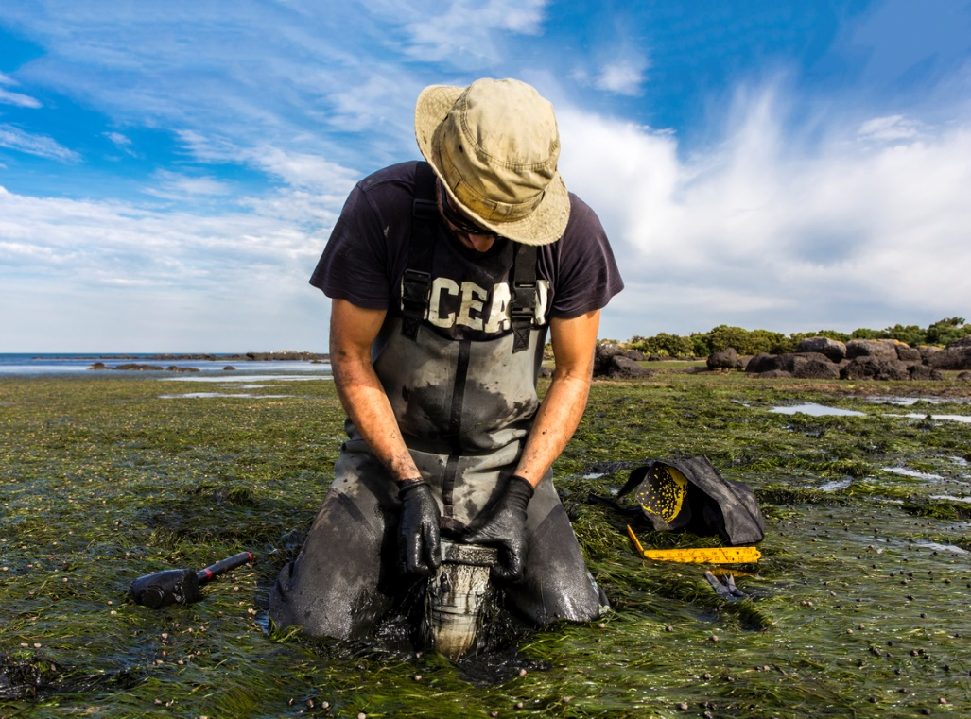It is closely linked to other criteria including Measurement, Reporting and Verification (MRV), methodology certification, and baseline setting.

### Baseline setting

A baseline refers to the emissions that would occur under a business-as-usual scenario. Baseline emissions are compared to emissions that occur during the lifetime of a project to determine the emissions reductions or removals associated with the project.

Baseline setting is closely related to additionality but is not the same. Baseline setting seeks to ensure that activities are not over-credited by considering the most likely counterfactual.

### Leakage avoidance

Leakage occurs when, as a result of undertaking an emissions reduction activity, emissions increase elsewhere through the moving of the activity itself or where the activity leads to changes in a market that encourage an increase in emissions elsewhere.

Leakage avoidance standards aim to prevent crediting of abatement that is offset by an increase in emissions elsewhere. Examples include leakage assessments and quantification, requiring projects to publish leakage estimates, and adjusting issuance amounts to account for leakage.

### Stakeholder inclusivity

Stakeholder inclusivity means active consultation throughout a project to help protect against adverse impacts and encourage positive outcomes. Standards include mandating engagement that ensures stakeholders have adequate information on a project and the development of methods. Standards also include formal complaints and appeal procedures.

### Transparency

Transparency means information about projects and schemes are available to the public. Transparency requirements can include the mandating of publication of detailed project design and operational information, with reasonable restrictions to protect the commercial viability of a project or privacy.

### Legal compliance

Legal compliance means requiring projects to be compliant with all applicable laws and regulations within the jurisdiction in which they are being developed. While legal compliance is broad ranging, standards for land tenure have emerged as a key issue. Standards can require that ownership of the land associated with the project is undisputed.

### Avoiding adverse impacts

Offsets projects can have unintended adverse impacts. For example, sequestration projects can compete with agriculture, industry and local communities for land. Offset projects may also conflict with adaptation activities, for example land-based mitigation projects may affect biodiversity, increasing an ecosystem’s susceptibility to the impacts of climate change (Ravindranath, 2007). The Nature Conservancy raised concerns in its submission to this review about the potential of trade-offs with land rights, biodiversity, food security, and local community livelihoods. Box 4.1 references studies on adverse impacts, and attempts to remediate them, that have been identified in relation to carbon offset projects under the REDD+ scheme.

Standards for mitigating risks of adverse impacts (often called ‘guardrails’) include requiring informed consent and engagement of individuals or communities that are directly impacted by offset projects. The Business Council of Australia suggested including an assessment of adverse impacts to ensure international credits with unacceptable environmental and social guardrails are ineligible for use in Australia.

WeAct considered Gold Standard’s Safeguard Principles to be best practice. The Principles are based on standards developed by the International Finance Corporation, the United Nations Environment Environmental, Social and Economic Sustainability Framework and the United Nations Development Programme standards (Gold Standard, 2019b).

A key practice for mitigating adverse impacts in communities, and encouraging positive outcomes, is community engagement. In regard to international offsets, many developing countries have complex and diverse Indigenous communities but do not have Indigenous advisory groups. For example, Papua New Guinea, a regional source of offsets projects for many Australian entities, has 840 spoken languages in the country (Eberhard, Simons, & Fennig, 2019). To ensure all voices are heard, the United Nations Development Programme has a stakeholder response mechanism that allows individuals and communities to escalate their project-related grievances, with any claims that a project is non-compliant leading to a review (United Nations Development Programme, 2022). Gold Standard has a Continuous Input and Grievance Expression Mechanism for this purpose (Gold Standard, 2022c) and VCS has a grievance redress procedure (Verra, 2022a).

|  |  |  |
| --- | --- | --- |
| BOX 4.1: REDD+: Managing adverse impacts | | |
| REDD+ is a framework designed to guide activities that reduce emissions from deforestation and forest degradation and promote the conservation and management of forests in developing countries (United Nations Framework Convention on Climate Change, 2022a). Article 5 of the Paris Agreement recognises and encourages forestry activities, having regard to both their carbon and associated non-carbon benefits.  The implementation of REDD+ to date provides insights into potential adverse impacts and conflict associated with carbon projects. REDD+ activities have achieved great success in some areas. However they have also resulted in conflicts in Indonesia, Vietnam, Africa and Panama (Alusiola, Schilling, & Klär, 2021; Galudra, van Noordwijk, Agung, Suyanto, & Pradhan, 2014; Hoang, Satyal, & Corbera, 2018; Holmes, Potvin, & Coomes, 2017; Scheba & Rakotonarivo, 2016).  Alusiola, Schilling, & Klär (2021) analysed eight case studies to understand the drivers behind conflict pathways in REDD+ projects. The conflict driver in all case studies was restricting local communities’ access to land for their usual activities such as farming, grazing animals and timber access to other resources. Displacement from land also had flow on impacts including loss of income, physical injury, community division and political instability. |  | In some case studies, project developers worked with the government and local communities to create land boundaries, new forest governance arrangements and integrate local community land use with the project. Community members were allowed partial access for their livelihood and forest guards were removed or reduced. One company built boreholes and valley dams for the farmers to access water outside of the project area while others created an equal pay scheme and allowed joint management and benefit sharing of a rubber plantation. These measures improved project implementation and therefore carbon outcomes.  Projects were independently audited and claims of conflict were investigated, and an Advisory Council on Conflict Resolution and REDD+ was formed in response to findings.  Despite the risks associated with REDD+ projects, they remain a substantial portion of VCS credits (17 per cent) and Plan Vivo credits (16 per cent) (EY, 2022). The remainder of Plan Vivo credits are also nature-based[6] projects. Gold Standard does not certify REDD+ projects, reflecting concerns that potential adverse impacts could undermine the “long-term sustainability” of resulting units (Gold Standard, 2020). |

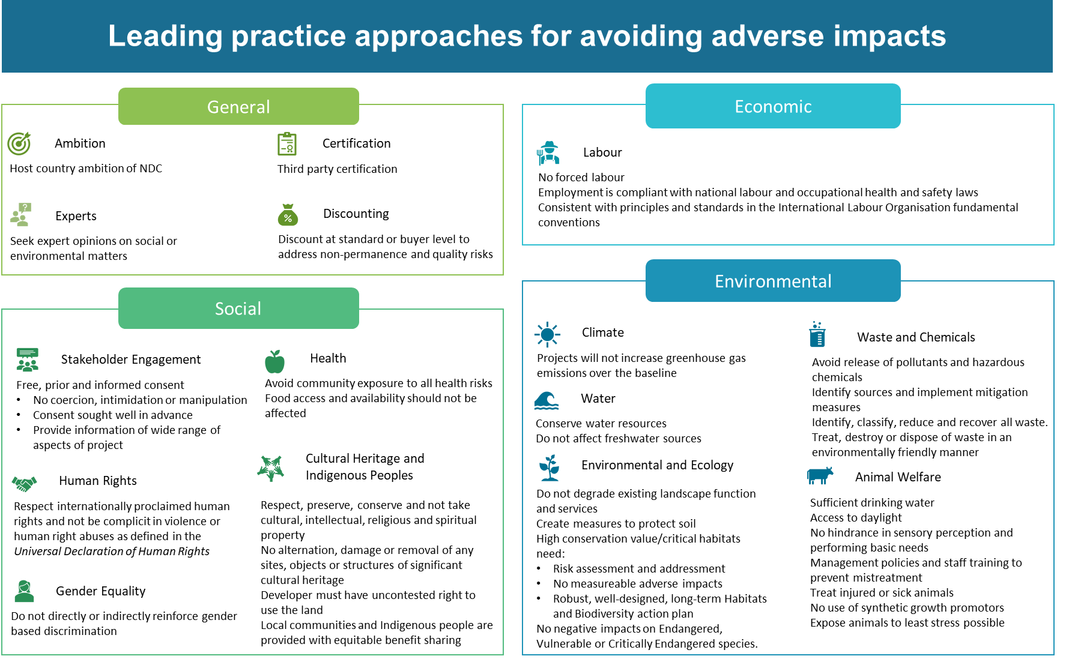

Figure 4.1: Leading practice approaches for avoiding adverse impacts  
**Source**: Climate Change Authority based on (Gold Standard, 2019b; United Nations Human Rights Council, 2018; United Nations Development Programme, 2021).

**RECOMMENDATION 10**

**Adopt robust, best-practice standards for avoiding adverse impacts of international projects under Australian schemes.**

Leading practice approaches for avoiding adverse impacts of offsets projects are set out in Figure 4.1.

### Non-carbon benefits

Non-carbon benefits of abatement projects include the positive social, economic and environmental outcomes of an offset projects.

In the submissions received for this review, several stakeholders (Engineers Australia, Australian Aluminium Council, Origin Energy, Australian Industry Greenhouse Network, BP Australia, EnergyAustralia, Business Council of Australia) considered non-carbon benefits to be secondary to the primary purpose of greenhouse gas mitigation, and view defining, valuing and verifying non-carbon benefits as the responsibility of buyers rather than governments.

Some stakeholders (Woodside Energy, BP Australia, EnergyAustralia, Engineers Australia) have identified the need for transparent information regarding the non-carbon benefits to be available for both domestic and international offsets. Simply Energy suggested the Government develop guidance material to assist offset buyers to do their own due diligence research on the non-carbon benefits of offsets projects.

Other stakeholders (Tasman Environmental Markets, EnergyAustralia) recognised purchasing international offsets can support international development. Non-carbon benefits may be aligned to the United Nations’ 17 Sustainable Development Goals (SDGs). The SDGs were developed for the 2030 Agenda for Sustainable Development and adopted by all UN Member States in 2015 (United Nations, 2015). Some international offset schemes, such as Gold Standard and Verra, classify non-carbon benefitsbased on SDGs.

**RECOMMENDATION 11**

**Build investor confidence in the identification and valuation of non-carbon benefits by developing criteria and standards that enable transparent reporting and assessment of different types of non-carbon benefits.**

**RECOMMENDATION 12**

**Coordinate work between federal and sub-national government agencies to design programs that optimise outcomes for the atmosphere, the environment, health, and communities.**

## 4.3 Governance criteria

Governance criteria relate to a scheme’s overall corporate framework, including its independence, how it manages conflicts of interest, and whether the scheme’s standards are “rules-based” (i.e. based on a centralised set of rules and verification system) or “principles-based” (i.e. decentralised and based on general principles and criteria).

### Measurement, Reporting and Verification

MRV refers to:

* measurement of emissions and removals of greenhouse gases;
* reporting, including through inventories or other guidelines; and
* verification of project outcomes, including technical review and analysis.

The reporting element of MRV is important for tracking the progress of a project. Verification ensures that the project’s abatement being credited is real and that the claimed abatement is occurring. Robust MRV also underpins other fundamental criteria including quantifiability, baseline setting, and leakage avoidance.

At a scheme’s governance level, procedures for MRV provide assurance that a project is meeting the applicable scheme’s criteria and standards throughout the crediting period. Key considerations to determine whether this criterion is met include:

* whether MRV procedure can identify and quantify abatement and assess permanence;
* whether outcomes from MRV are monitored frequently and transparently; and
* whether MRV facilitates public consultation.

### Methodology certification and modification

Methodology certification and modification refers to processes in place within a scheme for certifying methodologies as approved for the generation of offsets. Standards include identifying real and measurable greenhouse gas reductions, defining project boundaries, addressing non-permanence risks, and establishing guardrails against negative social, economic and environmental impacts. Other standards include requiring independent verification during the certification process and undertaking public consultation on proposed methodologies, and reviewing and modifying methods over time.

### Regrowth, after the fire, Boranup Forest. Caves Road, South West, Western AustraliaValidation and verification body requirements

Validation and verification bodies (VVB) assess whether a methodology or project is compliant with the scheme’s standards. VVB standards include criteria that a VVB must meet, a selection process that ensures the independence of the VVB, and transparency of the fee structure for a VVB including the source of funds for its work.

### Crediting period

The crediting period is the amount of time that a project owner can be confident of being issued units, provided the project meets all scheme requirements. Standards typically limit crediting periods to ensure actual mitigation is additional for the duration of the project crediting period, that the amount of creditable abatement is not overestimate as technologies and methodologies change over time, and can provide for renewal or extensions of a crediting period in certain circumstances.

## 4.4 Criteria in the Paris Plus context

### Alignment with Article 6 and double counting

With agreement having been reached on the Article 6 Rules in late 2021, national and voluntary schemes are in a transition phase as nations and participants interpret and implement the new Rules. As the Article 6 Rules evolve, the role of the voluntary carbon market in achieving the goals of the Paris Agreement and contributing to national targets will need to be clarified.

Standards of alignment with Article 6 might include:

* active engagement with Article 6, including working with national governments to meet the requirements for offsets to be ITMOs;
* aligning crediting periods and renewal of crediting periods with NDC implementation periods and Article 6.4;
* enabling offset schemes to coordinate and integrate, such as through transfer of information; and
* updating standards to reflect the Paris Agreement and the logistics of NDCs.

In their submissions to this review, most stakeholders supported standards on double counting in line with Article 6 provisions. Standards to manage double counting include individually identifying carbon credits, ensuring no other projects are occurring on the same land targeted at the same carbon pool, and having strong credit trading and registry procedures that ensure units are tracked, traded and cancelled as appropriate.

The Authority considers that it is not currently necessary to make specific amendments to the Climate Active program to align it with Article 6. However, this will become increasingly important if the program is to contribute to Australia’s targets, as discussed in Part 3. Alignment with Article 6 should be regarded as essential in the design of the IPCOS from the start. Recommendations around alignment with Article 6 are considered in Part 5.

### Adequate ambition

The Article 6 Rules provide an additional level of confidence in the integrity of offsets where they are in the form of ITMOs. Governments effectively underwrite the risk of low integrity units by making corresponding adjustments. Even if an exported unit *doesn’t* represent genuine abatement, the host country will need to make a corresponding adjustment to deduct the amount from its NDC account. To meet its NDC target, the host country may need to find abatement elsewhere to make up for the difference.

However, there is a risk that the Article 6 framework could create a perverse incentive for exporting governments to set less ambitious targets. Exporting governments might be inclined to set less ambitious targets so that they would need less abatement to meet their own target, and thus more to export. To guard against this perverse incentive, importing governments will need to ensure that they only import units from countries with adequately ambitious targets.

### Sustainable development

Under the Paris Agreement, the role of carbon markets is contextualised within the broader aspirations of decarbonisation and obligations towards human rights. Article 6 explicitly requires carbon trading to support sustainable development regardless of whether trades occur under Articles 6.2 or 6.4.[7]

As discussed above, offset projects can have social, environmental and economic outcomes beyond the reduction or removal of greenhouse gas emissions. Promoting non-carbon benefits and avoiding adverse impacts are increasingly important criteria in international and voluntary carbon markets.

### Vintage

The ‘vintage’ of a unit can refer to the year the credit was issued, the abatement occurred, or the project was registered (Broekhoff, Gillenwater, Colbert-Sangree, & Cage, 2019; Department of Industry, Science, Energy and Resources, 2021a). Typically, a unit will not expire until it is retired, but the reporting requirement of a standard may dictate what vintage is eligible to be retired (Maddaford, 2022).

Climate Active currently requires all units to have a vintage year later than 2012 (Department of Industry, Science, Energy and Resources, 2020). Offsets that meet Climate Actives eligibility rules and which have been retired may be banked and used for three years from the date of retirement, regardless of any subsequent changes to Climate Active carbon offset eligibility rules. Offsets retired more than three years ago must meet the latest policy rules to be eligible for use.

In their submissions to this review, stakeholders expressed mixed views on whether there should be restrictions on using units of a particular vintage. Some were concerned about limiting supply and argue vintage is less important than ensuring regular reviews of methods to identify, for example, when a project type is no longer additional (Shell Energy, University of Adelaide).

Others suggested that a ‘rolling vintage period’ that updates consistently over time would be appropriate (The Nature Conservancy Australia, Carbon Market Institute). Origin Energy suggested the vintage of offsets used should align with the relevant NDC period – a Paris Agreement requirement under Article 6.2 or 6.4 for offsets used for compliance purposes.

Under the Paris Agreement, mitigation outcomes and transfers authorised under Article 6.2 or 6.4 must be used within the NDC period in which the abatement occurs (United Nations Framework Convention on Climate Change, 2022b). Aligning the vintage of credits used in the voluntary carbon market with the NDC implementation period would enable Article 6 units to contribute to meeting the target. As a transition measure, the Article 6 Rules allow for pre-2021 CERs to be used towards the host country’s first NDC (United Nations Framework Convention on Climate Change, 2021b).

Under the Kyoto Protocol, RMUs cannot be carried over to a subsequent commitment period. Any RMUs currently in existence in the Australian National Registry of Emissions Units will not be eligible for use towards NDCs.

### Activity types

Abatement efforts fall into three broad categories: reducing emissions; avoiding activities that emit greenhouse gases; and removal and sequestration of carbon from the atmosphere.

The Authority notes that the eligibility of emissions avoidance projects under Article 6 Rules is not settled, with debate on this to be revisited at COP27.[8]

Efforts to abate emissions directly are regarded as more effective than offsetting emissions (Science Based Targets initiative, 2020). Avoiding emissions negates risks associated with low integrity and adverse impacts of offsetting projects, discussed further in ‘demand-side integrity criteria’ below.

As economies transition towards net zero, emissions avoidance opportunities should be exhausted, with the remaining emissions attributable to only the hardest-to-abate sources.

Many of the various scenarios examined by the IPCC indicate that the world will overshoot the levels of greenhouse gas emissions that would be consistent with the temperature goals of the Paris Agreement, and hence there will be a global need to achieve net negative emissions. The IPCC has previously noted that all scenarios limiting global warming to 1.5°C require high levels of carbon sequestration in all its forms, including negative emissions technologies (Intergovernmental Panel on Climate Change, 2018; Intergovernmental Panel on Climate Change, 2022).

To support the development of the National Carbon Market Strategy, the Government should prioritise increasing its understanding of Australia’s emissions removal potential.

Removals will help address emissions that are difficult to abate and will likely play a role in growing negative emissions in the future. Despite this, the role of removal technologies in Australia’s transition to net zero is a significant knowledge gap, including how to best utilise sequestration opportunities.

In a report entitled *Paris Plus: From Cost to Competitive Advantage*, the Authority indicated that it will investigate Australia’s carbon sequestration potential, including negative emissions technologies. This will help build the evidence base for Australia’s future emissions reduction targets. It will shed light on where further work is needed to fully understand the extent to which Australia might use international units and negative emissions technologies to meet future targets.

**RECOMMENDATION 13**

**Build on the Authority’s research to better understand the potential for sequestration and negative emissions technologies in Australia.**

### Demand-side integrity criteria

Demand-side integrity criteria are increasingly important in the Paris Plus context and towards net negative. Entities are increasingly establishing their own decarbonisation strategies and targets, often with a role for offsetting. Relevant market guidance includes the:

* the International Organisation for Standards, which is preparing to launch an International Workshop Agreement on *Net-Zero Guiding Principles* that would enable a common approach to achieving net zero through alignment of voluntary initiatives, standards and national and international policy objectives (International Organisation of Standards, 2022);
* International Science-Based Targets initiative (SBTi), a partnership between CDP, the United Nations Global Compact, World Resources Institute and the World Wide Fund for nature, which requires companies to measure their scope 1, 2 and 3 emissions and annually disclose their performance against Science Based Targets (SBTs), with targets considered to be ‘science-based’ if they align with the Paris Agreement’s temperature goals[9] (Science Based Targets initiative, 2020);
* the International Sustainability Standards Board, established at COP26 to develop a comprehensive global baseline of sustainability disclosures for capital markets, is currently consulting on its first two proposed standards which include consideration of offsets (International Sustainability Standards Board, 2022); and
* Taskforce on Climate-related Financial Disclosure (TCFD), which assists companies account for climate change in assessing risks and undertaking transition planning (Taskforce on Climate-related Financial Disclosure, 2021).

In Australia, the Australian Securities and Investments Commission and Australian Prudential Regulation Authority recognised the TCFD framework as best practice in 2019 and the Corporate Governance Council of the Australian Securities Exchange has recommended that all listed companies disclose climate risk in line with the TCFD framework (Australian Securities & Investments Commission, 2021; Australian Prudential Regulation Authority, 2019). Unless material, it is not mandatory for entities to report on climate-related risks to their operations, strategy and financial planning in Australia. However, the Government has confirmed its intention to introduce a mandatory disclosure regime, and greenwashing is an identified priority for the corporate regulator (Bowen, Albanese, & McAllister, 2022).

The Provisional Claims Code of Practice by VCMI (Voluntary Carbon Markets Integrity Initiative, 2022) provides guidance on credible voluntary use of carbon credits, which includes the following recommended actions:

* making a public commitment to achieve science-aligned long-term net zero emissions no later than 2050, covering scope 1, 2 and 3 and actions are in alignment with the Paris Agreement;
* making public interim emissions reduction targets;
* provide detailed information on plans and strategies to achieve targets; and
* maintaining a publicly available greenhouse gas emissions inventory following the greenhouse gas protocol or equivalent.

Climate Active requires that participants introduce an emissions reductions strategy demonstrating an emissions reduction target and the measures necessary to support that target (Department of Industry, Science, Energy and Resources, 2021a).

**RECOMMENDATION 14**

**When the Voluntary Carbon Markets Integrity initiative’s (VCMI) Claims Code of Practice is finalised, consider updating the Climate Active Technical Guidance Manual to reflect the Code.**

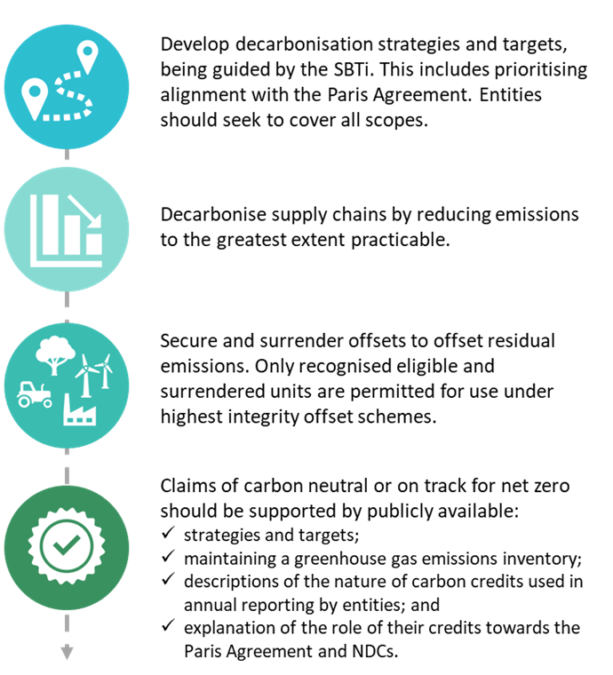Figure 4.2 summarises best practice based on approaches encouraged by VCMI’s provisional Code of Practice and Climate Active.

Figure 4.2: Offsets in best practice approaches to decarbonising

**Source**: Climate Change Authority, based on Climate Active and Voluntary Carbon Markets Integrity initiative provisional Claims Code of Practice.

## 4.5 Criteria that matter for Australian schemes

The terms of reference requested the Authority’s advice on the most important criteria for accepting emissions offsets for use in Climate Active and as part of the IPCOS, including considering emissions offset claims from within and across different carbon accounting frameworks and potential differences in criteria relating to the use of those offsets.

The following section describes the Authority’s view on these terms of reference (Part 1.1) in the Paris Plus context. The eligible units that flow from these conclusions are considered in Part 5.

The most important criteria for offsets can be characterised in three ways: fundamental to integrity, bolstering integrity, and context-specific.

Criteria fundamental to integrity are necessary in all circumstances to ensure offsets represent genuine abatement. These represent the “most important criteria” in schemes that prioritise least cost abatement.

Criteria that bolster integrity are not essential for determining that an offset represents genuine abatement but are indicators useful in assessing integrity.

The relevance of context-specific criteria depends upon the objectives of the policy under which an offset is being generated or utilised. This criterion has no inherent relationship to integrity. The context-specific criteria for the IPCOS and Climate Active differ, given their distinct policy purposes.

|  |  |  |
| --- | --- | --- |
| Table 4.1: Criteria for offset schemes | | |
| **Fundamental to integrity** | **Bolstering integrity** | **Context-specific** |
| * Additionality * Permanence * MRV * Quantifiability * Baseline setting * Leakage avoidance * Crediting period * Methodology certification * Validation/ verification * Avoiding double counting | * Vintage * Stakeholder inclusion * Transparency * Legal compliance * Avoiding adverse impacts | * Non-carbon benefits * Activity types * Article 6 alignment |

### Indo-Pacific Carbon Offsets Scheme

The Government released the draft principles for the IPCOS in November 2021 (Table 4.2) (Department of Industry, Science, Energy and Resources, 2021b). The scheme will run for 10 years until 2031, and will be operationalised through bilateral agreements with partner countries including Papua New Guinea and Fiji (Department of Industry, Science, Energy and Resources, 2021c; Department of Industry, Science, Energy and Resources, 2022a).

In developing the IPCOS, Australia should assist other countries in the region to build the regulatory architecture, and institutional and technical capacity to participate in Article 6 as a precursor to establishing a regional carbon market in the Asia Pacific.

Program design may first require an initial capacity building investment phase followed by the development of offset projects. The IPCOS should be developed to ensure host countries will be able to facilitate trades under the Article 6 Rules once they are confident they can meet their own NDC, now and into the future.

A second phase regarding the sale of units should encourage benefit sharing, for example where a certain percentage of units are reserved for OMGE or the host country’s NDC. The IPCOS should:

* ensure alignment with the Paris Agreement, including through the promotion of SDGs;
* create a mechanism for feedback from individuals and groups affected by offset projects and initiate compliance audits for any reports of non-compliance; and
* be subject to regular review.

**RECOMMENDATION 15**

**In designing the Indo-Pacific Carbon Offsets Scheme (IPCOS), include fundamental, bolstering and context-specific criteria, align with the Sustainable Development Goals, ensure adequate ambition and plan to review the design of the scheme regularly.**

The Authority supports promoting non-carbon benefits as a priority for the IPCOS where the Government has a substantial role, either procuring units or directly claiming mitigation benefits as a consequence of units.

Table 4.2: Indo-Pacific Carbon Offsets Scheme Principles

|  |  |
| --- | --- |
| **Principle** | **Detail** |
| Transparent and inclusive governance | * The IPCOS is a partnership arrangement between the private and not-for profit sectors, Australian Government, and Indo-Pacific countries hosting projects. * Governance arrangements must give a voice to peoples and communities impacted by projects and deliver market assurance while respecting countries’ sovereignty and acknowledging project host countries’ circumstances. |
| Aligned with the Paris Agreement and SDGs | * The IPCOS will align with Article 6 of the Paris Agreement, including the application of robust accounting to ensure the avoidance of double counting. Projects should endeavour to deliver co-benefits which contribute to SDGs. |
| Responsibility and cooperation amongst parties | * Partners must support and cooperate with each other through the design of the IPCOS. A partner usually responsible for a sector or activity in a host project country should also have corresponding responsibility under the Indo-Pacific Carbon Offsets Scheme. Partners have a responsibility to participate actively and engage constructively. Scheme design will create opportunities for participation. * Where possible, the use of existing public and private infrastructure, frameworks and policies should be used to optimise engagement of, and use of, existing knowledge, experience, information and data. |
| High-integrity units | * Scheme design must recognise the importance of environmental integrity, social and environmental safeguards, and participatory and equitable community benefit-sharing arrangements, for the successful implementation of emissions reduction projects in the region. * Abatement will be real, measured, reported and independently verified with no advanced or retro-active crediting. Reporting of abatement should be accurate, conservative, and timely. * The abatement should be permanent with risk assessments and treatments, such as buffers and reversal requirements, safeguards for permanence after crediting periods, and notification of reversals. * Projects must not already be required by law and must be additional. Leakage should be assessed and treated, monitored and deductions made as appropriate. The IPCOS units are only issued once and not simultaneously sold to multiple parties (i.e. no fraudulent creations or transactions) with realistic and credible project baselines that are conservative, updated over time and nested within NDCs. |

Source: (Department of Industry, Science, Energy and Resources, 2021b).

### Climate Active

##### BOX 4.2: Climate Active offsets integrity principles

* Additional: it must result in emissions reductions that are unlikely to occur in the ordinary course of events, including due to any existing commitment or target publicly agreed by the entity responsible for issuing the units. It must represent abatement that has not been double counted.
* Permanent: it must represent permanent reductions in greenhouse gas emissions. In the case of sinks, this requires that the carbon stored is sequestered and will not be released into the atmosphere for a period of 100 years. Where a period of less than 100 years is applied to sequestration units, an appropriate discount must be applied.
* Measurable: methods used to quantify the amount of emissions reductions generated must be supported by clear and convincing evidence.
* Transparent: consumers and other interested stakeholders must have access to information about the offset project that generated the abatement, including the applied methodology and project-monitoring arrangements.
* Address leakage: the system responsible for generating the offset unit must provide deductions for any material increases in emissions elsewhere which nullify or reduce the abatement that would otherwise be represented by the offset unit.
* Independently audited: the circumstances responsible for the generation of the unit must be verified by an independent, appropriately qualified third party and not found to be in contradiction with these integrity principles.
* Registered: the offset unit must be listed and tracked in a publicly transparent registry.

**Source**: Department of Industry, Science, Energy and Resources, 2020.

The Climate Active scheme identifies some criteria fundamental to integrity in its offset integrity principles (Box 4.2), which are modelled on the ERF criteria and Offsets Integrity Standards (Department of Industry, Science, Energy and Resources, 2020) as set out in section 133 of the CFI Act.

Climate Active sets minimum standards for operations, events, buildings, precincts, products or services seeking recognition under the program.

Climate Active does not currently require units to produce non-carbon benefits, although non-carbon benefits can be reported (Department of Industry, Science, Energy and Resources, 2021a) and it is expected that buyers will conduct their own due diligence (Clean Energy Regulator, 2020; Clean Energy Regulator, n.d.). The Authority’s review of Climate Active projects found:

* organisations often seek to reflect aspects of their businesses into their offset purchase decisions. For example, water delivery companies chose to support international water purification offset projects, while a wholesaler that sources ingredients from Peru chose to support a forestry project in Peru (Big Springs Water, 2022; Kiewa Valley, 2021; Phyto-Therapy, 2021);
* over half of the ACCU purchases for use under Climate Active rely on the savanna fire management method, which has biodiversity and Indigenous employment benefits (Figure 4.3);
* the majority of international offsets rely on solar and wind power (Figure 4.4); and
* 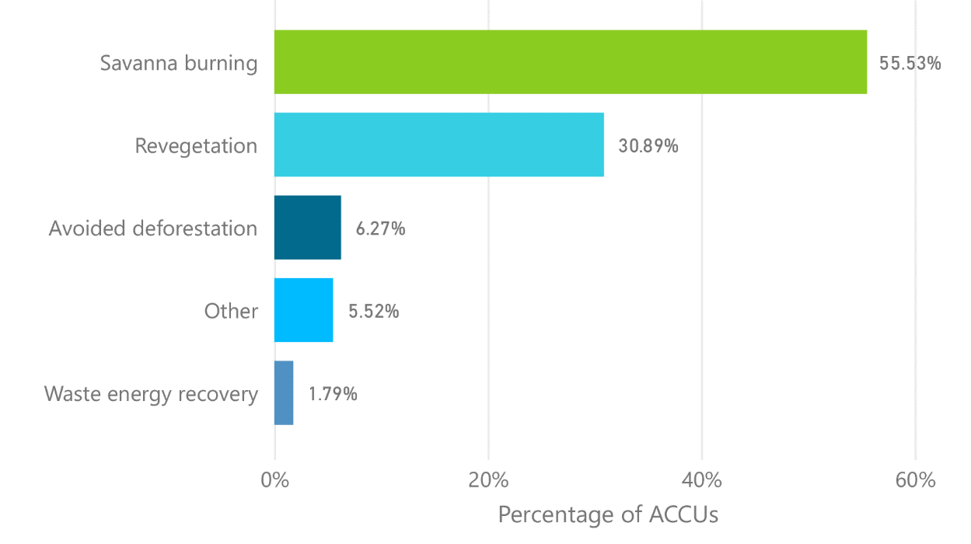participants are purchasing stapled offsets which see international offset units bundled with future carbon removal and potentially other non-carbon benefits.[10] EcoAustralia credits staple wind, energy efficiency or hydro VERs with Australian Biodiversity Units (ABUs)[11] to promote non-carbon benefits overseas and domestically (South Pole, 2022).

The Authority does not consider mandating non-carbon benefits necessary under Climate Active as units are being voluntarily sourced by entities. Buyers can seek offsets with non-carbon benefits and recognise their premium value in the absence of a mandate on co-benefits. The Authority notes some eligible schemes, as identified in Part 5, incorporate non-carbon benefits into units and some Climate Active participants may favour offset projects based on offset prices and their entity’s goals.

Figure 4.3: ACCU project types purchased by Climate Active participants

**Source**: Climate Change Authority based on data provided by Climate Active and is from 2019 to present as of 18 May 2022.

**RECOMMENDATION 16**

**Produce a guidance document to assist Climate Active participants to recognise and make informed decisions about offsets projects that deliver non-carbon benefits.**

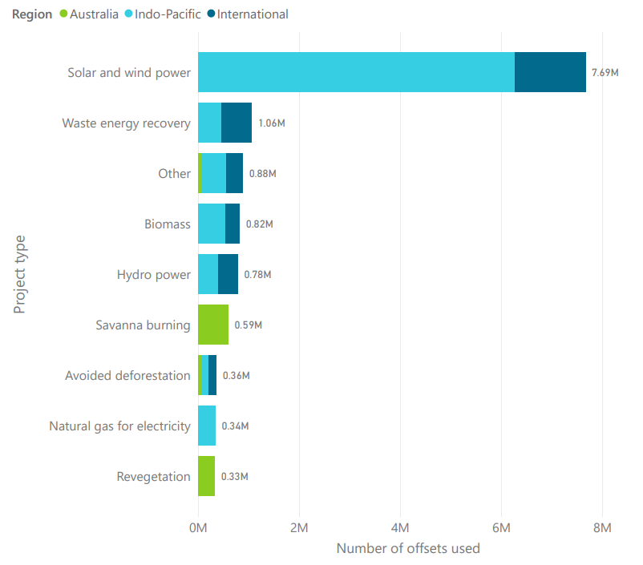

Figure 4.4: Offset type and location used under Climate Active.

**Source**: Climate Change Authority based on data provided by Climate Active and is from 2019 to present as of 18 May 2022.

# **Part 5 Climate Active - eligible offsets**

“… which offsets could be eligible for use under Climate Active at the present time.”

**Key Insights**

The Government’s response to this review provides it with the opportunity to set the standard for Australia’s voluntary and compliance markets beyond Climate Active.

The assessment framework presented in Part 4 is a useful tool for examining and comparing the quality of offsets, used alongside consultation, analysis and sound judgement.

It’s time to phase out older units. A rolling five-year vintage rule should be applied to all units under Climate Active to phase out Kyoto-era units, to keep up with evolving practices, and to encourage continuous improvement.

The assessment framework will need to be updated and applied regularly to keep up with a rapidly evolving voluntary carbon market.

## 

## 5.1 Summary

To inform its recommendations on the international offsets that should be eligible for use under Climate Active, the Authority commissioned EY to prepare a technical report incorporating:

* a stocktake of international offset schemes;
* an assessment framework for examining and comparing the quality of offsets; and
* application of the framework to assess shortlisted schemes, drawing on feedback from stakeholder consultations.

The Authority’s secretariat worked with EY to refine the assessment framework and shortlist schemes for assessment (Figure 5.1).

## 5.2 Methodology

### Stocktake and shortlist

EY scanned currently operating carbon offset schemes, identifying 11 schemes in total. Due to the limited time available for this review, the Authority prioritised five schemes for assessment based on the current eligible offset units under Climate Active, the presence of units in the Indo-Pacific region and the equivalence of similar schemes.

Figure 5.1: Assessing carbon offset schemes

**Source**: Climate Change Authority based on EY 2022.

Shortlisted schemes were:

* Gold Standard, Verra[12] and the CDM, which all have some standards accepted under Climate Active;
* Plan Vivo, as an example of a scheme that prioritises non-carbon benefits; and
* 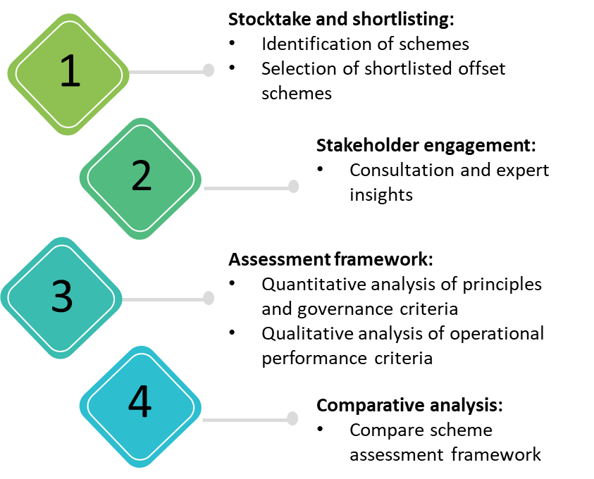Japan’s JCM, an example of a units generated through bilateral agreements.

The JCM is discussed in EY’s report, however the scheme was ultimately excluded from the quantitative assessment because of challenges applying the framework to a bilateral scheme.

The Authority recommends that the following schemes be considered in the future for possible Climate Active eligibility:

* Article 6.4 centralised mechanism (once operational);
* Article 6.2 cooperative approaches (as they are established);
* American Carbon Registry;
* Regen Registry;
* Climate Action Reserve;
* UK Woodland Carbon Code; and
* Global Carbon Council.

The Authority considers the following schemes to be a lower priority for the stated reasons.

* Joint Implementation – Joint Implementation is a Kyoto Protocol mechanism that could transition to Article 6.2 cooperative approaches or the Article 6.4 mechanism, included above.
* Architecture for REDD+ Transactions / The REDD+ Environmental Excellence Standard – there are few registered projects and limited information on issued credits publicly available. Activities undertaken as REDD+ projects may be able to transition to cooperative approaches under Article 6.2 or the Article 6.4 mechanism.
* China Greenhouse Gas Voluntary Emission Reduction Program – has a limited geographical presence and detailed program data are not available for analysis.
* Republic of Korea Offset Credit Mechanism – operations are dependent on CDM and its geographical presence is limited.

### Assessment framework

The Assessment Framework has a three-layer approach, comprising Principles, Governance criteria, and Operations performance (Figure 5.1). Each layer contains criteria that enable more granular assessments. The Principles and Governance criteria are scored, weighted and compiled to enable quantitative analysis, while Operational performance is assessed using qualitative methods.

#### Principles and Governance

The Principles and Governance criteria used in the assessment framework are set out in Part 4.

To ensure lesser performance against important criteria is not obscured by a high overall score, an asterisk note (*note) approach is used[13]. An asterisk assessment means a scheme did not score highly enough on an important criterion, encouraging further investigation and due diligence.

Criteria and layers were ascribed a weighting to assist with the quantification of the schemes. A sensitivity analysis of weightings showed that variable weightings had negligible effect on the overall weighted average results. Thus equal ratings for criteria associated with the layers were used. The exceptions to even weightings were:

* double-issuance, double-use and double-claiming as these are all elements of double counting, and thus were each assigned a third of the weighting of the other criteria; and
* SDG alignment and non-carbon benefits as these criteria are similar in representing benefits additional to emissions reduction, and thus were assigned half of the weighting compared to other criteria.

#### Operational performance

Operational performance was analysed qualitatively due to the subjective nature of assessing the operational performance of an offset scheme. For example, an offset scheme that is growing fast and producing large volumes of credits could be the result of a well-run offset scheme, but could also be the result of an offset scheme with lenient principles and governance.

On receiving the technical report from EY, the Authority conducted further analyses to investigate:

* whether certain low scores or asterisk notes were due to scheme-level concerns or particular activity types. For example, an asterisk related to leakage avoidance applies at the scheme level, but further assessment might reveal leakage is not a risk in certain locations or project types;
* how schemes would score when weightings of criteria were adjusted to better reflect the priorities of different uses of the offsets. For example, non-carbon and SDG benefits and geographical diversity should be weighted higher for the IPCOS than for Climate Active or compliance mechanisms; and
* how schemes might perform in the transition to the Paris Agreement, drawing from the report prepared by Gilbert + Tobin, submissions to this report, and consultation with experts.

### Level of analysis

The terms of reference requested that the Authority advise whether the criteria set out in Part 4 can or should be applied at a scheme level, by classes of units or project types or individual projects.

The appropriate level depends on the purpose, context – including the resources available to conduct the assessment – and the desired amount of interrogation. For example, scheme-level assessment can be supported with more granular assessment where concerns regarding a particular class of project or methodology arise. Similarly, project level assessments can consider whether the schemes they operate within are well-governed.

In their submissions to this Review, stakeholders identified the need for international offsets to use quality standards to ensure high levels of integrity (Australian Aluminium Council, Snowy Hydro, Tasman Environmental Markets, Australian Industry Greenhouse Network, Simply Energy, University of Adelaide, BP Australia, Business Council for Sustainable Development Australia, Integrity Council for the Voluntary Carbon Market, EnergyAustralia, The Nature Conservancy Australia, Business Council of Australia). However, there were varying views on whether current voluntary carbon market standards are of sufficient quality.

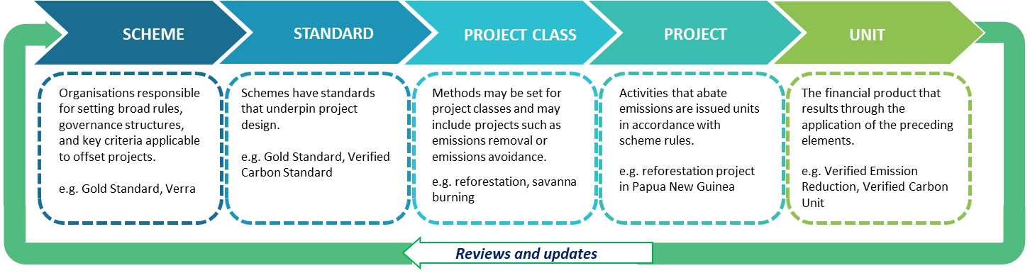CORSIA lists both eligible schemes and units where they have met the CORSIA Emissions Unit Eligibility Criteria (International Civil Aviation Organisation, 2022) (International Civil Aviation Organisation, 2019). For this review, the Authority considers assessment at the scheme level to be appropriate, with regular literature review and stakeholder consultation to identify problematic units.

Figure 5.2: Various levels of the generation of carbon offsets

**Source**: Climate Change Authority.

The decision-making framework must be transparent and should be regularly reviewed. Assessing offsets at a project or methodology level provides a resourcing challenge for an approving body such as Climate Active. For example, the CDM has more than 100 approved methodologies, whilst Verra and Gold Standard have more than 50 methodologies each (EY, 2022).

## **5.3 Results**

Based on the quantitative assessments, two schemes demonstrated high overall quantitative integrity. Gold Standard scored highest on integrity principles and rated second on governance with the inverse the case for Verra. Plan Vivo and CDM demonstrated relatively lower scores.

Table 5.1: Overall Quantitative Integrity Scores

|  |  |  |  |  |  |
| --- | --- | --- | --- | --- | --- |
|  | **Criteria** | **Gold Standard** | **Verra** | **Plan Vivo** | **CDM** |
| 1. | Principles | 95% | 87% | 81% | 74% |
| 2. | Governance | 88% | 91% | 70% | 67% |
|  | Overall score | 91% | 89% | 75% | 70% |

**Source**: EY 2022.

Principles

The principles include two broad groups: core integrity principles that focus on the integrity of the abatement itself (e.g. additionality, permanence, leakage avoidance); and newer principles that have become more important under the Paris Agreement (e.g. double issuance, double use, double claiming, SDG alignment, non-carbon benefits) as discussed in Part 4 above.

*Table 5.2: Principles Assessment*

|  |  |  |  |  |  |
| --- | --- | --- | --- | --- | --- |
|  | **Criteria** | **Gold Standard** | **Verra** | **Plan Vivo** | **CDM** |
| 1. | Double issuance | 100% | 63% | 88% | 63% |
| 2. | Double use | 83% | 83% | 100% | 67% |
| 3. | Double claiming | 92% | 58% | 75% | 75% |
| 4. | Additionality | 94% | 89% | 72% | 94% |
| 5. | Permanence | 94% | 100% | 81% | 94% |
| 6. | Transparency | 100% | 79% | 71% | 93% |
| 7. | Quantifiability | 100% | 100% | 100% | 100% |
| 8. | Baseline setting | 88% | 100% | 81% | 88% |
| 9. | Leakage avoidance | 100% | 100% | 75% | 100% |
| 10. | Stakeholder inclusivity | 83% | 83% | 83% | 83% |
| 11. | Legal compliance | 100% | 100% | 100% | 50% |
| 12. | Guardrails against negative impacts / do no harm principle | 100% | 50% | 80% | 20% |
| 13. | SDG Alignment | 100% | 100% | 17% | 0% |
| 14. | Non-carbon benefits | 79% | 79% | 100% | 43% |
|  | **Principle overall score** | 95% | 87% | 81% | 74% |

**Source**: EY 2022.

### Governance framework

Governance criteria are important for the effective implementation of principles. Gold Standard and Verra scored highly on governance, though all four schemes have room for improvement.

Table 5.3: Governance Assessment

|  |  |  |  |  |  |
| --- | --- | --- | --- | --- | --- |
|  | **Criteria** | **Gold Standard** | **Verra** | **Plan Vivo** | **CDM** |
| 1. | Standard governance framework | 80% | 100% | 50% | 60% |
| 2. | Methodology certification / modification | 100% | 100% | 100% | 67% |
| 3. | Crediting period | 100% | 100% | 75% | 100% |
| 4. | Project documentation requirements | 100% | 100% | 67% | 83% |
| 5. | Stakeholder engagement | 63% | 75% | 50% | 75% |
| 6. | Validation and verification body requirements | 100% | 100% | 88% | 88% |
| 7. | Measurement, Reporting and Verification Procedure | 100% | 90% | 80% | 60% |
| 8. | Complaint and appeal procedure | 100% | 100% | 67% | 0% |
| 9. | Credits trading procedure | 50% | 50% | 50% | 67% |
|  | **Governance overall score** | 88% | 91% | 70% | 67% |

**Source**: EY 2022.

Operational performance was analysed through a qualitative approach, by considering transparency and data availability, carbon credit pricing, active credits and vintages, project type and methodology, geographical diversity, volume growth and project rejection rates.

### Summary of scheme results

#### Gold Standard

Gold Standard performed strongly against most criteria.

**Integrity Principles Criteria**

Gold Standard ranked highly across the integrity criteria (EY, 2022). The scheme addresses additionality and permanence through its Gold Standard Permanence Buffer, reserving 20 per cent of VERs issued for this purpose (Gold Standard, 2022b). The scheme also requires:

* evidence of legal ownership and compliance with a host country’s legal, environmental, ecological and social regulations (Gold Standard, 2019b);
* a minimum of three SDGs to be met, one of them being SDG 13 Climate action (Gold Standard, 2019a); and
* projects to conduct a Safeguarding Principles Assessment, a process based on [International Finance Corporation](https://www.ifc.org/wps/wcm/connect/Topics_Ext_Content/IFC_External_Corporate_Site/Sustainability-At-IFC/Policies-Standards/Performance-Standards) and [United Nations Development Programme](https://www.undp.org/accountability/social-and-environmental-responsibility/social-and-environmental-standards) standards (Gold Standard, 2019b).

**Governance Criteria**

Gold Standard has robust complaint and appeal procedures with a publicly available Grievance Procedure in place to assist any stakeholder submitting a grievance to the scheme (EY, 2022). While the scheme ranked well for transparency, there is no publicly available information on procedures for credit transfer and data on volume of transactions (EY, 2022).

**Operational Criteria**

Gold Standard generates 95 per cent of its credits from avoidance projects, however the scheme does not credit REDD+ projects (EY, 2022). The majority of the scheme’s available credits were generated between 2011 and 2018 (EY, 2022).

**Article 6 alignment**

Gold Standard has recently softened its approach to corresponding adjustments, permitting units on the voluntary carbon market to be traded without always requiring corresponding adjustments for internationally traded units (Gold Standard, 2022a). Previously, Gold Standard required all of their certified emissions to align with the Paris Agreement, but only some were to be authorised as ITMOs.

* Approved ITMOs can be adjusted by a host Party, and then be counted towards a receiving Party’s NDC, be treated as a voluntary offset, or be used under an international scheme such as CORSIA.
* Non-ITMOs can be traded domestically and counted by the host Party, but not adjusted (Gold Standard, 2021).

#### Verra

Verra performed well against most criteria. The VCS was largely the focus in this review however additional elements such as the registry functions of Verra were also considered. The Authority has adopted Verra for simplicity. Climate Active only endorses eligible units (i.e. VCUs) not schemes. Beyond the VCS, Verra also includes:

* VCS Jurisdictional and Nested REDD+ Framework;
* Climate, Community & Biodiversity (CCB) Program;
* Verra California Offset Project Registry;
* Sustainable Development Verified Impact Standard (SD VISta)
* LandScale; and
* Plastic Waste Reduction Standard.

The Authority did not conduct a detailed review of these standards.

**Integrity Principles Criteria**

Verra demonstrated strong regulations to ensure permanence by requiring all projects to prepare a non-permanence risk report as part of the validation and verification process (EY, 2022). This also requires projects to set aside non-tradable buffer credits to account for unforeseen losses in stock (EY, 2022). The scheme was a leader in baseline setting and requires the baseline to be updated based on technological improvements (EY, 2022). There is a need for clearer definitions on double issuance and double claiming (EY, 2022).

Verra requires a project proponent to demonstrate that a project contributes to at least three SDGs by the end of the first monitoring period, and in each subsequent monitoring period with the option of additional non-carbon benefits to be recognised under the SD VISta or CCB standard (Verra, 2022a). For SD VISta, projects are assessed by third parties to ensure the standards framework is followed and VCUs are assigned the SD VISta label (Verra, 2019). For CCB, projects need to support local communities and conserve biodiversity while addressing climate change (Verra, 2022a).

The assessment revealed that Verra could improve the guardrails it has in place to mitigate the risk of adverse impacts, scoring only 50 per cent against this criterion. While Verra does apply guardrails, these are at a high level and do not have detailed, quantifiable requirements (EY, 2022). Verra lacks a “negative list” to exclude project types that are known to have potential negative impacts or other integrity criteria concerns (EY, 2022).

**Governance Criteria**

The scheme was found to have a robust governance framework, with all project documentation templates published online, and all documents required to be submitted as part of the approval process (EY, 2022). However, the scheme does not clarify what information can be considered confidential (EY, 2022). Verra’s methodology certification has stringent requirements, including engaging independent reviewers, public consultation and engagement of a third party auditor for assurance purposes (EY, 2022). The scheme lacks publicly available information on procedures for credit transfer, data on credit retirement or volume of transactions (EY, 2022).

**Operational Criteria**

Under the scheme, a mix of removal and avoidance credits are generated through mostly Agriculture, Forestry and Other Land Use projects with a growing focus on Natural Climate Solutions (EY, 2022). The majority of the scheme’s available credits were generated in between 2011 and 2018 (EY, 2022).

**Article 6 alignment**

Verra is unlikely to require corresponding adjustments for voluntary offsets. While the scheme recognises that VCS credits could be incorporated under a host Party’s NDC accounting framework, corresponding adjustments will not be mandated and each country will be required to determine their approach (Verra, 2022a). Verra is developing a label for credits that demonstrate meeting the eligibility criteria for Article 6, however no timeframe has been given for when this will occur (Verra, 2022a).

#### Plan Vivo

Plan Vivo is a market leader on non-carbon benefits and is active in the Indo-Pacific region. However, it is still maturing as a standard and has room to improve on criteria including additionality, permanence and SDG alignment.

**Integrity Principles Criteria**

Plan Vivo requires projects to describe how they will ensure permanence relative to the Baseline Scenario (EY, 2022). Risks to the maintenance of the abatement for a period of at least 50 years must be identified and significant risks must be mitigated (EY, 2022). Projects are required to define a non-permanence risk buffer, the size of which should be set based on an analysis of the risks associated with carbon credits generated by the project (EY, 2022).

The standard is a market leader regarding non-carbon benefits. Plan Vivo prioritises non-carbon benefits by working closely with local communities, focusing on relieving poverty, restoring and protecting environments and building local capacity of developing countries (Plan Vivo, n.d.). However, projects are encouraged but not required to adopt carbon, livelihood or ecosystem indicators related to the United Nations SDGs.

Plan Vivo Environmental and Social Policy Framework requires a localised risk assessment to consider adverse impacts (EY, 2022). Risks of adverse impacts must be assessed, and mitigation and monitoring measures put in place where necessary, as part of the project design and throughout the Project Period (EY, 2022). Plan Vivo implements a variety of social, environmental and economic guardrails. Additionally, a minimum of 60 per cent of income from the sale of Plan Vivo Certificates, after payment of any charges, taxes or similar fees levied by the host country, must go directly to the Project Participant(s) and/or the broader community in the Project Region (Plan Vivo, 2013).

**Governance Criteria**

This scheme would benefit from providing clarity on stakeholder consultation requirements. Currently developers are only required to demonstrate that stakeholders have been informed and provided with information on the project. Whilst a complaints procedure is in place for certification, there are no appeal avenues.

**Operational Criteria**

Under the scheme, 97 per cent of projects are removal credits in developing countries, which includes REDD+ projects (EY, 2022). Nearly 40 per cent of available credits were generated in 2021 (EY, 2022).

**Article 6 alignment**

The recently updated Plan Vivo Standard seeks to demonstrate its alignment with the evolving voluntary carbon market by incorporating lessons learned from working with communities to strengthen socio-economic aspects of the standard and provide projects and the carbon credits derived from them with standardisation and transparency (Plan Vivo, 2021). Detail of Plan Vivo’s operationalisation of the Article 6 Rules was not found (Plan Vivo, 2021).

#### Clean Development Mechanism

The CDM is a well-established standard under the Kyoto Protocol but did not score as highly as other schemes.

**Integrity Principles Criteria**

Only afforestation or reforestation projects are required to meet permanence checks (EY, 2022). There is no requirement to align with SDGs or require projects to have non-carbon benefits (EY, 2022). Whilst a tool is available for project developers to demonstrate non-carbon benefits, this is not mandatory (EY, 2022).

CDM requires project participants to conduct environmental impact analysis, including transboundary impacts (EY, 2022). However, the CDM makes no reference in its guidance documents to preventing negative impacts and socio-economic impacts may also be analysed for specific projects (EY, 2022).

**Governance Criteria**

CDM has a detailed and publicly available procedure of credit ownership transfer (EY, 2022). It also ensures methodology certification is achieved via panels and working groups which are not independent and contained within CDM’s corporate structure (EY, 2022). CDM lacks complaint or appeal procedures for stakeholders (EY, 2022).

**Operational Criteria**

The CDM provides lessons in capacity building and how low-integrity units can undermine the broader marketplace. Under the scheme, the majority of credits are avoidance credits, with most generated more than six years ago (EY, 2022).

**Article 6 alignment**

CERs are only eligible for use towards a first (or updated first) NDC and will remain badged as CERs rather than A6.4ERs, meaning they are not permitted for export (Part 2.2). CDM activities can apply to transition to the Article 6.4 mechanism and apply their approved CDM methodology until the end of their current crediting period or 31 December 2025, whichever is earlier.

## 5.4 Updating the eligibility of offsets

Standards continue to be developed, and existing standards are often updated. External factors, such as market forces and the operationalisation of the Article 6 Rules, will also influence the validity of this assessment over time. The Authority recommends this assessment be revisited in two years’ time, and a regular review of units accepted in Australia be established.

Most stakeholders (BP Australia, The Nature Conservancy Australia, Business Council of Australia, Carbon Market Institute) support regular reviews of principles that underpin the creation of offsets to ensure they remain fit for purpose and of high integrity as technologies, policies, markets and knowledge evolve. However, there is a strong concern from other stakeholders (Simply Energy, Carbon Market Institute, Property Council of Australia, BP Australia) that transitional arrangements should apply where changes are made, to minimise disruption to the market and/or ensure appropriate lead times for regulatory changes to be known in the market. Many stakeholders (Australian Industry Greenhouse Network, Beyond Neutral, EnergyAustralia, Property Council of Australia, and Origin Energy) emphasised the importance of consultation on changes before they are applied.

The terms of reference asked the Authority to advise on:

(e) to what extent the vintage of units (such as relating to abatement, project registration or issuance) should be relevant to the use of those offsets; and

(f) which offsets could be eligible for use under Climate Active at the present time.

Climate Active currently requires all units to have an issuance vintage year of later than 2012[14] (Department of Industry, Science, Energy and Resources, 2020). The program currently permits retired and formally approved units under the program to be banked for use for three years from the date of retirement regardless of any subsequent changes to Climate Active rules. The eligibility of offset units under Climate Active may change where “new information or different offset units” are revealed to the program’s administrators (Department of Industry, Science, Energy and Resources, 2020, p. 7).

Eligible units should be subject to a five-year rolling vintage rule, whereby all units should have been issued no more than five years prior to their cancellation. A five-year rolling vintage would:

* assist the transition towards units that meet standards and rules of the Paris Agreement as they evolve;[15]
* mitigate the risk that any problematic units could flood the market and adversely impact confidence in integrity long term; and
* discourage speculative ‘unit banking’, which impedes liquidity and diverts units away from the primary purpose of enabling mitigation.

As voluntary and compliance markets evolve under the Paris Agreement, their rules for vintage may converge to align with NDC periods. A future review of offsets integrity in 2025 could consider bringing the vintage rules into alignment, changing to 5-year fixed vintages aligned with Australia’s NDC periods. Related regulatory reforms would be necessary to allow Australia to include units with a vintage of less than five years across to subsequent the NDC period.

The existing grandfathering provisions under Climate Active allow for discontinuation of the eligibility of pre-2021 units with minimal disruption.

**RECOMMENDATION 17**

**Enter a transition phase of Climate Active by introducing a rolling five-year vintage rule in order to phase out pre-2021 units by 2025.**

At the start of the transition phase, the units eligible under Climate Active should remain unchanged, but CERs and RMUs will phase out of the scheme because they are no longer being issued under the Paris Agreement. Some CDM projects could transition into the Article 6.4 mechanism, as discussed in Part 2. The eligibility of units issued by other schemes should be reviewed again by 2025 (see Recommendation 18).

With the Article 6 Rules now in place, by 2025 it is expected:

* the Article 6.4 centralised mechanism will be operating;
* cooperative approaches under Article 6.2 will draw broad participation;
* Parties will have improved regulatory architecture and domestic accounting to engage with markets;
* new international voluntary carbon market standards will be in place; and
* offset schemes will be updated or new ones established.

Australia is also required to submit its next NDC by the end of 2025, including an emissions reduction target for 2035. At this point, the contribution of voluntary and international offsetting towards meeting Australia’s NDC should be clear.

The Assessment Framework and methodology presented in this review should be revised and updated regularly to inform the next assessment of integrity of carbon units for use under Climate Active. Revisions should include considering the impacts of the operationalisation of the Article 6 Rules.

As it develops, the Assessment Framework could be made publicly available as an online tool to enable market participants to set the weightings of the criteria in a way that matters to them in order to identify sources of units that meet their objectives.

**RECOMMENDATION 18**

**By 2025, review the use of international offsets in Australia, including: the analytical framework used in this review, the unit types eligible for use, and the vintage rule.**

# Appendix A Stakeholder engagement

The Climate Change Authority conducts public consultations for all of its reviews and reports.

In March 2022, the Authority publicly released a consultation paper requesting written submissions from stakeholders to provide their views on the review.

A series of guiding questions were included in this consultation paper, seeking comment broadly on:

* the role of international offsets in global and domestic decarbonisation;
* the current use of offsets by Australian companies;
* criteria and standards used to govern offsets in Australia and used by international voluntary carbon markets;
* the key elements of good governance arrangements;
* the value and types of non-carbon benefits;
* how to consider adverse impacts; and
* any other unintended impacts of using international offsets in domestic policies.

The deadline for written submissions was 4 April 2022. Thirty-eight written submissions were received. Submissions are available on the Authority’s website except where stakeholders requested submissions be kept confidential.

The Authority thanks all those who provided submissions and/or engaged with the Authority for this work.

|  |  |  |
| --- | --- | --- |
| Australian Industry Greenhouse Network Ltd  Australian Securities and Investments Commission  Australian Aluminium Council Ltd  Australian Forest Products Association Ltd  The Australia Institute  The Australian National University  Australian Petroleum Production and Exploration Association Ltd  Beyond Neutral Pty Ltd  BP Australia Pty Ltd  Business Council of Australia  Business Council for Sustainable Development Australia  Carbon Market Institute Ltd  Clean Energy Regulator  Corporate Carbon Advisory Pty Ltd  Department of Agriculture, Water and the Environment  Department of Foreign Affairs and Trade | Department of Infrastructure, Transport, Regional Development and Communications  Department of Industry, Science, Energy and Resources  Department of Prime Minister and Cabinet  EnergyAustralia Pty Ltd  Engineers Australia  Gold Standard Foundation  Government of Japan  Government of New Zealand  Government of Singapore  Government of United Kingdom Climate Change Committee  The GPT Group  Grattan Institute  Green Building Council of Australia  Greenfleet Australia Ltd  Hydro-Electric Corporation (Hydro Tasmania)  Iberdola Australia Ltd  Integrity Council for the Voluntary Carbon Market  Korea Forestry Promotion Institute | Low Emissions Technology Australia Ltd  Minerals Council of Australia  National Farmers Federation Ltd  The Nature Conservancy Australia  Northern Territory Government  New South Wales Government  Origin Energy Ltd  Pollination Group  Property Council of Australia Ltd  puro.earth  RepuTex  Shell Energy Australia Pty Ltd  Simply Energy (ENGIE)  Snowy Hydro Ltd  Stockholm Environment Institute  Tasman Environmental Markets Pty Ltd  The University of Adelaide  Voluntary Carbon Markets Integrity Initiative  Vertree Partners Ltd  WeAct Pty Ltd  Woodside Energy Ltd. |

# Appendix B Costs and benefits of recommendations

The Authority is required to have regard to the principles set out in the *Climate Change Authority Act 2011* (Cth) when performing its functions. The cost benefit table below presents a summary of the recommendations’ outcomes against these criteria. Further analyses of the costs and benefits of the recommendations are made throughout the report.

| **RECOMMENDATION** | **COSTS** | **BENEFITS** |
| --- | --- | --- |
| RECOMMENDATION 1: Update Australia’s institutional and regulatory infrastructure for participation in Article 6. | General policy development - given expenditure required for the implementation of the Kyoto Protocol, there should limited additional costs to Departments to implement framework that supports Article 6 participation. | Supports meeting and potentially enabling a more ambitious national target by designing and implementing the necessary infrastructure to participate in Article 6 of the Paris Agreement.  Alignment of Australian rules and international law supports engagement with international trading which in turn improves economic efficiency and reduces the cost of achieving Australia’s targets.  Provides an environmental benefit by improving market confidence and limiting double counting. |
| RECOMMENDATION 2: Work with partners in our region to support capacity building needs, including for governance, institutional and regulatory infrastructure and technical capacity to participate in cooperative approaches under Article 6. | General policy development.  Programs such as the IPCOS may require further funding where expanded. | Increases Australia’s role in the Indo-Pacific to support the goals of the Paris Agreement including decarbonisation and sustainable development.  Provides opportunities for Australia to engage with Indo-Pacific partners.  Increases access to lower cost, high integrity abatement.  Supports meeting and potentially enabling more ambitious national targets by Australia and Indo-Pacific partners.  Supports increased carbon-related financial flows into partner countries as the investment environment is de-risked and private sector confidence in the regulatory and governance capacity of those countries increases.  Provides an environmental benefit by improving market confidence and limiting double counting. |
| RECOMMENDATION 3: Enhance collection of data on voluntary use of international offsets and report estimated future use in Australia’s emissions projections to inform policy decisions. | General policy development.  Potential cost to collate additional data.  Potential reporting burden on companies. | Builds understanding of the range of offsets utilised by Australian entities.  Supports policy-making, including the development of Australia’s future NDCs and the policies used to meet them. |
| RECOMMENDATION 4: Determine an approach to voluntary offsetting that works in Australia’s national interest, and build understanding of that approach with other nations. | General policy development. | Increases the types of abatement that can contribute to Australia’s target.  Enables better-informed policy-making and more efficient outcomes. |
| RECOMMENDATION 5: If voluntary offsetting contributes to meeting Australia’s Nationally Determined Contribution (NDC), make commensurate increases in the ambition of future NDCs. | General policy development costs. | Accelerates progress towards net zero emissions.  Discourages entities ending their participation in schemes like Climate Active because their offsetting is not counted as additional to the target. |
| RECOMMENDATION 6: Facilitate voluntary contributions to Overall Mitigation in Global Emissions (OMGE) by supporting access to international Article 6 units for that purpose. | General policy development - given expenditure required for the implementation of the Kyoto Protocol, there should be limited additional costs to departments implementing a framework that supports Article 6 participation. | Contributes to accelerating global decarbonisation.  Provides an opportunity for entities to contribute to global mitigation beyond national targets. |
| RECOMMENDATION 7: Publish a National Carbon Market Strategy. | General policy development. | Increased certainty to businesses, investors and policy makers by encouraging efficient carbon markets.  Supports meeting and potentially enabling a more ambitious national target by increasing certainty for market participants about the long-term policy position. |
| RECOMMENDATION 8: Engage internationally to harmonise rules and support well-functioning international markets. | General policy development. | Improved efficiency from a broader base and lower transaction costs from harmonised rules.  Potential to improve governance and enhance integrity of voluntary carbon market offsets.  Greater assurance that carbon offsetting is genuine and that offsets reflect actual emissions reduction or removals. |
| RECOMMENDATION 9: Work globally to develop enhanced and harmonised approaches to managing risk of non-permanence. | General policy development. | Enhances the management of non-permanence risks globally.  Greater transparency and fairness in providing accurate accounting for permanence of emissions reductions across global markets. |
| RECOMMENDATION 10: Adopt robust, best-practice standards for avoiding adverse impacts of international projects under Australian schemes. | General policy development.  Potential costs to undertake additional reviews of best-practice standards and mechanism for reporting under the IPCOS. | Greater assurance that carbon offsetting by market participants is genuine and provides benefits alongside emissions reductions.  Maximises benefits and reduces risk of adverse outcomes for partner countries.  Limits reputational risks for the Australian Government and/or entities involved in international projects. |
| RECOMMENDATION 11: Build investor confidence in the identification and valuation of non-carbon benefits by developing criteria and standards that enable transparent reporting and assessment of different types of non-carbon benefits. | General policy development. | Greater assurance that carbon offsetting by market participants is genuine and provides benefits alongside emissions reductions. |
| RECOMMENDATION 12: Coordinate work between federal and sub-national government agencies to design programs that optimise outcomes for the atmosphere, the environment, health, and communities. | General policy development. | Promotes harmonisation of standards, regulation and laws across jurisdictions allowing for increased certainty and lower costs to businesses, investors and the community.  Improved efficiency and reduced transaction costs. |
| RECOMMENDATION 13: Build on the Authority’s research to better understand the potential for sequestration and negative emissions technologies in Australia. | Costs associated with research.  General policy development absorbs costs associated with implementing research. | Increased understanding of sequestration potential in Australia and its potential contribution to Australia’s targets, and increased market awareness of future opportunities.  Lower abatement cost in the longer term, including negative emissions technologies and potential export opportunities. |
| RECOMMENDATION 14: When the Voluntary Carbon Markets Integrity initiative’s (VCMI) Claims Code of Practice is finalised, consider updating the Climate Active Technical Guidance Manual to reflect the Code. | General policy development. | Encourages best-practice alignment of the voluntary carbon market internationally and domestically. |
| RECOMMENDATION 15: In designing the Indo-Pacific Carbon Offsets Scheme (IPCOS), include fundamental, bolstering and context-specific criteria, align with the Sustainable Development Goals, ensure adequate ambition and plan to review the design of the scheme regularly. | General policy development. | Greater assurance that the IPCOS provides non-carbon benefits alongside emissions reductions.  Formal guardrails to ensure that adverse impacts of projects have been considered during program design and on an ongoing basis.  Maximises benefits and reduces risks of adverse outcomes for partner countries. |
| RECOMMENDATION 16: Produce a guidance document to assist Climate Active participants to recognise and make informed decisions about offsets projects that deliver non-carbon benefits. | General policy development. | Increased certainty to businesses, investors and policy makers by identifying best-practice non-carbon benefits.  Greater transparency for assessing non-carbon benefits across voluntary and compliance markets. |
| RECOMMENDATION 17: Enter a transition phase of Climate Active by introducing a rolling five-year vintage rule in order to phase out pre-2021 units by 2025. | General policy development costs to draft a transition plan for the phasing out of Kyoto-era units. | Ensures older credits that are not eligible for use towards NDCs are phased out with appropriate transition periods for the market to make adjustments.  Assists the transition towards units that meet standards and rules of the Paris Agreement.  Mitigates the risk that any problematic units could flood the market and persist in the market long term.  Discourages speculative hoarding. |
| RECOMMENDATION 18: By 2025, review the use of international offsets in Australia, including: the analytical framework used in this review, the unit types eligible for use, and the vintage rule. | General policy development. | Assists the transition towards units that meet standards and rules of the Paris Agreement. Facilitates amendments to Climate Active rules where other high-integrity units are identified by the review.  Greater assurance that voluntary carbon offsetting by market participants is genuine. |

# References

ACT Government. (2019). *ACT Climate Change Strategy 2019-25.* Canberra: Australian Capital Territory. Retrieved from https://www.environment.act.gov.au/__data/assets/pdf_file/0003/1414641/ACT-Climate-Change-Strategy-2019-2025.pdf/_recache

Alusiola, R., Schilling, P., & Klär, P. (2021). REDD+ Conflict: Understanding the Pathways between Forest Projects and Social Conflict. *Forest, 12*(6), 748; https://doi.org/10.3390/f12060748.

Amellina, A. (2017). Chapter 7 Enhancing the Joint Crediting Mechanism MRV to Contribute to Sustainable Development. In J. Uitto, J. Puri, & R. (. van den Berg, *Evaluating Climate Change Action for Sustainable Development* (pp. 111-127). Springer, Cham. Retrieved from https://library.oapen.org/bitstream/handle/20.500.12657/27728/1002278.pdf?sequence=1#page=129

Archer, D. (2005). Fate of fossil fuel CO2 in geologic time. *Journal of Geophysical Reserach, 110*(C9). doi:https://doi.org/10.1029/2004JC002625

Australian Government. (2022). *Australia's Nationally Determined Contribution Communication 2022.* Canberra: Commonwealth of Australia. Retrieved from https://unfccc.int/sites/default/files/NDC/2022-06/Australias%20NDC%20June%202022%20Update%20%283%29.pdf

Australian Prudential Regulation Authority. (2019). *Information Paper Climate change: Awareness to action.* Australian Prudential Regulation Authority.

Australian Securities & Investments Commission. (2021). *Corporate governance update: climate change risk and disclosure*. Retrieved from Australian Securities & Investments Commission: https://asic.gov.au/about-asic/news-centre/speeches/corporate-governance-update-climate-change-risk-and-disclosure/

Beyond Zero Emissions. (2018). *Australian Local Government Climate Review 2018.* Melbourne: Beyond Zero Emissions, ICLEI - Local Governments for Sustainability (ICLEI Oceania) and Ironbark Sustainability. Retrieved from https://bze.org.au/wp-content/uploads/2020/12/aus-local-government-climate-review-bze-report-2018.pdf

Big Springs Water. (2022). *Big Springs Water*. Retrieved from Climate Active: https://www.climateactive.org.au/buy-climate-active/certified-members/big-springs-water

Bowen, C. (2022). Independent Review of ACCUs [Media Release]. Retrieved from https://minister.dcceew.gov.au/bowen/media-releases/independent-review-accus

Bowen, C., Albanese, A., & McAllister, J. (2022). Stronger action on climate change [Media release].

Broekhoff, D., Gillenwater, M., Colbert-Sangree, T., & Cage, P. (2019). *Securing Climate Benefit: A Guide to Using Carbon Offsets.* Stockholm Environment Institute & Greenhouse Gas Management Institute. Retrieved from https://www.offsetguide.org/wp-content/uploads/2020/03/Carbon-Offset-Guide_3122020.pdf

Clean Energy Regulator. (2020). *Track the co-benefits from your carbon credits*. Retrieved from Clean Energy Regulator: http://cleanenergyregulator.gov.au/ERF/Pages/News%20and%20updates/News-item.aspx?ListId=19b4efbb-6f5d-4637-94c4-121c1f96fcfe&ItemId=753

Clean Energy Regulator. (2021). *Australian carbon credit unit supply*. Retrieved from Clean Energy Regulator: https://www.cleanenergyregulator.gov.au/Infohub/Markets/buying-accus/australian-carbon-credit-unit-supply

Clean Energy Regulator. (2022a). *Corporate Emissions Reduction Transparency report*. Retrieved from Clean Energy Regulator: http://www.cleanenergyregulator.gov.au/Infohub/Markets/cert-report

Clean Energy Regulator. (2022b). *Corporate Emissions Reduction Transparency report guidelines*. Retrieved from Clean Energy Regulator: http://www.cleanenergyregulator.gov.au/DocumentAssets/Documents/Corporate%20Emissions%20Reduction%20Transparency%20Report%20Guidelines.pdf

Clean Energy Regulator. (2022c). *QCMR data workbook – March Quarter 2022.* Retrieved from http://www.cleanenergyregulator.gov.au/Infohub/Markets/Pages/qcmr/march-quarter-2022/Quarterly-Carbon-Market-Report-March-Quarter-2022.aspx

Clean Energy Regulator. (2022d). *QCMR data workbook – December Quarter 2021.* Retrieved from http://www.cleanenergyregulator.gov.au/Infohub/Markets/quarterly-carbon-market-reports/quarterly-carbon-market-report-%E2%80%93-december-quarter-2021

Clean Energy Regulator. (n.d.). *Purchasing carbon credits with co-benefits*. Retrieved 2022, from Clean Energy Regulator: http://www.cleanenergyregulator.gov.au/csf/how-you-can-benefit/Pages/purchasing-carbon-credits-with-co-benefits.aspx

Climate Change Authority. (2014). *Reducing Australia's Greenhouse Gas Emissions - Targets and Progress Review.* Canberra: Climate Change Authority. Retrieved from https://www.climatechangeauthority.gov.au/sites/default/files/2020-06/Target-Progress-Review/Targets%20and%20Progress%20Review%20Final%20Report.pdf

Climate Change Authority. (2016). *Towards a Climate Policy Toolkit: Special Review on Australia's Climate Goals and Policies.* Retrieved from https://www.climatechangeauthority.gov.au/sites/default/files/2020-06/Special%20review%20Report%203/Climate%20Change%20Authority%20Special%20Review%20Report%20Three.pdf

Climate Change Authority. (2020a). *Review of the Emissions Reduction Fund 2020.* Canberra: Climate Change Authority. Retrieved from https://www.climatechangeauthority.gov.au/publications/2020-review-emissions-reduction-fund

Climate Change Authority. (2020b). *Prospering in a low-emissions world: An updated climate policy toolkit for Australia.* Canberra: Climate Change Authority. Retrieved from https://www.climatechangeauthority.gov.au/publications/prospering-low-emissions-world-updated-climate-policy-toolkit-australia

Climate Change Authority. (2021). *Paris Plus: From cost to competitive advantage.* Canberra: Climate Change Authority. Retrieved from https://www.climatechangeauthority.gov.au/sites/default/files/2021-10/Paris%20Plus%20Insights%20Paper%20FINAL.pdf

Department for Environment and Water. (2022). *South Australia’s greenhouse gas emissions*. Retrieved from Government of South Australia: https://www.environment.sa.gov.au/topics/climate-change/south-australias-greenhouse-gas-emissions

Department of Environment and Heritage Protection. (2017). *Pathways to a climate resilient Queensland: Queensland Climate Adaptation Strategy 2017-2030.* Queensland Government. Retrieved from https://www.qld.gov.au/__data/assets/pdf_file/0017/67301/qld-climate-adaptation-strategy.pdf

Department of Environment and Natural Resources. (2020). *Northern Territory Climate Change Response: Towards 2050.* Northern Territory Government. Retrieved from https://depws.nt.gov.au/__data/assets/pdf_file/0005/904775/northern-territory-climate-change-response-towards-2050.pdf

Department of Industry, Science, Energy and Resources. (2020). *Climate Active Carbon Neutral Standard for Organisations.* Retrieved from Climate Active: https://www.industry.gov.au/sites/default/files/2020-07/climate-active-carbon-neutral-standard-organisations.pdf

Department of Industry, Science, Energy and Resources. (2021a). *Climate Active Technical Guidance Manual.* Retrieved from Department of Industry, Science, Energy and Resources: https://www.industry.gov.au/sites/default/files/2020-09/climate-active-technical-guidance-manual.pdf

Department of Industry, Science, Energy and Resources. (2021b). *Design principles to guide the Indo-Pacific Carbon Offsets Scheme*. Retrieved from Department of Industry, Science, Energy and Resources: https://www.industry.gov.au/news/design-principles-to-guide-the-indo-pacific-carbon-offsets-scheme

Department of Industry, Science, Energy and Resources. (2021c). *Australia partners with Fiji and Papua New Guinea to reduce emissions*. Retrieved from Department of Industry, Science, Energy and Resources: https://www.industry.gov.au/news/australia-partners-with-fiji-and-papua-new-guinea-to-reduce-emissions

Department of Industry, Science, Energy and Resources. (2022a). *Supporting climate action in developing countries*. Retrieved from Department of Industry, Science, Energy and Resources: https://www.industry.gov.au/policies-and-initiatives/international-climate-change-commitments/supporting-climate-action-in-developing-countries

Department of Industry, Science, Energy and Resources. (2022b). *Tracking and reporting greenhouse gas emissions*. Retrieved from Department of Industry, Science, Energy and Resources: https://www.industry.gov.au/policies-and-initiatives/australias-climate-change-strategies/tracking-and-reporting-greenhouse-gas-emissions

Department of Planning, Industry and Environment. (2020). *Net Zero Plan Stage 1: 2020-2030.* Parramatta: NSW Government. Retrieved from https://www.environment.nsw.gov.au/-/media/OEH/Corporate-Site/Documents/Climate-change/net-zero-plan-2020-2030-200057.pdf

Directorate-General for Climate Action. (2021). *Updated information on exchange and international credits’ use in the EU ETS*. Retrieved from European Commission: https://ec.europa.eu/clima/news-your-voice/news/updated-information-exchange-and-international-credits-use-eu-ets-2021-05-25_en

Directorate-General for Climate Action. (n.d.). *Use of international credits*. Retrieved from European Comission: https://ec.europa.eu/clima/eu-action/eu-emissions-trading-system-eu-ets/use-international-credits_en

Donald, R. (2022). *PNG suspends new carbon deals, scrambles to write rules for the schemes*. Retrieved from Mongabay: https://news.mongabay.com/2022/04/png-suspends-new-carbon-deals-scrambles-to-write-rules-for-the-schemes/

Donofrio, S., Maguire, P., Myers, K., Daley, C., & Lin, K. (2021). *State of the Voluntary Carbon Markets 2021 Installment 1: Market in Motion.* Washington, DC: Ecosystem Marketplace. Retrieved from https://www.forest-trends.org/publications/state-of-the-voluntary-carbon-markets-2021/

Eberhard, D., Simons, G., & Fennig, C. (2019). *Ethnologue: Languages of the World, 22nd Edition.* SIL International.

European Union. (2020). *Submission by Germany and the European Commission on behalf of the European Union and its Member States.* Retrieved from UNFCCC: https://unfccc.int/sites/default/files/NDC/2022-06/EU_NDC_Submission_December%202020.pdf

EY. (2022). *Stocktake and analysis of international carbon offset programs.* Canberra: Climate Change Authority. Retrieved from https://www.climatechangeauthority.gov.au/

Galudra, G., van Noordwijk, M., Agung, P., Suyanto, S., & Pradhan, U. (2014). Migrants, land markets and carbon emissions in Jambi, Indonesia: Land tenure change and the prospect of emission reduction. *Mitigation and Adaptation Strategies for Global Change, 19*, 715-731. doi:https://doi.org/10.1007/s11027-013-9512-9

Garnaut, R. (2011). *The Garnaut Review 2011.* New York: Cambridge University Press. Retrieved from https://webarchive.nla.gov.au/awa/20190509030847/http://www.garnautreview.org.au/update-2011/garnaut-review-2011.html

Gilbert + Tobin. (2022). *Briefing report on the Article 6 Rules agreed at COP 26.* Climate Change Authority. Retrieved from https://www.climatechangeauthority.gov.au/

Gold Standard. (2019a). *Gold Standard for the Global Goals Principles and Requirements.* Retrieved from Gold Standard: https://www.goldstandard.org/project-developers/standard-documents

Gold Standard. (2019b). *Safeguarding Principles and Requirements Version 1.2.* Retrieved from Gold Standard: https://globalgoals.goldstandard.org/standards/103_V1.2_PAR_Safeguarding-Principles-Requirements.pdf

Gold Standard. (2020). *Will Gold Standard support REDD+ projects?* . Retrieved from Gold Standard: https://goldstandardhelp.freshdesk.com/support/solutions/articles/44001989623-will-gold-standard-support-redd-projects-

Gold Standard. (2021). *Treatment of Double Counting and Corresponding Adjustments in Voluntary Carbon Markets.* Retrieved from Gold Standard: https://www.goldstandard.org/sites/default/files/documents/gs_guidance_correspondingadjustments_feb2021.pdf

Gold Standard. (2022a). *Claims Guidelines.* Retrieved from Gold Standard: https://globalgoals.goldstandard.org/standards/105_V2.0_PAR_Claims-Guidelines.pdf

Gold Standard. (2022b). *Land Use activities + Nature Based solutions*. Retrieved from Gold Standard: https://www.goldstandard.org/our-story/sector-land-use-activities-nature-based-solutions

Gold Standard. (2022c). *Stakeholder consultation and engagement requirements*, 2.1. Retrieved from Gold Standard: https://globalgoals.goldstandard.org/102-par-stakeholder-consultation-requirements/

Government of WA. (2020). *Western Australian Climate Policy: A plan to position Western Australia for a prosperous and resilient low-carbon future.* Joondalup: Department of Water and Environmental Regulation. Retrieved from https://www.wa.gov.au/system/files/2020-12/Western_Australian_Climate_Policy.pdf

HM Government. (2021). *Net Zero Strategy: Build Back Greener.* Retrieved from GOV.UK: https://assets.publishing.service.gov.uk/government/uploads/system/uploads/attachment_data/file/1033990/net-zero-strategy-beis.pdf

Hoang, C., Satyal, P., & Corbera, E. (2018). ‘This is my Garden’: Justice Claims and Struggles over Forests in Vietnam’s REDD+. *Climate Policy, 19*, S23-S35.

Holmes, I., Potvin, C., & Coomes, O. (2017). Early REDD+ Implementation: The Journey of an Indigenous Community in Eastern Panama. *Forests, 8*, 67.

Integrity Council for the Voluntary Carbon Market. (2022). *The Core Carbon Principles*. Retrieved from The Integrity Council for the Voluntary Carbon Market: https://icvcm.org/the-core-carbon-principles/

Intergovernmental Panel on Climate Change. (2007). *Working Group I Contribution to the Fourth Assessment Report of the Intergovernmental Panel on Climate Change.* Retrieved from https://www.ipcc.ch/site/assets/uploads/2018/05/ar4_wg1_full_report-1.pdf

Intergovernmental Panel on Climate Change. (2018). *Global warming of 1.5°C An IPCC Special Report on the impacts of global warming of 1.5°C above pre-industrial levels and related global greenhouse gas emission pathways.* Intergovernmental Panel on Climate Change. Retrieved from https://www.ipcc.ch/site/assets/uploads/sites/2/2019/06/SR15_Full_Report_High_Res.pdf

Intergovernmental Panel on Climate Change. (2022). *Climate Change 2022: Mitigation of Climate Change. Contribution of Working Group III to the Sixth Assessment Report of the Intergovernmental Panel on Climate Change.* Cambridge, UK and New York, NY, USA: Cambridge University Press. doi:doi: 10.1017/9781009157926

International Civil Aviation Organisation. (2019). *CORSIA Emissions Unit Eligibility Criteria.* ICAO. Retrieved from https://www.icao.int/environmental-protection/CORSIA/Documents/ICAO_Document_09.pdf

International Civil Aviation Organisation. (2022). *CORSIA Eligible Emissions Units.* ICAO. Retrieved from ICAO: https://www.icao.int/environmental-protection/CORSIA/Documents/TAB/ICAO%20Document%2008_CORSIA%20Eligible%20Emisions%20Units_March%202022.pdf

International Institute for Sustainable Development. (2022). *Summary report, 6–16 June 2022*. Retrieved from Earth Negotiations Bulletin: https://enb.iisd.org/bonn-climate-change-conference-sbi56-sbsta56-summary

International Organisation of Standards. (2022). *Defining Net Zero*. Retrieved from ISO: https://www.iso.org/contents/news/2022/06/defining-net-zero.html

International Sustainability Standards Board. (2022). *Draft IFRS S2 Climate-related Disclosures.* International Sustainability Standards Board.

Investor Group on Climate Change. (2021). *Aspiration to action: Insights into investor progress towards net zero.* Retrieved from IGCC: https://igcc.org.au/wp-content/uploads/2021/08/ASPIRATION-TO-ACTION_FINAL_17AUG2021.pdf

Japanese Government. (2021). *Japan's Nationally Determined Contribution (updated).* Retrieved from UNFCCC: https://unfccc.int/sites/default/files/NDC/2022-06/JAPAN_FIRST%20NDC%20%28UPDATED%20SUBMISSION%29.pdf

Kiewa Valley. (2021). *Kiewa Valley*. Retrieved from Climate Active: https://www.climateactive.org.au/buy-climate-active/certified-members/kiewa-valley

Maddaford, K. (2022). *Carbon Offsets: Understanding offset credibility and applicability*. Retrieved from Schneider Electric: https://perspectives.se.com/blog-stream/carbon-offset-credibility-applicability

Ministry of Economy, Trade and Industry and Ministry of the Environment, Japan. (2017). *About The Mechanism*. Retrieved from JCM: https://www.jcm.go.jp/about

National Climate Change Secretariat. (2022). *Singapore Will Raise Climate Ambition to Achieve Net Zero Emissions By or Around Mid Century, and Revises Carbon Tax Levels from 2024*. Retrieved from https://www.nccs.gov.sg/media/press-release/singapore-will-raise-climate-ambition

New Zealand Government. (2021). *Interim guidance voluntary climate change mitigation.* Wellington: New Zealand Government. Retrieved from https://environment.govt.nz/assets/publications/interim-guidance-voluntary-climate-change-mitigation.pdf

New Zealand Government. (2022). *Te hau mārohi ki anamata Towards a productive, sustainable and inclusive economy.* Wellington: Minister of Climate Change. Retrieved from https://environment.govt.nz/assets/publications/Aotearoa-New-Zealands-first-emissions-reduction-plan.pdf

Papua New Guinea. (2020). *Papua New Guinea’s Enhanced Nationally Determined Contribution 2020.* UNFCCC. Retrieved from UNFCCC: https://unfccc.int/sites/default/files/NDC/2022-06/PNG%20Second%20NDC.pdf

Phyto-Therapy. (2021). *Phyto-Therapy*. Retrieved from Climate Active: https://www.climateactive.org.au/buy-climate-active/certified-members/phyto-therapy

Plan Vivo. (2013). *The Plan Vivo Standard for Community Payments for Ecosystem Services Programmes.* Retrieved from Plan Vivo: https://www.planvivo.org/Handlers/Download.ashx?IDMF=a677d7d1-ce55-4925-aeea-71b8c95caf1c

Plan Vivo. (2021). *COP26 Reflections: What does this mean for Plan Vivo?* Retrieved from Plan Vivo: https://www.planvivo.org/blog/reflecting-on-cop26

Plan Vivo. (n.d.). *What we do*. Retrieved from Plan Vivo For nature, climate and communities: https://www.planvivo.org/what-we-do

Ravindranath, N. (2007). Mitigation and adaptation synergy in forest sector. *Mitigation and Adaptation Strategies for Global Change, 12*, 843-853. doi:https://doi.org/10.1007/s11027-007-9102-9

Republic of Indonesia. (2016). *Republic of Indonesia, First Nationally Determined Contribution.* Retrieved from UNFCCC: https://unfccc.int/sites/default/files/NDC/2022-06/First%20NDC%20Indonesia_submitted%20to%20UNFCCC%20Set_November%20%202016.pdf

Republic of Korea. (2020). *2050 Carbon Neutral Strategy.* Retrieved from UNFCCC: https://unfccc.int/sites/default/files/resource/LTS1_RKorea.pdf

Scheba, A., & Rakotonarivo, O. (2016). Territorialising REDD plus: Conflicts over Market-based Forest Conservation in Lindi, Tanzania. *Land Use Policy, 57*, 625-637.

Science Based Targets initiative. (2020). *Science-Based Target Setting Manual Version 4.1.* Retrieved from Science Based Targets: https://sciencebasedtargets.org/resources/legacy/2017/04/SBTi-manual.pdf

Singapore Government. (2020). *Singapore's update of its first Nationally Determined Contribution (NDC) and accompanying information.* UNFCCC. Retrieved from https://unfccc.int/sites/default/files/NDC/2022-06/Singapore%27s%20Update%20of%201st%20NDC.pdf

South Pole. (2022). *EcoAustralia™ Credits*. Retrieved from South Pole: https://www.southpole.com/sustainability-solutions/ecoaustralia

Spalding-Fecher, R., & Broekhoff, D. (2021). Assessing crediting scheme standards and practices for ensuring unit quality under the Paris Agreement. *Carbon Management, 12*(6), 635-648. doi:https://doi.org/10.1080/17583004.2021.1994016

Swiss Re Institute. (2021). *The insurance rationale for carbon removal solutions.* Zurich: Swiss Reinsurance Company Ltd. Retrieved from https://www.swissre.com/dam/jcr:31e39033-0ca6-418e-a540-d61b8e7d7b31/swiss-re-institute-expertise-publication-insurance-%20rationale-for-carbon-removal-solutions.pdf

Switzerland. (2021). *Switzerland’s information necessary for clarity, transparency and understanding in accordance with decision 1/CP.21 of its updated and enhanced nationally determined contribution (NDC) under the Paris Agreement (2021-2030).* UNFCCC. Retrieved from https://unfccc.int/sites/default/files/NDC/2022-06/Swiss%20NDC%202021-2030%20incl%20ICTU_December%202021.pdf

Taskforce on Climate-related Financial Disclosure. (2021). *Task Force on Climate-related Financial Disclosures: Guidance on Metrics, Targets and Transition Plans.* Retrieved from Financial Stability Board: https://www.fsb.org/wp-content/uploads/P141021-2.pdf

Tasmanian Government. (2022). *Reducing our emissions*. Retrieved from Renewables, Climate and Future Industries Tasmania: https://www.stategrowth.tas.gov.au/recfit/climate/greenhouse_gas_reducing_emissions

Taylor, A. (2021). Address at the Carbon Market Institute 8th Australasian Emissions Reduction Summit. Retrieved from Ministers for the DISER: https://www.minister.industry.gov.au/ministers/taylor/speeches/address-carbon-market-institute-8th-australasian-emissions-reduction-summit

The Federal Council. (2021). *Climate protection: Green light for agreements with Senegal and Vanuatu*. Retrieved from Federal Office for the Environment FOEN: https://www.bafu.admin.ch/bafu/en/home/topics/international-affairs/news-releases.msg-id-84104.html

The Fijian Government. (2020). *Fiji's Updated Nationally Determined Contribution.* Retrieved from UNFCCC: https://www4.unfccc.int/sites/ndcstaging/PublishedDocuments/Fiji%20First/Republic%20of%20Fiji's%20Updated%20NDC%2020201.pdf

The Government of Canada. (2021). *Canada’s 2021 Nationally Determined Contribution Under the Paris Agreement.* Retrieved from UNFCCC: https://www4.unfccc.int/sites/ndcstaging/PublishedDocuments/Canada%20First/Canada's%20Enhanced%20NDC%20Submission1_FINAL%20EN.pdf

The United States of America. (2021). *The United States of America Nationally Determined Contribution.* Retrieved from UNFCCC: https://unfccc.int/sites/default/files/NDC/2022-06/United%20States%20NDC%20April%2021%202021%20Final.pdf

Tilly, M. (2022). *Indonesia confirms limited offset issuance delays, unclear on way forward*. Retrieved from Carbon Credits: https://carbon-pulse.com/156591/

United Nations. (2015). *Transforming our world: the 2030 Agenda for Sustainable Development*. Retrieved from Sustainable Development Goals: https://sdgs.un.org/2030agenda

United Nations Development Programme. (2021). *UNDP Social and Environmental Standards.* UNDP. Retrieved from https://info.undp.org/sites/bpps/SES_Toolkit/SES%20Document%20Library/Uploaded%20October%202016/UNDP%20Social%20and%20Environmental%20Standards_2019%20UPDATE.pdf

United Nations Development Programme. (2022). *Stakeholder Response Mechanism*. Retrieved from UNDP: https://www.undp.org/accountability/audit/secu-srm/stakeholder-response-mechanism

United Nations Framework Convention on Climate Change. (1997). Kyoto Protocol to the United Nations Framework Convention on Climate Change. *Conference of the Parties 3.* Kyoto: UNFCCC. Retrieved from https://unfccc.int/sites/default/files/resource/docs/cop3/l07a01.pdf#page=24

United Nations Framework Convention on Climate Change. (2021a). Decision 2/CMA.3: Guidance on cooperative approaches referred to in Article 6, paragraph 2, of the Paris Agreement. *UNFCCC.*

United Nations Framework Convention on Climate Change. (2021b). Decision -/CMA.3: Rules, modalities and procedures for the mechanism established by Article 6, paragraph 4, of the Paris Agreement. UNFCCC.

United Nations Framework Convention on Climate Change. (2022a). *What is REDD+?* Retrieved from UNFCCC: https://unfccc.int/topics/land-use/workstreams/redd/what-is-redd

United Nations Framework Convention on Climate Change. (2022b). *COP26 Outcomes: Market mechanisms and non-market approaches (Article 6)*. Retrieved from United Nations Climate Change: https://unfccc.int/process-and-meetings/the-paris-agreement/the-glasgow-climate-pact/cop26-outcomes-market-mechanisms-and-non-market-approaches-article-6

United Nations Framework Convention on Climate Change. (2022c). *New Supervisory Body Ready to Help Unleash Potential of Carbon Markets*. Retrieved from UNFCCC: https://unfccc.int/news/new-supervisory-body-ready-to-help-unleash-potential-of-carbon-markets

United Nations Framework Convention on Climate Change. (2022d). *Preparation of NCs and BRs*. Retrieved from UNFCCC: https://unfccc.int/preparation-of-ncs-and-brs

United Nations Human Rights Council. (2018). *Free, prior and informed consent: a human rights-based approach - Study of the Expert Mechanism on the Rights of Indigenous Peoples.* Retrieved from United Nations: https://www.ohchr.org/en/documents/thematic-reports/free-prior-and-informed-consent-human-rights-based-approach-study-expert

Verra. (2019). *Sustainable Development Verified Impact Standard*. Retrieved from Verra: https://verra.org/project/sd-vista/

Verra. (2020). *Data and Insights VCS Quarterly Update Issue #2 - Q/2020*. Retrieved from Verra: https://verra.org/datainsights/april-2020/#:~:text=In%20the%20end%2C%20we%20issued,are%20part%20of%20the%20action.

Verra. (2021). *VCS Standard v4.1 Will Scale Up Finance for Climate Mitigation*. Retrieved from Verra: https://verra.org/vcs-standard-v4-1-will-scale-up-finance-for-climate-mitigation/

Verra. (2022a). *VCS Standard.* Retrieved from Verra: https://verra.org/wp-content/uploads/2022/02/VCS-Standard_v4.2.pdf

Verra. (2022b). *Additional Background Information on Tonne-Year Accounting.* Verra. Retrieved from https://verra.org/wp-content/uploads/2022/04/Tonne-year-additional-background-2022.04.01.pdf

Verra. (2022c). *Proposed New Verra Unit Labels.* Retrieved from Verra: https://verra.org/wp-content/uploads/2022/06/Proposed-new-Verra-unit-labels-1.pdf

Voluntary Carbon Markets Integrity Initiative. (2022). *Provisional Claims Code of Practice.* VCMI.

World Bank. (2022). *State and Trends of Carbon Pricing 2022.* Washington, DC: World Bank. Retrieved from World Bank: https://openknowledge.worldbank.org/handle/10986/37455

This page is intentionally blank

**CLIMATE CHANGE AUTHORITY**

**ENQUIRIES@CLIMATECHANGEAUTHORITY.GOV.AU**

1. Emissions avoidance is yet to be formally defined under the UNFCCC. Emission avoidance does not include emission reductions or removals activities (e.g. transition to renewable energy, REDD+) which are defined as mitigation activities under IPCC.
2. The Verified Carbon Standard (VCS) which produced Verified Carbon Units (VCUs) was largely the focus in this review of Verra however additional elements such as the registry functions of Verra were also considered. Climate Active only endorses eligible units not schemes.
3. **Note** – Scope 3 is assessed only where relevant against criteria set out in the carbon neutral standard.
4. **Note** – For precincts the emissions involved are all relevant emissions sources (against a relevance test) generated from the day-to-day running off the precinct, defined in terms of a geographic area. For products and services, the emissions involved are ‘attributable’ emissions within a lifecycle assessment of the product or service.
5. Abatement recognised by the Gold Standard may be subject to double counting if the abatement occurs in a host country or region that is affected by international or national emissions trading, cap and trade or carbon tax mechanisms. Where this occurs, in order to be eligible the additionality of the VER will need to be ensured by cancelling an Eligible Cancellation Unit (as defined by the Gold Standard). The Eligible Cancellation Unit must meet the eligibility and reporting requirements outlined in (Department of Industry, Science, Energy and Resources, 2021a).
6. Key project types: Afforestation / Reforestation, Forestry, REDD+, Improved land management and Assisted natural regeneration.
7. Article 6.1 recognises that voluntary cooperation allows for the promotion of sustainable development and environmental integrity. Article 6.2 requires parties engaging in cooperative approaches that involve the use of ITMOs towards NDCs to promote sustainable development. Under Article 6.4 it is the responsibility of the Supervisory Body to “review the sustainable development tool in use for the clean development mechanism and other tools and safeguard systems in use in existing market-based mechanisms to promote sustainable development with a view to developing similar tools for the mechanism by the end of 2023”.
8. In preparation for COP27 the Bonn Climate conference in June 2022 debated emissions avoidance for inclusion in the Article 6 Rules. Some Parties were seeking clarity on what is considered “avoidance” with some suggesting it is not a priority issue (International Institute for Sustainable Development, 2022).
9. Scope 3 emissions targets are only required under the SBTi where they represent more than 40 per cent of a company’s overall emissions (Science Based Targets initiative, 2020). The SBTi requires that companies set targets based on emission reductions through direct action within their own boundaries or their value chains. Offsets are only considered to be an option for companies wanting to finance additional emission reductions beyond their science-based target or net-zero target.
10. These types of units are currently eligible in Climate Active although introduce complexities for domestic accounting. Buyers may choose stapled offsets to get domestic non-carbon benefits for the cheaper prices of international units.
11. An ABU is equivalent to 1.5 m2 government-accredited, protected Australian vegetation. For example, the Mount Sandy project works with Aboriginal elders to conserve native vegetation in South Australia (South Pole, 2022).
12. The VCS which produces VCUs was largely the focus in this review of Verra however additional elements such as the registry functions of Verra were also considered. Climate Active only endorses eligible units not schemes.
13. There are 12 important principle criteria: double issuance, double use, double claiming, additionality, permanence, transparency, quantifiability, baseline setting, leakage avoidance, stakeholder inclusivity, legal compliance and guardrails against negative impacts. There are four important governance criteria: standard governance framework, methodology certification/modification, validation and verification body requirements and measurement, reporting and verification processes.
14. Offsets that meet Climate Actives eligibility rules and which have been retired before the time of a carbon neutral claim may be banked and used for three years from the date of retirement, regardless of any subsequent changes to Climate Active carbon offset eligibility rules. Offsets retired more than three years ago must meet the latest policy rules to be eligible for use.
15. Pre-2021 units are not eligible under the Paris Agreement with few exceptions related to CERs.