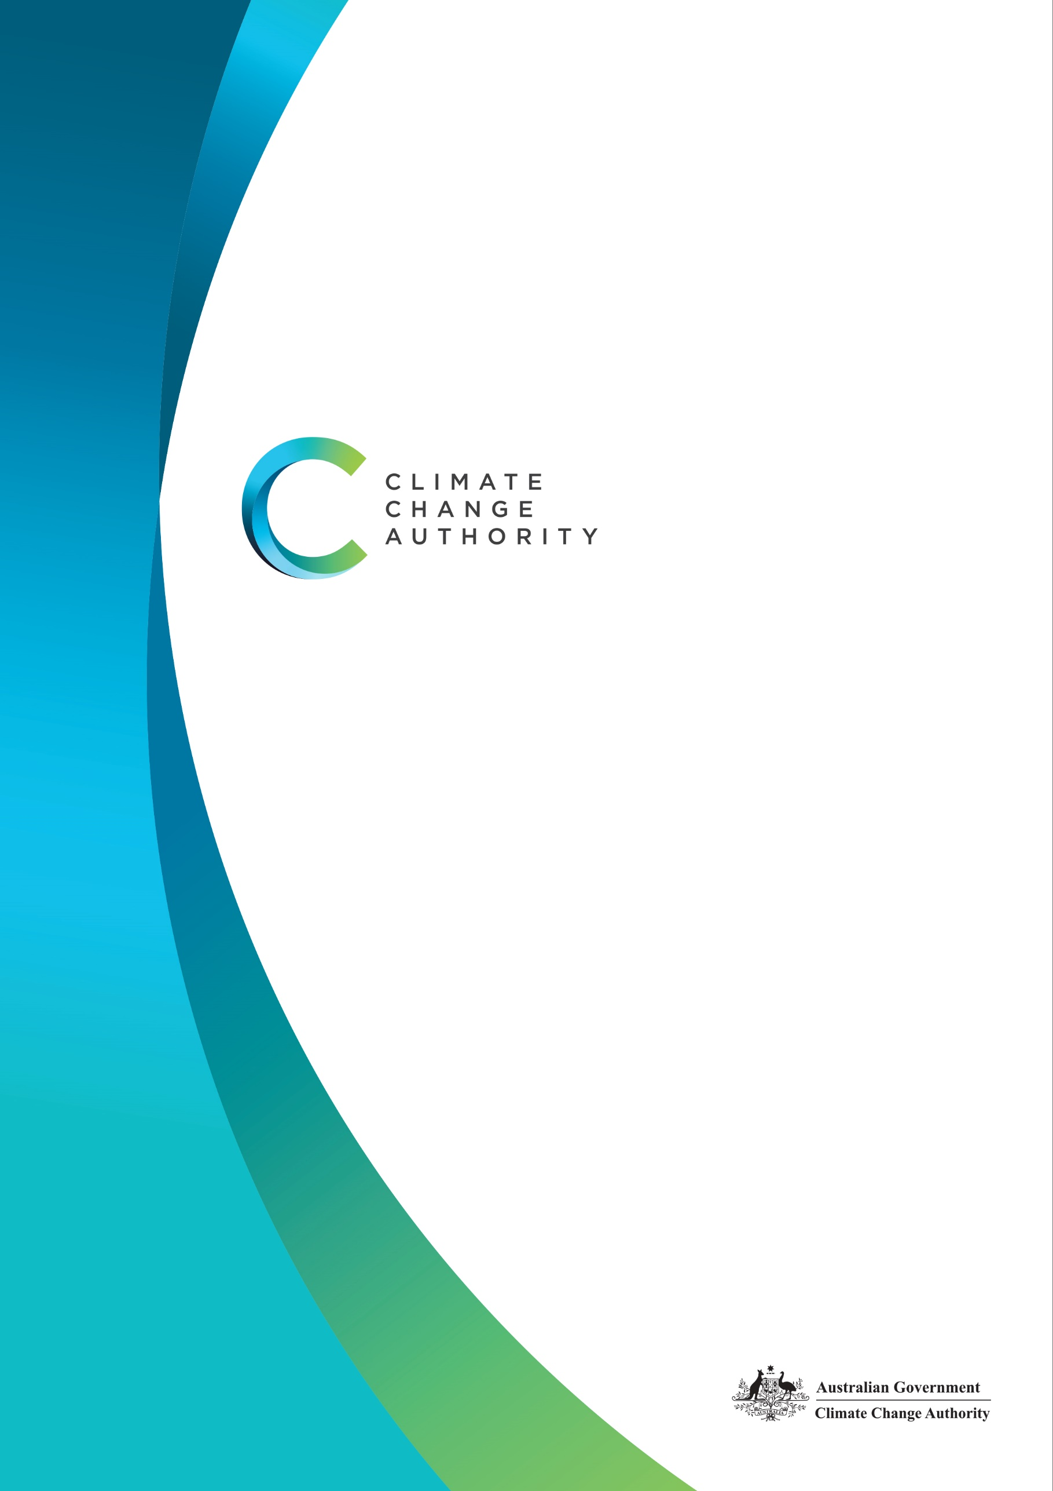

# Paris Plus: From cost to competitive advantage

Insights Paper

October 2021



**The Authority recognises the First Peoples of this nation and their ongoing connection to culture and country. We acknowledge First Nations peoples as the Traditional Owners, Custodians and Lore Keepers of the world’s oldest living cultures, and pay our respects to their elders – past, present and future.**

Published by the Climate Change Authority

www.climatechangeauthority.gov.au

© Commonwealth of Australia 2021

This work is licensed under the Creative Commons Attribution 3.0 Australia Licence.To view a copy of this license, visit http://creativecommons.org/licenses/by/3.0/au

The Climate Change Authority asserts the right to be recognised as author of the original material in the following manner:

 or 

©Commonwealth of Australia (Climate Change Authority) 2021.

IMPORTANT NOTICE – PLEASE READ

This document is produced for general information only and does not represent a statement of the policy of the Commonwealth of Australia. The Commonwealth of Australia and all persons acting for the Commonwealth preparing this report accept no liability for the accuracy of or inferences from the material contained in this publication, or for any action as a result of any person’s or group’s interpretations, deductions, conclusions or actions in relying on this material.

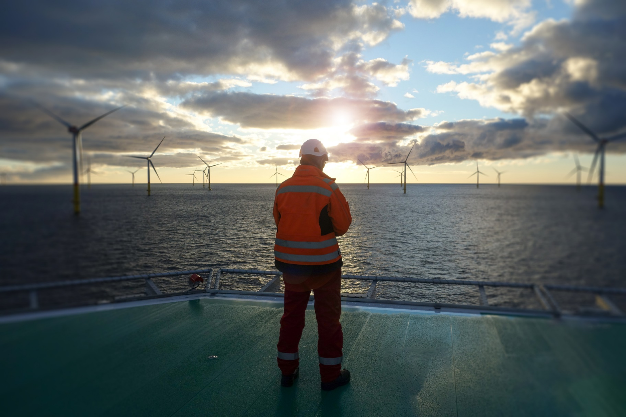

Contents

Introduction 4

Figure 1: Australia’s emissions 6

Trade 7

Figure 2: Australia’s most valuable merchandise goods exports 8

Investment 10

The Climate Change Authority’s strategic framework 11

Figure 3: Strategic framework 12

Carbon neutral production of LNG 14

Reducing emissions in the livestock industry 15

Paris Plus: key insights for increasing ambition 16

Increasing ambition is not without challenges 18

Figure 4: Australia’s emissions trajectory 18

Conclusion 20

# Paris Plus: From cost to competitive advantage

*Governments, investors and consumers around the world are accelerating action to tackle climate change. Low emissions trade and investment trends will have big impacts on the Australian economy. In this world, it no longer makes sense to think about lowering carbon emissions as a cost. It is a source of competitive advantage.*

## **Introduction**

As the world heads into the COP26 climate conference in Glasgow in November, the IPCC’s latest articulation of the accelerating risk of climate change[1] frames the growing momentum for rapid and global decarbonisation. It is clear from the IPCC’s report that Australia is significantly exposed to accelerating risks related to weather and climate extremes.

With much of the developed world committed to achieving net zero by 2050, and many (e.g. US, EU, UK and Canada) having already strengthened their Paris Agreement targets, we are now seeing a focus on greater ambition for 2030 and the decades thereafter.

Also of significance to Australia is that customers for Australia’s exports, and the investors who finance their development, are increasingly ambitious in their responses to climate change. Australian jobs, regions and the broader economy are exposed to risks related to shifting markets for emissions intensive goods.

**Paris Plus**

[pa-rəs pluhs] *noun*

The various agreements, targets and cross-border instruments with the purpose of contributing to the goals of the Paris Agreement, such as:

* the Paris Agreement Rulebook
* carbon trading mechanisms
* carbon border tariffs and clubs
* subnational and corporate targets
* climate-related financial disclosure
* taxonomies and certification schemes
* international agreements to reduce aviation and maritime emissions

While the Paris Agreement is the centrepiece of global cooperation on climate change, a new global climate architecture is emerging, reflecting actions that implement and complement the 2015 agreement. Actions are not just by governments but by buyers, sellers and investors in markets as well. We call it ‘Paris Plus’.

The Climate Change Authority’s forthcoming trade and investment research report*,* describes a major reorientation underway as governments and markets around the world begin transitioning to net zero emissions. Markets, perhaps more than governments, have been leading the way for the world’s response to climate change. In response to growing recognition of climate change risks, players in international markets are increasingly taking unilateral actions in pursuit of emissions reductions across global supply chains.

Governments are also looking more closely at the emissions generated across the global supply chains that cross their borders – that is, domestic emissions *and* emissions that occur in other countries. Minilateral approaches, such as carbon trade agreements, are already in place in Europe and North America[2]. Others, such as a high integrity carbon offsets scheme in the Indo-Pacific[3] and a carbon border tax club are in development or under discussion[4].

These emerging trends in trade and investment are of critical importance to jobs, prosperity and regions of Australia. Exports were equivalent to 24% of Australia’s GDP in 2019-20, almost 40% of our domestic emissions are associated with the production of our exports[5] (Figure 1), and we are a net importer of capital to fund investment and growth in our economy[6].

On a trajectory to net zero emissions, governments, investors and consumers around the world will increasingly favour lower emissions products. Decisions taken by others in our export markets will reverberate along global supply chains right back to jobs and growth in the Australian economy.

Rapidly reducing emissions makes good sense, not just to mitigate climate change but to position the Australian economy to prosper, rather than falter, as the world decarbonises.

### **Figure 1: Australia’s emissions – inventory and economic sectors, and end-use**

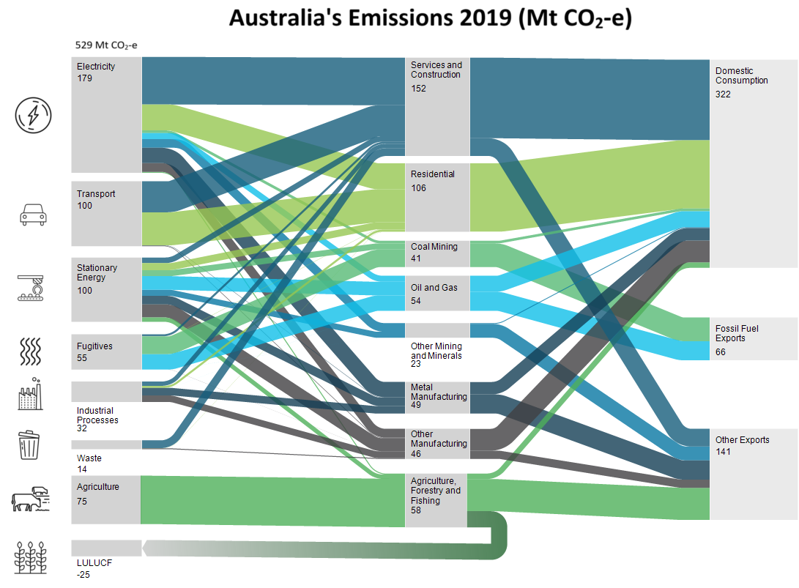

(27%)

(12%)

(61%)

Source: Department of Industry, Science, Energy and Resources (2018-19 data)

## **Trade**

Australia has historically enjoyed competitive advantages as an exporter, through being a reliable producer of high-quality, low cost resources in the fastest growing region of the world. Our traded goods are now exposed to actions in support of emissions reductions both domestically and overseas, with implications for jobs, prosperity and regions in Australia. As the world decarbonises, we are not only competing on cost and quality, but also on lowest emissions.

While governments are more focused on emissions within their borders, markets are interested in emissions across the entire value chain. Investors and consumers are increasingly focusing on emissions from production, to transport, to consumption, regardless of where in the world the emissions occur.

Under international greenhouse gas accounting rules, countries are not responsible for emissions that occur from the use of their exports overseas. That’s why governments have traditionally focused on emissions that occur within their borders. However, some countries are starting to explore trade measures, such as carbon border adjustment mechanisms, as a way of managing carbon leakage and protecting their trade exposed industries as markets decarbonise.

If these trade and investment trends continue, carbon competitiveness will increasingly depend on the emissions that occur along the whole value chain.

Many of Australia’s most valuable exports are emissions or energy intensive, such as coal, gas, iron ore, aluminium and beef. For some exports, such as beef, most emissions occur domestically during the production phase. For others, such as aluminium, energy use contributes the bulk of the emissions. Others, such as coal and natural gas, emit more greenhouse gases when they are used.

While Australia’s domestic emissions comprise less than 1.3% of global emissions, approximately three times as much carbon is emitted when Australia’s coal and gas exports are used by customers overseas. Trade and investment trends bring Australia’s carbon risk associated with overseas emissions into sharp focus.

Figure 2 shows the value of Australia’s three largest exporting sectors (light blue bars), as well as their emissions from production in Australia (dark blue bars) and, for coal and gas, from their use overseas (green bars). Emissions from the overseas use of metalliferous ores, such as iron ore and alumina, also present a risk to the Australian economy, but are not included in Figure 2 due to a lack of data. For example, when Australian bauxite is used to produce aluminium overseas, the emissions intensity of the product depends on the type of energy used to produce it. With more information about emissions along Australia’s export value chains, we could better understand the Australian economy’s exposure to carbon risks.

We not only need better emissions data but also clarity on how carbon is priced around the world in order to understand the competitive environment. For example:

* Emissions from LNG production in Australia could be offset with Australian Carbon Credit Units (ACCUs), currently around AU$27/tonne CO2-e.
* Emissions from transport and combustion of Australian LNG overseas could be offset with voluntary carbon credits at lower prices.
* Steel produced overseas from Australian iron ore and coal could be subject to a carbon border adjustment mechanism, with emissions priced at the EU carbon price, currently around AU$100/tonne CO2-e.

Figure 2 gives some idea of the value of exports and their exposure to carbon risk. This risk points to the importance of Australia’s engagement in negotiations to set the international rules for carbon markets. Efficient and effective international carbon trading will allow countries to access the cheapest, highest integrity abatement available and ensure carbon costs are no higher than they need to be.

### **Figure 2: Australia’s most valuable merchandise** **goods exports – value and emissions**

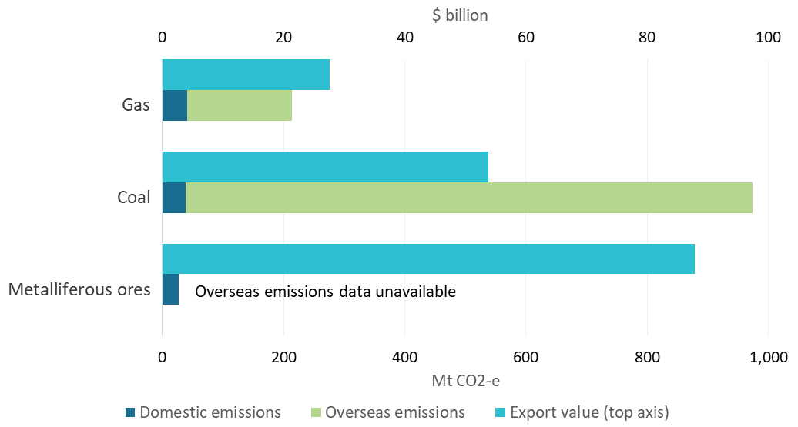

Sources: DISER *Quarterly Update of Australia’s National Greenhouse Gas Inventory: June 2019*, DISER *Australian Energy Update 2021*, DISER *National Greenhouse Account Factors: August 2021*, CCA analysis, 2017-18 data.

Notes: The domestic emissions includes direct emissions and indirect emissions associated with all of the inputs to an export, estimated using the implied emissions factor for every real dollar of value and total export value from the June 2019 update of the greenhouse gas quarterly. Overseas emissions from coal and gas are estimated based on the emissions from the combustion of these fuels abroad, using export volumes, fuel energy contents and combustion emissions intensities consistent with the Australian Energy Update and National Greenhouse Account Factors. Overseas emissions do not include emissions associated with transport.

Managing the carbon risk to the economy means adding to our historical sources of competitive advantage. We need to produce the products our customers want at a lower emissions intensity than our competitors, if we are to secure a competitive advantage in these markets. The Government’s Technology Investment Roadmap, which aims to accelerate the development of new and emerging technologies by making them economically competitive, is helping to mitigate carbon risks.

The recent International Energy Agency (IEA) report, *Net Zero by 2050 - A Roadmap for the Global Energy Sector[7]*, highlights the transformation in the world’s energy mix required to support the achievement of global net zero emissions. The pathway to net zero by 2050[8] identified by the IEA as the most technically feasible, cost effective and socially acceptable includes:

* a major decline in the share of fossil fuels in the global energy mix, from 80% in 2020 to just over 20% in 2050. A rapid drop in fossil fuel demand means that no new oil and natural gas fields are required beyond those already approved for development, and no new coal mines or mine extensions are required.
* renewable sources supplying almost 90% of electricity generation by 2050. However, fossil fuel use does not end overnight – accounting for more than half of total energy supply in 2030 and over a third in 2040.
* what remains of fossil fuel use in 2050 is paired with carbon capture, use and storage and unabated fossil fuel use is offset by negative emissions technologies.
* electric cars representing 20% of all cars on the road in 2030 and 60% in 2040, compared with 1% today.

Retaining our competitive advantage, and playing our part in global decarbonisation, does not require Australia to immediately cease exporting emissions-intensive products today. There is a risk that other suppliers could fill the void to meet demand, and global emissions would continue. It does require that we lower the emissions intensity of our exports and do this at a faster rate than the countries we compete with, while also anticipating and planning for the inevitable decline in demand for high emissions products.

We need to have cleaner, cost-competitive products to push the emissions intensive competition out of the market.

## **Investment**

Historically, Australia has been a net recipient of foreign investment. As explained by the Productivity Commission[9]:

*Foreign investment into Australia means that more capital is deployed than would have been possible if funded solely through domestic savings. In effect, foreign capital lowers the cost of capital for domestic investments, increasing the number of viable investments for both businesses and households (such as through lower mortgage rates).*

Foreigners invest in Australia for a number of reasons including our fast-growing and well-educated population, rich natural resource base, and stable cultural and legal environment. Investment in Australian export sectors has been attractive given the competitive advantage these industries, as mentioned in the previous section, have enjoyed. The stock of foreign direct investment (FDI) in Australia was over $1 trillion at December 2020 (52% of GDP)[10].

As discussed in the Authority’s forthcoming trade and investment research report, capital is increasingly being allocated to less carbon intensive investments. Australia’s top ten sources of FDI are (in order) the United States, the European Union, the United Kingdom, Japan, Hong Kong, Singapore, China, New Zealand, Canada and Switzerland. Of these, Singapore is the only country without a target to reach net zero emission by 2050 or 2060[11]. Several of these countries are also using sustainable finance policies to channel investment towards low carbon activities.

As a country that has increasingly imported capital to fund investment in the growth of the Australian economy, changes in how capital is allocated can significantly affect the growth of the economy.

If Australia is to maintain its competitive advantage and attract the capital necessary to support a growing economy, Australian producers must compete for capital by offering investment opportunities that align with global low emission investment trends.

## **The Climate Change Authority’s strategic framework**

It no longer makes sense to think about lowering carbon emissions as a cost. In a world taking increasingly strong action to reduce carbon emissions, and given the trends we see in global trade and investment, lowering emissions is a necessary source of competitive advantage for Australia to continue to grow and prosper.

The Australian Government’s Technology Investment Roadmap is a good example of a strategy to change the task of lowering carbon emissions from a cost to a competitive advantage. At its core the strategy seeks to identify and encourage investment in key technologies critical to the long term decarbonisation of the Australian economy, at a cost competitive with existing technologies. In other words, to reduce the ‘clean premium’ to zero. The Technology Investment Roadmap is a central component of the Government’s response to climate change.

What follows is the Climate Change Authority’s high level strategic framework to shape the preservation and enhancement of Australia’s competitive advantage in a decarbonising world.

Abatement and adaptation are the apex of the Authority’s framework. As noted in the IPCC’s *Climate Change 2021: The Physical Science Basis* report, ‘every tonne of CO2 emissions adds to global warming’. The report also notes that ‘climate change is already affecting every inhabited region across the globe with human influence contributing to many observed changes in weather and climate extremes’[12]. Climate changes have already occurred, and Australia will be affected no matter what domestic strategies are pursued.

It follows that every tonne abated avoids adding to global warming. It also follows that Australia must prepare to adapt to climate change.

The goal of abatement in the language of the Paris Agreement is to hold the increase in the global average temperature to well below 2°C above pre-industrial levels and pursue efforts to limit the temperature increase to 1.5°C. Since the Paris Agreement was struck, the IPCC has highlighted the significant benefits (avoided costs) of keeping warming to 1.5°C, relative to 2°C, and the need to achieve net zero emissions by the middle of the century. As noted above, the latest report by the IPCC highlights the new urgency of achieving net zero emissions even sooner and the magnitude of the global task. The IPCC has previously noted that all scenarios limiting global warming to 1.5°C require high levels of carbon sequestration in all its forms, including negative emissions technologies.

The Authority’s strategic framework for responding to climate change therefore encompasses abatement – both mitigation and sequestration – and adaptation. The framework prioritises the following actions (Figure 3):

* *Increasing productive efficiency* – reduce the emissions intensity of production and reduce inefficient use of resources such as energy and land.
* *Switching fuels* –shift from high emitting fuels to zero- or low-emissions alternatives.
* *Electrif*y*ing* – generate enough affordable, reliable, clean electricity to meet growing demand and electrify as much as possible.
* *Deploying technology* *solutions* – do as much as we can with the mitigation and sequestration technologies we already have, accelerate their deployment, and develop new technologies.
* *Sequestering* – Mitigate as much as possible and sequester the rest (i.e. capturing and storing emissions, through biosequestration and geosequestration).
* *Managing climate risks* – Build resilience, plan for and manage the risks that climate change present to Australian industries, businesses, communities, the environment and our region.

### **Figure 3: Strategic framework: From cost to competitive advantage**

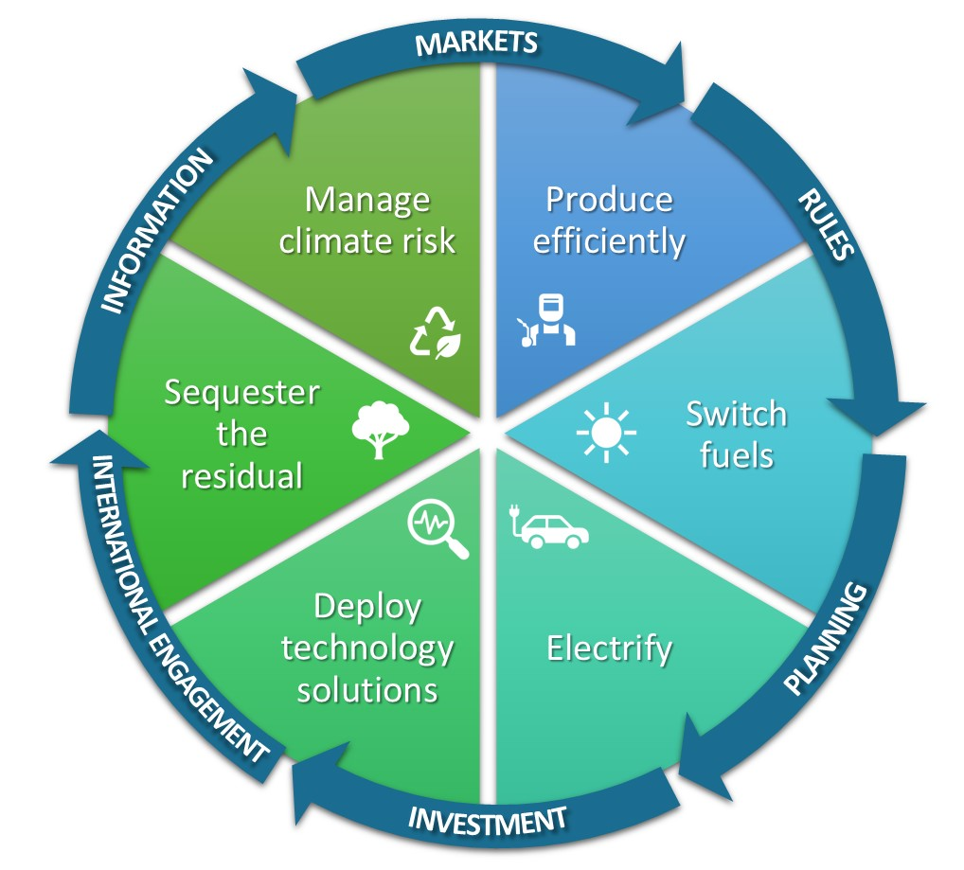

**Wedges = Actions**

**Arrows = Enablers**

Only well-functioning markets that provide choice among competitive offerings can mobilise and allocate the massive amounts of capital needed to finance the transition to a resilient, ‘net zero economy’. Governments have a critical role in enabling these actions.

Below are six key enablers governments could pursue in support of the drive to net zero emissions. The Australian Government already has in place many policies and programs across these enablers[13].

* *Information* – ensuring the necessary information is available for decision making. Efficient collection of accurate, consistent and comprehensive information on emissions and decarbonisation will minimise costs on business, while informing consumer choices and supporting optimal business and government decision-making.
* *Markets* – encouraging the development of open, competitive and transparent markets, to drive lowest cost decarbonisation outcomes. Many abatement technologies are viable today and ready to be deployed to market, subject to investor and consumer choices. For example, investment in and private sector demand for sequestration has grown recently, with prices for Australian Carbon Credit Units (ACCUs) reaching record highs and stimulating more sequestration projects.
* *Rules* – implementing rules and regulations to create trust in markets and guard against market failures, and ensuring that they are up-to-date and not impeding new ways of doing things that eliminate emissions.
* *Planning* – guiding and facilitating investment through appropriate long term planning. Urban, infrastructure, workforce and land use planning can support timely and efficient mitigation, sequestration and adaptation. Governments can also assist workers and communities to make decisions about the future by planning and communicating their intent in advance.
* *Investment* – public investment in areas where markets are failing to make the necessary investments; in science, research, development and deployment of abatement technologies and in infrastructure. Governments can stimulate innovation and provide high-risk capital for new technologies, shift activities down the cost curve to price parity and catalyse new markets.
* *International engagement* – through diplomatic and trade channels, the Government can maintain and foster international partnerships and collaborations on emissions reductions that ensure Australia’s interests are advanced and support efforts to decarbonise the economy.
  + We should strive to harmonise international and domestic rules – such as taxonomies, classification, and Guarantee of Origin schemes – in order to establish well-functioning international markets that recognise Australia’s unique circumstances.
  + 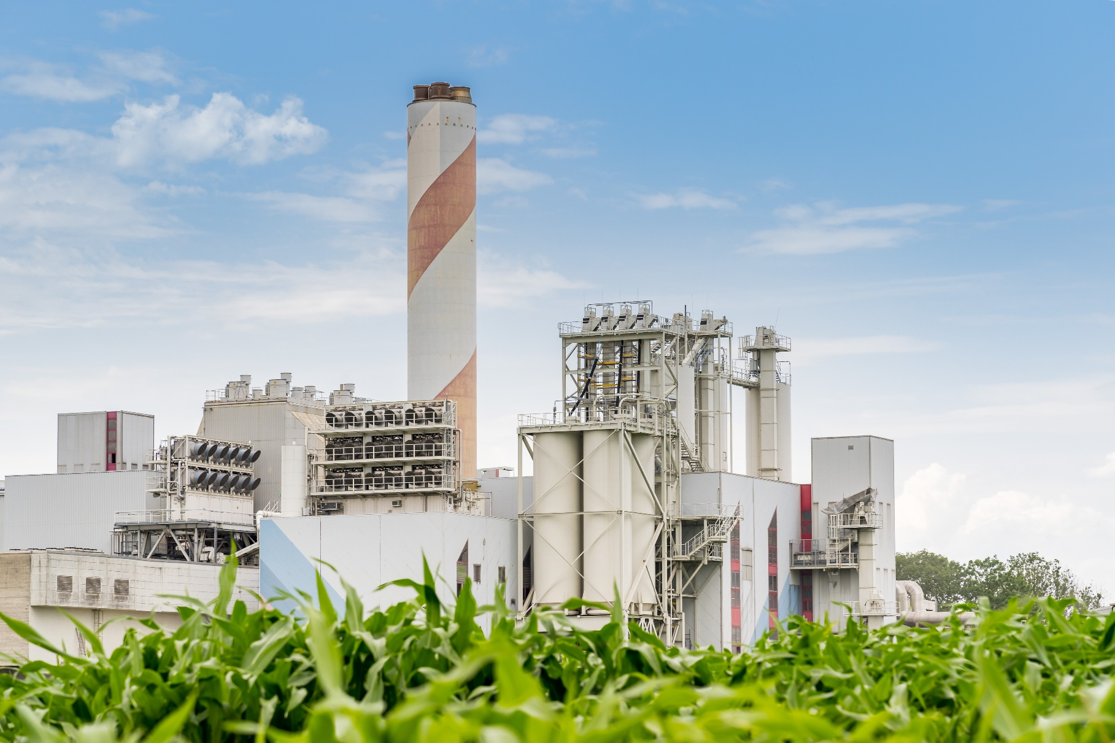Partnering with countries to support the development and deployment of clean technologies and fuels will create new trade opportunities. It will also help less developed countries lift communities out of poverty while bypassing the emissions intensive development of industrialised nations.

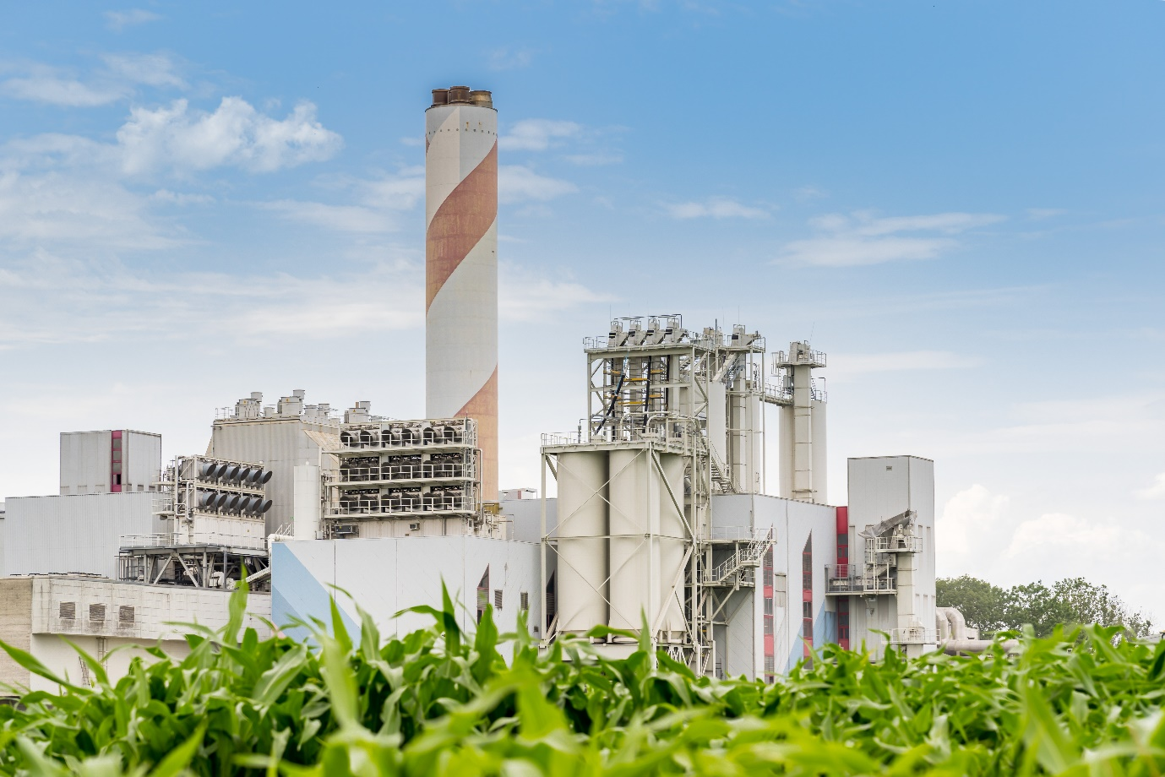

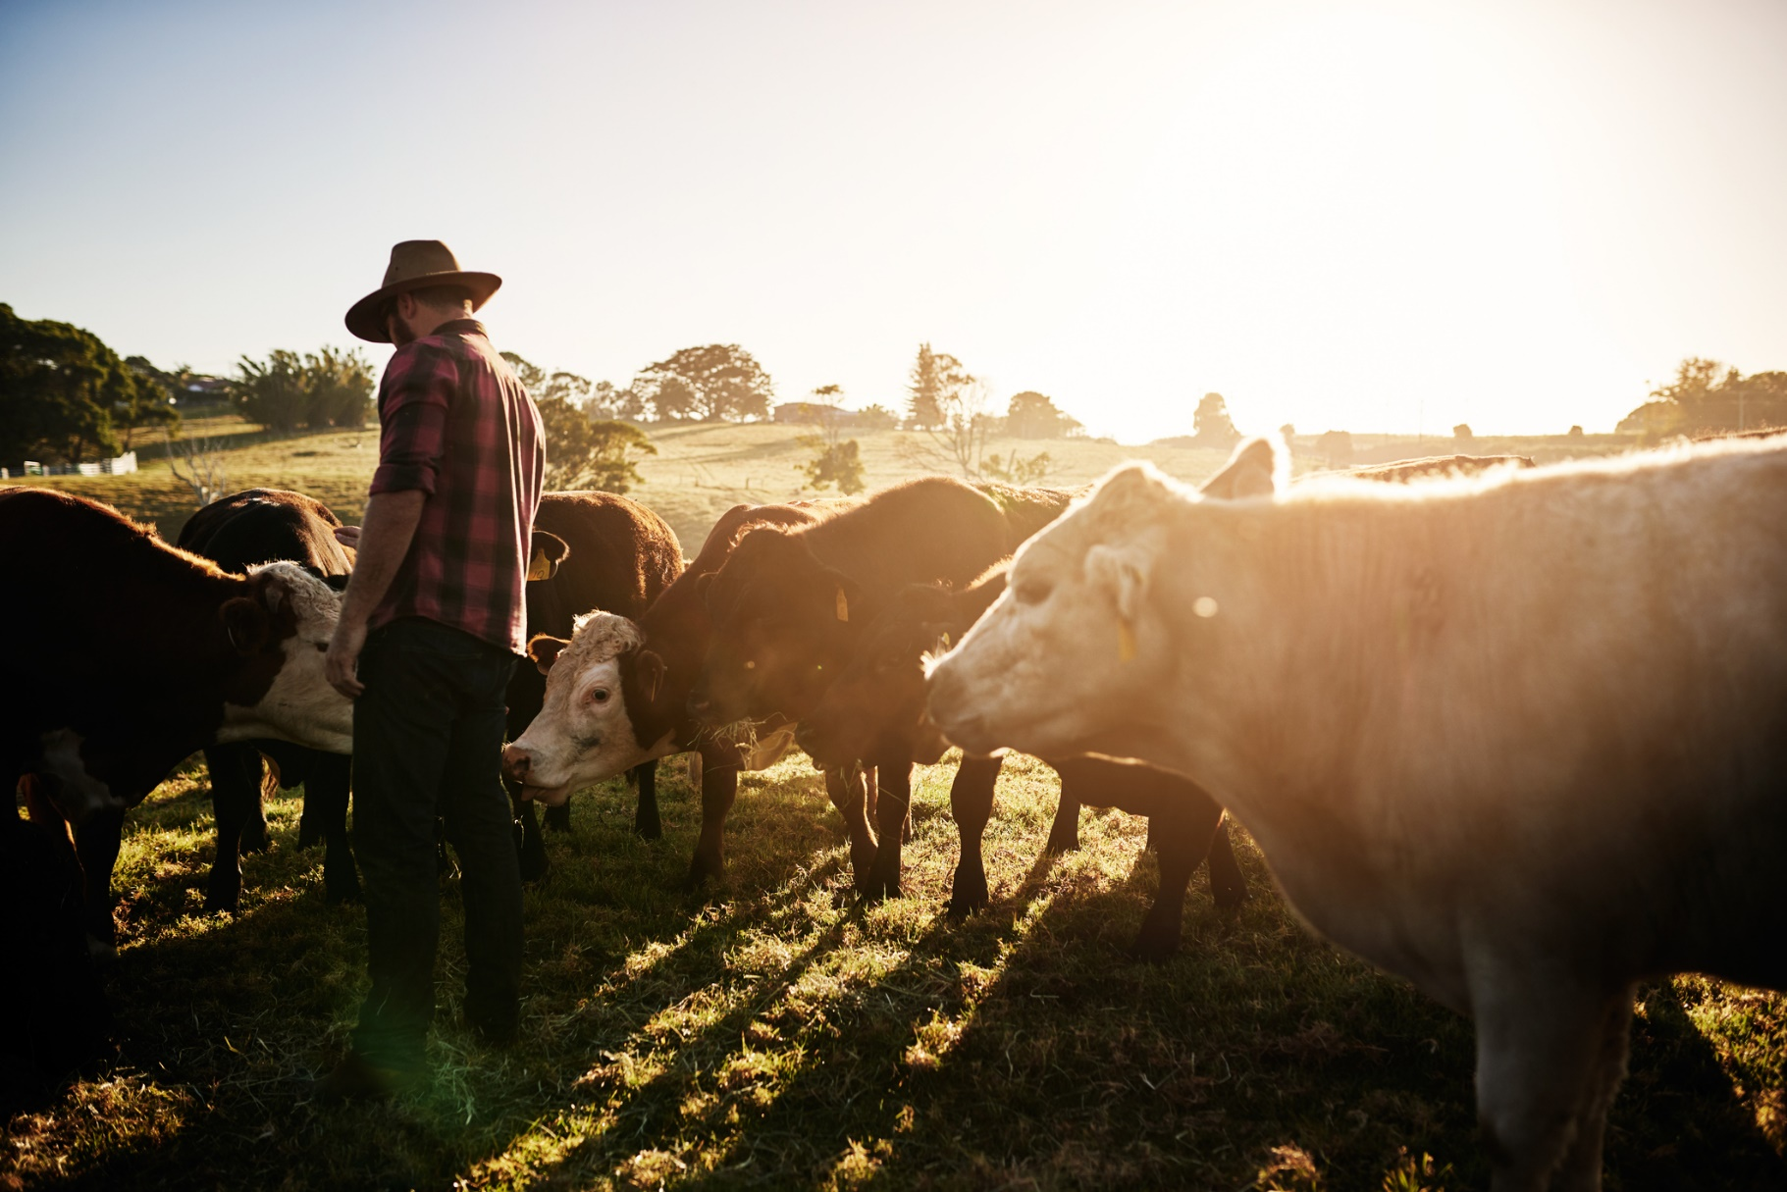

### actions and enablers

### **Carbon neutral production of LNG**

There is growing interest in the global market for ‘carbon neutral’ LNG - where emissions from production, transport and/or consumption of the gas have been offset.[14] For example, in July 2021, Inpex Corporation offset a shipment of Australian LNG to Japan using carbon credits for emissions along the entire supply chain, including production, processing, transportation and combustion by users.[15] Shell has offset a number of LNG shipments through the purchase of credits from ‘nature-based solutions’, including reforestation and land transformation.[16]

Carbon capture and storage (CCS) may be used to reduce the emissions intensity of LNG production. The Australian Government recently included a CCS method as part of the ERF, which provides a monetary incentive to accelerate technology maturation. Santos has since begun registering its $210 million Moomba CCS project in South Australia under the scheme, which will be one of the biggest in the world and has the potential to store 1.7 million tonnes of CO2 each year, the equivalent of powering about 200,000 homes.[17] CCS has begun at the Gorgon LNG facility in Western Australia, and several other Australian LNG producers are considering carbon capture projects.[18]

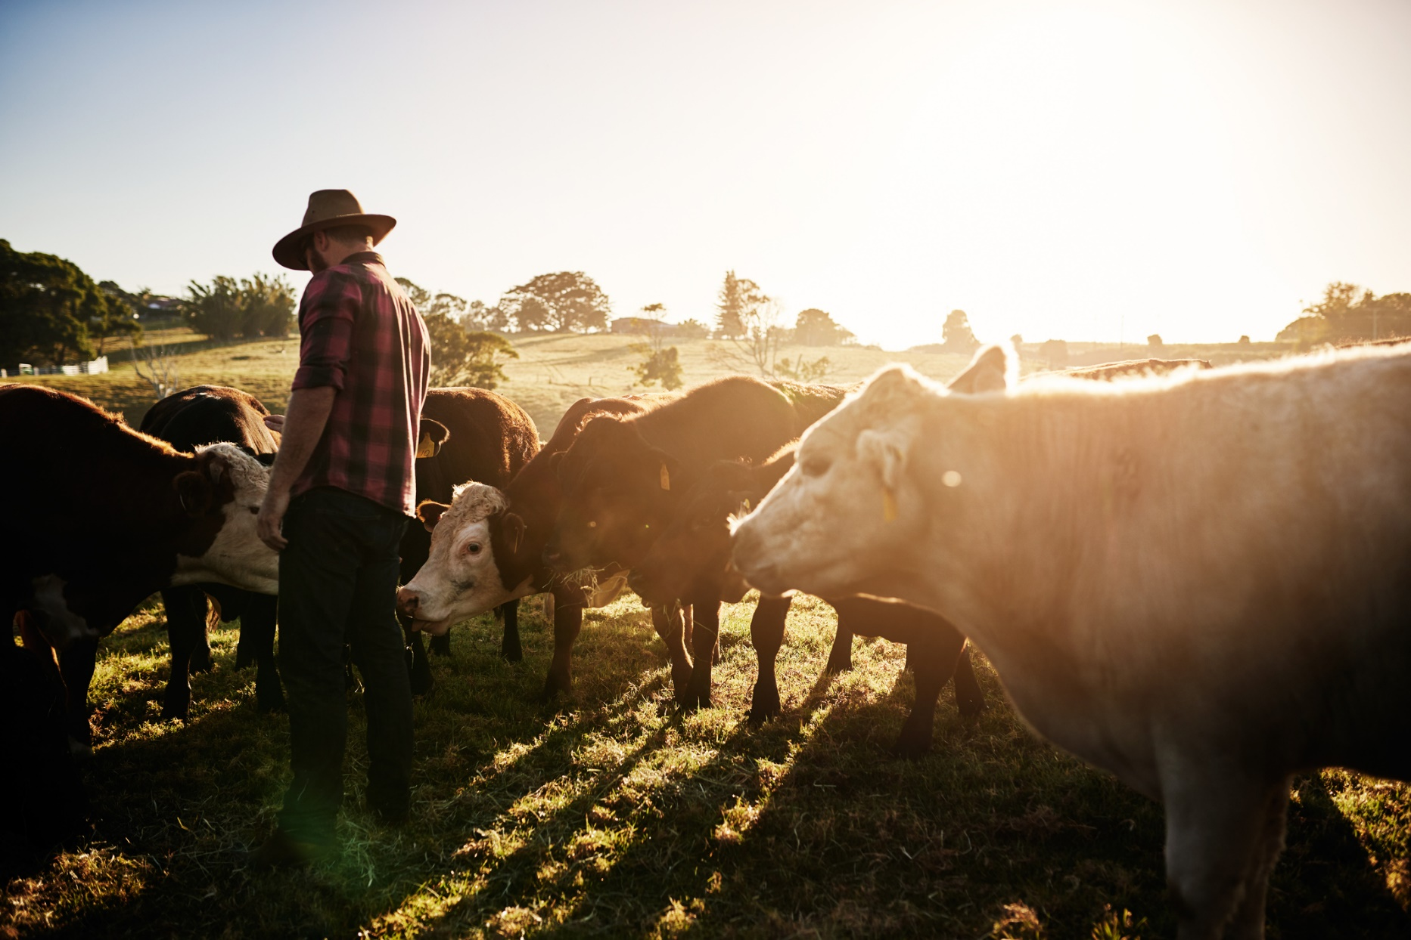

### actions and enablers

### **Reducing emissions in the livestock industry**

Meat and Livestock Australia (MLA), representing Australia’s red meat and livestock industry, has set an aspirational target for Australian livestock production, including feeding and processing, to become carbon neutral by 2030.[19] To do this, MLA will invest in ways to avoid greenhouse gas emissions and store carbon on pastoral land. It will also focus on building capacity, providing information to stakeholders, and forming integrated management systems.

In Australia, research and commercialisation of methods to reduce emissions intensity is occurring. For example, after CSIRO discovered the methane-reducing properties of the *Asparagopsis* seaweed, it worked with MLA and James Cook University to develop FutureFeed, a feed supplement to reduce methane emissions from livestock. If just 10% of livestock producers added 1.0% of *Asparagopsis* Seaweed Meal to the daily feed intake of ruminant livestock, the emissions reduction impact would be the equivalent of removing 100 million cars off the road.[20] The Australian Government is investing in livestock feed technologies to support a potential future ERF method.[21]

Maleny Dairies is taking action to offset its 2,561 tonnes of emissions from its milk processing and bottling plant in the Sunshine Coast, responding to customer demand for responsible action.[22] Certified carbon neutral under the Australian Government’s Climate Active scheme, it offsets emissions from its operations (excluding milk production and farming) by supporting a forestry project in Queensland and an avoided deforestation project in Papua New Guinea. Maleny Dairies plans to pursue Climate Active Carbon Neutral Product Certification for its products at which time emissions from farming activities will be incorporated in the life cycle assessment of the products.

## **Paris Plus: key insights for increasing ambition**

Drawing on the Authority’s analysis and interpretation of low emissions trade and investment trends, and the strategic framework for responding to climate change identified above, we have distilled five key insights for securing Australia’s competitive advantage in a net zero world:

1. *We need to produce the cleanest exports at the lowest cost to succeed in overseas markets as the world shifts towards net zero emissions.* A new dynamic is emerging – carbon competitiveness – where competitive advantage increasingly rests with those producing the most competitively priced, high quality products with the lowest carbon content. This means mitigating and sequestering emissions so that our products are less emissions intensive than those of our competitors. The IPCC has found that abatement pathways consistent with limiting warming to 1.5°C require both approaches to abatement. Australia’s clean energy resources and large, geologically stable land mass are endowments we can leverage.
2. *We should take every commercially viable opportunity to mitigate and sequester emissions as fast and efficiently as possible.* Emissions today will be added to the growing stock of greenhouse gases already in the atmosphere, further accelerating climate change. Arresting the growth of that stock will require a technology agnostic approach, using every means at our disposal. The longer we wait, the greater the risk that Australia becomes uncompetitive in the low emissions global economy, and the more disruptive and costly the economic adjustment could be. This means reducing emissions from legacy assets, transforming emissions intensive businesses, and investing now to develop and deploy new, clean technologies.
3. *Policy choices and investment decisions should be based on information about our competitors, supply chains and the factors that contribute to Australia’s competitive advantage.* Australia’s emissions reporting is world class. Robust reporting on countries’ emissions reduction targets and progress against those targets will increase the confidence with which we make decisions about how Australia can decarbonise without emissions simply shifting to another part of the world. Data can help policymakers understand Australia’s incumbent, emerging and potential low emissions industries, the new jobs they could deliver, and what it will take for them to thrive and contribute to the Australian economy in a net zero world.
4. *Australia should be deeply embedded in international climate change rule-making.* New trade and investment rules are emerging. The countries that shape these rules will enhance their trade competitiveness and investment attractiveness, while countries that do not could have unfair rules imposed on them. Australia has a valuable depth of knowledge and expertise in transparent emissions reporting and high integrity carbon markets, through established institutions and world-leading policy architecture, including the National Greenhouse Gas Inventory, the National Greenhouse Energy and Reporting Scheme, the Emissions Reduction Fund and Clean Energy Regulator.
5. *Well-functioning global markets will accelerate, smooth and lower the cost of achieving net zero emissions.* Markets will mobilise the private capital required to fund the transition to a net zero world. Carbon trading can smooth the trajectory by enabling the most efficient sequencing of abatement options internationally, allowing countries to access the cheapest abatement options and reduce the overall cost of meeting global targets. Using credible, high integrity international units could lower the cost of meeting Australia’s emissions reduction goals and may also reduce international competitiveness concerns for Australian businesses, by providing access to a wider range of low-cost emissions reductions opportunities. Australia has carbon market expertise and capacity to influence the development of high integrity standards for offsets schemes in our region. This will benefit Australian businesses and help ensure international standards align with our existing schemes.

If we do these things well, the economic advantages of lifting the ambition of our emissions reduction efforts are clear.

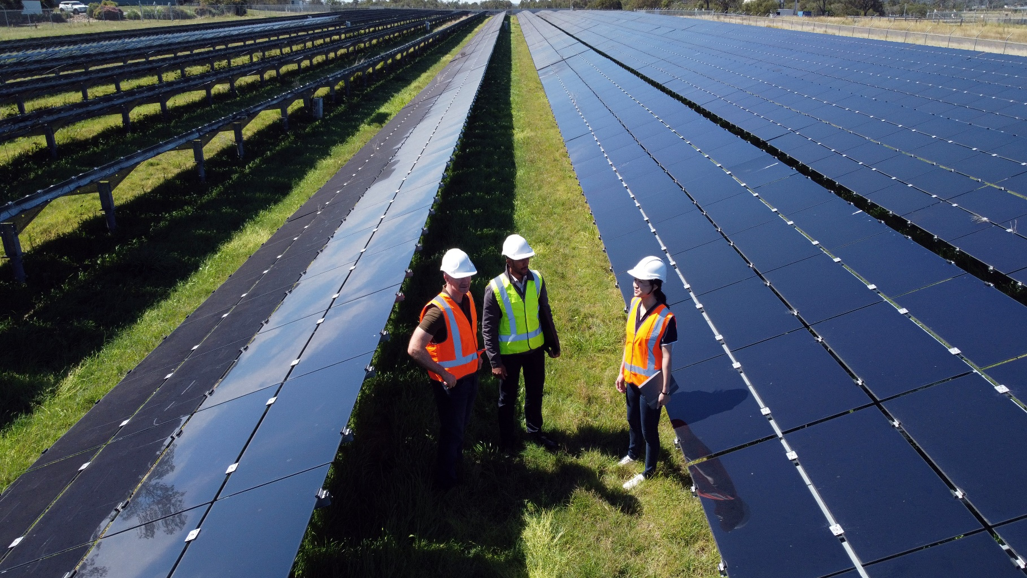

## **Increasing ambition is not without challenges**

The challenge is apparent when we consider the past and projected emissions trajectories of different sectors (Figure 4). Australia’s annual emissions have fallen from a peak in 2006, with much of the heavy lifting attributed to avoided land clearing and clean electricity generation. Emissions from only one sector – electricity – are projected to fall further this decade. It makes good sense to bend the curve more steeply for each and every sector, and the sooner the better.

### **Figure 4: Australia’s emissions trajectory**

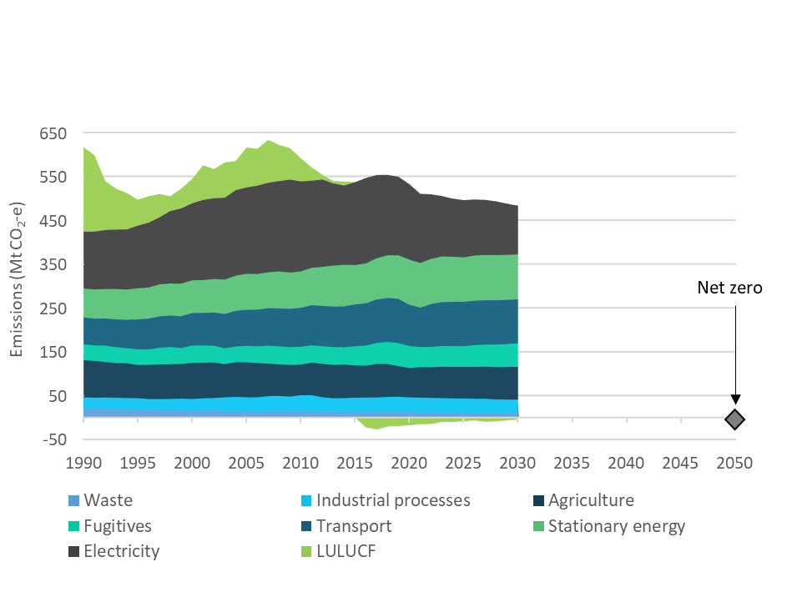

Source: Historical and projected emissions data: DISER 2020

With Australia on track to meet and most likely exceed its initial Paris Agreement emissions reduction target for 2030, we should explore how we might increase our ambition to achieve net zero as soon as possible. This can be considered in the context of choosing our next (post-2030) emissions reduction target under the Paris Agreement, which is due to be submitted in 2025.



**To ensure Australia can set increasingly ambitious emissions reduction goals and policies backed by a strong evidence base, we recommend that the Government prioritise the following work:**

Identifying the optimal decarbonisation trajectory for electricity generation, given the fundamental importance of clean energy to achieving emissions reductions in other sectors. This includes better understanding how to maintain reliability of supply during rare, but inevitable, prolonged periods of low wind and low solar output. It is important to know how fast and how far we can go.

Better understanding the biological and geological sequestration potential of the Australian landmass, as well as the means through which sequestration opportunities could be allocated. Sequestration helps address emissions that are hard to mitigate and will likely play a role in growing negative emissions in the future.

Assessing the ‘net zero preparedness’ of our high emitting industries, including their progress and potential to reduce emissions, and their understanding of the implications of net zero trade and investment trends for the supply chains to which they belong.

Building on the above, examining the role that different sectors of the economy can play in driving towards net zero emissions, in terms of the quantity and timing of abatement and jobs, and interdependencies between sectors.

Revisiting and identifying solutions for the barriers to the take-up of negative- and low-cost abatement opportunities in a Paris Plus context.

The Authority intends to make a strong contribution to the evidence base required for setting Australia’s future emissions reductions goals and policies through its forward work program:

* Consulting with industry on the potential for accelerating emissions reductions, and the priority actions governments can pursue to help businesses realise that potential.
* Investigating the scale, distribution and environmental effectiveness of biological and geological sequestration opportunities in Australia, with a view to addressing potential barriers and risks.
* Investigating cost effective approaches to generating robust, trustworthy data on emissions embedded within goods and services supply chains, to support informed consumer choice and well-functioning markets.
* Exploring what additional economic statistics we need for tracking changes in the Australian economy – such as job creation, investment in R&D and capital investment in new technologies – as we transition to net zero. Better data enable better decision-making by governments, the private sector and the broader community.
* Undertaking the next statutory reviews of the Emissions Reduction Fund and National Greenhouse and Energy Reporting scheme, with a view to ensuring they are fit-for-purpose in the world of Paris Plus.
* Analysing the dynamic interplay between abatement opportunities across the different sectors of the economy, to prioritise the pursuit of those opportunities over time and ensure Government interventions provide the biggest returns.

In all of its work the Authority will continue to have regard to the principle, set out in our legislation, that any measures to respond to climate change should: be economically efficient; be environmentally effective; be equitable; be in the public interest; take account of the impact on households, business, workers and communities; support the development of an effective global response to climate change; and be consistent with Australia’s foreign policy and trade objectives.

## **Conclusion**

Governments, businesses and communities around the world are taking stronger action in response to climate change risks. The IPCC has shown that these actions need to accelerate. The implications for the Australia economy are significant. Lifting our ambition to reduce emissions will ensure not only that Australia is playing its part, as we should, but that we continue to be competitive in global trade and investment markets. The key to increasing ambition is to no longer think about lowering carbon emissions as a cost, but as a source of competitive advantage. Maintaining our prosperity as the world transitions to net zero emissions depends on it.

1. Intergovernmental Panel on Climate Change (2021). [*AR6 climate change 2021: The physical science basis.*](https://www.ipcc.ch/report/ar6/wg1/)  Cambridge University Press.
2. EU Emissions Trading Scheme, Western Climate Initiative (subnational US and Canada).
3. Ministers Angus Taylor and Sussan Ley (2021, April 23). [*Australia announces $100 million initiative to protect our oceans*](https://www.minister.industry.gov.au/ministers/taylor/media-releases/australia-announces-100-million-initiative-protect-our-oceans.);

   Climate Change Authority (2020). [*Prospering in a low emissions world: An updated climate policy toolkit for Australia*](https://www.climatechangeauthority.gov.au/prospering-low-emissions-world-updated-climate-policy-toolkit-australia.) (Recommendation 6).
4. Climate Change Authority (2021). *Trade and investment research report* (forthcoming).
5. Australian Bureau of Statistics (ABS) (2020)*.* [*Australian system of national accounts*](https://www.abs.gov.au/statistics/economy/national-accounts/australian-system-national-accounts/latest-release)*.*
6. Productivity Commission (2020). [*Foreign investment in Australia*.](https://www.pc.gov.au/research/completed/foreign-investment/foreign-investment.pdf)
7. International Energy Agency (2021, June). [*Net Zero by 2050 - A Roadmap for the Global Energy Sector*](https://www.iea.org/reports/net-zero-by-2050)*.* 
8. Based on the preceding report: International Energy Agency (2021, May). [*Net Zero Emissions by 2050 Scenario*](https://www.iea.org/data-and-statistics/data-product/net-zero-by-2050-scenario).
9. Productivity Commission (2020, June). [*Foreign investment in Australia*](https://www.pc.gov.au/research/completed/foreign-investment/foreign-investment.pdf).
10. Australian Bureau of Statistics (2021a). [*International investment position, Australia: Supplementary statistics*](https://www.abs.gov.au/statistics/economy/international-trade/international-investment-position-australia-supplementary-statistics/latest-release).
11. ClimateWatch (2021). [*Net-Zero Tracker*](https://www.climatewatchdata.org/net-zero-tracker).
12. Intergovernmental Panel on Climate Change (2021). [*AR6 climate change 2021: The physical science basis.*](https://www.ipcc.ch/report/ar6/wg1/) Cambridge University Press.
13. See for example: Department of Industry, Science, Energy and Resources (n.d.). [*Australia’s climate change strategies*](https://www.industry.gov.au/policies-and-initiatives/australias-climate-change-strategies)*.* Australian Government.
14. Erin M. Blanton & Samer Mosis (2021, July 8). [*The carbon neutral LNG market: Creating a framework for real emissions reductions*](https://www.energypolicy.columbia.edu/research/commentary/carbon-neutral-lng-market-creating-framework-real-emissions-reductions). Centre on Global Energy Policy, Columbia University SIPA;

    Gavin Thompson (2020, November 18). [What is carbon-neutral LNG? Buyers in Asia are calling for more scrutiny of LNG’s carbon footprint](https://www.woodmac.com/news/opinion/what-is-carbon-neutral-lng/). *Wood Mackenzie*.
15. Inpex Corporation (2021, July 10). [*INPEX receives carbon-neutral LNG shipment from Ichthys PNG project at Naoetsu LGN terminal in Japan*](https://www.inpex.co.jp/english/news/assets/pdf/20210710.pdf)*.* Corporate Communications Unit, Minato-ku, Tokyo.
16. Shell Australia (n.d.). [*Nature-based solutions*](https://www.shell.com.au/energy-and-innovation/shell-australia-new-energies/nature-based-solutions.html#iframe=L3dlYmFwcHMvMjAxOV9uYXR1cmVfYmFzZWRfc29sdXRpb25zL3VwZGF0ZS8)*.*
17. Santos (2021, October 1). [*Santos welcomes CCS method for Emissions Reduction Fund, clearing way for Moomba CCS project to apply for registration*](https://www.santos.com/news/santos-welcomes-ccs-method-for-emissions-reduction-fund-clearing-way-for-moomba-ccs-project-to-apply-for-registration/).
18. Helen Clark Mark & Tilly (2021, May 31). [Coleman full of hot air over Browse CCS remarks: Feds](https://www.energynewsbulletin.net/environment/news/1411129/coleman-full-of-hot-air-over-browse-ccs-remarks-feds). *Energy News Bulletin*;

    Angela Macdonald-Smith (2021, May 5). [Santos targets cross-border CCS project in Timor Sea](https://www.afr.com/companies/energy/santos-targets-cross-border-ccs-project-in-timor-sea-20210504-p57ovl). *Australian Financial Review.*
19. Meat & Livestock Australia (2020). [*The Australian red meat industry’s carbon neutral by 2030 roadmap*](https://www.mla.com.au/globalassets/mla-corporate/research-and-development/program-areas/environment-and-sustainability/2689-mla-cn30-roadmap_d3.pdf)*.*
20. FutureFeed (n.d.). [*Fighting climate change and producing more food with fewer resources*](https://www.future-feed.com).
21. Minister Angus Taylor (2021, October 1) [*New ERF method and 2022 priorities announced*](https://www.minister.industry.gov.au/ministers/taylor/media-releases/new-erf-method-and-2022-priorities-announced)
22. Maleny Dairies (2020). [*Maleny Dairies*](https://www.climateactive.org.au/buy-climate-active/certified-members/maleny-dairies). Climate Active.