

**Economic Data for a Decarbonising World**

Insights Paper

December 2021

**The Authority recognises the First Peoples of this nation and their ongoing connection to culture and country. We acknowledge First Nations peoples as the Traditional Owners, Custodians and Lore Keepers of the world’s oldest living cultures, and pay our respects to their elders – past, present and future.**

Published by the Climate Change Authority

www.climatechangeauthority.gov.au

© Commonwealth of Australia 2021

This work is licensed under the Creative Commons Attribution 3.0 Australia Licence.To view a copy of this license, visit http://creativecommons.org/licenses/by/3.0/au

The Climate Change Authority asserts the right to be recognised as author of the original material in the following manner:

 or 

©Commonwealth of Australia (Climate Change Authority) 2021.

IMPORTANT NOTICE – PLEASE READ

This document is produced for general information only and does not represent a statement of the policy of the Commonwealth of Australia. The Commonwealth of Australia and all persons acting for the Commonwealth preparing this report accept no liability for the accuracy of or inferences from the material contained in this publication, or for any action as a result of any person’s or group’s interpretations, deductions, conclusions or actions in relying on this material.

# Executive summary

Net zero is the destination and data can light the way. Australia is committed to achieving net zero emissions by 2050, a colossal transformation for an emissions-intensive, trade-exposed economy. Governments, investors, businesses and communities all have roles to play in restructuring the economy to thrive in a net zero world.

The right data made widely available can show the way and steer all actors—from investors and employers to town planners and job seekers—towards destination net zero. Climate data can show the physical risks we need to manage, and emissions data can show us what needs to change. But only economic data—the focus of this report—can show us how regions and the broader economy can navigate the transition in terms of jobs, outputs, investment and trade.

By tracking decarbonisation-driven changes, economic data can help investors, businesses and communities plan their own pathways and spot roadblocks, such as skills or supply shortages, along the way. The same data can give policymakers the information they need to respond to those roadblocks and guide the economy through an efficient and equitable transition. Leading indicators can help us assess likely progress towards emissions reduction targets and hence the need or otherwise for adjustments to policy.

Australia has world-class economic and emissions data systems. These systems provide strong foundations to build on and develop further for a decarbonising world. We offer the following key insights on the issue of economic data for a decarbonising world, drawing on our recent research on net zero trade and investment trends and a survey of international efforts to measure the low emissions economy:

# Insights

**Zoom in, not out**



Transition is a dynamic process, and what qualifies as ‘low emissions’ today might not be low enough in the future. Zooming out to categorise parts of the economy as ‘low emissions’ or ‘high emissions’ can help simplify information to guide investment and purchase decisions, but only granular data can help us understand and plan for the transformation of the economy.

More granular data can reveal trends and opportunities hidden within the more common aggregated sectoral or regional bundles of data. For example, the beef industry’s transition path could be better understood if we could zoom in on the broader ‘agriculture’ data bundle. The outlook for the lithium industry could be better understood by zooming in on the ‘mining’ data bundle. More granular employment data could inform Australia’s approach to planning workforces and helping regional communities to benefit from global decarbonisation trends.



**Bring datasets together**

To make good decarbonisation decisions, businesses, governments and consumers need good information about the link between emissions and exports, output and investment. Improving the alignment of economic, emissions and other data in a more granular, comprehensive, and timely way would be a sensible step towards making it easier to understand how the economy can transition to net zero and prosper.

**Look ahead to plan ahead**



As well as tracking economic impacts, economic data could yield insights about what might be to come for the economy. Electric vehicle import data and investment in low emissions research and development (R&D), for example, are leading indicators of emissions reductions to follow. Investment in battery minerals could indicate future jobs and demand for skills and training. Leading indicators could be used to develop ‘transition projections’ to sit alongside Australia’s annual emissions projections, and provide early notice of the sectors and regions on track for economic growth or decline. Better economic data enable better scenario modelling and better transition plans.

## **Recommendations**

The Authority recommends the Australian Government invest in the development of new economic data to help policymakers guide and track the economy through the transformation to net zero, and help investors, businesses and communities identify and respond to the challenges and opportunities that lie ahead. Specifically, the Authority recommends that:

1. the Australian Bureau of Statistics develop enhanced data for tracking economic trends associated with the decarbonisation of the economy, including data that could contribute to leading indicators of climate change mitigation and adaptation outcomes, by;
2. undertaking a pilot project that identifies useful economic data available within existing statistical collections, including preparation of a historical time series (e.g. 10 years)
3. building on the pilot project, identifying opportunities for addressing gaps and improving the granularity and publication frequency of relevant data
4. drawing on 1a. and 1b, designing and publishing new ongoing data series, where necessary varying existing collections and/or implementing new collections, subject to cost-benefit analysis and minimising the reporting burden on business
5. the Department of Industry, Science, Energy and Resources explore building on its current annual reporting of emissions by economic sector with more frequent and granular data
6. relevant agencies including the Authority work together to develop a regular report on leading indicators of Australia’s net zero transition.

# Introduction

A new data and information architecture is emerging as the world transitions towards net zero emissions. This new architecture is helping to reshape global trade and investment flows by tracking emissions along global supply chains and helping investors and businesses assess climate risk.[1]

|  |  |
| --- | --- |
| Information is one of the key enablers for supporting emissions reductions actions identified by the Authority in its strategic framework for the net zero transition (Figure 1). Efficient collection of accurate, consistent and comprehensive information on emissions and decarbonisation will minimise costs on business, while informing consumer choices and supporting optimal business and government decision-making.  This Insights Paper focuses on one part of the data and information architecture needed to guide policy-making as the world moves towards net zero: economic data. | **Figure 1: Actions and enablers for emissions reductions (CCA 2021a)** |
| This figure shows six key actions and six key enablers for emissions reductions. Key actions are: produce efficiently, switch fuels, electrify, deploy technology solutions, sequester the residual and manage climate risk. The enablers are: markets, rules, planning, investment, international engagement and information. |

Economic data include gross domestic product (GDP), industry value added, trade, investment and employment. Economic data (often measured in dollars or number of people employed) are measured at the level of economies, whether they be national, regional or local.

Figure 2 (next page) shows where economic data fit into the data and information architecture that is needed to support decarbonisation efforts. Economic data are distinct from other types of data, such as corporate performance data (measured at the organisational level in a variety of units) and emissions data (measured in tonnes of greenhouse gas emissions). They are also distinct from investment taxonomies that classify whether certain activities are aligned with climate and other sustainability objectives, and emissions certification schemes that certify the ‘embedded emissions’ in particular products.

Better data enable better decisions. Economic data have a wide range of applications and are a public good when made widely and freely available. Employment data inform regional adjustment and skills and training policy. Trade and investment data shed light on market opportunities and risks of the transition to net zero. Other economic data—such as R&D spending and investment in adaptation—could act as ‘leading indicators’ of Australia’s progress to targets and preparedness for climate change.

For policymakers, the global recession triggered by COVID-19, and the Global Financial Crisis before that, provide examples of the need for timely, reliable and comprehensive monitoring of economic activity to inform decision-making. As the global and domestic shift towards net zero emissions unfolds, new approaches to economic data could enable governments, businesses and communities to effectively manage the transition and identify and seize new opportunities. Australia has developed new datasets to meet the demands of a changing world before. The Australian Bureau of Statistics satellite account for tourism and its estimates for employment in renewable energy generation are examples.

In 2021, the Authority commissioned Accenture to undertake a comprehensive international comparison of how other countries define and measure low emissions economic activity and, on this basis, suggest what approach might suit Australia (Accenture 2021). The Australian Bureau of Statistics and the Office of the Chief Economist at the Department of Industry, Science, Energy and Resources provided technical and strategic input into this work. The Authority also undertook targeted consultation with a small group of stakeholders, including government agencies, international bodies, and industry and research organisations.

This Insights Paper summarises the Authority’s views on how Australia could further develop its approach to economic data in the context of the economic transition to a net zero world. It draws on the framework provided in Accenture’s technical report (Accenture 2021) for the development of new economic datasets.

**Figure 2: Data and information for decarbonisation**

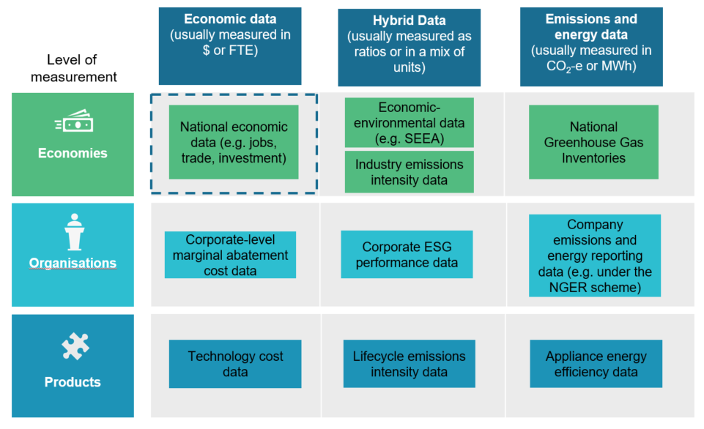

Notes: FTE – full-time equivalent; SEEA – System of Environmental and Economic Accounting; NGER – National Greenhouse and Energy Reporting; ESG – environmental, social and governance.  
Source: CCA adapted from Accenture (2021).

Accenture’s technical report is focused on developing new data related to the ‘low emissions economy’ (see Box 1 below). This Insights Paper takes a broader view of the economic data that policymakers will require to navigate the energy transition, noting that a focus on the ‘low emissions economy’ is problematic. As the economy decarbonises, the threshold for what is considered a low emissions product or industry is likely to change, potentially undermining the coherency of data that attempt to pin down low emissions activities. In addition, more detailed data on industries which are not likely to decarbonise, such as coal mining and coal-fired electricity generation, would help with planning for the transition. In short, defining and honing in on the ‘low emissions economy’ risks creating a false dichotomy and obscuring important aspects of the net zero transformation.

In contrast, a broader analysis of economic data for a decarbonising world will help policymakers understand the full breadth of economic restructuring over coming decades. Traditional industries that rapidly adopt abatement technologies may make a bigger contribution to emissions reductions than more niche industries that produce a product that directly reduces emissions (e.g. geothermal electricity generation). Going beyond the ‘low emissions economy’ also has methodological advantages: the development of consistent and comparable data between different sectors of the economy as it transitions to net zero.

The final section of this Insights Paper discusses how better economic data can support decision-making across a number of policy areas, including how to manage the impact of the transition on different industries and regions.

# Current economic data

Data produced by the Australian Bureau of Statistics on economic activity in Australia have significant breadth and detail.[2] Nevertheless, current datasets were not designed with the economic restructuring driven by decarbonisation in mind, and therefore do not necessarily capture all of the types of information that policymakers require to manage the transition. There are two broad reasons why existing economic data do not always capture how economic activity is changing as a result of decarbonisation: granularity and structure.

**Granularity:** granularity is a measure of the detail or disaggregation available in a particular dataset. More detailed economic data would provide a much better view of how industries which are being reshaped as a result of decarbonisation are changing.

For example, the mining of lithium—an essential input into low emissions technologies—is sometimes grouped with a range of other mineral mining activities. Another example is the Liquefied Natural Gas (LNG) industry, which is often grouped into a broader economic category that includes all oil and gas extraction. Similarly, economic data often group thermal and metallurgical coal mining together, but global decarbonisation efforts will impact these commodities in different ways.

**Structure:** economic data are not always structured in a way that would reveal how industries affected by decarbonisation are changing, even if data have sufficient granularity. For example, Australia’s industry classification system records activity according to *what* is produced rather than *how* it is produced. This means that current economic data would not distinguish between, for example, clean versus conventional aluminium, steel or hydrogen.

In short, there are opportunities to continue to enhance Australian economic data. Further data could be developed to show how industries and regions are tracking economically as Australia decarbonises.

# A way forward

Developing new economic data involves a two-step process of defining the scope of activity to be captured and developing a measurement methodology (Accenture 2021).

## Scope

There are a wide variety of ways in which existing economic data collections could be augmented to monitor the economy as it transitions to net zero. However, it is not possible to collect all relevant economic data due to administrative cost and reporting burden considerations. This introduces the issue of scope.

Accenture (2021) proposes a conceptual framework for determining which activities should be considered part of Australia’s ‘low emissions economy’ (see Box 1). While the distinction between high and low emitting industries is not always helpful (see discussion above), the use of a conceptual framework to identify what data to include in a new economic data collection is potentially useful.

Another way forward may be to take a user-centred approach to designing new economic data collections—an approach under which the needs of policymakers, businesses and communities guide design choices. This would involve a process of ascertaining how new economic data might be used and involving data users in the process of designing new data collections. A number of overarching principles should also be kept in mind when defining the scope of data to be collected, including: coverage (comprehensive), credibility (widely accepted), comparability (internationally comparable) and measurability (practical to measure) (Accenture 2021).



**Box 1: Defining the scope of the low emissions economy**

Should an entire electric vehicle be considered part of the low emissions economy? Or just certain components, like the battery? And should goods like low emissions steel be included if all products in the economy will eventually have low embedded emissions?

Defining the scope of any new data collection presents challenges. Accenture (2021) suggests defining ‘low emissions’ activities as those which have both a significant and intentional role in emissions reductions. Under this definition, activities that incidentally reduce emissions, such as switching from paper to electronic billing, would be excluded from the low emissions economy.

International efforts to define the low emissions economy are distinct from sustainable finance taxonomies that are designed to align finance with climate and other sustainability objectives. However, European policymakers are considering how national economic data might be used to monitor economic activity in areas listed in the European Union’s taxonomy (Accenture 2021). In Australia, the Council of Financial Regulators is monitoring the development of taxonomies and how they align investments with sustainability objectives (Council of Financial Regulators 2021).

## Measurement

An approach to measurement must first consider what economic indicators to measure (e.g. industry value added, employment, trade) and how this data should be disaggregated, whether by activity, region, industry and/or occupation (Accenture 2021). Figure 3 provides an example of how data from the United Kingdom’s Low Carbon and Renewable Energy Economy (LCREE) survey can show the level of employment for certain activities in particular regions. An Australian approach (discussed below) could also allow economic indicators like employment to be disaggregated by geography, but should go beyond focusing on low carbon activities to cover all major sectors of the economy.

The second key step in designing a measurement approach is deciding how to measure each economic indicator. A key issue is whether to collect new data (known as ‘primary data’), draw on existing data (known as ‘secondary data’) or use a combination of these approaches (Accenture 2021). All three of these approaches have been used internationally. Decisions about where and when to use primary and secondary data should be based on five core principles: usefulness, cost-effectiveness, timeliness, repeatability and credibility.

**Figure 3: Low carbon and renewable energy employment in the United Kingdom, 2019**

Notes: Employment on a full-time equivalent basis.  
Source: Office of National Statistics 2021.

## An Australian approach

Australia should take a staged approach to developing new economic data: priority information could be targeted first, and coverage scaled up over time (Accenture 2021). Such an approach would allow policymakers to weigh the benefits of new data with cost and reporting burden considerations.

Against this backdrop, the Authority makes several suggestions for an Australian approach, drawing on elements of Accenture (2021).

**Start with jobs data:** Australia should prioritise the development of more granular employment data, and later look to expand measurement to investment, trade and industry value added. More granular employment data are particularly relevant for Australia, given the need to ensure that regional communities currently dependent on high emitting industries receive the benefits of the energy transition. A focus on jobs would support the development of other labour indicators like wages and underemployment and lay the groundwork for understanding the extent of labour market mobility within regions.

**Consider Australia’s distinct economic structure:** Australia should look to collect economic data for industries and occupations that reflect the distinctive features of the Australian economy—not just those for which data have been developed internationally. For example, both agriculture and mining are more prominent features of Australia’s economy than for other countries that have developed economic data in response to decarbonisation pressures.

**Use secondary data where possible:** Australia should begin by relying on existing or ‘secondary’ data, and consider where primary data should be used to fill any gaps. Australia should explore the use of existing open and private data sources when developing new economic data. This approach would help minimise the reporting burden on business.

Primary data could be collected via a new survey or, over the long term, through modifications to Australia’s industry and occupational classification systems. Further work would be needed on how best to deliver a new survey, such as whether the survey should be delivered by the Australian Bureau of Statistics or another party and whether it should be mandatory of voluntary.

**Link datasets:** A fourth feature of Australia’s approach should be to look at opportunities to better link economic data with other types of data, particularly emissions data. Economic and emissions data are reported using different frameworks: emissions data are based on the Intergovernmental Panel on Climate Change (IPCC) emissions sectors, while the structure of economic data flows from the System of National Accounts.

These different reporting frameworks mean that it can sometimes be difficult to monitor both the economic and decarbonisation performance of industries based on publicly available data. For example, aluminium production is not treated as a source of emissions in IPCC reporting (the sources of emissions are purchased electricity, industrial processes and stationary energy, excluding electricity).

Nevertheless, since 2006 the Australian Government has published integrated economic and emissions datasets, as part of its National Greenhouse Accounts (NGA). The NGA are a series of publicly available reports and databases produced by the Department of Industry, Science, Energy and Resources that estimate, and account for, Australia’s greenhouse gas emissions from 1990 onwards (DISER 2021a). In addition to fulfilling the Government’s international obligation to report Australia’s national greenhouse gas estimates each year, the NGA publish annual emissions data at state, territory and industry levels, as well as on a quarterly and projections basis.

The NGA provide a number of integrated economic and emissions datasets in a public facing way on a regular basis, including a quarterly consumption-based inventory (DISER 2021b), an annual national inventory by economic sector (DISER 2021c) and annual emissions projections by a number of key commodities (DISER 2021d). Building upon efforts like these, further work could be undertaken to link data in a more granular, comprehensive, ongoing and timely way to allow policymakers, businesses and communities to better understand how the economy can transform towards a low emissions world.

Current commercial and legislative confidentiality requirements constrain the level of granularity that can be made publicly available, an issue the Authority will consider in its next statutory review of the National Greenhouse and Energy Reporting scheme, commencing in mid-2022. More granular and frequent economic data may also be needed to achieve a deeper integration of emissions and economic data.

# Policy applications

Economic data are an important public good—for investors, businesses and communities. They are also critical ingredients for good policymaking (ABS 2011). The shift to a net zero world is set to entail huge economic change, placing new demands on policymakers. In this context, new statistical approaches will be important. There is a range of policy issues for which further data and statistics on how the economy is responding to decarbonisation efforts would be useful.

## Employment data and an equitable transition

An increasingly important issue is managing the impacts of global decarbonisation efforts on affected communities. The International Energy Agency’s (IEA) 2021 *Net Zero by 2050* report has highlighted the potential employment impacts (IEA 2021a). In the IEA’s Net Zero by 2050 scenario, 14 million new jobs are generated in clean energy supply by 2030, while 5 million jobs are lost in fossil fuel production. While overall employment in the energy sector grows in this scenario, new jobs may not always be in the same place, arise at the same time or be suitable for the same workers as jobs that are lost.

Governments may have a role in managing the potentially uneven impacts of the energy transition on industries and regions, one which needs to be informed by good data. Internationally there is a growing recognition of the need for more granular data to understand the impact of the energy transition on jobs. The IEA-convened Global Commission on People-Centred Clean Energy Transitions has noted that more detailed energy employment data are “essential for informed decision-making”, whether this be in education and training or regional development programs (IEA 2021b). The IEA and the Enel Foundation have recently initiated the Glass House Project, an effort to improve global energy sector employment data and provide insights on the labour market shifts underway (Enel Foundation 2021).

Partly driven by the need to assist policymakers understand employment trends in a rapidly changing energy landscape, both the United States and United Kingdom have developed new economic surveys in recent years (Office of National Statistics 2021; National Association of State Energy Officials 2020). The United States Energy and Employment Report is regarded as the gold standard when it comes to measuring energy sector employment (RACE for 2030 2021).

The Australian Government has announced as part of its Long-Term Emissions Reduction Plan that the Productivity Commission will report every five years on the socio-economic impacts of Commonwealth, State and Territory emissions reduction policies (Australian Government 2021; Prime Minister of Australia 2021). The reviews, to commence in 2023, will examine impacts on households and regional communities and report against a range of key economic indicators such as energy prices, employment (particularly regional employment), export volumes and trends, investment trends and growth in national income. More detailed data would support such reviews. For example, more detailed employment data would be of benefit to Australia in navigating the transition to net zero, informing the necessary skills and investment policies to support regional communities (see Box 2).

More granular data could also shed light on currently unseen but potentially important employment trends—jobs in thermal coal versus metallurgical coal, or employment in the LNG industry versus domestic oil and gas extraction—although measurement challenges would need to be addressed.

The RACE for 2030—an industry led collaborative research centre established with Commonwealth funding—has found that there is a need for a robust methodology for tracking energy sector jobs in Australia to manage the transformation of the workforce (RACE for 2030 2021). Such baseline data would not only shed light on the employment impacts of the energy transition to date, but could also underpin projections of how the workforce is likely to change over coming decades, and thus inform the response to issues such as regional adjustment and skills shortages.

The United States and United Kingdom approaches to developing more granular employment data could provide a starting point for Australia’s approach. However, Australia’s approach to employment data might benefit from covering a broader suite of industries than covered in the United States and United Kingdom surveys, such as critical minerals mining and energy-intensive manufacturing industries like aluminium.

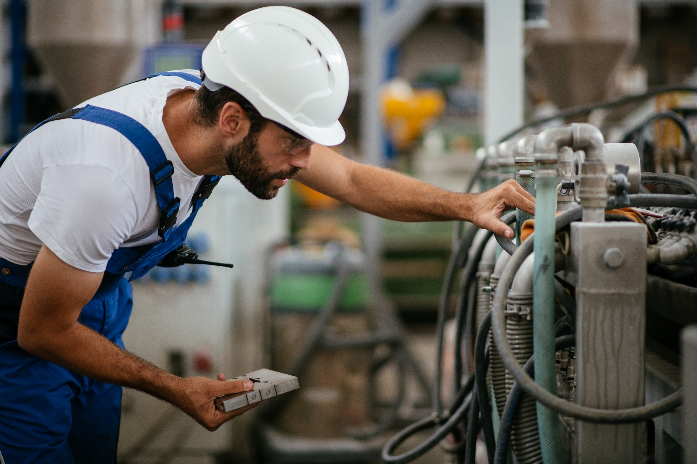

**Box 2: Employment data for Australia’s net zero transition**

In 2016, around 100,000 people in Australia were employed in carbon-intensive industries such coal mining, oil and gas extraction, fossil fuel electricity generation, cement manufacturing, and integrated steel-making (Grattan 2020). While only a small proportion of Australians work in these industries, they are important employers in regional communities across Australia, from central Queensland, to the Hunter Valley, Whyalla and Collie.

More granular employment data—on both traditional and emerging industries—could support workforce planning and regional adjustment policies in Australia. Such data are the starting point for answering questions about whether workers in traditional industries are gaining jobs in emerging industries, and the role for policy in supporting workforce transition. The Australian Government has announced a Clean Hydrogen Industrial Hubs program, aimed at lowering emissions and creating regional jobs, which will enable the rollout of hydrogen hubs across seven priority regional sites (Minister for Industry, Energy and Emissions Reduction 2021).

## Net zero leading indicators

Net zero leading indicators could be used to anticipate how the economy—and its emissions intensity—are likely to change. Decision-makers could use such information to assess likely progress towards emissions reduction targets and hence the need or otherwise for adjustments to policy. Net zero leading indicators could be developed with consideration given to the many interlinked drivers of decarbonisation and the long period of time over which it unfolds. Used in conjunction with other sources of information, such as emissions data and scenarios, they could provide a helpful picture of future developments.

Australia’s Emissions Projections take into account recent emissions data, economic data and new policy announcements as important indicators of likely future emissions. Economic data could be used to develop additional leading indicators of activity in the real economy that have flow-on effects that reduce emissions. Public and private sector investment in research and development of low emissions technologies, for example, could be a leading indicator of future emissions reductions.

Net zero leading indicators could also help policymakers understand the future prospects for key emissions reduction technologies and make decisions accordingly. For example, economic data and other leading indicators could inform the allocation of public support to the priority technologies identified in the Government’s Low Emissions Technology Statement 2021 (DISER 2021e). Similarly, data on investment in adaptation could be a leading indicator of whether Australia is preparing sufficiently for the physical risks posed by climate change and inform adaptation planning.

## Trade and industry policy

There are other policy areas where more economic data would be useful. Data on exports and imports support trade policy and provide important context for business decisions.

Further data could also support industry policy—government policy aimed at promoting the development of particular industries or technologies, from subsidies to regulatory reform. According to the IEA, an expansion in public financing to support the transition is required and this public finance needs to catalyse further private investment if global climate targets are to be met (IEA 2021c). More data on key industries and technologies would help governments to direct investments to areas where they will generate the best economic and emissions outcomes.

Similarly, more granular economic data that are linked to emissions and other data would help paint a picture of how quickly different sectors are transitioning and where greater effort is needed.

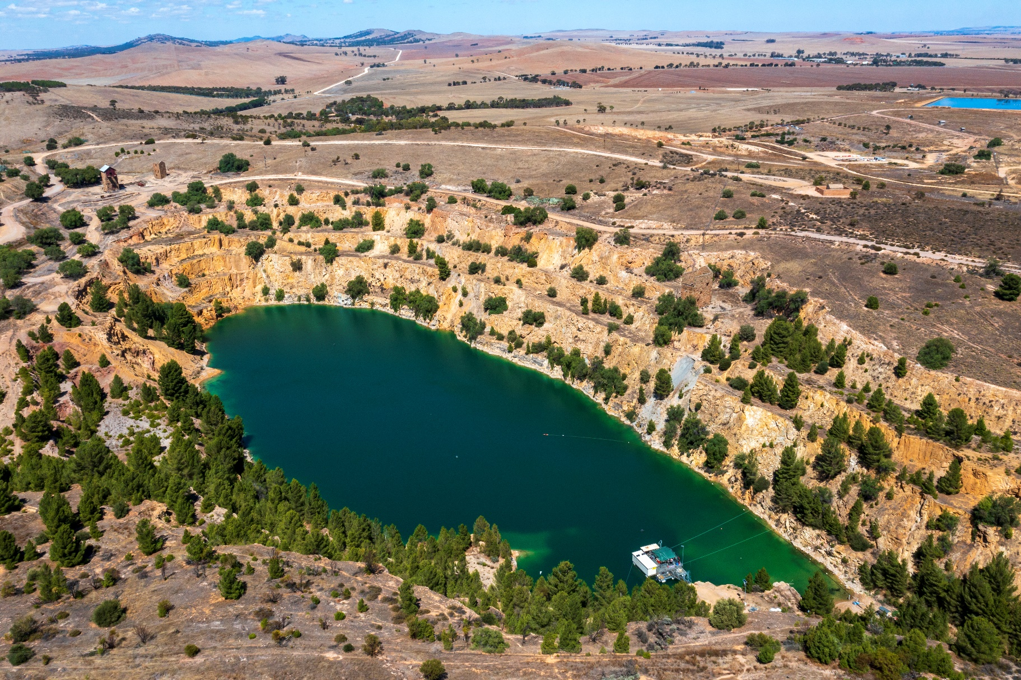

**Box 3: Economic data as leading indicators**

Leading indicators are data that can be used to predict movements in another variable. A single leading indicator often lacks predictive power. However, when taken together and used in conjunction with other sources of information, leading indicators provide a picture of future developments.

Leading indicators are ubiquitous in economics. For example, economists looking at the mining sector use data published by the Australian Bureau of Statistics—such as companies’ spending on exploration for new resources—to understand where the sector is heading. Similarly, economists track new mining projects along the various stages of the project pipeline—from being publically announced to a final investment decision being taken—to inform their assessment of future production levels.

Leading indicators such as these are important for understanding the future of energy commodities like coal and gas, and the mineral commodities needed for low carbon technologies such as copper, nickel and lithium. With a better understanding of the future of energy and mineral commodities, we can better understand Australia’s trajectory to net zero emissions.

## International engagement

Australia has an opportunity to play a key role in the area of economic data and decarbonisation. Globally, there is a long history of trying to understand the relationship between the environment and the economy, but developing economic statistics that shed light on energy transitions is a relatively new field. The United Kingdom and the United States are two of the foremost jurisdictions in the area, having established new economic surveys in 2015 and 2016 respectively, but the field remains immature.

Australia could look to engage internationally through both bilateral and multilateral forums. The Australian Bureau of Statistics’ partnerships with other countries’ national statistical agencies could be a natural starting point for bilateral cooperation. There may be opportunities for Australia to contribute to the development of an international standard for measuring employment in the energy sector through engagement with organisations like the IEA. Australia should also be an active participant in international discussions on longer-term reforms to industrial and occupational classification systems, and could also work constructively with New Zealand on Australia-New Zealand classification standards.

With significant expertise in both economic and emissions data, Australia could make a valuable contribution to the development of data for a decarbonising world.

## Acknowledgements

The Climate Change Authority thanks the Australian Bureau of Statistics; Department of Industry, Science, Energy and Resources; Department of Foreign Affairs and Trade; Productivity Commission, Treasury; Clean Energy Finance Corporation; UK Office of National Statistics; BW Research; International Energy Agency; RACE for 2030 and Accenture for their feedback on and contributions to this work, and hopes they find this report a valuable input as they plan their own next steps in a decarbonising world.

# References

**Accenture (2021).** *Measuring the low-emissions economy in Australia.* Retrieved from <https://www.climatechangeauthority.gov.au/publications/economic-data-decarbonising-world>

**Australian Bureau of Statistics (ABS) (2011).** *Measuring the green economy*. Retrieved from <https://unstats.un.org/unsd/envaccounting/londongroup/meeting17/LG17_23b.pdf>

**Australian Government (2021).** *Australia’s Long-term Emissions Reduction Plan: a whole-of-economy plan to achieve net zero emissions by 2050*. Retrieved from <https://www.industry.gov.au/data-and-publications/australias-long-term-emissions-reduction-plan>

**Climate Change Authority (CCA) (2021a).** *Paris Plus: From cost to competitive advantage.* Retrieved from <https://www.climatechangeauthority.gov.au/publications/paris-plus-cost-competitive-advantage>

**Climate Change Authority (CCA) (2021b).** *Paris Plus: Trade and investment trends in a decarbonising world.* Retrieved from <https://www.climatechangeauthority.gov.au/publications/paris-plus-trade-and-investment-trends-decarbonising-world>

**Council of Financial Regulators (2021).** *Council of Financial Regulators Climate Change Activity Stocktake 2021*. Retrieved from <https://www.cfr.gov.au/publications/policy-statements-and-other-reports/2021/council-of-financial-regulators-climate-change-activity-stocktake-2021/>

**Department of Industry, Science, Energy and Resources (DISER) (2021a).** *Tracking and reporting greenhouse gas emissions.* Retrieved from <https://www.industry.gov.au/policies-and-initiatives/australias-climate-change-strategies/tracking-and-reporting-greenhouse-gas-emissions>

**Department of Industry, Science, Energy and Resources (DISER) (2021b).** *National Greenhouse Gas Inventory: Quarterly updates.* https://www.industry.gov.au/data-and-publications/national-greenhouse-gas-inventory-quarterly-updates

**Department of Industry, Science, Energy and Resources (DISER) (2021c).** *National Inventory by Economic Sector.* Retrieved from <https://ageis.climatechange.gov.au/anzsic.aspx>

**Department of Industry, Science, Energy and Resources (DISER) (2021d).** *Australia’s emissions projections 2021.* Retrieved from <https://www.industry.gov.au/data-and-publications/australias-emissions-projections-2021>

**Department of Industry, Science, Energy and Resources (DISER) (2021e).** *Technology Investment Roadmap: Low Emissions Technology Statement 2021.* Retrieved from <https://www.industry.gov.au/data-and-publications/technology-investment-roadmap-low-emissions-technology-statement-2021/at-a-glance>

**Enel Foundation (2021).** *Enel Foundation and IEA launch The Glass House Project.*Retrieved from <https://www.enelfoundation.org/news/a/2021/04/enel-foundation-and-iea-launch-the-glass-house-project--a-look-a>

**Grattan Institute (2020).** *Start with steel: a practical plan to support carbon workers and cut emissions.* Retrieved from <https://grattan.edu.au/wp-content/uploads/2020/05/2020-06-Start-with-steel.pdf>

**International Energy Agency (IEA) (2021a).** *Net zero by 2050: A roadmap for the global energy sector.* Retrieved from <https://www.iea.org/reports/net-zero-by-2050>

**International Energy Agency (IEA) (2021b).** *The importance of focusing on jobs and fairness in clean energy transitions.* Retrieved from <https://www.iea.org/commentaries/the-importance-of-focusing-on-jobs-and-fairness-in-clean-energy-transitions>

**International Energy Agency (IEA 2021c).** *World Energy Outlook.* Retrieved from <https://www.iea.org/reports/world-energy-outlook-2021/mobilising-investment-and-finance>

**Minister for Industry, Energy and Emissions Reduction (2021).** *Future hydrogen industry to create jobs, lower emissions and boost regional Australia.* Retrieved from <https://www.minister.industry.gov.au/ministers/taylor/media-releases/future-hydrogen-industry-create-jobs-lower-emissions-and-boost-regional-australia>

**National Association of State Energy Officials (NASEO) (2020).** *2020 U.S. Energy & employment report.* Retrieved from <https://www.usenergyjobs.org/>

**Office of National Statistics (2021).** *Low carbon and renewable energy economy, UK: 2019.* Retrieved from <https://www.ons.gov.uk/economy/environmentalaccounts/bulletins/finalestimates/2019>

**Organisation for Economic Co-operation and Development (OECD) (2014).** *Understanding national accounts: Second addition*. Retrieved from <https://www.oecd.org/sdd/UNA-2014.pdf>

**Prime Minister of Australia (2021).** *Transcript: 26 October 2021.* Retrieved from <https://www.pm.gov.au/media/press-conference-canberra-act-27>

**RACE for 2030 (2021).** *E3 Opportunity Assessment: Developing the future energy workforce**(final report).* Retrieved from <https://www.racefor2030.com.au/project/developing-the-future-energy-workforce/>

**United Nations (2021).** *The System of National Accounts (SNA).* Retrieved from <https://unstats.un.org/unsd/nationalaccount/sna.asp>

1. This data and information architecture forms part of a broader ‘Paris Plus’ global climate architecture that reflects the actions of not only governments, but buyers, sellers and investors (CCA 2021a).
2. The core framework for modern economic statistics is the System of National Accounts—the internationally agreed standard for compiling measures of economy activity (United Nations 2021). The System of National Accounts was first published in the early 1950s to help monitor the post-war reconstruction of Europe and has now been under development for around 70 years, with major versions released in 1968, 1993 and 2008 (OECD 2014). Australian economic data are aligned with these international standards.