**2020 Review of the Emissions Reduction Fund Consultation Paper**

**APRIL 2020**



Published by the Climate Change Authority

www.climatechangeauthority.gov.au

© Commonwealth of Australia 2020

This work is licensed under the Creative Commons Attribution 3.0 Australia Licence. To view a copy of this license, visit http://creativecommons.org/licenses/by/3.0/au

The Climate Change Authority asserts the right to be recognised as author of the original material in the following manner:

 

© Commonwealth of Australia (Climate Change Authority) 2020.

IMPORTANT NOTICE – PLEASE READ

This document is produced for general information only and does not represent a statement of the policy of the Commonwealth of Australia. The Commonwealth of Australia and all persons acting for the Commonwealth preparing this report accept no liability for the accuracy of or inferences from the material contained in this publication, or for any action as a result of any person’s or group’s interpretations, deductions, conclusions or actions in relying on this material.

**Contents**

**2020 Review of the Emissions Reduction Fund Consultation Paper** 0

**Contents** 2

**1.** **Inviting submissions to 2020 review of the Emissions Reduction Fund** 3

**2.** **Areas of investigation for this review** 5

2.1 How this review will interact with other Government processes 6

**3.** **Overall performance of the ERF** 6

**4.** **Maintaining integrity and optimising governance of the ERF** 6

4.1 Crediting genuine, additional abatement 6

4.2 Governance to support a mature ERF 7

4.3 Method development process 7

**5.** **Managing risks to abatement** 8

**6.** **Opportunities for enhancing outcomes** 9

6.1 The role of the ERF in future economic recovery efforts 9

6.2 Opportunities for land-based ERF projects 9

**Background** 11

**7.** **ERF abatement** 11

**8.** **The Authority’s previous ERF advice and Government response** 12

**9.** **The ERF as part of a climate policy toolkit for Australia** 13

**10.** **Anticipated changes to the ERF in 2020** 13

10.1 Initiatives by the Clean Energy Regulator 13

10.2 Issues of focus for the Department 14

10.3 Expert panel review examining opportunities for further abatement 14

**Appendices** 15

A. Guiding principles for this review 15

B. Reports and references 15

1. **Inviting submissions to 2020 review of the Emissions Reduction Fund**

The Climate Change Authority is an independent statutory agency, established to provide expert, evidence-based advice on Australia’s climate change policy.

The *Carbon Credits (Carbon Farming Initiative) Act 2011* (Cth) (CFI Act) implements the crediting and purchasing elements of the Emissions Reduction Fund (ERF). The CFI Act requires that every three years the Authority review the operation of the Act and regulations and other instruments made under the Act, such as ERF methods (Appendix A). The Authority previously reviewed the ERF in 2014 and 2017.

The safeguard mechanism is the third element of the ERF and is contained in the National Greenhouse and Energy Reporting legislation, which is subject to separate reviews by the Authority, the first being completed in 2018.

The Authority’s 2017 review of the ERF generally found it to be performing well. The Government accepted the majority of the Authority’s recommendations, which were primarily focused on enhancing the integrity and streamlining operational aspects of the scheme, and has taken steps to enact them.

In addition, the Clean Energy Regulator (Regulator) is currently seeking ways to boost opportunities under the ERF and the Government commissioned a review led by Mr Grant King to examine how abatement might be expanded including through the additional funding available under the Climate Solutions Fund (the Expert Panel Review).

In the 2020 review, the Authority is focusing on issues not explicitly being addressed through other processes.

This consultation paper is seeking submissions to inform this review. The paper sets out:

* Issues the Authority proposes to consider in this review
* Background information

The performance and operation of the ERF

The Authority’s previous advice to Government on the ERF

Anticipated changes to the ERF in 2020

|  |  |
| --- | --- |
| |  | | --- | | 1. How to provide input to our consultation   To inform the 2020 review of the Emissions Reduction Fund, the Authority invites organisations, businesses and individuals to provide input to our consultation.  This consultation paper identifies matters the Authority considers most pertinent to this review however, views on other issues in relation to the ERF are also welcome.  The Authority recognises the severe disruption caused by Covid-19 and acknowledges this may be a difficult time for stakeholders to take part in consultation. In order to assist you to provide input to this review we are providing a range of options for consultation. Lodging written submissions If you would like to provide a written submission, you can do this by emailing it to [submission@climatechangeauthority.gov.au](mailto:submission@climatechangeauthority.gov.au) until 20 May 2020.  If you intend on making a written submission but will require additional time beyond 20 May 2020, please contact the Authority at [enquiries@climatechangeauthority.gov.au](mailto:enquiries@climatechangeauthority.gov.au).  A coversheet for submissions can be found on the Authority’s website at: www.climatechangeauthority.gov.au/consultations. Please indicate on the coversheet whether your submission is made in confidence. Submissions made in confidence will not be published on the Authority's website. Submissions to previous reviews In conducting this review, the Authority will consider relevant submissions made by stakeholders to inform our recent report *Prospering in a low emissions world: An updated climate policy toolkit for Australia*. If you made such a submission, it does not need to be re-submitted.  If you have made a submission to a different panel or department and you would like the Authority to consider the same information as part of this review, you are invited to email that submission to the Authority at submission@climatechangeauthority.gov.au. Targeted consultation The Authority will also be undertaking targeted consultation with stakeholders to complement the written submissions. If you would like to be part of these discussions either in addition to or as an alternative to making a written submission, please contact us at [enquiries@climatechangeauthority.gov.au](mailto:enquiries@climatechangeauthority.gov.au).  Your contributions are greatly valued by the Authority and will inform the Authority’s final review report. | |

|  |
| --- |
| 1. What is the Emissions Reduction Fund?   The ERF is a key Australian Government policy to incentivise emissions reductions. Projects that reduce emissions or enhance carbon storage can be issued with Australian Carbon Credit Units (ACCUs), which can then be purchased by the Government to help meet Australia’s 2030 target.  The ERF was established in 2014. The crediting aspect of the ERF had its foundations as the Carbon Farming Initiative, a voluntary offset scheme that operated between 2011 and 2014 to support compliance with the Carbon Pricing Scheme. Crediting mechanism Under the crediting mechanism, the ERF issues ACCUs to businesses, community organisations, local councils, individuals, and others that successfully undertake an emissions reduction project registered with the Regulator.  An ACCU represents one tonne of carbon dioxide equivalent (t CO2-e) stored or avoided by a project. Registered projects must comply with methods developed by the Department of Industry, Science, Energy and Resources (the Department) and approved by the Minister.  There are currently 34 approved methods. These methods cover activities in agriculture, energy efficiency, facilities, mining, oil and gas, transport, vegetation management, savanna fires, waste and wastewater management.  All methods under the ERF accredit emissions reductions or carbon storage activities that can be used to meet Australia’s international emissions reduction commitments. Purchasing mechanism The Australian Government can purchase ACCUs from scheme participants who have registered a project with the Regulator, and has allocated significant funds for this purpose. To date, the Regulator has purchased ACCUs through auctions, although it can also purchase them through other means that meet the principles in the Act. A key principle is the purchase of least cost abatement.  A more detailed explanation of the ERF is in the final report of the Authority’s [2017 ERF review](http://www.climatechangeauthority.gov.au/review-emissions-reduction-fund). |

1. **Areas of investigation for this review**

In this review, the Authority is considering the overall performance of the ERF and has identified the following areas of focus, based on its previous ERF reviews and consultation undertaken for the *Prospering in a low emissions world* report:

* Maintaining integrity and optimising governance
* Managing risks to abatement
* Opportunities for enhancing outcomes

The Authority is open to considering other matters and welcomes all views on how the ERF is performing and/or how its operation could be improved.

2.1 How this review will interact with other Government processes

The Government and Regulator are actively working on options to streamline the ERF, enhance uptake and recognise co-benefits. These areas were also identified by stakeholder submissions to the Authority’s *Prospering in a low emissions world*. The Authority does not intend to give detailed consideration to these same issues in this review where it would lead to duplication.

The Authority will, however, consider the implications of any new proposals that are announced by Government or the Regulator during the period of this review, including any response to the Expert Panel Review.

This report describes the Government’s activities in more detail in section 10.

1. **Overall performance of the ERF**

This review will consider the overall performance of the ERF in crediting genuine, additional abatement and purchasing least cost abatement to help meet Australia’s 2030 emissions target. As of April 2020, the ERF has credited over 75 million[1] ACCUs (tonnes of abatement) and the Government has awarded contracts for the delivery of 193 million ACCUs. ERF abatement is described in more detail in the background to this paper.

How is the ERF performing overall?

What parts of the ERF could be improved and how?

1. **Maintaining integrity and optimising governance of the ERF**

4.1 Crediting genuine, additional abatement

The offsets integrity standards, set out in the CFI Act, are designed to ensure that ACCUs issued under the ERF are for genuine emissions reductions that are additional to business as usual. They include that abatement is evidence-based, able to be measured and verified, and contributes to Australia’s international obligations. To ensure the integrity of the ERF, the Emissions Reduction Assurance Committee and the Minister have to take the standards into account when making and reviewing methods.

Additionality is one of the offset standards, designed to ensure the ERF encourages activities that would not have occurred anyway. It underpins the integrity and value of offsets. The ERF additionality requirements also include ‘regulatory additionality’ and ‘newness’.

The regulatory additionality requirements are that the activity not be required by other government regulations or already supported by some government programs. The activity also needs to be new – it cannot have already started. The newness requirement is intended to be a practical filter to ensure that only projects established in response to the ERF incentive would be eligible for ERF crediting and purchasing. In 2017, the Authority considered that these requirements were generally fit for purpose and appeared to be working reasonably well.

Some stakeholders have continued to express the view that the ‘newness test’ could be a potential barrier to innovation and early implementation of an abatement activity ahead of a method being in place. A project can only be registered if there is a method to support it and an abatement activity must not have already begun at the time the project is registered as an ERF project with the Regulator.

Now that the ERF has been in place for several years, we are interested in reviewing the operation of the offsets integrity standards, including the application of the principle of additionality, given both their importance to the integrity of the ERF and their impact on the range of activities that are eligible to participate in the scheme.

Do you have any views on the operation of the offsets integrity standards and the additionality provisions as key principles supporting the integrity of abatement under the ERF?

4.2 Governance to support a mature ERF

The Department, Regulator and Emissions Reduction Assurance Committee (the Committee) all have defined roles in the operation of the ERF; these are summarised in Table 1.

**TABLE 1** Roles in the ERF

|  |  |
| --- | --- |
| Clean Energy Regulator | Administers the ERF, including the registration of projects, crediting (or issuance) of ACCUs to scheme participants, purchasing of ACCU on behalf of the Government (including the conduct of auctions for this purpose) and the management of contracts for the delivery of ACCUs.  The Regulator is also responsible for monitoring of compliance with the rules of the scheme, as well as pursuing breaches of these rules if they occur. |
| The Department | Responsible for advising the Government on overall policy direction and development, method prioritisation, maintenance of tools that support methods, and provision of secretariat support to the Committee.  In scoping and developing new methods, the Department seeks advice from the Regulator and the Committee. |
| Emissions Reduction Assurance Committee | An independent, expert committee responsible for assessing whether methods developed by the Department meet the ERF’s offsets integrity standards.  Conducts reviews of ERF methods to assess whether they continue to meet the offsets integrity standards and provides advice to the Minister on whether a method should be made, varied or continue to be part of the ERF. |

The Minister for Energy and Emissions Reduction has the role of making or varying methods based on advice from the Committee and having regard to the offsets integrity standards. Other Ministers have some specific roles in the ERF. For example, the Minister for Agriculture can exclude projects that intend to establish new plantations if it is determined this would result in an undesirable impact on agricultural production in the region.

In 2017 the Authority found that the governance of the ERF was sound, and recommended two changes to facilitate smoother administration.

Do you think the governance structures of the ERF remain fit for purpose?

4.3 Method development process

Currently, the Department develops methods in conjunction with technical working groups. In 2017, the Authority considered that this process for method development should continue. However, the Authority also recommended that stakeholders be able to submit proposals for new methods to the Department which would then prioritise them for development. This could alert the Department to new practical opportunities from industry. The Department accepted these recommendations in-principle, and has published more information on its website about prioritisation.

The Authority is aware the Department is trialling greater collaboration with industry, scientists, state governments and other stakeholders to build understanding of future method opportunities and obstacles for abatement in certain sectors. It is intended to help guide investment, research and method development. The Department has developed a roadmap for savanna fire management activities, and is developing roadmaps for abatement from livestock and blue carbon.

In the Authority’s consultation for *Prospering in a low-emissions world*, stakeholders requested more methods, more resources to expedite the process and more industry knowledge utilised in method development.

What are your views on method prioritisation, method development and method review processes in the ERF? Please include any thoughts on how these processes could be improved, including how the expertise of industry could be better incorporated.

1. **Managing risks to abatement**

The Authority’s recent report, *Prospering in a low-emissions world,* recommended government programs fully integrate climate risks into decision making. This review will look broadly at the issue of climate risk to ERF abatement and the existing and potential mechanisms by which it is being/can be managed by the Government and by project proponents.

The Authority’s review will focus on risks to delivery and permanence of abatement from land-sector projects that store carbon in vegetation and soils, including the risks from projected climate change impacts. Relevant ERF risk management mechanisms include the risk of reversal buffer and the 25‑year permanence period discount (Table 2). In 2017, the Authority said it would examine both these mechanisms in the 2020 ERF review.

**TABLE 2** Risk of reversal buffer and permanence period discount

|  |  |
| --- | --- |
| **Types of risk** | **Risk management measure** |
| Carbon is lost due to a natural disturbance event removing vegetation or biomass in soil from a project area. | Only 95 per cent of credits from the project are issued to the project proponent. Five per cent of credits are not issued (known as the **risk of reversal buffer**).  There are also other tools for risk management such as the carbon maintenance obligations for landholders and method specific measures. |
| A completed land-based project loses carbon after obligations to maintain the project are completed. | Projects have an obligation to maintain carbon stores (with penalties for not doing so) for 100 years, or for 25-years with a 20 per cent (in most cases) discount to crediting (the **permanence period discount**). |

Currently, close to half of all contracted abatement is to come from revegetation projects in western New South Wales and south-western Queensland. Another 11 per cent of contracted abatement is estimated to come from avoided deforestation projects in the same part of New South Wales. This geographical concentration of projects is potentially a risk to abatement, as a large proportion of the ERF abatement could be affected by an event, for example a major drought affecting this region of Australia.

What are your views on the suitability of the permanence period discount?

What are your views on the suitability of the risk of reversal buffer?

What are your views on the risks posed to land-based abatement and the adequacy of ERF and project-level risk mitigation measures?

What are your views on the risks to contracted abatement resulting from ERF projects being concentrated geographically and by method type?

1. **Opportunities for enhancing outcomes**

6.1 The role of the ERF in future economic recovery efforts

The COVID-19 pandemic’s impact on the Australian economy will not be fully understood for some time but is expected to be significant for many sectors. The ERF is an economy-wide scheme that provides incentives to business and landholders to undertake emission abatement activities through the Government purchasing of ACCUs. These activities offer a range of benefits for businesses and landholders including the ability to decrease their energy costs, increase their production efficiency and diversify their income.

In *Prospering in a low-emissions world*, the Authority has updated its advice on how the Australian economy can transition to and prosper from a low emissions future. Given the possibility of the need for future economic stimulus to support the ongoing recovery of the Australian economy from COVID-19, the Authority is interested in exploring whether and how the ERF can support that recovery while contributing to Australia’s emissions reductions.

What role could the ERF play in future economic recovery efforts?

6.2 Opportunities for land-based ERF projects

One of the stated objectives of the CFI Act is to increase emissions reductions in a way that protects Australia’s natural environment and improves resilience to the effects of climate change.

As noted in *Prospering in a low-emissions world* the land sector is a source of emissions offsets that can help meet emissions reduction targets and, potentially, make a significant contribution to transitioning the economy towards net-zero emissions in the longer term.

At the same time, Australia’s agriculture sector and natural environment are being affected by the impacts of climate change which are reducing farm profitability and threatening native wildlife. There are smart land practices that increase the carbon stored in the landscape as well as enhance climate resilience. Increasingly the land sector will need to manage for both outcomes. Although the ERF purchasing component requires the Government to purchase least cost abatement, the ERF also provides for the recognition of multiple benefits and contains checks to manage adverse impacts on the environment.

### 6.2.1 Building a climate resilient ERF

The hot, dry summer of 2019-20 caused unprecedented bushfires and there has been sustained drought across areas of Australia. These changes are consistent with climate change and bring to the fore the need to incorporate the impacts of climate change into land management policies and programs.

In 2017, the Authority recommended fire management plans be developed for ERF projects. The ERF also requires projects to meet all state environmental and land use planning legislation.

Through the Authority’s consultation for *Prospering in a low-emissions world*, stakeholders asked that greater consideration be given in the ERF to benefits beyond carbon abatement in order to support more climate-resilient projects. As part of this review, we will consider whether potential exists for any further measures with the ERF, including increased coordination with other policies, to achieve this end.

There is also the potential for the ERF, together with other programs, to contribute to enhancing the recovery from drought or bushfire in affected areas and to bolster ongoing land management practices.

Should the ERF more explicitly address climate resilience and impacts? If so, how?

### 6.2.2 Promoting best practice land management and multiple benefits

In addition to providing abatement, some projects have the ability to achieve other environmental, social and cultural benefits and/or to improve on-farm profitability generally.

In [*Reaping the Rewards*](http://www.climatechangeauthority.gov.au/reaping-rewards-research-report), the Authority made recommendations on a number of ways that governments, industry bodies and natural resource management organisations could assist landholders to realise these multiple benefits. This included coordinating ERF projects with other programs and measures seeking to deliver these co-benefits.

The Regulator has signalled that it will be working to help the market to identify ERF projects with environmental, social and cultural co-benefits. In March 2020 it released an update to the national registry of emissions units that will enable purchasers of ACCUs to check that the ACCUs delivered have come from the project that they had expected. This will help reassure purchasers of ACCUs who are interested in supporting projects with co-benefits that they are in fact doing so. The Regulator considers that direct financial support for co-benefits would be provided by private sector purchasing of ACCUs or through other government initiatives, such as the Queensland Land Restoration Fund, while the ERF continues with least cost purchasing as required by legislation.

Not all project proponents will seek to have co-benefits formally recognised, so there may be benefit in less formal promotion of best practice management of ERF projects, for example through guidance on land management practices to achieve carbon storage and other beneficial outcomes for different project types. Governments and industry bodies often produce best practice management guides for aspects of agricultural production.

Is there a need for enhanced guidance on how to manage ERF projects for multiple benefits? If so, should this be part of the ERF or complementary programs and policies?

**Background**

1. **ERF abatement**

As of April 2020, the ERF has generated a total of 75.8 million ACCUs (tonnes of abatement) including ACCUs generated under the original Carbon Farming Initiative from 2012.[2]

97 per cent of the ACCUs issued are from vegetation, waste and savanna fire management projects.

1. 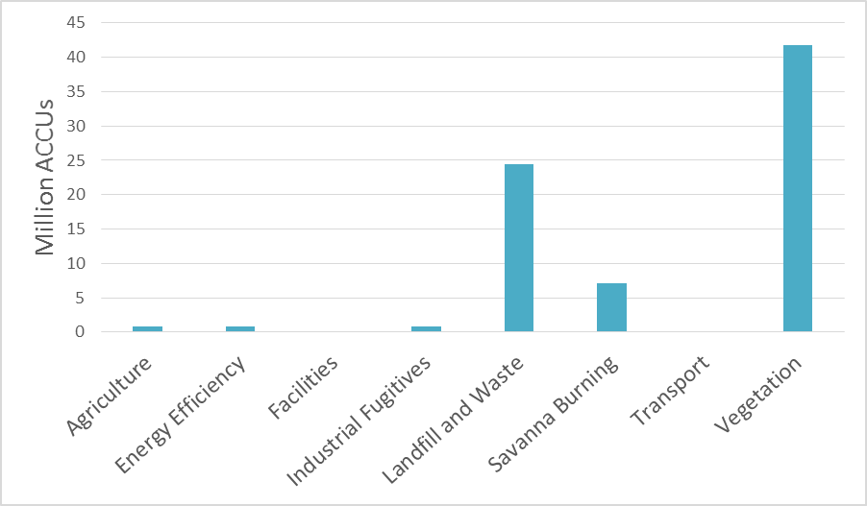ACCUs issued by method type

**Source**: ERF project register, April 2020

In 2014, the Australian Government made $2.55 billion available to purchase ACCUs over a period of ten years. As of April 2020, the ERF has awarded contracts for a total of 193 million tonnes of abatement at a total commitment of $2.3 billion, of which:

* 52.7 million tonnes (27 per cent), has been delivered
* 140 million tonnes is scheduled for delivery.

In 2019, the Australian Government announced a $2 billion Climate Solutions Fund that would include money to continue the purchase of abatement through the ERF. At this stage, it is not clear how much of this money will be allocated for ERF purchases, and how much will be used for other mechanisms.

Since the Authority’s 2017 review, there has been a small increase in net abatement in the Government’s total contract portfolio. This may reflect a number of factors including uncertainty about the future of the ERF discouraging the development of ERF projects (especially prior to the Government's Climate Solutions Fund announcement) and potential market participants seeking higher auction prices than being offered by the Regulator.

New contracts have been entered into for around 11.7 million tonnes of abatement since 2018. At the same time, 22 contracts for 10.6 million tonnes of abatement have lapsed without any credits earned or funds paid under the contracts. In 2017, the Authority noted it is normal for some contracts to lapse or terminate, and this allows the funding originally allocated to these contracts to become available for future purchasing. The auctions held over the last two years have mostly replaced the abatement ‘lost’ from the portfolio due to lapsed contracts.

1. 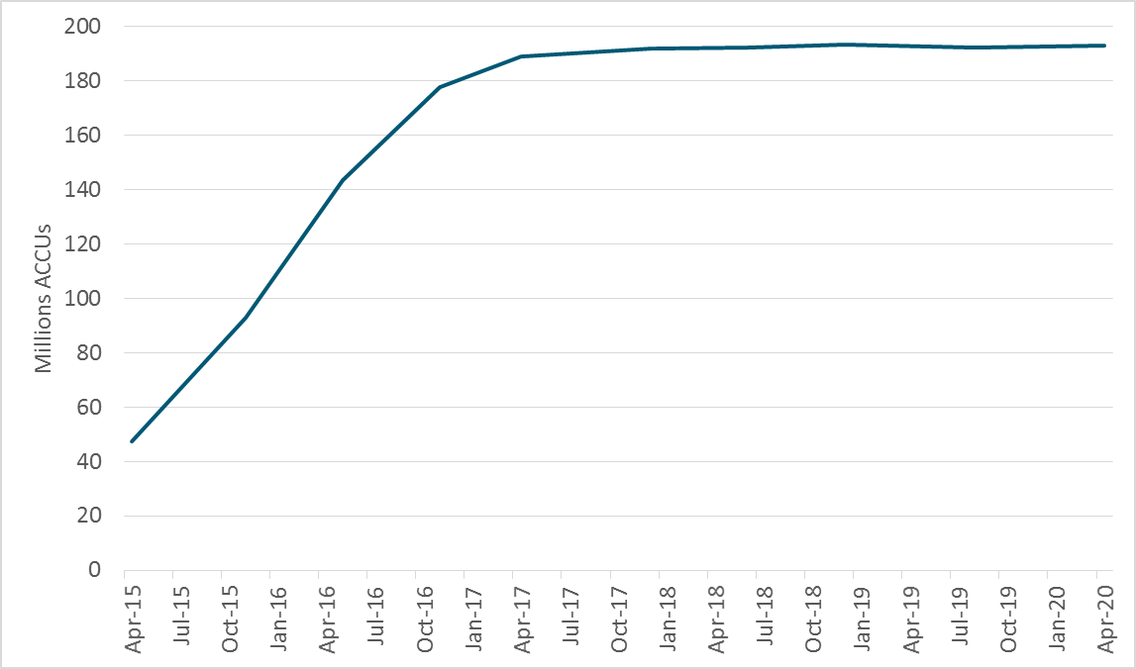Cumulative contracted abatement under the ERF (millions of tonnes CO2-e) from April 2015 to April 2020.

**Source**: Clean Energy Regulator, Auction results.

**Note**: Graph shows portfolio abatement following each auction (first to tenth auction results included). A small number of lapsed/terminated contracts are included in the portfolio total up to April 2017, after which the total is expressed net of lapsed/terminated contracts.

1. **The Authority’s previous ERF advice and Government response**

The Authority found in its 2017 review that the ERF was generally operating well, including the environmental integrity of the credits issued. This was due in large part to robust mechanisms for ensuring the environmental integrity of ACCUs issued under the ERF and sound administration by the Regulator.

In 2017, the Authority made 26 recommendations to further enhance the ERF by:

* enhancing environmental integrity and increasing abatement
* further securing the permanence of carbon stored in vegetation and soil
* strengthening investment and contract delivery
* enhancing administration and compliance
* expanding access and opportunity for new participants.

The Government has since accepted most of these recommendations, rejecting only two as the Regulator stated they had other mechanisms in place to manage the issues. The Government has implemented some of the recommendations it accepted and others are still in the process of being implemented.

1. **The ERF as part of a climate policy toolkit for Australia**

*Prospering in a low-emissions world* sets out the Authority’s latest advice on how Australia can meet its emissions reduction targets and position for the long-term global transition to net-zero emissions.

The Authority recommended the ERF continue as an offsets scheme for facilities covered by an enhanced safeguard mechanism and available for use in other (for example, voluntary) markets, and that the ERF should retain a focus on offsets from the land and agriculture sector.

The Authority recommended an enhanced safeguard mechanism with declining baselines. To ensure they meet their declining baselines, the Authority considered that liable entities under the enhanced safeguard mechanism could take action to reduce their emissions, acquire Australian Carbon Credit Units (ACCUs) or offset their emissions using over-achievement from another entity or period. This approach would foster a deeper and more certain market for ACCUs generated via the ERF.

The Authority also recommended that Government purchasing should continue until an enhanced safeguard mechanism provides a strong source of demand for ACCUs.

1. **Anticipated changes to the ERF in 2020**

The Authority notes the following ongoing areas of work and will take them into account as needed and as further information becomes available during its 2020 ERF review.

10.1 Initiatives by the Clean Energy Regulator

The Regulator has identified actions to support greater participation in the ERF through extension and outreach, market development and market innovation. The Regulator plans to:

* increase awareness, interest and understanding of the ERF among prospective project proponents and service providers
* enhance contracting options; reduce barriers and increase participation from smaller projects and industrial facilities; and look at ways to assist the market to better value ACCUs with co-benefits
* consider ways to streamline compliance costs and develop tools to simplify reporting.

It has started working on these areas, including piloting a flexible ‘options’ approach for contracting the purchase of ACCUs from project proponents. This involves giving contract proponents the option to sell abatement to the Government at the price bid at auction, or not, allowing abatement to be sold to other purchasers. This is intended to help generate supply of abatement by providing a guaranteed ACCU price before a project is developed. It was piloted in the tenth auction on 25-26 March 2020 and 8 of the 12 contracts entered into from the tenth auction made use of an options contract.

10.2 Issues of focus for the Department

The Department has stated that it will be developing a framework for sharing the risks associated with changes to methods and tools between the Government and ERF project participants. The Department’s aim is to ensure continued scheme integrity together with appropriate levels of certainty to enable continued scheme growth.

The Government has amended an ERF regulation that manages potential adverse impacts on water availability from ERF plantation and farm forestry projects in higher rainfall areas. The amendments will allow proposed projects in specified regions to apply to register without needing to meet other conditions in the regulation.

10.3 Expert panel review examining opportunities for further abatement

The Expert Panel examining additional sources of low cost abatement, led by Mr Grant King, the outgoing president of the Business Council of Australia and a former chief executive of Origin Energy, has provided its report to the Minister for Energy and Emissions Reduction, the Hon. Angus Taylor MP. The Panel was tasked with providing advice on how to incentivise low cost abatement opportunities across the economy, with a focus on the industrial, manufacturing, transport and agriculture sectors, and energy efficiency. The Government is currently considering its response.

**Appendices**

1. Guiding principles for this review

The principles established in the *Climate Change Authority Act 2011* (Cth) guide all of the Authority’s work. These include that measures to respond to climate change should:

* be economically efficient, environmentally effective, equitable and in the public interest
* support the development of an effective global response to climate change, and be consistent with Australia’s foreign policy and trade objectives
* take account of the impact on households, businesses, workers and communities.

The objects of the *Carbon Credits (Carbon Farming Initiative) Act 2011* (Cth) provide specific direction for this review. The objects are to:

* remove greenhouse gases from the atmosphere, and avoid emissions of greenhouse gases, in order to meet Australia’s obligations under international agreements
* create incentives for people to carry on offset projects
* increase emissions reductions in a way that protects Australia’s natural environment and improves resilience to the effects of climate change
* authorise the purchase by the Commonwealth of units that represent emissions reductions.

1. Reports and references

### Related previous reports by the Climate Change Authority

[CCA 2020, Prospering in a low emissions world: An updated climate policy toolkit for Australia](http://www.climatechangeauthority.gov.au/prospering-low-emissions-world-updated-climate-policy-toolkit-australia)

[CCA 2018, Reaping the Rewards](http://www.climatechangeauthority.gov.au/reaping-rewards-research-report)

[CCA 2017, Review of the Emissions Reduction Fund](http://www.climatechangeauthority.gov.au/review-emissions-reduction-fund)

[CCA 2017, Consultation paper on the ERF review](http://www.climatechangeauthority.gov.au/review-carbon-farming-initiative-legislation-and-emissions-reduction-fund-%E2%80%93-consultation-paper)

[CCA 2014, Carbon Farming Initiative Review](http://www.climatechangeauthority.gov.au/reviews/carbon-farming-initiative-review)

### External references

[Clean Energy Regulator website](http://www.cleanenergyregulator.gov.au/)

[Department of Agriculture, Water and the Environment website](http://www.environment.gov.au/)

[Government response to 2017 review of the ERF](https://www.environment.gov.au/about-us/accountability-reporting/tabled/response-cca-review-erf)

[Intergovernmental Panel on Climate Change Special Report on Climate Change and Land](https://www.ipcc.ch/srccl/)

1. The total number of Australian carbon credits issued since 31 December 2012.
2. About 10 million ACCUs were issued under the CFI and many CFI projects transitioned to the ERF and continued to generate ACCUs under the ERF.