­­­­

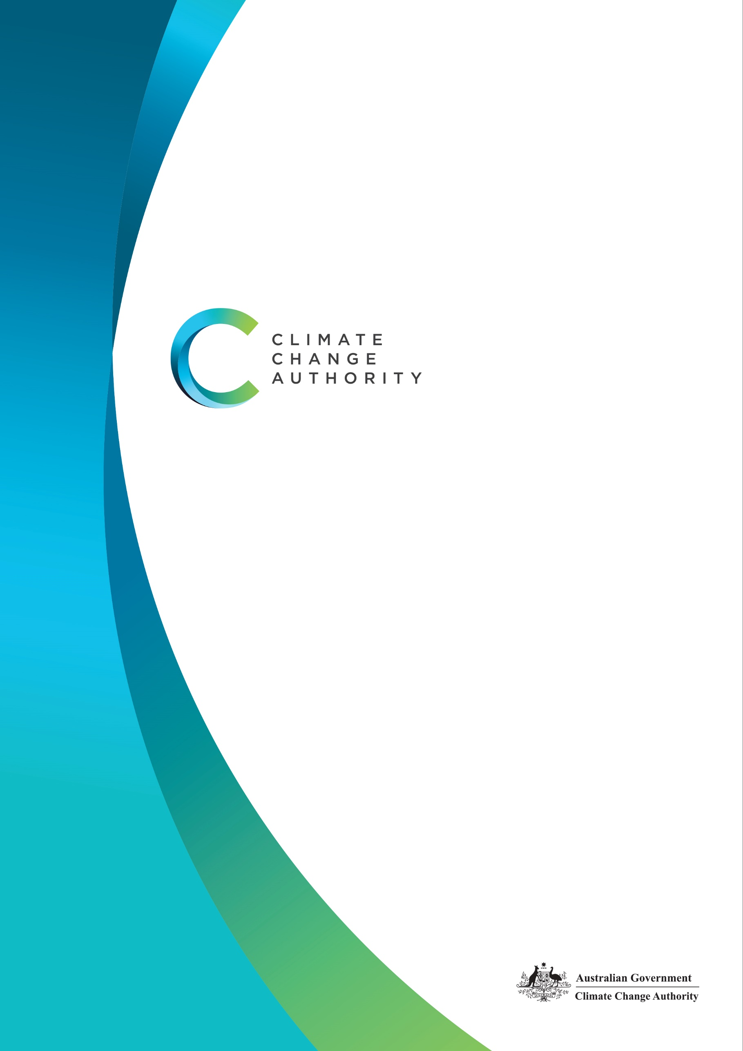

CLIMATE CHANGE AUTHORITY

CORPORATE PLAN 2022-23

AUGUST 2022

**The Authority recognises the First Nations people of this land and their ongoing connection to culture and country. We acknowledge First Nations people as the Traditional Owners, Custodians and Lore Keepers of the world's oldest living cultures, and pay our respects to their Elders - past, present and emerging.**

**Statement of Preparation**

I, Brad Archer, as the Accountable Authority of the Climate Change Authority, present the Authority’s Corporate Plan 2022-23, which covers reporting periods 2022-23 to 2025-26 as required under s35(1)(b) of the Public Governance, Performance and Accountability Act 2013 (Cth) and Division 8 of the Climate Change Authority Act 2011 (Cth). The plan is prepared in accordance with the Public Governance, Performance and Accountability Rule 2014.

**Brad Archer**   
Chief Executive Officer

**Copyright**

Published by the Climate Change Authority [www.climatechangeauthority.gov.au](http://www.climatechangeauthority.gov.au)

This work is licensed under the Creative Commons Attribution 3.0 Australia Licence. To view a copy of this license, visit <http://creativecommons.org/licenses/by/3.0/au>

The Climate Change Authority asserts the right to be recognised as author of the original material in the following manner:

 or 

©Commonwealth of Australia (Climate Change Authority) 2022.

**IMPORTANT NOTICE – PLEASE READ**

This document is produced for general information only and does not represent a statement of the policy of the Commonwealth of Australia. The Commonwealth of Australia and all persons acting for the Commonwealth preparing this report accept no liability for the accuracy of or inferences from the material contained in this publication, or for any action as a result of any person’s or group’s interpretations, deductions, conclusions or actions in relying on this material.

Contents

Chair’s opening statement 4

Chief Executive’s foreword 5

Purpose and strategy 6

Our function 6

Our purpose 6

Our approach 6

Our guiding principles 7

Our strategy 8

Governance 10

Who we are 10

Our operating context 11

Corporate governance 14

Our activities and Performance 17



### Chair’s opening statement

We present the Climate Change Authority’s 2022-23 Corporate Plan in what is a landmark year for the Authority. Having celebrated the Authority’s 10th anniversary in July, we are now scaling up in response to the Government restoring the Authority’s role in advising on Australia’s emissions reductions targets and climate change policies.

This year has shown that while the regions of Australia are heavily impacted by the effects of climate change, there are also opportunities for the regions to benefit from the transition to net zero, evident, for example, in the continued development of the carbon market and through the establishment of renewable energy and hydrogen hubs.

The Climate Change Bill 2022, which is before Parliament, lays out new ways for the Authority to assist not only Government but business, regions and the community to achieve the nation’s emission reduction goals and to prosper while doing so.

We will continue to advise the Minister for Climate Change and Energy, the Parliament and the broader community by providing evidence-based advice on climate change policy, underpinned by guiding principles, a strategic framework, legislation and consultation with the community. We take a holistic view to ensure our advice delivers results for the entire nation.

The Authority will advise on ways to accelerate emissions reductions, help Australia play its role in the global effort to limit temperature increases, and enhance Australia’s prosperity and resilience as the climate changes. I look forward to continuing to work with Authority members, staff and with our Minister and stakeholders to advise on Australia’s response to climate change.

**Grant King**Chair



### Chief Executive’s foreword

I am pleased to present the Climate Change Authority’s ninth corporate plan, which will guide our activities over the next four years.

This plan comes at a time of increased ambition, both in terms of Australia’s climate change targets, and policies to achieve them, and in respect of the Authority’s role in providing advice.

The Climate Change Bill 2022 is before Parliament and aims to legislate Australia’s emissions reduction targets — the Government’s higher interim target of 43 per cent below 2005 levels by 2030 and net zero by 2050. The Bill also restores the Authority’s role in providing advice on Australia’s emissions reduction targets, progress to targets and climate policy generally. The Government has committed to restoring the Authority’s resources to fulfil this mandate.

This Corporate Plan outlines who we are, what we will do, and how we will measure our performance in achieving our purpose over the life of the plan. This plan builds on the foundations of an agency with a proven track record of undertaking rigorous, independent reviews and research and providing evidence-based advice on climate change matters.

Over the past year, the Authority has released:

* the [Review of International Offsets](https://www.climatechangeauthority.gov.au/publications/2022-review-international-offsets), including 18 recommendations to ensure the integrity of international offsets and prepare and plan for international carbon trading under new rules that implement Article 6 of the Paris Agreement;
* two self-initiated research reports, [Paris Plus: Trade and Investment Trends in a Decarbonising World](https://www.climatechangeauthority.gov.au/publications/paris-plus-trade-and-investment-trends-decarbonising-world) and [Paris Plus: From Cost to Competitive Advantage](https://www.climatechangeauthority.gov.au/publications/paris-plus-cost-competitive-advantage), which examine the global trade and investment shift in the transition to net zero emissions and the opportunities for Australia; and
* research on [Economic Data for a Decarbonising World](https://www.climatechangeauthority.gov.au/publications/economic-data-decarbonising-world), outlining how enhanced data could help Australia navigate the transition to net zero.

I’m pleased that our reports are contributing to broader policy discussions – they have had hundreds of downloads, received broad media coverage, and sparked insightful debates at our COP26 events.

The Authority plans to expand its in-house expertise in both depth and breadth to deliver on our expanded mandate. The Authority will also deepen its engagement with communities and business in Australia, including First Nations peoples.

In the next twelve months, the Authority will:

* provide its advice for the Minister’s first annual statement to the Parliament on climate change, and continue to develop and refine its approach for the next annual statement advice;
* commence work on its advice for Australia’s next Nationally Determined Contribution;
* deliver statutory reviews on the Emissions Reduction Fund, National Greenhouse and Energy Reporting Scheme and the Safeguard Mechanism; and
* continue its self-initiated research on Australia’s carbon sequestration potential and industry transition planning.

In all its work, the Authority seeks to embody its principles and values of independence; broad and meaningful outreach and engagement; excellence in research and analysis; transparency; and good governance and accountability.

I’d like to thank the Authority’s Chair Mr Grant King, members Ms Susie Smith, Mr John McGee, Mr Mark Lewis, Dr Russell Reichelt AO and Chief Scientist Dr Cathy Foley AO PSM, who lead the work of the Authority and who provide valued guidance.

The Authority is supported by an expert secretariat. I thank them for their hard work, commitment to excellence, collegiality, and good humour.

**Brad Archer**  
Chief Executive Officer

# Purpose and strategy

### Our function

The Authority’s functions are set out in its enabling legislation, the *Climate Change Authority Act 2011* (Cth), and can be summarised as follows.

* conduct reviews of the Emissions Reduction Fund and the National Greenhouse and Energy Reporting Scheme
* conduct special reviews of matters relating to climate change as requested by the Minister responsible for climate change or by both Houses of the Australian Parliament
* undertake research about matters relating to climate change and other matters relating to the performance of our functions

New functions for the Authority are set out in the Climate Change Bill 2022, which is currently before Parliament. The Authority will provide advice on Australia’s progress on emissions reduction targets and climate change policies for the Minister for Climate Change and Energy’s annual statement to the Parliament, and on Australia’s Nationally Determined Contributions (NDCs) under the Paris Agreement.

### Our purpose

The Climate Change Authority’s purpose is to provide evidence-based advice on the response to climate change, in order to:

* accelerate emissions reductions and help Australia play its role in the global effort to limit temperature increases; and
* enhance Australia’s prosperity and resilience as the climate changes and the world transitions to net zero emissions.

### Our approach

We strive to deliver on our purpose and functions by:

* conducting and publishing robust and transparent reviews and research, taking an holistic and strategic approach
* taking account of diverse perspectives by engaging with a wide range of contributors
* partnering and collaborating with others, in the public and private sectors
* meeting our statutory obligations, including by completing statutory and special reviews on time.

### Our guiding principles

In performing our functions, our legislation requires us to have regard to the principle that any measures to respond to climate change should:

* be economically efficient
* be environmentally effective
* be equitable
* be in the public interest
* take account of the impact on households, business, workers and communities
* support the development of an effective global response to climate change
* be consistent with Australia’s foreign policy and trade objectives

*The Climate Change (Consequential Amendments) Bill 2022, which is before Parliament, has added the following two considerations to the principle described above:*

* *take account of the matters set out in Article 2 of the Paris Agreement; and*
* *boost economic, employment and social benefits, including for rural and regional Australia.*

Additional principles that the Authority considers relevant to its work are:

**Independence**

The Authority operates independently under its own legislation, budget allocation and staff, as a non-corporate, statutory body located in the Climate Change, Energy, the Environment and Water portfolio. We are committed to independence and impartiality when undertaking research and reviews and providing advice based on our own research and judgements.

**Transparency**

The Authority operates in an open and transparent manner. We have a statutory obligation to publish our research and review reports and all (non-confidential) public submissions to our review reports. Our reports are a result of reviewing and synthesising existing materials, engaging with stakeholders and undertaking independent research to generate original reporting, analysis and advice.

**Valuing our most valuable asset**

The Authority's professional, capable and committed workforce is its most valuable resource. Continued investment in our staff, in an inclusive way that respects and reflects the diversity of our skills, knowledge and backgrounds, is vital for maintaining and enhancing the Authority's performance. We provide all staff with the opportunity to develop skills and knowledge through formal training and other development opportunities.

**Excellence in research and analysis**

The credibility of the Authority relies on the quality of its research, analysis and reporting. We undertake detailed planning and thorough research and analysis, drawing on the best available knowledge. We also have a skilled workforce with a broad range of experience, and established links to relevant national and international expert organisations.

**Good governance and accountability**

The Authority maintains high standards of accountability and governance. As a Government agency, the Authority is subject to the Public Governance, Performance and Accountability Act 2013 (Cth) and Public Service Act 1999 (Cth), and has specific additional governance requirements under the Climate Change Authority Act 2011 (Cth).

**Broad and positive stakeholder engagement**

The Authority takes account of all available inputs and perspectives by engaging with a wide range of stakeholders and other contributors with an interest in climate change policy and related matters. We consult the public on every review, consistent with the requirements set out in our legislation.

### Our strategy

The Authority will deliver influential, independent and expert advice by:

* undertaking thorough policy development and analysis, including extensive and rigorous research and analysis
* conducting in-depth analysis of relevant sectors and contemporary research
* commissioning other analytical work (for example, economic modelling) where required
* conducting meaningful and transparent consultation with experts and stakeholders, including business, industry, environment and other community groups to gather information and debate policy options
* monitoring developments in climate change policy by reviewing publicly available resources and building networks with expert, local and international organisations
* presenting insightful and practical reports
* operating within a strong governance and accountability framework.

The Authority has identified six actions that can drive the bulk of abatement and adaption changes needed for a prosperous and resilient net zero Australia. These actions are supported by six enablers that the Government has a critical role in facilitating.

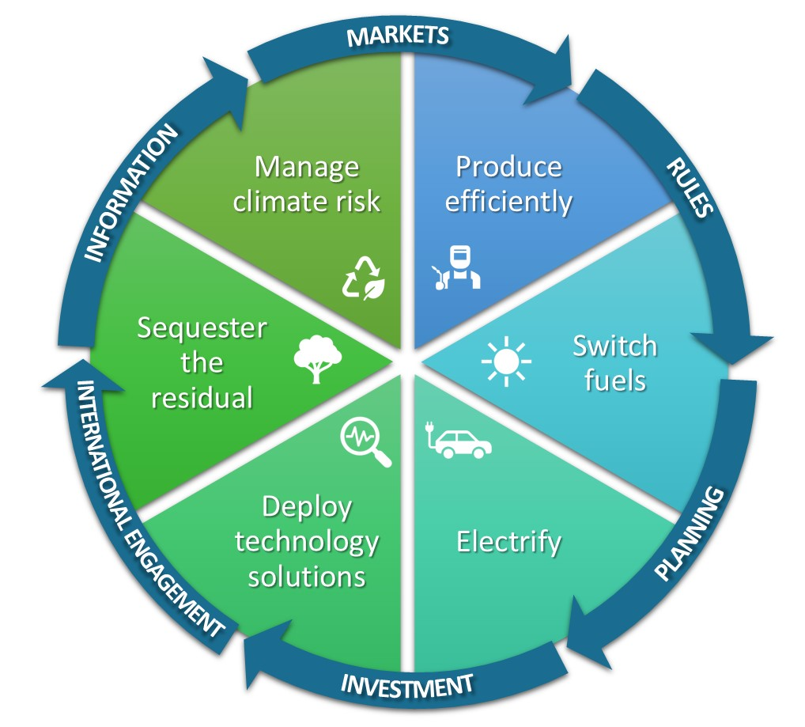

**Wedges = Actions**

**Arrows = Enablers**

**THE ACTIONS**

**Produce efficiently**

Reduce the emissions intensity of production and reduce inefficient use of resources such as energy and land.

**Switch fuels**

Shift from high emitting fuels to lower and ultimately zero-emissions alternatives.

**Electrify**

Generate enough affordable, clean energy to meet growing demand and electrify as much as possible.

**Deploy technology solutions**

Do as much as we can with the mitigation and sequestration technologies we already have, and accelerate the development and deployment of new technologies.

**Sequester the residual**

Mitigate as much as possible and sequester the rest.

**Manage risks**

Build resilience and plan for and manage the risks that climate change present to Australian industries, businesses, communities, the environment and our region.

**THE ENABLERS OF ACTIONS**

**Information**

Efficient collection of accurate, consistent and comprehensive information on emissions and decarbonisation will minimise costs on business, support optimal decision-making and Australia’s competitive position in the global economy.

**Markets**

Open, competitive, and transparent markets.

**Rules**

Governments can use rules to solve market failures. Governments are responsible for compliance with rules through appropriate combinations of formal and informal mechanisms and dealing with conflicts that arise among stakeholders with different perspectives, interests and priorities.

**Planning**

Governments can enable industries, workers, and communities to make decisions about the future by planning and communicating their intent in advance. Urban planning, infrastructure and land use planning can enable timely and efficient mitigation, sequestration, and adaptation. Governments can enable a smooth transition by planning for institutional adaptation and change.

**Investment**

Invest in science such as the research, development and deployment of abatement technologies. Public investment can stimulate innovation and provide high-risk capital for new technologies, shift activities down the cost curve to price parity and catalyse new markets.

**International engagement**

Actively partnering with countries to support the development of carbon markets, transparent reporting of emissions and deployment of clean technologies and fuels will create new trade opportunities, help less developed countries lift their disadvantaged communities out of poverty while bypassing the emissions intensive development of industrialised nations. Internationally consistent, transparent ways of sharing information will enable sustainable finance, trade, and carbon markets to play their part.

### Governance

The Climate Change Authority is an independent statutory authority and consists of a Chair, the Commonwealth Chief Scientist and up to seven other members.

The members are supported by a Chief Executive Officer (CEO), who is the Accountable Authority responsible for the day-to-day running of the Authority, and secretariat staff engaged under the *Public Service Act 1999* (Cth).

As a Government agency, the Authority is subject to the *Public Governance, Performance and Accountability Act 2013* (Cth) and *Public Service Act 1999* (Cth), and has specific additional governance requirements under the *Climate Change Authority Act 2011* (Cth).

### Who we are

Authority members

The current membership comprises:

*Chair*: Mr Grant King

*Member*: Ms Susie Smith

*Member*: Dr Russell Reichelt AO

*Member*: Mr John McGee

*Member*: Mr Mark Lewis

*Member*: Dr Cathy Foley AO PSM (Chief Scientist of Australia) (ex officio)

The Authority members bring substantial experience, knowledge and standing in the vast majority of fields that underpin our work and are identified in our Act, including economics, industry, technology development and adoption, energy production and supply, greenhouse gas emissions measurement and reporting, greenhouse gas abatement measures, financial markets and investment, trading of environmental instruments, land resource management, environmental management and public administration. Details of Authority members’ qualifications and expertise can be found on the Authority’s website at [www.climatechangeauthority.gov.au](http://www.climatechangeauthority.gov.au/).

Authority secretariat

The Authority is supported by a secretariat which holds broad expertise in climate change issues and skills including policy, analysis and communications and engagement.

The secretariat’s corporate team manages finance, human resources, procurement, accommodation and security, risk and governance and information technology. Secretariat staff members have expertise and qualifications in climate change, science, economics, law, international relations, public affairs and communications.

# Our operating context

Operating environment

The Authority’s operating environment is shaped by science, particularly the work of the Intergovernmental Panel on Climate Change (IPCC), the United Nations body established to assess and advise on the science related to climate change. In February this year, the IPCC released the Working Group II contribution to its sixth assessment report[1], noting the urgent need for stronger climate action—projected global warming under current global climate policies would leave many of the Australasian region's human and natural systems at very high risk and beyond adaptation limits.

In April, the IPCC’s Working Group III[2] [cautioned](https://www.ipcc.ch/report/ar6/wg3/resources/press/press-release/) that without immediate and deep emissions reductions across all sectors, limiting global warming to 1.5oC is unlikely. It found emissions reductions are best achieved through institutions and governance that support new mitigation policy while simultaneously reviewing existing policies.

To limit warming to 1.5 oC, the report stated that global greenhouse emissions must decline from 2025, with a reduction of 43 per cent by 2030 from a 2019 baseline. All global modelled pathways that limit warming to 1.5 oC involve rapid and in most cases immediate emission reductions in all sectors, including phasing out unabated fossil fuels, improving energy efficiency, reducing industry and transport emissions, reducing non-CO2 emissions, and deploying carbon dioxide removal technologies.

With rising costs of living and growing security pressures, combatting climate change must remain a priority. Globally, but particularly in Europe, there is a tension between meeting demands for energy in the near-term while investing for the long-term to reduce the impacts of climate change. Nonetheless, the underlying need to increase action on climate change and lower the costs of decarbonisation remain. With policies that support effective short-term actions and send the right long-term signals, we can avoid the price and supply shocks that could lead to emissions spiking and affect energy security.

The Australian Government is implementing its climate change agenda, acting quickly to introduce the Climate Change Bill 2022 that legislates emissions reduction targets of 43 per cent below 2005 by 2030, and net zero by 2050. The Bill also includes an expanded role for the Authority, including providing advice for the annual climate change statement to the Parliament and on Australia’s current and future NDCs.

Now, more so than at any other time, all communities, businesses and institutions need to engage to meet the need, voiced domestically and internationally, to halt and redress the effects of the changing climate. The Authority for its part will build on its strong consultation practices by engaging further with communities, regions, industries and First Nations peoples to ensure its climate change policy advice to Government is effective, efficient, equitable, for the benefit of Australia as an economy and a society.

Capability

The Government has committed to restore the Authority. Since 2017, the Authority has been running with the minimum level of resourcing necessary to operate as an independent statutory agency and perform its reduced legislated functions. In 2021-22, the Authority operated with 11 ASL and a budget of $2.6 million. The Authority anticipates that the question of additional resourcing to support the Authority undertake its new functions will be considered in the context of the October 2022 Budget.

A restored Authority will be able to address the additional functions set out in the Climate Change Bill 2022. It will have enhanced strategic capabilities including:

* broader and deeper engagement with stakeholders to ensure advice reflects the latest developments in theory, practice, technology and policy thinking
* advice on progress with climate adaptation and resilience measures
* advice that supports an equitable, efficient and effective transition and complementary and appropriately sequenced approaches that are in the national interest
* enhanced capacity to engage with the community to explain the reasons for recommended policy actions – helping to build the social licence for climate action
* to engage internationally.

The Authority plans to expand its in-house expertise to maintain a greater breadth of sectoral and technical knowledge including in relation to:

* carbon and energy markets, and systems innovation to support development of transition pathways to net zero emissions for hard to abate sectors
* international climate change developments
* the power, transport, industry, land and agriculture sectors
* climate science, adaptation, resilience and carbon removal
* data analysis and presentation and climate change modelling.

The Authority’s corporate function will also grow to support the efficient and effective operation of the restored agency.

The Authority will continue to use its partnerships to deliver some of its functions. For example, the Authority intends to work closely with the Treasury as it rebuilds its climate change modelling capability and is not intending to duplicate that capability.

Workforce

The Authority relies on its staff to undertake the research and analysis that supports its reviews and reports, and to manage the corporate functions of the agency. Staff expertise and professionalism are critical to the production of high-quality reports, building and maintaining good stakeholder relationships, and ensuring the smooth operation of the agency.

The Authority encourages employees to undertake learning and development to build up competencies relevant to their roles. The Authority has a study assistance policy that sets out the assistance provided to staff for learning and development opportunities. The policy provides financial and leave assistance to its staff enrolled in study or training that is relevant to the operational needs of the agency.

The Authority also provides one-on-one coaching to address particular development needs and extensive on-the-job training. Each staff member has the opportunity to identify and access appropriate training through the Authority’s Performance and Development Program.

Cooperation – partnerships

#### Shared services arrangements

As a small agency, the Authority maintains agreements for the receipt of corporate and IT services from the Department of Industry, Science and Resources. These cover the provision of finance, payroll, human resources and legal services, and information technology systems and support. These arrangements have been in place since early 2020 when the Authority became part of the Industry portfolio.

These arrangements are performed on a fee-for-service basis. They are appropriate for a small agency, in line with the Government’s shared services agenda.

Following the recent Machinery of Government changes, the Authority will seek to negotiate the transition of shared service arrangements with other Commonwealth Government entities as appropriate.

The Authority also works closely with other Government agencies, including the Clean Energy Regulator with which we have a shared graduate program.

#### Strategic Relationship Agreement – Climate Science Advice

In 2021, the Authority and the Bureau of Meteorology entered a Strategic Relationship Agreement to strengthen engagement and enhance coordination between the two agencies. The Bureau of Meteorology partners with Geoscience Australia, CSIRO and Australian Bureau of Statistics to bring together world leading science, information and expertise on climate and natural hazards.

#### Thought leaders and expert engagement

The Authority draws on an array of thought leaders and subject matter experts to support the Authority’s research, reviews, and advice. The expert advice from across the private sector, think tanks, academia and government ensures the Authority has access to insights and the potential to reality test advice and ensure it is practical and implementable.

#### Membership

The Climate Change Authority is an associate member of the Carbon Markets Institute, which facilitates knowledge sharing and insights on how business can manage risks and capitalise on opportunities in the transition to a net zero emissions economy.

#### Indigenous partners

In 2021, the Authority developed its first Reconciliation Action Plan. Our plan includes actions to build mutually beneficial relationships and, where appropriate, partnerships with First Nations peoples. The Authority will continue to build on and extend these actions into 2023.

#### International partners

In 2021, the Authority met with other independent climate change agencies from around the world, coming together as an International Climate Councils Network, to share experiences, discuss common challenges and explore how to support one another in our work. The Authority will continue to participate in the network as part of its international engagement.

# Corporate governance

Corporate governance framework

The Authority undertakes its work within a strong governance framework, including meeting governance requirements under the *Public Governance, Performance and Accountability Act 2013* (Cth). To ensure it complies with governance requirements, the Authority will continue to:

* ensure that delegations for human resources and finances are appropriate
* ensure there is control and oversight to deal with fraud and risk
* maintain an Audit Committee
* educate its staff to apply APS Code of Conduct and Values on a day-to-day basis
* educate new staff on the Authority’s governance practices
* track and manage potential and actual conflicts of interest
* maintain governance issues as standing agenda items on regular senior management meetings.

*Risk oversight and management*

The Authority has a Risk Management Framework to drive a positive risk management culture. The framework complies with the requirements of the Commonwealth Risk Management Policy 1 July 2014 and the *Public Governance, Performance and Accountability Act 2013* (Cth). The Framework and Risk Management Policy are updated regularly and reviewed by the Authority’s Audit Committee.

Table 1 sets out the Authority’s high-level strategic risks for the reporting period, along with risk ratings and mitigation strategies. Risk treatments and treatment owners are outlined in the Authority’s Strategic Risk Register and Plan, which is reviewed regularly. The Authority’s strategic objectives are the starting point of the strategic risk identification process. Our enterprise strategic risks are those that, if realised, would materially affect our ability to achieve the Authority’s purposes. The Authority’s purpose is achieved through the accomplishment of the Authority’s functions.

The Authority has also prepared a separate COVID-19 Risk Assessment and Treatment Plan in response to the challenges raised by the pandemic. The Authority has continued to operate effectively during the pandemic and the restrictions imposed by governments to limit harm and exposure.

TABLE 1: CLIMATE CHANGE AUTHORITY STRATEGIC RISKS

|  |  |  |
| --- | --- | --- |
| RISK DESCRIPTION | LIKELIHOOD, CONSEQUENCE AND RATING | MITIGATION STRATEGIES |
| **Maintain confidence and trust** |  |  |
| * The Authority is unable to maintain the confidence and trust of the government, industry and the public. | **Unlikely; moderate; minor** | * The Authority operates in a transparent and accountable way and stakeholder opinions are valued and considered * Outputs are reviewed for quality assurance and accuracy and conclusions are supported by evidence based advice * Maintain a constructive working relationship with the Minister, Minister’s Office and the Department * Maintain good lines of communication with relevant government policy and regulatory agencies, including during design and implementation of work plans * Conflict of interest are declared by employees and Authority members and are managed in keeping with legislative requirements, relevant guidance and expectations of the APS * Stakeholder networks are reviewed and maintained and their operating environments are well understood |
| **Advice** |  |  |
| * The Authority fails to deliver high quality, evidenced based advice. | **Possible; moderate; medium** | * Adequate scoping of tasks, problem definition, and review methodologies is undertaken * Outputs are reviewed for quality assurance and accuracy * Knowledge resources are available * External expertise accessed/procured as required and as resourcing allows * Scheduling tools and progress reporting are implemented * Open and ongoing communication and collaboration with staff and the Authority members * Ideas and recommendations are tested both internally and, where appropriate, externally |
| **People capability** |  |  |
| * The Authority is unable to attract, develop and retain the people capability it needs. | **Possible; moderate; medium** | * Staff retention practices are reviewed and refined where retention issues become apparent * Implement activity and project scheduling and planning to optimise the use of resources * Professional career development and training opportunities are available to all staff * Recruitment material and engagement strategies attract appropriately skilled people |
| **Information** |  |  |
| * The Authority fails to protect its information and information systems. | **Possible; moderate; medium** | * System controls and monitoring is in place to identify breaches and misuse of data and information * Business continuity plans and compliance checks are in place * Restricted access to applications and files for officials * Formal process for release of information and data * Police checks and security clearances are required for all employees and contractors working for the Authority |
| **Legal obligations** |  |  |
| * The Authority fails to adhere to its legal obligations. | **Unlikely; moderate; minor** | * Appropriately experienced staff are engaged to perform roles across the Authority * Appropriate guidance, documentation and training is available * Systems to capture instances of non-compliance with legislation are in place * Instances of non-compliance are reviewed with appropriate remediation and mitigation strategies implemented |
| **Financial sustainability** |  |  |
| * The Authority is unable to maintain financial sustainability. | **Unlikely; substantial; medium** | * Key priorities are planned and align to funding allocation * Budget expenditure is monitored closely and any under/over spends are communicated and addressed * Actions to increase the Authority’s funding are pursued when necessary with the portfolio department * The Chief Executive Officer and the Chief Finance Officer monitor budget expenditure closely |
| **COVID -19 pandemic** |  |  |
| * Harm to staff as a result of contracting COVID-19 in the workplace * Effective operations of the Authority are compromised by one or more of: * COVID-19 transmission in the workplace * Reduced staff availability * Remote working arrangements which increase OH&S risks | **Possible, moderate, high** | * Monitor and act on health advice and Government and ASPC guidance, including the adoption of physical distancing and remote working arrangements * Re-prioritise work program and resource allocation as required * Frequent communication with all staff, including provision of relevant information and guides for how to respond in relevant circumstances * Frequent check-ins with staff with an emphasis on support networks and tools * Regular liaison/consultation with shared services provider |

# 

# Our activities and Performance

As set out in the Government’s Portfolio Budget Statements, the Authority is responsible for the outcome:

*“Provide expert advice to the Australian Government on climate change initiatives, including through conducting regular and specifically commissioned reviews and through undertaking climate change research.”*

Accordingly, our objective is to provide rigorous, independent and expert advice to the Minister for Climate Change and Energy and to assist the Department and the Australian Parliament on climate change policy, in order to improve the quality of life for all Australians.

This corporate plan covers the four years from July 2022 to June 2026, with activities and key performance indicators listed in Table 2.

*Our performance framework*

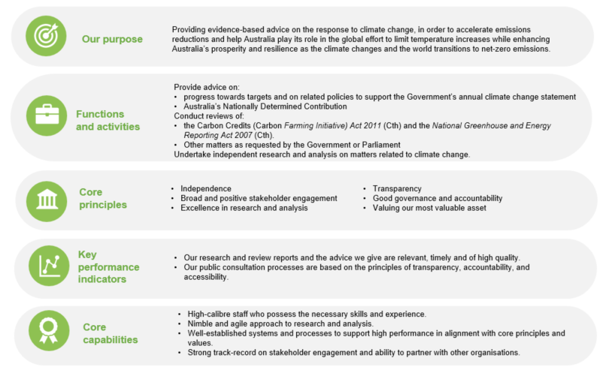

TABLE 2: ACTIVITIES AND KEY PERFORMANCE INDICATORS

**2022-23 – 2025-26**

|  |  |  |  |  |
| --- | --- | --- | --- | --- |
| YEAR | ACTIVITY | KEY PERFORMANCE INDICATORS | TARGET | ASSESSMENT |
| 2022-23  -  2025-26 | Provide advice on:   * progress towards targets and on related policies to support the Government’s annual climate change statement to the Parliament. * Australia’s Nationally Determined Contribution.   Conduct reviews of:   * the *Carbon Credits (Carbon* *Farming Initiative) Act 2011* (Cth); * the *National Greenhouse and Energy Reporting Act 2007* (Cth); and * other matters as requested by the Government or the Parliament (Special Reviews).   Undertake other self-initiated research on climate change matters. | * Our research and review reports, and the advice we give, are relevant, timely, and of high quality. * Our public consultation processes are based on the principles of transparency, accountability and accessibility. | * Reviews and research reports and advice draw on the best available knowledge and are informed by a broad range of perspectives. * Public consultation is comprehensive, representative and transparent. * The Authority’s analysis, findings and advice is communicated clearly and effectively. * Reviews and research reports and advice are provided by the due date. * Research and review reports and advice are relevant to the government and stakeholders of the day, and influence the public debate on climate change policy. * Government considers the Authority’s findings and recommendations in developing and implementing policy. | * Relevant and up-to-date academic, scientific, scholarly and other external sources are referenced in the research and analysis that informs the Authority’s advice. * Levels of stakeholder participation in consultation processes and references to representative stakeholder views in the Authority’s reports. * Date of delivery to the Minister responsible for climate change or the Parliament and date of publication on the Authority’s website. * Analysis of feedback by the Government and other stakeholders on the Authority’s research and analysis. * Analysis of the use and discussion of the Authority’s reports in public policy forums and discussions. |

*2022-23 Reporting period*

The Authority’s activities over the 2022-23 reporting period will focus on advice on progress towards targets and related policies to support the Government’s annual statement to the Parliament on climate change; statutory reviews of the *Carbon Credits (Carbon Farming Initiative) Act 2011* (Cth) and *National Greenhouse and Energy Reporting Act 2007* (Cth); and self-initiated research on climate change matters. The Authority may also undertake Special Reviews as requested by the Minister or the Parliament.

**Activity 1: Annual statement advice: progress towards targets and on related policies**

In 2022, the Authority will deliver its advice to inform the Government’s first annual climate change statement.

The Authority will commence work on its advice in 2023 to inform the Government’s second annual climate change statement.

**Activity 2: Nationally Determined Contribution advice**

The Authority will commence research and analysis on Australia’s NDC in 2023 ahead of providing advice to support the Government determining its next NDC under the Paris Agreement, due in 2025.

**Activity 3: Complete statutory reviews**

In 2023, the Climate Change Authority will review the legislation underpinning the Emissions Reduction Fund and the national emissions reporting framework concurrently for the first time.

The Authority is legally required to review, by 31 December 2023:

* the *Carbon Credits (Carbon Farming Initiative) Act 2011* (Cth)*,* whichunderpins the Emissions Reduction Fund
* the *National Greenhouse and Energy Reporting Act 2007* (Cth), which establishes a single national reporting framework for greenhouse gas emissions and companies’ energy consumption and production. The legislation also supports the safeguard mechanism, which sets limits on the emissions of large businesses.

**Activity 4: Self-initiated research and analysis**

The Authority’s self-initiated research often supports its other mandated functions. Given the importance of the orderly development of a well-functioning carbon market in Australia, the Authority is focusing much of its research effort on the supply and demand sides of the carbon market. This includes better understanding Australia’s sequestration and removal potential, industry transition planning, and emissions embodied within supply chains.

During the period covered by this corporate plan, the Authority will identify and undertake further research on climate change matters if opportunities arise.

1. Intergovernmental Panel on Climate Change (IPCC) (2022), [Climate Change 2022: Impacts, Adaptation and Vulnerability](https://www.ipcc.ch/report/sixth-assessment-report-working-group-ii/)
2. IPCC (2022), [Climate Change 2022: Mitigation of Climate Change](https://www.ipcc.ch/report/ar6/wg3/)