# Chapter 6 Australia’s progress to date in reducing emissions

Australia’s emissions were broadly the same in 2012 as in 1990, despite a doubling in the size of the economy over this period. This means that the emissions intensity of the economy (emissions per dollar of GDP) has halved.

Falling emissions intensity is in part due to economic conditions and the changing composition of the economy. For example, emissions-intensive manufacturing’s share of the economy has decreased.

Policy has also played an important role over the past two decades. Regulation in the land sector has reduced emissions from land clearing. In the electricity sector, policies such as the Renewable Energy Target, appliance and building standards, and state-based schemes (such as the New South Wales Greenhouse Gas Reduction Scheme, the Queensland Gas Scheme and other state-based energy efficiency schemes) have helped shift the fuel mix towards lower emission alternatives and reduce demand for electricity, particularly since 2008.

In 2012–13, electricity emissions decreased more rapidly than in previous years, with a fall in emissions intensity and slower growth in electricity demand. These emissions reduction trends need to be sustained and accelerated if Australia is to meet its long-term emissions reduction objectives.

Chapter 5 discussed policy tools used to reduce emissions. Chapter 6:

* describes Australia’s emission trends between 1990 and 2012
* assesses the drivers of these trends, including the role of policy.

The level of emissions reductions required to meet future goals is discussed in Part C of this report.

## Box 6.1: Data conventions in this report

Emissions data varies slightly across sources. In this report, historical and projected emissions for the period 1990 to 2030 are taken from the Treasury and DIICCSRTE modelling (2013), which provides continuous data sets for four scenarios of future action for emissions reduction.

Emissions for 2012 are based on preliminary inventory data and modelled estimates available at the time the Treasury and DIICCSRTE modelling was undertaken. They do not reflect 2012 or 2013 emissions reported in the June 2013 Quarterly Update of Australia’s National Greenhouse Gas Inventory, released in December 2013. The June 2013 Quarterly Update is the source of Australia’s estimated carryover from the first commitment period of the Kyoto Protocol. Revisions incorporated in the June 2013 Quarterly Update revise estimated 2012 emissions, but have almost no effect on the rate of growth in emissions between 2011–12 and 2012–13.

Emissions reported for 2013 and beyond are modelled estimates.

All annual data in this report is for the financial year ending 30 June unless otherwise indicated. For example, data reported for 2013 is for the financial year 2012–13.

Australian dollars ($A) are reported in 2012 real terms (that is, adjusted for inflation) unless otherwise specified.

All emissions data has been converted to CO2-e using global warming potentials from the IPCC Fourth Assessment Report. Historical emissions for land use, land use change and forestry (LULUCF) for the period 1990 to 2012 have been adjusted to be consistent with the new accounting rules agreed for the second commitment period of the Kyoto Protocol. This means historical and projected emissions data throughout the report is directly comparable.

These conventions apply to all data in the report unless otherwise noted.

## 6.1 Emissions trends between 1990 and 2012

In 2012, Australia’s emissions were about 600 Mt CO2-e. The majority (72 per cent) of Australia’s CO2 emissions are energy-related (Treasury and DIICCSRTE 2013). That is, they are produced in the combustion and production of fossil fuels for transport and stationary energy. The remainder of Australia’s emissions result from agriculture, fossil fuel extraction and distribution, waste, LULUCF and industrial processes.

Australia’s total greenhouse gas emissions in 2012 were 3.5 per cent higher than in 1990 and 2.5 per cent higher than in 2000 (Figure 6.1).

## Figure 6.1: Australia’s emissions by sector, 1990–2012

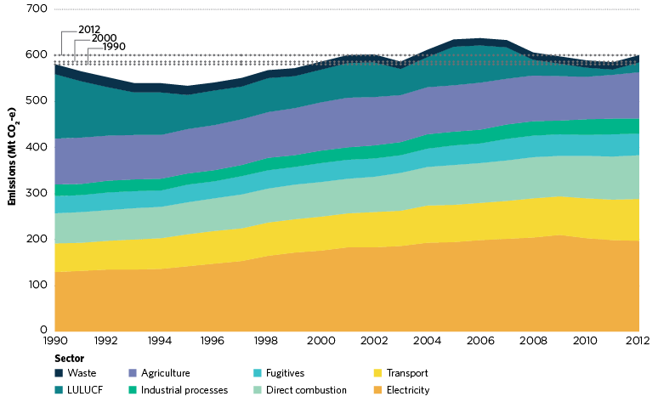

**Source:** Treasury and DIICCSRTE 2013; for more detail see Box 6.1

Emissions in most sectors have grown steadily, resulting in a 32 per cent increase in emissions excluding LULUCF in the period 1990 to 2012. In contrast, LULUCF emissions fell by 85 per cent in the same period. These steep reductions offset the increase in emissions from the rest of the economy (Figure 6.2).

## Figure 6.2: Australia’s emissions by sector, 1990 and 2012

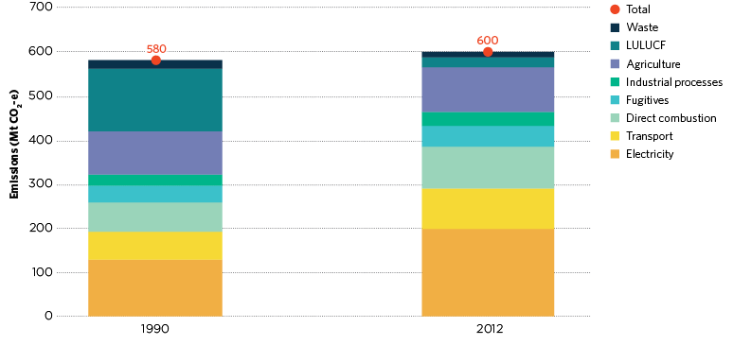

**Source:** Treasury and DIICCSRTE 2013

According to Treasury and DIICCSRTE (2013), the main trends by sector between 1990 and 2012 are:

* electricity and direct combustion of fuels (for example, in buildings and industry) grew by 50 per cent (a 97 Mt CO2-e increase)
* transport emissions increased by 46 per cent (29 Mt CO2-e)
* fugitive emissions (greenhouse gases emitted during the extraction, production, processing, storage, transmission and distribution of fossil fuels) increased by 28 per cent (10 Mt CO2-e)
* industrial process emissions increased by 27 per cent (7 Mt CO2-e)
* agricultural emissions rose by 1 per cent (1 Mt CO2-e)
* LULUCF emissions decreased by 85 per cent (119 Mt CO2-e)
* waste emissions decreased by 26 per cent (5 Mt CO2-e).

## Figure 6.3: Growth in Australia’s emissions by sector, 1990–2012

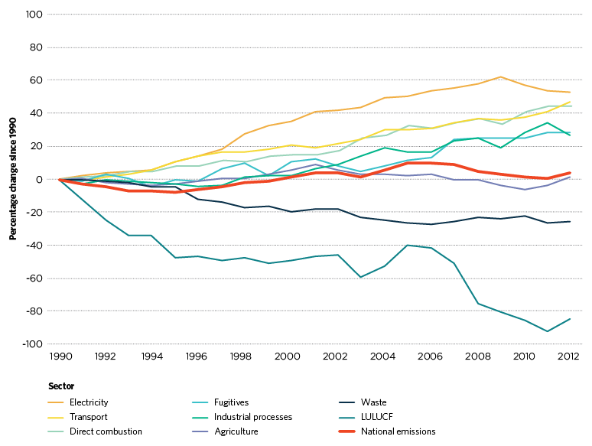

**Source:** Treasury and DIICCSRTE 2013

There has been a departure from longer term trends in emissions since 2008. Between 1990 and 2008, total national emissions rose by about 4 per cent, but fell by about 1 per cent between 2008 and 2012. This is due to changes in economic conditions (for example, the global economic downturn slowed growth, while rising energy prices reduced growth in demand for energy) and emissions reduction activities in particular sectors. The departure from long-term growth trends after 2008 is most pronounced in the electricity sector.

Although Australia’s total emissions in 2012 are at broadly the same levels as in 1990, this has been achieved in a period of strong growth in GDP. The economy has doubled in size since 1990, from $0.7 to $1.5 trillion in real $2011 terms. This means the emissions intensity of the economy has approximately halved.

Australia’s first commitment under the Kyoto Protocol required it to limit emissions in the period 2008–2012 to an average of 108 per cent of 1990 level emissions. Australia’s emissions were below this level, averaging 104 per cent over the period. This creates a ‘carryover’, which can be used towards Australia’s second commitment under the Kyoto Protocol. The treatment of this carryover is discussed in Chapter 7.

## 6.2 Major drivers of emissions trends

Australia’s falling emissions intensity indicates that progress is already being made towards a lower emissions economy.

The Authority commissioned Vivid Economics1 (2013) to assess the main drivers behind Australia’s historical emissions trends between 2000 and 2011 (the last year for which data was available when the work was done). Vivid’s analysis suggests that changes in patterns of economic activity have been the strongest driver (Figure 6.4). Emissions growth due to economic growth has been largely offset by:

* a shift in the structure of the economy towards lower emissions sectors; for example, from manufacturing to services
* emissions reductions activities; in particular, in the electricity and land sectors.

These changes are detailed below.

### 6.2.1 Economy-wide drivers—economic activity and structural shifts

Australia has experienced strong and sustained economic growth at an average annual rate of 3 per cent in real terms between 1990 and 2012 (ABS 2013a), which has led to higher emissions. While Figure 6.4 suggests structural change after 2008 had little impact on emissions, this masks two offsetting effects—change within manufacturing led to falling emissions, whereas change within agriculture following the end of the drought increased emissions.

Figure 6.4 also highlights the role of emissions reduction activities and shows they accelerated after 2008. This is discussed in detail in the next section.

## Figure 6.4: Drivers of emissions trends, 2000–2011

Figure 6.4 shows the drivers of emission trends in the Australian economy between 2000 and 2011, quantifying the effect of economic activity, structural shifts in the economy, and emissions reduction activities. The figure shows that growing economic activity has been the main driver of emissions in this period, particularly before 2008. This was offset to a degree by shifts in the structure of the economy (particularly before 2008) and emissions reduction activities (which had greatest effect since 2008). 
The sum total or net impact of these effects is also shown—significant growth prior to 2008, and negligible growth since.


**Note:** Emissions reduction activities include implementing new energy-efficient technologies, fuel switching and changing operating practices to make sectors more efficient.  
**Source:** Vivid Economics 2013; Climate Change Authority

Emissions growth due to economic growth weakened in some sectors after 2008, in part reflecting the global economic downturn. These changes were significant—manufacturing activity fell at an average annual rate of 1.4 per cent between 2008 and 2012, compared with 1.7 per cent growth from 2000 to 2008 (ABS 2013a). This is reflected in moderated emissions growth from economic activity after 2008 (Figure 6.4).

The sectoral pattern of growth is changing over time. Emissions-intensive manufacturing as a share of the Australian economy fell by about 4 per cent between 1990 and 2011. High commodity prices and exchange rates in recent years have accelerated the decline in this share (Treasury and DIICCSRTE 2013). The share of less emissions-intensive sectors rose; for example, the services sector increased its share of the economy by 6 per cent (Table 6.1).

## Table 6.1: Change in share of economic value by sector, 1990–2011

| **Sector** | **Change in contribution to overall economic value (GVA) from 1990 to 2011** | **Emissions intensity of sector in 2011 (kg CO2-e/$AUD)** |
| --- | --- | --- |
| Manufacturing (C) | –4.3% | 0.66 |
| Commercial and services (F–H, J–Q) | 6.0% | 0.04 |
| Electricity, gas and water supply (D) | –0.9% | 6.06 |
| Construction (E) | 1.1% | 0.08 |
| Mining (B) | 0.4% | 0.52 |
| Transport, postal and warehousing (I) | 0.4% | 0.39 |
| Agriculture, forestry and fishing (A) | –0.2% | 3.22 |

**Note:** GVA (Gross value added) in real $2011 terms using a chain-value measure to approximate volumes net of changes in commodity prices. Bracketed letters are relevant ANZSIC codes. Emissions by ANZSIC code for 2012 were not available at the time of drafting.   
**Source:** Treasury and DIICCSRTE 2013; ABS 2013a.

### 6.2.2 Emissions reduction activities and the role of policy

Emissions reduction activities are broadly defined to include the implementation of new energy-efficient technologies, fuel switching to lower emissions fuels and changing operating practices in a way that makes sectors more efficient. These activities may be driven by policy, such as increases in renewable energy due to the RET or market factors such as rising fuel prices and falling technology costs.

Detailed sector-by-sector analysis, including by ClimateWorks (2013, p. 5), shows that the emissions reduction activities are concentrated where there have been significant policy initiatives, particularly in the land and electricity sectors.

##### Land use, land use change and forestry

Between 1990 and 2012, emissions from LULUCF fell by 119 Mt CO2-e, or 85 per cent.

Drought and weakening economic conditions for farmers were important drivers of reductions in land clearing emissions, together with the declining availability of uncleared productive land in the early to mid-1990s (ANU Centre for Climate Law and Policy, Issues Paper submission, pp. 7–8). Since 1990, deforestation emissions have decreased by 67 per cent (Treasury and DIICCSRTE 2013), largely due to the ongoing reform of land clearing regulations.

The vast majority of land clearing took place in New South Wales and Queensland. Regulations to restrict land clearing have been implemented at a state level, partly in response to community concerns about biodiversity and climate change. The annual area deforested has halved since 2003, primarily due to these regulations (see Appendix D for more detail).

In 2013, Queensland, Western Australia and New South Wales revised their land clearing restrictions. Queensland’s revisions make it easier for farmers to clear trees and natural vegetation and expand cropping operations. Western Australia’s revisions allow farmers to increase their annual land clearing rate for specified purposes without a permit. New South Wales’s revisions allow clearing of isolated paddock trees and thinning of native vegetation, subject to a self-assessable code.

Rates of new timber forest plantations peaked in 2000. This was largely in response to Managed Investment Schemes, which provided tax incentives for new plantations. New plantations fell sharply after 2000 as investment regulations were tightened, and again in 2007 in response to economic factors and the collapse of investment companies during the global financial crisis.

##### The electricity sector

Between 2000 and 2012, there was a shift in the fuel mix towards lower emissions fuels and renewables, largely driven by policies such as the state-based schemes in New South Wales and Queensland, and the RET. This shift accelerated in 2013 (Section 6.3).

The New South Wales Greenhouse Gas Reduction Scheme was introduced in 2003, and the Queensland Gas Scheme in 2005. This helped the share of gas in electricity generation across Australia grow from 8 to 19 per cent between 2000 and 2012.

The RET was introduced in 2001 and expanded in 2009, contributing to the share of non-hydro renewable generation increasing from 0.6 per cent in 2000 to 3.9 per cent in 2012 (BREE 2013a).

Recent emissions reductions in the electricity sector are due to a combination of falling emissions intensity of generation and flattening demand for electricity.

* The emissions intensity of Australia’s electricity supply fell at an average annual rate of about 1.9 per cent over the period 2008 to 2012 due to increases in renewables and gas generation (BREE 2013a; Treasury and DIICCSRTE 2013):
  + renewable generation grew 1.3 per cent on average per year from 2000 to 2008, accelerating to 4.9 per cent between 2008 and 2012 (BREE 2013a)
  + installation of solar photovoltaics has increased rapidly since 2008, from about 30 MW installed in that year to about 2,300 MW in 2012, linked to the RET and state-based incentive schemes (CEC 2012, p. 49)
  + the emissions intensity of electricity sourced from the National Electricity Market (NEM2) decreased at a yearly average of 1.5 per cent from 2008 to 2012, and fell a further 4.6 per cent in 2013 (AEMO 2013).
* In the period 1990 to 2008, Australia-wide demand for electricity grew 2.5 per cent on average per year. Between 2008 and 2012, growth softened to 1.1 per cent.3 Rising electricity prices, lower economic activity and an improvement in energy efficiency have contributed to this:
  + retail electricity prices rose by about 60 per cent between 2008 and 2012. The analysis by Vivid Economics (2013) suggests that the manufacturing sector was the most responsive to these price increases, followed by the commercial and residential sectors
  + economic activity slowed for some key sectors (as described in Section 6.2.1)
  + uptake of efficient lights and appliances (described below) has contributed to moderating consumption.

There were regional differences in the trends for electricity demand; in particular, for Western Australia and the NEM jurisdictions:

* Consumption in Western Australia grew at an average of 6 per cent per year between 2008 and 2012, faster than the average increase across Australia of 1.1 per cent, linked to economic growth.
* Demand for remote and off-grid power sources is thought to be growing, particularly in Western Australia, although relatively little data is available (BREE 2013b, p. 2). As noted above, deployment of solar PV is also growing Australia-wide.
* Demand for electricity supplied by the NEM (not including off-grid or solar PV generation) fell between 2010 and 2013 at an average annual rate of 1.3 per cent (AEMO 2013).

##### Energy efficiency and fuel-switching

There is some evidence of energy efficiency and fuel-switching contributing to emissions reductions in the building and industry sectors.

The most significant contributor to emissions reductions in the residential sector between 1990 and 2012 was gas heating. Gas replaced emissions-intensive electric heating as the gas network expanded (BREE 2012, p. 45). The energy intensity of Australia’s buildings has decreased by 3 per cent between 2003 and 2011, led by improvements in the operation of buildings, better energy efficiency standards, more efficient appliances and distributed energy (ClimateWorks 2013, p. 20). However, these improvements have been offset by additional buildings and increased use of electronics in homes:

* Building standards have improved energy efficiency in new buildings in particular. For example, new offices now use about 32 per cent less energy than offices built 10 years ago (ClimateWorks 2013, p. 20). Due to the slow turnover of stock, this will take some time to have a significant impact on overall building energy use.
* While minimum standards on appliances have made an impact, gains have been offset by the increase in appliance ownership. For example, ownership of computer and IT equipment has increased from close to zero per household in 1990 to more than one per household by 2008 (BREE 2012, p. 51). More recently, this effect may have been moderated by a shift towards less energy-intensive appliances; for example, from desktop computers to laptops and tablets, and from plasma to LCD televisions.

In industry, higher energy prices combined with policy instruments like the EEO program and minimum standards on some equipment are driving energy efficiency improvements. The government has announced funding for the EEO program will cease from 1 July 2014.

ClimateWorks (2013, p. 3) reports that the falls in energy consumption for large industrial users over the last four years are equivalent to the energy use of about 800,000 households. Since 2008, industrial companies have been implementing about three times more energy efficiency improvements each year than they had previously. Emissions from these companies have been substantially reduced; for example, by self-generating electricity using gas, which has led to an estimated 10 per cent improvement in industrial emissions intensity. This has been offset by large increases in production. The factors that influence the uptake of energy efficiency were the subject of a recent report by ClimateWorks, detailed in Box 6.2.

## Box 6.2: ClimateWorks Australia Special Report on factors influencing large industrial energy efficiency

In July 2013, ClimateWorks published a report on the factors that influence large industrial energy efficiency. This research involved in-depth interviews with 47 large industrial companies that account for 70 per cent of Australia’s industrial energy use.

The report identified the key drivers of energy efficiency as higher energy prices, the carbon price, the EEO program and organisational changes:

**Higher energy prices**—87 per cent of respondents identified energy prices as a driver of energy efficiency; companies with higher energy intensities identified prices as strong drivers.

**Carbon price**—81 per cent of respondents reported the carbon pricing mechanism had an impact. While its financial impact has been relatively small, respondents reported it focused their attention on energy and carbon management, and influenced their strategic approach to energy management; for example, prompting consideration of fuel-switching opportunities.

**EEO**—80 per cent of respondents stated the EEO program was a key influence; in particular, that it provided a structure for energy management. Respondents mentioned that the program had changed cultural attitudes to, and catalysed, energy efficiency. The EEO had a greater influence on respondents from companies within sectors with higher profitability and growth profiles. This could mean that companies that are not under financial stress may respond more readily to compliance and reputational drivers.

**Organisational factors**—respondents with better internal practices in certain key areas implement more energy efficiency. For example, companies who analyse energy data, embed energy efficiency in their practices and have senior management oversight of energy efficiency realised more potential for energy savings (by up to 275 per cent) than those without.

The report also investigated barriers to further uptake of energy efficiency, and found that access to internal capital, the long payback periods of energy efficiency projects and opportunity cost of alternative investments were the most prominent barriers. These would need to be overcome for a higher rate of energy efficiency to be achieved.

##### Factors contributing to reduced growth in electricity consumption

Saddler (2013) projects that if NEM electricity consumption had continued to grow from 2005 at the same rate as it had for the previous 20 years, consumption would have been 23 per cent higher in 2013 than it was. Table 6.2 shows the range of factors Saddler identified contributing to the turnaround in electricity consumption growth in the NEM. The biggest contributor was estimated to be the suite of efficiency programs for appliances, equipment and, to a lesser extent, buildings. Structural changes in the economy—notably reduced relative share of emissions-intensive industries and major industrial closures in New South Wales—followed. The other main contributors were reduced energy consumption in response to higher energy prices, primarily by households, and rooftop solar photovoltaics.

## Table 6.2: Contribution of factors to observed reductions of electricity demand growth in the NEM: 2005–06 to 2012–13

| **Factor** | **Reduction  (TWh)** | **Share of reduction  (per cent)** |
| --- | --- | --- |
| Energy efficiency programs | 13.5 | 37 |
| Price effect | 5.2 | 14 |
| Reduced growth in demand from large electricity users | 5.0 | 14 |
| Major industrial closures | 3.6 | 10 |
| Rooftop PV | 2.7 | 7 |
| Increase in other embedded generation | 2.0 | 5 |
| Income effect | 1.4 | 4 |
| Residual | 3.6 | 10 |
| Total | 36.9 | 100 |

**Note:** Income effect assumes real GDP per capita after 2008 grows at 1.5 per cent per annum; totals may not add due to rounding. **Source:** Saddler 2013, p. 59

Renewable electricity generation also increased over the period, further reducing fossil fuel generation levels.

## 6.3 Effect of the carbon pricing mechanism on Australia’s emissions

It is difficult to assess the impact of the carbon pricing mechanism given it has only been in place for one year. The Department of the Environment (2013, p. 12) reports that Australia’s total emissions increased 1.5 per cent between 2012 and 2013, with the economy growing 2.7 per cent over the same period (ABS 2013a). Excluding LULUCF, emissions decreased 0.1 per cent over the period.4

In aggregate, electricity, direct combustion, fugitive and industrial process emissions (sectors covered by the carbon pricing mechanism) fell by 1.5 per cent in 2013, mostly due to a 6 per cent fall in electricity emissions. Emissions from transport, agriculture, waste and LULUCF rose by 6.5 per cent in aggregate.

At a sectoral level:

* electricity emissions declined by over 6 per cent, due to both a 2.6 per cent fall in demand in the NEM and an increased share of generation from lower emissions sources. Both black and brown coal had their lowest generation levels in more than a decade
* fugitive emissions grew by over 11 per cent due to increased production of black coal and natural gas
* direct combustion and industrial process emissions rose by about 2 and 1 per cent respectively (Department of the Environment 2013, p. 3).

Of the sectors of the economy not directly covered by the carbon pricing mechanism, transport and agriculture emissions both increased about 3 per cent, deforestation emissions increased about 12 per cent, sequestration from afforestation and reforestation decreased by about 14 per cent and waste emissions remained relatively steady (Department of the Environment 2013). Some of these sources are covered by an equivalent carbon price (for example, transport fuels used for domestic aviation and marine and rail transport); others are eligible to create offsets under the CFI (for example, agriculture, land use, and waste deposited before 2012).

A range of studies has tried to assess the impact of the carbon pricing mechanism on Australia’s economy and emissions (AEMO 2012; Frontier Economics 2013; Reputex 2013). This assessment is complex because:

* The effect of the carbon pricing mechanism must be calculated relative to a counterfactual scenario, rather than year-on-year change. It is impossible to observe this alternative scenario, though modelling provides some insight. The Treasury and DIICCSRTE modelling (2013), for example, projected that Australia’s emissions in 2012–13 would have been 17 Mt CO2-e (2.8 per cent) higher in the absence of the carbon pricing mechanism.
* Comparing emissions over time can identify trends and, in doing so, allow the effect of measures such as the carbon pricing mechanism to be assessed. A single year’s emissions data cannot establish a trend.
* Disruptions to electricity generators, such as the flooding of the Yallourn coal-fired power station in 2012, also contributed to a reduction in brown coal generation during 2013 (AEMO 2012, p. 4).
* Preparation by parties affected by the carbon pricing mechanism may have influenced emissions prior to its start. Hydroelectric generators, for example, may have withheld capacity in 2011–12 in anticipation of higher wholesale prices (Frontier Economics 2013, p. 2); this could have contributed to the 34 per cent increase in hydroelectric generation over 2012 (Department of the Environment 2013, p. 7).
* Uncertainty over the longevity of the carbon pricing mechanism may have influenced investment decisions.

## 6.4 The future role of policy

Policies affecting LULUCF, discussed in Section 6.2.2, have helped offset growth in emissions across the rest of the economy. In 2012, net emissions from LULUCF were 85 per cent below 1990 levels. In future, LULUCF emission reductions may not continue to offset absolute emissions growth in the rest of the economy.

Australia’s emissions reduction goals must be achieved in the context of projected ongoing growth in economic activity and population. There is growing demand for energy resource and livestock exports, as well as for domestic aviation and road transport, among other sectors. Australia’s population is projected to increase by about 15 per cent between now and 2020, from approximately 23 million to 26 million people (ABS 2013b).

For the past two decades, Australia’s rate of emissions intensity improvement has approximately matched the rate of growth in the economy. To achieve absolute emissions reductions, Australia requires a rate of improvement in emissions intensity that exceeds its rate of economic growth.

Australia’s goals are expressed in net terms, meaning they can be met through a mix of domestic and international emissions reductions (Chapter 7). As the world takes action to reduce emissions and limit warming to 2 degrees, Australia will need to transition to a low-emissions economy to continue to be competitive.

To do this, Australia must maintain and build upon the progress made in key sectors, such as LULUCF and electricity, and realise further cost-effective emissions reductions in the remainder of the economy. The associated challenges and opportunities are outlined in Chapter 11.

## Conclusions

C.8 Australia has made progress towards decarbonising its economy—the emissions intensity of the economy (emissions per unit of GDP) has fallen by about 50 per cent since 1990.

C.9 The falling emissions intensity is in part due to the changing composition of the economy, away from emissions-intensive manufacturing. Policy has also played an important role, particularly in the land and electricity sectors.

1 Vivid Economics’s analysis does not include LULUCF emissions. However, the broader assessment of emissions reduction activities includes this sector.

2 The NEM electricity grid covers New South Wales, Queensland, Victoria, South Australia, Tasmania and the Australian Capital Territory, and in 2012 accounted for 86 per cent of total electricity consumed in Australia.

3 Vivid Economics (2013) suggests that BREE data for the commercial and services sector appears inconsistent with data from the NEM. If a correction is applied to the BREE data, the annualised rate of growth falls from 1.1 to 0.2 per cent.

4 Section 6.3 uses the June 2013 updates to the National Greenhouse Gas Inventory, released in December 2013 (Department of the Environment 2013).