# Chapter 2 Science and impacts of climate change

Human activities produce greenhouse gases that are causing the climate to warm. If emissions continue to grow at current rates, warming is projected to increase rapidly over the 21st century, exceeding 2 degrees within the next few decades and foreseeably reaching 4 degrees or more by the end of the century.

Higher temperatures are projected to bring increasingly severe impacts on a global scale, which could include inundation of low-lying coastal areas, climate-induced migration of millions of people, growing risks to human health from many sources and the collapse of vulnerable ecosystems. In Australia, impacts are projected to include changes in rainfall; more frequent extreme events such as drought, flood and heatwaves; damage to sensitive ecosystems and infrastructure; and health effects. The extent of impacts will be determined by a number of factors, including future emissions of greenhouse gases and the climate system’s response.

The international community has committed to limiting global warming to below 2 degrees, which requires strong action to reduce the world’s emissions. No level of warming is considered ‘safe’, but 2 degrees would avoid the worst of the projected impacts and could allow Australia to adapt to many of the expected changes. As temperatures increase, adaptation will become increasingly costly and challenging. Global action to limit warming to below 2 degrees provides clear benefits to Australia.

The Targets and Progress Review is founded on science. There is extensive evidence that human activity is causing the world to warm at unusually rapid rates. Despite this evidence, coverage of climate science can be misleading and confusing. This chapter provides a clear summary of the science and the potential impacts of climate change for Australia. It discusses:

* climate science and the relationship between greenhouse gases and global warming
* the impacts caused by climate change to date
* the projected impacts of climate change, both globally and in Australia
* the social and economic costs of climate change.

## 2.1 Climate science

Human activity is causing the climate to warm. Activities such as burning fossil fuels, undertaking industrial processes and clearing land produce greenhouse gases. These gases trap heat radiated from Earth within the atmosphere, like a greenhouse. As concentrations of greenhouse gases increase, more heat is retained and the climate gets warmer.

Since the beginning of the Industrial Revolution in 1750, the concentration of carbon dioxide in the atmosphere has grown by 40 per cent, methane by 150 per cent and nitrous oxide by 20 per cent (IPCC 2013a, p. 7). According to ice core records, which show the atmosphere’s historical composition, the current concentrations of these three gases substantially exceed the concentrations at any other time over the past 800,000 years (IPCC 2013a, p. 7). Figure 2.1 charts their concentrations over the past 1,000 years, showing rapid increases in all three major greenhouse gases, particularly since the 1950s.

## This figure charts the concentrations of carbon dioxide (in parts per million) and methane and nitrous oxide (in parts per billion) in the atmosphere over the past 1 000 years. Concentrations of the three gases were relatively stable from the year 1000 to about the year 1800: carbon dioxide at about 280ppm; methane at about 700ppb; nitrous oxide at about 270ppb. Concentrations rise gradually from 1800, accelerate in the 1900s, and grow very rapidly from the 1950s. Growth in the concentration of methane slows in the 1990s. At the end of the time period the concentration of carbon dioxide is almost 390ppm; methane is almost 1,800ppb; and nitrous oxide is just above 320ppb. Figure 2.1: Carbon dioxide, methane and nitrous oxide concentrations over the past 1,000 years

**Source:** Adapted from CSIRO and BoM 2012, p. 8

Climate change is a long-term issue, as greenhouse gases can remain in the atmosphere over very long time scales. Carbon dioxide is the most important long-lived greenhouse gas and it is produced in large quantities by human activities. About one-third of the carbon dioxide increase due to emissions this year will remain in the atmosphere in 100 years and about 20 per cent will still be present in 1,000 years. So, long-lived greenhouse gases released now ‘lock in’ future warming, even if no more are emitted. For example, maintaining greenhouse gas concentrations (and other atmospheric constituents) at 2000 levels would have increased warming by an additional 0.6 degrees by the end of the 21st century. This is in addition to the 0.8 degrees of warming observed to 2000 (IPCC 2007a, SPM, 10.7.1). The long-term effects of greenhouse gases mean that the worst climate change impacts will be imposed on future generations, regardless of whether they contribute additional emissions themselves.

While it is unequivocal that the climate is warming, the climate system is complex and there are scientific uncertainties about how much the climate will change in the future. There is uncertainty about future emissions and levels of greenhouse gas concentrations, which will be determined by policies, population and technology changes. There is also uncertainty in the precise temperature response to future greenhouse gas concentrations. Climate models project future temperature changes that could be experienced under different greenhouse gas concentration scenarios, but can only estimate temperature increases within a probability range. The probability of limiting warming to 2 degrees under different levels of greenhouse gas emissions is discussed in detail in Chapter 3.

There is also some uncertainty about how land and ocean carbon sinks will operate in a warmer climate. To date, about 55 per cent of carbon dioxide emissions from fossil fuel combustion has been absorbed by the land and ocean combined, with the rest remaining in the atmosphere. However, the ocean has become less effective at absorbing carbon dioxide over the past 50 years, and the ability of trees to increase their uptake of carbon dioxide is projected to peak and decline by the middle of this century (Canadell et al. 2007; IPCC 2007b, p. 213). These changes would result in more carbon dioxide remaining in the atmosphere where the greenhouse effect takes place, so warming could be amplified in future.

While these uncertainties are real, the scientific understanding of climate change impacts has increased substantially since 1990, when the first comprehensive assessment of the state of climate change science was published by the Intergovernmental Panel on Climate Change (IPCC) (see Box 2.1 for an explanation of the IPCC’s reports). Since then, there have been large increases in the number of climate observations and studies, substantial development in the scientific understanding of the climate system and increased sophistication of climate models. These advances have resulted in greater confidence in the connection between human activities and climate change, as well as in predicting future climate impacts (Figure 2.2).

## Figure 2.2: Advances in scientific understanding of climate change

| **IPCC report** |  | **First Assessment Report (1990)** |  | **Fourth Assessment Report (2007)** |  | **Fifth Assessment Report (2013)** |
| --- | --- | --- | --- | --- | --- | --- |
| **Temperature levels** |  | Warming over the last 100 years is estimated at 0.3–0.6 degrees | 144077.png | Between 1906 and 2005, global average temperatures warmed 0.74 degrees  11 of the past 12 years (between 1995 and 2006) were the warmest since instrumental records began in 1850 | 144089.png | Between 1880 and 2012, average global surface temperatures increased 0.85 degrees  The last three decades in the Northern Hemisphere were likely the warmest in 1,400 years |
| **Human involvement in the climate system** |  | It is certain that greenhouse gases have a natural warming effect and emissions from human activities are substantially increasing the atmospheric concentrations of some greenhouse gases | 144080.png | ‘Very likely’ (over 90 per cent certainty) that humans have caused most of the warming observed since the mid-20th century | 144087.png | ‘Extremely likely’ (95–100 per cent certainty) that humans are the dominant cause of warming since the mid-20th century |
| **Extreme events** |  | No firm evidence of increased weather variability to date  ‘Most likely’ that with an increase in mean temperature, episodes of high temperatures will become more frequent, and cold episodes less frequent | 144082.png | ‘Very likely’ that cold days became less frequent and warm days became more frequent in the late 20th century (~1960)  ‘Very likely’ that warm spells, heatwaves and heavy rainfall events will continue to become more frequent over the 21st century  ‘Likely’ that the area affected by drought will increase over the 21st century  ‘Likely’ increased incidence of extreme high sea level events over the 21st century | 144085.png | ‘Very likely’ that cold days became less frequent and warm days became more frequent since 1950  ‘Very likely’ that frequency and duration of heatwaves and high rainfall events will increase by the late 21st century  ‘Likely’ that drought intensity or duration will increase by the late 21st century  ‘Very likely’ that incidence and magnitude of extreme high sea level events will increase by the late 21st century |

The improvement in scientific understanding over time also points to earlier underestimates of climate change impacts. Lower levels of warming are now considered to have worse impacts than earlier assessments and are expected to affect more people. There is a greater risk that lower levels of warming could trigger ‘tipping points’ that result in permanent, highly disruptive changes in the climate system, compared with earlier projections (Smith et al. 2009).

## Box 2.1: Background to the IPCC and its Fifth Assessment Report

The IPCC is the leading international scientific body for the assessment of climate change and operates under the auspices of the United Nations. Its role is to review, assess and synthesise the latest information on climate change, based on the most recent peer-reviewed scientific, technical and socioeconomic literature worldwide. The IPCC produces periodic Assessment Reports that provide comprehensive assessments of the latest science on climate change, vulnerability, impacts and adaptation. The summaries for these reports (called Summaries for Policy Makers) are approved, line-by-line, by the governments of the IPCC’s member countries.

The IPCC’s reports demonstrate the continually mounting evidence for climate change and its causes. The Working Group I report (on the physical science basis of climate change) for the Fifth Assessment Report was published in September 2013, citing more than 9,200 scientific publications, with contributions from more than 600 authors (IPCC 2013c). The report confirms that the human influence on the climate is clear—it is between 95 and 100 per cent certain that humans have been the dominant cause of warming since the 1950s, when most of the increase in greenhouse gas emissions and temperature has been observed.

## 2.2 Evidence of the climate warming

The Earth has warmed in response to the rapid increase in greenhouse gas concentrations since the Industrial Revolution. Between 1880 and 2012, average global surface temperatures over land and the ocean warmed by 0.85 degrees, with each of the last three decades successively warmer than any preceding decade since 1850 (IPCC 2013a, p. 3). The average conceals substantial regional variation, with warming greatest at northern latitudes—the Arctic has warmed at twice the global average rate over the past century and the three decades to 2012 were likely the warmest 30-year period in the Northern Hemisphere for the last 1,400 years (IPCC 2007b, p. 30; IPCC 2013a, p. 3).

Following the release of the IPCC Working Group I report (IPCC 2013a) on the physical science of climate change, some reporting suggested global warming had paused. The evidence does not support this claim (see Box 2.2).

## Box 2.2: Has global warming ‘paused’?

Contrary to some statements about warming over the last 15 years, global warming has not paused. The recent IPCC report (IPCC 2013a) confirms that the world is still getting warmer because of human activities. This long-term trend is unchanged.

The climate can experience a high degree of natural variability over short periods of time. Selection of data over particular short periods can give different results for trends to those obtained when longer periods are considered. The IPCC report identified, for example, that the warming of surface temperatures for the last 15 years (1998 to 2012) was relatively slow. This was due to a combination of factors, including volcanic eruptions that increased the amount of cooling aerosols in the atmosphere, redistribution of heat within the ocean and lower solar radiation levels due to the natural solar cycles. Warming was, however, relatively fast from 1990 to 2006 so, over the longer timeframe of 1990 to 2012, warming has been in line with projections.

Short-term reductions in the rate of climate warming do not mean climate change has ‘paused’. Many other observations of changes in the climate system confirm that warming continues. Globally, average surface temperatures over land and oceans have been successively warmer in each of the last three decades compared with any preceding decade since 1850. The first decade of the 2000s was the warmest on record. Sea levels have continued to rise, warming is occurring at greater depths of the ocean and ice sheets have been melting at greater rates compared to earlier periods.

Numerous Australian temperature records were broken during 2013, which was the warmest year on record, had the warmest summer (2012–13) and spring, and had the hottest winter and summer day ever recorded (BoM 2014). Maximum temperatures in 2013 were 1.45 degrees above the average, while minimum temperatures were 0.94 degrees above the average (BoM 2014). Sophisticated climate models show that Australia’s average temperature in 2013 could not have been reached in the absence of human emissions of greenhouse gases (Lewis and Karoly 2014).1

Figure 2.3 charts the variation in annual mean temperatures in Australia between 1910 and 2013, compared with the 1961 to 1990 average (red line). The 10-year rolling average is shown in black. While there is considerable natural variability in climate over the short term, every decade in Australia has been warmer than the previous one since the 1980s.

## Figure 2.3: Annual average temperature anomalies in Australia over the past century

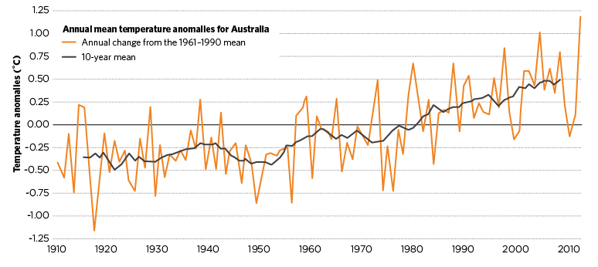 **Note:** Anomalies are compared with the 1961–1990 average temperature.   
**Source:** Adapted from BoM 2014

The world’s oceans are also warming. Since the 1970s, oceans have absorbed about 90 per cent of the additional heat within the Earth’s system (IPCC 2013a, p. 4). The take-up of heat by the ocean (shown in Figure 2.4) is important for moderating air temperature increases and reduces the climate impacts for humans and land-based ecosystems. Most of the ocean temperature increases have occurred at the sea’s surface and upper ocean (to 700 metres depth) (IPCC 2013a, p. 5). In Australia, sea surface temperatures have warmed by about 1 degree since 1910—more than the global average (BoM 2014; CSIRO and BoM 2012). In 2010, sea surface temperatures in Australia were the highest on record (CSIRO and BoM 2012, p. 7).

## Figure 2.4: Changes in ocean heat content since 1960

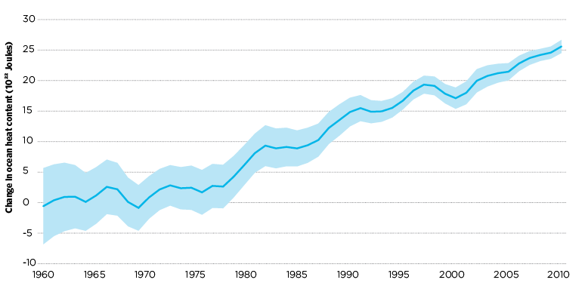

**Note:** Ocean heat content is relative to 1970 levels. Shading provides an indication of the accuracy of the estimate.   
**Source:** CSIRO and BoM 2012, p. 7

Warmer temperatures are also triggering other changes in the climate system:

* Global average sea levels rose 0.19 metres between 1901 and 2010. This was driven by a combination of thermal expansion (water expanding as it warms), glacier melting and Greenland and Antarctic ice sheet melting. These ice sheets are melting at an accelerating pace and are estimated to have lost a total of about 4,000 billion tonnes of ice combined between 1992 and 2011 (Shepherd et al. 2012; IPCC 2013b, Table 13.1).
* Arctic summer sea ice extent has declined sharply since the 1950s, reaching a record low in the Northern Hemisphere summer of 2012 (IPCC 2007b, p. 83; NSIDC 2012). The melting of ice exposes darker water and landscapes, which absorb more solar radiation and amplify warming (Lenton 2008, p. 3).
* In recent years, glaciers have retreated worldwide, Northern Hemisphere snow cover in spring has declined and substantial thawing of permafrost has occurred, particularly in Russia (IPCC 2013b, ch. 4, pp. 4–5).   
  **In Australia, there is evidence that snow has declined** in depth and length of season at some sites, but trends are hard to identify because of considerable annual variability (Hennessy et al. 2008).
* Weather extremes have changed since around 1950. On a global scale, the number of cold days and nights has decreased, while the number of warm days and nights has increased (IPCC 2013a, p. 4).

**In Australia, the frequency of record high temperatures has been increasing since the 1950s, while record lows have been decreasing in frequency.** In the decade to 1966, record low temperatures occurred twice as frequently as record high temperatures. For the decade to 2009, record high temperatures occurred twice as often as record lows (Trewin and Vermont 2010).

* The frequency of heatwaves across parts of the world including Europe and Asia appears to have increased.   
  **In Australia, heatwaves have increased in duration and frequency since the 1970s.** The heatwave that commenced in late December 2012 was easily the longest continent-wide heatwave on record, and temperatures more than 10 degrees above average were recorded across extensive areas of Australia until mid-January 2013 (BoM 2014). Bushfires are also virtually certain to have increased in intensity (IPCC 2007b, TS p. 50).   
  Heat extremes are discussed in more detail in Box 2.3.
* The ocean has become more acidic because it has absorbed about 30 per cent of the additional carbon dioxide released into the atmosphere (IPCC 2013a, SPM p. 7). Increasing ocean acidity decreases the ability of shelled organisms, including coral, small molluscs and zooplankton, to form shells.   
  **In the Great Barrier Reef, the coral population has declined by 50 per cent since the 1980s** (De’Ath et al. 2012).

## Box 2.3: Extreme heat events

As shown in Figure 2.5, an increase in average temperatures can have a large effect on the frequency and extent of extreme hot weather (Climate Commission 2013b). In Australia, this pattern is becoming more apparent. Average temperature in Australia has increased by 0.9 degrees since 1910 and, as predicted, there has been a significant increase in the number of hot days (over 35 degrees) and hot nights, and a general decrease in the number of cold days and nights. The 2012–13 Australian summer was the hottest since records began, with more than 80 heat-related records set in January 2013 alone, including the hottest day on record (BoM 2013).

## Figure 2.5: The relationship between climate averages and extremes

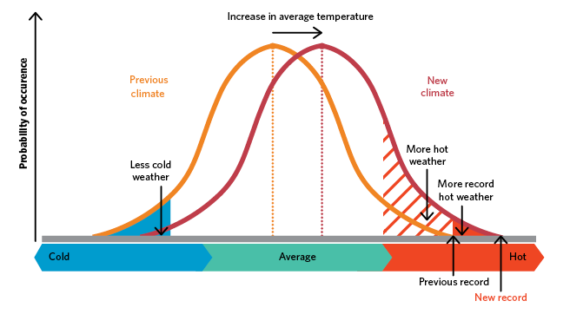 **Source:** Modified from Climate Commission 2013b

Over the past decade, many other countries and regions have experienced periods of extreme heat, including severe heatwaves in India (2002 and 2003), Europe (2003) and various parts of China (2010) (WMO 2011, p. 5). The 2010 Russian heatwave was of particular note, not only for its intensity and resulting death toll of over 55,000 people (CRED 2011, p. 1), but also for demonstrating another linkage between climate change and extreme weather. The loss of Arctic sea ice resulting from increased air and ocean temperatures has been linked to changes in the polar jet stream—the river of high-altitude air that works to separate Arctic weather from that of northern Europe, Russia and Canada. There is now growing evidence that aberrations in jet streams contributed to various recent extreme weather events, including the record-breaking Russian heatwave (2010), the wet summer and autumn in the United Kingdom and Ireland (2012), the blocking of Hurricane Sandy’s trajectory (which subsequently hit New York in 2012) and the recent historic floods in Central Europe (2013) (Grumm 2011; Met Office et al. 2012; Centre for Climate and Energy Solutions 2012; NASA 2013).

## 2.3 Projected climate change impacts

Global warming will affect all components of the climate system, which will have wide-ranging impacts on natural systems and human life. Depending on the level of warming, climate change impacts could affect the quality of our environment, where we live, how healthy we are, what we do and what we eat. Impacts will not necessarily be localised due to the strong interconnections between many sectors. For example, higher temperatures or declines in rainfall could reduce the productivity of land in some locations, which could increase food prices and lead to higher costs of living.

The precise extent, timing and location of impacts from climate change cannot be known with certainty. The climate is a highly complex system, influenced by atmospheric composition, ocean circulation, frozen surfaces and water bodies, land surfaces and the biosphere. Climate science and modelling continue to improve in projecting future states of the world and the likelihood of certain types of impacts occurring in particular regions. Impacts will depend on how much and how rapidly the climate warms, which is influenced by the future concentration of greenhouse gases and the sensitivity of the climate. Scientific research and climate models provide a strong basis for anticipating possible outcomes.

Warming above 2 degrees increases the likelihood that the world will cross irreversible ‘tipping points’ in the climate system that result in abrupt and permanent changes. Examples of tipping points include a shift in the location and strength of the Indian summer monsoon, which could endanger food production for over one billion people, and the triggering of permanent melting of Greenland and West Antarctic ice sheets, which could increase sea levels by many metres over several hundred years. Two of the most fragile tipping points are believed to be the permanent melting of Arctic summer sea-ice and the Greenland Ice Sheet, which may occur between 1 and 2.5 degrees of global warming (compared with pre-industrial levels). These changes could amplify warming, cause ecosystem changes and raise global sea levels by several metres (Lenton et al. 2008). Crossing any of these tipping points would cause substantial regional and global consequences.

As temperatures increase, impacts can generally be expected to become more severe, as shown in Figure 2.6 and explained in the subsequent examples.

## Figure 2.6: Global impacts projected to result from rising temperatures

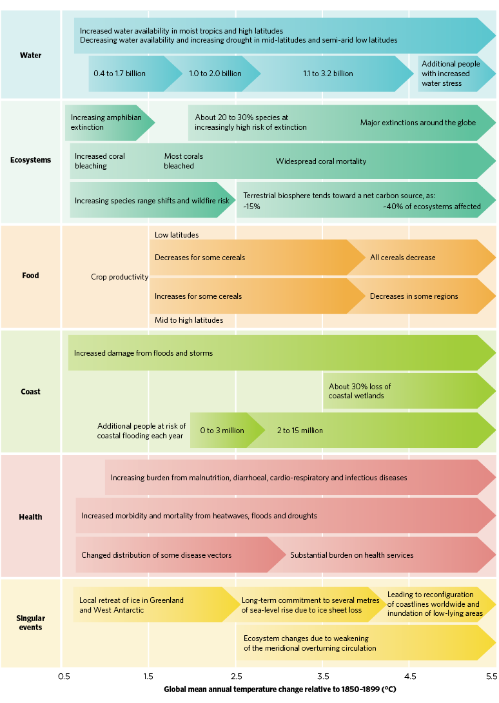

**Source:** Adapted from IPC 2007b, Table TS.3

* Across the world, dry regions are generally projected to become drier (through increased evaporation) and wet regions to become wetter (through increased rain) (IPCC 2007a). Extreme weather events such as heatwaves, droughts, storms, floods and wildfires are projected to become more frequent and more intense for some locations. With 4 degrees of warming, the most extraordinary heatwaves experienced today will become the norm and a new class of heatwaves, of magnitudes never experienced before, will occur regularly (Schaeffer et al. 2013, p. 15).
* **In Australia, the frequency and intensity of fires in many regions are expected to increase substantially in coming decades**, particularly for current high-risk areas, some of which are close to populated centres.   
  A low global warming scenario (with temperatures 0.7 degrees above 1990 levels in 2050) would increase the frequency of ‘very high’ fire danger days by 5–23 per cent and ‘extreme’ fire danger days by 10–50 per cent.   
  A high global warming scenario (with temperatures 2.9 degrees above 1990 levels in 2050) would increase the frequency of ‘very high’ fire danger days by 20–100 per cent and ‘extreme’ fire danger days by 100–300 per cent (Lucas et al. 2007, Table E.1).
* **Floods, landslides, droughts and storm surges in Australia are very likely to become more frequent and intense,** and there is high confidence that snow and frost will become less frequent (IPCC 2007b, TS p. 50).   
  Snow cover is projected to reduce to zero in most Australian locations that currently experience a significant snow season under a high-emissions scenario (warming of 2.9 degrees above 1990 levels by 2050). This compares with a 38 per cent reduction in snow cover under a low-emissions scenario (warming of 0.6 degrees above 1990 levels in 2050) (Hennessy et al. 2008).
* Sea levels are projected to continue to rise as a result of thermal expansion from warmer waters and melting of ice sheets and glaciers. Under a scenario of strong global emissions reductions (warming of 0.9–2.3 degrees by 2100), sea levels are projected to rise by an average of 0.4 metres. In contrast, sea levels are projected to rise by 0.63 metres under a high-emissions scenario (with a likely temperature range of 3.2–5.4 degrees) (IPCC 2013a, Table SPM.2).   
  The long-term effect of temperatures this century on sea levels in 2300 is striking. Sea levels under strong global emissions reductions scenarios are projected to be 0.41–0.85 metres higher in 2300, compared to 0.92–3.59 metres projected for high-emissions scenarios (IPCC 2013b, Table 13.8).
* Sea level rise will increase risks of flooding, coastal erosion and salt contamination of fresh water, with more significant damage to human settlements, infrastructure and coastal ecosystems.   
  Under the projected minimum sea level rise in Asia of 40 centimetres over the course of this century, the number of people in coastal populations flooded each year is projected to rise from 13 million to 94 million (IPCC 2007b, ch. 10.4.3).   
  **In Australia, coastal flooding events are projected to increase in frequency in many locations.** If sea levels rise by 0.5 metres, the frequency of coastal flooding events in Sydney is projected to increase by a factor of 1,000, so that a flooding event that currently occurs once in 100 years would occur 10 times per year, on average (Climate Commission 2013a, Figure 39). Under a 1.1 metre sea level rise (a high-end 2100 estimate), coastal assets with an estimated worth of $226 billion are potentially exposed to inundation and erosion hazards (Department of Climate Change and Energy Efficiency 2011).
* Ecosystems are projected to experience major changes in structure and function under climate change, with 20–30 per cent of assessed plant and animal species at increased risk of extinction for an average temperature increase of 2–3 degrees, and 40–70 per cent of assessed species committed to extinction above 4 degrees (IPCC 2007b, pp. 38, 242). Particularly vulnerable ecosystems include coral reefs, Arctic and alpine ecosystems, and tropical forests (including the Amazon rainforest). Projected losses of individual species are also likely to have serious ramifications across interlinked ecosystems as well as affecting human food sources and livelihoods (IPCC 2007b, p. 11).
* Coral reefs are projected to experience substantial degradation, even under scenarios where warming is limited to 2 degrees, due to the dual threats of coral bleaching and ocean acidification. Coral reefs are one of the most biologically diverse and economically important ecosystems worldwide. They provide habitat for over a million species and are a major source of fish, supplying more than one-quarter of the total annual fish catch in Asia alone. Coral reefs are also important for coastal protection against storms and are a major tourist attraction (Hoegh-Guldberg et al. 2007; Frierler 2012). By 3 degrees of warming, coral reefs as they currently exist are expected to be destroyed (Hoegh-Guldberg et al. 2007).
* With rising sea levels and more frequent extreme weather events, populations in affected regions may be forced to relocate. Climate-induced migration could create humanitarian crises and cause or exacerbate ethnic, political and international conflict and even terrorism (Department of Defence 2013, p. 18). Under a high-emissions scenario with one metre of sea level rise in the 21st century, one study has estimated that up to 187 million people could experience forced displacement (Schaeffer et al. 2013, pp. 16–17). This is roughly the equivalent of the current populations of Germany, Thailand, Canada and New Zealand combined.
* Human health will be affected by climate change, with increased injuries and deaths from extreme weather events, heat-related illness, food and water scarcity, and disease (including bacterial and vector-borne disease). The risks from higher temperatures, particularly among vulnerable populations, are well documented. For example, the Russian heatwave of 2010 is estimated to have resulted in the deaths of about 55,000 people (CRED 2011).   
  In the developing world, climate change is projected to cause increased malnutrition due to declines in local agricultural production. Malnutrition is projected to increase the incidence of stunted growth in children and result in higher numbers of famine-related deaths (Lloyd et al. 2011; Black et al. 2008).   
  **In Australia, under a hot and dry scenario with average global warming of 4.5 degrees by 2100, about 17,000 temperature-related deaths would be expected each year** by the end of the century, compared with about 8,500 with no additional climate change, but accounting for population growth (Bambrick et al. 2008, p. 13).   
  A warming climate is also projected to increase the area suitable for transmission of vector-borne disease. **Under 4.5 degrees of global warming, the area suitable for mosquitos that transmit dengue fever in Australia is projected to extend southwards from Far North Queensland**, exposing an estimated 4.96–7.93 million people in 2100. This compares with 0.72 million projected to be exposed if the world acts to mitigate the worst of climate change (Bambrick et al. 2008, p. 38).

Australia will be able to adapt to many of the impacts projected from warming of 2 degrees or less. Above 2 degrees, adaptation will become increasingly challenging and, with warming of 4 degrees or more, Australia would not be able to manage its exposure to many severe impacts. Life would become far more difficult (CSIRO 2010, p. 60).

## 2.4 Costs of climate change to Australia’s economy and society

The impacts of climate change will be accompanied by far-ranging economic, environmental and social costs that will increase over time with higher levels of warming. The Authority must have regard to these issues in any of its reviews.

### 2.4.1 Social costs

The effects of climate change are likely to differ across social groups, depending on gender, age, socioeconomic status, existing health conditions or disabilities, ethnicity, migration and housing tenure. Research by the Australian Council of Social Service (2013) found that people with the fewest resources have the least ability to cope, adapt and recover from climate change impacts. Within Australia, the following groups have been identified as the most vulnerable to climate change:

* **Households**—Australians on low incomes and those who are unemployed, homeless, living in poor-quality accommodation or frail through age or chronic health conditions are more vulnerable to climate change impacts. This includes impacts on food availability and prices, health effects, water availability, energy and transport costs, and the costs of adaptation—such as investing in water tanks and energy-efficient appliances or retrofitting homes to provide protection from extreme weather.
* **Indigenous Australians**—higher rates of socioeconomic disadvantage and strong income and cultural connections to the natural environment make Indigenous Australians particularly vulnerable to climate change.
* **Australian industries and their workers**—industry and labour mobility will be affected to a greater or lesser extent by climate change impacts on natural resources, such as increased severity and frequency of extreme weather events, water shortages and increased exposure to tropical diseases. Agricultural and tourism sectors may be most vulnerable, with the local community affected by financial, emotional and physical stress (ACOSS 2013; NCCARF 2013).

### 2.4.2 Economic costs of climate change

Stern (2006) and Garnaut (2008) both examined the economic consequences of climate change and came to the same broad conclusions—the economic cost of strong climate action is less than the cost of inaction. Focusing only on market impacts of climate change, Stern found that the total cost of ‘business-as-usual’ climate change (with no action to reduce emissions) over the next two centuries would reduce average global consumption per person by at least 5 per cent per year, now and every year (Stern 2006, p. 153). This compares with the much lower cost of action to reduce emissions consistent with achieving stabilisation at 550 parts per million (ppm) CO2-e, which was estimated at 1 per cent of annual global GDP by 2050 (Stern 2006, p. xii). Garnaut’s study considered both market and non-market impacts of climate change and also concluded that the costs of inaction are greater than the costs of strong action to reduce emissions (Garnaut, ch. 11).

Estimating the true size of climate change impacts is a challenging task—there is inherent uncertainty in climate sensitivity and the timing, size and extent of the climate change impacts themselves. Despite these challenges, Stern made the following conclusions:

* The costs of climate change are invariably underestimated, due to the difficulties in valuing non-market impacts such as environmental damages and health:
  + Stern’s attempt to measure environmental and health impacts more than doubled his estimates of the global costs of climate change, from 5 per cent of global GDP per year to 11 per cent.
  + Other non-market impacts are even more difficult to value, such as social and political instability triggered by climate change impacts. Such impacts could have substantial economic and social consequences.
* Models that estimate the costs of climate change also tend to omit the impact of high-risk climate change impacts where there is scientific uncertainty on when or where they will occur:
  + Most cost models do not fully capture extreme weather events, which are projected to increase in frequency and severity under greater levels of warming, and can give large shocks (up to several per cent of a country’s GDP) with a single event.
  + Such models also generally omit the economic impacts of the climate crossing thresholds for tipping points, such as the failure of the Indian summer monsoon. While there is scientific uncertainty on the precise temperature threshold at which the monsoon could permanently alter, such significant disruptions to the normal climate cycle would have very large economic, social and environmental consequences (Stern 2006, ch. 6).

Climate change impacts that occur in Australia will also have economic, social and environmental costs. The 2010–11 Queensland floods highlight the types of costs that Australia may need to endure with increasing frequency, as extreme weather events are projected to increase in number and intensity. The floods had the following consequences:

* 35 people died in the 2011 floods and 200,000 people were affected (King et al. 2014, ch. 10).
* Community organisations observed higher rates of homelessness, relationship breakdown and alcohol-related violence in the months after the floods (Climate Institute 2012, p. 21).
* A survey of flood-affected residents in Mackay found that 23 per cent would consider relocating within their town and 15 per cent would consider moving elsewhere if floods increased in frequency. Emigration would have consequences for local economies, growth rates and viability of affected towns (King et al. 2014, ch. 10, p. 95).
* Damage to Queensland’s agricultural production pushed up fruit and vegetable prices by 15 per cent and increased national inflation (Climate Institute 2012, p. 22).
* Businesses that were directly affected were still operating below business-as-usual six months after the floods (Climate Institute 2012, p. 22).
* Insurance premiums tripled in many areas of Queensland and Suncorp Insurance embargoed new policies for Roma and Emerald, which had experienced three floods in as many years (Climate Institute 2012, p. 22). To raise $1.8 billion for reconstruction, the Commonwealth Government imposed a flood and cyclone levy on taxpayers earning more than $50,000 in the 2011–12 financial year (ATO 2012; Gillard 2011).

## 2.5 Australia’s national interest in limiting warming to 2 degrees

The risks of continuing to emit greenhouse gases under business-as-usual are severe. Without strong action, the world is likely to experience 4 degrees of warming by the end of the century, which would mean sea level rises of metres over several centuries; displaced populations in some locations; damage, injury and death from more extreme weather; and major disruptions to food production and ecosystem function. In Australia, average global warming of 4 degrees by the end of this century would see temperatures 3–5 degrees higher in coastal areas and 4–6 degrees higher inland. Snow in many alpine areas is projected to disappear completely and winter rainfall in southern Australia could decline by 50 per cent. Life would be substantially harder and many people and sectors would suffer, including future generations that have had no role in producing additional greenhouse gas emissions.

The global community has agreed to limit warming to below 2 degrees. Even under this scenario, Australia would still have to adapt to additional sea level rise, increased frequency and intensity of bushfires, more frequent heatwaves and drought, increased water scarcity, and year-round higher temperatures (CSIRO 2010). Such an outcome would be substantially better than a 4 degree world. It is in Australia’s national interest to contribute to the global effort to limit warming to below 2 degrees.

## Conclusion

C.1 Australia is vulnerable to climate change and will face increasingly severe impacts under higher levels of warming. It is in Australia’s national interest to contribute to the global goal of limiting warming to below 2 degrees.

1 The 2014 analysis is based on the same methods and models used in the peer-reviewed journal paper by Lewis and Karoly (2013).