# Chapter 12 Using international emissions reductions to help meet Australia’s goals

International emissions reductions are an environmentally sound and cost-effective complement to domestic emissions reductions for Australia.

There are substantial potential benefits to using international reductions to help meet Australia’s goals—they could reduce costs, help to address competitiveness concerns and support broader Australian trade and foreign policy objectives. In turn, these benefits could encourage more ambitious action, both in Australia and overseas, giving a better chance of staying below 2 degrees.

There are risks. In particular, that international emissions reductions are not genuine or their use detracts from the task of transitioning Australia’s domestic economy to a low-emissions future. These risks are real but, in the Authority’s view, they can be effectively managed by good governance, judicious access arrangements and policies that drive domestic emissions reductions.

It is important that Australia begins transitioning from a high- to low-emissions economy in a cost-effective way. As discussed in Chapter 11, there are already policies in place to support this transition. More are needed and they will take time to have an effect. International reductions can play an important role in complementing domestic efforts to help Australia meets its goals, in the immediate period to 2020 and beyond.

If current legislation is repealed and replaced by the Direct Action Plan, the Authority recommends that the government purchase international emissions reductions created under the Clean Development Mechanism (CDM). This mechanism has high standards to ensure its units represent genuine emissions reductions. There is currently a large supply of CDM units available at historically low prices. Australia could choose to limit its purchases to projects with the highest environmental standards and still have access to low-cost, genuine international emissions reductions.

The government has stated it intends to reduce Australia’s emissions by 5 per cent domestically, but has not ruled out using some international reductions to meet a target beyond 5 per cent. The Authority recommends international emissions reductions be used to ‘fill the gap’ between 5 per cent and the recommended 2020 goals. The Authority also considers international reductions could have a role to play in meeting the 5 per cent target.

The Authority recommends the government establish a fund to purchase international emissions reductions to complement domestic reductions under the Direct Action Plan. A fund of about A$210  million to A$850 million should be sufficient to purchase the reductions needed to move beyond the minimum 5 per cent target to the recommended 2020 goals.

There are good reasons for Australia to reduce its domestic emissions and accelerate its transition to a low-emissions economy. Still, climate change is a global phenomenon; from an environmental perspective, there is no special merit in reducing emissions in one country over another. What matters is that the overall quantity of emissions is reduced in line with the global budget. From an economic perspective, it is sensible to reduce emissions in the most cost-effective manner, taking account of both short-term prices and the need for a long-term domestic transition. The trade of international emissions reductions can improve both environmental and economic outcomes.

This concept is recognised in the international climate framework. The Kyoto Protocol allows countries to meet their targets by reducing their own emissions and by purchasing emissions reductions from other countries. Many countries have adopted this approach—the EU, Norway, the UK and New Zealand use international emissions reductions to help meet their climate change goals; the United States and Canada do so at the sub-national level.

This chapter looks at the role international emissions reductions can play in helping achieve Australia’s emissions reduction goals. It discusses:

* the benefits and risks of using international emissions reductions
* how Australia can use international emissions reductions to help meet the recommended 2020 goals in a way that maximises the benefits and minimises the risks
* how international emissions reductions could complement the Direct Action Plan to ensure Australia meets its current international commitments and the recommended goals.

## 12.1 Benefits of international emissions reductions

There are substantial benefits to using international emissions reductions. Three are of particular interest to Australia:

* providing access to a wider range of cost-effective mitigation opportunities, which lowers the overall cost of meeting Australia’s targets
* helping to address competitiveness concerns for industry by equalising the price of emissions reductions across countries
* buying international emissions reductions that are targeted to support other trade, foreign policy and development objectives.

These benefits can lead to a ‘virtuous cycle’ of greater climate action. By reducing costs and competitiveness concerns, trade in international emissions reductions can make stronger targets more achievable. And, by helping developing countries build robust environmental governance, trade can help them take more action.

Almost all stakeholders, including both industry and environment groups, support using international emissions reductions to complement domestic efforts in Australia.

### 12.1.1 Lowering costs to meet Australia’s emissions reduction goals

Allowing access to international emissions reductions would lower the cost of Australia’s emissions reduction task, making it cheaper to attain any given target. It also means that, for any given cost, stronger targets can be achieved. Trade in emissions reductions gives countries and businesses access to a wider range of emissions reduction opportunities than exist domestically. This improves cost-effectiveness.

Industry groups, including the Business Council of Australia (BCA), support access to international reductions on the grounds that it lowers the cost of meeting Australia’s target.

The Authority’s analysis (Chapter 10) shows that Australia can achieve the recommended goals at a manageable cost through a mix of domestic and international reductions. A mix is likely to be significantly cheaper than if Australia was to only use domestic reductions. For example, the modelling indicates that under current legislation a carbon price incentive of more than A$65 per tonne would be required by 2020 to meet Australia’s minimum 5 per cent target through domestic emissions reductions alone. This is much higher than the current price of international emissions reductions—CDM units, for example, are currently trading at less than A$1 per tonne.

While Chapter 10 shows Australia could meet the recommended goals at relatively low cost, in practice the cost could be even lower than projected by the modelling. The Authority’s analysis and cost estimates are based on the price forecast for European units. Emissions reductions, including CDM units, are currently available in large volumes at significantly lower prices. If these were used, the costs of meeting the recommended target would be lower.

### 12.1.2 Contributing to broader trade and foreign policy objectives

Purchases of international emissions reductions can be tailored to advance other government objectives, including trade, foreign policy and development aims. For example, Australia could target purchases to support projects and programs in the region, or encourage greater climate action by supporting the development of the international carbon market and improving environmental governance arrangements in developing countries. This benefit was recognised in the Prime Ministerial Task Group on Emissions Trading report in 2007: ‘At the global level, the recognition of [international emissions reductions] created in developing countries can be an effective way of promoting their involvement in global efforts to limit emissions’ (p. 111).

Other countries tailor some of their purchases of international emissions reductions in this way. For example:

* Sweden will purchase 500,000 CDM units from a clean cook stove project in Ghana. The project will provide community benefits by curbing local air pollution and reducing household expenses
* the UK will purchase £50 million of CDM units from least developed countries to bolster the international carbon market
* Norway will purchase 30 million CDM units to support CDM projects at risk of financial collapse due to historically low prices.

### 12.1.3 Helping to address long-term competitiveness concerns

Using international emissions reductions can help to address long-term industry competitiveness concerns by providing a cost-effective source of emissions reductions.

A number of industry stakeholders expressed concern that strong climate action by Australia would adversely affect their competitiveness because local businesses would face a carbon price higher than that of their international competitors. For example, the Cement Industry Federation is not convinced that its competitors will face meaningful carbon costs in the near future (Draft Report submission, p. 3).

Depending on policy design, trade in international emissions reductions could help address industry competitiveness concerns by equalising carbon prices (or incentives) across countries. The Australian Industry Group considers that access to international emissions reductions could reduce competitive distortions by ensuring the cost of emissions reductions in Australia is similar to those overseas (Draft Report submission, p. 8). If a business has access to international emissions reductions to meet its obligations, it will face the international carbon price, rather than the price that would otherwise have been imposed by the policy. This can help level the international playing field over the longer term.

In turn, if competitiveness concerns are addressed, it can be easier to set stronger emissions reduction goals and foster joint political commitment to action on climate change.

## 12.2 Risks of using international emissions reductions

Using international reductions to help meet Australia’s goals has some risks:

* spending money on emissions reductions that are not genuine
* carbon market fraud
* costs and disruption in Australia that stem from delaying the domestic transition to a low-emissions economy.

These risks can be effectively managed and they are discussed below, along with strategies to mitigate them.

### 12.2.1 Environmental integrity

It is important that international emissions reductions are genuine; otherwise, the environmental integrity of Australia’s action is compromised, and public and investor confidence in such arrangements is weakened.

To ensure emissions reductions are genuine, Australia could choose to use international reductions only from credible sources—for example, tried-and-tested mechanisms with strong measurement, reporting and verification arrangements, such as the CDM. The CDM has operated since 2006 and has detailed rules and governance arrangements to ensure its emissions reductions are genuine. Its operation has improved over time, and its Executive Board has made a conscious and consistent effort to identify and address environmental concerns. It now operates with a high level of environmental integrity and has similar governance arrangements and verification processes as Australia’s CFI (see Box 12.1).

Many countries target their purchases to particular sources of international emissions reductions. For example, the EU allows international reductions from UNFCCC mechanisms, including the CDM. Within this, it does not accept reductions from projects it considers environmentally or developmentally questionable, such as those involving the destruction of synthetic greenhouse gases (GHG) and large-scale hydroelectric generation projects. Australia adopted similar rules for compliance under the carbon pricing mechanism. Section 12.3 discusses the international emissions reductions Australia could use to meet its 2020 goals to ensure a high level of environmental integrity.

## Box 12.1: The Clean Development Mechanism

Like the CFI, the CDM is a baseline-and-credit scheme where projects earn credits by reducing emissions below a defined baseline. Project developers present plans and methodologies to the CDM Executive Board for its initial approval. The Board must be satisfied the emissions reductions are ‘additional’ to what would have occurred without the project, and that the project would not have occurred in the absence of the financial incentive provided by the CDM. The project must also be validated by an independent auditor to ensure the reductions are real, measurable and verifiable. The Board must approve the project before CDM units can be issued. There are periodic independent reviews of projects to verify that emissions reductions continue.

The CDM Executive Board is supported by the UNFCCC secretariat, including its roster of experts, and a number of specialist panels and advisory groups. These groups comprise experts who develop recommendations on the submitted proposals and issue guidelines for new methodologies to assess and inform new projects.

Many of the concerns raised about whether emissions reductions generated from the CDM are genuine relate to the question of ‘additionality’—whether the reductions would have happened in the absence of CDM support. As with all baseline-and-credit schemes, it can be difficult to define the counterfactual and determine additionality. Over time, the CDM has developed a sophisticated set of methodologies and rules for determining whether reductions are additional and these are constantly refined. Indeed, some criticism of the CDM arises because of the complexity and expense of proving projects meet these rules.

### 12.2.2 Carbon market fraud

Carbon market fraud can cause environmental integrity issues (if, for example, it results in the same emissions reductions being counted twice) and financial loss.

The risk of fraud in the carbon market is no different from other more established markets. For example, the Australian Stock Exchange continues to experience and respond to incidences of fraud. If governments work together, put in place robust governance arrangements, and respond quickly and effectively if fraud does occur, the risk is manageable. Australia can draw on its experience working with foreign governments in other contexts to establish systems to mitigate the risks.

There have been a number of well-publicised incidents of fraud in the EU ETS. In 2010–11, about 2 Mt of EUAs were stolen from individual accounts. The EU responded immediately by suspending trade until new security requirements were implemented. The EU revised its systems to reduce the risk of similar events—replacing the national registries of EU member states with a single EU-wide registry and tightening its rules on proof of identity. To further protect against fraud, the European Commission is seeking to align the rules governing the carbon market with other European financial markets. This means higher integrity standards, simpler access and better transparency for all carbon market participants.

### 12.2.3 Delaying Australia’s transition to a low-emissions economy

An over-reliance on international emissions reductions to meet Australia’s goals could delay its transition to a low-emissions economy. A number of stakeholders expressed this concern in the Authority’s consultation, including WWF-Australia. The Authority believes it is important to support Australia’s transition—as the world takes action on climate change, Australia needs to put in place policies and mechanisms to drive domestic emissions reductions and encourage low-emissions investments. As discussed in Chapter 5, Australia currently has a number of such policies, including:

* the RET to encourage investment and deployment of renewable energy
* land clearing controls
* national, state and territory energy efficiency standards and schemes.

The Authority has identified additional policies that might capture emissions reductions opportunities in Australia (see Chapter 11). A strong and sustained suite of policies will drive domestic emissions reductions that will put Australia on the path to a low-emissions economy. Targets and long-term guidance about Australia’s future climate change action will also help to shape expectations and encourage low-emissions investment.

International emissions reductions can complement these domestic efforts. It takes time to develop and implement new policies and there are inherent lags due to the time needed to turn over existing capital stock. It is important Australia puts these policies in place now to drive emissions reductions in the future. However, particularly in the period to 2020, international emissions reductions could play an important complementary and timely role. The balance between domestic and international emissions reductions is likely to change over time as national and global economies move closer to a low-emissions footing.

The Authority considers a balanced approach is appropriate—international emissions reductions should not be used to meet all of Australia’s target, but nor should they be excluded. The benefits—lower costs, industry competitiveness and other national objectives—are substantial and, in turn, may drive stronger climate action. The risks can be managed by good governance, judicious access arrangements and policies that drive domestic emissions reductions. A mix of domestic and international reductions will help Australia transition to a low-emissions future, while reducing the costs of meeting the recommended 2020 goals.

## 12.3 International emissions reductions to help meet Australia’s 2020 goals

Section 12.2 outlines why Australia should use international emissions reductions to complement domestic efforts and help meet its emissions reduction goals. This section considers which international reductions Australia could use to meet its 2020 goals in the context of the government’s Direct Action Plan to maximise the benefits and minimise the risks.

There is a wide range of credible international emissions reductions available to help countries meet their goals:

* the UNFCCC and Kyoto Protocol market mechanisms, such as the CDM
* established emissions trading schemes, such as the EU
* bilateral offset mechanisms, whereby countries work together to establish programs and projects that generate emissions reductions.

Until 2020, the most reliable sources of units for Australia are established mechanisms, such as the CDM and the EU ETS. These mechanisms have sophisticated arrangements in place to promote environmental integrity and reduce fraud. In time, other mechanisms may develop and mature, providing further opportunities for Australia. These could be explored for Australia’s post-2020 goals.

Australia negotiated access to EU allowances as part of the carbon pricing mechanism. If this legislation is repealed, EU allowances are unlikely to be available to Australia, so the Authority has focused its analysis on the CDM.

### 12.3.1 CDM units

The CDM supports a wide range of projects from developing countries. Some of the projects able to produce CDM units include rural electrification projects that use solar panels, the installation of more energy-efficient boilers and power generated from agricultural waste.

Figure 12.1 shows that most of the CDM units issued to date have come from destroying synthetic GHGs (about 52 per cent of total), hydro (13 per cent) and wind projects (10 per cent). Through to 2020, hydro projects are forecast to become the major source of CDM units (55 per cent of total), followed by wind (17 per cent) and destroying synthetic GHGs produced by industry (7 per cent). The share of synthetic GHG projects declines to 2020 as many markets, including the EU ETS, are refusing to accept them. Figure 12.2 shows that most of the CDM units issued to date are from China (61 per cent), followed by India (13 per cent), the Republic of Korea (8 per cent) and Brazil (6 per cent). China is expected to remain the major source through to 2020.

## Figure 12.1: CDM units by technology

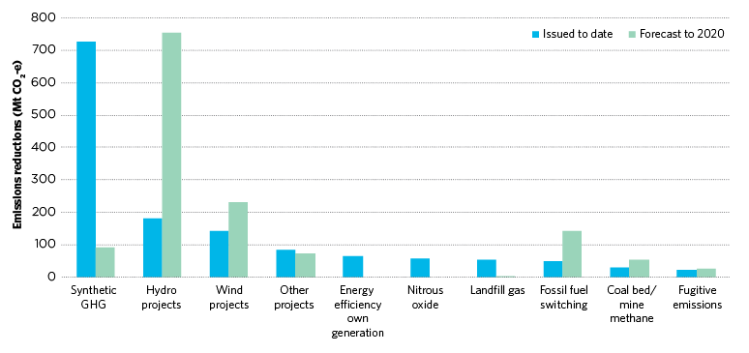

**Source:** BNEF 2014

## Figure 12.2: CDM units by country

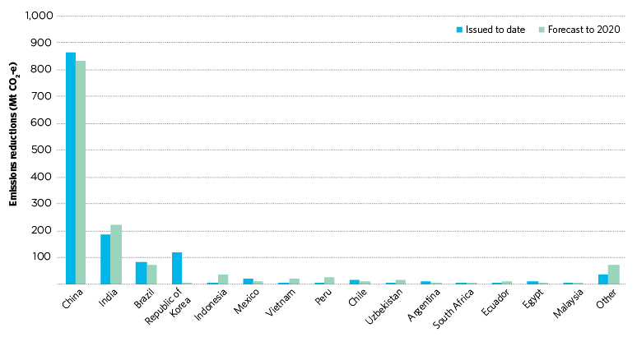

**Source:** BNEF 2014

### 12.3.2 The price of CDM units

There is currently a large number of CDM units available at low cost. The price is now less than A$1 per tonne (BNEF 2014). The low price of CDM units does not imply they are not credible—prices were about A$35 in 2008. Like other tradable commodities, the price movement of CDM units is subject to changing market demand and supply fundamentals. The dramatic decline is largely due to weakened demand from the EU—the main buyer of CDM units. The EU economic crisis has caused EU emissions to fall, so fewer international emissions reductions are required to meet its targets.

A large number of CDM projects was registered when the price was higher and these are still generating credible emissions reductions. If the price rises slightly, more units are likely to be available, as current prices are less than the cost of having credits issued for some projects. BNEF (2014) estimates that a price increase to about A$7 would encourage the supply of at least an additional two billion tonnes of CDM units.

Sufficient CDM units are likely to be available to satisfy both future EU ETS demand and other remaining demand centres, including Australia, without significantly increasing the price.

### 12.3.3 Which CDM units to use?

To enhance the integrity of the CDM units used, Australia could choose to exclude units from projects with environmental or developmental concerns. This would be similar to the approach taken by the EU, which excludes units from nuclear energy projects, afforestation or reforestation activities, large-scale hydro projects and, from 2013, projects involving the destruction of synthetic GHGs.

The reasons these units are excluded vary. Some are excluded for developmental concerns; for example, large-scale hydroelectric generation projects can displace local communities, and lead to loss of agricultural land and a decline in biodiversity.

Carbon Market Watch, a non-government organisation that monitors the global carbon market, has also raised concerns about coal-fired power plant projects, which could lock in more emissions-intensive infrastructure.

The government could choose to exclude a sub-set of CDM units if it shared these concerns. Even if it did so, the CDM would still be a cost-effective source of emissions reductions. Large amounts of credible units are likely to be available to 2020 at a low cost.

In addition to purchasing units on the secondary market, the government could choose to support the establishment of new projects in specific countries to enhance its trade, foreign policy and aid objectives. The outlays for these purchases are likely to be higher as they would need to cover their establishment costs. However, many such projects are still likely to be cheaper than an increasing reliance on domestic emissions reductions in Australia.

## 12.4 International emissions reductions and the Direct Action Plan

The government intends through its Direct Action Plan to reduce Australia’s domestic emissions by 5 per cent from 2000 levels by 2020.

International emissions reductions could be a useful complement to domestic efforts. The central mechanism of the government’s Direct Action Plan is the Emissions Reduction Fund. This has a fixed budget and it is unclear precisely how many tonnes of emissions it will reduce. Some analysis (see, for example, RepuTex 2013) suggests the currently committed funding will be insufficient to reduce emissions by 5 per cent. The Authority considers international emissions reductions would be a useful and low-cost way to help ensure Australia achieves its minimum 5 per cent target.

The government has not stated how it would meet stronger targets.

The Authority’s analysis shows that there are many opportunities to reduce emissions in Australia, but they are likely to require a relatively high price per tonne. Using international emissions reductions to ‘fill the gap’ between the 5 per cent domestic reduction and the recommended target would be a cost-effective way for Australia to take responsible climate change action. Figure 12.3 shows the balance of domestic emissions reductions required to meet the 5 per cent target and the additional international reductions used to meet the recommended goals.

## Figure 12.3: Emissions reductions required to meet 5 per cent target and recommended goal

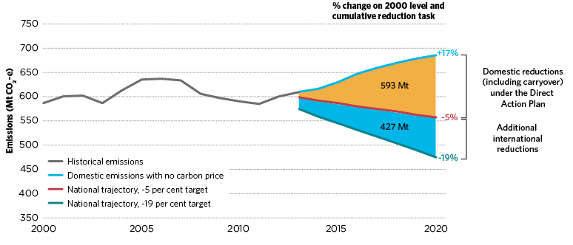

**Source:** Climate Change Authority based on Treasury and DIICCSRTE (2013)

### 12.4.1 Establishing a government fund

The government could access international emissions reductions by establishing a fund and managing it directly. Other countries have taken this approach; for example, Norway uses the state-owned Nordic Environment Finance Corporation fund to purchase international emissions reductions.

Alternatively, the government could use an intermediary like the World Bank to purchase CDM units based on specified criteria on its behalf. The World Bank has extensive experience in purchasing international emissions reduction units on behalf of governments and companies. The Netherlands and Spain have both provided funding to the World Bank to purchase CDM units on their behalf from a particular set of projects including renewable energy, biomass, energy efficiency improvement, fossil fuel switching, methane recovery and sequestration.

The size of the fund would depend on the volume of international emissions reductions required and their price. As discussed in Section 10.4, if the minimum 5 per cent target is achieved domestically, an additional 427 Mt of reductions would be needed to meet the Authority’s recommended 2020 target (Figure 12.3). CDM unit prices of A$0.50 would require a government fund of about A$210 million. If CDM unit prices rose substantially, say to A$2, the required fund would be about A$850 million.

In addition to direct purchase, the government could allow some private purchase of international emissions reductions. The government’s Green Paper on the Emissions Reduction Fund leaves open the possibility of using international emissions reductions for ‘make-good’ and ‘safeguarding’ arrangements. Many stakeholders support this approach; for example, the Australian Industry Greenhouse Network recommends: ‘If companies find themselves with a liability, Direct Action compliance arrangements should consider the possibility of acquittal using CFI permits and/or international permits’ (AIGN response to the ERF White Paper Terms of Reference, p. 9).

## Recommendations

R.11 The government use international emissions reductions to bridge any gap between domestic reductions achieved under the Direct Action Plan and the recommended 2020 goals.

R.12 The government establish a fund to purchase Clean Development Mechanism units to complement the Direct Action Plan and help meet the recommended 2020 goals.