# Chapter 1 About this review

Climate change poses serious risks to the Australian community, economy and environment. Effective policies that reduce Australia’s emissions and support a global solution are in Australia’s interest.

The Climate Change Authority is an independent body established to provide expert advice to the Commonwealth Government on Australian climate change policy. This report fulfils the Authority’s legislative requirements to make recommendations about Australia’s emissions reduction goals and report on progress in reducing its emissions.

The report recommends short-, medium- and long-term emissions reduction goals, as well as the corresponding trajectory ranges and emissions budgets. This will help inform government decision-making on future international commitments and the design of new policy.

In the Targets and Progress Review, the Authority has considered the latest climate science, international action, Australia’s progress in reducing emissions, international and inter-generational equity, the economic costs of different targets and opportunities for future emissions reductions. Australia’s existing international obligations and undertakings were a starting point for the Review.

This chapter introduces the Targets and Progress Review. It provides information about the Authority, discusses the Review, and explains the Authority’s approach to its analysis and recommendations.

## 1.1 The Climate Change Authority

The Climate Change Authority is an independent statutory agency, established to provide expert advice on Australian climate change policy, including through a scheduled series of reviews of climate programs and legislation.

The Authority is chaired by Mr Bernie Fraser and comprises nine members with expertise in climate science, economics, business and public policy. Its work is guided by a set of principles under the Climate Change Authority Act 2011 (Cth). The Act states that, in conducting a review, the Authority must have regard to the following matters:

* economic efficiency
* environmental effectiveness
* equity
* the public interest
* the impact on households, business, workers and communities
* the development of an effective global response to climate change
* Australia’s foreign policy and trade objectives
* any additional principles the Authority considers relevant.

The Authority has taken these matters into account in the Targets and Progress Review.

The Authority is required to consult in conducting its reviews. Public consultation has been a key part of the Targets and Progress Review. The Authority has engaged with a wide range of interested parties, who have provided essential input to the review process.

## 1.2 Context

Climate change is an ongoing global problem that poses serious risks to the Australian community, economy and environment. Effective policies that reduce Australia’s emissions and support a global solution are in Australia’s interest.

This report can help inform the Commonwealth Government as it makes decisions in the near future about Australia’s 2020 target and post-2020 emissions reduction goals (outlined in Figure 1.1). Under the United Nations Framework Convention on Climate Change (UNFCCC) and the Kyoto Protocol, countries are considering ways to increase global action to reduce emissions. Australia has committed to reviewing its 2020 Kyoto target and advising whether it intends to strengthen it from the minimum 5 per cent reduction (on 2000 levels) by April 2014. At the same time, UNFCCC Parties are considering a post-2020 international climate framework and Australia will be expected to indicate its post-2020 goals by the first quarter of 2015. The government is also free to strengthen its emissions reduction efforts at any time.

## Figure 1.1: The Authority’s Review and international climate change milestones 2014–15

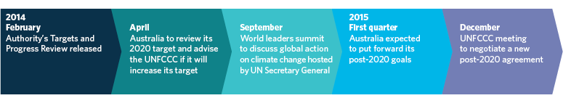

This report can also inform government decision-making as it determines new policy settings to address climate change. The government has announced it intends to repeal the carbon pricing mechanism and replace it with a Direct Action Plan. In December 2013, the government released a Green Paper setting out its preferred options for the design of an Emissions Reduction Fund, which is the centrepiece of the Direct Action Plan. A White Paper outlining the fund’s final design is due in early 2014.

## 1.3 The Targets and Progress Review

The Targets and Progress Review covers two legislated reviews under the Clean Energy Act 2011 (Cth), which require the Authority to:

* make recommendations about Australia’s emissions reduction goals, including specifically an indicative national emissions trajectory and a national carbon budget (referred to in this report as an emissions budget) and carbon pollution caps (s. 289)
* report on Australia’s progress in achieving its medium- and long-term emissions reduction targets, and progress in meeting a national emissions budget (s. 291).

The matters to which the Authority must have regard in conducting these reviews are set out in the Clean Energy Act and listed at Box 1.1.

## Box 1.1:Legislated review requirements

The Clean Energy Act sets out specific matters to which the Authority must have regard in the Targets and Progress Review:

**Review of caps, trajectories and budgets** (s.  289)

(a) Australia’s international obligations under international climate change agreements;

(b) undertakings relating to the reduction of greenhouse gas emissions that Australia has given under international climate change agreements;

(c) Australia’s medium-term and long-term targets for reducing net greenhouse gas emissions;

(d) progress towards the reduction of greenhouse gas emissions;

(e) global action to reduce greenhouse gas emissions;

(f) estimates of the global greenhouse gas emissions budget;

(g) the economic and social implications associated with various levels of carbon pollution caps;

(h) voluntary action to reduce Australia’s greenhouse gas emissions;

(i) estimates of greenhouse gas emissions that are not covered by this Act;

(j) estimates of the number of Australian carbon credit units that are likely to be issued;

(k) the extent (if any) of non-compliance with this Act and the associated provisions;

(l) the extent (if any) to which liable entities have failed to surrender sufficient units to avoid liability for unit shortfall charge;

(m) any acquisitions, or proposed acquisitions, by the Commonwealth of eligible international emissions units;

(n) such other matters (if any) as the Climate Change Authority considers relevant.

**Review of progress** (s. 291)

(a) the level of greenhouse gas emissions in Australia;

(b) the level of purchases of eligible international emissions units (whether by the Commonwealth or other persons);

(c) the level of greenhouse gas emissions that:

(i) are attributable to activities in the Australian economy; and

(ii) are not reflected in the provisional emissions numbers of liable entities;

(d) voluntary action to reduce greenhouse gas emissions;

(e) such other matters (if any) as the Climate Change Authority considers relevant.

In line with the legislative requirements, this report:

* presents evidence about climate science and international action to reduce greenhouse gas emissions
* assesses Australia’s progress in reducing greenhouse gas emissions across the whole economy and within specific sectors
* recommends a coordinated set of emissions reduction goals for Australia:
  + a short-term target for 2020, and an emissions budget and trajectory to 2020 providing a clear course for short-term action
  + a trajectory range to 2030 and a national emissions budget to 2050, providing guidance for longer term planning, subject to periodic review to respond to new information and changing circumstances
* identifies and assesses opportunities for emissions reductions in different sectors of the economy, and policies to capture these opportunities
* recommends international emissions reductions be used to help Australia meet its emissions reduction goals (in particular, its 2020 target).

Box 1.2 defines the key terms, including ‘target’, ‘budget’, ‘trajectory’ and ‘net target’.

## Box 1.2: Key definitions—Australia’s emissions reduction goals

**Target:** A national emissions goal for a specific year. The Authority will recommend a 2020 target expressed as a percentage reduction in emissions from 2000 (see Figure 1.2).

**Budget:** Australia’s cumulative emissions allowance over a period of time. The Authority will recommend a short-term budget for total emissions between 2013 and 2020, and a long-term budget between 2013 and 2050.

**Trajectory:** Australia’s indicative year-by-year national emissions pathway to its target. The Authority will recommend a 2013 to 2020 trajectory. It will also recommend a trajectory range from 2020 to 2030 (see ‘trajectory range’ below). The year-by-year points on the trajectory are indicative (non-binding) targets in each year. The area under the trajectory constitutes an emissions budget.

**Trajectory range:** The range within which future trajectories may be set. A trajectory range provides an indication of future trajectories and flexibility to take into account new information. The Authority is recommending a trajectory range from 2020 to 2030.

## Figure 1.2: Target, trajectory, trajectory range and budget

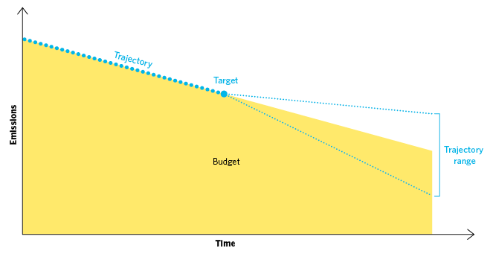

**Source:** Climate Change Authority

**‘Net’ targets:** The recommended emissions reduction goals are net of trade. This means that any international emissions reductions Australia buys will count as reductions towards its target—but any emissions reductions sold overseas cannot be counted. Emissions in Australia could be higher than the target if offset by purchases of international emissions reductions.

### 1.3.1 The Authority’s approach to recommending emissions reduction goals and assessing Australia’s progress

The Authority has weighed a broad range of considerations in reaching its recommendations, including climate science, global action, the costs of reducing emissions and Australia’s appropriate contribution to global emissions reductions.

Figure 1.3 illustrates the key considerations of the Targets and Progress Review, as set out in this report.

## Figure 1.3 Targets and Progress Review—key considerations and structure of the report

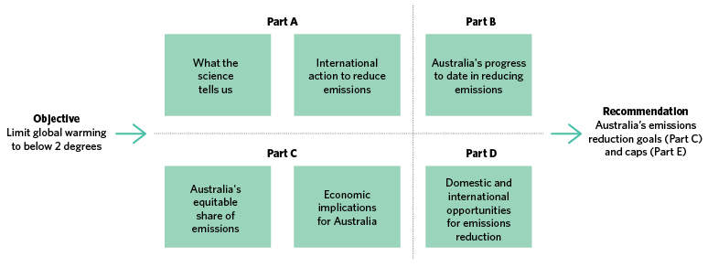

**Source:** Climate Change Authority

The Authority has taken Australia’s existing international obligations and undertakings as a starting point for its deliberations, including Australia’s commitment to the global goal to limit warming to below 2 degrees. It has also taken into account Australia’s other emissions reduction commitments, including its international undertakings under the:

* UNFCCC—to reduce emissions by 5 per cent (unconditional) to 25 per cent below 2000 levels by 2020
* Kyoto Protocol—to limit average annual emissions in the period 2013 to 2020 to 99.5 per cent of 1990 levels, a calculation based on the unconditional 5 per cent target.

None of the Authority’s recommendations would lead to Australia breaching its existing international obligations and undertakings. In other words, Australia’s existing UNFCCC and Kyoto Protocol commitments have been taken as minimums.

### 1.3.2 Public consultation

The Authority conducted extensive consultation as part of the Review. Feedback from stakeholders was invaluable in informing this report and its recommendations. The public consultation included targeted roundtable discussions as well as workshops with experts on a global emissions budget, modelling assumptions and the electricity sector. Details of stakeholder consultation are at Appendix A.

The Authority released an Issues Paper in April 2013 and a Draft Report in October 2013. It received 69 Issues Paper submissions and 138 Draft Report submissions, plus over 12,000 submissions through a GetUp campaign. Submissions are available on the Authority’s website at www.climatechangeauthority.gov.au.

## 1.4 Structure of this report

This report is divided into five parts.

##### Part A: Introduction and context

The Authority has considered Australia’s emissions reduction goals in a global context. Part A outlines:

* what climate science tells us about the risks climate change poses for Australians (Chapter 2)
* how climate science can inform the calculation of global emissions budgets and limits on global emissions consistent with a given limit on global warming (Chapter 3)
* global action underway to reduce emissions and Australia’s role in that global action (Chapter 4).

##### Part B: Australia’s policies and progress to date

Australia’s progress to date in reducing emissions is relevant to considering future action. Part B outlines:

* Australia’s policies to address climate change (Chapter 5)
* Australia’s progress in reducing greenhouse gas emissions between 1990 and 2012 (Chapter 6).

##### Part C: Australia’s emissions reduction goals

This sets out recommendations on:

* the timeframe, form and scope of Australia’s emissions reduction goals (Chapter 7)
* a long-term budget for Australia, including consideration of equity between countries and generations (Chapter 8)
* Australia’s emissions reduction goals (Chapter 9).

Part C also considers the economic implications of the recommended emissions reduction goals (Chapter 10).

##### Part D: Reducing Australia’s emissions—opportunities and challenges

This part examines:

* emissions reduction opportunities across different sectors of the Australian economy and challenges to realising those opportunities (Chapter 11)
* the benefits and risks of using international emissions reductions to help meet Australia’s goals (Chapter 12).

##### Part E: Implementation issues under the carbon pricing mechanism

The Authority’s recommendations to achieve Australia’s emissions reduction goals under the carbon pricing mechanism, including:

* recommendations for annual carbon pollution caps (Chapter 13).