# 3 Coverage and uptake

The government intends to expand and streamline the CFI so it becomes an integral part of the ERF. It will need to decide what emissions reduction activities will be eligible under the crediting mechanism as well as what facilities will be subject to the safeguard mechanism.Wider coverage should increase the scheme’s access to low-cost emissions reductions and the quantity of emissions reductions relative to the current CFI. Not all covered sources of emissions reductions will be brought forward under the ERF, however, because mitigation costs and barriers vary across sectors and activities.

This section considers experiences with the CFI and other baseline and credit schemes to address the following questions:

* What are the important considerations when deciding coverage?
* What types of abatement activities are well suited to baseline and credit schemes, and what are not?

## 3.1 CFI approach to coverage and uptake

The CFI is an offset mechanism designed to credit emissions reductions and sequestration in the land sector—namely through agriculture, legacy waste and LULUCF. Under the carbon pricing mechanism, the land sector does not face an emissions liability; instead, projects in the sector are able to generate and sell CFI credits to entities that do face an emissions liability. Business and individuals who voluntarily wish to offset their emissions may also purchase CFI credits.

Activities that are eligible under the CFI are listed on a ‘positive list’—these are not common practice in an industry, and are therefore considered to represent genuine additional emissions reductions. The ‘negative list’ identifies activities that are not eligible under the CFI—practices that cause negative social or environmental consequences, including impacts on water availability, biodiversity conservation, employment and other values.

The CFI has been operating for just over two years at a time of significant broader change in Australia’s emissions reduction policies. This makes it difficult to assess its effectiveness and draw conclusive lessons or insights. However, because the CFI is a voluntary scheme, the activities and projects established to date are likely to represent emissions reductions that were relatively easy and low cost (the ‘low-hanging fruit’), or were encouraged in other ways (for example, through previous policies). It is also instructive to consider what eligible activities are not well represented in the scheme to date.

The type and mix of methodologies approved under the CFI provide a good starting point to review the activities the scheme supports (see Figure 3.1). As many methodologies have been initiated and developed by industry, they broadly represent the areas of greatest perceived opportunity. To date, 22 CFI methodology determinations have been made; the majority for activities in the forestry and waste sectors:

* permanent environmental plantings and revegetation (eight)
* methane capture at landfills and alternative waste treatment (six)
* capture and disposal of methane generated in piggeries and dairies (four)
* management of savanna burning (two)
* avoided deforestation (one)
* reduced methane generation through dietary additives for dairy (one).

At present, there are six methodologies under DOIC consideration. The DOIC has not approved eight methodology proposals, including for avoided deforestation, grazing management of livestock, removal of feral camels and the addition of feed additives for livestock. These proposals were not approved on numerous grounds, with a lack of clarity around baseline setting and additionality assessment dominating many decisions.

Since the release of the first CFI methodology in June 2012, 108 projects have been approved to create credits under the CFI. About two-thirds have been credited with ACCUs—meaning the project has reduced emissions, the emissions reductions have been verified and the credits have been awarded by the Clean Energy Regulator. The total amount of ACCUs generated at 24 February 2014 was 4.54 million, representing over 4.5 Mt CO2-e of abatement. Most of these reductions (about 85 per cent) were generated from waste activities, principally from landfill gas capture activities, as shown in Figure 3.2.

The prevalence of waste sector projects is partly explained by arrangements that allowed eligible projects under the pre-existing Greenhouse Friendly and GGAS schemes to transition to the CFI when it commenced in 2011. As of 20 January 2014, 59 projects registered under the CFI had transitioned from these schemes, collectively representing more than 3.7 Mt CO2-e. These projects could begin creating ACCUs straight away as the emissions reduction technologies were already installed. This level of uptake also likely reflects the relatively simple and mature technology available to capture and measure methane from waste facilities, which translates to straightforward baseline setting and measurement, reporting and verification. In the waste sector, landfill gas capture is also supported in a number of other ways, including through regulatory standards and the ability to generate electricity and receive renewable energy certificates.

Non-waste-related activities account for about 15 per cent of the total ACCUs generated to date. The forestry sector is well represented in methodologies developed under the CFI and has the second largest number of projects registered.

Involvement from traditional ‘farmers’—the agriculture sector—has been more limited. To date, only five agriculture sector projects have been registered and only one has generated credits—a project in the piggery industry that captures methane from manure. While a methodology aimed at reducing methane emissions through the use of dietary feed additives has been approved, no projects utilising this methodology have yet been registered.

## Figure 3.1: Number of methodologies by project type and status

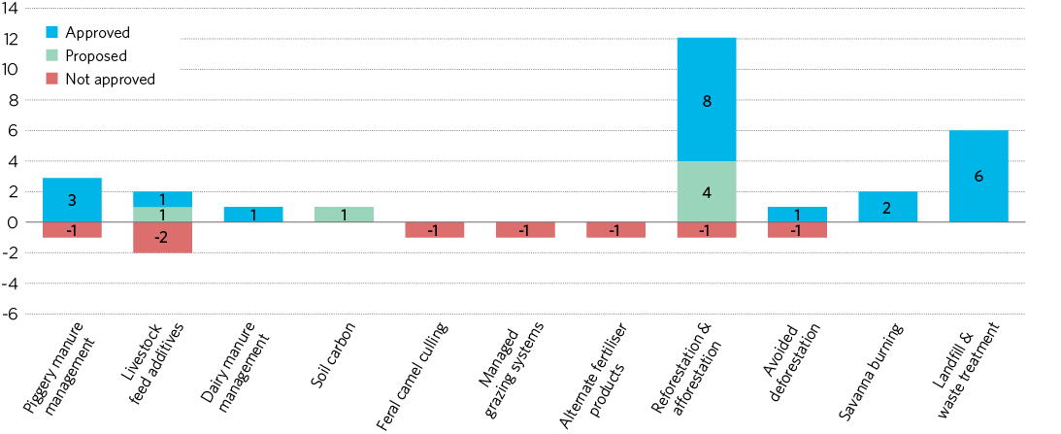

**Source:** Climate Change Authority based on Department of the Environment website, 2014.

## Figure 3.2: Quantity of emissions and number of projects

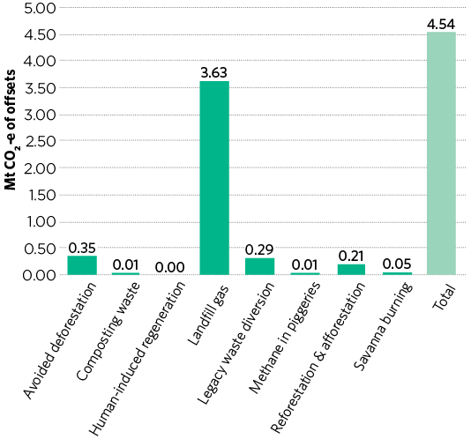

|  | **Number of registered projects** |
| --- | --- |
| Avoided deforestation | 5 |
| Landfill gas | 62 |
| Piggeries | 5 |
| Reforestation & afforestation | 15 |
| Savanna burning | 10 |
| Waste - composting | 2 |
| Legacy waste diversion | 8 |
| Human induced regeneration | 1 |
| Total | 108 |

**Note:** Data current as at 24 February 2014.  
**Source:** Clean Energy Regulator, Register of Offset Projects, 2014.

## 3.2 Experiences from other schemes

This section examines the scope of coverage and actual abatement resulting from other baseline and credit schemes.

### 3.2.1 Scope of coverage

Coverage varies across baseline and credit schemes, reflecting different policy objectives and government priorities.

White certificate schemes, such as the New South Wales ESS and Victorian Energy Efficiency Target, tend to be focused on energy efficiency and generally limit coverage to electricity consumption in relevant sectors (for example, commercial, industrial and residential electricity use). The Indian PAT scheme also has relatively narrow coverage, reflecting the scheme’s objective to reduce energy consumption. Coverage is targeted to eight major energy and industrial sectors, with no external offsets. Narrower sectoral coverage may improve scheme performance by allowing administrators and participants to develop specific expertise and by reducing administrative costs.

Greenhouse gas baseline and credit schemes generally include a wider range of sectors. The Alberta and California offset programs have potentially very wide coverage, subject to the development of methodologies to measure and verify additional emissions reductions. In both, the key limitation is that offset projects may not be carried out in a sector or operation that is covered by the corresponding liability scheme (this avoids double-counting of the emissions reductions). The Alberta scheme currently has 34 methodologies covering a range of sectors, while the California scheme has four methodologies for forestry, destruction of ozone-depleting substances and destruction of methane from manure management systems.

Similarly, the United Nations CDM is an offset mechanism with very wide coverage, covering all sources and gases with only two exclusions (for nuclear projects and land use change and forestry projects other than afforestation and reforestation). The main limitation on coverage is a geographical one; CDM projects can only be undertaken in developing nations. This is because CDM offset credits are used by developed nations with emissions reduction targets under the Kyoto Protocol. Emissions reduction projects in developed countries already contribute to achieving these targets, so crediting those projects would double-count emissions reductions.

The New South Wales GGAS imposed liabilities on electricity retailers and some large electricity consumers. It allowed crediting in a wider set of defined activities, including by liable parties and separate offset providers without a scheme liability.

Wider coverage increases the scope for the scheme to identify and realise low-cost emissions reduction opportunities. Where this is the objective of the scheme, limitations on coverage are generally driven by interactions with other measures, particularly a desire to avoid double-counting emissions reductions achieved by other measures.

### 3.2.2 Sources of emissions reductions

Some baseline and credit schemes with wide coverage have been operating for an extended period. The CDM (operating since 2005) and Alberta’s program (since 2007) are the two main examples. Domestically, the GGAS operated from 2003–12, although with a narrower scope. Some of the energy efficiency activities now credited under the New South Wales ESS were originally part of the GGAS. In addition, several schemes have been operating for a shorter period, such as the California scheme.

In the CDM, crediting has been heavily weighted towards industrial gas disposal projects (for example, hydrofluorocarbons created as a by-product in hydrochlorofluorocarbon (HCFC) production, and nitrous oxide created in adipic and nitric acid production). These account for about 75 per cent of credits allocated since the commencement of the CDM. Renewable energy has a substantial and growing share; it overtook industrial gases as a source of credits in 2013 (Figure 3.3).

The prevalence of industrial gas projects in the CDM was driven by the very low cost and high volumes of emissions reductions available in those projects (Wara 2006). The use of pre-existing technologies and relatively straightforward methodologies to assess emissions reductions and additionality for these projects are also likely to be important factors. Crediting of industrial gas projects has declined following tightening of crediting rules for HCFC projects in 2011.

## Figure 3.3: CDM crediting by project type, 2005–2013

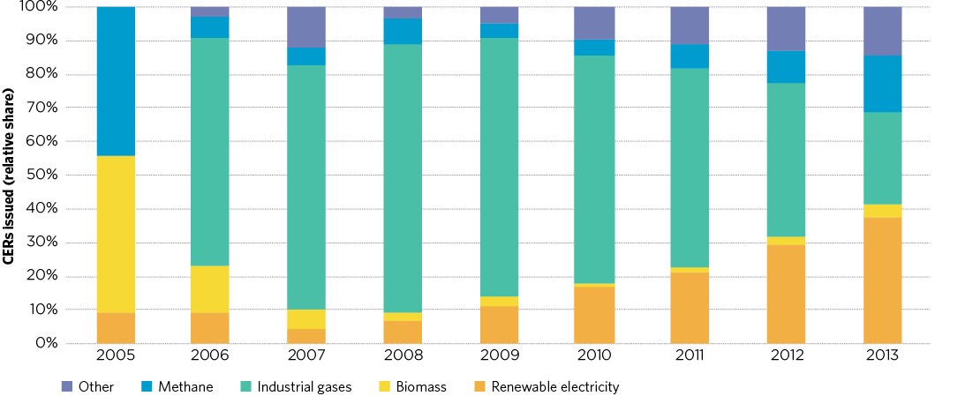

**Source:** Climate Change Authority, based on UNFCCC, 2014.

The increasing significance of renewables is attributable to rapid growth in the electricity sector in many developing countries; this provides project opportunities, often at large scale. The electricity sector also has simple and standardised methodologies to measure emissions reductions and develop baselines.

By contrast, forestry and agriculture projects are poorly represented, at about 2.5 per cent and 0.6 per cent of credits issued to date respectively (Australian Government 2013). The agriculture and forestry sectors account for a much larger share of global emissions—about 22 per cent in 2010—and tend to comprise a larger share again in developing countries (UNEP 2012, pp. 11, 14). A key challenge for forestry projects is ‘permanence’. There is a risk that credited forestry sequestration will be reversed in future (if, for example, the forest is harvested or damaged). As a result, the CDM only issues temporary units for forestry projects—these must be replaced or renewed by the purchaser of the credits after a period of time. These temporary credits have a much lower value than credits issued to other activities. Relatively complex and specific methodologies are also required to measure sequestration and emissions reductions from forestry and agriculture activities, in part because the abatement achieved by those projects relies on natural systems.

The Alberta offset program is unique in bringing forward substantial quantities of non-forestry carbon sequestration from the land sector. Projects that reduce or eliminate tillage of agricultural soils to increase carbon sequestration have generated 38 per cent of offset credits used under the program. Most of the remainder of the credits are from the energy and industrial sectors (Figure 3.4).

## Figure 3.4: Alberta offsets program—credits retired for compliance by project type, 2007–2012

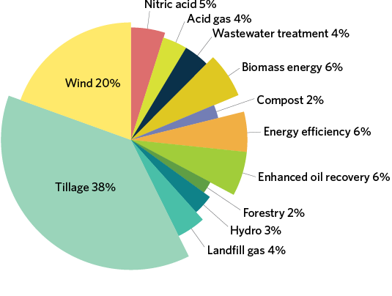

**Source:** Alberta Environment and Sustainable Resource Development Department, 2014.

A number of factors have contributed to this outcome. The Alberta scheme reduced barriers to uptake by allowing credit for up to five years of early action, increasing the immediate return to participants. Feedback from the administrators of the Alberta scheme suggests that many smaller participants do not find continued participation cost-effective and may drop out after taking up this one-off larger opportunity. The risk of reversal of sequestration was dealt with in the Alberta scheme by reducing the number of credits allocated to reflect an estimate of future reversals, rather than by requiring that sequestration be maintained for a minimum period as in other schemes (such as the 100-year requirement currently used in the CFI). This approach reduces the need for ongoing monitoring (beyond the crediting period) and therefore lowers scheme costs, but requires a high level of confidence in the estimate used.

In addition, low tillage was already a relatively well-established practice, and so avoided some of the technology and measurement difficulties often faced in the agriculture sector. This experience may therefore have limited relevance for the ERF, as historical emissions reductions made through relatively common technology or practices are unlikely to be considered additional (see Section 4).

GGAS abatement certificates were predominantly allocated to generation activities, reflecting a scheme focus on the electricity sector. About 70 per cent of total certificates were allocated to generation that had lower-than-average grid emissions intensity, while 22 per cent were allocated to demand-side abatement, including energy efficiency measures and on-site generation by consumers to displace grid generation. In 2009, energy efficiency activities under the GGAS were transferred to the New South Wales ESS and expanded to include more activities (IPART 2013).

Certificates could also be created by non-electricity projects; however, only eight per cent of certificates were allocated to these—about five per cent for on-site non-electricity abatement by large electricity consumers, and three per cent to afforestation and reforestation activities (Figure 3.5).

The New South Wales ESS issued 4.7 million certificates for energy efficiency activities from 2009-12, with approximately 60 per cent provided for the use of more efficient commercial lighting, 16 per cent for more efficient shower heads and 14 per cent for more efficient commercial processes or control systems. Commercial and industrial projects accounted for 86 per cent of certificates issued, with the remaining 14 per cent for residential uses (IPART 2013, pp. 41–42).

The California scheme has only been in operation since 2012 and currently only has four methodologies in place. Crediting to date has been dominated by projects to destroy ozone-depleting refrigerant gases (which also have strong global warming effects) and existing forestry projects that have transitioned from earlier voluntary schemes.

Overall, the schemes surveyed show that emissions reductions tend to be concentrated in a limited number of sectors. Generally, large volumes of emissions reductions have been achieved in the industrial and energy sectors, with agriculture, forestry and transport making relatively small contributions to emissions reductions.

## Figure 3.5: GGas—Certificates allocated by project type, 2003–2012

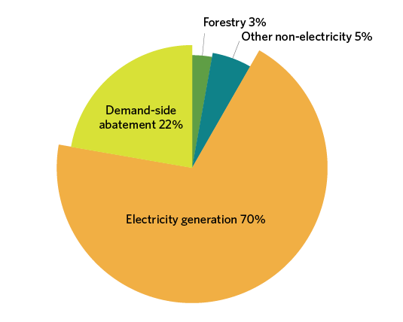

**Source:** IPART, 2012.

## Table 3.1: Credits issued by the California offsets scheme

| **Project type** | **Ozone-depleting  substances** | **Livestock digester** | **US forest** | **Urban forest** |
| --- | --- | --- | --- | --- |
| Compliance | 827,746 | – | – | – |
| Early action | 2,697,690 | 105,957 | 1,649,864 | – |

**Source:** California Air Resources Board, 2014.

## 3.3 Insights for the ERF— coverage and uptake

Scheme coverage—that is, which emitting facilities and activities are eligible for crediting, and which are subject to penalties under the safeguard mechanism—will be a key decision in the design of the ERF. Given the ERF’s primary objective of achieving low-cost emissions reductions, broad coverage of emitting sectors would seem appropriate, as it provides access to the widest range of low-cost opportunities. There may, however, be good reasons to apply some limitations on coverage. Further, even with broad coverage, some sectors are more likely to participate and generate more emissions reductions than other sectors.

### 3.3.1 Key considerations for coverage

Experience illustrates that one of the key reasons for limiting coverage of baseline and credit schemes is the interactions with other measures.

The ERF Green Paper notes the importance of avoiding overlaps with other measures that provide direct incentives for activities that reduce emissions. This is important because activities that receive incentives under these schemes will occur anyway, without the need for crediting under the ERF. For example, the RET and state based energy efficiency schemes encourage emissions reductions in the electricity sector. As a result, coverage of that sector under the ERF is an open question. However, these schemes do not provide general incentives for emissions reductions across the entire electricity sector—the sector identified as having the greatest emissions reduction potential.

* The RET provides incentives for additional renewable generation, but does not provide incentives for fuel-switching by electricity generators (for example, from coal to lower emitting natural gas).
* Existing energy efficiency schemes in Victoria, New South Wales, South Australia and the Australian Capital Territory provide incentives for some energy efficiency activities, but the same incentives are not present in other states.
* The electricity sector has the greatest identified emissions reduction opportunities. A blanket exclusion of the electricity sector from the ERF would therefore forego important emissions reduction opportunities. On the supply side, renewable generation could be excluded from coverage under the ERF given the overlaps with the RET, however, the ERF or other policies could play a role in encouraging fuel-switching.

On the demand side, coverage of energy efficiency activities could lead to overlaps with state-based energy efficiency schemes in Victoria, New South Wales, South Australia and the Australian Capital Territory. There are no easy solutions to avoid these overlaps; the broad options are to:

1. Exclude types of activities that are eligible for the state-based schemes from the ERF entirely, regardless of where they occur in Australia (resulting in non-coverage of energy efficiency activities in the other states and territories).
2. Include these activities in the ERF to provide the same incentives for the whole of Australia under the ERF (this could lead to double crediting, unless the state-based schemes were replaced with the national ERF scheme).
3. Exclude activities that receive an incentive under the state-based schemes from eligibility for crediting under the ERF. Include activities that are eligible but not paid for under those schemes and activities in other states and territories.

Option one would narrow the coverage of the ERF and provide no incentive for energy efficiency opportunities outside of Victoria, New South Wales, South Australia and the Australian Capital Territory. Option two would decrease the overall amount of emissions reductions brought forward by using ERF funds to pay for reductions that would otherwise be made under state-based schemes. Option two could also be time-consuming to develop and implement, requiring negotiation with the states and territories to withdraw their programs. States may be reluctant to discontinue programs due to uncertainties about the final ERF design, duration and long term funding.

Option three would maximise the extra incentive for emissions reductions provided by the ERF by avoiding double crediting while retaining the incentives provided by state-based schemes. The main limitation of this option is that it may be seen as inequitable, favouring states and territories without existing energy efficiency programs. This option would, however, allow the ERF to purchase emission reductions in states and territories with programs provided that the emissions reductions went beyond the requirements of the program. This option could also create a perverse incentive for states and territories to change regulations, or avoid introducing new regulation, to shift costs to the Commonwealth. On balance, however, option three appears the best fit with the objectives set out in the ERF Green Paper.

### 3.3.2 Some sectors may not be well suited to baseline and credit schemes

Experience demonstrates that extending coverage to particular activities or sectors will not necessarily result in matching uptake of emissions reduction opportunities in these sectors. Schemes such as the CDM show that even with nominally broad coverage, some activities and sectors have very low representation and crediting rates.

The bulk of emissions reductions from baseline and credit schemes arise from activities with low costs, established or readily available technologies, where baselines (the business-as-usual scenario) are easily established and with relatively large emissions sources. This is evident in the CFI, where emissions reductions to date have been dominated by projects for the capture and destruction of methane from landfill. Industrial gas projects have traditionally dominated the CDM for similar reasons. Australia does not currently manufacture HCFCs and adipic acid, which have accounted for the bulk of crediting from industrial gas projects in the CDM. The stationary energy, industrial and fugitive sectors tend to be the main sources of emissions reductions in schemes that have broad coverage. This matches what appear to be Australia’s main emissions reduction opportunities, suggesting that expanding the CFI to these sectors could increase the volume of emissions reductions.

Conversely, baseline and credit schemes have not generally been effective at driving emissions reductions in the agriculture, transport and forestry sectors. There are a number of potential reasons for this:

* In the agriculture sector, there are challenges associated with measuring and verifying emissions reductions in natural systems, and high levels of local variability, making it difficult to set emissions baselines (Saddler and King 2008).
* Many potential emissions reduction options in the agriculture sector remain at an early stage of development and may be years away from commercial deployment (ABARES 2011).
* For projects that sequester carbon, the risk of reversal introduces additional requirements to guarantee ‘permanent’ storage of carbon (currently for 100 years on average in the CFI).
* Emissions reductions opportunities in the agriculture, forestry and transport sectors tend to be more dispersed and of a smaller scale, making it difficult for projects to compete with larger opportunities in other sectors with lower transaction costs per tonne of emissions reductions.

Uptake will inevitably be affected by perceptions of the scheme’s likely stability and longevity. Some activities such as those with high up-front capital costs and/or long payback periods require confidence that an incentive will be provided over the long term. Uncertainty about the policy time horizon will deter participation.

In some cases, alternative policy measures may be more appropriate to target emissions reductions. For instance, fuel economy standards for passenger vehicles or direct regulation to phase down usage of synthetic greenhouse gases in refrigerants have both been successfully applied in other countries.

For those sectors or activities where alternative regulation is not used, tailoring ERF settings to the sector could help to realise emissions reduction opportunities. For instance, projects that have high up-front capital costs would be assisted by longer term contracts for purchase of emissions reductions, reducing uncertainties about future income streams and improving access to capital. In cases where individual project monitoring, reporting and verification is especially challenging or costly (for instance forestry projects, livestock and small-scale energy efficiency projects), there may be a role for default values or for centralised development of monitoring, reporting and verification tools. These have helped smaller emissions sources that are relatively homogenous and can be readily aggregated make an important contribution in the NSW GGAS and Alberta schemes.

Another approach that could help uptake in difficult sectors is for the government to provide support for the development of projects. This could include direct assistance in completing applications and developing methodologies, education and outreach, and complementary financial assistance such as research and development funding.

The government has provided substantial assistance for CFI project application grant funding under the Carbon Farming Futures program, the Biodiversity Fund and the Indigenous Carbon Farming Fund, and extension and outreach services such as the Carbon Farming Skills program. Other examples include the Alberta offsets program, where the government of Alberta disseminates information to help with agriculture projects, including listing aggregators and providing information on carbon contract and company best practices. In the CDM, some complementary measures have been applied on a regional basis. These include a loan facility to support methodology development, and regional collaboration centres to help with capacity-building and reducing investor risk.

Providing supporting resources will add to the costs of the ERF (beyond the price paid to project providers per tonne of emissions reductions), with higher costs likely in sectors where there are many small projects or less well-resourced participants. These resources could, however, deliver increased participation and boost the environmental effectiveness of the ERF.

### 3.3.3 It takes time to bring forward emissions reductions at scale

Most baseline and credit schemes show a significant delay between commencement and delivering large volumes of emissions reductions. A number of steps need to be undertaken before credits can be issued to projects, with one of the most important being the development of methodologies to measure and credit emissions reductions. There can also be substantial lead times for businesses to develop capacity and identify opportunities for emissions reductions in new sectors or activities.

In the first two years of the CDM, about 26 million (year one) and 77 million credits (year two), were issued. Volumes increased significantly over time; the CDM has issued an average of about 180 million credits annually since 2006 (UNFCCC CDM Registry 2014). Early projects were heavily dominated by relatively easy and large-scale opportunities for the destruction of industrial gases, with other opportunities such as renewable energy taking longer to come through at scale.

In the CFI, crediting in the first year (2012–13) was about 1.7 million, increasing to 2.8 million in 2013–14 (to date). The majority of these credits were, however, from existing landfill gas projects that had transitioned from the GGAS and Greenhouse Friendly programs. If landfill gas projects were excluded, crediting from other activities in the CFI was about 0.2 million in 2012–13, more than tripling to about 0.7 million in 2013–14 (to date).

This experience shows it will take time to develop methodologies and implement projects in the ERF for new activities not already covered by the CFI. The Government is currently undertaking preparatory work so that methodologies are available as soon as possible upon commencement of the scheme. Activities already approved under the CFI are likely to dominate initially in the ERF but provide limited scale. This suggests that the scale of abatement achieved by the ERF will increase over time.