# 2 Key characteristics of baseline and credit schemes

Baseline and credit schemes identify, measure and provide incentives for activities that reduce emissions. Australia has implemented a range of baseline and credit schemes at the state and national level, including the Renewable Energy Target (RET), the New South Wales Greenhouse Gas Reduction Scheme (GGAS) and the New South Wales Energy Savings Scheme (ESS). The CFI is a baseline and credit scheme, as is the government’s ERF.

This section explains the key characteristics of baseline and credit schemes, introduces the different schemes and design features that have been surveyed as part of this study, and discusses the types of emissions reduction activities driven by those schemes.

Baseline and credit schemes can be designed in a variety of ways to suit a range of different policy objectives, including promoting energy efficiency and meeting emissions reduction targets. A baseline is established against which performance can be measured; it forms a pathway between now and the future, and represents a scenario of emissions levels in the absence of the project. If actual emissions are below the baseline, the difference between the two represents emissions reductions, and is eligible for credits.

Offset schemes are designed to provide financial incentives (credits) to undertake projects that reduce emissions below a baseline (Figure 2.1). Participation is typically voluntary. Offset schemes often complement other policies that create a liability for emissions, such as a carbon tax or cap-and-trade scheme. In this context, offset schemes can provide a way for liable entities to meet their liabilities at lower cost and drive emissions reductions in a wider set of sectors. The CFI is an offset scheme—it was designed to complement the carbon pricing mechanism and encourage emissions reductions in the land and waste sectors. The credits can be sold to firms in the electricity, industrial and other sectors to offset their carbon price liabilities.

Some baseline and credit schemes also include a penalty for entities whose emissions are above the baseline. The design of a scheme that has both penalties and crediting can vary. For example:

* The entity liable under the penalty and the entity eligible to generate credits could be one and the same—a firm could generate credits if it performs under the baseline, and be subject to a liability if it performs above the baseline. Alternatively, the entity liable under the penalty could be different to an entity eligible to generate credits—a firm that is not subject to the penalty mechanism could generate credits that can be sold to a different firm that has a liability for performance above than the baseline.
* In some schemes, the penalty and crediting baseline are exactly the same. In others, they can be different, depending on the objectives of the scheme.

This study focuses on baselines for crediting (see Section 5).

## Figure 2.1: offsets baseline and credit scheme

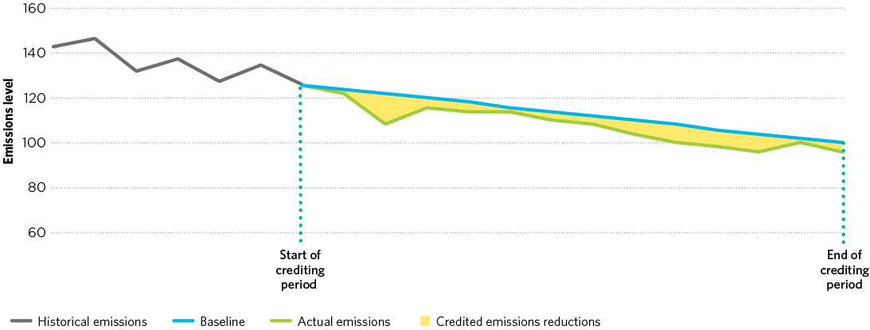

**Source:** Climate Change Authority.

The ERF, as proposed in the government’s Green Paper, places a strong emphasis on the crediting side of the scheme. The ERF Green Paper proposes a potential penalty in the form of the ‘safeguarding’ mechanism; the penalty baseline may be different to the crediting baseline.

While there are many different configurations of baseline and credit schemes, they all share some common design elements that are relevant to the design of the ERF. This study will focus on three key baseline and credit design features:

* coverage and uptake—what entities or sectors are included in the scheme and likely to participate
* additionality—how to distinguish activities that are eligible to receive credits from ones that would have happened anyway
* baseline setting—how to appropriately measure the amount of emissions reductions generated.

This study draws on a range of experiences with baseline and credit schemes from Australia and around the world to provide insights for the design of the ERF. The schemes considered include:

* Australia—Carbon Farming Initiative (CFI)
* NSW—Greenhouse Gas Reduction Scheme (GGAS)
* NSW—Energy Savings Scheme (ESS)
* Clean Development Mechanism (CDM)
* China—Certified Emission Reduction Scheme (CCER)
* India—Perform Achieve Trade scheme (PAT)
* Alberta—Specified Greenhouse Emission Reductions
* California—Air Resource Board Compliance Offsets.

Detailed summaries of each of these schemes are in Appendix A.

Baseline and credit schemes have the potential to drive a wide range of different emissions reduction activities. Box 2.1 categorises these into different types of activities to facilitate comparison. These activity types are common across schemes and provide a good reference for the sorts of emissions reduction activities that could be achieved under the ERF. They typically would not occur without the incentive of the crediting scheme, and therefore would require an ongoing incentive over time.

## Box 2.1: Emissions reduction activities

#### Emissions avoidance

These are activities where the release of emissions into the atmosphere is avoided. For example, the treatment of waste streams before entering landfill to avoid the methane emissions that would occur if the waste was deposited into landfill. Other emissions avoidance activities include reduced fertiliser use, wastewater emissions avoidance, biomass projects, reduced leakage from gas distribution systems and avoided deforestation. These types of activities have been credited in the CFI, Clean Development Mechanism (CDM), Alberta and California.

#### Emissions destruction

These activities destroy emissions and often include the capture and burning of gases. For example, the capture and burning of methane from landfills, which prevents methane being released into the atmosphere. Other activities include the capture and burning of methane from piggeries and coal mines, and the destruction of ozone-depleting gases. These sorts of activities have been credited in the CFI, GGAS, ESS, CDM, Alberta, and California.

#### Removal by sinks

These are activities that remove and store CO2 from the atmosphere—for example, establishing new forestry plantations. These types of methodologies have been credited in the CFI, CDM, Alberta, California and GGAS.

#### Emissions displacement

Activities where the consumption of a more emissions-intensive output is displaced with a less emissions-intensive output. These types of activities include, for example, the displacement of fossil fuel-generated electricity with renewable energy or a less emissions-intensive fossil fuel. They also include fuel- or feedstock-switching where an emissions-intensive fossil fuel or feedstock is replaced by a less emissions-intensive alternative. Some avoidance projects might also displace more emissions intensive output—for example, if a landfill captures methane and burns it to generate electricity. The energy from this process displaces fossil fuel-generated electricity. Displacement activities have been credited in GGAS, the CDM and Alberta. The RET is based on the displacement premise—that additional renewable energy displaces more emissions-intensive generation from coal and gas.

#### Energy efficiency

These are activities that enhance energy efficiency. They are typically demand-side measures and relate to the consumption of energy or other inputs. By reducing the energy used, the activity also reduces emissions resulting from the generation of energy.

The New South Wales ESS includes methodologies for a range of energy efficiency activities, including improving efficiency of commercial buildings (through re-design, and improved use of air conditioning and lighting), replacing commercial lighting and halogen lights, and upgrading and replacing domestic whitegoods. Methodologies for these types of activities have also been used in the CDM and Alberta.