# 1 Introduction

## 1.1 About this study

The Climate Change Authority is an independent statutory agency, established to provide expert advice on Australian climate change policy, including through a scheduled series of reviews of climate programs and legislation. The Authority’s work is guided by the principles listed in the Climate Change Authority Act 2011 (Cth) including equity, environmental effectiveness and economic efficiency.

The Carbon Farming Initiative (CFI) was originally designed as a domestic offsets scheme focused on the land sector, to complement Australia’s carbon pricing mechanism. It commenced operation in December 2011.

The government plans to replace the carbon pricing mechanism with the Direct Action Plan to reduce Australia’s emissions, including an Emissions Reduction Fund (ERF). It has indicated the CFI will play a central role in the design of the ERF. The government plans to streamline the CFI and expand coverage beyond the land sector under the ERF (Green Paper 2013).

This study provides insights on key design issues facing the ERF. The CFI and the proposed ERF are types of ‘baseline and credit schemes’ that reward emissions reductions relative to a pre-defined baseline. There is extensive domestic and international experience with baseline and credit schemes. This paper draws on that experience, with a preliminary analysis of the CFI and a desktop review of other domestic and international schemes (see Appendix A). It investigates:

* the types of activities well suited to baseline and credit schemes, and lessons from the performance of such schemes to date (Section 3: Coverage and uptake)
* how baseline and credit schemes ensure they credit only genuine and additional emissions reductions, and the trade-offs involved (Section 4: Additionality)
* key considerations for setting baselines (Section 5: Baseline setting).

How these three areas—coverage, additionality and baseline setting—are approached is central to the design of any baseline and credit scheme. It is intended that this research paper, by assessing different approaches and experiences and drawing insights from domestic and international schemes, will contribute to development of the ERF.

## 1.2 About the Carbon Farming Initiative

The CFI is a national, voluntary project-based scheme that provides incentives for individuals and organisations to sequester carbon and avoid or reduce greenhouse gas emissions.

The CFI was originally established to complement Australia’s carbon pricing mechanism and help Australia meet its emissions reduction target. The CFI covers emissions from a number of sectors not covered under the carbon pricing mechanism—namely agriculture; legacy waste (emissions from waste deposited prior to 1 July 2012, when the carbon pricing mechanism was introduced); and land use, land use change and forestry (LULUCF).

A number of steps are necessary in a baseline and credit scheme such as the CFI. To ensure their environmental integrity, emissions reductions need to be accurately measured at an activity level and the regulator needs to be satisfied that reductions are real. The CFI involves multiple processes and institutions. Figures 1.1 and 1.2 provide an overview of the CFI process, highlighting the main institutions and governance structures important to the scheme. The main elements of the CFI, discussed in more detail below, are:

* the overarching legislation and accompanying regulations, which specify the sectoral coverage and governing principles for the scheme
* the positive list, the primary form of additionality test, which specifies eligible activities under the CFI
* methodologies, which set out rules for undertaking and monitoring a project and generating credits
* projects (that is, activities that reduce emissions) that are proposed and operated by individuals and organisations
* crediting, where emissions reductions or sequestration from approved projects are verified and credits issued by an independent administrator, the Clean Energy Regulator.

## Figure 1.1: Overview of CFI Process

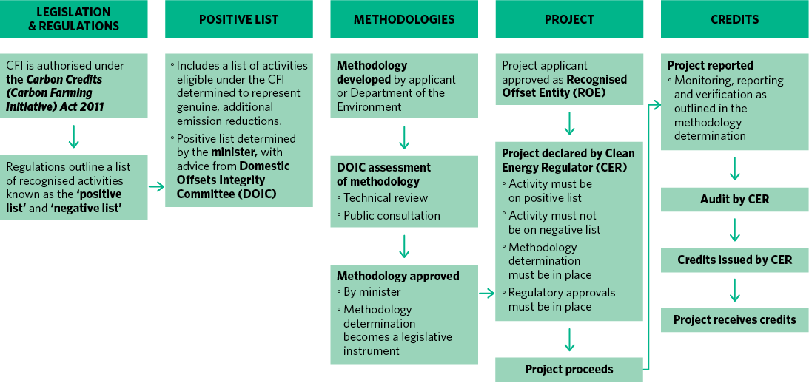

**Notes:** CER: Clean Energy Regulator; DOIC: Domestic Offsets Integrity Committee.

**Source:** Climate Change Authority based on CFI Handbook 2012.

## Figure 1.2: Overview of CFI governance structure

Figure 1.2 outlines the key governance structures important to the Carbon Farming Initiative:
• the Federal Parliament controls the overarching legislation
• the Minister approves methodologies, the positive list and other regulations
• the Department of the Environment advises the Minister on CFI matters, develops methodologies and provides support to methodology developers
• the Domestic Offsets Integrity Committee assesses methodologies and makes recommendations to the Minister
• the Clean Energy Regulator implements, regulates and enforces compliance of the CFI.


**Source:** Climate Change Authority based on CFI Handbook 2012.

#### Legislation and regulations

The CFI is authorised under the Carbon Credits (Carbon Farming Initiative) Act 2011 (Cth). It is underpinned by a number of key concepts common to many baseline and credit schemes. These are outlined in the ‘integrity standards’ that form part of the CFI legislation. They are based on internationally accepted principles to ensure that CFI credits are only issued for genuine emissions reductions and ensure that:

* emissions reductions are measurable and verifiable
* measurement methods are supported by peer-reviewed science and consistent with Australia’s international greenhouse gas emissions accounts
* measurement methods account for leakage and variability, and use conservative assumptions
* emissions reductions are additional to what would occur in the absence of the project
* carbon sequestration is permanent (carbon stocks maintained on average for a 100-year period).

The CFI also has a negative list, which identifies types of projects that are likely to cause negative social or environmental consequences, including impacts on water availability, biodiversity conservation, employment and other values. The negative list is contained in the Carbon Credits (Carbon Farming Initiative) Regulations 2011 (Cth).

#### Positive list

Activities that are eligible under the CFI are listed on a ‘positive list’—these are not common practice in an industry, and are therefore considered to represent genuine additional emissions reductions.

The positive list is established in the Carbon Credits (Carbon Farming Initiative) Regulations by the Minister for the Environment, on advice from the independent Domestic Offsets Integrity Committee (DOIC). The positive list is discussed further in Section 4.1.

#### Methodologies

Methodologies establish detailed rules for how projects must be carried out, including setting project boundaries and baselines, and how emissions reductions must be measured and verified.

CFI methodologies have been developed for:

* sequestration projects (for example, planting of trees)
* agriculture emissions avoidance projects (for example, managed savanna burning, methane capture in piggeries)
* landfill legacy emissions capture and avoidance projects (for example, the capture and destruction of emissions from waste deposited prior to the introduction of the carbon pricing mechanism).

Methodologies can either be developed by the Department of the Environment or proposed by an individual, company or project proponent. They are then submitted to the DOIC for review, which includes a period of public consultation, and ultimately to the Minister for the Environment for approval.

#### Projects

The CFI is a project-based mechanism, meaning that emissions reductions activities occur and are credited at the project level. Each project must operate in accordance with a methodology determination.

Anyone wishing to undertake a CFI project must first apply to the Clean Energy Regulator to become a ‘registered offsets entity’, which ensures the applicant is a fit and proper person. The next step is to have the project declared, which involves meeting a range of eligibility criteria, including that it:

* is covered by a methodology
* passes the ‘additionality test’ (discussed further in Section 4.1)
* meets the environmental integrity requirements.

#### Crediting

Credits are only awarded for emissions reductions by approved projects conducted and calculated in accordance with the methodology. Once the Clean Energy Regulator is satisfied that the claimed amount of emissions reductions has occurred, it awards the project Australian Carbon Credit Units (ACCUs). Each ACCU is equivalent to one tonne of carbon dioxide equivalent (CO2-­e). All ACCUs can be traded or sold in Australia, and some can be exchanged for an equivalent number of Kyoto units and be sold or traded internationally. ACCUs do not have an expiry date, and can be ‘banked’ or sold for future use. The Clean Energy Regulator is responsible for approving all projects, issuing credits and managing the ACCU registry.

## 1.3 About the Emissions Reduction Fund

The ERF is the government’s centrepiece policy to reduce Australia’s emissions and is planned to commence operation on 1 July 2014. The ERF will provide a price incentive to reduce emissions. Unlike a cap and trade scheme, the government will purchase emissions reductions from individuals or businesses. In December 2013, the government released the Emissions Reduction Fund Green Paper to consult on its design.

The primary objective of the ERF is to achieve lowest cost emissions reductions across the economy. The government has indicated that the CFI will play a central role in the design of the ERF, with CFI coverage expanded to other eligible activities across the economy. In a departure from the operation of the CFI to date, it may include both project- and facility-level activities. Emissions reductions would be purchased through a ‘reverse auction’ where bids would be ranked and accepted on a least-cost basis.

The ERF Green Paper also outlines a mechanism for ‘safeguarding’ emissions reductions, which would impose compliance obligations on facilities that exceed their historical emissions baseline. This is not a feature of the existing CFI. The government has indicated that safeguard arrangements would be introduced in mid-2015, to allow sufficient time for industry consultation.

## Figure 1.3: Australia’s emissions by sector 1990–2012

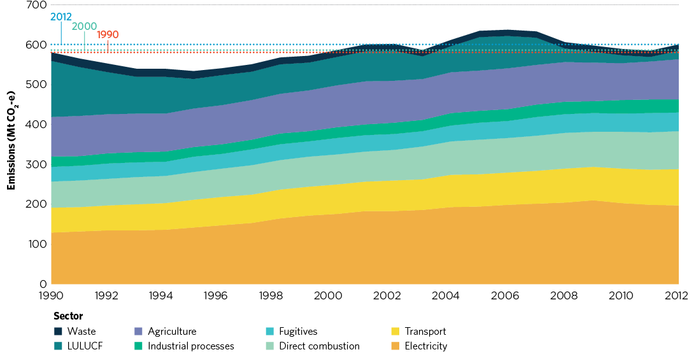

**Source:** Climate Change Authority 2014.

## 1.4 Australia’s emissions reduction task and opportunities

Before discussing the design of the ERF, it is important to have an understanding of Australia’s emissions trends, emissions goals and the emissions reduction opportunities. The ERF and any complementary policies will need to be designed to capture those opportunities in an effective and efficient manner.

In 2012, Australia’s total greenhouse gas emissions were about 600 Mt CO2-e. The majority (72 per cent) are energy-related (Treasury and DIICCSRTE 2013). That is, they are produced in the production and combustion of fossil fuels for transport and stationary energy. The remainder of Australia’s emissions result from agriculture, fossil fuel extraction and distribution, waste, LULUCF and industrial processes.

Australia’s total greenhouse gas emissions in 2012 were 3.5 per cent higher than in 1990 and 2.5 per cent higher than in 2000 (Figure 1.3). Emissions in most sectors have grown steadily, resulting in a 32 per cent increase in emissions excluding LULUCF in the period 1990–2012. In contrast, LULUCF emissions fell by 85 per cent in the same period, primarily due to more stringent land-clearing regulations and weaker economic conditions for farmers. These steep reductions offset the increase in emissions from the rest of the economy.

In the absence of either the Direct Action Plan or a carbon price, Australian emissions are projected to grow to 17 per cent above 2000 levels by 2020, well above the minimum reduction target of 5 per cent below 2000 levels by 2020 (Figure 1.4). To achieve this minimum target, emission reductions of 593 Mt CO2-e are required over the period to 2020 (Climate Change Authority 2014).

The Authority recently completed a major assessment of Australia’s emissions reduction opportunities (Climate Change Authority 2014). This highlighted significant opportunities across the Australian economy. These opportunities vary considerably, depending on each sector’s proportion of Australia’s total emissions and its responsiveness to incentives.

An incentive, such as that provided through the ERF, could moderate growth in Australia’s emissions—and the stronger the incentive, the greater the emissions reductions.

The Authority’s assessment highlights the following emissions reduction opportunities.

* Electricity offers the largest opportunity for emissions reductions by lowering the emissions intensity of generation, including through the continued deployment of wind and solar technologies, increased energy efficiency improvements, and retrofitting of existing fossil fuel-fired plant and equipment.
* Sectors that are primarily driven by export demand—direct combustion, fugitives and agriculture—present the greatest challenge. Emissions growth is projected for these even with an incentive.
  + Direct combustion emissions could be reduced through improvements in emissions intensity—such as increased gas turbine and machinery efficiency—and a switch to alternative lower emissions energy sources, such as biofuels.
  + Fugitive emissions could be reduced through a shift away from higher emission mines, an expansion of lower emissions mines, and the deployment of additional pre- and post-mine drainage, where gas could be flared or used to generate electricity.
  + Agriculture emissions reduction opportunities are limited to manure management, animal feed supplementation, feedlot finishing and pasture improvements. Most technologies and practices for reducing livestock emissions are still in development and not ready for commercial use.
* Transport emissions can be reduced in three ways:
  + increasing vehicle efficiency
  + reducing the emissions intensity of fuels
  + improving demand management through mode shift from road freight to rail or shipping, and from private vehicles to public transport and physical activity (cycling and walking).
* Industrial process emissions are projected to be highly responsive to an incentive. Emissions could be significantly reduced through the use of nitrous oxide conversion catalysts for nitric acid production and the destruction and replacement of synthetic greenhouse gases.
* Greater reforestation and afforestation activities, avoided deforestation and improved land management could deliver emissions reductions from the land sector.
* Waste emissions reductions are still available through the expansion of alternative waste treatment facilities to reduce waste volumes being sent to landfill.

In recent years, there have been a number of other assessments of the likely emissions reductions opportunities in the Australian economy, including analysis by ClimateWorks Australia in 2010 (partially updated in 2013). While the ClimateWorks studies use a different approach to the Targets and Progress Review, they reach similar conclusions on the magnitude of the emissions reduction task and the sectors likely to offer the greatest opportunities. ClimateWorks has highlighted that non-financial barriers exist in some sectors; for example, in the industrial sector where many profitable opportunities to improve energy efficiency have not been taken up. This suggests that a combination of incentives and complementary policies and practices will be required to harness Australia’s emissions reduction opportunities.

## Figure 1.4: Australia’s projected emissions reduction taskFigure 1.4 shows the projected emissions reductions with existing measures excluding a carbon price and any new measures. It also shows the emissions reduction task for a 5 per cent target by 2020. To achieve a 5 per cent reduction in emissions by 2020 Australia will have to reduce its emissions by 593 million tonnes of carbon dioxide equivalent between 2012 and 2020

**Source:** Climate Change Authority 2014.