Chapter 1 Introduction
This chapter introduces the review and provides an overview of the Carbon Farming Initiative (CFI) and Emissions Reduction Fund (ERF). It also outlines the criteria the Climate Change Authority (the Authority) has used to assess the performance of the scheme and introduces the concept of additionality, which plays a central role in the operations of the CFI and ERF.

1.1. About this review
The Authority is an independent statutory agency, established to provide expert advice on Australian climate change policy. The Authority is required by the Carbon Credits (Carbon Farming Initiative) Act 2011 (Cth) to review the CFI every three years; this is its first review.
Uncertainty about the future of the Authority, together with staffing and other constraints, has led to the review being conducted over a short timeframe. Reflecting this, the review is not comprehensive but concentrates on what the Authority considers to be the some of the more significant issues.
The review considers:
- performance of the CFI to date
- prospects for improving on that performance in the newly introduced ERF
- interactions between the CFI/ERF and other policies
- the role of the scheme in meeting Australia’s greenhouse gas emissions targets.
The Authority recognises that the CFI is a relatively new scheme (with three years of operation) that has recently morphed into the ERF. This is a relatively short period on which to assess the performance of the scheme.
During the course of the review, the Authority has engaged with a range of stakeholders across various sectors. An issues paper was released on 17 October 2014; this generated 17 submissions. The Authority met directly with 20 individual stakeholders and held a roundtable meeting on 25 November 2014, at which some preliminary conclusions were tested. Some stakeholders raised issues that the Authority has not been able to examine in this review; some of these are noted in this report. Further details on consultations are included in Appendix A.
Given the competitive nature of the CFI market, some of the Authority’s discussions with stakeholders were conducted on a confidential basis; where relevant this confidentiality has been respected in this report.
The Authority has had regard to the legislation passed recently to amend the CFI Act to form the ERF, as well as to the extensive consultations (including public submissions on the ERF green paper) leading up to the legislative change. The Authority has also drawn on its own previous consultations and research reports; in particular, the April 2014 study Coverage, Additionality and Baselines—Lessons from the Carbon Farming Initiative and Other Schemes.

1.2. Overview of the Carbon Farming Initiative and Emissions Reduction Fund
The CFI was originally designed as a ‘carbon offset’ scheme to complement the carbon pricing mechanism. The carbon pricing mechanism has since been repealed, and the CFI has been transformed into the ERF, which is now the central element of the government’s Direct Action Plan to reduce Australia’s greenhouse gas emissions.
The ERF has been introduced through amendments to the CFI Act, so the CFI could be said to continue. In the interests of simplicity, however, in this report references to the CFI are to the scheme as originally configured, while the ERF refers to the scheme as approved by the parliament in November 2014. This approach is consistent with the white paper on the ERF, which states that the ‘Carbon Farming Initiative will be folded into the Emissions Reduction Fund so there is one programme’ (Commonwealth of Australia 2014, p. 58).

1.2.1. The Carbon Farming Initiative as originally configured
The CFI, which commenced operation in December 2011, was a voluntary project-based initiative that provided incentives for individuals and organisations to sequester carbon and avoid or reduce greenhouse gas emissions. The CFI focused on sectors that were not covered by the carbon pricing mechanism, namely: agriculture; legacy waste (that is, emissions from waste deposited before the introduction of the carbon pricing mechanism); and land use, land use change and forestry (Figure 1). Firms in the sectors covered by the carbon pricing mechanism (such as electricity generation and industrial processes) could buy credits from CFI projects and use these to ‘offset’ their carbon price liability. In this way, the CFI extended the reach of the carbon price to a wider set of activities across the Australian economy.

Figure 1: The Carbon Farming Initiative in the broader policy context
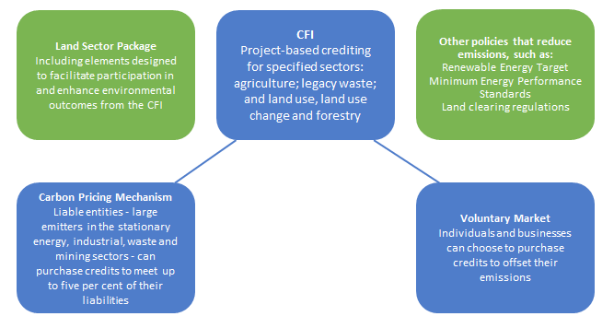
Note: Green boxes are policy elements that are not part of the CFI and are not involved in the purchase of credits.
Source: Climate Change Authority
The CFI created incentives by crediting projects for achieving emissions reductions below a defined baseline (essentially ‘business-as-usual’ levels). To be accepted into the CFI, projects were required to meet a range of criteria, including that they could be conducted under an approved method or ‘methodology’. Project proponents were issued with credits, known as Australian carbon credit units (ACCUs), for verified emissions reductions, and these could be sold to entities with liabilities under the carbon pricing mechanism. This opportunity exists until 2 February 2015, which is the deadline for the final surrender period of the carbon pricing mechanism (CER 2014). The CFI process is summarised in Figure 2 and discussed further in Chapter 2.

Figure 2: Overview of the CFI process
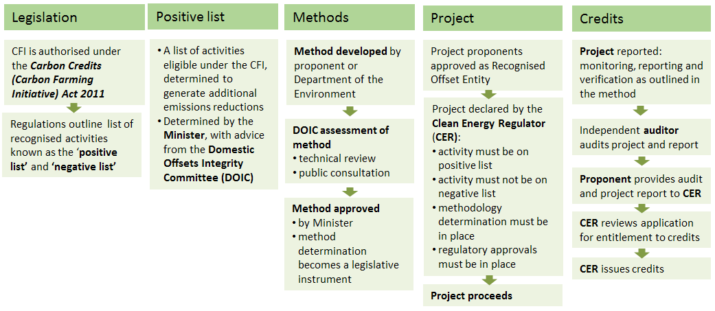
Source: Climate Change Authority based on DCCEE (2012)
The Land Sector Package was announced at the same time as the CFI, in July 2011. It was designed to improve the resilience of Australia’s flora and fauna to the impacts of climate change and enhance the environmental outcomes of carbon farming projects. Some parts of the package facilitated participation in the CFI; for example, $20 million was allocated under Carbon Farming Futures to convert research into practical CFI methods (Commonwealth of Australia 2011, p. 95). A $22 million Indigenous Carbon Farming Fund was also established to assist Indigenous communities benefit from the CFI (Commonwealth of Australia 2011, p. 97).

1.2.2. The scheme in its new form as the Emissions Reduction Fund
Amendments made recently to the CFI Act established the ERF. The amendments retain some of the main features of the original scheme, while substantially altering or expanding others (Figure 3). The amendmentsalso require the development of a ‘safeguard mechanism’, to commence on 1 July 2016. In developing the ERF the government has sought to build upon lessons learnt under the CFI.

Figure 3: The Emissions Reduction Fund in the broader policy context
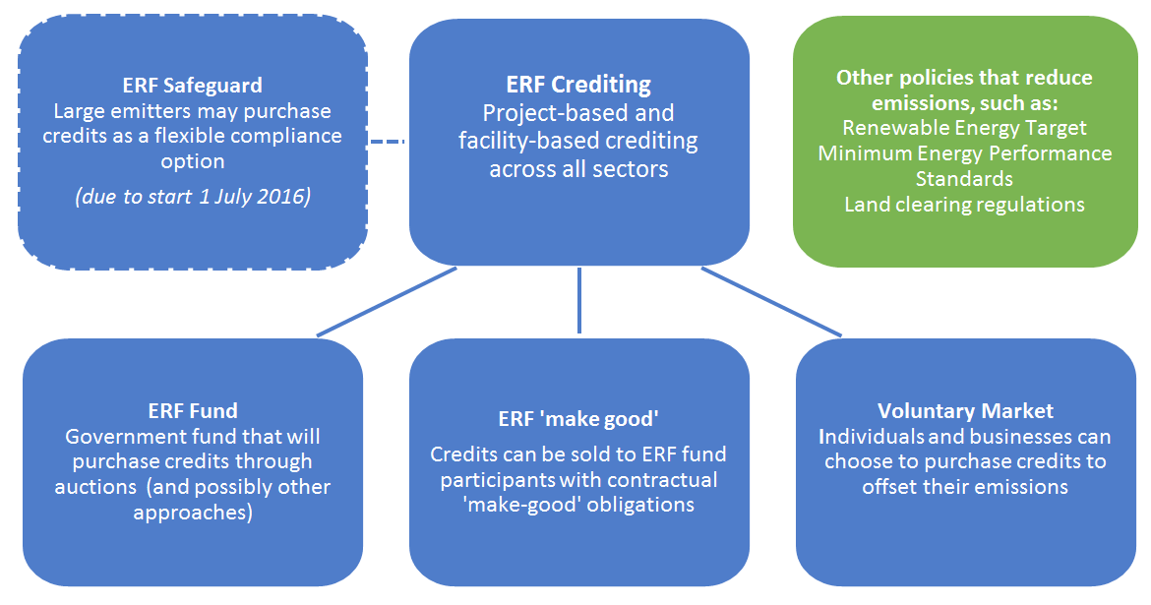
Note: Green box shows policy elements that are not part of the ERF and are not involved in the purchase of credits.
Source: Climate Change Authority
The main changes under the ERF are:
- Coverage has been expanded to allow all sectors of the economy to participate (whereas the CFI covered sectors that account for about 20 per cent of Australia’s emissions).
- The government will be the main purchaser of credits (whereas under the CFI credits were sold mainly to liable entities under the carbon pricing mechanism).
- The processes for developing methods, approving projects and crediting emissions reductions have been ‘streamlined’.
- A safeguard (penalty) mechanism will operate from 1 July 2016.
The government has committed $2.55 billion for purchasing credits, with further funding to be considered in future budgets (Commonwealth of Australia 2014). Credits will be purchased through auctions (and potentially also through other means) and the government will enter into contracts with successful bidders. The standard contract period will be seven years, with longer contracts possible in some circumstances. A new set of draft rules proposes that longer contracts not exceed 10 years’ duration (DOE 2014a). Some private sales may occur through the voluntary market, make-good provisions (under which ERF project proponents buy credits to make up for shortfalls in contracted quantities) and, possibly in the future, to entities with liabilities under the safeguard mechanism. The ERF process is summarised in Figure 4.
The purpose of the safeguard mechanism is to ensure that emissions reductions paid for through the ERF are not offset by increases in emissions elsewhere in the economy (Commonwealth of Australia 2014, p. 51).
While the mechanism is under development, the government has indicated it will:
- apply to facilities with direct emissions over 100,000 tonnes per year (covering about 52 per cent of Australia’s emissions)
- use baselines that reflect the highest level of reported emissions for a facility over the period 2009–10 to 2013-14 (DOE 2014b).
Existing CFI projects will automatically be registered under the ERF and projects will receive a new crediting period starting from the commencement of the scheme. Registered projects will have the option to continue to use the version of the method in force when the project was approved, or proponents may apply to use another applicable method. CFI project proponents will be able to participate in an auction run by the Clean Energy Regulator (CER) (DOE 2014c).

Figure 4: Overview of the ERF process
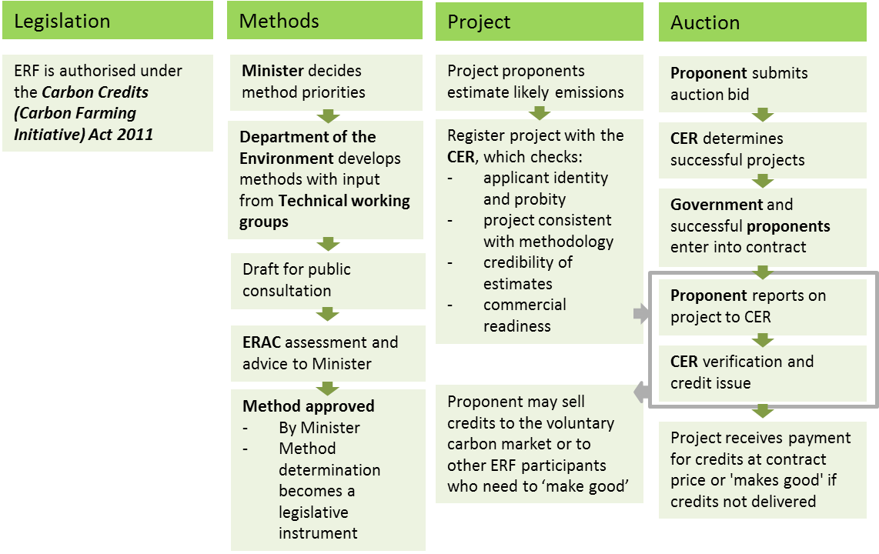
Source: Climate Change Authority based on Commonwealth of Australia (2014)
Governance arrangements for the ERF are different in some respects from those that applied to the CFI (Figure 5). The government has stated that it will review operational elements of the ERF towards the end of 2015 (Commonwealth of Australia 2014).

Figure 5: Overview of governance arrangements
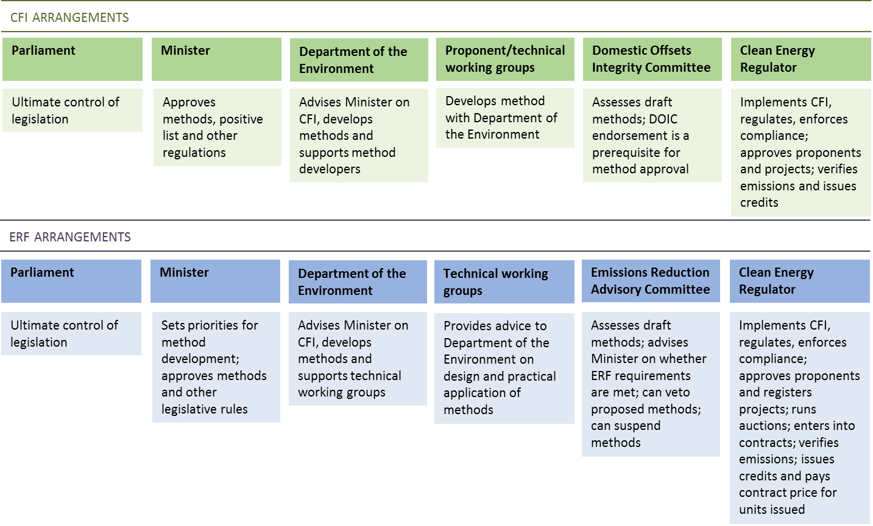
Source: Climate Change Authority

1.3. Criteria for assessing performance
The Authority’s work is guided by the principles set out in the Climate Change Authority Act 2011 (Cth). These include that measures to respond to climate change should:
- be economically efficient, environmentally effective, equitable and in the public interest
- support the development of an effective global response to climate change, and be consistent with Australia’s foreign policy and trade objectives
- take account of the impact on households, businesses, workers and communities.
The Authority has assessed the CFI (in its old and new forms) against both these guiding principles, and the objects of the CFI Act, which are to:
- implement some of Australia’s obligations under the United Nations Framework Convention on Climate Change (UNFCCC) and the Kyoto Protocol to that convention
- create incentives for people to carry on offset projects
- reduce greenhouse gas emissions in a way that protects Australia’s natural environment and improves resilience to the effects of climate change.
The Authority’s view is that the most important criteria for this review are environmental effectiveness (i.e. generating additional reductions in emissions) and economic efficiency (i.e. and doing so in cost-effective ways relative to alternative approaches). Other criteria have been referred to where relevant.
The scheme’s environmental effectiveness is a function of the quantity of real (that is, accurately measured, and ‘permanent’) emissions reductions it brings about. This means that effectiveness can be measured in tonnes of carbon dioxide equivalent greenhouse gases (CO₂-e). To help interpret the significance of the emissions reductions achieved, this review compares the scheme’s impact with relevant benchmarks, such as the emissions reductions achieved by other policies. Interim indicators, such as the number of methods developed and approved, and number of projects established are also useful, particularly for what is a relatively new scheme.
The emissions reductions achieved by the scheme depend on the level of participation and the environmental integrity of the scheme. Environmental integrity would be eroded if the scheme were to issue credits for emissions reductions that:
- were measured or estimated, but did not in fact occur, or occurred to a lesser extent (measurement risk)
- occurred, but would have happened even without the scheme (additionality risk)
- relate to sequestration that did not persist for the required period (permanence risk)
- triggered an increase in emissions outside the project (leakage risk).
The environmental effectiveness of the scheme determines its contribution to meeting Australia’s emissions reduction targets, and therefore its international commitments. This contribution is of direct relevance to the performance of the CFI and ERF, given the CFI Act object relating to Australia’s obligations under the UNFCCC. It is particularly important now, given that the ERF is the centrepiece of the government’s plan to reduce Australia’s emissions.
Estimating the costs of dangerous climate change is a notoriously difficult task, but it is one that is unnecessary in a review such as this. Australia has set emissions reduction targets, and implicit in this is an acceptance that the benefits of achieving those targets will outweigh the costs involved. This means that assessing the economic efficiency of the CFI and ERF schemes predominately relates to the cost to the community per tonne of emissions reductions brought about through the schemes.
In making this assessment a broad concept of cost should be adopted, factoring in:
- direct project costs—for example, costs associated with planting trees, maintaining them and forgoing the income that could have come from using the land for agricultural production
- transaction costs borne by project proponents—including the time and expense in contributing to method development, developing projects, and reporting and verifying emissions reductions
- transaction costs borne by the government—including for developing policy and methods, and administering the scheme.
Where any of these costs is higher than necessary there is at least some degree of inefficiency. Therefore, in this review assessments are made on the extent to which there are opportunities to reduce costs without reducing environmental integrity.

1.4. The importance of additionality
The CFI and ERF are specific examples of a broad type of policy called ‘baseline and credit schemes’. These schemes take many different forms, but they all share some basic features, including setting a baseline, and issuing credits when the outcome is better than the baseline. Australia has implemented a range of baseline and credit schemes at the state and national level, including the Renewable Energy Target (RET), the New South Wales Greenhouse Gas Reduction Scheme (GGAS) and the New South Wales Energy Savings Scheme (ESS).
A key challenge in baseline and credit schemes is to set the baseline at a level that ensures credits are only issued for ‘additional’ emissions reductions—that is, reductions that would not have occurred but for the scheme. If the emissions reductions would have occurred anyway (that is, under business-as-usual), they do not contribute to the environmental effectiveness of the scheme. Moreover, where this occurs, all transaction costs associated with participation in the scheme are a waste of the community’s resources. Additionality is therefore central to the environmental effectiveness of baseline and credit schemes (CCA 2014; PC 2008; World Bank 2010).
It is possible for all or only some of the credits issued to a project to be non-additional. The former occurs where the project being credited would have taken place without the scheme. The latter occurs where the project would not have proceeded, but the baseline set is above business-as-usual. An example of the latter is where a firm upgrades to more energy efficient equipment and the baseline is set based on the emissions associated with the old equipment, when business-as-usual behaviour would have seen it upgraded in two or three years’ time.
Experience in Australia and elsewhere indicates that non-additional credits can substantially reduce a scheme’s effectiveness:
- One study estimated that 70 per cent or more of credits under the New South Wales GGAS scheme were likely to relate to non-additional emissions reductions over the life of the scheme (MacGill et al. 2005).
- A recent review of the Victorian Energy Efficiency Target scheme estimated that only 8 million tonnes of emissions reductions could be attributed to the 16.7 million certificates created. Both non-additional credits and measurement problems contributed to this discrepancy (DSDBI 2014).
Additionality tends to be harder to assess for projects that offer low-cost emissions reductions. If a firm is proposing to undertake an activity that is rarely undertaken in its sector, and is (without scheme support) clearly commercially inferior to alternatives, additionality can be self-evident. In contrast, if a firm proposes an activity that is only slightly commercially inferior to an alternative with higher emissions, it can be all but impossible to independently verify that the activity is additional.
There is no easy answer to how to deal with additionality issues under a baseline and credit scheme. A wide range of approaches has been developed and used, including considering regulatory requirements, common practices in the industry and the individual project’s finances. Stringent additionality tests can be costly and can exclude some projects that were actually additional, while a more relaxed approach can impair the integrity (and therefore effectiveness) of the scheme. The best approach is to try to strike a reasonable balance between the costs involved in assessing additionality and those resulting from incorrect assessments.

