## Actions and enablers of a prosperous, resilient net zero Australia

**April, 2022**

**A strategic framework to guide Australia’s response to climate change**

A clear consensus is emerging, based on advice from the Intergovernmental Panel on Climate Change, that globally we need to reach net zero emissions as soon as possible if we are to limit warming to 1.5 degrees.

Australia and our top ten trading partners all have a net zero target and over 130 other countries have pledged the same. The Australian Government and all states and territories have made it clear that they want to achieve net zero emissions by 2050.

The scale and pace of decarbonisation both globally and in Australia is accelerating rapidly.

By acting now, Australia can manage the physical and economic risks of climate change. We can play our part in strong global action to reduce emissions, we can position our economy for changes in global trade and investment markets, and we can do more to ensure we are prepared for the unavoidable impacts of climate change.

We can do a lot with the technologies already commercially available and competitive today.

Australia’s abundance of land, sea, sun, and wind mean that we have potential to generate some of the cheapest clean energy in the world and to sequester large volumes of carbon dioxide. Some existing and new industries could thrive, and the same technologies will make carbon removal from the atmosphere possible and affordable in the future.

Australia’s annual emissions have fallen from a peak in 2007, mainly in the land sector and more recently electricity generation. Emissions from electricity are projected to fall further (Figure 1). To be more competitive as the world decarbonises, we need to lower emissions in all sectors of the economy as quickly as we can.

The challenge of getting to net zero becomes apparent when we exclude the electricity sector: we see that emissions for the remaining sectors rise from 2021 to 2025 and then stagnate from 2025 to 2030. Longer-term declines in waste, industrial processes and transport (which features a short term rise after the impact of the pandemic) are offset by rises in agriculture, fugitives and the land sector (Figure 1). It makes good sense to bend the curve for every sector more steeply and sooner than 2030.

Getting to net zero after 2030 is a daunting prospect. It won’t be a straight line, but the longer we wait, the steeper and more challenging the economic adjustment will be. Waiting for silver bullets would be a mistake. We should look for the lowest cost and long lead time actions, take all viable abatement opportunities now, move along the cost curve from there, and continue to develop new solutions as soon as we can.

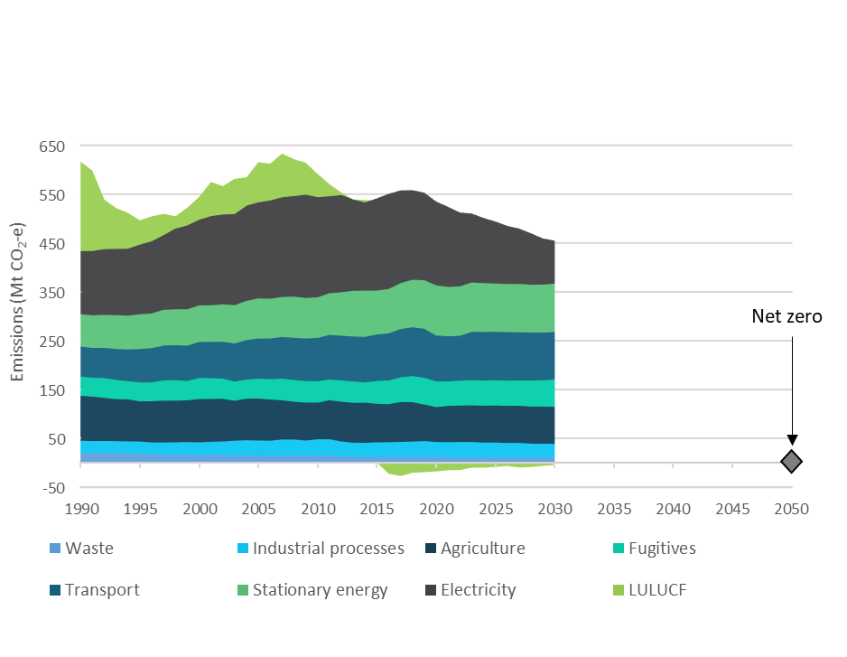

**Figure 1**. Australia’s emissions trajectory

Source: Past and projected emissions data: *DISER 2021*

Climate change presents diabolical risks in terms of physical impacts like heatwaves and floods, and economic impacts such as shifting demand for emissions intensive goods.

In simple terms, responding to these climate change risks comes down to two things:

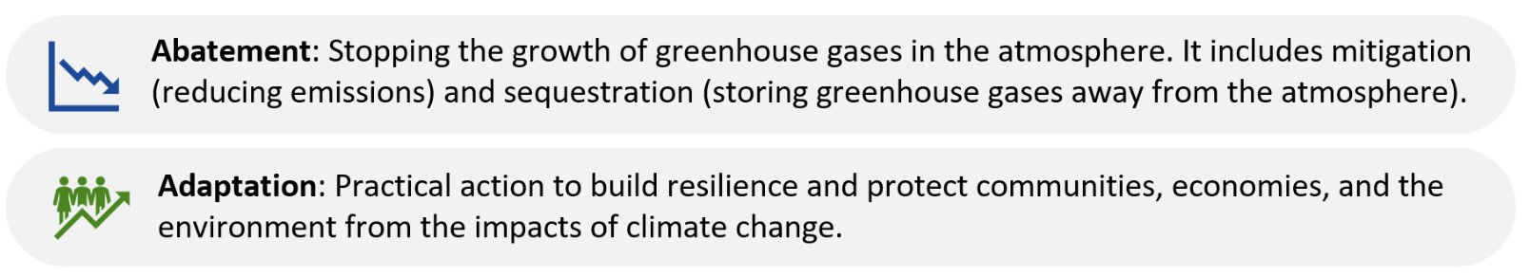

Six actions can drive the bulk of the abatement and adaptation changes we need to see, and they are deployable today.

Governments have a critical role in six enablers of those actions, so that individuals, communities, and businesses can make abatement and adaptation a part of standard practice.

The six actions and six enablers are set out in Figure 2.

Net zero is a collective challenge, not a challenge for governments alone. Societal choices matter. Governments can enable market forces. Indeed, only markets can mobilise and allocate the massive amounts of capital to make the investments required for transition to a resilient, net zero economy.

For example, governments around the world are acting to mobilise private capital, which is essential for the massive levels of investment required to drive the decarbonisation. Businesses, investors, and individuals play their part with their investment decisions and spending choices.

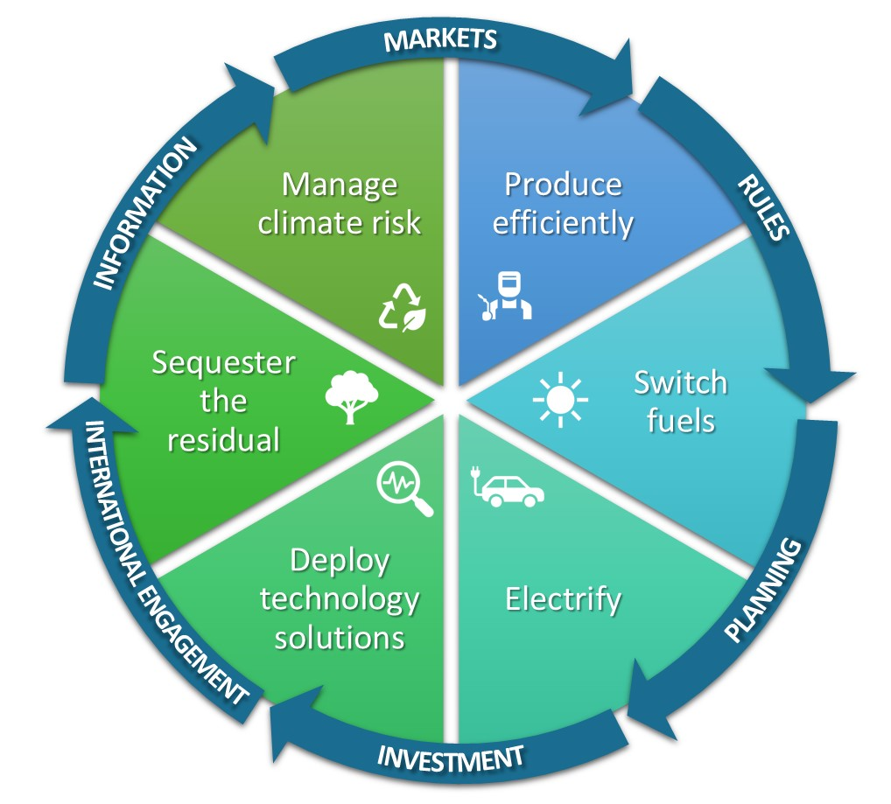

**Wedges = Actions**

**Arrows = Enablers**

**Figure 2.** Six actions and six enablers of a prosperous, resilient net zero Australia

**Six actions**

**Produce efficiently –** Reduce the emissions intensity of production and reduce inefficient use of resources such as energy and land.

**Switch fuels –** Shift from high emitting fuels to lower and ultimately zero-emissions alternatives.

**Electrify –** Generate enough affordable, clean energy to meet growing demand and electrify as much as possible.

**Deploy technology solutions –** Do as much as we can with the mitigation and sequestration technologies we already have, accelerate their deployment, improvement and the development of new technologies.

**Sequester the residual –** Mitigate as much as possible and sequester the rest (i.e. capturing and storing, through biosequestration and geosequestration).

**Manage risks –** Build resilience and plan for and manage the risks that climate change present to Australian industries, businesses, communities, the environment, and our region.

**Six enablers of action**

**Information –** Not everyone has the knowledge or resources they need to play their part. For example, households might have mistaken ideas about which actions have the greatest impact, and struggle to find and understand the information required to make well-informed decisions. Businesses might not have access to the information they need to make the best decisions about their supply chains and to understand how their emissions intensity compares to that of their competitors – their “carbon competitiveness”. Similarly, adaptation can be difficult for individuals and groups with limited scientific expertise to determine which actions will best achieve their objectives. Governments can help them by providing good, trustworthy information and implementing programs to reduce cognitive burdens and overcome other barriers. Efficient collection of accurate, consistent, and comprehensive information on emissions and decarbonisation will minimise costs on business, while supporting optimal decision-making and Australia’s competitive position in the global economy.

**Markets –** Governments can enable economic forces to drive decarbonisation by ensuring open, competitive, and transparent markets. Many abatement technologies are viable today and ready to be deployed to market, subject to investor and consumer choices. For example, investment in and private sector demand for sequestration has grown recently, with prices for Australian Carbon Credit Units reaching record highs and stimulating more sequestration projects.

**Rules –** Governments can use rules to solve market failures such as imperfect information, under-provision of public goods, externalities, and common pool resource dilemmas. For example, financial regulators could use rules to ensure companies disclose climate-related financial risks, and Commonwealth legislation could be enacted to enable the development of offshore wind farms. Governments are also responsible for compliance with rules through appropriate combinations of formal and informal mechanisms and dealing with conflicts that arise among stakeholders with different perspectives, interests and priorities.

**Planning –** Governments can enable industries, workers, and communities to make decisions about the future by planning and communicating their intent in advance. Urban planning, infrastructure and land use planning can enable timely and efficient mitigation, sequestration, and adaptation. Governments can also enable a smooth transition by planning for institutional adaptation and change.

**Investment –** Governments can use fiscal spending to invest in science and address the under-provision of public goods such as the research, development, and deployment of abatement technologies. Public investment can stimulate innovation and provide high-risk capital for new technologies, shift activities down the cost curve to price parity and catalyse new markets.

**International engagement –** The Government has a pivotal role to play in enabling Australia to pursue its interests in a competitive, net zero world. Internationally consistent, transparent ways of sharing information enable sustainable finance, trade, and carbon markets to play their part. Partnering with countries to support the development and deployment of clean technologies and fuels will create new trade opportunities. It will also help less developed countries lift their disadvantaged communities out of poverty while bypassing the emissions intensive development of industrialised nations.

