**This report**

* The Climate Change Authority is pleased to release its research report: ***Prospering in a low-emissions world: An updated climate policy toolkit for Australia.***
* This report updates the Authority’s *2016 Special Review* on policies for meeting Australia’s emissions reduction commitments under the historic Paris Agreement.
* The climate policy toolkit recommended in this report builds on and further develops Australia’s existing policies to ensure we make our contribution to the global task of reducing emissions in both the short- and long-term, and position Australia to take advantage of the opportunities of a global low-emissions economy.

**What’s covered?**

In this report, the Authority details the **climate change challenge** and makes the case for strong global action if we are to avoid the worst impacts of climate change. We also recognise that while more needs to be done, **global action is accelerating** and the transition to a low-emissions global economy has commenced.

The Authority proposes that **Australia can prosper in a low-emissions world if we plan for the future** and take advantage of the opportunities presented by the global transition, for example by making the most of our abundant clean energy resources.

To achieve this we can:

* **Develop new strategies and frameworks to deal with climate change**
* **Do more to reduce emissions**
* **Empower people to act**

**Our approach**

In updating our advice, the Authority took into account significant developments in the climate science and policy landscape since the Authority's *2016 Special Review*.

* Scientific understanding of the current and future impacts of climate change has improved, as has our understanding of the global task to limit global warming in line with the 2°C temperature goal. Current global commitments are not sufficient to limit emissions to 2°C and the current level of countries' ambition needs to roughly triple.
* The costs of low-emissions technologies, including solar PV, wind, lithium-ion batteries and electric vehicles, have fallen and technological progress continues to accelerate.
* A number of major economies are enhancing their ambition and implementing policies to lift progress towards reducing emissions.

This report draws on previous internal research, further desktop research, analysis and consultation with interested parties from industry, government and the non-profit sector.

**Key findings and recommendations**

**The challenges of climate change**

Globally, temperatures are 1.1°C above pre‑industrial levels and 2015–2019 was the warmest 5-year period observed.

The rise in global temperature has already increased the frequency and severity of heatwaves, droughts, floods and some other extreme weather events, altered ecosystems and exacerbated biodiversity losses across the world.

**Frequency of extreme heat events in Australia 1910 - 2020**

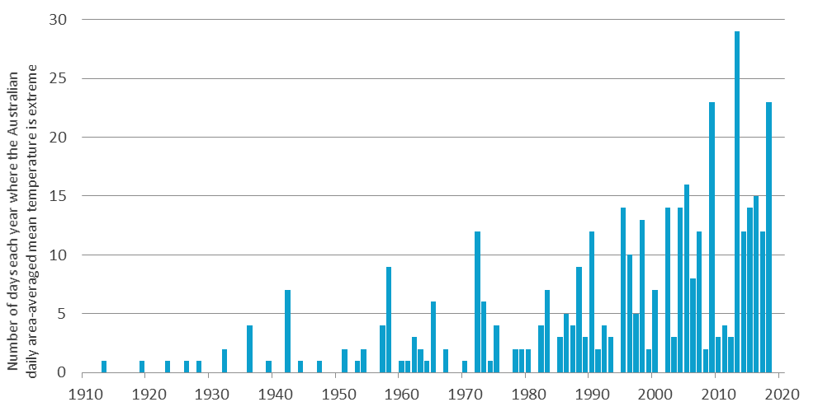

Source: BOM

**Accelerating global action**

While countries' current pledged responses do not meet the level of ambition required to achieve the goals of the Paris Agreement, the global transition is underway.

* In keeping with the Paris Agreement, many countries are increasing their ambition, adopting net zero emission targets and deploying long-term climate change strategies.
* Regional and local governments are also taking action, in response to falling technology costs and changing community demands.
* Businesses have started to consider, disclose and manage climate risks, motivated by a desire to meet the expectations of customers, investors, regulators and, increasingly, the courts.

This means Australia will need to respond to changing global circumstances, or risk getting left behind.

**New strategies and frameworks**

As a resource-rich trading nation whose prosperity depends on continued access to overseas markets, strong global action to reduce emissions presents opportunities to grow our economy, increase jobs and reduce our living expenses.

The Authority has considered how the Government’s forthcoming **long-term climate strategy** and technology investment roadmap can most effectively support Australia’s transition to a low-emissions economy and our contribution to the aims of the Paris Agreement. The long-term climate strategy should incorporate or be complemented with:

* **a trade and investment strategy** that identifies Australia’s competitive advantages in a low-emissions world
* an international climate change strategy to **support a strong global response to climate change** and grow international demand for Australia's emerging low-emissions export industries
* efforts to **support the development of Australia’s green finance market;** and ensure Australian low-carbon industries, products and services are able to benefit from increased international green investment flows
* strategies and pathways for **supporting regions and communities position for new technologies** and **economic opportunities.**

**Australia’s emissions profile**

* In 2018–19, Australia’s emissions were 532 Mt of CO2-e, 13 per cent lower than in 2005—the base year for Australia’s 2030 Paris Agreement emissions reduction target.
* Australia’s emissions have fluctuated since 2005, peaking at 627 Mt CO2-e in 2007.
* Since 2016, Australia’s emissions have increased slightly. This is primarily attributable to increasing emissions in transport, direct combustion and fugitives—driven by the rapid expansion in liquefied natural gas production for export.
* A decrease in emissions from increased uptake of renewable electricity, reduced coal-fired generation and the effects of drought on agriculture, have offset some of this increase.

**Australia’s emissions by sector 2005 – 2019**

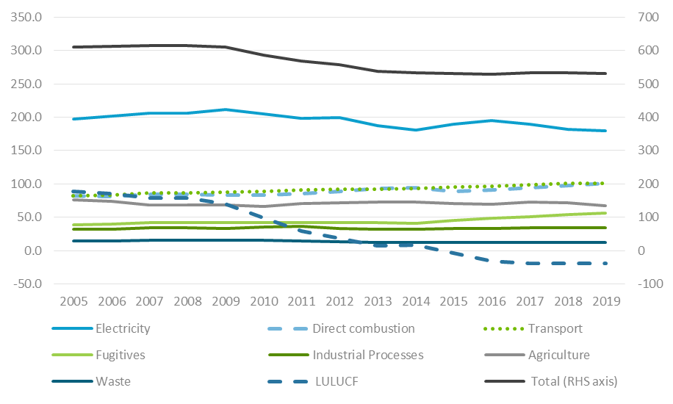

**We can do more to reduce emissions**

The Government's initial Paris Agreement target is to achieve a 26 to 28 per cent reduction in emissions by 2030 compared with 2005 levels. More ambitious targets will be required in Australia and around the world over time to meet the goals of the Paris Agreement. Consequently, mitigation policies implemented today should be sufficiently flexible and scalable to deliver emissions reductions beyond those required for the 2030 target.

The Authority recommends Australia aim to **meet all of our 2030 emissions reduction target with new reductions** generated between 2021 and 2030 to help set Australia on a transition path to a prosperous low-emissions economy.



**Electricity**

Australia's electricity sector is undergoing a transformation. Government support for renewable energy, the emergence of new clean energy technologies, declining technology costs and the need to replace an ageing coal-fired generation fleet are all playing a part. The sector has already been a major contributor to emissions reductions and is well placed to lead Australia's transition to a low-emissions economy. To **support a reliable, secure and affordable energy system,** the Australian Government and the states should align supported **low-emissions and transmission projects** with the priorities identified by the Australian Energy Market Operator’s Integrated Systems Plan and the price signals from the market.The COAG Energy Council should fast-track reforms to facilitate the **integration of large amounts of low- and zero-emissions generation, energy storage and other technologies** to ‘firm up’ intermittent renewables and demand-side response into the electricity market.



**Transport**

The transport sector is the second largest source of emissions in Australia and transport emissions have sustained a clear upward trend over the past decade.

The Authority recommends the Government reconsider the case for the **implementation of a greenhouse gas emissions standard for light vehicles,** which would deliver reduced emissions, savings for motor vehicle users and health benefits for the community.

The Government's forthcoming **electric vehicle strategy** offers an excellent opportunity to **ensure that potential barriers to the uptake of electric vehicles are addressed**. The Authority has identified several barriers to the uptake of electric vehicles that could be addressed in the forthcoming strategy.

The Authority has also recommended further work be done to identify and pursue **opportunities** **to shift more of Australia's domestic freight task onto less emissions‑intensive forms of transport.**



**Industry**

The primary policy for managing industry emissions is the Australian Government’s Safeguard Mechanism. While working as intended, the Safeguard Mechanism is not designed to reduce emissions or cap them in absolute terms.

The Authority's view remains that **an enhanced Safeguard Mechanism should be deployed with declining baselines** to reduce direct combustion, industrial process and fugitive emissions, and ensure these sectors contribute towards the 2030 and subsequent Paris Agreement targets.

Declining baselines should have clear trajectories and **there should be an ability for facilities to trade under- and over-achievement** once baselines have commenced declining and are binding.

Where there is a demonstrated risk of carbon leakage to other countries as a result of the enhanced Safeguard Mechanism, **targeted, transitional and transparent competitiveness assistance** should be offered to emissions intensive trade exposed industries captured by the Mechanism.



**Waste**

In the waste sector, the Authority views the best way forward to ensure continued reductions in waste emissions is by **enhancing and harmonising current state and territory regulatory approaches** to reducing emissions from waste, especially landfill gas, and **diverting organic waste from landfill**.



**Agriculture and Land**

There is significant potential for the land sector to contribute to achieving Australia’s long‑term emission reduction goals through holistic management approaches, including by reforesting and regenerating the land.

The Authority has recommended **continuing to cover land use and agriculture activities under the Emission Reduction Fund**, with credits continuing to be used as offsets for facilities covered by the Safeguard Mechanism and available for use in other (voluntary) markets. The **ERF purchasing should continue until the enhanced Safeguard Mechanism provides a source of demand for credits.**



**Energy efficiency**

Energy efficiency improvements can reduce emissions in all sectors of the economy, including in transport, industry and the built environment. The Authority’s view remains that energy efficiency offers some of the cheapest ways to reduce emissions.

Persistent barriers have continued to prevent increased uptake of energy efficiency improvements. **Effective regulation and information programs can unlock significant cost-effective emissions reductions**.

Recommended actions include **targeted programs to improve energy efficiency** in public housing and other government owned and leased buildings and for priority groups such as low income households, and **accelerating the introduction and/or enhancement of energy efficiency standards** for appliances, new buildings and the existing building stock**.**

**We can empower people to act**

Beyond direct policy interventions, there is a range of ways government can empower businesses, households, communities, non-governmental organisations and others to take action to reduce emissions, as well as help them better prepare for the changes in our climate already locked in.

There are opportunities to do more to **remove impediments to low-emissions activities,** **support the research and development** that is required to solve the difficult abatement challenges that remain across our economy, and help arm businesses, communities and consumers **with better information to enhance their decision-making** when it comes to reducing emissions and managing the risks of a changing climate.



**R&D, innovation and technology**

Research, development and innovation are critical to Australia’s response to climate change.

Effective mitigation of climate change and decarbonisation in the long-term is heavily reliant on the development and deployment of new knowledge, technology and practices. This is particularly the case of harder-to-abate, emissions intensive industries.

The Authority views the Australian Government’s focus on low-emissions technologies, through the recent release of the National Hydrogen Strategy and forthcoming release of the technology investment roadmap as significant steps in the right direction.

In developing and implementing the Technology Investment Roadmap, the Authority recommends partnering with industry and researchers to **identify areas** **where R&D support** **is needed to capitalise on areas of comparative advantage** **for Australia** as well as several funding policy actions through the Australian Renewable Energy Agency, the ERF and the Clean Energy Finance Corporation.

**Finance and investment**

Transitioning to a low-emissions economy will require a re‑orientation of public and private investment away from high-emitting activities towards existing and emerging low-emissions industries.

Australia’s large and highly sophisticated funds management industry and growing climate finance capacity mean we are well-placed to become a major investor in low-emissions opportunities and a green finance hub for the region.

Currently, markets fail to adequately recognise and price climate-related risk because of a lack of information and short-termism in investment decision making. However, this is changing quickly as relevant tools become available and financial regulators divert more attention to the issue.

The Authority has recommended that a **review be conducted of the data** necessary to enable industry, investors and business **understand and manage climate-related financial risk** and develop and implement plans to address gaps and deficiencies in the data.

The Authority is encouraged by the work Australia’s financial regulators are doing to assist the finance and investment sector manage and report on climate-related risk. We have identified **several areas where the quality and usefulness of climate risk reporting can continue to be enhanced.**

**New electricity generation**

New gains in emissions reduction can be achieved through new sources of electricity production and through 'electrification' in sectors such as transport and industry.

In the electricity sector, **providing greater certainty on the timing of the retirement of coal-fired power stations** will raise the prospects for timely investment in replacement, lower emissions generation capacity. It will also enhance planning support for local workforces and the development of alternative industries providing employment.

**Fast-tracking reforms to energy market rules to better facilitate the integration of large amounts of low- and zero-emissions generation** will ensure the significant investor appetite for the sector is not held back.

**Growing sustainability**

Agriculture producers are looking for opportunities to demonstrate their environmental credentials to meet emerging demand from domestic and export markets. For our agricultural products to retain market access, we need to ensure international standards and 'carbon footprint' labelling schemes take account of Australia's circumstances.

The Authority has identified a suite of recommendations to help the sector to **identify, fund and access mitigation and sequestration opportunities** and position themselves competitively in a global market demanding environmentally sustainable, low-emissions produce.



**Circular economy**

Transitioning to a circular economy presents opportunities for significant emissions reductions in the waste sector. A circular economy displaces landfill gas emissions by reducing waste and avoiding landfill disposal. A circular economy also enables broader emissions reductions in other sectors such as transport and manufacturing.

The Authority has recommended the **National Waste Policy Action Plan be implemented** in a way that considers industry development, the waste hierarchy, research and development needs, training requirements, barriers to adoption and an emphasis on creating industries in regions undergoing transition.

**Preparing for a changing climate**

Enhancing our preparedness for future climate impacts will protect the resilience, health and well-being of Australians and sustain Australia’s economic productivity and natural systems.

The Authority recognises that **all levels of government have differentiated, yet complementary responsibilities in preparing Australia for a changing climate**. The federal government has overall responsibility for the national economy and Australia’s national interests and should therefore play a leading role in positioning Australia to adapt to climate change as it impacts on the nation’s prosperity and security. State and territory and local governments also have a crucial role in relation to the delivery of services and infrastructure.

The Government has a range of initiatives currently underway on building climate resilience and strengthening government coordination. The Authority has proposed an **update of the National Climate Resilience and Adaptation Strategy**, both to better communicate these initiatives and to identify future priority actions to enhance Australia’s readiness for climate impacts.

The Authority sees an increased role for governments in the provision of information about the impacts of climate change and options to manage future changes. **The Australian Government and its science agencies are well placed to lead and coordinate the production and communication of Australian-specific climate change information.**

In particular, climate change represents a significant risk to the outlook for the agriculture sector. **Development of appropriate adaptation measures, supported by information and government policies, are needed.**

The Authority has therefore recommended that the federal and state and territory governments continue to coordinate and integrate programs designed to increase mitigation, build resilience to drought and climate impacts, enhance biodiversity and provide benefits for Indigenous communities.

**Contact the Authority**

To contact the Climate Change Authority Freecall 1800 475 869 or email at [enquiries@climatechangeauthority.gov.au](mailto:enquiries@climatechangeauthority.gov.au).

The full report can be found at [www.climatechangeauthority.gov.au](http://www.climatechangeauthority.gov.au)