report

Renewable energy TARget review

December

2014

Published by the Climate Change Authority

[www.climatechangeauthority.gov.au](http://www.climatechangeauthority.gov.au)

ISBN: 978-0-9925422-3-8

© Commonwealth of Australia 2014

This work is licensed under the Creative Commons Attribution 3.0 Australia Licence. To view a copy of this license, visit <http://creativecommons.org/licenses/by/3.0/au>

The Climate Change Authority asserts the right to be recognised as author of the original material in the following manner:

 or 

© Commonwealth of Australia (Climate Change Authority) 2014.

IMPORTANT NOTICE – PLEASE READ

This document is produced for general information only and does not represent a statement of the policy of the Commonwealth of Australia. The Commonwealth of Australia and all persons acting for the Commonwealth preparing this report accept no liability for the accuracy of or inferences from the material contained in this publication, or for any action as a result of any person’s or group’s interpretations, deductions, conclusions or actions in relying on this material.

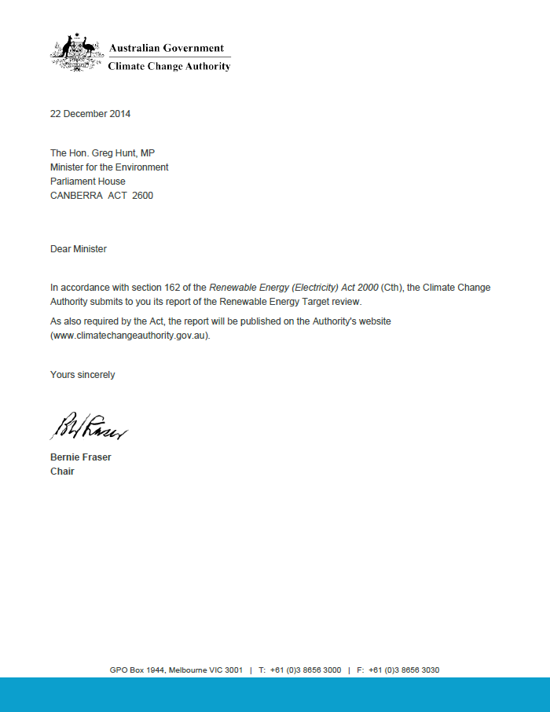

Acknowledgements

The Authority would like to thank the people and organisations who contributed time and expertise to this review and in the process enhanced the quality of the review.

Various government departments and public agencies have also assisted the work of the Authority, including the Department of the Environment, Clean Energy Regulator, Australian Energy Market Operator, Australian Energy Market Commission, Clean Energy Finance Corporation and Department of Industry.

Over the course of the review, the Authority has received submissions from individuals, environment organisations, electricity generators and retailers, business and electricity sector peak bodies, and electricity sector investors.

Contents

Acknowledgements 4

Summary 7

Conclusions and recommendations 10

Chapter 1. About this review 12

1.1. The Climate Change Authority 12

1.2. Approach and context 12

1.3. Scope of review and report structure 13

1.4. Consultation 14

Chapter 2. The Renewable Energy Target and Australia's emissions reduction task 15

2.1. Introduction 15

2.2. The Renewable Energy Target—its operation and impacts 16

2.3. Australia's emissions reduction task 21

2.4. The role of the electricity sector 22

2.5. Is the RET an appropriate policy instrument? 25

Chapter 3. The Large-scale Renewable Energy Target 30

3.1. Feasibility of the current Large-scale Renewable Energy Target 30

3.2. Case for adjusting the Large-scale Renewable Energy Target 37

3.3. Exemptions for emissions-intensive, trade-exposed industries 41

3.4. The Renewable Energy Target after 2020 44

Chapter 4. The Small-scale Renewable Energy Scheme 45

4.1. The Authority's 2012 conclusions and subsequent developments 45

4.2. Impacts of the SRES 48

4.3. SRES assistance for solar PV and value for money 51

4.4. Conclusions on assistance for PV under the SRES 52

Chapter 5. Other issues for the review 54

5.1. Diversity of access and uptake 54

5.2. Future statutory reviews 55

Appendix A Public consultation 56

Appendix B Requirements for Authority Renewable Energy Target reviews 57

Appendix C Outcomes of previous reviews 59

Glossary 65

Abbreviations and acronyms 70

References 73

Figures

Figure 1 Proposed re-phase for LRET targets 8

Figure 2 Generation by fuel source, Australia, 2001–2013 18

Figure 3 Share of renewables in Australian electricity generation, 2001–2013 19

Figure 4 Generation and displacement from solar PV and hot water, 2001–2013 19

Figure 5 Changes in emissions intensity of Australia's electricity supply to 2050—2 and 3 degree scenarios 23

Figure 6 Australia's current and projected share of renewables in electricity generation to 2050, various scenarios 24

Figure 7 Profit by generator type with and without the RET, 2015–2040 28

Figure 8 Large fossil fuel power stations acquired or commissioned, 2009–2014 29

Figure 9 Annual LRET targets 2001–2030 37

Figure 10 Proposed re-phase for LRET targets 40

Figure 11 Emissions intensity and electricity intensity of selected activities eligible for partial exemptions from RET costs 43

Figure 12 Trends in Australian PV system costs, 2000–2013 46

Figure 13 Share of installed PV capacity by system size, 2009–2014 47

Figure 14 Options for an accelerated phase-out of PV assistance 53

Tables

Table 1 Projected share of renewables in 2020, different RET reviews 17

Table 2 Estimates of the cost of emissions reductions of the RET from ACIL Allen modelling 20

Table 3 Large-scale renewables project pipeline 31

Table 4 Illustrative re-phase of the 2020 LRET target—two examples 41

Table 5 Submissions received 56

Boxes

Box 1 ‘At least 20 per cent' and the 41,000 GWh target 17

Box 2 Comparing commissioned modelling of the RET 34

Box 3 Treatment of commercial-scale PV in the RET 49

Box 4 Estimating the cost-effectiveness of assisting PV under the SRES 52

Summary

This is the Climate Change Authority's second review of the Renewable Energy Target (RET). The RET targets reductions in greenhouse gas emissions from the electricity sector and thereby contributes significantly to reducing Australia's overall emissions.

In its 2012 review of the RET, the Authority found that the RET was stimulating considerable investment in renewable energy and argued that a stable and predictable policy was essential to sustain this investment. It concluded that no major changes were warranted to the overall RET design, but suggested some minor operational changes.

The uncertain future of the Authority until recently has limited the time available to conduct this review. Largely for that reason, the Authority has focused on what, it its view, are the most important issues. The Authority has also drawn on both its 2012 Authority review, and on the review conducted this year by a panel headed by Mr Dick Warburton AO LVO.

* + - 1. The RET and Australia's emissions reduction goals

In 2010, when the Large-scale Renewable Energy Target (LRET) was set at 41,000 GWh, it was estimated that this contribution, with contributions from the Small‑scale Renewable Energy Scheme (SRES) and other pre-existing renewables (notably hydro), would together represent at least 20 per cent of Australia’s (then) projected total electricity demand in 2020. Given that electricity accounts for approximately one‑third of Australia’s emissions of greenhouse gases, renewable sources were seen as making a significant contribution to Australia’s broader emissions reduction goals.

Reducing emissions in the electricity sector plays a pivotal role in climate change policies around the world. Unchecked climate change is widely seen as posing serious risks for the Australian community and its economy. Together with the broader international community, Australia has agreed to a goal of limiting global warming to no more than 2 degrees Celsius above pre‑industrial levels to avoid the worst impacts of climate change. This requires concerted action by all countries—including Australia—to reduce their greenhouse gas emissions. The RET, as currently legislated, is a significant part of Australia’s policy response to that challenge.

The RET arrangements were envisaged to deliver ‘at least 20 per cent’ of Australia’s electricity from renewable sources by 2020 and are projected to reduce Australia's emissions by 58 million tonnes of carbon dioxide equivalent (Mt CO2-e) over 2015–20, and by much larger amounts in later periods.

The RET arrangements are not perfect but, in the Authority’s view, they are effective in reducing emissions (at reasonable cost) in the centrally important electricity sector. Given the absence of effective alternative measures bearing upon this sector, the Authority does not favour any significant scaling back of the 2020 LRET target of 41,000 GWh.

* + - 1. Possible extension of end year for the Large-scale Renewable Energy Target

In its 2012 review, the Authority considered the feasibility of achieving the 2020 LRET target. It concluded that the task was challenging but could be met, provided there was ongoing confidence on the part of renewables investors and assuming that the carbon price remained in place. Since then, confidence in the industry has waned and now investment has tapered off, on the back of the erosion of bipartisan support, continuing uncertainty about possible changes and the repeal of the carbon price.

Confidence within the industry that bipartisan support for the LRET can be restored quickly in a convincing manner is essential to have a strong chance of achieving the 2020 goal of 41,000 GWh. At this time this is looking rather problematic.

Another change which has occurred since the 2012 review is that the projected demand for electricity in the National Electricity Market in 2020 has declined by about 16 per cent. This would imply a somewhat greater adjustment on the part of incumbent generators than was previously envisaged.

Having regard to these various changes—and to upholding the credibility of the present LRET target—the Authority recommends that the present target be preserved but the current 2020 timeframe for achieving it be extended by, say, up to three years (Figure 1). As discussed in the report, two consequential changes would flow from the adoption of this recommendation:

* the annual LRET targets should be re-phased after 2017
* to assist delayed projects to recoup their costs, the end date for the LRET would need to be extended by at least the same number of years as the 2020 target was deferred.

Figure 1 Proposed re-phase for LRET targets

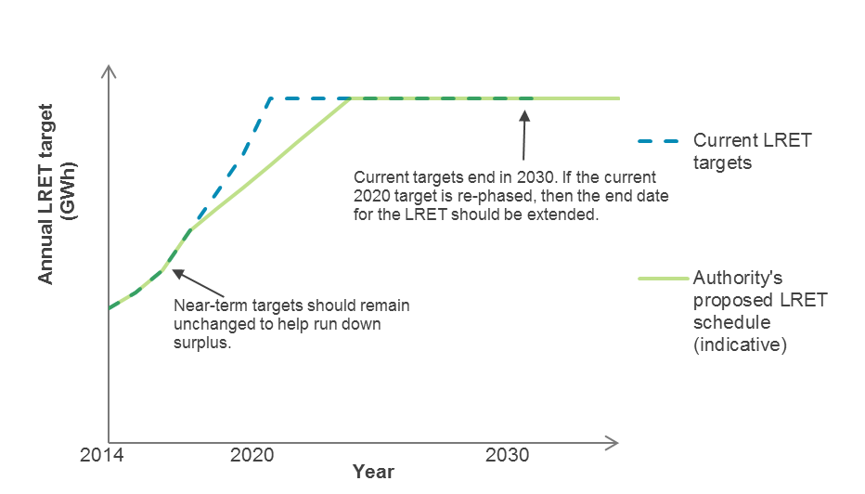

Source: Climate Change Authority

* + - 1. Exemptions

Exemptions from RET costs are provided to some business activities based on their overall emissions intensity, regardless of whether those emissions are related to electricity use. Providing assistance with electricity costs to businesses that are not particularly electricity intensive leads to anomalies and places greater costs onto non-exempt electricity users. If broadening of assistance is considered, it should be based on need, the best measure of which in this context is electricity intensity.

* + - 1. The role of the RET after 2020

The challenges of climate change are ongoing and Australia will need to pursue policies capable of reducing its emissions well into future.

The government proposes to set Australia's post-2020 emissions reduction targets in the first half of 2015.

The Authority noted in its 2012 review that the RET was not a ‘first best’ approach to reducing emissions in the electricity sector. A more comprehensive approach that encouraged or discouraged different types of generation on the basis of their emissions intensity would be better in this sector in the long term. In the absence of such an approach, however, the Authority believes that increases in, and extensions of, the existing RET targets should remain an option in the period beyond 2020, as should expanding arrangements to cover a wider set of technologies.

* + - 1. Rooftop solar under the Small-scale Renewable Energy Scheme

The small-scale solar photovoltaic (PV) industry has been very successful in installing rooftop solar systems for Australian households, community groups and small businesses. Assistance provided under the SRES has encouraged this growth but, as costs have fallen, the case for maintaining current levels of support has become less compelling. Some evidence also suggests that subsidising small-scale PV at these levels is a relatively expensive way of reducing emissions from the electricity sector.

That said, the cost impacts on electricity consumers are modest and the gradual phase‑out of the scheme is to commence shortly. Any more rapid phase‑out should be designed to avoid disruptive cycles in the industry.

Conclusions and recommendations

|  |  |  |
| --- | --- | --- |
| CONCLUSIONS | NUMBER | PAGE |
| Substantial reductions in electricity sector emissions over the coming decades—including through greater deployment of renewables—must be a key focus for Australia in playing its part in reducing global emissions and the risks of dangerous climate change. | C 1 | 25 |
| The Renewable Energy Target arrangements are currently the primary policy instruments for electricity sector decarbonisation, and no more cost-effective and scalable measures are in prospect at this time. Their overall impacts on electricity consumers are quite modest, and are mitigated through the provision of targeted assistance. |  | 29 |
| If any further exemptions from electricity costs under the RET are to be granted, this should be on the basis of electricity intensity, rather than emissions intensity. |  | 43 |
|  |  | 53 |
|  |  | 55 |
|  |  | 55 |

|  |  |  |
| --- | --- | --- |
| RECOMMENDATIONS | NUMBER | PAGE |
| Given the sharp decline in investor confidence, the resulting slowdown in investment, and the further reduction in projected electricity demand, the government should:   * defer the 2020 target for the LRET by, say, up to three years and * extend the scheme as a whole by at least the same amount of time, with a view to providing sufficient time for projects to recover their costs.   Given the large overhang of certificates, there is no case to reduce the annual targets until after 2017. | R.1 | 41 |
| Over the longer term increased recourse to renewables in electricity generation is essential to Australia’s efforts to reduce its total greenhouse gas emissions. In the absence of effective alternatives, RET arrangements will have to carry much of this burden, so consideration should be given—at the appropriate time—to the nature and timeframe of possible RET arrangements in the post 2020 period. In particular, the government should consider increasing and extending targets, and expanding arrangements to cover a wider set of technologies. | R.2 | 44 |

1. About this review

|  |
| --- |
| This chapter outlines the scope and context of the Climate Change Authority’s 2014 Renewable Energy Target (RET) review. It provides information about the Authority and its approach to the review. |

* 1. The Climate Change Authority

The Climate Change Authority ('Authority') is an independent statutory agency, established to provide expert advice on Australian climate change policy, including through a scheduled series of reviews of climate programs and legislation.

The Authority currently comprises a Chair (Mr Bernie Fraser) and four members with expertise including in climate science, economics, and public policy. Its work is guided by a set of principles under the Climate Change Authority Act 2011 (Cth), which requires the Authority to have regard to the following matters:

* economic efficiency
* environmental effectiveness
* equity
* the public interest
* the impact on households, business, workers and communities
* the development of an effective global response to climate change
* Australia’s foreign policy and trade objectives
* any additional principles the Authority considers relevant.
  1. Approach and context

The Authority's requirements for reviewing the RET are set out in the Renewable Energy (Electricity) Act 2000 (Cth) (the REE Act) and Climate Change Authority Act 2011 (Cth) (see Appendix B). Any recommendations must be consistent with the objects of the REE Act (s. 3) which are to:

* encourage the additional generation of electricity from renewable sources
* reduce emissions of greenhouse gases in the electricity sector
* ensure that renewable energy sources are ecologically sustainable.

The Authority reviewed the RET in 2012. In that review the Authority emphasised the role of the RET in reducing emissions and the importance of a stable and predictable policy environment to its success. It concluded that no major changes were warranted to the overall scheme, but suggested some minor operational changes.

The Authority conducted its 2012 review against the policy backdrop existing at that time. Since then, significant changes have occurred. In particular, the carbon pricing mechanism has been repealed and the outlook for electricity demand is more subdued than it was in 2012.

The government initiated a new review of the RET in 2014 by a panel headed by Mr Dick Warburton AO LVO, and supported by a secretariat located within the Department of the Prime Minister and Cabinet. The report of the Expert Panel (hereafter, the 'Warburton review' report) was released in August 2014. The review concluded that the cost of the RET outweighed its benefits and that significant change was required. The review recommended that:

* the Large-scale Renewable Energy Target (LRET) be either closed to new entrants or modified so that targets to 2020 are set one year in advance and increase by half of projected additional electricity demand in that year.
* the Small-scale Renewable Energy Scheme (SRES) be either terminated immediately or phased out more rapidly (by 2020 rather than 2030).

A full list of the Authority's 2012 recommendations and those of the 2014 Warburton review are at Appendix C. Consistent with its 2012 report and in line with its legislative requirements, the Authority's 2014 RET review pays particular attention to:

* the objective of reducing emissions (both now and in the longer term)
* the research demonstrating the crucial role that decarbonisation of the electricity sector will play as Australia and the world move to a low-emissions economy.

The Authority concluded in its 2012 review that two-yearly reviews of the RET risked undermining policy stability and investment in the sector and recommended that they occur only every four years (CCA 2012, p. 39); this recommendation has not been implemented and the Authority's statutory obligation to conduct this review remains in place.

* 1. Scope of review and report structure

This review covers a small number of issues which the Authority believes are of most significance at this time. The lingering uncertainty about the future of the Authority has also necessitated the fairly narrow focus of the review. As appropriate, the Authority has drawn on previous consultation and analysis from both the 2012 Authority review and this year’s Warburton review.

The important issues considered by the Authority include:

* The role of the electricity and renewables sectors in contributing to the goal of keeping global average warming to below 2 degrees (chapter 2).
* The case for rescheduling the LRET target; the appropriateness of current assistance to emissions‑intensive, trade‑exposed activities; and the role of the RET after 2020 (chapter 3).
* Whether any changes should be made to the level of assistance provided to small‑scale solar photovoltaic (PV) generation under the SRES (chapter 4).
* Whether any changes to the RET design to promote access by more diverse renewable technologies are warranted; and the appropriate frequency of statutory reviews of the RET (chapter 5).

The limited scope of this review has meant that some questions, such as the treatment of larger, commercial-scale PV, could not be addressed on this occasion. For the same reason the Authority did not commission additional economic modelling of the electricity sector for this review, but has drawn on several previous exercises including modelling commissioned for the Authority’s earlier review and the Warburton review.

* 1. Consultation

The Authority has reviewed the public submissions made to the Warburton review, and met with and secured input from interested stakeholders (see Appendix A for a list of submissions received). The Authority would like to thank the people and organisations who contributed time and expertise to the review.

1. The Renewable Energy Target and Australia's emissions reduction task

|  |
| --- |
| The RET works by creating a market for additional renewable electricity that supports investment in new renewable generation capacity.  This chapter outlines the operation and impacts of the RET and places them in the broader context of Australia's emissions reduction goals.  It examines Australian and international research on the transition to a low-emissions economy. This suggests major decarbonisation of electricity systems by 2050 is required to reduce the risks of dangerous climate change. Two consistent findings of this research are that significantly more needs to be done both before and beyond 2020 to reduce electricity sector emissions, and that renewable energy is likely to play a major role in this task.  This chapter also considers the extent to which the RET is the ‘right’ policy instrument for reducing electricity sector emissions. It finds that the RET can make significant emissions reductions at reasonable cost, with modest impacts on electricity consumers. |

* 1. Introduction

The RET arrangements are designed to deliver the equivalent of at least 20 per cent of Australia's electricity from renewable sources by 2020 (see Box 1). The term 'equivalent' is used because the scheme includes displacement technologies, such as solar water heaters, which reduce electricity demand rather than generate electricity. The primary legislation for the RET, the REE Act, sets out the formal objects of the Act which are to:

* encourage the additional generation of electricity from renewable sources
* reduce emissions of greenhouse gases in the electricity sector
* ensure that renewable energy sources are ecologically sustainable.

The RET's objectives should be seen in the context of Australia's broader goal of contributing to global efforts to reduce the risks posed by climate change.

* 1. The Renewable Energy Target—its operation and impacts
     1. How the RET works

The RET works by creating a market for additional renewable electricity that supports investment in new renewable generation capacity. It places a legal obligation on entities that purchase wholesale electricity (mainly electricity retailers) to surrender a certain number of certificates to the Clean Energy Regulator (CER) each year. These certificates are generated by accredited renewable power stations and eligible small‑scale renewable technologies. Each certificate represents one megawatt hour (MWh) of additional renewable energy for compliance purposes; the certificates are tradeable and can be 'banked' for use in later compliance years. If a liable entity does not surrender the number of certificates required, a 'shortfall charge' of $65/MWh applies to the outstanding amount. Costs incurred by purchasing certificates are tax‑deductible, while the payment of the shortfall charge is not. Assistance with the costs of the RET is provided to eligible emissions-intensive, trade‑exposed businesses. Generators producing and consuming their own electricity (‘self‑generators’) are exempt.

Since 2011, the RET has operated as two schemes—the Large-scale Renewable Energy Target (LRET) and the Small-scale Renewable Energy Scheme (SRES).

The LRET supports large-scale renewable energy projects, such as wind and large-scale solar generators, by helping to bridge the cost between renewable and fossil-fuel generation. It sets annual targets for the amount of large-scale renewable energy; these targets rise to 41,000 GWh in 2020 and stay constant at that level until the scheme ends in 2030 (see Figure 9 in chapter 3). These annual targets are allocated among liable parties in proportion to their purchases of wholesale electricity.

The SRES helps households, small businesses and community groups with the upfront cost of installing small-scale renewable systems, such as rooftop solar photovoltaic (PV) systems and solar hot water heaters. The SRES has no fixed annual targets; rather, liable entities are obliged to purchase all of the certificates generated from the installation of eligible small-scale systems. Unlike the LRET, where certificates are generated in arrears, owners of eligible small-scale technologies receive certificates upfront for the amount of renewable electricity the system is 'deemed' to create over a given period. This approach reduces the administrative burden on households and the CER. The scheme will phase out gradually (from 2017 or 2022 depending on the technology), with the number of years of deeming reducing by one each year until the scheme ends in 2030. Small‑scale technology certificates (STCs) can be sold through the Clearing House for $40; this provides a price cap for the scheme, the level of which can be altered by the Minister.

The Authority's 2012 RET review provides further detail about the operation of the two schemes.

|  |  |  |  |  |  |  |  |  |  |  |  |  |  |  |  |  |  |  |  |  |  |  |  |  |
| --- | --- | --- | --- | --- | --- | --- | --- | --- | --- | --- | --- | --- | --- | --- | --- | --- | --- | --- | --- | --- | --- | --- | --- | --- |
| 1. ‘At least 20 per cent' and the 41,000 GWh target   The RET aims to ensure that ‘the equivalent of at least 20 per cent of Australia’s electricity generation comes from renewable resources by 2020’ (Explanatory Memorandum, REE Amendment Bill 2009 (Cth)). To meet this target, the legislation specifies a fixed amount of large-scale electricity generation each year, providing clear signals about the amount of large-scale generation capacity required to meet the targets. The legislated 2020 LRET target is 41,000 GWh. The amount of renewable energy in Australia in 2020 was never going to be exactly 20 per cent. It will be higher or lower depending on several factors, including overall demand for electricity. The SRES is uncapped.  In its 2012 RET review, the Authority considered the merits of fixed versus floating targets and preferred a fixed target, based on the argument that setting gigawatt hour targets to achieve a particular share of demand would require continuous revision, leading to significant uncertainty about the amount of investment required to meet the target.  Estimates of the share of electricity that will be supplied by renewable generation in 2020 vary depending on both the method used (for example, what counts as renewable energy) and the projections of future electricity supply and renewable energy generation.  The RET (and Mandatory Renewable Energy Target (MRET) before it) was designed to encourage additional renewable electricity generation, so generation from pre-existing renewable plant needs to be considered when estimating the total share of renewables in a given year. This means there are three distinct components that affect the share of renewable energy:   * electricity demand * eligible generation under the RET (both large‑scale and small‑scale) * 'below baseline' generation from renewable generators that existed before the MRET ('pre‑existing' renewable generators). Pre‑existing renewable generators are allocated baselines based on their average historical output and are eligible to receive certificates for output above these baselines. The amount of generation below their baselines needs to be added to generation from the RET to get the total amount of renewable generation.   When the initial 20 per cent by 2020 target was translated to a fixed gigawatt hour amount in 2007, Australia‑wide electricity supply was projected to be about 300,000 GWh in 2020 and below‑baseline generation was expected to be about 15,000 GWh per year (CCA 2012, p. 43). With a RET of 45,000 GWh per year by 2020, this translated into a total renewable energy contribution of 60,000 GWh per year, equivalent to 20 per cent of (then) forecast demand in 2020. When the RET was split, the LRET target was revised to 41,000 GWh in 2020 (and through to 2030) and the SRES was left uncapped, but notionally allocated at least 4,000 GWh.  Over time, projections have changed, increasing the projected share of renewable energy in 2020. In 2012, the Authority projected the share of renewables in 2020 would be about 26 per cent. The updated forecasts included in the Warburton review project a 2020 renewables share of 26 per cent (if displacement from solar hot water is excluded) or 28 per cent (if it is included, as per the Authority's analysis, which was based on previous approaches). Table 1 compares the modelling outputs and resulting share of renewables from the two reviews.  Table 1 Projected share of renewables in 2020, different RET reviews   |  |  |  |  |  |  |  |  | | --- | --- | --- | --- | --- | --- | --- | --- | |  | LRET target (GWh) | Below base-line gen. (GWh) | Solar PV (GWh) | SHW  (GWh displaced) | Total  renewables  (GWh) | Total  generation  (GWh) | Share of renewables in 2020 (%) | | CCA 2012 RET Review (p. 43) | 41,000 | 14,300 | 7,900 | 3,000 | 66,200 | 258,500 | 26 | | 2014 Warburton review (pp. 126‑130) | 41,000 | 16,150 | 9,920 | 3,500  (not in Warburton method) | 70,570 | 255,300 | 28 |   Source: Climate Change Authority based on CCA 2012 and Warburton review 2014 |

* + 1. Renewables capacity and generation so far

The recent Warburton review found that the RET has been successful in promoting additional generation from renewable sources. Over 2001–2014, more than 400 renewable power stations with a total capacity of more than 5,000 MW were installed under the RET—equivalent to about 10 per cent of Australia's current grid‑connected capacity (Climate Change Authority calculation based on Warburton review 2014 and Energy Supply Association of Australia (ESAA) 2014). About three‑quarters of this is wind power; the rest includes biomass, hydro, landfill gas and solar (Warburton review 2014, p. 8). Figures 2 to 4 show the increase in renewable generation over 2001–2013. The amount of renewable energy generation almost doubled over the period, from about 17,800 GWh in 2001–02 to about 32,500 GWh in 2012–13, with the share of renewables rising from eight to 13 per cent over the same period.

So far, about 2.2 million small-scale renewable systems have been installed under the RET (Clean Energy Regulator 2014a). About 1.3 million of these are small‑scale solar PV systems, which have been installed by more than 10 per cent of Australian households (ACIL Allen 2013a, p. viii).

To date, the emissions reductions from the RET have been relatively small, because annual targets have been relatively low. Modelling by SKM for the Clean Energy Council estimated that Australia’s emissions over 2001–2012 were 22.5 Mt CO2-e lower with the RET in place (SKM 2012, p. 1). This is equivalent to about 10 per cent of Australia's current annual electricity sector emissions (CCA 2014, p. 159).

Figure 2 Generation by fuel source, Australia, 2001–2013

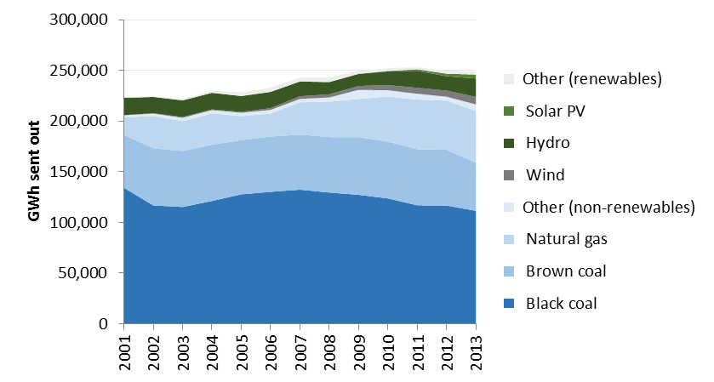

Note: Other (renewables) includes bagasse (wood), biogas and geothermal. Other (non-renewables) includes oil products and multi-fuel-fired power plants. Year refers to financial year ending June. Solar PV includes rooftop solar; generation includes off-grid.

Source: BREE 2014

Figure 3 Share of renewables in Australian electricity generation, 2001–2013

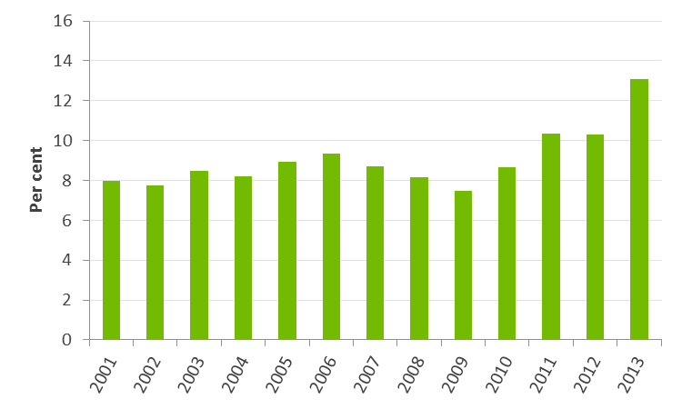

Source: Climate Change Authority based on BREE 2014

Figure 4 Generation and displacement from solar PV and hot water, 2001–2013

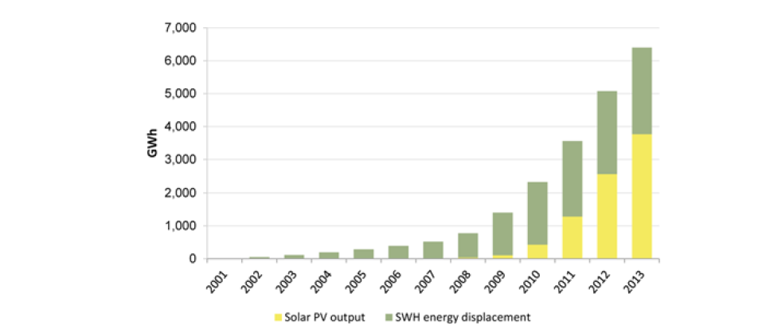

Note: 'SWH'= solar water heater.

Source: Warburton review 2014

* + 1. Projected impacts of the RET and their distribution

The rest of this section looks at RET’s likely future performance, resource costs and the distribution of those costs. As mentioned, the Authority has not conducted any new modelling for this review, but has drawn on a number of published studies on the impacts of the RET, including the modelling by ACIL Allen commissioned for the Warburton review and by SKM MMA for the Authority's 2012 review. Box 2 in chapter 3 compares these and other recent studies.

The RET is projected to deliver substantial volumes of emissions reductions in the future: modelling for the Warburton review (2014, p. 41) estimates that (relative to a scenario in which the RET was repealed) the current RET would reduce emissions by:

* 58 Mt CO2-e over 2015–2020—about the same as annual emissions from all of Australia’s passenger cars and light commercial vehicles (CCA 2014a)
* 299 Mt over 2015–2030—about half of Australia’s current total annual emissions (CCA 2014b).

These projected emissions reductions result from increasing the amount of renewables in the generation mix, which has an economic cost. The cost of the RET is commonly measured by its incremental resource cost to the electricity sector; that is, the difference between the net present value (NPV) of the resources allocated to the electricity sector with or without the RET in place. The incremental resource costs include the costs of building and running a renewable plant, minus the avoided fuel costs of displaced fossil fuel plant, other avoided running costs, and any avoided capital costs. The RET generally raises the capital cost of generation, which is partly offset by lower ongoing costs. ACIL Allen estimated the additional resource cost of the current RET to 2030 at $10,430 million in NPV terms relative to a situation of no RET (in 2014 dollars, ACIL Allen 2014, p. 116).

Dividing the incremental resource cost of the RET by its emissions reductions gives the average cost per tonne, a measure of the policy's cost effectiveness. The Warburton review provides estimates of the average cost of emissions reductions from the RET, the LRET and solar PV under the SRES, calculated in two different ways (Table 2). It estimates the cost of the LRET from 2014–2030 to be $32 per tonne (when future emissions reductions are not discounted), or $62 per tonne (when the emissions reductions are discounted at the same rate as future resource costs). Subsidising rooftop PV is more expensive per tonne of emissions reductions, at $95 per tonne without discounting. The method of estimating the cost per tonne of emissions reductions under the RET is discussed further in section 4.3.

Table 2 Estimates of the cost of emissions reductions of the RET from ACIL Allen modelling

|  |  |  |  |  |  |  |
| --- | --- | --- | --- | --- | --- | --- |
|  | Cost per tonne ($/tCO2-e) | | | | | |
| 2014–2030 | | | 2014–2040 | | |
|  | RET | LRET | Rooftop PV | RET | LRET | Rooftop PV |
| Undiscounted emissions reductions | 35 | 32 | 95 | 25 | 22 | 79 |
| Discounted emissions reductions | 68 | 62 | 175 | 62 | 56 | 185 |

Note: ‘undiscounted emissions reductions’ means that future emissions reductions are not discounted relative to those today. ‘Discounted emissions reductions’ means that emissions reductions in the future are discounted at the same rate as future resource costs (a 7 per cent real discount rate). The Authority considers the estimate with undiscounted emissions is the more appropriate measure. See text for further details.

Source: Warburton review 2014

The Authority considers the estimate with undiscounted emissions is the more appropriate measure. Unlike holdings of money, over the timeframes and volumes of emissions reductions considered here, a tonne of emissions reductions in the future is as valuable as a tonne now, as it has the same consequences for climate change outcomes. In its 2012 review, the Authority did not discount future emissions reductions, and estimated the average cost of the RET to be $40 per tonne (in 2012 dollars).

Looking beyond the resource cost of the RET, the scheme has distributional impacts on households and businesses. These impacts arise from changes in the wholesale and retail prices of electricity which affect electricity consumers' purchasing power and the profits of existing generators. These price changes are different from the 'costs of the RET to the economy'—they involve transfers from some households or businesses to others.

Retail electricity prices are made up of the costs of generating, transmitting, distributing and selling the electricity to end users. The overall impact of the RET on retail prices is the net impact of two main effects that work in different directions:

* The RET tends to lower wholesale electricity prices—because the RET increases the available supply of electricity from sources with lower operating costs than fossil fuel generation.
* The RET tends to raise the retail component of electricity prices—retailers have to purchase certificates to acquit their RET liabilities, the costs of which are passed on to customers.

Existing generators are affected in two ways. Increased generation displaces fossil-fuelled plant output. Also, lower wholesale prices mean they make less money for the electricity they sell.

The impact on households and other retail customers depends on the relative size of the wholesale and retail price effects. For a particular level of renewable capacity, the larger the wholesale price effect, the smaller the overall cost impact on consumers; the magnitude of these impacts is discussed in section 2.5.

* 1. Australia's emissions reduction task

Climate change poses serious risks for the Australian community and its economy. Together with the broader international community, Australia has agreed to a goal of limiting average global warming to no more than 2 degrees Celsius above pre-industrial levels to avoid the worst impacts of climate change. This requires large and ongoing reductions in greenhouse gas emissions by all countries, including Australia.

Australia’s emissions were about 600 Mt CO2-e in 2012, 2.5 per cent above 2000 levels (CCA 2014, p. 86). With the currently legislated RET in place, but without other strong policies, the most recent official estimates projected that emissions would grow to 685 Mt in 2020, 17 per cent above 2000 levels (Treasury and Department of Industry, Innovation, Climate Change, Science, Research and Tertiary Education (DIICCSRTE) 2013). The next set of official projections is expected to be lower, reflecting the effects of structural changes in the Australian economy, behavioural change and the impacts of past policies, including energy efficiency (see, for example, Frontier Economics 2014). Even if the growth in emissions slows, however, absolute emissions are likely to grow in the absence of additional strong policies.

Australia has an international undertaking to reduce its emissions by 5–25 per cent by 2020, relative to 2000 levels, and is considering its goals for reductions beyond 2020. The government has indicated it will make decisions on post-2020 targets in the first half of 2015.

In its Targets and Progress review, the Authority considered Australia’s current (and prospective) emissions reduction goals. It recommended a long-term emissions budget for Australia that is consistent with the 2 degrees goal, and corresponding short-term and medium-term targets of:

* a minimum 15 per cent reduction compared with 2000 levels by 2020 (which increased to 19 per cent when taking account of surplus emissions units carried over from the first commitment period of the Kyoto Protocol)
* between 40 and 60 per cent reductions compared with 2000 levels by 2030 (CCA 2014, p. 10).

Based on the available evidence, the Authority concluded that Australia’s minimum 5 per cent 2020 target is inadequate, because it does not keep pace with the action taken by many other countries and is inconsistent with the 2 degrees goal (CCA 2014, pp. 121–2).

Since that review climate scientists have reaffirmed their conclusions about the risks ahead, and some of the world’s largest emitters have announced commitments for post-2020 action:

* The United States has pledged to reduce its net greenhouse gas emissions by 26 to 28 per cent—compared with 2005 levels—by 2025 (White House 2014).
* China has pledged to peak CO2 emissions by 2030 and to increase its non-fossil fuel share of energy to around 20 per cent by that year.
* The European Union has pledged to cut greenhouse gases by at least 40 per cent from 1990 levels by 2030 (Barroso 2014).
  1. The role of the electricity sector

The electricity sector features prominently in Australian and international research on reducing greenhouse gas emissions, with a consistent finding that limiting warming to no more than 2 degrees would require virtual decarbonisation of global electricity systems by 2050 (Sachs et al., 2014, p. 32; IPCC 2014b p. 64, IEA 2014a p. 125).

The electricity sector is important for three reasons:

* It accounts for a significant share of current emissions—one-third of Australia's total emissions and 28 per cent of total global emissions (CCA 2014, p. 246, Audoly et al. 2014, p. 1).
* Deep cuts in electricity sector emissions are technically feasible with currently known technologies, and more cost-effective than deep cuts in some other sectors.
* Low- and zero-emission electricity generation can be a precursor to feasible, least‑cost decarbonisation pathways for the sectors that use energy.

The survey of decarbonisation pathways by the Intergovernmental Panel on Climate Change (IPCC 2014b) found that in least-cost pathways consistent with less than 2 degrees of warming, the electricity sector is decarbonised more rapidly, whereas deep reductions in emissions in some other sectors accrue after 2050 (IPCC 2014b pp. 6‑86). In these scenarios, renewables are projected to replace fossil fuels as the dominant source of electricity generation by 2050. In the International Energy Agency’s (IEA’s) 2 degree scenario, for example, renewables are projected to surpass 70 per cent of global generation capacity by 2050, with fossil fuels declining to just over 20 per cent and nuclear maintaining its current share of seven per cent (IEA 2014a, p. 125). The importance of decarbonising global electricity supplies for reducing energy emissions is reflected in the IEA's (2014b) advice to policy-makers in the lead up to the climate change negotiations in Lima this month: electricity sector decarbonisation is one of five priority actions on the IEA's list for reducing energy sector emissions.

Substantial decarbonisation of electricity supply facilitates decarbonisation for energy‑consuming sectors, as electricity can displace the direct use of fossil fuels for energy (IEA 2014a, pp. 127-128; Sachs et al. 2014, pp. 12-13). Recent modelling for Australia conducted as part of a multi-country United Nations project (Pathways to Deep Decarbonisation in 2050) provides examples:

* In industry, emissions could fall 60 per cent on 2012 levels by 2050, driven substantially by decarbonisation of the electricity supply and electrification of industrial processes (ClimateWorks Australia et al. 2014a, p. 25).
* Emissions from Australian buildings could be virtually eliminated by 2050 through a combination of energy efficiency and switching from gas to electricity for all heating, hot water and cooking (ClimateWorks Australia et al. 2014b, p. 120).
* Emissions from road transport, which currently accounts for the vast majority of transport emissions, could be reduced by about 70 per cent by 2050 (ClimateWorks Australia et al. 2014b p.69, CCA 2014b p.17). Much of this is due to a substantial shift towards electric and hybrid light vehicles. Emissions from cars and light commercial vehicles are projected to fall by around 85 per cent between 2012‑2050, while kilometres travelled grow by about 75 per cent over the same period (ClimateWorks Australia 2014b p. 67, p.69).

Australia's current trends lag well behind these projections. In 2012, the emissions intensity of Australia's electricity supply was higher than China’s and 87 per cent above the OECD average (IEA 2014c, pp. II.61-3). Even with the currently legislated RET (but without other strong policies):

* the emissions intensity of Australia's electricity supply is projected to decline only slightly, from 0.78 tonnes of carbon dioxide equivalent per megawatt hour (tCO**2**‑e/MWh) in 2012 to 0.69 tCO**2**-e/MWh in 2030 (CCA 2014, p. 250)
* absolute emissions from electricity generation are projected to grow.

For Australia to get onto a cost-effective pathway consistent with global action to limit warming to no more than 2 degrees, the emissions intensity of its electricity would need to fall rapidly. Modelling conducted for the Authority's Targets and Progress review projected about a 70 per cent reduction on 2012 emissions intensity levels by 2030, and about a 90 per cent reduction by 2050. This trend is projected to hold even in the case of weaker global action—a scenario consistent with limiting warming to 3 degrees found emissions intensity would fall 15 per cent below 2012 levels by 2030 and about 65 per cent by 2050 (Figure 5).

Figure 5 Changes in emissions intensity of Australia's electricity supply to 2050—2 and 3 degree scenarios

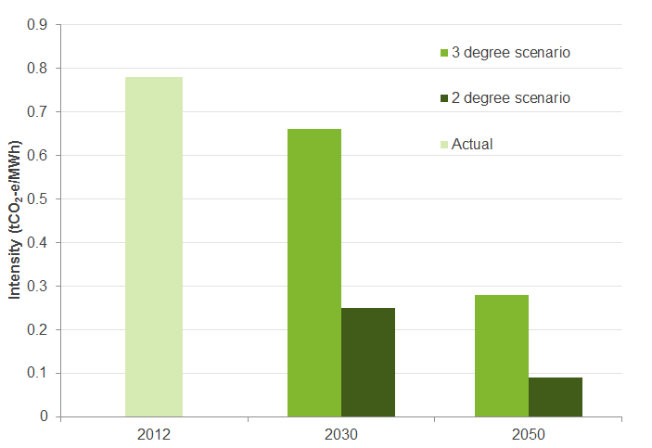

Note: The 2 degree scenario is the 'high' scenario and the 3 degree scenario the 'central policy' scenario from modelling for the Authority’s Targets and Progress review. Both scenarios assume a fixed carbon price to July 2014, with the 2 and 3 degree scenarios reaching $65/t CO2-e and $27/t CO2-e in 2020, respectively. Prices are in real 2012 Australian dollars.

Source: Climate Change Authority 2014 based on Treasury and DIICCSRTE 2013 and ACIL Allen 2013b

This modelling—and the projected decline in emissions intensity—reflects a strong shift from fossil fuel to renewable generation, with the share of total renewable generation increasing from 12 per cent in 2012 to about 70 per cent in 2030 in the 2 degree scenario, and to about 25 per cent in the 3 degree scenario (Figure 6).

The Pathways to Deep Decarbonisation modelling discussed above reinforces these findings. It suggests that even if other zero- or low-emissions technologies are deployed—such as nuclear and carbon capture and storage (CCS)—renewables would still dominate the generation mix (ClimateWorks Australia et al. 2014b). The project investigated three pathways for electricity generation consistent with the Authority's recommended long-term emissions budget for Australia, namely: a 100 per cent renewable grid scenario; a scenario in which CCS is included in the possible technology mix; and a scenario in which CCS and nuclear are included (ClimateWorks Australia et al. 2014a p.22, 2014b pp. 42-5). Even in the nuclear and CCS scenarios, renewables are projected to account for more than 70 per cent of total generation in 2050.

Figure 6 Australia's current and projected share of renewables in electricity generation to 2050, various scenarios

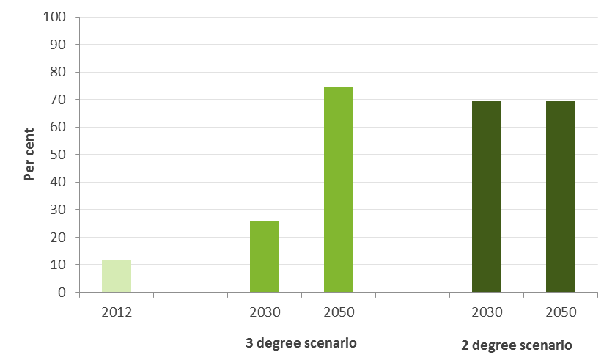

Note: Generation is calculated in GWh sent out. ‘Renewables’ includes hydro, wind, geothermal, biomass, solar thermal and solar PV (including rooftop solar). Generation displaced by solar water heating is not included in the share of renewables. Non-renewable generation includes coal, gas, cogeneration, liquid fuel, black coal with carbon capture and storage (CCS) and gas with CCS. CCS technology plays a larger role under a 2 degree scenario from 2030 resulting in a lower share of renewables in 2050 than in the 3 degree scenario.

Source: Climate Change Authority based on ACIL Allen 2013b

The modelling discussed above projects a major and expanding role for large-scale renewables through to 2050. On the other hand, some changes underway in the electricity sector—including rapid reductions in small-scale battery costs—could result in a more decentralised electricity sector in the future. This raises the question of whether near-term investment in large-scale renewables may be stranded if the grid was to become much more decentralised over the coming decades.

While it is impossible to know how the sector will evolve, modelling for the CSIRO’s Future Grid Forum (Graham et al. 2013, pp.53, 68, 84) provides some insights. Even across scenarios resulting in extremely different levels of centralised electricity generation in 2050, investment in large-scale renewables to 2020 is reasonably similar. This suggests near-term investment in large-scale renewables could be robust to a range of possible futures.

In summary, the available studies consistently find:

* Significantly more will need to be done to reduce emissions beyond 2020 to keep Australia on a path towards limiting global warming to no more than 2 or even 3 degrees.
* Renewables are likely to play a major role in decarbonising future electricity supplies.

|  |
| --- |
| Conclusion   1. Substantial reductions in electricity sector emissions over the coming decades—including through greater deployment of renewables—must be a key focus for Australia in playing its part in reducing global emissions and the risks of dangerous climate change. |

* 1. Is the RET an appropriate policy instrument?

In its 2012 review, the Authority concluded that while the RET was not a perfect policy, the benefits of any changes should be assessed in light of their implications for ongoing investment in renewables. Since then, many stakeholders have suggested the RET should be reduced or abolished, arguing that:

* lower cost emissions reductions exist elsewhere
* the Emissions Reduction Fund (ERF) should be the main policy in the economy and the electricity supply sector
* the distribution of costs (including their incidence on existing fossil fuel generators) is undesirable.

The Authority’s responses are listed below and elaborated in the subsequent sections:

* some cheaper emissions reductions are available elsewhere, but policy needs to consider the size and cost of the overall emissions reduction task
* within the electricity supply sector, it is doubtful that the prospective alternative policies would deliver comparable reductions
* the size and incidence of the RET's impacts do not warrant reductions in the targets.

This section expands upon each point in turn.

* + 1. some cheaper reductions are available, but policy needs to consider the size and cost of the overall task

As discussed in section 2.4, decarbonising the electricity supply sector is a critical part of Australia's transition to a low-emissions economy; this requires policies capable of making substantial reductions in electricity sector emissions.

Some lower‑cost emissions reduction opportunities do exist in Australia outside the electricity supply sector, and the Authority expects that some of these will be picked up by the ERF (CCA 2014c) or other current policies.

The existence of such opportunities, however, is not sufficient to conclude that the RET is too expensive. Policy‑makers need to consider the overall size of Australia's emissions reduction task and the costs for achieving not just some but all of the reductions required to meet Australia's targets. This includes considering the cost of the most expensive of those units (the ‘marginal cost’ or the cost ‘at the margin’).

The government's latest estimate of Australia's emissions reduction task is 421 Mt between 2015 and 2020 (Department of the Environment 2014). This is based on results of modelling by the Australian Treasury for the Authority’s Targets and Progress review (Treasury and DIICCSRTE 2013), which suggests that to achieve even Australia’s minimum 2020 commitment of a 5 per cent emissions reduction target domestically would cost up to $65 per tonne (in 2012 dollars) at the margin with the carbon pricing mechanism in place. That modelling assumed that the current RET remained in place. If the RET target were to be weakened or abolished, more emissions reductions would be required elsewhere and the marginal cost of delivering those additional reductions would be expected to be at least as high.

Sustained weak electricity demand means that the emissions reduction task to 2020 is likely to be smaller than previously estimated. Frontier Economics (2014, p. 7), for example, estimates that downward revisions to electricity demand forecasts will lower Australia's emissions reduction task by 142–196 Mt over 2014–2020. This would reduce the marginal cost of achieving the minus 5 per cent target. That said, there is no guarantee that it would reduce the cost to a level less than the average cost per tonne of a lower RET.

At an average cost of $35 per tonne to 2030 (Table 2), the Authority believes the RET is making a reasonably cost-effective contribution to emissions reductions in a strategically important sector—both out to 2020 and beyond, when steeper reductions will be required.

* + 1. Within the electricity supply sector, prospective alternatives are unlikely to deliver comparable reductions

Policies to reduce emissions from electricity can operate in one or more of the following five ways:

* using existing lower emissions plant more intensively ('fuel‑switching')
* improving the efficiency of existing fossil-fuel power stations so that they produce fewer emissions per unit of electricity
* retiring higher emissions plant
* building new zero- or low-emissions generation (large- or small-scale)
* reducing the demand for electricity by improving household and business energy efficiency.

Improving energy efficiency can often provide substantial low cost (or even financially beneficial) ways of reducing Australia's emissions (see for example CCA 2014a, p. 160). This can reduce overall electricity demand, but will not reduce the emissions intensity of the electricity supply.

The government is implementing the ERF as the centrepiece of its climate policy to reduce emissions across the economy. As discussed in the Authority’s Carbon Farming Initiative review (CCA 2014c), the crediting part of ERF (as currently designed) is not well suited to encouraging new zero- or low-emissions plant because the contract period is short relative to the life of the large infrastructure investment. It could encourage efficiency improvement at existing plants, but is less suited to encouraging fuel‑switching, as reductions are assessed at the facility level, rather than across the generation fleet as a whole.

The government is also designing a ‘safeguard mechanism’ to complement the ERF crediting mechanism. This remains under development (and is planned to commence from 1 July 2016), and the ERF White Paper notes that the application of the safeguard mechanism to the electricity sector would be a matter for industry consultation, given the interactions with other policies such as the RET. Given these uncertainties, there is no basis at this time to assume the ERF will be effective in delivering comparable volumes of emissions reductions to the RET at lower prices.

Renewable deployment policies like the RET reduce emissions through encouraging new zero‑emissions plant. While performance depends on the specifics of the design, schemes like the LRET are considered to be a relatively cost-effective way of reducing electricity sector emissions. The Productivity Commission’s 2011 review of more than 1,000 emissions reduction policies in nine countries concluded that, while emissions trading schemes delivered the lowest cost emissions reductions (by using all five of the options above), schemes to encourage the deployment of large‑scale renewable energy were the next most cost‑effective set of policies in the electricity supply sector. Within those policies, renewable energy targets such as Australia’s were found to be more cost effective than schemes that set the price for, rather than the quantity of, renewables (Productivity Commission 2011, pp. xiv, 80–1).

In the Authority’s view, the RET is the only currently prospective policy instrument in the electricity supply sector that can be relied upon to deliver sizeable volumes of emissions reductions.

* + 1. The size and incidence of the RET's impacts do not warrant reductions in the targets

Another objection to the RET raised by some stakeholders (see section 3.2) is that, even if its overall costs are reasonable, the burden on particular groups (in particular on existing fossil fuel generators) is too high.

As outlined in section 2.2.3, consumers and electricity generators share the costs of the RET and the impact of the RET on consumer prices is the net impact of two main effects that work in different directions.

ACIL's modelling for the Warburton review indicated that the RET would have almost no impact on consumer prices over the period 2015–2030:

* the wholesale and retail price impacts of the RET are projected to offset each other in NPV terms to 2030
* over the period to 2040, the RET is projected to make households better off.

The impacts of reducing the current RET are discussed further in section 3.2.

In the near term, the RET is projected to increase retail electricity prices by a small amount, with a typical household projected to pay about $250 more in total over the period 2015–2020 (in present value terms). This is considered a modest impact and is mitigated through the provision of targeted assistance (see AEMC 2014, p. 198 for current electricity concessions). Beyond 2020, the RET is projected to reduce retail prices by a small amount, which is why the net impact over the period to 2030 is projected to be neutral.

Other modelling exercises point to similarly modest impacts on household bills. Modelling by SKM MMA for the Authority's 2012 RET review suggested that, on average, the RET would increase household electricity bills by $15 per year over 2012–13 to 2030–31 (in 2012 dollars, CCA 2012, p. 150). Looking across other recent modelling exercises on the impacts of the RET (see Box 2), some project that the RET slightly lowers retail prices and some that it slightly raises them, but the projected changes in household bills are modest in either direction.

The RET’s impact on electricity bills for commercial and non-exempt industrial users are also considered to be modest. ACIL Allen’s modelling for the Warburton review indicated that the RET would increase electricity prices for commercial and industrial customers to 2020, but lower them in the period out to 2040 (Warburton review 2014, p.37). Modelling by SKM MMA projected that the RET would increase average electricity bills for small and medium enterprises by $17 per year over the period 2012–13 to 2030–31 (in 2012 dollars; CCA 2012, p. 151). When these costs are expressed as a share of electricity bills, they tend to be higher than for households because businesses generally have lower electricity tariffs (CCA 2012, p. 151).

The impacts of RET costs on very large energy users are difficult to assess because they generally have private bilateral contracts with their electricity retailer; the most emissions‑intensive users receive partial assistance for the impacts of the RET on their electricity costs (see section 3.3).

The RET lowers revenue and profits for thermal generators, relative to a situation of no RET. Figure 7 compares profitability by generator type between these two scenarios. It shows that the net present value of profits to black and brown coal-fired generators are about 40 and 38 per cent lower with the RET. Conversely, profits for wind generators are higher with the RET in place. Electricity generators’ profits are also affected by the current over-supply of generation capacity, which is causing low wholesale prices. A substantial adjustment task lies ahead for the electricity sector, as older plant eventually exit the market, regardless of the level of the RET (section 3.1.2).

Given their relatively high emissions intensity, it is difficult to imagine any effective policy to reduce greenhouse gases which had no impact on coal-fired generators. If the revenue impacts on incumbents were a primary concern for government, it could consider providing direct assistance, rather than weakening the policy causing the impacts. Two considerations argue against that course.

First, the current owners of many large coal- and gas-fired power stations acquired the assets in full knowledge of the 41,000 GWh 2020 target—as many of these plants were purchased after plans to expand the RET were announced. The government published a paper on expanding and extending the RET in July 2008 (COAG Working Group on Climate Change and Water 2008). Plans to introduce state-based renewable schemes, which would have had a comparable effect (and which the Commonwealth arrangements subsumed) were announced even earlier. Figure 8 lists thermal power stations with a capacity of 500 MW or more that were acquired or commissioned by private businesses from 2009 onwards. These assets represent 55 per cent of the total capacity of the largest power stations and 10 out of the 24 largest power stations by number.

Second, the government has already given a total of $2 billion in carbon price compensation to the 10 most emissions-intensive coal-fired generators by way of assistance with the impacts of a carbon price (Climate Change Authority calculation based on Clean Energy Regulator 2014b). The most emissions-intensive of these received about half a billion dollars each. The carbon price has since been repealed but generators are not obliged to repay this assistance.

Figure 7 Profit by generator type with and without the RET, 2015–2040

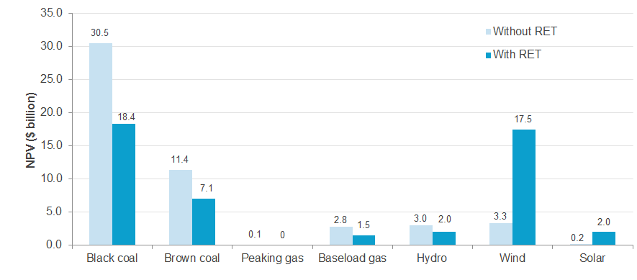

Note: The without RET scenario assumes the RET ceases operation from 1 January 2015 and any mechanism used to compensate investments made under the RET, if one were introduced, does not affect wholesale or retail price outcomes (ACIL Allen 2014, p. ii). The with RET scenario assumes the current RET remains in place. ACIL Allen calculated profit measure as modelled pool revenues (energy and LGCs), less fixed operating and maintenance costs and variable generating costs.

Source: Warburton review 2014, based on ACIL Allen 2014

Figure 8 Large fossil fuel power stations acquired or commissioned, 2009–2014

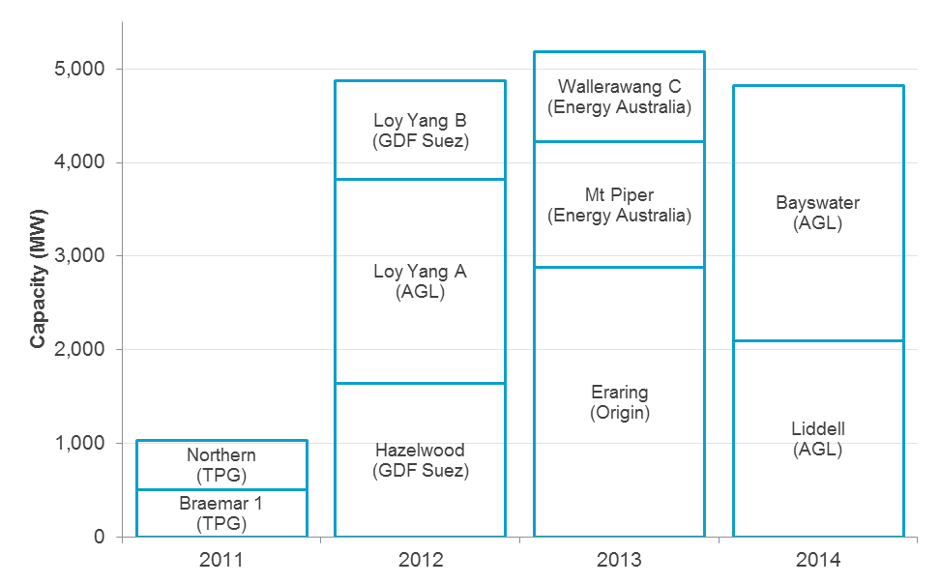

Note: For the purposes of this analysis, large power stations are those over 500 MW capacity. Name of commissioning or purchasing entity in brackets. Analysis covers the period 2009–2014; purchases and commissions only occurred from 2011 onwards. TPG purchased Alinta in 2011. Excludes plant purchased or commissioned by state-owned generators.

Source: Climate Change Authority based on ACIL Allen 2014 and public announcements listed in References

The Authority concludes that, in the absence of other policies, the RET remains the central policy instrument for reducing electricity sector emissions. The overall impacts on electricity consumers are modest and, where appropriate, best mitigated through the provision of targeted assistance to vulnerable households and electricity‑intensive businesses. It is difficult to be persuaded that existing fossil-fuelled generators are being unfairly burdened by the RET’s impacts, given the timing of many purchase decisions and the payment of compensation for a carbon price that has since been withdrawn.

|  |
| --- |
| Conclusion   1. The Renewable Energy Target arrangements are currently the primary policy instruments for electricity sector decarbonisation, and no more cost-effective and scalable measures are in prospect at this time. Their overall impacts on electricity consumers are quite modest, and are mitigated through the provision of targeted assistance. |

1. The Large-scale Renewable Energy Target

|  |
| --- |
| This chapter considers the role of the Large-scale Renewable Energy Target (LRET) in the current policy context, including the level of the LRET and exemptions for emissions‑intensive, trade‑exposed (EITE) industries.  First, it examines whether the current 2020 LRET target remains feasible, and the best course of action if this is not the case. It concludes that there is no case to reduce the target, but there is a case for deferring the current 2020 LRET target, for example by up to three years, to provide additional time to ensure it can be met.  Second, it considers the eligibility criteria for determining partial exemptions for trade‑exposed businesses, concluding that present anomalies should not be extended in the event that assistance is expanded in the future.  Finally, it explores the role of the LRET post‑2020 and recommends the government consider, in the absence of more comprehensive policies, an expanded role for the LRET after 2020 capable of delivering substantial decarbonisation in the electricity sector. |

* 1. Feasibility of the current Large-scale Renewable Energy Target

Given the repeal of the carbon price, and doubts about the capacity of the Emissions Reduction Fund and safeguard mechanism to drive necessary emissions reductions in the electricity sector, the LRET will likely be called upon to play a greater role in the decarbonisation of Australia's electricity sector out to 2020 and beyond.

In its 2012 RET review, the Authority considered the feasibility of the 2020 target and concluded that the target was challenging but achievable provided that a price on carbon remained. Since that time several developments have occurred which have undermined investor confidence in this sector and raised doubts about the feasibility of achieving the LRET in 2020. In particular, the erosion of bipartisan support for the target and the prospect of major changes has seen investment in large‑scale renewable projects in 2014 fall to levels not seen since 2002 (Bloomberg New Energy Finance 2014, p. 1).

In light of these developments, the Authority has considered:

* whether the current 2020 target is still ‘technically feasible’ (that is, can the required new capacity be built)
* whether it is still 'financially feasible' (that is, will it be financed)
* how might the current LRET target be modified if there are reasonable doubts about its achievability.
  + 1. Technical feasibility

The first question around the feasibility of any 2020 target is whether it is physically possible to meet. Recent estimates put the amount of new large-scale renewable capacity required to meet the full 41,000 GWh target by 2020 at just below 9,000 MW (Warburton review 2014, p. 29). Meeting this target would require sustaining higher build rates than Australia has achieved to date. Assuming relatively small amounts of construction in 2015, it would require an average annual build rate of about 1,800 MW over 2016–2020, almost three times the highest annual rate to date of 655 MW (Climate Change Authority calculation from Clean Energy Council 2014, p. 6).

One aspect of the feasibility of achieving the target is whether inputs such as steel, components and construction equipment can be obtained. In recent work commissioned by the Clean Energy Council, ROAM Consulting investigated the technical feasibility of meeting the 2020 target by conducting interviews with industry experts (ROAM Consulting 2014, pp. 8–10). ROAM found there are no physical constraints to meeting the target, with sufficient raw materials, components, labour and construction equipment available either domestically or (for some materials) overseas. Overall, and despite the higher build rates required, ROAM concluded that it would be technically possible to build the capacity required to meet the current 2020 target.

A second part of technical feasibility is whether there are enough potential projects sufficiently far advanced that they could be constructed if current investor uncertainties were resolved. Table 3 provides an estimate of the pipeline of new renewable projects by project status. The pipeline consists of about 16,100 MW of wind farm projects and 1,700 MW of large-scale solar projects. About 7,700 MW of the total already has planning approval.

While it is difficult to be certain given the compressed timeframes to 2020, there would appear to be an adequate project pipeline and availability of inputs for the current 2020 target to still be considered technically feasible.

Table 3 Large-scale renewables project pipeline

|  |  |
| --- | --- |
| Project status | Capacity (MW) |
| Undergoing approvals | 10,050 |
| Approvals finished, but other issues require resolution before financial close | 1,600 |
| Ready to build in 2015–16 pending financial close | 5,650 |
| Committed | 500 |
| Total | 17,800 |

Notes: Clean Energy Regulator (CER) information compiled from the Bureau of Resource and Energy Economics' Electricity Generation Major Projects Database and Australian Energy Market Operator’s (AEMO’s) operation planning database, complemented with interviews conducted with project proponents. The CER has not independently substantiated all information provided in these interviews. Information provided represents status at May 2014.

Source: Information provided by the CER to the Climate Change Authority

* + 1. Financial feasibility

For the LRET to remain financially feasible:

* the combination of the wholesale electricity and Large-scale Generation Certificate (LGC) prices must cover the costs of renewable generation
* the LGC price must not exceed the penalty price under the scheme (the 'shortfall charge')
* finance would need to be available to fund the necessary new large‑scale renewable energy projects.

At present, both wholesale electricity market and LGC prices are low, discouraging investment in new renewable capacity.

LGCs cover the gap between the costs of renewable and fossil fuel generation. Other things being equal, lower wholesale electricity market prices mean renewable generators need to earn more revenue from LGCs. If, for example, a wind project required about $90/MWh to be commercially viable, with a wholesale electricity price of about $35/MWh, it would need an LGC price of about $55. If the price of LGCs exceeds the shortfall charge, liable parties will probably choose to meet their liabilities by paying the charge, rather than purchasing renewable generation, with costs passed through to electricity consumers.

Current low LGC prices are heavily influenced by uncertainty about the future of the LRET. Even if Parliament reaches a conclusion soon, it could take some time for investor confidence to return, increasing the cost and reducing the likelihood of investors financing the new renewables required to meet any 2020 target.

The rest of this section discusses the financial feasibility of the target in more detail. It covers views and analysis on meeting the existing 2020 target, the causes and implications of low wholesale and LGC prices, and the potential availability of finance for new generation.

The current 2020 target and the shortfall charge

In submissions to the Warburton review,[1] participants expressed conflicting views about whether the existing target can be met without triggering the shortfall charge.

If a liable entity does not surrender the number of certificates required under the LRET or the SRES, a shortfall charge applies to the outstanding amount. The shortfall charge for both the LRET and SRES is a nominal price of $65/MWh. Costs incurred by purchasing certificates are tax‑deductible, while the payment of the shortfall charge is not. Liable parties could therefore purchase certificates at a higher price (a tax effective price of about $93/MWh, assuming a company tax rate of 30 per cent), before they were financially worse off than paying the shortfall charge (assuming the company is in a tax‑paying position). If the LGC price exceeds the shortfall charge, then liable entities will probably choose to pay the shortfall charge, so the amount of renewable energy for that year would be below the target level. Because the shortfall charge is not indexed, its value falls over time in real terms. By 2020, the tax-effective shortfall charge is estimated to be worth $79/MWh in today's dollars (ROAM Consulting 2014, p. 19).[2]

Infigen submitted that there are sufficient large‑scale renewable projects in the pipeline to reach the required capacity, provided regulatory certainty is restored. The Clean Energy Council agreed, citing its commissioned modelling from ROAM. Box 2 provides an overview of the different modelling exercises conducted on the RET.

Some participants, including the Australian Industry Group (AiG) and Origin Energy, noted that the 2020 target is becoming increasingly difficult to achieve, with AiG citing the uncertain political environment as a key factor.

Other participants, including AGL, the Australian Energy Market Commission (AEMC), Energy Australia and the Energy Supply Association of Australia (ESAA), stated that the target can no longer be achieved without triggering the shortfall charge. Energy Australia argued that the rapid build rate and suppressed wholesale prices would render new projects uneconomic. The AEMC cited modelling by Frontier Economics that indicated the target would not be met due to low wholesale prices, low demand growth and repeal of the carbon price (Frontier Economics 2014, pp. 28–9). AGL stated that:

At current LGC and wholesale electricity market prices, new investments in renewable energy projects cannot be justified economically. Given the market based policy mechanism of the RET and the energy-only market design of the National Electricity Market (NEM) in particular, it is inconceivable that the investment in renewable projects required to meet the LRET will be forthcoming, particularly against the backdrop of the manifest uncertainty in relation to broader energy policy. (AGL, Warburton review submission, p. 1)

Modelling commissioned for the Warburton review projected that the 2020 target could be met without the LGC price exceeding the shortfall charge (ACIL Allen 2014, p. 14). This and other commissioned modelling provides information about whether the current target would be met under a situation in which projects are built relatively steadily to meet the current targets. This means that it is less informative about a situation in which the regulatory uncertainty to date, or further lengthy delays in reaching a political agreement on the RET reduce investment in renewables over the next year or so.

* + - 1. Large-scale Generation Certificate prices

To ensure any LRET target is met through renewable generation, rather than retailers paying penalties, LGC prices should not exceed the shortfall charge, but they should be sufficient, in combination with expected wholesale prices, to cover the costs of new renewable generation. At present, LGC prices are low for two main reasons:

* a surplus of certificates created by small‑scale solar PV (these were created before the RET was split into the LRET and SRES)
* expectations of future cuts to the 2020 target.

Accounting for 2013 surrenders, there are currently about 26 million surplus LGCs (ACIL Allen 2014, p. 14), suppressing prices and making it more difficult for projects to reach financial close. The Investor Group on Climate Change (IGCC) commented on the effect of this LGC oversupply in its submission to the Warburton review:

We understand that energy suppliers have sufficient accumulated [LGCs] such that they would not need to enter the market to purchase additional [LGCs] for some time. For example, AGL indicated in 2013 that they had sufficient supply of [LGCs] for 5 years of obligations under the scheme. If as a result of weakening the RET, there is still a surplus of [LGCs] in the market for some years, further new build of assets may be delayed as a result of depressed LGC prices. (IGCC, Warburton review submission, p. 7)

More important, however, is that current low LGC prices principally reflect the view of likely cuts to the current 2020 target. In a recent paper, Nelson et al. noted:

Firms expect the target to be altered, and so LGC prices have softened and investment has hence been delayed. Now such little time is left to meet the target that policy makers will almost certainly as a minimum vary the target to avoid manifest policy failure or abandon the existing policy altogether, producing a second wave of dynamic inconsistency. (Nelson et al. 2014, p. 2)

The CER estimates that the volume‑weighted average market price for an LGC will be about $30 in 2015 (CER 2014), with this forward price reflecting anticipated cuts to the LRET (PricewaterhouseCoopers Australia (PwC) 2014, p. 8). This, in combination with current low wholesale prices, is significantly below required returns for new wind projects of at least $80/MWh (Bloomberg New Energy Finance 2013, p. 1).

|  |
| --- |
| 1. Comparing commissioned modelling of the RET   Almost a dozen modelling exercises have been conducted on the RET in recent years. While there are differences in approach and input assumptions, they are more notable for their overall similarity than their differences. For previous RET reviews, Warburton (2014) and the Authority (2012) commissioned modelling from ACIL Allen and SKM MMA, respectively. Other exercises include:   * Deloitte Access Economics (commissioned by the Australian Chamber of Commerce and Industry, the Business Council of Australia and the Minerals Council of Australia, 2014) * Frontier Economics (commissioned by AEMC, 2014) * Jacobs (commissioned by the Climate Institute, World Wildlife Fund and the Australian Conservation Foundation, 2014) * Oakley Greenwood (commissioned by ESAA, 2014) * ROAM Consulting (commissioned by the Clean Energy Council, 2014) * Schneider (2014).   Some of these modelling exercises indicate that the current 2020 target can be met without exceeding the shortfall charge; others indicate that the shortfall charge is triggered before the target is met. In general, the different modelling exercises indicate that, other things being equal, lower electricity demand, higher renewable technology costs and lower gas prices reduce the likelihood of the target being met. Frontier Economics' modelling, incorporating all of these assumptions, is the only one of these exercises finding that not even a ‘real’ 20 per cent target (that is, a target based on 20 per cent of current estimated demand in 2020) could be met.  All exercises show that reducing the LRET improves revenue for fossil fuel generators and that overall impacts on retail electricity prices are modest. Some project retail prices would be slightly lower, and some slightly higher with the abolition of LRET:   * ACIL Allen modelling projects that if the RET is repealed, households would be no better or worse off in the period to 2030 (ACIL Allen 2014, p. 32). * Deloitte estimates that repeal of the RET would reduce the household bills on average by around $49 per year (Deloitte 2014, p. 19). This represents three per cent of a typical household bill of around $1,400. * Jacobs estimates that repeal of the RET would increase electricity prices by between 2.1 and 8.3 per cent over the period to 2030 (Jacobs 2014, p. 27).   Some participants have questioned the technology cost and carbon pricing assumptions of the ACIL Allen modelling conducted for the Warburton review. The assumptions, sources and results from ACIL Allen's modelling are generally similar to those from the Authority's 2012 commissioned modelling:   * Electricity demand—both are based on the Australian Energy Market Operator’s (AEMO’s) medium growth forecasts for demand in the National Electricity Market (NEM). Since 2012 the projected demand for electricity in the National Electricity Market in 2020 has declined by about 16 per cent (Climate Change Authority calculation from AEMO 2012 and 2014a). * Technology costs—both are based on the Australian Energy Technology Assessment published by the Bureau of Resource and Energy Economics. * Gas prices—both forecast the gas price to reach around $9 per gigajoule by 2020.   One area of difference is the 'below baseline' generation for 'pre-existing' generators (largely hydro generators). As described in Box 1, the magnitude of output below baseline levels from pre‑existing generators is important when determining how much additional renewable energy is required to meet a 'real' 20 per cent target (if that were a policy goal). In general, higher output from pre‑existing generators means that a smaller amount of additional renewable generation is required to meet a given overall share of renewables. In 2012, the Authority estimated 2020 generation from these sources of about 14,300 GWh, whereas in 2014 ACIL Allen estimated output from pre‑existing generators of about 16,000 GWh. Actual long‑run output will depend on rainfall levels, which can affect the output of hydro generators. |

* + - 1. Wholesale electricity prices

Low current and expected future wholesale prices, caused largely by excess capacity in the electricity market, are also making it harder to invest in large-scale renewable energy projects, given current low LGC prices.

While the RET is certainly adding capacity, it is neither the sole nor primary cause of oversupply. Other drivers include weakening demand for electricity and barriers and disincentives to exit for incumbent, ageing generators. Reasons why even very old plant might not be exiting now include:

* The bulk of capital costs are sunk, and operating costs of most plants are quite low—so as long as revenues exceed operating costs, plants are likely to keep running.
* 'First-mover disadvantage'—generators that exit earlier make remaining generators (including their competitors) better off because reductions in supply increase wholesale market prices, other things being equal.
* Uncovered site remediation costs—these are potentially very high for some generators and holdings of bonds intended to cover these costs may be inadequate, exposing firms to large liabilities should the site be closed (Nelson et al. 2014, pp. 15–16).
* Uncertainty about the future policy environment—where investors perceive a possibility that generators could be paid to retire, they may continue to operate plant for longer than otherwise planned on the prospect they could be paid to close down.

Potential options to address the oversupply of generating capacity include:

* Let the market resolve the imbalance—allow the persistently low wholesale price to force generators from the market, particularly as large maintenance expenditure decisions fall due. There is some evidence this is starting to happen—in the NEM about 1,300 MW of mothballed generation has recently been or is soon to be permanently retired. About 1,150 MW remains mothballed and more mothballing is planned for the future (Climate Change Authority based on AEMO 2013; AEMO 2014b).
* Industry-supported plant closure—an ongoing revenue stream is provided by the electricity supply industry (which, in turn, would presumably be funded by electricity consumers) to fund the permanent closure of excess generation capacity.
* Taxpayer funding of plant closure.
* Direct regulation—for example, power stations could be required to close once they reach a certain age (Nelson et al. 2014, pp. 19–22).

Selecting the right response is a very important issue for electricity consumers and the electricity supply industry. The retirement of some existing fossil fuel capacity would certainly make it easier to invest in new renewables or any other type of low‑emissions plant. Ultimately, these new investments are essential if Australia is to transition to a low‑emissions economy.

Detailed consideration of the appropriateness of government intervention to deal with excess supply is beyond the scope of this review. The Authority observes, however, that there would be significant equity and precedent issues associated with options that require other parties paying to meet the remediation obligations that properly belong to generators. The Authority also notes that closing a small number of coal‑fired power stations would have a limited impact on Australia's emissions in the short term, to the extent that the lost output was replaced by increased output from other coal‑fired power stations.

The Authority’s concerns about equity issues are shared across state and federal governments. In December 2014, the Council of Australian Governments (COAG) Energy Council stated (p.1) that it does not support assistance to generators to exit the market and ‘opposes the transferral of the costs of retiring assets onto consumers or taxpayers’. The Council will consider whether there are any material barriers to orderly exit and task AEMO with further work on pathways to ensure the exit of generators does not create risks for electricity system security.

* + - 1. Availability and cost of finance for new renewable generation

A critical issue in determining the overall feasibility of meeting the LRET is whether prospective new projects will be able to secure the necessary finance.

To date, investment in new renewable generation to meet the RET has often, but not always, been based on power purchase agreements (PPAs). PPAs are long-term agreements between a renewable energy generator and an electricity retailer with obligations to surrender LGCs. The retailer typically agrees to purchase all electricity generated, with pricing for the LGCs and electricity covering the cost of the renewable investment. A PPA assists the renewable energy project in obtaining finance for construction, because potential investors know that it has a guaranteed price for its output. Retailers can benefit by contracting access to the LGCs required to meet their LRET liability, shielding themselves from unexpected increases in future LGC spot market prices.

For a renewable energy project, the alternative to signing a PPA is to be a ‘merchant’ generator. Merchant generators can rely on spot prices for both electricity and LGCs—or can hedge against future uncertainties through short‑term forward contracts. The lack of a guaranteed price for their output increases the risk relative to a generator with a PPA, which is reflected in higher risk premiums for finance.

As part of this review, the Authority held bilateral meetings with a number of banks and equity investors to better understand the conditions under which investment in new large-scale renewable energy projects would be commercially feasible. Taking these discussions into account, as well as evidence presented in submissions, the Authority concludes that:

* Bipartisan support is critical. Agreement between the two major political parties on the level and timing of the LRET would restore confidence to make investments in new capacity. Many stakeholders have highlighted the need for this commitment to unequivocal, even in the face of continued lobbying for the target to be cut. Given the extent of uncertainty and disruption caused by the recent period of policy uncertainty, investor confidence may take some time to return.
* Surplus LGCs are suppressing prices and making it more difficult to invest. This suggests that if changes are made to the level or timing of the annual targets, then the targets to 2017 should not be altered, to assist with running down the surplus.
* Sufficient generation to meet the target is unlikely to be financed without arrangements such as PPAs that provide certainty about future revenue streams. Given the suppressed wholesale price and uncertain outlook for electricity demand, PPAs (or mechanisms that provide similar certainty) are important for investors (PwC 2014). While investments can be made on a merchant basis, the increased risk raises the costs of finance, which will likely make some potential projects uneconomic.
* The current scheme end date of 2030 will likely curtail the volume of projects that are financially feasible. The IGCC noted that investors typically need 12, and preferably 15 years, of LGC revenue for a project to be commercially viable. Given the time required for investors to regain confidence, project developments may only begin in earnest from 2016 or 2017; even if developments started again in 2015 new projects would not be operational until 2017 at the earliest. The short remaining period for LGC creation would mean recovering costs from fewer certificates, potentially causing the required LGC price to rise above the shortfall charge. An extension of the scheme's horizon would reduce the certificate prices required to raise the same project revenues.
* Frequent reviews of the LRET create uncertainty which discourages investment in the sector. Investors suggested that legislated reviews should be removed altogether, or undertaken less frequently (see chapter 5).

In the near term, the Authority's view is that there is no difficulty in meeting annual targets under the LRET, because of the large overhang of LGCs and the gentle increase in the annual target levels. From 2017 to 2020, however, the annual targets increase steeply from 25,181 GWh to 41,000 GWh (Figure 9). This sharp increase, in combination with the current market conditions and political uncertainty, could make meeting the target too challenging a task, even if an early bipartisan agreement on the LRET were reached. Options for dealing with this situation are discussed in the following sections.

Figure 9 Annual LRET targets 2001–2030

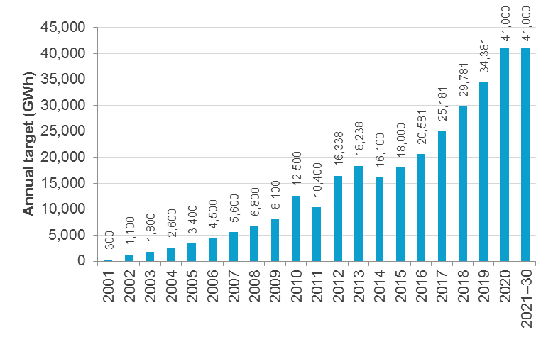

Notes: Targets from 2001–2010 are for the RET as a whole. Annual targets exclude allowance for waste coal mine gas generation. Since 2011 the RET has operated as the SRES and LRET; as part of the split the targets were re‑phased to reduce the number of excess certificates. This included increasing the 2012 and 2013 targets, and slightly reducing the targets from 2016–18 to balance the adjustment.

Source: Warburton review 2014

* 1. Case for adjusting the Large-scale Renewable Energy Target
     1. Level of the 2020 target

In 2012, the Authority considered arguments for changing the level of the LRET. At the time, the Authority considered that, on balance, the level of the target should not be changed. This judgement was largely based on providing stability, predictability and investor confidence for the LRET and climate policy more broadly.

Since then, the risk of the LRET not being met has increased significantly. If liable parties meet their RET obligations by paying penalties rather than surrendering certificates, this increases consumer electricity prices for no environmental benefit. This is a situation to be avoided. Not only would it impose costs on consumers, but it could undermine public confidence in climate policies and erode support for mitigation measures.

In submissions to this review and the Warburton review, some participants, including incumbent generators and emissions‑intensive businesses, argued that the target should be reduced to a 'real' 20 per cent target (that is, one based on 20 per cent of either current estimated or actual electricity demand in 2020) or be abolished completely. Four main reasons were advanced—the LRET does not represent low‑cost emissions reductions, the difficulty of meeting the current target, the oversupply of capacity in the market and the LRET’s large impact on trade‑exposed industries. Stanwell, for example, submitted:

Stanwell supports efficient, industry wide approaches to emissions abatement at least cost to the Australian economy. The current RET does not meet this criteria. (Stanwell, submission to the Climate Change Authority, p. 1)

Other participants, largely renewable energy proponents and non‑government organisations, argued that substantial investment and planning had occurred based on the current target, and that its level should be maintained. WWF Australia noted:

The RET has … mobilised national and international investment and built a strong domestic renewable energy industry which will be important to Australia’s future economic prosperity. The renewable energy target has mobilised around $20 billion in investment to date and will generate nearly $15 billion more by 2020 under the current target. Reducing the RET would threaten these investments and harm Australia’s reputation as a reliable investment destination. (WWF Australia, submission to the Climate Change Authority, p. 2)

The modelling conducted for the Warburton review indicates that reducing the target to a 'real' 20 per cent target (25,500 GWh in the ACIL Allen modelling) would:

* Reduce the amount of new large-scale renewable capacity built between 2014–2020 from about 8,200 MW to 3,200 MW (a reduction of about 60 per cent).
* Reduce the LGC price in 2014 by about $14, which is 26 per cent lower than with the current RET. LGC prices would be consistently more than 10 per cent lower to 2030.
* Improve coal-fired generators' aggregate profits to 2030 by about $9.3 billion in NPV terms ($6.6 billion for black coal; $2.7 billion for brown coal).
* Reduce investment in the renewables sector from about $14 billion to around $6 billion over the period to 2030.
* Lower household bills slightly to 2020, then increase them slightly to 2030, resulting in a cumulative increase of $118 over 2015–2030 in NPV terms.
* Increase cumulative emissions by 39  Mt CO2‑e over the period 2015–20 and 190 Mt CO2‑e over the period 2015–30 (ACIL Allen 2014, pp. 40–50; Warburton review 2014, pp. 51–2).

Many participants acknowledged the need to make provisions for existing projects in the event the target is cut. The Business Council of Australia (BCA) noted:

Recognising that investments have now been made under the scheme, the scheme cannot be scrapped without stranding assets and creating issues of sovereign risk. Therefore, any amendments to the RET should seek to not adversely affect investments that have already been made and should be mindful of their impact on investments currently being planned or already subject to approval. (BCA, Warburton review submission, p. 15)

The design and implementation of appropriate transitional assistance for existing projects would not be straightforward. Providing standardised assistance by fixing an LGC price would likely lead to windfall gains or losses for individual projects. Project‑specific measures would avoid this problem, but implementation would be more complex. For example, criteria would need to be established for assessing what were reasonable expectations of the LGC price on commencement of a project and who bore the risk for a reduction in the price under each contract. In addition, providing transitional assistance to existing projects raises the costs of any weakening of the LRET targets. These costs are likely to be borne ultimately by electricity consumers or taxpayers.

Any sizeable reduction in the target would also retard the decarbonisation of Australia’s electricity sector. As outlined in section 2.4, the electricity sector will play an important role in Australia's transition to a low‑emitting economy. Cuts to the RET now would require more rapid emissions reductions in the sector later, and more reductions to be made up from elsewhere to meet Australia’s 2020 target. At this time, there is no evidence that emissions reductions of the scale required from the electricity supply sector could be obtained more cheaply through the ERF.

The importance of the RET in reducing Australia's emissions was noted by some stakeholders, including AiG:

If the RET were removed or significantly scaled back, there would be a much larger gap between likely emissions and Australia’s commitment to reduce greenhouse gas emissions to at least five per cent below 2000 levels by 2020. The cost and difficulty of bridging this gap through other policies could be significant, particularly if low‑cost international abatement options are excluded. (AiG, Warburton review submission, p. 4)

It should be noted that the RET was always intended to deliver ‘at least 20 per cent’ renewables and had the goal of subsuming the existing and planned state-based targets that existed when it was developed (Explanatory Memorandum, REE Amendment Bill 2009 (Cth)).

In the Authority’s view, the changed circumstances since its last review do not warrant a reduction in the target. In particular, there is no compelling justification for reducing the target to a level representing 20 per cent of an updated electricity demand forecast for 2020. There is no reason to think that 20 per cent is the ‘right’ amount of renewable energy. As noted above, a significant reduction in the target would not decrease consumer prices and would not provide a satisfactory solution to the current oversupply problem. It would, however, defer investment in renewable generation, leading to higher electricity sector emissions, making it harder for Australia to achieve the deeper emissions reductions required beyond 2020. While modelling indicates that maintaining the current target level reduces fossil fuel generators' profits, it is likely that any effective mitigation policy will have this kind of effect. The next section considers the Authority’s preferred option for adjusting the LRET.

* + 1. Rescheduling the LRET targets

The current target of 41,000 GWh of renewable energy in 2020 is looking increasingly challenging to achieve. Rather than cutting the 2020 target, the Authority suggests that consideration be given to extending the end year for achieving the target. This could help to restore confidence in the scheme, and provide the industry with some 'breathing space' to resume building the required capacity, following the disruptions of recent years. It would also provide some extra time for incumbent generators to adjust to further falls in projected electricity demand in 2020—for example, projected demand for electricity in the NEM in 2020 has declined by about 16 per cent since 2012.

Figure 10 shows a proposed reschedule, which:

* retains the current annual targets to 2017 to run down the present surplus of certificates
* extends the end date for operation of the LRET by at least the same number of years as the 41,000 GWh target is extended to ensure projects built later in the period have enough time to recoup the cost of their investments.

Figure 10 Proposed re-phase for LRET targets



Source: Climate Change Authority

Recent modelling of the LRET has not specifically analysed the effects of deferring the 41,000 GWh target. A few stakeholders have commented on the case for deferring the current 2020 LRET target. The Major Energy Users Association submitted that:

The proposition by some liable parties to extend the transition period (to 41,000 GWh LRET) beyond 2020 while ramping up the target in the years between 2020 and 2030 (e.g. the 30/30 proposition) suggests a reasoned compromise. It avoids the heavy short‑term burden on industry and consumers, but provides ongoing signals for investment in renewable energy as demand grows and/or international agreements emerge. (Major Energy Users Association, Warburton review submission, p. 48)

Schneider has modelled an LRET scenario where the targets are reshaped, with obligations reduced in the near term (to 2020) and added at the back end of the scheme (2020 to 2030), with overall obligations the same. This modelling suggests that deferring the target in this way would have a minimal impact on overall emissions (Schneider 2014, pp. 8–10).

* + 1. The Authority's view

On balance, the Authority considers it is better to extend the 2020 target and increase confidence it can be met, than to retain the target and miss it.

Given the doubts about achieving the LRET target by 2020 discussed earlier—reflecting policy uncertainty and low investor confidence—this approach would seem to be a pragmatic basis for moving forward.

A 'minimal change' approach would be to extend the targets by up to three years—and extend the end of the scheme by at least the same amount of time (Table 4). Any new LRET schedule should take account of the current LGC surplus, and leave targets to 2017 unchanged. The revised schedule should also take account of the time required for restoration of investor confidence and the physical construction of required capacity.

Table 4 Illustrative re-phase of the 2020 LRET target—two examples

|  |  |  |  |
| --- | --- | --- | --- |
|  | LRET Targets (GWh) | | |
| year | Current | 2‑year extension | 3‑year extension |
| 2017 | 25,181 | 25,181 | 25,181 |
| 2018 | 29,781 | 28,345 | 27,818 |
| 2019 | 34,381 | 31,509 | 30,454 |
| 2020 | 41,000 | 34,672 | 33,091 |
| 2021 | 41,000 | 37,836 | 35,727 |
| 2022 | 41,000 | 41,000 | 38,364 |
| 2023 | 41,000 | 41,000 | 41,000 |
| *Ending* | *2030* | *2032 (at the earliest)* | *2033 (at the earliest)* |

Note: The table provides illustrative examples of extending the target by two or three years and extending the scheme by at least the same amount of time. Given the large overhang of certificates, there is no case to reduce the annual targets until after 2017.

Source: Climate Change Authority

|  |
| --- |
| recommendation   1. Given the sharp decline in investor confidence, the resulting slowdown in investment, and the further reduction in projected electricity demand, the government should:  * defer the 2020 target for the LRET by, say, up to three years and * extend the scheme as a whole by at least the same amount of time, with a view to providing sufficient time for projects to recover their costs.   Given the large overhang of certificates, there is no case to reduce the annual targets until after 2017. |

* 1. Exemptions for emissions-intensive, trade-exposed industries

This section considers whether the current basis for assisting particular businesses with RET costs remains appropriate.

Partial exemptions are provided for businesses undertaking emissions‑intensive, trade‑exposed (EITE) activities on the basis that RET costs reduce the competiveness of businesses competing in an international environment.

The current RET partial exemption framework determines eligibility and assistance rates based on an activity's overall emissions intensity, regardless of the extent to which those emissions are related to electricity use. Emissions intensity is determined using historical data and the exemption is only applicable to the portion of RET costs associated with expansion of the original 9,500 GWh MRET. Highly EITE activities are eligible to receive a 90 per cent exemption of their incremental RET costs, while moderately EITE activities are eligible for a 60 per cent exemption. In 2013, this translated to an exemption rate of about 75 per cent for highly EITE activities and about 50 per cent for moderately EITE activities (Warburton review 2014, p. 79).

There is some (understandable) confusion between 'exemption' and 'liability' under the RET. Most EITE businesses are not liable entities. Liable entities under the RET are those that acquire electricity from the wholesale market or electricity direct from a generator—in practice, primarily electricity retailers. When EITE businesses receive assistance with RET costs, overall RET liabilities remain unchanged, so RET costs are passed through to a smaller set of non­‑exempt customers.

Exemptions are provided through Partial Exemption Certificates issued by the CER to EITE businesses. The value of the exemption takes into account the assistance rate and a range of other inputs, including:

* electricity use per unit of output for the activity—each activity has a specified industry average electricity baseline, the value of which is predetermined from historical data and is set in regulations
* output—the quantity of relevant product is submitted to the CER by the EITE business every year
* proportion of electricity use from a given site that incurs a RET liability.

The Authority considered the assistance for EITE activities in its 2012 RET review, but did not form a conclusion. At the time, the carbon pricing mechanism included a similar assistance regime for the same activities, leading the Authority to recommend the Productivity Commission consider the issue as part of its broader review of carbon pricing assistance. With the repeal of the carbon price, the Authority has considered whether the eligibility criteria remain appropriate.

Providing assistance based on emissions intensity, rather than electricity intensity, leads to some anomalies. Figure 11 shows the emissions intensities and electricity intensities of selected activities and the thresholds for assistance. Based on the current eligibility thresholds, some activities, such as lime and ammonium nitrate, are highly emissions‑intensive, but not particularly electricity‑intensive. These activities receive a high level of exemption from RET costs, despite having lower electricity intensities than some moderately emissions‑intensive activities, such as tissue paper manufacturing.

Providing assistance with electricity costs to businesses that are not particularly electricity intensive places a greater burden on non-exempt electricity users. In the Authority's view, any changes to assistance with RET costs should be based on need and the best measure of need in this context is electricity intensity. If broadening of assistance is considered, it should be based on electricity intensity.

Figure 11 Emissions intensity and electricity intensity of selected activities eligible for partial exemptions from RET costs

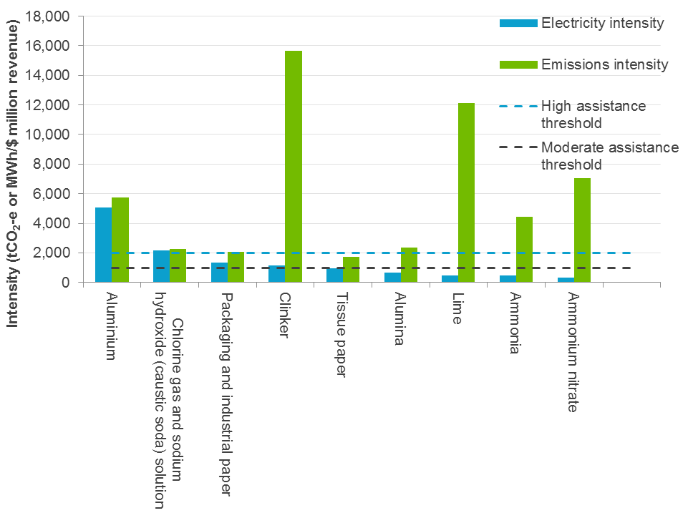

Note: The emissions intensity for each activity includes scope 2 (electricity) emissions, with 1 MWh of electricity use converted to 1 tCO2‑e. All numbers in this figure have been provided as midpoints of ranges to protect commercial confidentiality. The eligibility threshold for highly EITE activities is 2,000 tCO2‑e/$ million revenue and for moderately EITE activities it is 1,000 tCO2‑e/$ million revenue. (There are also thresholds based on tCO2‑e/$ million value added; activities are eligible for assistance if they qualify under either metric.) Data was originally provided to the Department of Climate Change and Energy Efficiency for the purpose of establishing the eligibility of EITE activities under the Jobs and Competiveness Program and Renewable Energy Target exemption scheme. Emissions data was provided for the financial years ending 2007 and 2008, and revenue data was provided for the financial year ending 2005 to the second half of 2008.

Source: Climate Change Authority based on data provided by the Department of the Environment

|  |
| --- |
| Conclusion   1. If any further exemptions from electricity costs under the RET are to be granted, this should be on the basis of electricity intensity, rather than emissions intensity. |

* 1. The Renewable Energy Target after 2020

Chapter 2 included comparisons of the projected emissions intensity of Australia's electricity supply in 2030 under low-emissions pathways with those under the current RET. This highlighted that more will need to be done beyond 2020 for Australia to follow a transition path consistent with global action to reduce the risks of dangerous climate change. This does not, of itself, necessarily mean that the RET should be maintained indefinitely, or increased or extended. Indeed, the Authority would like to see a more comprehensive approach to the electricity sector which would encourage all forms of zero- and low‑emissions generation technologies, and discourage more emissions‑intensive forms of generation, in a more cost-effective way than is attainable through the RET alone. That approach, however, seems some way off, and in the meanwhile further increases in and of RET targets post‑2020 should be considered.

As part of any consideration of increased and extended RET targets, eligibility for certificate creation should also be reconsidered. The RET might be modified, for example, to become a low‑emissions target through the inclusion of other zero- or low‑emissions technologies. This could include waste coal‑mine methane generation plants, plants burning industrial waste gases derived from fossil fuels, potentially coal or gas carbon capture and storage plant, and, if ever permitted by law, nuclear energy. Certificates created for non-zero‑emissions plant could be discounted relative to zero‑emissions plant.

Consistent with the conclusions drawn in its 2012 RET review, the Authority believes that issues of investor confidence and regulatory risk remain highly relevant to investors in renewables and should be taken into account when considering future policy options.

The Authority has recently been asked to conduct a special review under section 59 of the Climate Change Authority Act 2011 over the next 18 months. This will cover future national emissions reduction targets, emissions trading and other plausible measures relevant to Australia pursuing its post‑2020 emissions reductions targets. Stakeholder views on policy options for the electricity sector will be sought as part of this review.

|  |
| --- |
| Recommendation   1. Over the longer term increased recourse to renewables in electricity generation is essential to Australia’s efforts to reduce its total greenhouse gas emissions. In the absence of effective alternatives, RET arrangements will have to carry much of this burden, so consideration should be given—at the appropriate time—to the nature and timeframe of possible RET arrangements in the post 2020 period. In particular, the government should consider increasing and extending targets, and expanding arrangements to cover a wider set of technologies. |

1. The Small-scale Renewable Energy Scheme

|  |
| --- |
| The SRES provides support for small-scale renewable technologies, including small-scale solar PV. Owners of eligible small-scale technologies receive tradeable certificates upfront for the amount of renewable electricity the system is 'deemed' to create over a given period, which they generally assign to the installer in exchange for a lower system price. Installations of solar PV have exceeded expectations and so far, about 1.3 million solar PV systems have been installed under the RET, producing about 3,800 GWh of electricity in 2013.  This chapter focuses on solar PV and considers whether the level of assistance provided under the SRES should be adjusted, and, if so, how. It considers the impacts of the SRES and whether the benefits achieved represent value for money for Australia as a whole.  It concludes that subsidising PV under the SRES is a relatively expensive way of reducing emissions from the electricity sector, but does not see any strong case for urgent change, given that the overall costs are relatively modest and assistance will start phasing out from 2017. If any changes are introduced, they should be gradual to avoid creating disruption in the sector. |

* 1. The Authority's 2012 conclusions and subsequent developments

In its 2012 review (CCA 2012, p. 65), the Authority identified four potentially problematic issues with the design of the SRES, but did not recommend any fundamental changes. Those issues were:

* the uncapped nature of the scheme means that the SRES can account for a relatively large share of total RET costs for consumers under certain circumstances
* unlike the LRET, the subsidy provided to small-scale systems does not automatically reduce with falling technology costs, meaning that government intervention is required to reduce assistance rates
* there was no legislated end date for the scheme (this has now changed)
* paying for 15 years of generation upfront ('deeming') was unlikely to be justifiable for larger solar PV systems below the eligibility threshold of 100 kilowatts (kW).

The Authority considered a number of options for addressing these issues, including recombining the SRES and LRET, and introducing certificate discounting that the Minister could initiate under pre‑specified conditions. On balance, the Authority opted to propose modest adjustments to guard against possible booms and high costs, rather than any major and likely disruptive changes. Specifically, the Authority recommended lowering the eligibility threshold for solar PV and adding an end date to the scheme; the second of these was accepted and the scheme will now end in 2030.

At the time, the Authority noted that more disruptive options, such as recombining the LRET and SRES, might have been justified if the uptake of small-scale systems was expected to continue its strong growth. It found, however, that as the factors driving the boom—sharp falls in system costs, generous payments for exported electricity through state-based feed-in tariffs, and 'multiplier' credits for solar PV—were no longer present, and installations were expected to stabilise. This seems to be occurring—data from the Clean Energy Regulator (2014) shows that system installations in 2013 (the last year for which data are complete) were actually 44 per cent lower than their 2011 peak.

That said, with the exception of the legislated end date, the design issues and consequent risks that the Authority identified in 2012 remain today. Data from the Australian PV Institute indicate that since 2012, costs for PV modules and overall PV systems have continued to decline, albeit at slower rates (Figure 12). The average system size and the share of larger systems is rising (Figure 13); this increases the compliance costs of the SRES, other things being equal. Typical module prices fell from $1.50 per Watt in 2012 to $0.75 per Watt last year; installed prices for typical small residential systems dropped less rapidly, falling from $3 to about $2.50 per Watt. Very recently, there have been reports (see for example Edis 2014) that some suppliers have been offering prices as low as $1 per Watt for fully installed systems after SRES assistance, implying a total installed price of $1.60 per Watt.

Figure 12 Trends in Australian PV system costs, 2000–2013

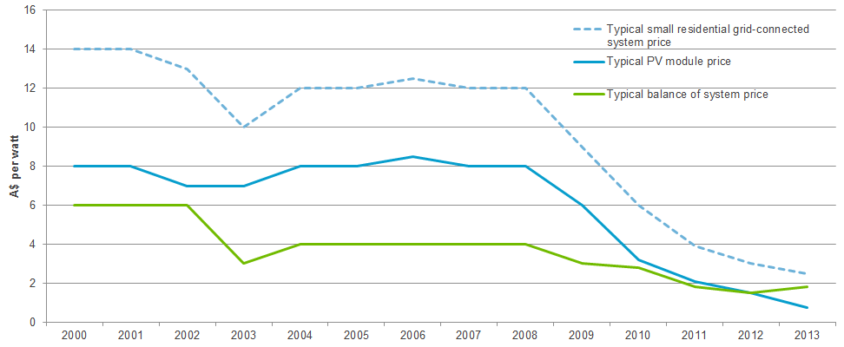

Note: Prices are prior to any assistance under the SRES and are in nominal dollars.

Source: Climate Change Authority based on Australian PV Institute 2013

Arguments for maintaining current levels of support have become less compelling with the decline in upfront costs.

Stakeholder views on the SRES are polarised. Liable entities, large energy users, peak electricity and some business peak bodies favoured scaling back or phasing out assistance on the grounds that solar is now a cost-effective economic investment for households and no longer requires a subsidy. Other stakeholders involved in the small-scale market argued that the SRES should be retained in its current form because of the public benefits it creates.

Figure 13 Share of installed PV capacity by system size, 2009–2014

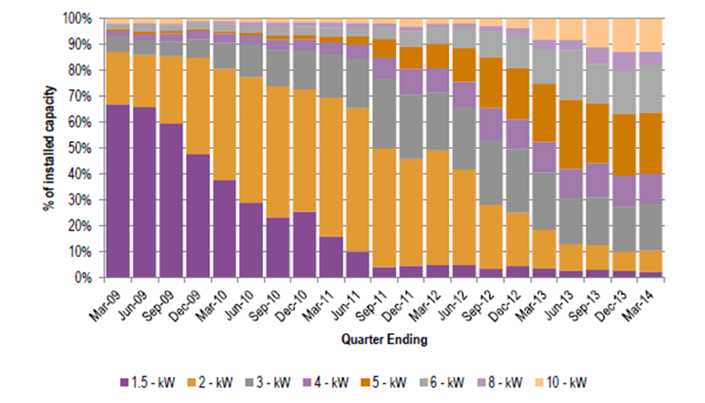

Note: 10 kW includes systems of 10–100 kW.

Source: ACIL Allen 2014

Submissions[3] from the Australian Industry Greenhouse Network, Business Council of Australia, and Energy Networks Association argued for abolition. Others supported an accelerated phase‑out, suggesting a range of approaches including capping the scheme, reducing the length of deeming periods and applying a discount factor to certificates. AiG proposed regular and predictable adjustments using a formula that accounts for changes in the consumer cost of small‑scale technologies and retail electricity prices.

Stakeholders advocating the SRES be retained highlighted the impacts on the industry should the scheme be abolished, and argued that it has beneficial impacts on electricity prices and has driven improvements in industry standards and innovation. The Australian PV Institute, REC Agents Association, Yingli Solar and SunWiz argued that the growth of distributed PV reduced reliance on higher cost generators during extreme temperature events, helping suppress wholesale power prices. The Clean Energy Council (CEC), REC Agents Association, Australian Solar Council and Australian PV Institute argued that rooftop solar will also deliver future benefits by deferring upgrades to the electricity network.

Many stakeholders in the industry pointed to the structure and wide geographical distribution of employment in small-scale renewables, and argued that abolishing the SRES would result in the loss of thousands of jobs. SunWiz argued that reducing or abolishing the SRES would increase upfront costs and payback periods for PV systems, and have a substantial impact upon their affordability and demand. The REC Agents Association pointed to the benefits of the SRES to the industry to date, arguing it has helped drive scale, resulting in lower costs through the industry supply chain and innovations in the marketing, delivery and installation of solar systems. The CEC argued that the SRES plays a vital role in ensuring high standards of quality assurance and safety within the industry because only PV systems designed and installed by accredited parties can access the SRES.

Whether the level of assistance provided under the SRES should be adjusted and, if so, how, are reasonable questions to be asking. Because assistance for PV systems is paid up‑front, changing the level of assistance will have no effect on households who have already installed PV—there is no 'stranded' asset risk for such households. Rapid step changes, however, could significantly disrupt installation businesses.

In considering assistance under the SRES, the Authority has looked at:

* the impacts of the SRES
* whether the benefits achieved represent value for money for Australia as a whole
* the need for a smooth transition if assistance were to be reduced, to avoid the risk of serious disruption in the installation industry.

Two preliminary points should be noted. First, the discussion here should not be interpreted as relating to assistance for technologies other than solar PV. In this limited review, the Authority has confined its focus to solar PV because it makes up the overwhelming majority of certificate creation under SRES (over 90 per cent of certificates in 2013) (Climate Change Authority calculation from IES 2014, p. 10). Modelling commissioned for the Warburton review suggests that this dominance will continue, with solar PV projected to make up 75 per cent of cumulative certificates created over 2015–2030 (Climate Change Authority calculation from data underlying ACIL Allen 2014, p. 17).

Second, this analysis focuses on household PV rather than larger, commercial-scale PV; time and resources have prevented the Authority from considering commercial-scale PV in this review; Box 3 provides an overview of the issues.

* 1. Impacts of the SRES

Small-scale PV has private and wider social costs and benefits. In addition to the net private benefits for households, installation of small-scale PV has three sources of wider social impact:

* emissions reductions associated with displacement of electricity from the grid
* the 'network impacts' of PV installations on the broader systems that transmit and distribute electricity from generators to consumers
* growth of the small-scale PV industry.
  + 1. Household costs and benefits of PV

As with measures to improve household energy efficiency, barriers to the uptake of PV can include price or other factors, some of which SRES addresses through an upfront subsidy. Installing household solar PV has net financial benefits for households—the reduction in ongoing electricity bills from self-generation is likely to more than offset the upfront cost of installing a PV system. Net financial benefits would probably accrue even without the SRES, but by providing an upfront payment[4] to households, the scheme lowers initial expenses and shortens the payback period. The upfront payment represents the amount of renewable energy the system is 'deemed' to create over a given time frame, and increases with system size and the ‘quality of the solar resource’ (that is, the sunniness of the broad location). This support will decrease from 2017 as the deeming period reduces by one year each year until the scheme ends in 2030.

|  |
| --- |
| 1. Treatment of commercial-scale PV in the RET   In its 2012 review, the Authority noted the risk that future increases in installations of commercial‑scale solar PV could increase the volume of STCs and therefore the costs of the uncapped SRES. The Authority recommended reducing the eligibility threshold for PV and that the government conduct further consultations to determine an appropriate threshold. Systems over the threshold would be incorporated in the LRET with five-year deeming. Earlier this year, the Warburton review made a similar recommendation, specifying an SRES eligibility limit of 10 kW (see Appendix C).  Installed capacity of systems over 10 kW grew by an estimated 150 per cent over 2012–13, albeit from a very low base. Much of this growth was encouraged by grants from the now‑discontinued Clean Technology Investment Program (Green Energy Markets 2014, p. 32). The Warburton review (2014, p. 74) notes the presence of barriers to uptake that would reduce the likelihood of a significant future boom in commercial-scale PV, such as the fact that industrial businesses pay lower electricity tariffs than households, and often rent their premises.  That said, as the market for household solar PV becomes more saturated, PV suppliers will likely increase their efforts to target business customers, including through offering arrangements such as solar leasing that would lower some of these barriers. This entails some risk of a boom in these systems, which would cause a rapid increase in SRES costs.  Both the renewable energy industry and the CER have raised concerns at the high compliance costs associated with shifting larger systems into the LRET. The Clean Energy Council (2014) reports that installing and checking the more sophisticated meters required would increase installation costs by several thousand dollars. The CER would experience very large increases in applications for accreditation.  Moving larger systems into the LRET is but one approach to managing the risks to future SRES cost blowouts (and would require a solution to the high transaction costs problem to be viable). Other options are:   * retaining commercial-scale PV in the SRES but issuing certificates more frequently (either fewer years of upfront deeming or at intervals in arrears) * retaining commercial-scale PV in the SRES with a more rapid phase-out of deeming.   The Authority believes further consideration of the consequences of these options is warranted, but it has not been possible in the course of this review. |

The average upfront cost of installing a 3 kW solar system (a common system size) is estimated at about $7,670 in 2014 (Green Energy Markets 2014, p. 27). SRES payments cover about one‑third of this cost; on average across states and territories, this lowers the simple payback period of a 3 kW system from 10 to about seven years (Warburton review 2014 p. 66). As the deeming period reduces in future, the absolute value of this upfront payment will fall by about $160 per year in nominal terms.[5]

In addition to net financial benefits, households also receive non-monetary benefits from installing PV. Many get satisfaction, for example, from reducing their reliance on energy retailers and feel that generating renewable energy at home is a 'practical' or direct way of contributing to Australia's emissions reduction task.

The funds for the SRES subsidy are ultimately provided by electricity consumers as a whole. Liable parties under the RET—generally electricity retailers—have to surrender certificates created by renewable energy from small-scale technologies: retailers pass the costs of purchasing these certificates onto their customers. In 2014, SRES costs were estimated to make up 1.6 per cent of an average household electricity bill (ACIL Allen 2014, p. 24); SRES costs would represent a larger share of commercial bills because commercial users generally have lower electricity tariffs.

* + 1. Social costs and benefits of PV
       1. Emissions reductions

Generating electricity from solar PV displaces emissions-intensive grid electricity. So far, about 1.3 million solar PV systems have been installed under the RET, producing about 3,800 GWh of generation in 2013 (Warburton review 2014 pp. 8,10). This total embraces all of the solar PV subsidised by the SRES, including systems that households would have installed in the absence of SRES. The emissions reductions properly attributable to policy depend on the number of ‘additional’ installations the SRES has encouraged.

Assessing ‘additionality’ is difficult, given the judgments that have to be made about how many systems would be installed without SRES. Modelling by SKM MMA for the Authority's 2012 RET review, and by ACIL Allen for the Warburton review, provides two estimates of the additional systems that might be encouraged by the SRES in future:

* ACIL Allen projected that about 2,800 MW of solar PV would be installed over 2015–2020 without the SRES and 3,700 MW would be installed with the SRES in place; this suggests about one-quarter of projected installations to 2020 might be additional (Climate Change Authority calculation from data underlying Warburton review 2014, p. 69). ACIL also projects ‘additional’ emissions reductions of 15 Mt CO2-e over the period to 2030 (ACIL Allen 2014, p. 116).
* SKM MMA projected about 3,400 MW of solar PV without the SRES and 3,500 with the SRES in place over 2012–13 to 2020–21, suggesting fewer than five per cent of installations would be additional (Climate Change Authority calculation from SKM MMA 2012).

It is possible that the proportion of 'additional' systems encouraged by the SRES is falling over time. The lower the pre-subsidy upfront costs, the shorter the payback period, so, other things being equal, falls in upfront costs are likely to raise the share of uptake that would occur regardless of the policy.

* + - 1. Impacts on the electricity network

Different electricity consumers place different demands on the networks that transmit and distribute electricity. Air conditioning, for example, can impose heavy demands at peak times, increasing network costs. Solar PV can reduce a consumer’s demand on the network during peak times, but also uses the network to export generation surplus to the household’s requirements. Current approaches to network pricing do not accurately reflect the costs and benefits created by different consumers. As a result, network pricing can tend to over- or under-encourage the installation and use of technologies such as PV and air conditioning.

The introduction of more cost-reflective network pricing is an important issue for the electricity sector. It is beyond the scope of this review, but is currently being addressed through other channels, such as Australian Energy Market Commission rule changes (AEMC 2014a).

Available estimates of the impact of PV on networks differ, but generally indicate that PV either imposes much smaller costs on other network customers than air conditioning does, or provides net benefits (NERA 2014, APVI 2013). A recent case study used modelled PV data to estimate that a household with a 2.5 kW north-facing PV system receives a reduction in their network charges that is approximately $120 per year greater than value of the reduction in network costs caused by the PV system. In contrast, a case study in respect of a large air conditioning unit found the additional network costs were approximately $680 per year more than the extra network charges paid by the household (NERA 2014 cited in AEMC 2014b, pp. 28–9).

* + - 1. Impacts on the installation industry

The final wider social impact of households' demand for PV is that businesses exist across Australia to satisfy it. Any changes to the level of assistance provided through the SRES would affect the owners and employees of these businesses and their suppliers. This is not directly relevant to the level of assistance provided under the SRES, but it does have implications for the manner in which any changes to the SRES are introduced. Sudden changes in government subsidies, for example, can have damaging effects on the owners and employees of businesses providing the subsidised good. The report of the Royal Commission into the Home Insulation Program details many examples of the impacts of such policy changes on the lives and wellbeing of business owners and staff, and was critical of how these issues were handled. It describes some of the impacts of that program's sudden termination in the following terms:

… many businesses found themselves with an immediate freezing of their cash flow. As a result, many businesses had ongoing commitments to suppliers with forward orders that could not be met. Businesses were left with commitments on property leases, vehicles, equipment, and held insulation stock which could not be moved and no longer had any appreciable value. Some businesses had a liability to financial institutions, sold or disposed of vehicles, stock and equipment at a loss, or had to sell their family home to meet their business debts. (Hanger 2014, p. 287)

This highlights the need for any changes to assistance arrangements under the SRES to be introduced in ways which avoid creating potential 'boom-bust' situations.

* 1. SRES assistance for solar PV and value for money

There is at least a strong suggestion that the SRES may subsidise a reasonably large volume of installations that would occur anyway. Even when viewed in terms of the probable additional installations, it appears that reducing emissions by installing small-scale solar PV is a relatively expensive way to reduce emissions in the electricity sector.

As discussed in section 2.2.3, the appropriate measure of the cost per tonne of emissions reductions is the incremental net present value of the resource cost divided by the incremental undiscounted emissions reductions delivered by the policy. Published estimates of the cost per tonne of emissions reductions from the SRES calculated in this way are very limited. ACIL Allen’s modelling for the Warburton review generated projections of about $95 per tonne of CO2-e over the period to 2030 for solar PV (in 2014 dollars; Warburton review 2014, p. 42). This modelling incorporates a levelised cost of energy (a measure of the cost of generating electricity from a technology that includes building and running costs) of about $190/MWh, which is about double the estimated levelised cost of wind (about $80–$100/MWh) (ACIL Allen 2014, p 115). Both estimates omit some avoided resource costs (see Box 4).

What is clear, however, is that the cost per tonne of emissions reductions from solar PV under the SRES is relatively expensive compared with:

* the LRET, which is projected to create about 20 times the volume of additional emissions reductions at an average of about one-third of the unit cost over the period to 2030 (ACIL Allen 2014, p. 116) and
* with what the modelling commissioned by the Authority (Treasury and DIICCSRTE 2013) suggests might be required to achieve the minus 5 per cent 2020 target domestically through efficient policy (about $65 per tonne in 2020, in 2012 dollars).

|  |
| --- |
| 1. Estimating the cost-effectiveness of assisting PV under the SRES   The appropriate measure of the cost per tonne of emissions reductions is the incremental net present value of the resource cost divided by the incremental undiscounted emissions reductions delivered by the policy. Ideally, the incremental NPV of the resource should incorporate:   * the incremental upfront costs of solar PV * its avoided resource costs, which can come about through both * reduced generation from large-scale plant * any (positive or negative) impacts on the electricity network.   In practice, impacts on the electricity network are often excluded from these calculations for the RET, given they are difficult to estimate.  ACIL Allen’s modelling estimates the cost per tonne of emissions reductions under the SRES at about $95 per tonne of CO2-e over the period to 2030 when compared with a no RET scenario (ACIL Allen 2014, p. 116). The modelling estimates the cost per tonne of emissions reductions from the RET as a whole, then apportions it between the LRET and SRES by calculating the cost per tonne for the SRES and assigning the remaining resource costs and avoided emissions to the LRET (Kelp 2014). The cost per tonne for the SRES is calculated as the incremental upfront costs of PV divided by the emissions displaced by the incremental PV installations. When compared with the 'ideal' approach outlined above, this omits some avoided resource costs. That said, the larger the share of PV that would be installed anyway, the smaller these incremental second-order effects would be. |

* 1. Conclusions on assistance for PV under the SRES

Overall, the Authority concludes that there is reasonable evidence that SRES support for small-scale PV is a relatively expensive way to reduce emissions from the electricity sector. At the same time, the cost impacts on electricity consumers generally are modest and the scheme is to start phasing out in 2017. This scheduled phase out could conceivably be accelerated while taking care to avoid serious disruption in the industry, by avoiding large ‘steps’ in the rate of deeming, which are likely to encourages rushes of installations before assistance rates change.

By way of illustration, a still smooth but slightly more rapid phase‑out might involve reducing deeming by 1.5 or three years each year over 2015–2025 or 2015–2020, respectively. This would reduce compliance costs for electricity retailers, with possible modest flow-on savings to electricity users. Figure 14 illustrates these possibilities, and compares them with the current policy and the Warburton review's accelerated phase-out option (its other recommended option was immediate abolition).

Figure 14 Options for an accelerated phase-out of PV assistance

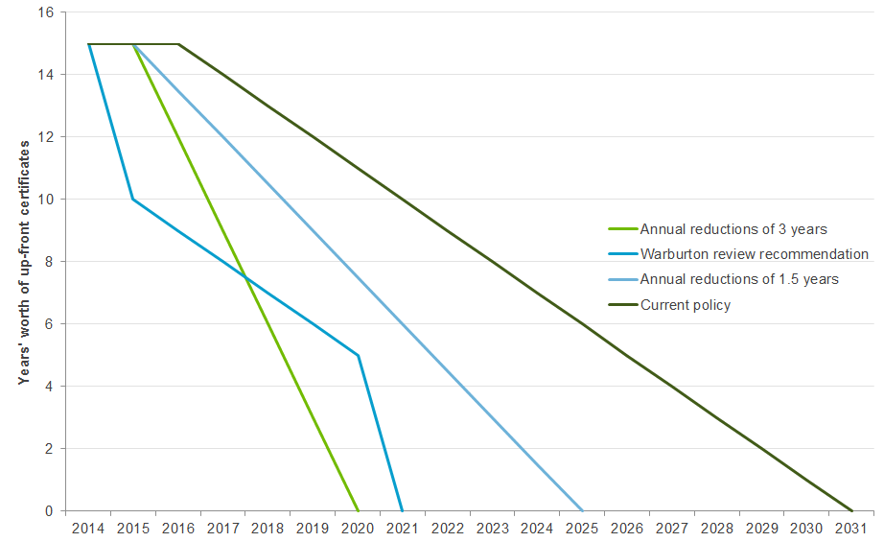

Source: Climate Change Authority based on Warburton review

|  |
| --- |
| Conclusion   1. Subsidising household PV under the SRES is a relatively expensive way to reduce emissions in the electricity sector. The Authority, however, has not recommended any changes, largely because the SRES assistance will shortly begin to phase out, and the overall costs are relatively modest. |

1. Other issues for the review

|  |
| --- |
| This chapter considers two issues—the diversity of access and uptake for renewable technologies under the RET, and the role and appropriate frequency for statutory reviews of the scheme. The first issue is a statutory requirement of the Authority's RET reviews.  On both issues, the Authority is inclined to reiterate the conclusions made in its 2012 reviews, namely that no change should be made to the RET to encourage particular technologies, and that statutory reviews should be conducted every four years rather than every two years. |

* 1. Diversity of access and uptake

The Authority has a statutory obligation to review diversity of access of renewable technologies to the scheme.

In its 2012 RET review, the Authority considered various measures that could be used to promote diversity of access and uptake, including:

* Multipliers, which could be applied to certificates from particular technologies to increase their uptake.
* A cap, which could be used to limit the total amount of generation from a particular technology, increasing the share of the target available to other eligible technologies.
* Banding, which would set a quota for total generation from each eligible technology. By assigning particular targets to different technologies, banding allows each technology the space to evolve without potentially being 'crowded out' by other technologies that might be cheaper in the short term.

The design of the LRET—which is neutral between renewable technologies—encourages the deployment of the lowest cost technologies, thereby minimising the costs to consumers of meeting a given target.

In 2012, the Authority concluded that the adoption of any measure to promote diversity within the RET, such as expanding the use of multipliers, or introducing banding or caps, would increase the costs of the scheme to consumers, and to the community as a whole. The Authority's view remains that the present approach should continue and that the current level of diversity of access is appropriate at this time. As recommended in section 3.4, the question of access to the scheme would warrant further consideration in the event the LRET were to be increased and extended in the period beyond 2020.

|  |
| --- |
| Conclusion   1. No changes should be made to the Renewable Energy Target framework to promote diversity of renewable technologies at this time. |

* 1. Future statutory reviews

Currently, the REE Act requires the Authority to conduct reviews of the RET every two years. When the Authority considered the review schedule in 2012 it concluded that full reviews every four years would provide an appropriate balance between policy flexibility and investor certainty. This is a position shared with many stakeholders—in submissions to the Warburton review and the Authority, the vast majority of participants addressing this issue argued for less frequent reviews—or no statutory reviews at all.

Statutory reviews that are transparent, predictable and principles-based are a valuable part of the governance of any major policy. In the context of the RET, they allow the tracking of progress towards nominated targets and evaluation of performance based on the goals of the scheme. They also allow actual and potential problems to be identified—and possible solutions to be explored in a formal (if stretched) timeframe.

As recent experience has demonstrated, frequent reviews of the RET in an environment lacking bipartisan political support for the scheme can cause investment and employment in the renewables industry to stall and fall. The Authority looks forward to an early resolution of uncertainty surrounding the RET, and especially the 2020 LRET target. In that event, the level and timing of the re-negotiated 2020 LRET target could be deemed to be outside the scope of future RET reviews.

A likely major issue for consideration in the next statutory review (assuming this is in 2018) is the possible role of the RET in the period beyond 2020, including its place in the overall post‑2020 policy framework. As noted earlier, in the absence of more comprehensive, cost‑effective measures to reduce emissions in the electricity sector, consideration would need to be given to increasing and extending the RET targets post 2020, along with eligibility for certificate creation (see section 3.4).

The Authority remains of the view that its previous suggestion that statutory reviews of the RET occur every four years strikes a reasonable balance between the need for policy flexibility and the risks to investor confidence created by too frequent reviews.

|  |
| --- |
| Conclusion   1. In the interest of maintaining investor confidence in the industry, the frequency of statutory reviews of the RET should be changed from every two years to every four years. For the same reason, if bipartisan agreement were to be reached on any revisions to the current 2020 LRET target, those revised arrangements should be outside the scope of future reviews. |

Appendix A Public consultation

The Authority is required to conduct public consultation for all of its reviews. Given the limited time available to conduct the review, the Authority did not release an issues paper or draft report. Nevertheless, throughout the review, the Authority consulted with a wide range of interested parties, including energy retailers, energy users, investors and the renewable energy industry. The Authority also drew on its previous work as well as the public submissions, analysis (including modelling) and report of the recent Warburton review.

Stakeholders were also invited to provide submissions to the Authority. Table 5 lists the individuals and organisations that provided submissions. These are available on the Authority’s website at: www.climatechangeauthority.gov.au/submissions/submissions-received.

Table 5 Submissions received

|  |  |
| --- | --- |
|  |  |
| AGL | Alstom |
| Australian Financial Markets Association | Australian Petroleum Production & Exploration Association |
| Australian Sugar Milling Council | Barbara J. Fraser |
| Clean Energy Council | CWP Renewables |
| Energy Networks Association | Energy Supply Association of Australia |
| Hydro Tasmania | Minerals Council of Australia |
| Origin Energy | Peter Cook |
| Recurrent Energy | Senvion Australia |
| Stanwell Corporation | Trustpower |
| WWF Australia |  |

Appendix B Requirements for Authority Renewable Energy Target reviews

The Climate Change Authority Act 2011 (Cth) (the CCA Act) and Renewable Energy (Electricity) Act 2000 (Cth) (the REE Act) establish the legislative requirements for the Authority's RET review. Together, they cover requirements for timing, scope and conduct of the reviews. The relevant parts of both of these Acts are reproduced below:

* Section 12 of the CCA Act sets out general principles that the Authority must have regard to in conducting reviews.
* Section 162 of the REE Act sets out the Authority’s specific requirements for reviewing the RET.
  + - 1. The Authority's principles (section 12 of the CCA Act)

In performing its functions, the Authority must have regard to the following principles:

(a) the principle that any measures to respond to climate change should:

* be economically efficient; and
* be environmentally effective; and
* be equitable; and
* be in the public interest; and
* take account of the impact on households, business, workers and communities; and
* support the development of an effective global response to climate change; and
* be consistent with Australia’s foreign policy and trade objectives;

(b) such other principles (if any) as the Authority considers relevant.

* + - 1. Periodic reviews of operation of renewable energy legislation (section 162 of the REE Act)

(1) The Climate Change Authority must conduct reviews of the following:

(a) the operation of this Act and the scheme constituted by this Act;

(b) the operation of the regulations;

(c) the operation of the Renewable Energy (Electricity) (Large‑scale Generation Shortfall Charge) Act 2000;

(d) the operation of the Renewable Energy (Electricity) (Small‑scale Technology Shortfall Charge) Act 2010;

(e) the diversity of renewable energy access to the scheme constituted by this Act, to be considered with reference to a cost benefit analysis of the environmental and economic impact of that access.

Public consultation

(2) In conducting a review, the Climate Change Authority must make provision for public consultation.

Report

(3) The Climate Change Authority must:

(a) give the Minister a report of the review; and

(b) as soon as practicable after giving the report to the Minister, publish the report on the Climate Change Authority’s website.

(4) The Minister must cause copies of a report under subsection (3) to be tabled in each House of the Parliament within 15 sitting days of that House after the review is completed.

First review

(5) The first review under subsection (1) must be completed before the end of 31 December 2012.

Subsequent reviews

(6) Each subsequent review under subsection (1) must be completed within 2 years after the deadline for completion of the previous review.

(7) For the purposes of subsections (4), (5) and (6), a review is completed when the report of the review is given to the Minister under subsection (3).

Recommendations

(8) A report of a review under subsection (1) may set out recommendations to the Commonwealth Government.

(9) In formulating a recommendation that the Commonwealth Government should take particular action, the Climate Change Authority must analyse the costs and benefits of that action.

(10) Subsection (9) does not prevent the Climate Change Authority from taking other matters into account in formulating a recommendation.

(11) A recommendation must not be inconsistent with the objects of this Act.

(12) If a report of a review under subsection (1) sets out one or more recommendations to the Commonwealth Government, the report must set out the Climate Change Authority’s reasons for those recommendations.

Government response to recommendations

(13) If a report of a review under subsection (1) sets out one or more recommendations to the Commonwealth Government:

(a) as soon as practicable after receiving the report, the Minister must cause to be prepared a statement setting out the Commonwealth Government’s response to each of the recommendations; and

(b) within 6 months after receiving the report, the Minister must cause copies of the statement to be tabled in each House of the Parliament.

(14) The Commonwealth Government’s response to the recommendations may have regard to the views of the following:

(a) the Climate Change Authority;

(b) the Regulator;

(c) such other persons as the Minister considers relevant.

Appendix C Outcomes of previous reviews

This appendix lists the recommendations from previous RET reviews for easy reference (the Authority’s 2012 review and the 2014 Warburton review).

The Authority's 2012 Renewable Energy Target review

Recommendation 1

The frequency of scheduled reviews should be amended from every two years to every four years, so the next scheduled review would be in 2016.

Recommendation 2

The form of the Large-scale Renewable Energy Target should continue to be expressed in legislation in terms of a fixed gigawatt-hour (GWh) level.

Recommendation 3

The existing Large-scale Renewable Energy Target of 41,000 GWh and interim targets should be maintained in their current form.

Recommendation 4

The RET review in 2016 is an appropriate time to consider adjusting the targets beyond 2020 in light of the policy and economic conditions prevailing at that time.

Recommendation 5

The Small-scale Renewable Energy Scheme should remain separate to the Large-scale Renewable Energy Target.

Recommendation 6

The threshold for solar photovoltaic units in the Small-scale Renewable Energy Scheme should be reduced from 100kW to, say, 10kW. The CCA recommends the Government conduct further consultation with stakeholders to determine an appropriate threshold. Units over the small-scale threshold would be included in the Large-scale Renewable Energy Target with five year deeming.

Recommendation 7

The ministerial power to lower the price cap should be retained to provide an immediate cost-containment mechanism should installations of small-scale systems boom.

Recommendation 8

The Small-scale Renewable Energy Scheme should be phased out by reducing deeming so that renewable energy generation is not rewarded after 2030.

Recommendation 9

The Clearing House should be amended to a ‘deficit sales facility’ whereby new certificates would only be placed in the Clearing House when it is in deficit.

Recommendation 10

The requirement to submit a solar hot water heater and small generation unit return should be removed from the Renewable Energy (Electricity) Act 2000.

Recommendation 11

The requirement to provide the out-of-pocket expense data for a small generation unit installation should be removed from the Renewable Energy (Electricity) Regulations 2001.

Recommendation 12

There should be no change to primary point of liability or the size threshold for coverage of grids.

Recommendation 13

Large electricity consumers should be permitted to opt-in to assume direct liability for RET obligations. The Government should consult further with stakeholders to develop a detailed approach to opt-in that is efficient for both large electricity users and retailers. The CCA considers that the New South Wales Greenhouse Gas Reduction Scheme opt-in model would be an appropriate starting point for this detailed design work.

Recommendation 14

No changes be made to the process for calculating individual liability.

Recommendation 15

The relevant Renewable Power Percentage and Small-scale Technology Percentage should be required to be set prior to a compliance year, and preferably by 1 December of the preceding year.

Recommendation 16

The current arrangements for surrender of certificates (annual surrender for the Large-scale Renewable Energy Target; quarterly surrender for the Small-scale Renewable Energy Scheme) should be maintained.

Recommendation 17

The Clean Energy Regulator should be able to refund over-surrendered certificates to a liable entity that ceases to trade, or transfer over-surrendered certificates if a liable entity is acquired by another entity which takes on a RET liability.

Recommendation 18

The current settings for the shortfall charge should be maintained. However, the level of the shortfall charge should be reconsidered by the CCA as part of its 2016 review of targets beyond 2020, or earlier if circumstances warrant.

Recommendation 19

The level of the emissions-intensive, trade-exposed exemption under the RET should be considered by the Productivity Commission as part of its broader review of the Jobs and Competitiveness Program.

Recommendation 20

The Government should take into consideration the impact of the RET on the competitiveness of an emissions-intensive, trade-exposed industry in any request to the Productivity Commission’s review of the level of industry assistance under the carbon pricing mechanism and the RET.

Recommendation 21

In cases where the RET costs are passed through to emissions-intensive, trade-exposed businesses, Partial Exemption Certificates should be tradeable, and thereby able to be used by any liable entity to reduce liable electricity acquisitions.

Recommendation 22

The Government should consider opportunities for efficiencies through the alignment of application processes and data requirements for emissions-intensive, trade-exposed industries under the Jobs and Competitiveness Program and the RET.

Recommendation 23

The self-generator exemption should continue in its current form.

Recommendation 24

Arrangements should be developed to allow for incidental electricity offtakes under the self-generators exemption which provide community benefits in remote locations.

Recommendation 25

No change is necessary to the list of eligible sources or the accreditation process for the Large-scale Renewable Energy Target.

Recommendation 26

Existing arrangements for waste coal mine gas should be maintained under the Large-scale Renewable Energy Target.

Recommendation 27

There should be no change to the Renewable Energy (Electricity) Act 2000 to allow for new waste coal mine gas to be eligible.

Recommendation 28

The Government should explore whether the RET eligibility for native forest wood waste is likely to increase the rate of logging of native forests. If it is not, then wood waste eligibility should be reinstated, subject to appropriate accreditation processes designed to ensure that no additional logging occurs as a result.

Recommendation 29

Maintain the Clean Energy Council as the sole accreditation body for installers under the Small-scale Renewable Energy Scheme.

Recommendation 30

New small-scale technologies should be included on a case-by-case basis for inclusion in the Small-scale Renewable Energy Scheme.

Recommendation 31

No additional new small-scale technologies should be made eligible in the Small-scale Renewable Energy Scheme at this time.

Recommendation 32

Existing arrangements for displacement technologies should be maintained.

Recommendation 33

No change should be made to the Renewable Energy (Electricity) Act 2000 to allow additional displacement technologies.

Recommendation 34

No change should be made to the RET framework to promote greater diversity.

Warburton 2014 Renewable Energy Target review

Recommendation 1

The Renewable Energy Target (RET) should be amended in light of the changing circumstances in Australia’s main electricity markets and the availability of lower cost emission abatement alternatives.

Recommendation 2

The Large-scale Renewable Energy Target (LRET) should be amended in one of the following two ways:

Option 1 – Closed to new entrants (‘grandfathering’)

In order to reduce the cost of the LRET and its impact on electricity markets, the Panel recommends that the LRET should be closed to new entrants.

a. The LRET is closed to new renewable energy power stations (subject to limited exceptions described below). The Clean Energy Regulator (CER) should set targets annually based on estimated output from accredited power stations.

b. In addition to those renewable energy power stations already accredited under the scheme, eligibility would be extended to:

i. Renewable energy power stations already under construction.

ii. Renewable energy power stations to be constructed where project proponents can demonstrate that there is full financial and contractual commitment to the project (e.g., final investment decision, engineering and procurement contract) within one month of the announcement of this approach.

c. The last year of the operation of the LRET is 2030.

or

Option 2 – Share of growth in electricity demand

In order to provide support for new renewable power stations and contribute to Australia’s emissions reduction target while achieving less reduction than Option 1 in the cost of the LRET, the Panel recommends that the target be set to allocate a share of growth in electricity demand to renewables in the following manner:

a. The target is set annually by the CER, increasing each year to 2020 by an amount equivalent to 50 per cent of projected growth in national electricity demand, ensuring that new renewable energy power stations are only supported under the RET where electricity demand is increasing.

b. Where national electricity demand is projected to remain flat or fall, the target is held at the previous year’s level.

c. From 2021 onwards, the target is fixed at the 2020 level until 2030, the last year of the operation of the LRET.

Based on current electricity demand forecasts, this approach would achieve a 20 per cent share of renewables in the electricity generation mix by 2020.

Recommendation 3

The Small-scale Renewable Energy Scheme (SRES) should be amended in one of the following two ways:

Option 1 – Abolition

In order to address the cost of the SRES (and its effect on electricity markets), the Panel recommends that it be closed immediately in the following manner:

a. The SRES should terminate upon announcement.

b. Those who contracted before the announcement for the installation of a small-scale system should receive the certificates they would have done.

or

Option 2 – Bring forward the phase-out of the SRES

In order to reduce the cost of the SRES while providing some support for new small-scale renewable energy systems, the Panel recommends that the phase-out of the SRES be brought forward in the following manner, to take effect immediately:

a. Bring forward the last year of operation of the SRES from 2030 to 2020.

b. Reduce the period for which certificates may be created for rooftop solar PV systems from 15 years to 10 years, and in each year from 2016 onwards further reduce the period for which certificates may be created, as set out below:

Rooftop solar PV: period certificates may be created

|  |  |
| --- | --- |
| Year installed | Period |
| Prior to announcement | 15 years |
| From announcement | 10 years |
| 2016 | 9 years |
| 2017 | 8 years |
| 2018 | 7 years |
| 2019 | 6 years |
| 2020 | 5 years |
| 2021 | Scheme closed |

c. Reduce system size eligibility threshold for rooftop solar PV systems from no more than100 kilowatts to no more than 10 kilowatts.

d. Reduce the period for which certificates may be created for solar and heat pump water heaters by one year each year, commencing in 2016, as set out below:

Solar and heat pump water heaters: period certificates may be created

|  |  |
| --- | --- |
| Year installed | Period |
| Prior to 2016 | 10 years |
| 2016 | 9 years |
| 2017 | 8 years |
| 2018 | 7 years |
| 2019 | 6 years |
| 2020 | 5 years |
| 2021 | Scheme closed |

Recommendation 4

The current partial exemption arrangements for emissions-intensive trade-exposed businesses should be maintained.

Recommendation 5

The self-generation exemption should be amended to extend the one kilometre radius restriction and to permit self-generators to supply incidental amounts of electricity (below a set threshold) to third parties without attracting a RET liability. The Government should consult with affected parties to determine an appropriate distance limit and threshold for incidental off-takes.

Recommendation 6

The Government’s commitment to the reinstatement of native forest wood waste as a renewable energy source under the LRET should be implemented through the reintroduction of the relevant regulations in force prior to 2011.

Recommendation 7

The requirement for statutory reviews of the scheme should be removed from the Renewable Energy (Electricity) Act 2000.

Glossary

| Term | Acronym/ abbreviation | Explanation |
| --- | --- | --- |
| Australian Energy Market Operator | AEMO | The Australian Energy Market Operator was established in 2009 and is responsible for the operation of the National Electricity Market, which includes the east and south-east regions of Australia (Queensland, New South Wales, Victoria, Tasmania and South Australia). |
| bankable certificates |  | Renewable energy certificates for both the large-scale and small-scale market do not have an expiry date. They may be purchased and held for any length of time before they are surrendered. |
| certificate costs |  | The amount passed on by liable parties (generally electricity retailers) to end-users to account for the costs of purchasing and surrendering Large-scale Generation Certificates (LGCs) and Small-scale Technology Certificates (STCs). |
| carbon pricing mechanism |  | The carbon pricing mechanism created a price on emissions by requiring large emitters to report on and surrender emissions units for their covered emissions. The carbon pricing mechanism commenced operation on 1 July 2012 and was abolished with effect from 1 July 2014. |
| Clean Energy Regulator | CER | The Clean Energy Regulator is an independent statutory authority that administers regulatory schemes relating to greenhouse gas emissions reductions, including the [Renewable Energy Target](http://www.cleanenergyregulator.gov.au/Renewable-Energy-Target), the [Carbon Farming Initiative](http://www.cleanenergyregulator.gov.au/Carbon-Farming-Initiative) and the [National Greenhouse and Energy Reporting](http://www.cleanenergyregulator.gov.au/National-Greenhouse-and-Energy-Reporting) Scheme. |
| Climate Change Authority | ‘the Authority’ | Established on 1 July 2012, the Climate Change Authority provides independent expert advice on Australian Government climate change mitigation initiatives. |
| commercial-scale PV |  | Larger capacity rooftop solar PV installed on non-residential premises. |
| compliance period |  | A full calendar year, the period over which each annual target under the Renewable Energy Target must be achieved. |
| Council of Australian Governments | COAG | The peak intergovernmental forum in Australia. The members of the Council of Australian Governments are the Prime Minister, State and Territory Premiers and Chief Ministers and the President of the Australian Local Government Association. |
| deeming |  | The estimation of the amount of electricity a solar panel or small-scale wind or hydro system generates, or the electricity a solar water heater or heat pump displaces. Deeming allows the owners of these technologies to receive their entitlement to small-scale technology certificates before the system has produced or displaced the electricity. |
| emissions-intensive trade-exposed | EITE | Businesses conducting specified emissions-intensive trade-exposed (EITE) activities are eligible for assistance under the RET scheme. |
| gigawatt hours | GWh | A measure of electricity generation or use over a period of time (or energy). |
| Intergovernmental panel on climate change | IPCC | Scientific intergovernmental body that produces reports that support the United Nations Framework Convention on Climate Change, which is the main international treaty on climate change |
| kilowatt | kW | A measure of power. |
| kilowatt hour | kWh | A measure of electricity generation or use over a period of time (or energy). |
| Kyoto Protocol |  | An agreement adopted under the United Nations Framework Convention on Climate Change in 1997. It entered into force in 2005. |
| Large-scale Generation Certificate | LGC | Represents one megawatt hour of renewable energy generation. |
| Large-scale Renewable Energy Target | LRET | Encourages the deployment of large-scale renewable electricity projects such as wind farms. |
| levelised cost of electricity | LCOE | A common tool for measuring and comparing power generation costs across different technologies. It represents the per kilowatt hour cost (in real dollars) of building and operating a generation technology over an assumed financial life and duty cycle. |
| liable entities |  | Entities that make wholesale acquisitions of electricity and are required by the legislation to surrender a specified number of renewable certificates or pay a renewable energy shortfall charge. |
| Mandatory Renewable Energy Target | MRET | The Mandatory Renewable Energy Target began operation in 2001. It had a target of 9,500 gigawatt hours in 2010 (mandated out to 2020) and interim targets that gradually increased year on year. |
| megawatt | MW | A measure of power (or demand). |
| megawatt hour | MWh | A measure of electricity generation/use over a period of time (or energy). |
| merchant generator |  | A stand‑alone electricity generator that does not have a power purchase agreement (PPA) with an electricity retailer, but rather sells its production to the spot and short‑term forward markets. |
| mothballing |  | The preservation of a production facility without using it to produce. Machinery in a mothballed facility is kept in working order so that production may be restored quickly if needed. |
| multiplier credits |  | Credits that are a multiple of the number of certificates that an eligible technology would generally be able to create. Previously in place under the Small-scale Renewable Energy Scheme. |
| National Electricity Market | NEM | The National Electricity Market interconnects five regional market jurisdictions (Queensland, New South Wales, Victoria, South Australia and Tasmania). Western Australia and the Northern Territory are not connected to the National Electricity Market. |
| native demand |  | Electricity load serviced by scheduled electricity generation, semi-scheduled generation and embedded generation (including rooftop solar PV). |
| net present value | NPV | Net present value is a standard method for using the time value of money to estimate future costs. It compares the present value of money today to the present value of money in the future, taking inflation into account. |
| partial exemption certificate | PEC | The Renewable Energy (Electricity) Act 2000 and the Renewable Energy (Electricity) Regulations 2001 include provisions to provide partial exemption from Renewable Energy Target liability for electricity used in defined emissions-intensive trade-exposed activities. To obtain exemption, prescribed persons may apply to the Clean Energy Regulator for a partial exemption certificate. |
| power purchase agreement | PPA | A long‑term agreement between an electricity generator and electricity retailer to purchase electricity generated (and in the case of renewable generators, LGCs). |
| ‘real’ 20 per cent target |  | A 2020 LRET target based on 20 per cent of either current estimated or actual electricity demand in 2020. The current 2020 LRET target is for a fixed amount of generation (41,000 GWh). |
| Renewable Energy Certificate | REC | The term used for renewable energy certificates generated under the Renewable Energy Target scheme prior to 2011. |
| Renewable Energy (Electricity) Act 2000 (Cth) | REE Act | The legislative framework for the Renewable Energy Target scheme. |
| Renewable Energy (Electricity) Regulations 2001 | REE Regulation | The detailed rules and provisions of the Renewable Energy Target scheme. |
| Renewable Energy Target | RET | The Renewable Energy Target operates in two parts—the Small‑scale Renewable Energy Scheme and the Large‑scale Renewable Energy Target. |
| Renewable Energy Target review | RET review | The Climate Change Authority’s review of the Renewable Energy Target. The review is defined in Section 162 of the Renewable Energy (Electricity) Act 2000 (Cth). |
| shortfall charge |  | A charge that applies to the outstanding amount when a liable entity surrenders less than the required number of certificates to meet obligations under the LRET or SRES. The shortfall charge under both the LRET and SRES is currently set at $65. |
| solar photovoltaic | PV | A method of generating electricity by converting the sun’s energy into electricity. |
| small-scale PV |  | Rooftop solar PV installed on by households. Also referred to as ‘household PV’. |
| Small-scale Renewable Energy Scheme | SRES | Supports the installation of small-scale systems, including solar photovoltaic systems and solar water heaters, and small generation units. |
| Small-scale Technology Certificate | STC | Certificates created by small-scale technologies like solar panels and solar water heaters. |
| Small-scale Technology Certificate Clearing House | STC Clearing House | Facilitates the exchange of small-scale technology certificates between buyers and sellers at the fixed price of $40 (excluding GST). |
| thermal generators |  | A power station in which electricity is generated by the production of steam. The steam is typically produced by burning fossil fuels such as gas and coal. |
| Warburton review |  | A review of the Renewable Energy Target conducted in 2014 by a panel headed by Dick Warburton AO LVO, supported by a secretariat located within the Department of the Prime Minister and Cabinet. |

Abbreviations and acronyms

| Term | Meaning |
| --- | --- |
| AEMC | Australian Energy Market Commission |
| AEMO | Australian Energy Market Operator |
| AiG | Australian Industry Group |
| AO | Officer of the Order of Australia |
| APVI | Australian Photovoltaic Institute |
| BCA | Business Council of Australia |
| BNEF | Bloomberg New Energy Finance |
| BREE | Bureau of Resources and Energy Economics |
| CCA | Climate Change Authority |
| CCS | Carbon capture and storage |
| CEC | Clean Energy Council |
| CER | Clean Energy Regulator |
| CO2 | Carbon dioxide |
| CO2-e | Carbon dioxide equivalent |
| COAG | Council of Australian Governments |
| CSIRO | Commonwealth Scientific and Industrial Research Organisation |
| Cth | Commonwealth |
| DIICCSRTE | Department of Industry, Innovation, Climate Change, Science, Research and Tertiary Education |
| EITE | Emission-intensive trade-exposed |
| ERF | Emissions Reduction Fund |
| ESAA | Energy Supply Association of Australia |
| GWh | Gigawatt hour |
| IEA | International Energy Agency |
| IES | Intelligent Energy Systems |
| IGCC | Investor Group on Climate Change |
| IPCC | Intergovernmental Panel on Climate Change |
| kW | Kilowatt |
| kWh | Kilowatt hour |
| LGC | Large-scale Generation Certificate |
| LRET | Large-scale Renewable Energy Target |
| LVO | [Lieutenant](http://en.wikipedia.org/wiki/Category:Lieutenants_of_the_Royal_Victorian_Order) of the Royal Victorian Order |
| MRET | Mandatory Renewable Energy Target |
| Mt | Million tonnes |
| MW | Megawatt |
| MWh | Megawatt hour |
| NPV | Net present value |
| OECD | Organisation for Economic Cooperation and Development |
| PPA | Power Purchase Agreement |
| PV | Photovoltaic |
| PwC | PricewaterhouseCoopers |
| REC | Renewable Energy Certificate |
| REE Act | Renewable Energy (Electricity) Act 2000 (Cth) |
| RET | Renewable Energy Target |
| SKM | Sinclair Knight Merz |
| SKM MMA | Sinclair Knight Merz and McLennan Magasanik Associates |
| SRES | Small-scale Renewable Energy Scheme |
| STC | Small-scale Technology Certificate |
| SWH | Solar water heater |
| t | Tonne |
| Wh | Watt hour |

References

Chapter 1

Climate Change Authority Act 2011 (Cth).

Climate Change Authority 2012, Renewable Energy Target Review—Final Report, Melbourne.

Renewable Energy (Electricity) Act 2000 (Cth).

Renewable Energy (Electricity) (Large-scale Generation Shortfall Charge) Act 2010 (Cth).

Renewable Energy (Electricity) (Small-scale Technology Shortfall Charge) Act 2010 (Cth).

Warburton review (Expert Panel), 2014, Renewable Energy Target Scheme—Report of the Expert Panel, Canberra.

Chapter 2

ACIL Allen 2013a, Drivers of domestic PV uptake—characteristics of households with solar photovoltaic systems, report to the Australian Renewable Energy Agency, Canberra.

ACIL Allen 2013b, Electricity Sector Emissions—Modelling of the Australian Generation Sector, report to Department of Industry, Innovation, Climate Change, Science, Research and Tertiary Education (DIICCSRTE), Canberra.

ACIL Allen Consulting 2014, RET Review modelling—Market modelling of various RET policy options, Report to the RET Review Expert Panel, Melbourne.

AGL 2012, AGL completes purchase of Loy Yang A power station and adjacent mine, viewed 8 December 2014,  
www.agl.com.au/about-agl/media-centre/article-list/2012/jun/agl-completes-purchase-of-loy-yang-a-power-station-and-adjacent-mine.

AGL 2014, AGL completes acquisition of Macquarie Generation assets, viewed 8 December 2014,  
www.agl.com.au/about-agl/media-centre/article-list/2014/september/agl-completes-acquisition-of-macquarie-generation-assets.

Audoly, R, Vogt-Schilb, A & Guivarch, A, 2014 Pathways Toward Zero-Carbon Electricity Required for Climate Stabilization, Policy Research Working Paper 7075, World Bank Group.

Australian Energy Market Commission (AEMC) 2014, Distribution network pricing arrangements, Rule determination, 27 November 2014, Sydney.

Barroso, J, 2014, Statement by President Barroso following the first day of the European Council of 23-24 October 2014, viewed 4 December 2014, <http://europa.eu/rapid/press-release_SPEECH-14-719_en.htm>.

BREE 2014, 2014 Australian energy statistics, BREE, Canberra, July.

Clean Energy Regulator 2014a, Small-Scale Installations by Postcode, Clean Energy Regulator, Canberra, viewed 27 November 2014, <http://ret.cleanenergyregulator.gov.au/REC-Registry/Data-reports>.

Clean Energy Regulator 2014b, Coal-fired generation assistance, Clean Energy Regulator, Canberra, viewed 19 December 2014,   
http://www.cleanenergyregulator.gov.au/Carbon-Pricing-Mechanism/Industry-Assistance/coal-fired-generators/Pages/default.aspx.

Climate Change Authority (CCA) 2012, Renewable Energy Target Review—Final Report, Melbourne.

CCA 2014a, Targets and Progress Review—Final Report, Melbourne.

CCA 2014b, Light Vehicle Emissions Standards for Australia—Research Report, Melbourne.

Climate Change Authority 2014c, Carbon Farming Initiative Review, Melbourne.

ClimateWorks Australia, Australian National University 2014a, Pathways to Deep Decarbonisation in 2050‑How Australia can prosper in a low carbon world—Initial Project Report, ClimateWorks Australia, Melbourne.

ClimateWorks Australia, Australian National University, CSIRO & Centre for Policy Studies 2014b, Pathways to Deep Decarbonisation in 2050—How Australia can prosper in a low carbon world‑Technical report, ClimateWorks Australia, Melbourne.

COAG Working Group on Climate Change and Water 2008, Design Options for the Expanded National Renewable Energy Target Scheme, Canberra.

Department of Environment 2014, Emissions Reduction Fund White Paper, Canberra.

Energy Australia 2013, Energy Australia acquires Mt Piper and Wallerawang power stations, viewed 8 December 2014,  
[www.energyaustralia.com.au/about-us/media-centre/current-news/ea-acquires-mtpiper-wallerawang](http://www.energyaustralia.com.au/about-us/media-centre/current-news/ea-acquires-mtpiper-wallerawang).

Energy Supply Association Australia (ESAA) 2014, Australian electricity markets, viewed 4 December 2014, <http://www.esaa.com.au/policy/australian_electricity_markets_1_1_1>.

Explanatory Memorandum, Renewable Energy (Electricity) Amendment Bill 2009 (Cth).

Frontier Economics 2014, Can Australia still meet its emissions target with changes in the RET?, Frontier Economics, September 2014.

GDF SUEZ 2012, Full ownership of International Power: GDF SUEZ reaches a strategic milestone for development in high growth markets, viewed 8 December 2014,  
www.gdfsuez.com/en/journalists/press-releases/full-ownership-of-international-power-gdf-suez-reaches-a-strategic-milestone-for-development-in-high-growth-markets/.

Graham, P, Brinsmead, T, Dunstall, S, Ward, J, Reedman, L, Elgindy, T, Gilmore, J, Cutler, N, James, G, Rai, A, & Hayward, J 2013, Modelling the Future Grid Forum Scenarios, CSIRO, Canberra.

International Energy Agency 2014a, Energy technology perspectives 2014—Harnessing electricity's potential, IEA, Paris.

International Energy Agency 2014b, [The Way Forward—Five Key Actions to Achieve a Low-Carbon Energy Sector](https://www.iea.org/topics/climatechange/The_Way_Forward.pdf), IEA, Paris.

International Energy Agency 2014c, IEA Statistics—CO2 emissions from Fuel Combustion, IEA, Paris.

Intergovernmental Panel on Climate Change (IPCC) 2014a, Working Group III Contribution to the Fifth Assessment Report, Climate Change 2014‑ Mitigation, Summary for Policy Makers, Cambridge University Press, Cambridge.

IPCC, 2014b. Working Group III Contribution to the Fifth Assessment Report, Climate Change 2014—Mitigation, Cambridge University Press, Cambridge.

Origin Energy 2013, Origin to acquire Eraring Energy and enter into new fuel supply arrangements, viewed 8 December 2014,  
[www.originenergy.com.au/news/article/asxmedia-releases/1499](http://www.originenergy.com.au/news/article/asxmedia-releases/1499).

Productivity Commission 2011, Carbon emissions policies in key economies, Research report, Canberra.

Renewable Energy (Electricity) Act 2000 (Cth).

Sachs, J, Tubiana, L, Guerin, E, Waisman, H, Mas, C, Colombier, M & Schmidt-Traub, G, 2014. Pathways to Deep Decarbonisation—Interim 2014 Report, United Nations' Sustainable Development Solutions Network (SDSN) and Institute for Sustainable Development and International Relations (IDRI), New York and Paris.

SKM 2012, Benefit of the Renewable Energy Target to Australia's Energy Markets and Economy—Report to the Clean Energy Council.

The Australian 2011, Lenders take charge of utility Alinta Energy,16 March, viewed 8 December 2014,  
www.theaustralian.com.au/business/lenders-take-charge-of-utility-alinta-energy/story-e6frg8zx-1226022097297.

Treasury and the Department of Industry, Innovation, Climate Change, Science, Research and Tertiary Education (DIICCSRTE) 2013, Climate change mitigation scenarios, Report for the Climate Change Authority in support of its Caps and Targets Review, Canberra.

Warburton review (Expert Panel), 2014, Renewable Energy Target Scheme—Report of the Expert Panel, Canberra.

The White House 2014, *U.S.-China Joint Announcement on Climate Change and Clean Energy Cooperation*—*fact sheet*, 11 November, viewed 27 November 2014, [www.whitehouse.gov/the-press-office/2014/11/11/fact-sheet-us-china-joint-announcement-climate-change-and-clean-energy-c](http://www.whitehouse.gov/the-press-office/2014/11/11/fact-sheet-us-china-joint-announcement-climate-change-and-clean-energy-c).

Chapter 3

ACIL Allen Consulting 2014, RET Review modelling—Market modelling of various RET policy options, Report to the RET Review Expert Panel, Melbourne.

AGL 2014, AGL to mothball South Australian generating units, viewed 10 December 2014,   
www.agl.com.au/about-agl/media-centre/article-list/2014/december/agl-to-mothball-south-australian-generating-units.

Australian Energy Market Operator (AEMO) 2012, National Electricity Forecasting Report 2012, Sydney.

AEMO 2013, 2013 Electricity Statement of Opportunities, Sydney.

AEMO 2014a, 2014 National Electricity Forecasting Report 2014, Sydney.

AEMO 2014b, 2014 Electricity Statement of Opportunities, Sydney.

Bloomberg New Energy Finance (BNEF) 2013, Australia LCOE update: Wind cheaper than coal and gas, 31 January, Melbourne.

BNEF 2014, Investment freeze in Australia Continues, 3 October, Melbourne.

Clean Energy Council (CEC) 2014, Practical, social and financial considerations for meeting the 2020 Renewable Energy Target, Melbourne.

Clean Energy Regulator (CER) 2014, Volume weighted average market price for a renewable energy certificate (REC) / large-scale generation certificate (LGC), Canberra, viewed 21 November 2014,   
[http://ret.cleanenergyregulator.gov.au/For-Industry/Emissions-Intensive-Trade-Exposed/Volume-Weighted-Average-Market-Price/market-price.](http://ret.cleanenergyregulator.gov.au/For-Industry/Emissions-Intensive-Trade-Exposed/Volume-Weighted-Average-Market-Price/market-price)

Climate Change Authority (CCA) 2012, Renewable Energy Target Review— Final Report, Melbourne.

COAG Energy Council 2014, Meeting Communique, 11 December, Adelaide.

Deloitte 2014, Assessing the impact of the renewable energy target, Report to the Australian Chamber of Commerce and Industry, Melbourne.

Explanatory Memorandum, Renewable Energy (Electricity) Amendment Bill 2009 (Cth).

Frontier Economics 2014, RET Review Analysis, Report to the Australian Energy Market Commission (AEMC), Melbourne.

HRL Limited 2014, Media Release‑Study underway to repower Energy Brix Australia Corporation briquette factory - temporary closure at end August 2014, viewed 8 December 2014,   
www.hrl.com.au/media-release-29th-july-2014/w1/i1041955/.

Jacobs 2014, Impacts of Changes to the RET on Electricity Market Participants, Report to the Climate Institute, Australian Conservation Foundation and WWF‑Australia, Melbourne.

Nelson, T, Reid, R & McNeill, J 2014, Energy-only markets and renewable energy targets‑complementary policy or policy collision?, AGL Applied Economic and Policy Research, Sydney.

Oakley Greenwood 2014, A report on the implications of the RET and generation over‑supply, Sydney.

PricewaterhouseCoopers Australia (PwC) 2014, State of the Debt Markets for the Energy Supply Industry, Report to the Energy Supply Association of Australia, Melbourne.

ROAM Consulting 2014, RET policy analysis, Report to the Clean Energy Council, Brisbane.

Schneider Electric 2014, Australia's Large-scale Renewable Energy Target—Three Consumer Benefits, Sydney.

Sinclair Knight Merz and McLennan Magasanik Associates (SKM MMA) 2012, Modelling the Renewable Energy Target, Report to the Climate Change Authority, Sydney.

Warburton review (Expert Panel) 2014, Renewable Energy Target Scheme—Report of the Expert Panel, Canberra.

Chapter 4

ACIL Allen Consulting 2014, RET Review modelling—Market modelling of various RET policy options, report to the RET Review Expert Panel, Melbourne.

Australian Energy Market Commission (AEMC) 2014a, Distribution network pricing arrangements, Rule determination, 27 November 2014, Sydney.

Australian Energy Market Commission (AEMC) 2014b, Distribution network pricing arrangements, Draft rule determination, 28 August 2014, Sydney.

Australian PV Institute 2013, Impacts of PV, AC, other technologies and tariffs on consumer costs—report to the Centre for Policy Development.

Australian PV Institute 2014, Australian PV in Australia Report 2013, APVI.

Climate Change Authority (CCA) 2012, Renewable Energy Target Review—Final Report, Melbourne.

CCA 2014, Targets and Progress Review—Final Report, Melbourne.

Clean Energy Council 2014, Briefing paper—the impacts of changes to the SRES threshold, CEC, Melbourne.

Clean Energy Regulator 2014, Small-Scale Installations by Postcode, viewed 27 November 2014, <http://ret.cleanenergyregulator.gov.au/REC-Registry/Data-reports>.

Edis, T 2014, '$1 per watt solar – it’s here now', Climate Spectator, 7 November, viewed 4 December 2014,   
www.businessspectator.com.au/article/2014/11/7/solar-energy/1-watt-solar-%E2%80%93-its-here-now.

Green Energy Markets 2014, Small-scale technology certificates—Data modelling for 2014 to 2016, Report to Clean Energy Regulator, Melbourne.

Hanger, I 2014, Report of the Royal Commission into the home insulation program, Commonwealth of Australia, Canberra.

Intelligent Energy Systems (IES) 2014, Small-scale technology certificates forecasts—2014 to 2016,, Sydney.

Kelp, O 2014, Personal communications between Owen Kelp of ACIL Allen and the Climate Change Authority.

NERA Economic Consulting 2014, Efficiency of tariffs for current and emerging technologies, report to the Australian Energy Market Commission, Sydney.

Renewable Energy (Electricity) Regulations 2001 (Cth).

Sinclair Knight Merz and McLennan Magasanik Associates (SKM MMA) 2012, Modelling the Renewable Energy Target, Report to the Climate Change Authority, Sydney.

Treasury and the Department of Industry, Innovation, Climate Change, Science, Research and Tertiary Education (DIICCSRTE) 2013, Climate change mitigation scenarios, Report for the Climate Change Authority in support of its Caps and Targets Review, Canberra.

Warburton review (Expert Panel) 2014, Renewable Energy Target Scheme—Report of the Expert Panel, Canberra.

Chapter 5

Climate Change Authority (CCA) 2012, Renewable Energy Target Review—Final Report, Melbourne.

Warburton review (Expert Panel) 2014, Renewable Energy Target Scheme—Report of the Expert Panel, Canberra.

Appendices

Climate Change Authority 2012, Renewable Energy Target Review—Final Report, Melbourne.

Climate Change Authority Act 2011 (Cth).

Renewable Energy (Electricity) Act 2000 (Cth).

Warburton review (Expert Panel) 2014, Renewable Energy Target Scheme—Report of the Expert Panel, Canberra.

1. Quotations are taken from participants' submissions to both the Warburton and Climate Change Authority reviews as indicated. For a list of submissions to the Authority review see Appendix A.
2. In this chapter, all currency amounts are in real 2014 Australian dollars unless otherwise specified.
3. References to submissions in this chapter are those made to the Authority if the organisation made a submission to the Authority (see Appendix A), otherwise references are to organisations’ submissions to the Warburton review.
4. Technically, the SRES allows households who install solar PV to create tradeable certificates. In practice, the vast majority of households assign these certificates to the installer in exchange for a reduction in the installation price, hence the shorthand ‘payment’.
5. Climate Change Authority calculation based on an STC price of $38, a 3 kW system and solar zone data from Renewable Energy (Electricity) Regulations 2001 (Cth), schedule 5. It is a simple average across solar zones that determine the volume of STCs deemed in one year to create an Australia-wide approximation.